Q1.Add a gradle dependency and its related repository url.
apply plugin:'java'
sourceSets{
main{
java.srcDirs=['src']
}
}
dependencies{
compile group: 'commons-io',name: 'commons-io',version: '2.6'
}
repositories{
mavenCentral()
}

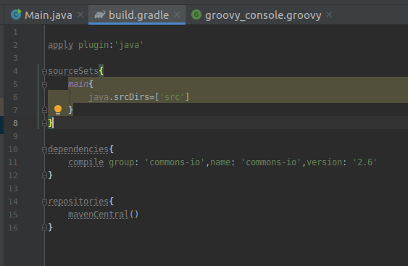

Q2.Using java plugin, make changes in the manifest to make the jar executable. Using java -jar JAR_NAME, the output should be printed as "Hello World"
Demo.java
public class Demo {
public static void main(String[] args) {
System.out.println("Hello world");
}
}
build.gradle
apply plugin:'java'
sourceCompatibility=1.8
jar{
manifest{
attributes 'Main-Class': 'Demo'
}
}
sourceSets{
main{
java.srcDirs=['src']
}
}
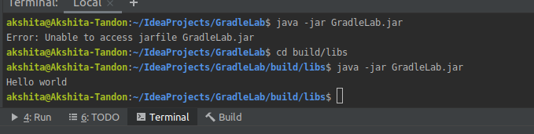

Q3.Differentiate between the different dependency scopes: compile, runtime, testCompile, testRuntime using different dependencies being defined in your build.gradle.

Compile:At compile time, we will use the dependencies that are required to compile the production source of the project.
Runtime:These dependencies are used at runtime by production classes. By default, it also contains the compile-time dependencies.
Test Compile:hese dependencies are required to compile the test source of the project. It also contains the compiled production classes and the compile-time dependencies.
Test Runtime:These dependencies are required to run the tests. It also contains runtime and test compile dependencies.

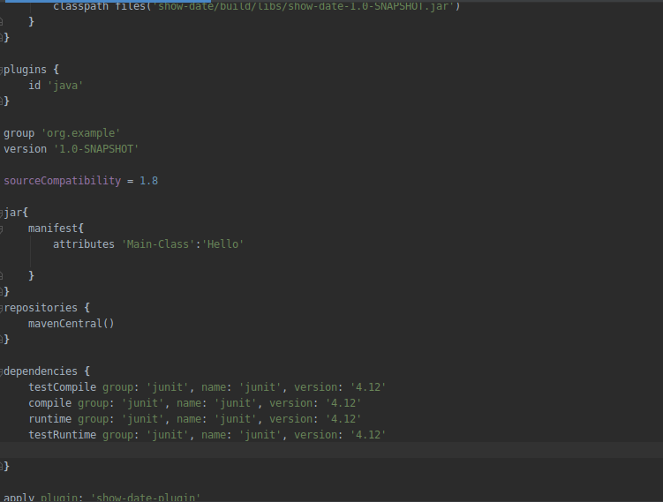

Q4.Create a custom plugin which contains a custom task which prints the current date-time. Using that plugin in your project, execute that task after the jar task executes.
buildscript{
dependencies {
classpath files('show-date/build/libs/show-date-1.0-SNAPSHOT.jar')
}
}
plugins {
id 'java'
}
group 'org.example'
version '1.0-SNAPSHOT'

sourceCompatibility = 1.8
jar{
manifest{
attributes 'Main-Class':'Hello'

}
}
repositories {
mavenCentral()
}

dependencies {
testCompile group: 'junit', name: 'junit', version: '4.12'
compile group: 'junit', name: 'junit', version: '4.12'
runtime group: 'junit', name: 'junit', version: '4.12'
testRuntime group: 'junit', name: 'junit', version: '4.12'

}

apply plugin: 'show-date-plugin’

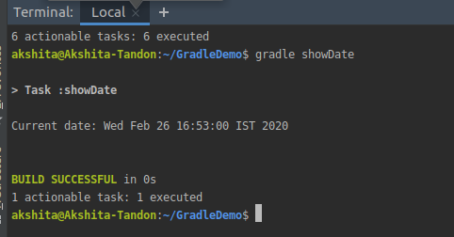

Q5.Instead of using default source set, use src/main/javaCode1, src/main/javaCode2 to be taken as code source. Make sure that the JAR created contains files from both the directories and not from src/main/java.
buildscript{
dependencies {
classpath files('show-date/build/libs/show-date-1.0-SNAPSHOT.jar')

}
}

plugins {
id 'java'
}

group 'org.example'
version '1.0-SNAPSHOT'

sourceCompatibility = 1.8

sourceSets{
main{
java.srcDirs=['src/main/java']
java.srcDirs= ['src/main/javaCode1']
java.srcDirs= ['src/main/javaCode2']
}
}
jar{
manifest{
attributes 'Main-Class':'java/Hello.java'

}
}
repositories {
mavenCentral()
}

dependencies {
testCompile group: 'junit', name: 'junit', version: '4.12'
compile group: 'junit', name: 'junit', version: '4.12'
runtime group: 'junit', name: 'junit', version: '4.12'
testRuntime group: 'junit', name: 'junit', version: '4.12'

}
wrapper {
gradleVersion= '3.5'
distributionUrl= distributionUrl.replace("bin","all")
}
apply plugin: 'show-date-plugin'
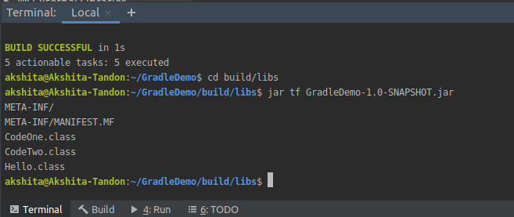
}*/

Q6.Override the Gradle Wrapper task to install a different version of gradle. Make sure that the task written in Q4 also executes with it.
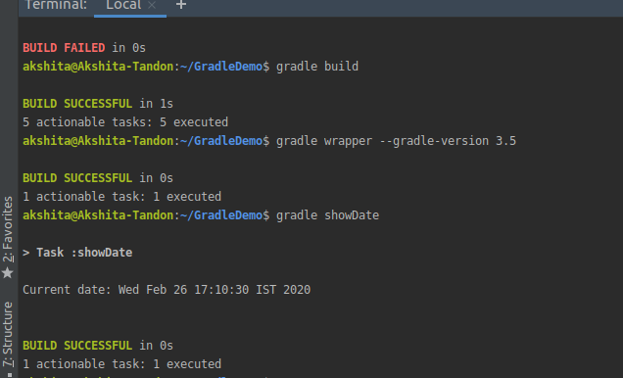

Q7.Run the gradle profile command and attach the resulting files.

