Problem Statement: There can be multiple customers, who can place multiple orders on the site. Now a sales person can handle these orders will distribute into multiple sales persons (One order will be assign to one salesperson only). So a sales person can have multiple orders of multiple customers
- Create Database
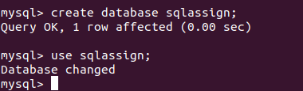

- Design Schema
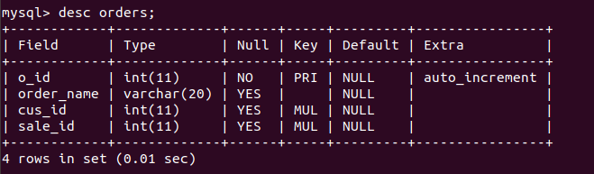
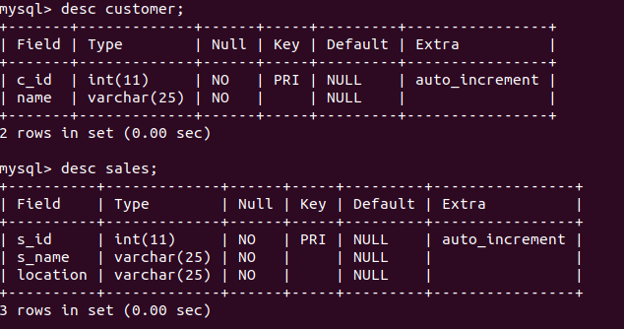

- Create tables

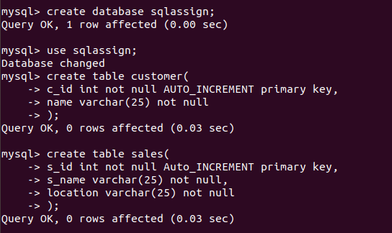
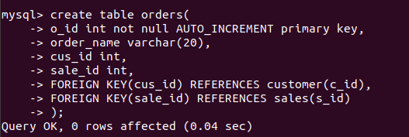

- Insert sample data

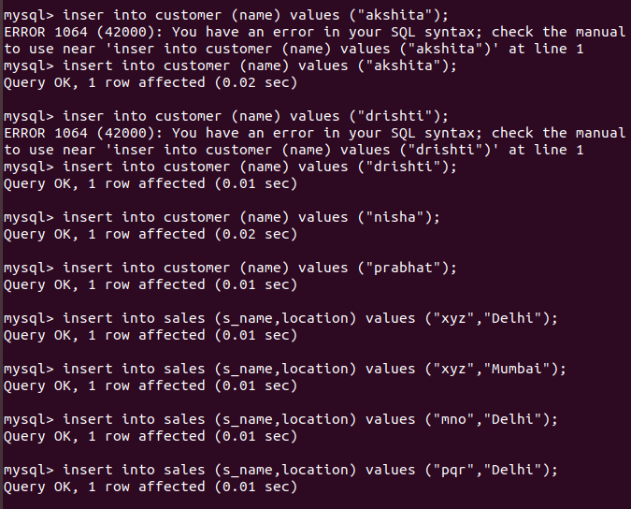
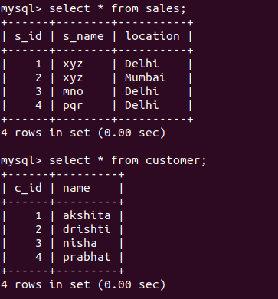

Inserting values into orders table

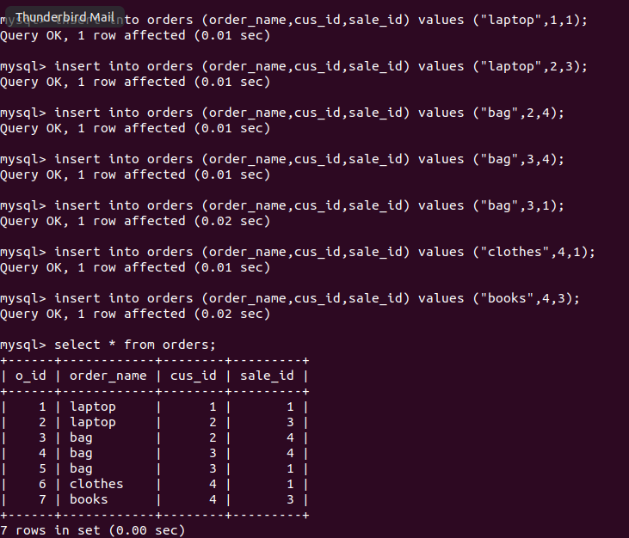

- Find the sales person have multiple orders.

Query: select s_id,s.s_name from sales s where (select count(*) from orders o where s.s_id=o.sale_id)>1;
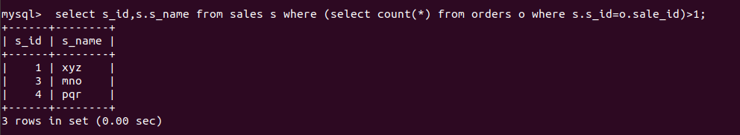

- Find the all sales person details along with order details

Query: select s.s_name as SalePerson,o.o_id as Orderid,o.order_name as Ordername from sales s inner join orders o where s.s_id=o.sale_id;
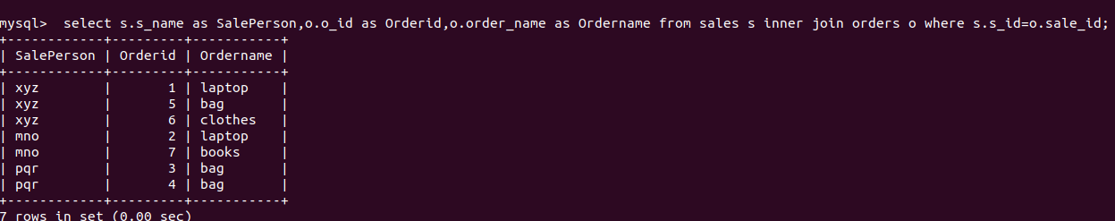
- Create index
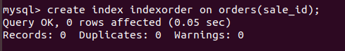

- How to show index on a table
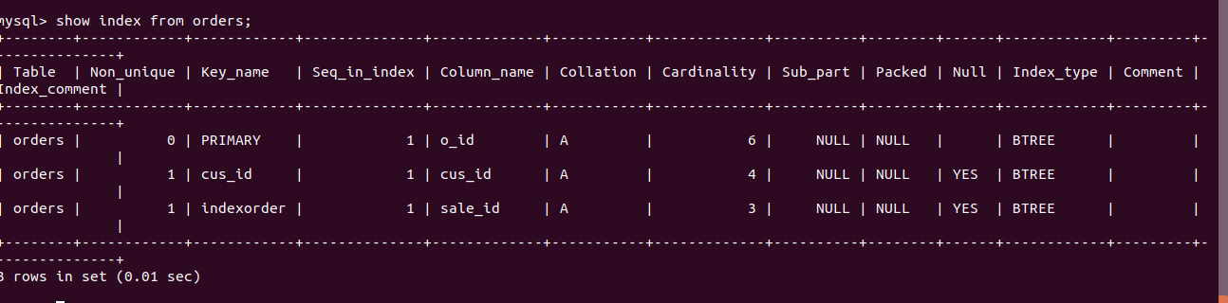
- Find the order number, sale person name, along with the customer to whom that order belongs to
Query: select o.o_id as OrderId,c.name as CustomerName,s.s_name as SalesPersonName from sales s, customer c, orders o where s.s_id=o.sale_id and c.c_id=o.cus_id;
