1. Create Java classes having suitable attributes for Library management system.Use OOPs concepts in your design.Also try to use interfaces and abstract classes.
package com.firstjava;
interface customer_operations{
public void add(String customer_name,String customer_address,Books books);
public void display();
public void checkout(int date_of_issue,int date_of_return);
}
abstract class books_operations{

public abstract void add(String book_name, String book_author, String book_publisher);
public abstract void delete(String book_name);
public abstract void display();
public abstract void submit(String book_name);
}
class Books extends books_operations{
private String book_name;
private String book_author;
private String book_publisher;

@Override
public void add(String book_name, String book_author, String book_publisher) {

}

@Override
public void delete(String book_name) {

}

@Override
public void display() {

}

@Override
public void submit(String book_name) {

}
}
class Customers implements customer_operations{
private String customer_name;
private String customer_address;
private int date_of_issue;
private int date_of_return;

@Override
public void add(String customer_name, String customer_address, Books books) {

}

@Override
public void display() {

}

@Override
public void checkout(int date_of_issue, int date_of_return) {

}
}
public class Library {
public static void main(String[] args) {
}
}
2. WAP to sorting string without using string Methods?.
package com.firstjava;
import java.util.Arrays;
import java.util.Scanner;
public class SortingStrings {
public static void main(String[] args) {
System.out.println("Enter the string");
Scanner sc=new Scanner(System.in);
String str=sc.nextLine();
String[] strarray=str.split("");
for(int i=0;i<strarray.length-1;i++)
{
for(int j=i+1;j<strarray.length;j++)
{
if(strarray[i].compareTo(strarray[j])>0)
{
String temp=strarray[i];
strarray[i]=strarray[j];
strarray[j]=temp;
}
} }
System.out.println(Arrays.toString(strarray));
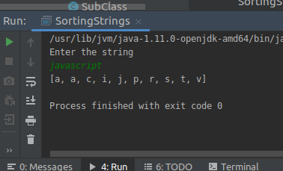
}
}

3. WAP to produce NoClassDefFoundError and ClassNotFoundException exception.
package com.firstjava;

public class Exception {
public static void main(String[] args) {
try {
Class.forName("JavaException");
}catch (ClassNotFoundException cpe){
cpe.printStackTrace();
}
}
}
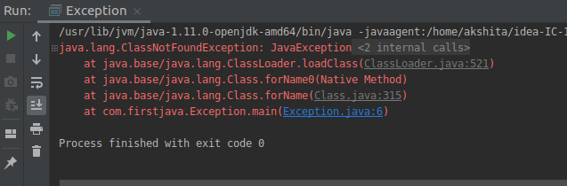
package akshita;
class Data{
private int id;
public int getId(){return id;}
public void setId(int id){this.id=id;}
}
public class DataTest {
public static void main(String[] args) {
Data data=new Data();
data.setId(10);
System.out.println("Data id="+data.getId());

}
}
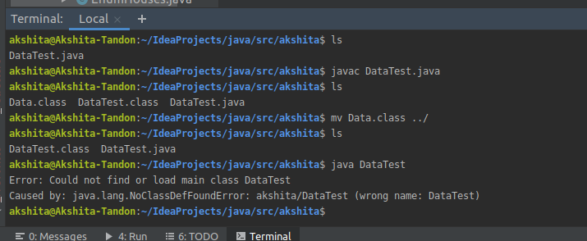
4. WAP to create singleton class.
package com.firstjava;

public class SingletonClass {

public String firstStr;
private static SingletonClass single_instance=null;
private SingletonClass()
{
firstStr="This is an object of Singleton Class";
}
public static SingletonClass getInstance()
{
if(single_instance==null)
{
return single_instance=new SingletonClass();
}
else
return single_instance;
}
}
class Demo{
public static void main(String[] args) {
SingletonClass sc1=SingletonClass.getInstance();
SingletonClass sc2=SingletonClass.getInstance();
SingletonClass sc3=SingletonClass.getInstance();
System.out.println("First Object "+sc1.firstStr+" "+sc1);
System.out.println("Second Object "+sc2.firstStr+" "+sc2);
System.out.println("Third Object "+sc3.firstStr+" "+sc3);
System.out.println("Changing to Uppercase");
sc3.firstStr=sc3.firstStr.toUpperCase();
System.out.println("First Object "+sc1.firstStr+" "+sc1);
System.out.println("Second Object "+sc2.firstStr+" "+sc2);
System.out.println("Third Object "+sc3.firstStr+" "+sc3);
}
}
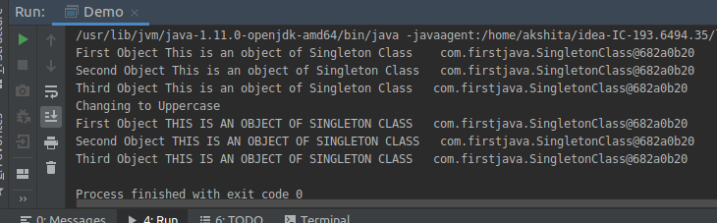
5. WAP to show object cloning in java using cloneable and copy constructor both.
package com.firstjava;

public class Human implements Cloneable {
private String name;
private int age;

Human(String name,int age){
this.name=name;
this.age=age;
}
Human(Human h){
this.name=h.name;
this.age=h.age;
}
public void display(){
System.out.println("Name: "+name);
System.out.println("Age: "+age);
}
public Object clone() throws CloneNotSupportedException{
return super.clone();
}

}
class DemoCopy{
public static void main(String[] args) {
Human h1 = new Human("Akshita", 23);
Human h2 = new Human("Kunal", 26);
System.out.println("Copy Constructor: ");
Human h3 = new Human(h1);
h3.display();
try{
System.out.println("Using Clone: ");
Human h4= (Human) h2.clone();
h4.display();
} catch (CloneNotSupportedException e) {
e.printStackTrace();
}
}
}
package com.firstjava;

public class Human implements Cloneable {
private String name;
private int age;

Human(String name,int age){
this.name=name;
this.age=age;
}
Human(Human h){
this.name=h.name;
this.age=h.age;
}
public void display(){
System.out.println("Name: "+name);
System.out.println("Age: "+age);
}
public Object clone() throws CloneNotSupportedException{
return super.clone();
}

}
class DemoCopy{
public static void main(String[] args) {
Human h1 = new Human("Akshita", 23);
Human h2 = new Human("Kunal", 26);
System.out.println("Copy Constructor: ");
Human h3 = new Human(h1);
h3.display();
try{
System.out.println("Using Clone: ");
Human h4= (Human) h2.clone();
h4.display();
} catch (CloneNotSupportedException e) {
e.printStackTrace();
}
}
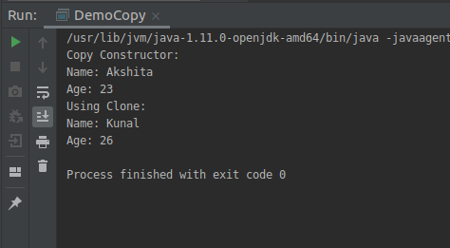
}

6. WAP showing try, multi-catch and finally blocks.
package com.firstjava;
public class ExceptionExample {
public static void main(String[] args) {
try {
System.out.println("Before Exception");
throw new NullPointerException();
}catch (NullPointerException npe){
System.out.println("In Specialised catch block");
npe.printStackTrace();
}catch (Exception e){
System.out.println("In Generalised Catch block");
e.printStackTrace();
}finally {
System.out.println("In Finally Block");
}
System.out.println("After finally Block");
}
}
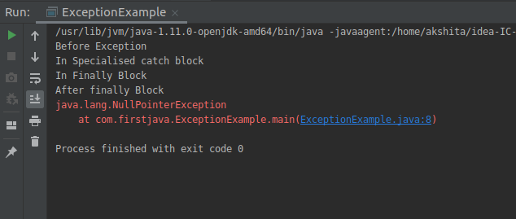

7. WAP to convert seconds into days, hours, minutes and seconds.
package com.firstjava;
import java.util.Scanner;
public class Time {
private int seconds;
private int days;
private int hours;
private int minutes;
Time(int seconds){
days=0;
hours=0;
minutes=0;
this.seconds=seconds;
}
public void convertTime(int seconds){

days = (seconds / (24 * 3600) );
int temp= (seconds % (24 * 3600));
hours=temp/3600;
temp=temp%3600;
minutes=temp/60;
temp=temp%60;
this.seconds=temp;
}
public int getDays(){
return days;
}
public int getHours(){
return hours;
}
public int getMinutes(){
return minutes;
}
public int getSeconds(){
return seconds;
}

public static void main(String[] args) {

System.out.println("Enter the time in seconds: ");
Scanner sc=new Scanner(System.in);
int second=sc.nextInt();
Time t1=new Time(second);
t1.convertTime(second);
System.out.println("Time converted in "+t1.getDays()+" days "+t1.getHours()+" hours "+t1.getMinutes()+" minutes "+t1.getSeconds()+" seconds ");

}
}
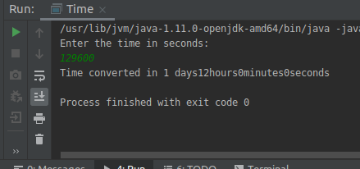

8. WAP to read words from the keyboard until the word done is entered. For each word except done, report whether its first character is equal to ts last character. For the required loop, use a
a)while statement
package com.firstjava;
import java.util.Scanner;
public class FirstCharEqualslast {
public static void main(String[] args)
{
Scanner sc = new Scanner(System.in);
System.out.println("Enter a word");
String word = sc.next();
while (!word.equals("done")) {
if (word.charAt(0) == word.charAt(word.length() - 1))
{
System.out.println("First and last character are equals for the word: " + word);
} else
{
System.out.println("First and last character are NOT equals for the word: " + word);
}
word = sc.next();
}
}
}
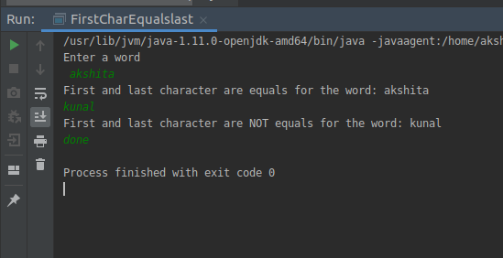
b)do-while statement
package com.firstjava;
import java.util.Scanner;
public class FirstCharEqualslast {
public static void main(String[] args)
{
Scanner keyboard=new Scanner(System.in);
System.out.println("Enter a word");
String word=keyboard.nextLine();
do {
if(word.charAt(0)==word.charAt(word.length()-1))
{
System.out.println("First and the last Characters are equal for the word: " +word);
}
else
{
System.out.println("First and last characters are NOT equal for the word: " +word);
}
word=keyboard.nextLine();
}
while (!word.equals("done"));
}
}
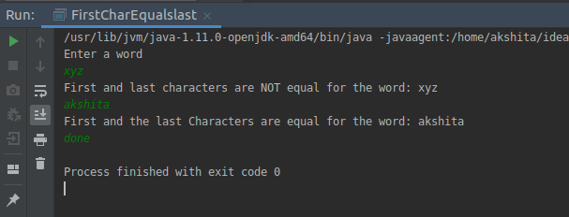
9. Design classes having attributes for furniture where there are wooden chairs and tables, metal chairs and tables. There are stress and fire tests for each products.
package com.firstjava;
interface Furniture{
abstract public void stressTest();
abstract public void fireTest();
}
abstract class Chairs implements Furniture{
public abstract String chairType();
}
abstract class Table implements Furniture{
public abstract String tableType();

}
class MetalChair extends Chairs{

@Override
public void stressTest() {
System.out.println("Stress Test of Metal Chair approved");
}

@Override
public void fireTest() {
System.out.println("Fire Test of Metal Chair approved");
}

@Override
public String chairType() {
String S="This is a metal Chair";
return S;
}
}
class WoodenChair extends Chairs{

@Override
public void stressTest() {
System.out.println("Stress Test of Wooden Chair approved");
}

@Override
public void fireTest() {
System.out.println("Fire Test of Wooden Chair approved");
}

@Override
public String chairType() {
String S="This is a wooden Chair";
return S;
}
}
class MetalTable extends Table{
@Override
public void stressTest() {
System.out.println("Stress Test of Metal Table approved");
}

@Override
public void fireTest() {
System.out.println("Fire Test of Metal Table approved");
}

@Override
public String tableType() {
String s="This is a Metal table";
return s;
}
}
class WoodenTable extends Table{

@Override
public void stressTest() {
System.out.println("Stress Test of Wooden Table approved");
}

@Override
public void fireTest() {
System.out.println("Fire Test of Wooden Table approved");
}

@Override
public String tableType() {
String s="This is a wooden Table";
return s;
}
}

public class FurnitureClass {
public static void main(String[] args) {
MetalChair mc=new MetalChair();
WoodenChair wc=new WoodenChair();
MetalTable mt=new MetalTable();
WoodenTable wt=new WoodenTable();
String ct=mc.chairType();
System.out.println("Chair Type "+ct);
mc.stressTest();
mc.fireTest();
System.out.println("--------------------------------");
String ct1=wc.chairType();
System.out.println("Chair Type "+ct1);
wc.stressTest();
wc.fireTest();
System.out.println("--------------------------------");
String tt=wt.tableType();
System.out.println("Table Type "+tt);
wt.stressTest();
wt.fireTest();
System.out.println("--------------------------------");
String tt1=mt.tableType();
System.out.println("Table Type "+tt1);
mt.stressTest();
mt.fireTest();

}
}
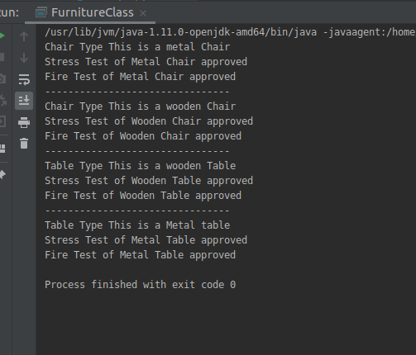

10. Design classes having attributes and method(only skeleton) for a coffee shop. There are three different actors in our scenario and i have listed the different actions they do also below
* Customer
Pays the cash to the cashier and places his order, get a token number back
- Waits for the intimation that order for his token is ready
- Upon intimation/notification he collects the coffee and enjoys his drink
( Assumption: Customer waits till the coffee is done, he wont timeout and cancel the order. Customer always likes the drink served. Exceptions like he not liking his coffee, he getting wrong coffee are not considered to keep the design simple.)
* Cashier
- Takes an order and payment from the customer
- Upon payment, creates an order and places it into the order queue
- Intimates the customer that he has to wait for his token and gives him his token
( Assumption: Token returned to the customer is the order id. Order queue is unlimited. With a simple modification, we can design for a limited queue size)
* Barista
- Gets the next order from the queue
- Prepares the coffee
- Places the coffee in the completed order queue
- Places a notification that order for token is ready

package com.firstjava;

class Customer{
public int TokenNumber;
public String order;
private int payment;

public int getTokenNumber() {
return 0;
}
public void waitForCoffee() {}
public void collectCoffee(){}
public void payPayment(){}
public void placeOrder(){}
}
class Cashier{
private String order;
private String getOrder(){
return null;
}
public void receivePayment(){}
public void notify(Customer c1){}

}class Barista{
public void prepareCoffee(){}
public void placeCoffee(){}
public void notify(Customer c1){}
}
public class CoffeeShop {
public static void main(String[] args) {

}
}

11. Convert the following code so that it uses nested while statements instead of for statements:
int s = 0;
int t = 1;
for (int i = 0; i < 10; i++)
{
s = s + i;
for (int j = i; j > 0; j−−)
{
t = t * (j - i);
}
s = s * t;
System.out.println("T is " + t);
}
System.out.println("S is " + s);
answer:
int s = 0;
int t = 1;
int i=0;
while(i<10){
s = s + i;
int j=i;
while(j>0)
{
t = t * (j - i);
j--;
}
s = s * t;
System.out.println("T is " + t);
i++;
}
System.out.println("S is " + s);
}

12.What will be the output on new Child(); ?
class Parent extends Grandparent {
{
System.out.println("instance - parent");
}
public Parent() {
System.out.println("
}
static {
System.out.println("static - parent");
}
}
class Grandparent {
static {
System.out.println("static - grandparent");
}
{
System.out.println("instance - grandparent");
}
public Grandparent() {
System.out.println("
}
}
class Child extends Parent {
public Child() {
System.out.println("
}
static {
System.out.println("static - child");
}
{
System.out.println("instance - child");
}
}
Output
static - grandparent
static - parent
static - child
instance - grandparent
constructor - grandparent
instance - parent
constructor - parent
instance - child
constructor - child

Q13. Create a custom exception that do not have any stack trace.
package com.firstjava;

public class CustomException extends Exception {
public CustomException(String s)
{
super(s);
}

@Override
public synchronized Throwable fillInStackTrace() {
return this;
}
}
class DemoNew
{
public static void main(String args[])
{
try
{
throw new CustomException("This is Custom Exception");
}
catch (CustomException ce)
{
System.out.println("Caught");
System.out.println(ce.getMessage());
ce.printStackTrace();
}
}
}
