Q1.Write the following a functional interface and implement it using lambda:
(1) First number is greater than second number or not Parameter (int ,int ) Return boolean
(2) Increment the number by 1 and return incremented valueParameter (int) Return int
(3) Concatination of 2 stringParameter (String , String ) Return (String)
(4) Convert a string to uppercase and return . Parameter (String) Return (String)

package com.java8features;

interface FirstGreaterThanSecond{
boolean firstGreaterThanSecond(int numberOne, int numberTwo);
}
interface Increment{
int increment(int numberOne);
}
interface Concatenation{
String concatenation(String stringOne, String stringTwo);
}
interface UpperCaseToLowerCase{
String toUpperCase(String stringChange);
}
public class Ques1 {
public static void main(String[] args) {
FirstGreaterThanSecond first=(numberOne, numberTwo) -> {
if(numberOne>numberTwo){
return true;
}
else
return false;
};
Increment inc=(numberOne) -> {

return numberOne+1;
};
Concatenation concatenation=(stringOne, stringTwo) -> {
return stringOne+stringTwo;
};

UpperCaseToLowerCase upperCaseToLowerCase=stringChange -> {
return stringChange.toUpperCase();
};
System.out.print("Is the first number greater than second: ");
System.out.println(first.firstGreaterThanSecond(10,4));
System.out.print("Increment the Number ");
System.out.println(inc.increment(4));
System.out.print("Concatenate two strings: ");
System.out.println(concatenation.concatenation("hello","world"));
System.out.print("Change to UpperCase: ");
System.out.println(upperCaseToLowerCase.toUpperCase("Hello"));
}
}
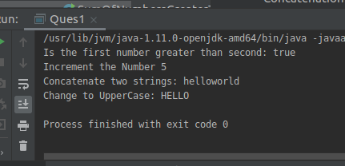

Q2.Create a functional interface whose method takes 2 integers and return one integer.
package com.java8features;

interface Addition{
int add(int numberOne,int numberTwo);
}
public class Ques2 {
public static void main(String[] args) {
Addition addition=(numberOne, numberTwo) ->{
return numberOne+numberTwo;
};

System.out.println(addition.add(5,7));
}
}
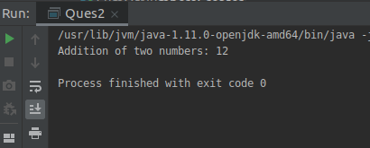

Q3.Using (instance) Method reference create and apply add and subtract method and using (Static) Method reference create and apply multiplication method for the functional interface created.
package com.java8features;
interface Operations{
void operation(int numberOne,int numberTwo);
}
public class Ques3 {

public static void add(int numberOne,int numberTwo){
System.out.println("Addition of two numbers: "+(numberOne+numberTwo));
}
public static void subtract(int number1,int number2){
System.out.println("Subtraction of two numbers: "+(number1-number2));
}
public void multiplication(int numOne,int numTwo){
System.out.println("Multiplication of two numbers is: "+(numOne*numTwo));
}
public static void main(String[] args) {

Operations operations=Ques3::add;
Operations operations1=Ques3::subtract;
System.out.println("Addition using static method");
operations.operation(2,3);
System.out.println("Subtraction using static method" );
operations1.operation(100,34);
Operations operations2=new Ques3()::multiplication;
System.out.println("Multiplication using instance method");
operations2.operation(5,7);

}
}

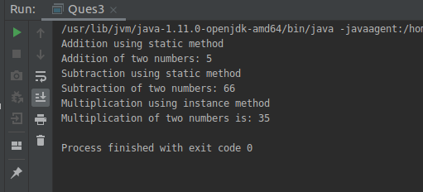
Q4.Create an Employee Class with instance variables (String) name, (Integer)age, (String)city and get the instance of the Class using constructor reference
package com.java8features;
import java.util.Objects;
@FunctionalInterface
interface ConstructInterface{
Employee constructorEmployee(String name,Integer age,String city);
}
public class Employee {
private String name;
private Integer age;
private String city;
public Employee(String name,Integer age,String city){
this.name=name;
this.age=age;
this.city=city;
}
@Override
public boolean equals(Object o) {
if (this == o) return true;
if (o == null || getClass() != o.getClass()) return false;
Employee employee = (Employee) o;
return Objects.equals(name, employee.name) &&
Objects.equals(age, employee.age) &&
Objects.equals(city, employee.city);
}
@Override
public int hashCode() {
return Objects.hash(name, age, city);
}
@Override
public String toString() {
return "Employee{" +
"name='" + name + '\'' +
", age=" + age +
", city='" + city + '\'' +
'}';
}
public static void main(String[] args) {
ConstructInterface constructorInterface =Employee::new;
Employee e1=constructorInterface.constructorEmployee("Akshita",23,"Delhi");
Employee e2=constructorInterface.constructorEmployee("Drishti",23,"Delhi");
System.out.println(e1);
System.out.println(e2);
}
}
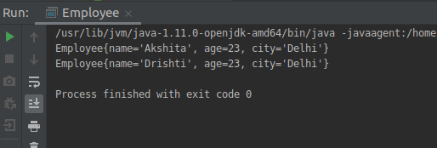

Q5.Implement following functional interfaces from java.util.function using lambdas:
(1) Consumer
(2) Supplier
(3) Predicate
(4) Function
package com.java8features;

import java.util.Arrays;
import java.util.List;
import java.util.function.*;

public class Functionals {
public static void main(String[] args) {

List<Integer> list= Arrays.asList(1,2,3,4,5);
System.out.print("Using Consumer interface: ");
Consumer consumer=(e)->{
System.out.println(e);
};
consumer.accept(list);
Supplier<String> supplier=()->{

return "this is supplier";
};
Predicate<Integer> predicate=(e)->{
return e%2==0;
};
Function<Integer,Integer> function=(e)->{
return e*2;
};

System.out.print("Using Supplier interface: ");
System.out.println(supplier.get());
System.out.print("Using Predicate interface: ");
System.out.println(predicate.test(4));
System.out.print("Using Function interface: ");
System.out.println(function.apply(4));

}
}
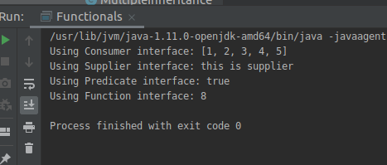

Q6.Create and access default and static method of an interface.
package com.java8features;
interface NewInterface{
default void methodOne(){
System.out.println("This is the default method");
}
}
interface StaticInterface{
public static void staticMethod() {
System.out.println("This is the static method");
}
}
public class AccessingDefaultAndStaticMethods implements NewInterface{

public static void main(String[] args) {
System.out.println("Default Method of an Interface");
AccessingDefaultAndStaticMethods accessingDefaultAndStaticMethods=new AccessingDefaultAndStaticMethods();
accessingDefaultAndStaticMethods.methodOne();

System.out.println("Static method of an interface");
StaticInterface.staticMethod();
}
}
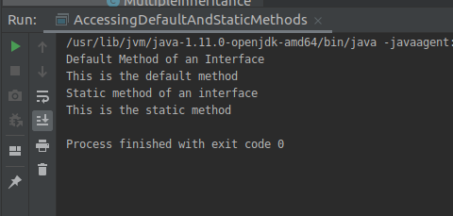

Q7.Override the default method of the interface.
package com.java8features;
interface DefaultInterface{
default void defaultMethod(){
System.out.println("this is the Default method");
}
}
public class OverrideMethods implements DefaultInterface {
public void defaultMethod(){
System.out.println("This is the overriden method");

}

public static void main(String[] args) {

OverrideMethods overrideMethods=new OverrideMethods();
overrideMethods.defaultMethod();
}
}
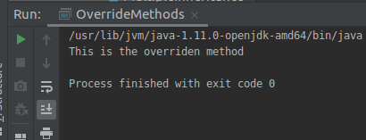

Q8.Implement multiple inheritance with default method inside interface.
package com.java8features;
interface SuperInterface{
default void defaultMethod(){
System.out.println("This is the default method of Super interface");
}
}
interface ChildOneClass extends SuperInterface{
default void defaultMethod(){
System.out.println("This is the default method of Child1 interface");
}
}
interface ChildTwoClass extends SuperInterface{
default void defaultMethod(){
System.out.println("This is the default method of Child2 interface");
}
}
public class MultipleInheritance implements ChildOneClass,ChildTwoClass{

@Override
public void defaultMethod() {
System.out.println("This is the default overridden method ");
}

public static void main(String[] args) {

MultipleInheritance multipleInheritance=new MultipleInheritance();
multipleInheritance.defaultMethod();
}
}
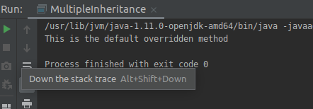

Q9.Collect all the even numbers from an integer list.
package com.java8features;
import java.util.Arrays;
import java.util.List;
import java.util.stream.Collectors;
public class CollectEvenNumbers {
public static void main(String[] args) {
List<Integer> integerList= Arrays.asList(1,2,5,3,6,4,8);
System.out.println(integerList);
System.out.print("Even numbers: ");
System.out.println(integerList.stream().
filter(integer -> integer%2==0)
.collect(Collectors.toList()));
}
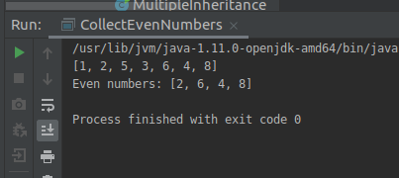
}

Q10.Sum all the numbers greater than 5 in the integer list.
package com.java8features;
import javax.swing.*;
import java.util.Arrays;
import java.util.List;
import java.util.SortedMap;
import java.util.stream.Collectors;

public class SumOfNumbersGreaterThan5 {
public static void main(String[] args) {
List<Integer> integerList= Arrays.asList(1,2,5,3,6,4,8);
System.out.println(integerList);
System.out.println("Numbers Greater than 5");
System.out.println(integerList.stream()
.filter(integer -> integer>5)
.collect(Collectors.toList()));
System.out.println("Sum of Numbers Greater than 5");
System.out.println(integerList.stream()
.filter(integer -> integer>5)
.collect(Collectors.summingInt(integer -> integer)));
}
}
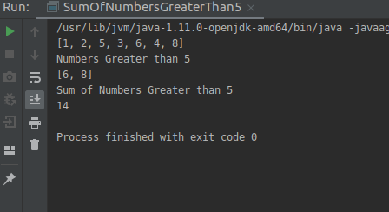

Q11.Find average of the number inside integer list after doubling it.
package com.java8features;
import java.util.Arrays;
import java.util.List;
import java.util.stream.Collectors;
public class AverageAfterDoubling {
public static void main(String[] args) {

List<Integer> integerList= Arrays.asList(1,2,5,3,6,4,8);
System.out.println("Average after doubling");
System.out.println(integerList.stream()
.map(integer -> integer*2)
.collect(Collectors.toList()));
System.out.print("Average is: " );
System.out.println(integerList.stream()
.map(integer -> integer*2)
.collect(Collectors.averagingInt(integer -> integer)));

}
}
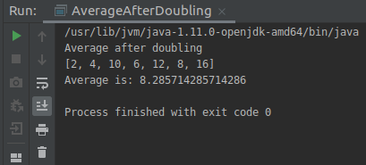

Q12.Find the first even number in the integer list which is greater than 3.
package com.java8features;

import java.util.Arrays;
import java.util.List;
import java.util.stream.Collectors;

public class FirstEvenNumberGreaterThree {
public static void main(String[] args) {

List<Integer> integerList= Arrays.asList(1,2,5,3,6,4,8);
System.out.println(integerList);
System.out.println("First Even number greater than 3");
System.out.println(integerList.stream()
.filter(integer -> integer%2==0)
.filter(integer -> integer>3)
.findFirst()
);
}
}
