(1) Create an Employee Entity which contains following fields
Name
Id
Age
Location
package com.spring.jpa.SpringBootJPA.Entity;
import javax.persistence.Entity;
import javax.persistence.GeneratedValue;
import javax.persistence.GenerationType;
import javax.persistence.Id;
@Entity
public class Employee {
@Id
private Integer id;
private String name;
private Integer age;
private String location;
public Integer getId() {
return id;
}
public void setId(Integer id) {
this.id = id;
}
public String getName() {
return name;
}
public void setName(String name) {
this.name = name;
}
public Integer getAge() {
return age;
}
public void setAge(Integer age) {
this.age = age;
}
public String getLocation() {
return location;
}
public void setLocation(String location) {
this.location = location;
}
}

(2) Set up EmployeeRepository with Spring Data JPA
package com.spring.jpa.SpringBootJPA.Repository;
import com.spring.jpa.SpringBootJPA.Entity.Employee;
import org.springframework.data.repository.CrudRepository;
public interface EmployeeRepository extends CrudRepository<Employee,Integer> {
}
(3) Perform Create Operation on Entity using Spring Data JPA
package com.spring.jpa.SpringBootJPA;
import com.spring.jpa.SpringBootJPA.Entity.Employee;
import com.spring.jpa.SpringBootJPA.Repository.EmployeeRepository;
import org.junit.jupiter.api.Test;
import org.springframework.beans.factory.annotation.Autowired;
import org.springframework.boot.test.context.SpringBootTest;
import java.util.List;
@SpringBootTest
class SpringBootJpaApplicationTests {
@Autowired
EmployeeRepository employeeRepository;
@Test
void contextLoads() {
}
@Test
void testCreate(){
Employee employee=new Employee();
employee.setId(1);
employee.setName("Akshita");
employee.setAge(23);
employee.setLocation("New Delhi");
employeeRepository.save(employee);
}
}
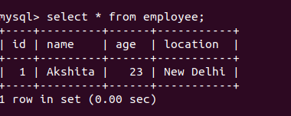

(4) Perform Update Operation on Entity using Spring Data JPA
package com.spring.jpa.SpringBootJPA;
import com.spring.jpa.SpringBootJPA.Entity.Employee;
import com.spring.jpa.SpringBootJPA.Repository.EmployeeRepository;
import org.junit.jupiter.api.Test;
import org.springframework.beans.factory.annotation.Autowired;
import org.springframework.boot.test.context.SpringBootTest;
import java.util.List;
@SpringBootTest
class SpringBootJpaApplicationTests {
@Autowired
EmployeeRepository employeeRepository;
@Test
void contextLoads() {
}
@Test
void testCreate(){
Employee employee=new Employee();
employee.setId(1);
employee.setName("Akshita");
employee.setAge(23);
employee.setLocation("New Delhi");
employeeRepository.save(employee);
}
@Test
void testUpdate(){
Employee employee=employeeRepository.findById(1).get();
employee.setAge(24);
employeeRepository.save(employee);
}
}
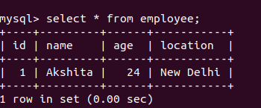

(5) Perform Delete Operation on Entity using Spring Data JPA
package com.spring.jpa.SpringBootJPA;
import com.spring.jpa.SpringBootJPA.Entity.Employee;
import com.spring.jpa.SpringBootJPA.Repository.EmployeeRepository;
import org.junit.jupiter.api.Test;
import org.springframework.beans.factory.annotation.Autowired;
import org.springframework.boot.test.context.SpringBootTest;
import java.util.List;
@SpringBootTest
class SpringBootJpaApplicationTests {
@Autowired
EmployeeRepository employeeRepository;
@Test
void contextLoads() {
}
@Test
void testCreate(){
Employee employee=new Employee();
employee.setId(1);
employee.setName("Akshita");
employee.setAge(23);
employee.setLocation("New Delhi");
Employee employee1=new Employee();
employee1.setId(2);
employee1.setName("Drishti");
employee1.setAge(23);
employee1.setLocation("New Delhi");
employeeRepository.save(employee1);
}
@Test
void testUpdate(){
Employee employee=employeeRepository.findById(1).get();
employee.setAge(24);
employeeRepository.save(employee);
}
@Test
void testDelete(){
employeeRepository.deleteById(1);
}
}

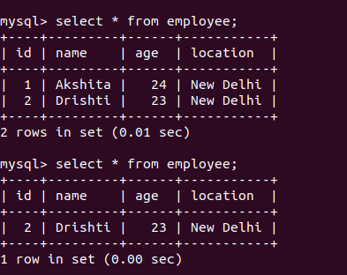

(5) Perform Read Operation on Entity using Spring Data JPA
package com.spring.jpa.SpringBootJPA;
import com.spring.jpa.SpringBootJPA.Entity.Employee;
import com.spring.jpa.SpringBootJPA.Repository.EmployeeRepository;
import org.junit.jupiter.api.Test;
import org.springframework.beans.factory.annotation.Autowired;
import org.springframework.boot.test.context.SpringBootTest;
import java.util.List;
@SpringBootTest
class SpringBootJpaApplicationTests {
@Autowired
EmployeeRepository employeeRepository;
@Test
void contextLoads() {
}
@Test
void testCreate(){
Employee employee=new Employee();
employee.setId(1);
employee.setName("Akshita");
employee.setAge(23);
employee.setLocation("New Delhi");
Employee employee1=new Employee();
employee1.setId(2);
employee1.setName("Drishti");
employee1.setAge(23);
employee1.setLocation("New Delhi");
employeeRepository.save(employee1);
}
@Test
void testUpdate(){
Employee employee=employeeRepository.findById(1).get();
employee.setAge(24);
employeeRepository.save(employee);
}
@Test
void testDelete(){
employeeRepository.deleteById(1);
}
@Test
void testRead(){
System.out.println(employeeRepository.findById(2).get().getName());
}
}
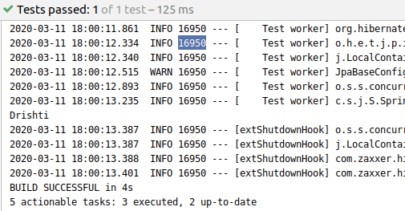

(6) Get the total count of the number of Employees
package com.spring.jpa.SpringBootJPA;
import com.spring.jpa.SpringBootJPA.Entity.Employee;
import com.spring.jpa.SpringBootJPA.Repository.EmployeeRepository;
import org.junit.jupiter.api.Test;
import org.springframework.beans.factory.annotation.Autowired;
import org.springframework.boot.test.context.SpringBootTest;
import java.util.List;
@SpringBootTest
class SpringBootJpaApplicationTests {
@Autowired
EmployeeRepository employeeRepository;
@Test
void contextLoads() {
}
@Test
void testCreate(){
Employee employee=new Employee();
employee.setId(1);
employee.setName("Akshita");
employee.setAge(23);
employee.setLocation("New Delhi");
employeeRepository.save(employee);
Employee employee1=new Employee();
employee1.setId(2);
employee1.setName("Drishti");
employee1.setAge(23);
employee1.setLocation("New Delhi");
employeeRepository.save(employee1);
}
@Test
void testUpdate(){
Employee employee=employeeRepository.findById(1).get();
employee.setAge(24);
employeeRepository.save(employee);
}
@Test
void testDelete(){
employeeRepository.deleteById(1);
}
@Test
void testRead(){
System.out.println(employeeRepository.findById(2).get().getName());
}
@Test
void testCount(){
System.out.println("Employee Count ====== " + employeeRepository.count());
}
}

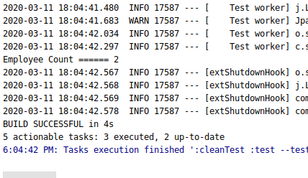

(7) Implement Pagination and Sorting on the bases of Employee Age
package com.spring.jpa.SpringBootJPA;
import com.spring.jpa.SpringBootJPA.Entity.Employee;
import com.spring.jpa.SpringBootJPA.Repository.EmployeeRepository;
import org.junit.jupiter.api.Test;
import org.springframework.beans.factory.annotation.Autowired;
import org.springframework.boot.test.context.SpringBootTest;
import org.springframework.data.domain.Page;
import org.springframework.data.domain.PageRequest;
import org.springframework.data.domain.Pageable;
import org.springframework.data.domain.Sort;
import java.util.List;
@SpringBootTest
class SpringBootJpaApplicationTests {
@Autowired
EmployeeRepository employeeRepository;
@Test
void contextLoads() {
}
@Test
void testCreate(){
Employee employee=new Employee();
employee.setId(1);
employee.setName("Akshita");
employee.setAge(23);
employee.setLocation("New Delhi");
employeeRepository.save(employee);
Employee employee1=new Employee();
employee1.setId(2);
employee1.setName("Drishti");
employee1.setAge(29);
employee1.setLocation("New Delhi");
employeeRepository.save(employee1);
Employee employee2=new Employee();
employee2.setId(3);
employee2.setName("Aradhya");
employee2.setAge(30);
employee2.setLocation("Mumbai");
employeeRepository.save(employee2);
Employee employee3=new Employee();
employee3.setId(4);
employee3.setName("Nisha");
employee3.setAge(28);
employee3.setLocation("New Delhi");
employeeRepository.save(employee3);
Employee employee4=new Employee();
employee4.setId(5);
employee4.setName("Shreya");
employee4.setAge(28);
employee4.setLocation("New Delhi");
employeeRepository.save(employee4);
Employee employee5=new Employee();
employee5.setId(6);
employee5.setName("Neha");
employee5.setAge(23);
employee5.setLocation("New Delhi");
employeeRepository.save(employee5);
}
@Test
void testUpdate(){
Employee employee=employeeRepository.findById(1).get();
employee.setAge(24);
employeeRepository.save(employee);
}
@Test
void testDelete(){
employeeRepository.deleteById(1);
}
@Test
void testRead(){
System.out.println(employeeRepository.findById(2).get().getName());
}
@Test
void testCount(){
System.out.println("Employee Count ====== " + employeeRepository.count());
}
@Test
void testFindByName(){
List<Employee> employee=employeeRepository.findByName("Akshita");
employee.forEach(p-> System.out.println(p.getName() +" " + p.getAge()));
}
@Test
void testFindByNameLike(){
List<Employee> employee=employeeRepository.findByNameLike("A%");
employee.forEach(p-> System.out.println(p.getName() +" " + p.getAge()));
}
@Test
void testFindByAgeBetween(){
List<Employee> employee=employeeRepository.findByAgeBetween(28,32);
employee.forEach(p-> System.out.println(p.getName() +" " + p.getAge()));
}
@Test
void testFindAllByPagingAndSorting(){
Pageable pageable=PageRequest.of(0,3, Sort.Direction.ASC,"age");
Page<Employee> employees=employeeRepository.findAll(pageable);
employees.forEach(p-> System.out.println(p.getName() +" " + p.getAge()));
}
@Test
void testFindAllByPagingAndSortingNextPage(){
Pageable pageable=PageRequest.of(1,3, Sort.Direction.ASC,"age");
Page<Employee> employees=employeeRepository.findAll(pageable);
employees.forEach(p-> System.out.println(p.getName() +" " + p.getAge()));
}

}

PAGE 1

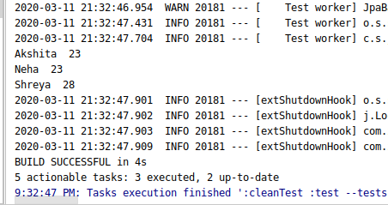
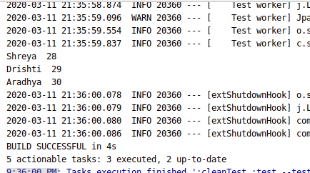
(8) Create and use finder to find Employee by Name
package com.spring.jpa.SpringBootJPA;
import com.spring.jpa.SpringBootJPA.Entity.Employee;
import com.spring.jpa.SpringBootJPA.Repository.EmployeeRepository;
import org.junit.jupiter.api.Test;
import org.springframework.beans.factory.annotation.Autowired;
import org.springframework.boot.test.context.SpringBootTest;
import javax.sound.midi.Soundbank;
import java.util.List;
@SpringBootTest
class SpringBootJpaApplicationTests {
@Autowired
EmployeeRepository employeeRepository;
@Test
void contextLoads() {
}
@Test
void testCreate(){
Employee employee=new Employee();
employee.setId(1);
employee.setName("Akshita");
employee.setAge(23);
employee.setLocation("New Delhi");
employeeRepository.save(employee);
Employee employee1=new Employee();
employee1.setId(2);
employee1.setName("Drishti");
employee1.setAge(23);
employee1.setLocation("New Delhi");
employeeRepository.save(employee1);
}
@Test
void testUpdate(){
Employee employee=employeeRepository.findById(1).get();
employee.setAge(24);
employeeRepository.save(employee);
}
@Test
void testDelete(){
employeeRepository.deleteById(1);
}
@Test
void testRead(){
System.out.println(employeeRepository.findById(2).get().getName());
}
@Test
void testCount(){
System.out.println("Employee Count ====== " + employeeRepository.count());
}
@Test
void testFindByName(){
List<Employee> employee=employeeRepository.findByName("Akshita");
employee.forEach(p-> System.out.println(p.getName() +" " + p.getAge()));
}
}

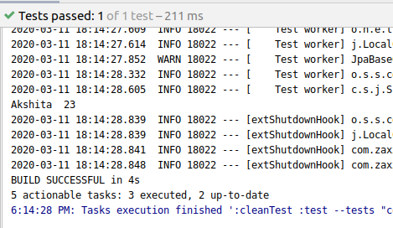

(9) Create and use finder to find Employees starting with A character
package com.spring.jpa.SpringBootJPA;
import com.spring.jpa.SpringBootJPA.Entity.Employee;
import com.spring.jpa.SpringBootJPA.Repository.EmployeeRepository;
import org.junit.jupiter.api.Test;
import org.springframework.beans.factory.annotation.Autowired;
import org.springframework.boot.test.context.SpringBootTest;
import javax.sound.midi.Soundbank;
import java.util.List;
@SpringBootTest
class SpringBootJpaApplicationTests {
@Autowired
EmployeeRepository employeeRepository;
@Test
void contextLoads() {
}

@Test
void testCreate(){
Employee employee=new Employee();
employee.setId(1);
employee.setName("Akshita");
employee.setAge(23);
employee.setLocation("New Delhi");
employeeRepository.save(employee);
Employee employee1=new Employee();
employee1.setId(2);
employee1.setName("Drishti");
employee1.setAge(23);
employee1.setLocation("New Delhi");
employeeRepository.save(employee1);
Employee employee2=new Employee();
employee2.setId(3);
employee2.setName("Aradhya");
employee2.setAge(23);
employee2.setLocation("Mumbai");
employeeRepository.save(employee2);
}
@Test
void testUpdate(){
Employee employee=employeeRepository.findById(1).get();
employee.setAge(24);
employeeRepository.save(employee);
}
@Test
void testDelete(){
employeeRepository.deleteById(1);
}
@Test
void testRead(){
System.out.println(employeeRepository.findById(2).get().getName());
}
@Test
void testCount(){
System.out.println("Employee Count ====== " + employeeRepository.count());
}
@Test
void testFindByName(){
List<Employee> employee=employeeRepository.findByName("Akshita");
employee.forEach(p-> System.out.println(p.getName() +" " + p.getAge()));
}
@Test
void testFindByNameLike(){
List<Employee> employee=employeeRepository.findByNameLike("A%");
employee.forEach(p-> System.out.println(p.getName() +" " + p.getAge()));
}
}

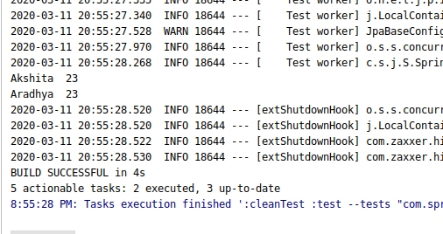
(10) Create and use finder to find Employees Between the age of 28 to 32

package com.spring.jpa.SpringBootJPA;
import com.spring.jpa.SpringBootJPA.Entity.Employee;
import com.spring.jpa.SpringBootJPA.Repository.EmployeeRepository;
import org.junit.jupiter.api.Test;
import org.springframework.beans.factory.annotation.Autowired;
import org.springframework.boot.test.context.SpringBootTest;
import javax.sound.midi.Soundbank;
import java.util.List;
@SpringBootTest
class SpringBootJpaApplicationTests {
@Autowired
EmployeeRepository employeeRepository;
@Test
void contextLoads() {
}

@Test
void testCreate(){
Employee employee=new Employee();
employee.setId(1);
employee.setName("Akshita");
employee.setAge(23);
employee.setLocation("New Delhi");
employeeRepository.save(employee);
Employee employee1=new Employee();
employee1.setId(2);
employee1.setName("Drishti");
employee1.setAge(29);
employee1.setLocation("New Delhi");
employeeRepository.save(employee1);
Employee employee2=new Employee();
employee2.setId(3);
employee2.setName("Aradhya");
employee2.setAge(30);
employee2.setLocation("Mumbai");
employeeRepository.save(employee2);
Employee employee3=new Employee();
employee3.setId(4);
employee3.setName("Nisha");
employee3.setAge(28);
employee3.setLocation("New Delhi");
employeeRepository.save(employee3);
Employee employee4=new Employee();
employee4.setId(5);
employee4.setName("Shreya");
employee4.setAge(28);
employee4.setLocation("New Delhi");
employeeRepository.save(employee4);
Employee employee5=new Employee();
employee5.setId(6);
employee5.setName("Neha");
employee5.setAge(23);
employee5.setLocation("New Delhi");
employeeRepository.save(employee5);
}
@Test
void testUpdate(){
Employee employee=employeeRepository.findById(1).get();
employee.setAge(24);
employeeRepository.save(employee);
}
@Test
void testDelete(){
employeeRepository.deleteById(1);
}
@Test
void testRead(){
System.out.println(employeeRepository.findById(2).get().getName());
}
@Test
void testCount(){
System.out.println("Employee Count ====== " + employeeRepository.count());
}
@Test
void testFindByName(){
List<Employee> employee=employeeRepository.findByName("Akshita");
employee.forEach(p-> System.out.println(p.getName() +" " + p.getAge()));
}
@Test
void testFindByNameLike(){
List<Employee> employee=employeeRepository.findByNameLike("A%");
employee.forEach(p-> System.out.println(p.getName() +" " + p.getAge()));
}
@Test
void testFindByAgeBetween(){
List<Employee> employee=employeeRepository.findByAgeBetween(28,32);
employee.forEach(p-> System.out.println(p.getName() +" " + p.getAge()));
}
}

