*Internationalization
- Add support for Internationalization in your application allowing messages to be shown in English, German and Swedish, keeping English as default.
package com.springboot.SpringBootDemo;
import org.springframework.boot.SpringApplication;
import org.springframework.boot.autoconfigure.SpringBootApplication;
import org.springframework.context.ApplicationContext;
import org.springframework.context.annotation.Bean;
import org.springframework.context.support.ResourceBundleMessageSource;
import org.springframework.web.servlet.LocaleResolver;
import org.springframework.web.servlet.i18n.AcceptHeaderLocaleResolver;
import org.springframework.web.servlet.i18n.SessionLocaleResolver;
import java.util.Locale;
@SpringBootApplication
public class SpringBootDemoApplication {
public static void main(String[] args) {
SpringApplication.run(SpringBootDemoApplication.class, args);
}
@Bean
public LocaleResolver localeResolver(){
AcceptHeaderLocaleResolver localeResolver=new AcceptHeaderLocaleResolver();
localeResolver.setDefaultLocale(Locale.US);
return localeResolver;
}
/*@Bean
public ResourceBundleMessageSource messageSource(){
ResourceBundleMessageSource messageSource=new ResourceBundleMessageSource();
messageSource.setBasename("message");
return messageSource;
}*/
}

- Create a GET request which takes "username" as param and shows a localized message "Hello Username". (Use parameters in message properties)
package com.springboot.SpringBootDemo.Controllers;
import com.springboot.SpringBootDemo.HelloWorldBean;
import org.springframework.beans.factory.annotation.Autowired;
import org.springframework.context.MessageSource;
import org.springframework.context.i18n.LocaleContextHolder;
import org.springframework.web.bind.annotation.GetMapping;
import org.springframework.web.bind.annotation.PathVariable;
import org.springframework.web.bind.annotation.RequestHeader;
import org.springframework.web.bind.annotation.RestController;
import java.util.Locale;
@RestController
public class HelloWorldController {
@Autowired
private MessageSource messageSource;

@GetMapping("/{username}")
public String helloWorldBeanInternationalized(@PathVariable String username){
String message = messageSource.getMessage("hello.message", new String[]{username}, LocaleContextHolder.getLocale());
return message;
}
}
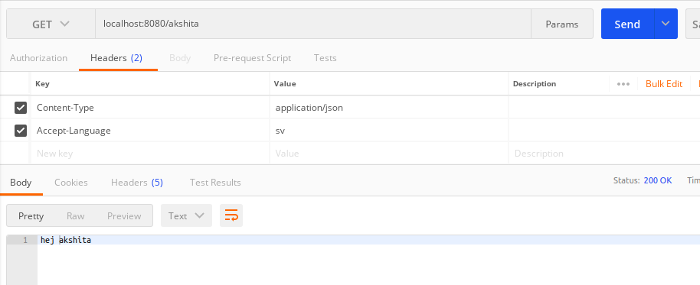
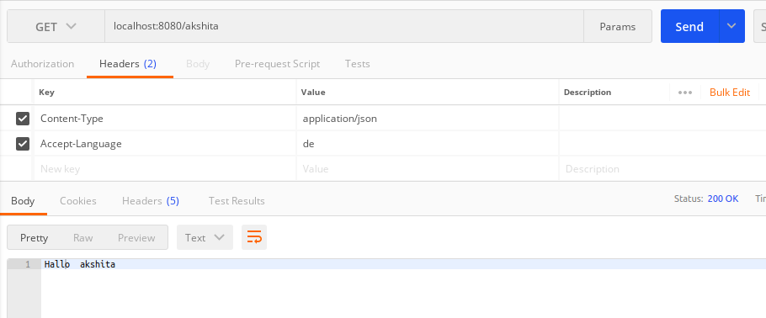
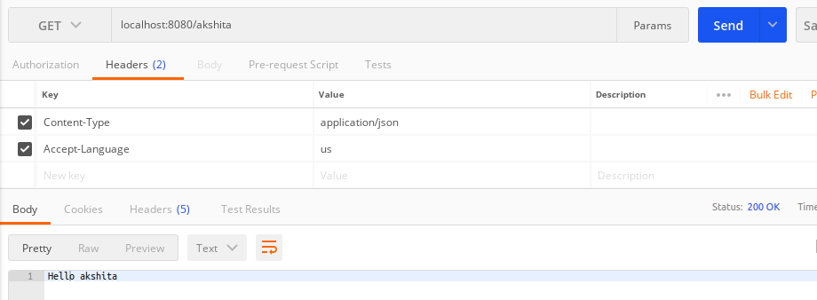

*Content Negotiation
package com.springboot.SpringBootDemo.Controllers;
//import static org.springframework.hateoas.server.mvc.WebMvcLinkBuilder.*;
import com.springboot.SpringBootDemo.EmployeeNotFoundException;
import com.springboot.SpringBootDemo.Model.Employees;
import com.springboot.SpringBootDemo.Service.EmployeesService;
import org.springframework.beans.factory.annotation.Autowired;
//import org.springframework.hateoas.EntityModel;
//import org.springframework.hateoas.server.mvc.WebMvcLinkBuilder;
import org.springframework.http.ResponseEntity;
import org.springframework.web.bind.annotation.*;
import org.springframework.web.servlet.support.ServletUriComponentsBuilder;
import javax.validation.Valid;
import java.net.URI;
import java.util.List;
@RestController
public class EmployeesController {
@Autowired
private EmployeesService employeesService;
@GetMapping("/welcome")
public String welcome(){
return "Welcome to Spring Boot";
}
@GetMapping(value = "/employees", produces="application/xml")
public List<Employees> retrieveAllEmployees()
{
return employeesService.findAll();
}
@GetMapping("/employees/{id}")
public Employees retrieveOneEmployee(@PathVariable Integer id){
Employees empFound = employeesService.findOne(id);
if(empFound==null)
throw new EmployeeNotFoundException("id " + id);
/*EntityModel<Employees> model= new EntityModel<>(empFound);
WebMvcLinkBuilder linkTo = linkTo(methodOn(this.getClass()).retrieveAllEmployees());
model.add(linkTo.withRel("all-employees"));
return model;*/
return empFound;
}
@PostMapping(value = "/employees",consumes = "application/xml")
public ResponseEntity<Object> createEmployees(@Valid @RequestBody Employees emp){
Employees addedEmployee = employeesService.addEmployee(emp);
//response sent to client
URI location = ServletUriComponentsBuilder.
fromCurrentRequest().
path("/{id}").
buildAndExpand(addedEmployee.getEmployeeId())
.toUri();
return ResponseEntity.created(location).build();
}
@DeleteMapping("/employees/{id}")
public void deleteEmployee(@PathVariable Integer id){
Employees empFound = employeesService.deleteById(id);
if(empFound==null)
throw new EmployeeNotFoundException("id " + id);
}
@PutMapping("/employees/{id}")
public void updateEmployee(@RequestBody Employees changedEmp, @PathVariable Integer id){
Employees newChange=employeesService.findOne(id);
employeesService.updateEmployee(newChange,changedEmp);
}
}
3. Create POST Method to create user details which can accept XML for user creation.

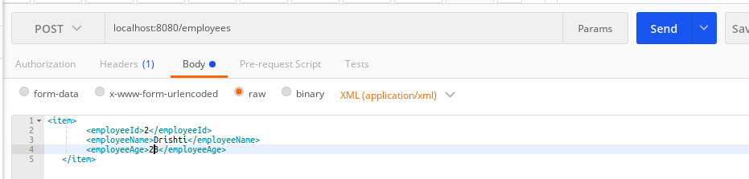

4. Create GET Method to fetch the list of users in XML format.
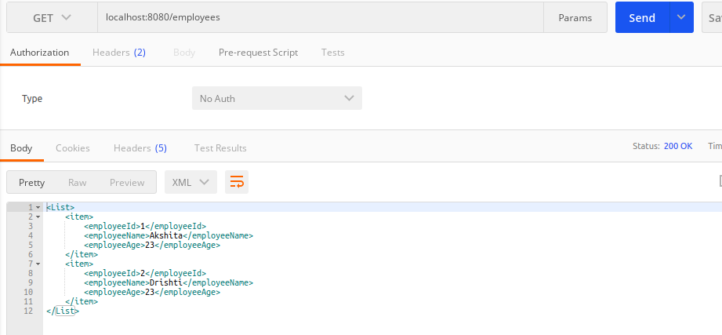

*Swagger
5. Configure swagger plugin and create document of following methods:
6.Get details of User using GET request.
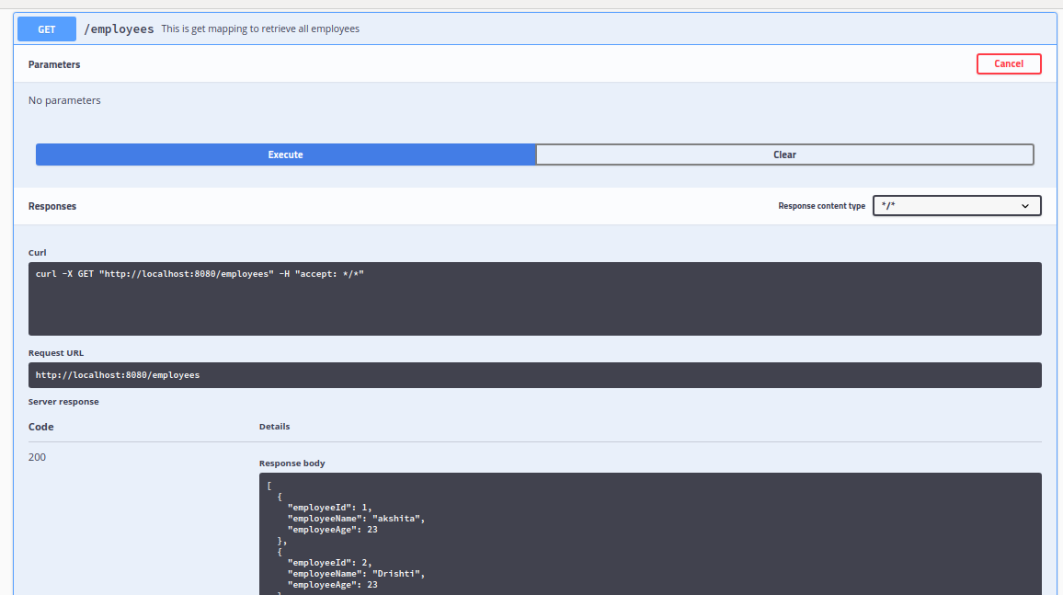
7.Save details of the user using POST request.
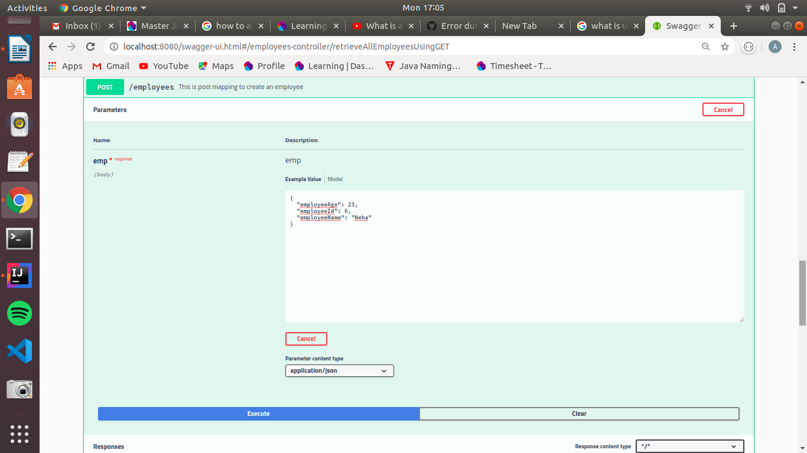

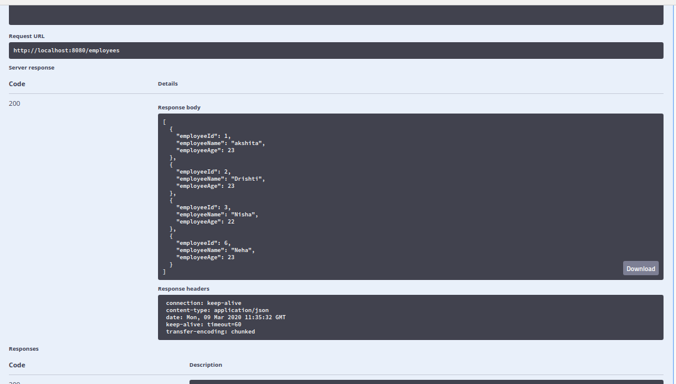
8.Delete a user using DELETE request.
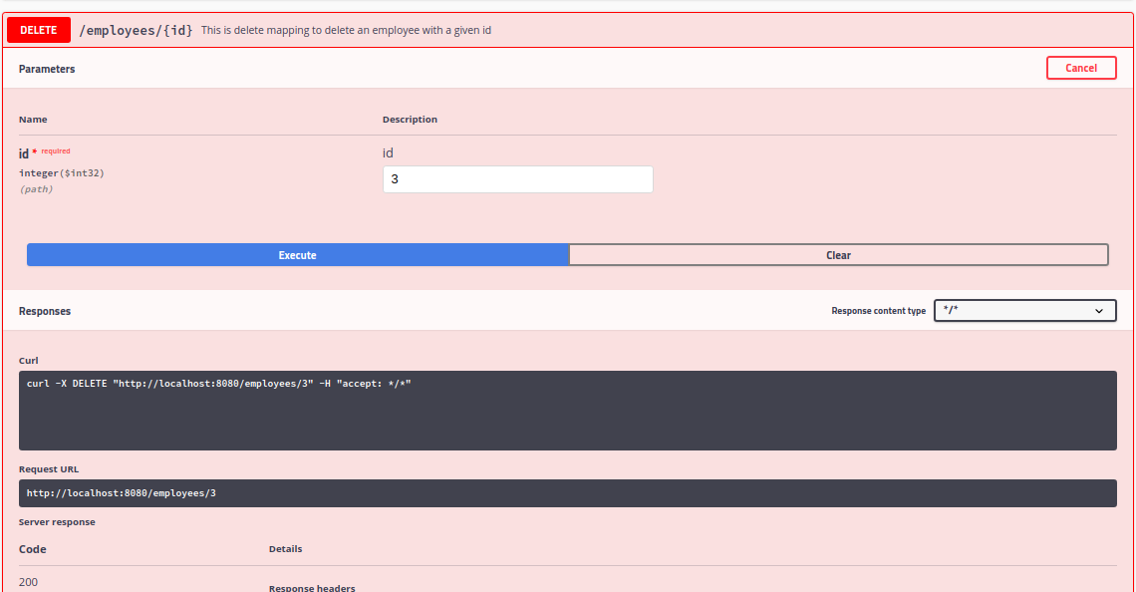
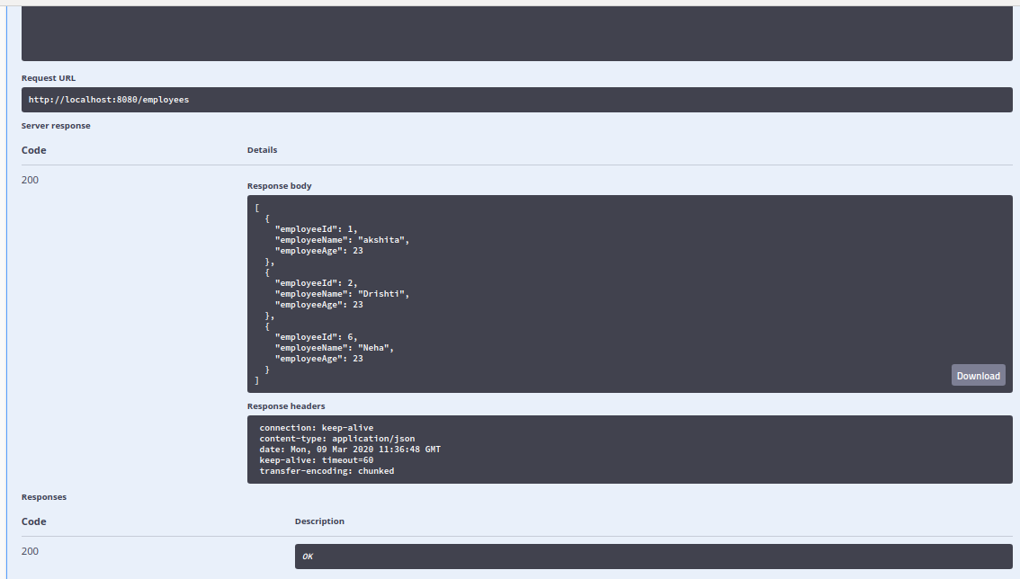

7. In swagger documentation, add the description of each class and URI so that in swagger UI the purpose of class and URI is clear.
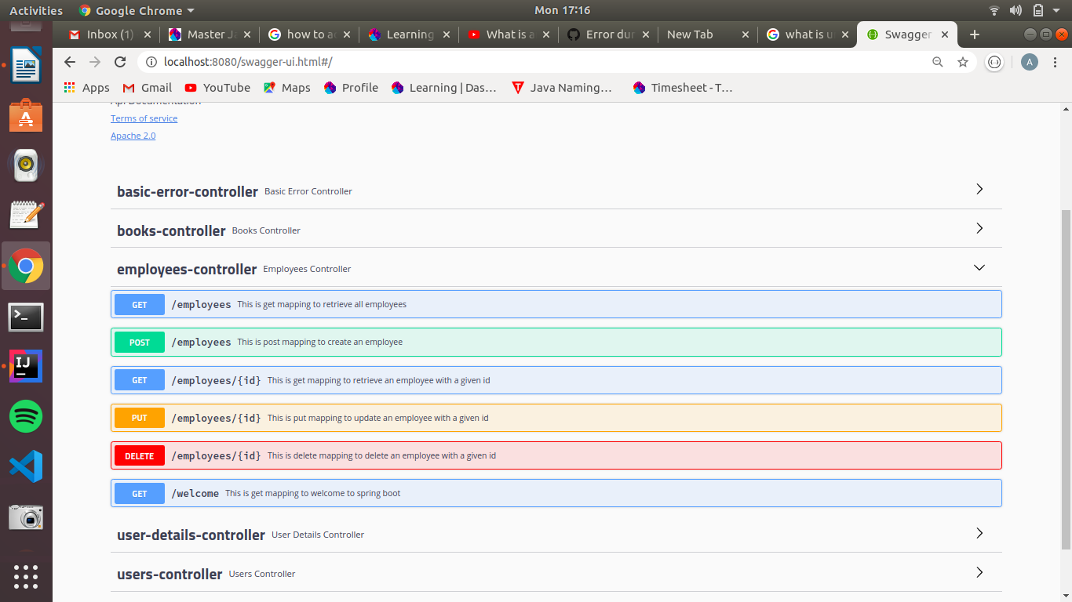
*Static and Dynamic filtering
8. Create API which saves details of User (along with the password) but on successfully saving returns only non-critical data. (Use static filtering)
package com.springboot.SpringBootDemo.Model;
//import net.minidev.json.annotate.JsonIgnore;
import com.fasterxml.jackson.annotation.JsonIgnore;
import io.swagger.annotations.ApiModel;
import javax.validation.constraints.Min;
import javax.validation.constraints.NotBlank;
import javax.validation.constraints.NotNull;
import javax.validation.constraints.Size;
@ApiModel(description = "This is the class containing all the information about employee class.")
public class Employees {
private Integer employeeId;
@NotBlank(message = "name should not be blank")
@Size(min=2,message = "Name should be greater than 2 characters")
private String employeeName;
@JsonIgnore
@NotNull
@Min(18)
private Integer employeeAge;
public Integer getEmployeeId() {
return employeeId;
}
public void setEmployeeId(Integer employeeId) {
this.employeeId = employeeId;
}
public String getEmployeeName() {
return employeeName;
}
public void setEmployeeName(String employeeName) {
this.employeeName = employeeName;
}
public Integer getEmployeeAge() {
return employeeAge;
}
public void setEmployeeAge(Integer employeeAge) {
this.employeeAge = employeeAge;
}
public Employees(Integer employeeId, String employeeName, Integer employeeAge) {
this.employeeId = employeeId;
this.employeeName = employeeName;
this.employeeAge = employeeAge;
}
@Override
public String toString() {
return "Employees{" +
"employeeId=" + employeeId +
", employeeName='" + employeeName + '\'' +
", employeeAge=" + employeeAge +
'}';
}
}

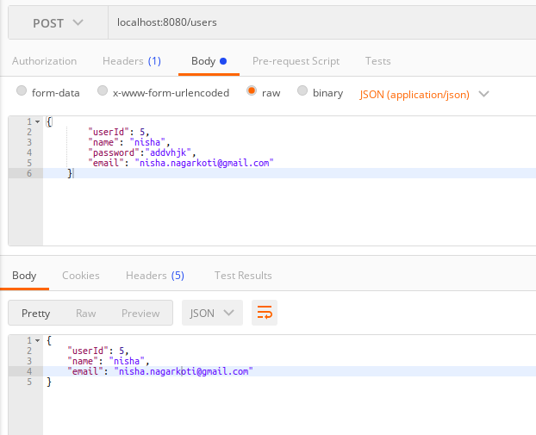

9. Create another API that does the same by using Dynamic Filtering.
package com.springboot.SpringBootDemo.Controllers;
import com.fasterxml.jackson.databind.ser.FilterProvider;
import com.fasterxml.jackson.databind.ser.impl.SimpleBeanPropertyFilter;
import com.fasterxml.jackson.databind.ser.impl.SimpleFilterProvider;
import com.springboot.SpringBootDemo.Model.Users;
import com.springboot.SpringBootDemo.Service.UserService;
import io.swagger.annotations.ApiOperation;
import org.springframework.beans.factory.annotation.Autowired;
import org.springframework.http.converter.json.MappingJacksonValue;
import org.springframework.web.bind.annotation.GetMapping;
import org.springframework.web.bind.annotation.PostMapping;
import org.springframework.web.bind.annotation.RequestBody;
import org.springframework.web.bind.annotation.RestController;
import javax.validation.Valid;
import java.util.List;
@RestController
public class UsersController {
@Autowired
private UserService userService;
@GetMapping(value = "/users")
@ApiOperation(value = "This is get mapping to retrieve all users ")
public MappingJacksonValue retrieveAllUsers()
{
List<Users> allUsers=userService.findAll();
SimpleBeanPropertyFilter filter=SimpleBeanPropertyFilter.filterOutAllExcept("userId","name","email");
FilterProvider filters=new SimpleFilterProvider().addFilter("UserBean",filter);
MappingJacksonValue mapping= new MappingJacksonValue(allUsers);
mapping.setFilters(filters);
return mapping;
}

@PostMapping(value = "/users")
@ApiOperation(value = "This is post mapping to create an user")
public Users createUsers(@Valid @RequestBody Users user){
Users addedUsers = userService.addUsers(user);
return addedUsers;
}
}

*Versioning Restful APIs
10. Create 2 API for showing user details. The first api should return only basic details of the user and the other API should return more/enhanced details of the user,
User Details:
package com.springboot.SpringBootDemo.Versioning;
public class UserDetails {
private int id;
private String name;
private String address;
private long phoneNumber;
private String designation;
private String salary;
public UserDetails(int id, String name, String address, long phoneNumber, String designation, String salary) {
this.name = name;
this.id = id;
this.address = address;
this.phoneNumber = phoneNumber;
this.designation = designation;
this.salary = salary;
}
public String getName() {
return name;
}
public void setName(String name) {
this.name = name;
}
public int getId() {
return id;
}
public void setId(int id) {
this.id = id;
}
public String getAddress() {
return address;
}
public void setAddress(String address) {
this.address = address;
}
public long getPhoneNumber() {
return phoneNumber;
}
public void setPhoneNumber(long phoneNumber) {
this.phoneNumber = phoneNumber;
}
public String getDesignation() {
return designation;
}
public void setDesignation(String designation) {
this.designation = designation;
}
public String getSalary() {
return salary;
}
public void setSalary(String salary) {
this.salary = salary;
}
}
UserDetailsNew
package com.springboot.SpringBootDemo.Versioning;
public class UserDetailsNew {
private int id;
private Name name;
private String address;
private Long phoneNumber;
private String designation;
private String salary;
public UserDetailsNew( int id,Name name, String address, Long phoneNumber, String designation, String salary) {
this.name = name;
this.id = id;
this.address = address;
this.phoneNumber = phoneNumber;
this.designation = designation;
this.salary = salary;
}
public Name getName() {
return name;
}
public void setName(Name name) {
this.name = name;
}
public int getId() {
return id;
}
public void setId(int id) {
this.id = id;
}
public String getAddress() {
return address;
}
public void setAddress(String address) {
this.address = address;
}
public Long getPhoneNumber() {
return phoneNumber;
}
public void setPhoneNumber(Long phoneNumber) {
this.phoneNumber = phoneNumber;
}
public String getDesignation() {
return designation;
}
public void setDesignation(String designation) {
this.designation = designation;
}
public String getSalary() {
return salary;
}
public void setSalary(String salary) {
this.salary = salary;
}
}
UserDetaislService
package com.springboot.SpringBootDemo.Service;
import com.springboot.SpringBootDemo.Versioning.UserDetails;
import org.springframework.stereotype.Service;
import java.util.ArrayList;
import java.util.List;
@Service
public class UserDetailsService {
private static List<UserDetails> userDetailsList=new ArrayList<>();
static {
userDetailsList.add(new UserDetails(1,"akshita","hari nagar",9899249068L,"Trainee","15k"));
}
public String basicDetails(){
for (UserDetails user: userDetailsList)
{
return "Id: "+ user.getId() +" "+"Name: "+ user.getName();
}
return null;
}
public String enhancedDetails(){
for (UserDetails user: userDetailsList)
{
return "Address: "+ user.getAddress() + " PhoneNumber: " +user.getPhoneNumber()+" Designation: "+ user.getDesignation()+" Salary: "+user.getSalary();
}
return null;
}
}
UserDetailsNewService
package com.springboot.SpringBootDemo.Service;
import com.springboot.SpringBootDemo.Versioning.Name;
import com.springboot.SpringBootDemo.Versioning.UserDetails;
import com.springboot.SpringBootDemo.Versioning.UserDetailsNew;
import org.springframework.stereotype.Service;
import java.util.ArrayList;
import java.util.List;
@Service
public class UserDetailsNewService {
private static List<UserDetailsNew> userDetailsNewList=new ArrayList<>();
static {
userDetailsNewList.add(new UserDetailsNew(1, new Name("Akshita","Tandon"),"hari nagar",9899249068L,"Trainee","15k"));
}
public String basicDetails(){
for (UserDetailsNew user: userDetailsNewList)
{
return "Id: "+ user.getId() +" "+"Name: "+ user.getName().getFirstName() + " Last Name: "+ user.getName().getLastName() ;
}
return null;
}
public String enhancedDetails(){
for (UserDetailsNew user: userDetailsNewList)
{
return "Address: "+ user.getAddress() + " PhoneNumber: " +user.getPhoneNumber()+" Designation: "+ user.getDesignation()+" Salary: "+user.getSalary();
}
return null;
}
}
Now apply versioning using the following methods:
MimeType Versioning
package com.springboot.SpringBootDemo.Controllers;
import com.springboot.SpringBootDemo.Service.UserDetailsNewService;
import com.springboot.SpringBootDemo.Service.UserDetailsService;
import org.springframework.beans.factory.annotation.Autowired;
import org.springframework.web.bind.annotation.GetMapping;
import org.springframework.web.bind.annotation.RestController;
@RestController
public class UserDetailsController {
@Autowired
private UserDetailsService userDetailsService;
@Autowired

@GetMapping(value = "/userdetails", produces = "version1/json")
public String userDetailsProducer(){
return userDetailsService.basicDetails();
}
@GetMapping(value = "/userdetails",produces = "version2/json")
public String userDetailsNewProducer(){
return userDetailsNewService.basicDetails();
}
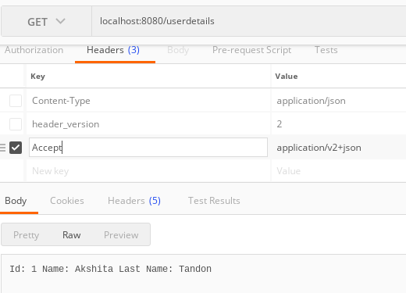
}
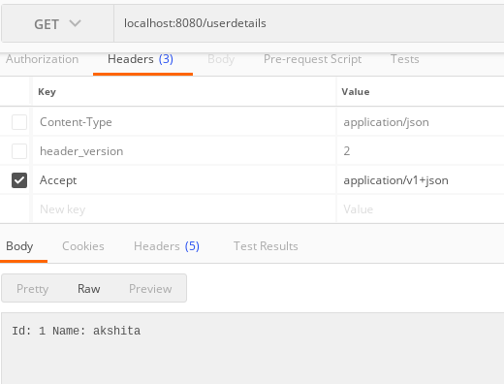
Request Parameter versioning
package com.springboot.SpringBootDemo.Controllers;
import com.springboot.SpringBootDemo.Service.UserDetailsNewService;
import com.springboot.SpringBootDemo.Service.UserDetailsService;
import org.springframework.beans.factory.annotation.Autowired;
import org.springframework.web.bind.annotation.GetMapping;
import org.springframework.web.bind.annotation.RestController;
@RestController
public class UserDetailsController {
@Autowired
private UserDetailsService userDetailsService;
@Autowired

@GetMapping(value = "/userdetails", params = "Version1")
public String userDetailsParam(){
return userDetailsService.basicDetails();
}
@GetMapping(value = "/userdetails",params = "Version2")
public String userDetailsNewParam(){
return userDetailsNewService.basicDetails();
}
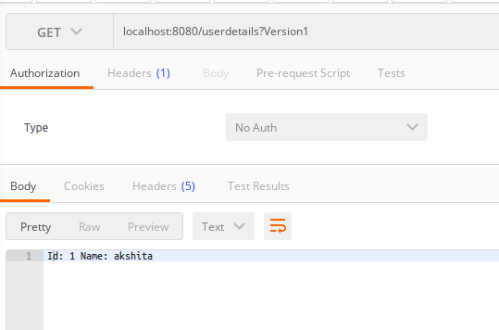
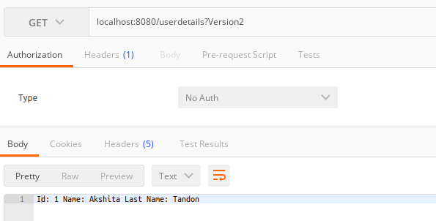

URI versioning
package com.springboot.SpringBootDemo.Controllers;
import com.springboot.SpringBootDemo.Service.UserDetailsNewService;
import com.springboot.SpringBootDemo.Service.UserDetailsService;
import org.springframework.beans.factory.annotation.Autowired;
import org.springframework.web.bind.annotation.GetMapping;
import org.springframework.web.bind.annotation.RestController;
@RestController
public class UserDetailsController {
@Autowired
private UserDetailsService userDetailsService;
@Autowired
private UserDetailsNewService userDetailsNewService;
@GetMapping("v1/userdetails")
public String userDetails(){
return userDetailsService.basicDetails();
}
@GetMapping("v2/userdetails")
public String userDetailsNew(){
return userDetailsNewService.basicDetails();

}
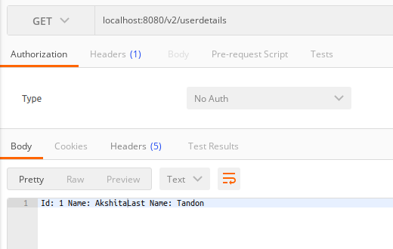
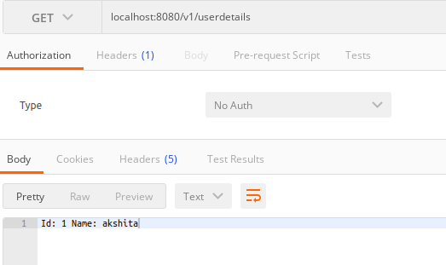
- Custom Header Versioning
package com.springboot.SpringBootDemo.Controllers;
import com.springboot.SpringBootDemo.Service.UserDetailsNewService;
import com.springboot.SpringBootDemo.Service.UserDetailsService;
import org.springframework.beans.factory.annotation.Autowired;
import org.springframework.web.bind.annotation.GetMapping;
import org.springframework.web.bind.annotation.RestController;
@RestController
public class UserDetailsController {
@Autowired
private UserDetailsService userDetailsService;
@Autowired

@GetMapping(value = "/userdetails", headers = "header_Version1")
public String userDetailsHeader(){
return userDetailsService.basicDetails();
}
@GetMapping(value = "/userdetails",headers = "header_Version2")
public String userDetailsNewHeader(){
return userDetailsNewService.basicDetails();
}

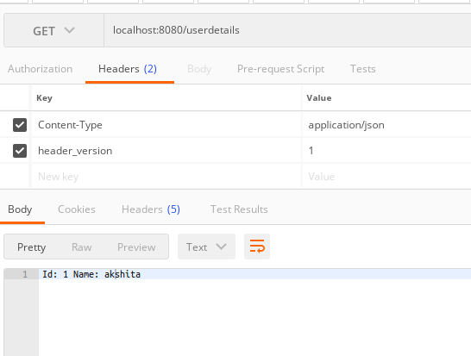
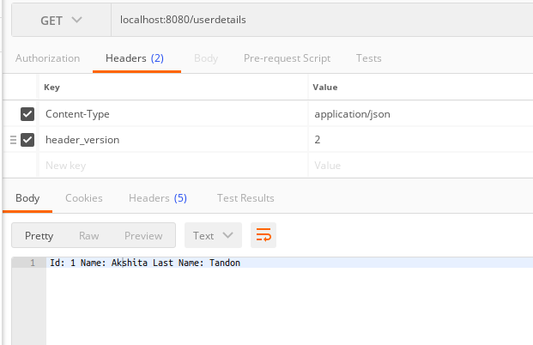

*HATEOAS
11.Configure hateoas with your springboot application. Create an api which returns User Details along with url to show all topics.
package com.springboot.SpringBootDemo.Controllers;
import static org.springframework.hateoas.server.mvc.WebMvcLinkBuilder.*;
import com.springboot.SpringBootDemo.EmployeeNotFoundException;
import com.springboot.SpringBootDemo.Model.Employees;
import com.springboot.SpringBootDemo.Service.EmployeesService;
//import io.swagger.annotations.ApiModel;
//import io.swagger.annotations.ApiModelProperty;
//import io.swagger.annotations.ApiOperation;
import org.springframework.beans.factory.annotation.Autowired;
import org.springframework.hateoas.EntityModel;
import org.springframework.hateoas.server.mvc.WebMvcLinkBuilder;
import org.springframework.http.ResponseEntity;
import org.springframework.web.bind.annotation.*;
import org.springframework.web.servlet.support.ServletUriComponentsBuilder;
import javax.validation.Valid;
import java.net.URI;
import java.util.List;
@RestController
//@ApiModel(description = "This is the controller class of employee class")
public class EmployeesController {
@Autowired
private EmployeesService employeesService;
// @ApiOperation(value = "This is get mapping to welcome to spring boot")
@GetMapping("/welcome")
public String welcome(){
return "Welcome to Spring Boot";
}
@GetMapping(value = "/employees", produces="application/xml")
//@ApiOperation(value = "This is get mapping to retrieve all employees ")
public List<Employees> retrieveAllEmployees()
{
return employeesService.findAll();
}
@GetMapping("/employees/{id}")
//@ApiOperation(value = "This is get mapping to retrieve an employee with a given id")
public EntityModel<Employees> retrieveOneEmployee(@PathVariable Integer id){
Employees empFound = employeesService.findOne(id);
if(empFound==null)
throw new EmployeeNotFoundException("id " + id);
EntityModel<Employees> model= new EntityModel<>(empFound);
WebMvcLinkBuilder linkTo = linkTo(methodOn(this.getClass()).retrieveAllEmployees());
model.add(linkTo.withRel("all-employees"));
return model;
//return empFound;
}
@PostMapping(value = "/employees",consumes = "application/xml")
// @ApiOperation(value = "This is post mapping to create an employee")
public ResponseEntity<Object> createEmployees(@Valid @RequestBody Employees emp){
Employees addedEmployee = employeesService.addEmployee(emp);
//response sent to client
URI location = ServletUriComponentsBuilder.
fromCurrentRequest().
path("/{id}").
buildAndExpand(addedEmployee.getEmployeeId())
.toUri();
return ResponseEntity.created(location).build();
}
@DeleteMapping("/employees/{id}")
// @ApiOperation(value = "This is delete mapping to delete an employee with a given id")
public void deleteEmployee(@PathVariable Integer id){
Employees empFound = employeesService.deleteById(id);
if(empFound==null)
throw new EmployeeNotFoundException("id " + id);
}
@PutMapping("/employees/{id}")
// @ApiOperation(value = "This is put mapping to update an employee with a given id")
public void updateEmployee(@RequestBody Employees changedEmp, @PathVariable Integer id){
Employees newChange=employeesService.findOne(id);
employeesService.updateEmployee(newChange,changedEmp);
}



