Assignment

Q: Create HTML for web-page.jpg

html file:

<!DOCTYPE html>
<html>
<head>
<meta charset="UTF-8">
<meta name="viewport" content="width=device-width, initial-scale=1">
<link rel="stylesheet" href="https://maxcdn.bootstrapcdn.com/bootstrap/3.4.1/css/bootstrap.min.css">
<script src="https://ajax.googleapis.com/ajax/libs/jquery/3.4.1/jquery.min.js"></script>
<script src="https://maxcdn.bootstrapcdn.com/bootstrap/3.4.1/js/bootstrap.min.js"></script>
<link rel="stylesheet" href="webpageboot.css">
<title>To THE NEW</title>
</head>
<body>
<div id="head" >
<h1>TO THE NEW</h1>
<nav class="navbar navbar-inverse">
<div class="container-fluid">
<div class="navbar-header">
<button type="button" class="navbar-toggle" data-toggle="collapse" data-target="#myNavbar">
<span class="icon-bar"></span>
<span class="icon-bar"></span>
<span class="icon-bar"></span>
</button>
</div>
<div class="collapse navbar-collapse" id="myNavbar">
<ul class="nav navbar-nav">
<li class = "active"><a href="#">Home</a></li>
<li><a href="#">Work</a></li>
<li><a href="#">About</a></li>
<li><a href="#">Contact</a></li>
</ul>
</div>
</div>
</nav>
<div id="body" class="container">
<img id="main_img" src="images/index.jpeg" class="img-rounded img-fluid " width="930" height="360 alt="main" >
<div class="row ">
<div class="col-sm-12" id="para"> <p> THIS IS RANDOM TEXT TO TEST THE FORMATTING AS PER THE GIVEN EXERCISE. THIS IS AM DOING WITH TWITTER
BOOTSTRAP AND IT GIVES DEFAULT STRUCTURE TO A HTML PAGE AND DEFUALT CSS FILE AND WE MAKE OUR OWN CSS FILE ALSO</p></div>
</div>
<div class="third_block">
<h4>LATEST FROM GALLARY</h4>
<hr/>
<div id="gallary" class=" container">
<div class="row">
<div class=" col-md-3 col-sm-12 "><img src="images/index1.jpeg" alt="main" width="215" height="315"><br/><span width="215" height="315">Img1</span> </div>
<div class="col-md-3 col-sm-12 "><img src="images/index2.jpeg" alt="main" width="215" height="315"><br/><span width="215" height="315">Img2</span></div>
<div class="col-md-3 col-sm-12 "><img src="images/index3.jpeg" alt="main" width="215" height="315"><br/><span width="215" height="315">Img3</span></div>
<div class="col-md-3 col-sm-12"><img src="images/index4.jpeg" alt="main" width="215" height="315"><br/><span width="215" height="315">Img4</span></div>
</div>
</div>
</div>
<div id="footer" class="row ">
<span class="left_part">&copy; all right reserved. 2018-20</span>
<span class="right_part" >By Akshita Tandon</span>
</div>
</div>
</div>
</body>
</html>
css file:

body{
background-color:#696969;
}
#head{
margin:auto;
background-color:grey;
width:90%;
height:150px;
background-color:#808080;
}
/*BODY*/
#body{
background-color:white;
height: auto;
width:100%;
}
#main_img{
max-width:100%;
margin:auto;
display:block;
margin-top:2%;
margin-bottom:2%;
}
#para{
margin-left:10%;
width:80%;
padding:5px 2px 5px 2px;
background-color:#d3d3d3;
}
/*Gallary*/
.third_block{
width:960px;
height:auto;
}
#gallary .row div
{
margin-bottom:10px;
}
#gallary .row div span{
background-color:grey;
padding-right:20%;
display:block;
width:83%;
text-align: center;
}
#footer{
margin-left:-1.5%;
margin-top:80px;
height:60px;
width:103%;
background-color:black;
color:#696969;
}
#footer .right_part{
margin-top:10px;
display:inline-block;
float:right;
margin-right:5px;
}
.left_part{
margin-top:10px;
display:inline-block;
margin-left:5px;
}
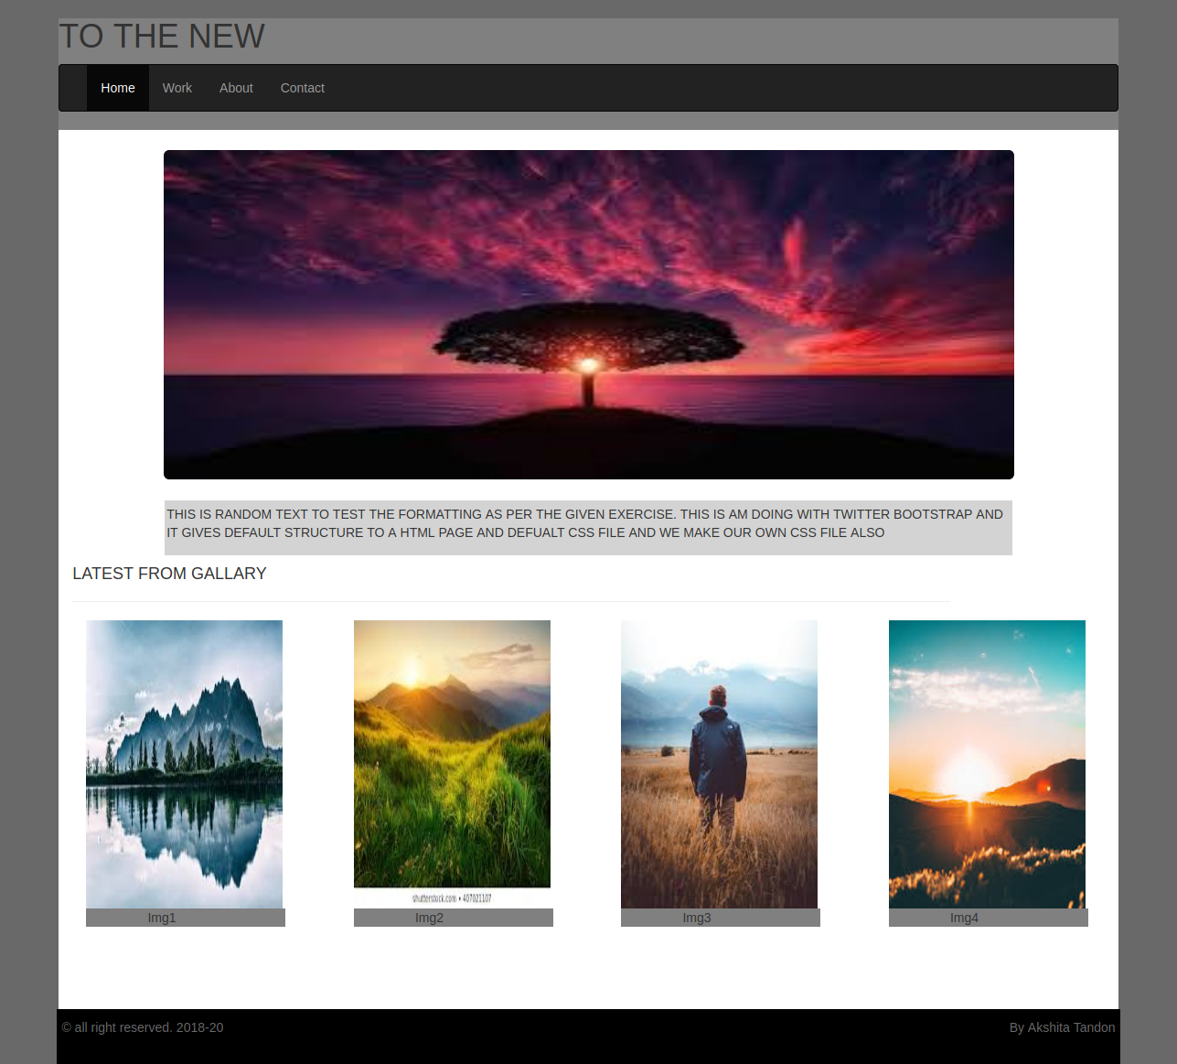

Q: Create HTML for form.png
Html file
<!DOCTYPE html>
<html>
<head>
<link href="https://stackpath.bootstrapcdn.com/bootstrap/4.4.1/css/bootstrap.min.css" rel="stylesheet" integrity="sha384-Vkoo8x4CGsO3+Hhxv8T/Q5PaXtkKtu6ug5TOeNV6gBiFeWPGFN9MuhOf23Q9Ifjh" crossorigin="anonymous">
<meta charset="UTF-8">
<meta name="viewport"
content="width=device-width, user-scalable=no, initial-scale=1.0, maximum-scale=1.0, minimum-scale=1.0">
<meta http-equiv="X-UA-Compatible" content="ie=edge">
<script src="https://stackpath.bootstrapcdn.com/bootstrap/4.4.1/js/bootstrap.min.js" integrity="sha384-wfSDF2E50Y2D1uUdj0O3uMBJnjuUD4Ih7YwaYd1iqfktj0Uod8GCExl3Og8ifwB6" crossorigin="anonymous"></script>
<script src="https://stackpath.bootstrapcdn.com/bootstrap/4.4.1/js/bootstrap.bundle.min.js" integrity="sha384-6khuMg9gaYr5AxOqhkVIODVIvm9ynTT5J4V1cfthmT+emCG6yVmEZsRHdxlotUnm" crossorigin="anonymous"></script>
<link rel="stylesheet" href="style_boot.css">
<title>Document</title>
</head>
<body>
<div class="container-fluid">
<div class="row">
<div class="col-sm-8">
<h2>TO THE NEW </h2>
</div>
<div class="col-sm-4">
<ul class="nav justify-content-end">
<li class="nav-item">
<a class="nav-link active" href="#">Home</a>
</li>
<li class="nav-item">
<a class="nav-link" href="#">Quick Help</a>
</li>
</ul>
</div>
</div>
<hr/>
</div>
<div class="container-fluid">
<h2 id="bug"><strong>Bug Report</strong></h2>
<form>
<div class="form-group">
<div class="col-sm-12">
<label for="title">Title*</label>
<input type="text" class="form-control" id="title">
</div>
</div>
<div class="form-group row">
<div class="col-sm-12">
<label for="description">Description*</label>
<textarea class="form-control" id="description" rows="3"></textarea>
</div>
</div>
<div class="form-group row">
<label >Operating System</label>
<select name="Operatingsystem">
<option class="select" value="Windows XP">Windows XP</option>
<option class="select" value="Windows 7">Windows 7</option>
<option class="select" value="Linux">Linux</option>
<option class="select" value="Mac ">Mac</option>
</select>
</div>
<div class="form-group row">
<label>Products</label>
<select name="products">
<option class="select" value="Windows XP">Laptop</option>
<option class="select" value="Windows 7">VS code</option>
<option class="select" value="Windows 10">Web Storm</option>
</select>
</div>
<div class="form-group" >
<div class="col-sm-5">
<label for="version">Version</label>
<input type="number" size="5" class="form-control" id="version" min="1" max="2">
</div>
</div>
<div class="form-group">
<label >License</label>
<br/>
<label class="radio-inline"><input type="radio" name="optradio">Free</label>
<label class="radio-inline"><input type="radio" name="optradio">Business</label>
</div>
<div class="form-group row">
<label>Severity</label>
<select name="Severity">
<option class="select" value="Critical">Critical</option>
<option class="select" value="Mild">Mild</option>
<option class="select" value="Moderate">Moderate</option>
</select>
</div>
<div class="form-group">
<label for="attach">Attachments*</label>
<input type="file" class="form-control" id="attach" accept="file/*">
</div>
<div class="form-group">
<div class="divide">
<button type="button" class="btn btn-success float-right">Send</button>
</div>
</div>
</form>
</div>
</body>
</html>

css file:

#bug{
color:white;
width:50%;
padding: 15px 2.5px 15px 15px;
margin:auto;
margin-top:20px;
background-color: #E7E4E4;
}
h2{
color:lightseagreen;
}
form label{
font-size:14px;
margin-left:20px;
margin-top:15px;
}
.form-group{
border:2px solid #E7E4E4;
color:black;
margin:auto;
width:50%;
}
.select,select{
background-color:#06A061;
color:white;
border:none;
font-weight:500;
}
form input,select,textarea{
margin-top:20px;
padding:5px 2px 5px 5px;
width:90%;
margin:auto;
border-radius:5px;
border:1px solid #E7E4E4;
}
.divide {
margin-top: 5px;
height: 50px;
border-radius: 5px;
background-color: #E7E4E4;
}

