SPRING SECURITY ASSIGNMENT

1.Implement oauth 2 using spring security and authenticate a user which is saved in database using spring data jpa.
User
package com.springbootcamp.springsecurity;
import javax.persistence.*;
import java.util.List;
@Entity
public class User {
@Id
@GeneratedValue(strategy = GenerationType.IDENTITY)
private Integer id;
private String username;
private String password;
@ManyToMany(cascade = CascadeType.ALL,fetch = FetchType.EAGER)
@JoinTable(
name = "user_role",
joinColumns = @JoinColumn(
name = "user_id", referencedColumnName = "id"),
inverseJoinColumns = @JoinColumn(
name = "role_id", referencedColumnName = "id"))
private List<Role> roles;
public List<Role> getRole() {
return roles;
}
public void setRole(List<Role> roles) {
this.roles = roles;
}
public Integer getId() {
return id;
}
public void setId(Integer id) {
this.id = id;
}
public String getUsername() {
return username;
}
public void setUsername(String username) {
this.username = username;
}
public String getPassword() {
return password;
}
public void setPassword(String password) {
this.password = password;
}
@Override
public String toString() {
return "User{" +
"id=" + id +
", username='" + username + '\'' +
", password='" + password + '\'' +
", role='" + roles + '\'' +
'}';
}
}
Role
package com.springbootcamp.springsecurity;
import javax.persistence.*;
import javax.validation.constraints.NotNull;
import java.util.Set;
@Entity
public class Role {
@Id
@GeneratedValue(strategy = GenerationType.IDENTITY)
private int id;
private String authority;
@ManyToMany(mappedBy = "roles",cascade = CascadeType.ALL)
private Set<User> user;
public Role() {
}
public Role(String authority) {
this.authority = authority;
}
public Set<User> getUser() {
return user;
}
public void setUser(Set<User> user) {
this.user = user;
}
public int getId() {
return id;
}
public void setId(int id) {
this.id = id;
}
public String getAuthority() {
return authority;
}
public void setAuthority(String authority) {
this.authority = authority;
}
}
UserDao
package com.springbootcamp.springsecurity;
import org.springframework.beans.factory.annotation.Autowired;
import org.springframework.security.core.GrantedAuthority;
import org.springframework.security.core.authority.SimpleGrantedAuthority;
import org.springframework.security.crypto.bcrypt.BCryptPasswordEncoder;
import org.springframework.security.crypto.password.PasswordEncoder;
import org.springframework.stereotype.Repository;
import java.util.Arrays;
import java.util.LinkedList;
import java.util.List;
import java.util.Optional;
@Repository
public class UserDao {
@Autowired
UserRepository userRepository;
AppUser loadUserByUsername(String username) {
User user = userRepository.findByUsername(username);
List<GrantedAuthority> grantedAuthorities = new LinkedList<>();
for (Role role : user.getRole()){
grantedAuthorities.add(new SimpleGrantedAuthority(role.getAuthority()));
}
System.out.println(user);
if (username != null) {
return new AppUser(user.getUsername(), user.getPassword(), grantedAuthorities);
} else {
throw new RuntimeException();
}
}
}
UserRepository
package com.springbootcamp.springsecurity;
import org.springframework.data.repository.CrudRepository;
public interface UserRepository extends CrudRepository<User,Integer> {
User findByUsername(String username);
}
SpringSecurityApplication

package com.springbootcamp.springsecurity;
import org.springframework.beans.factory.annotation.Autowired;
import org.springframework.boot.SpringApplication;
import org.springframework.boot.autoconfigure.SpringBootApplication;
import org.springframework.security.oauth2.common.OAuth2AccessToken;
import org.springframework.security.oauth2.provider.token.TokenStore;
import org.springframework.web.bind.annotation.GetMapping;
import org.springframework.web.bind.annotation.RestController;
import javax.servlet.http.HttpServletRequest;
@RestController
@SpringBootApplication
public class SpringSecurityApplication {
@Autowired
private TokenStore tokenStore;
@GetMapping("/doLogout")
public String logout(HttpServletRequest request){
String authHeader = request.getHeader("Authorization");
if (authHeader != null) {
String tokenValue = authHeader.replace("Bearer", "").trim();
OAuth2AccessToken accessToken = tokenStore.readAccessToken(tokenValue);
tokenStore.removeAccessToken(accessToken);
}
return "Logged out successfully";
}
@GetMapping("/")
public String index(){
return "index";
}
@GetMapping("/admin/home")
public String adminHome(){
return "Admin home";
}
@GetMapping("/user/home")
public String userHome(){
return "User home";
}
public static void main(String[] args) {
SpringApplication.run(SpringSecurityApplication.class, args);
}
}
Appuser
package com.springbootcamp.springsecurity;
import org.springframework.security.core.GrantedAuthority;
import org.springframework.security.core.userdetails.UserDetails;
import javax.persistence.Entity;
import java.util.ArrayList;
import java.util.Collection;
import java.util.LinkedList;
import java.util.List;
public class AppUser implements UserDetails {
private String username;
private String password;
List<GrantedAuthority> grantAuthorities;
public AppUser(String username, String password, List<GrantedAuthority> grantAuthorities) {
this.username = username;
this.password = password;
this.grantAuthorities = grantAuthorities;
}
@Override
public Collection<? extends GrantedAuthority> getAuthorities() {
List<GrantedAuthority> listAuthorities = new LinkedList<>();
listAuthorities.addAll(grantAuthorities);
for (GrantedAuthority auth: listAuthorities
) {
System.out.println(".................."+auth.getAuthority());
}
return listAuthorities;
}
@Override
public String getPassword() {
return password;
}
@Override
public String getUsername() {
return username;
}
@Override
public boolean isAccountNonExpired() {
return true;
}
@Override
public boolean isAccountNonLocked() {
return true;
}
@Override
public boolean isCredentialsNonExpired() {
return true;
}
@Override
public boolean isEnabled() {
return true;
}
}
AppUserDetailsService
package com.springbootcamp.springsecurity;
import org.springframework.beans.factory.annotation.Autowired;
import org.springframework.security.core.userdetails.UserDetails;
import org.springframework.security.core.userdetails.UserDetailsService;
import org.springframework.security.core.userdetails.UsernameNotFoundException;
import org.springframework.security.crypto.password.PasswordEncoder;
import org.springframework.stereotype.Service;
@Service
public class AppUserDetailsService implements UserDetailsService {
@Autowired
PasswordEncoder passwordEncoder;
@Autowired
UserDao userDao;
@Override
public UserDetails loadUserByUsername(String username) throws UsernameNotFoundException {
String encryptedPassword = passwordEncoder.encode("pass");
System.out.println("Trying to authenticate user ::" + username);
System.out.println("Encrypted Password ::"+encryptedPassword);
UserDetails userDetails = userDao.loadUserByUsername(username);
return userDetails;
}
}
AuthenticationManagerProvider
package com.springbootcamp.springsecurity;
import org.springframework.context.annotation.Bean;
import org.springframework.context.annotation.Configuration;
import org.springframework.security.authentication.AuthenticationManager;
import org.springframework.security.config.annotation.web.configuration.WebSecurityConfigurerAdapter;
@Configuration
public class AuthenticationManagerProvider extends WebSecurityConfigurerAdapter {
@Bean
@Override
public AuthenticationManager authenticationManagerBean() throws Exception {
return super.authenticationManagerBean();
}
}
AuthorizationServerConfiguration
package com.springbootcamp.springsecurity;
import org.springframework.beans.factory.annotation.Autowired;
import org.springframework.context.annotation.Bean;
import org.springframework.context.annotation.Configuration;
import org.springframework.context.annotation.Primary;
import org.springframework.security.authentication.AuthenticationManager;
import org.springframework.security.core.userdetails.UserDetailsService;
import org.springframework.security.crypto.password.PasswordEncoder;
import org.springframework.security.oauth2.config.annotation.configurers.ClientDetailsServiceConfigurer;
import org.springframework.security.oauth2.config.annotation.web.configuration.AuthorizationServerConfigurerAdapter;
import org.springframework.security.oauth2.config.annotation.web.configuration.EnableAuthorizationServer;
import org.springframework.security.oauth2.config.annotation.web.configurers.AuthorizationServerEndpointsConfigurer;
import org.springframework.security.oauth2.config.annotation.web.configurers.AuthorizationServerSecurityConfigurer;
import org.springframework.security.oauth2.provider.token.DefaultTokenServices;
import org.springframework.security.oauth2.provider.token.TokenStore;
import org.springframework.security.oauth2.provider.token.store.InMemoryTokenStore;
import org.springframework.security.oauth2.provider.token.store.JdbcTokenStore;
import org.springframework.security.oauth2.provider.token.store.JwtAccessTokenConverter;
import org.springframework.security.oauth2.provider.token.store.JwtTokenStore;
import javax.sql.DataSource;
@Configuration
@EnableAuthorizationServer
public class AuthorizationServerConfiguration extends AuthorizationServerConfigurerAdapter {
@Autowired
PasswordEncoder passwordEncoder;
@Autowired
AuthenticationManager authenticationManager;
@Autowired
UserDetailsService userDetailsService;
@Autowired
DataSource dataSource;
public AuthorizationServerConfiguration() {
super();
}
@Bean
@Primary
DefaultTokenServices tokenServices(){
DefaultTokenServices defaultTokenServices = new DefaultTokenServices();
defaultTokenServices.setTokenStore(tokenStore());
defaultTokenServices.setSupportRefreshToken(true);
return defaultTokenServices;
}
@Override
public void configure(final AuthorizationServerEndpointsConfigurer endpoints) {
endpoints.tokenStore(tokenStore()).userDetailsService(userDetailsService)
.authenticationManager(authenticationManager)
// .accessTokenConverter(accessTokenConverter())
;
}
// @Bean
// JwtAccessTokenConverter accessTokenConverter(){
// JwtAccessTokenConverter jwtAccessTokenConverter = new JwtAccessTokenConverter();
// jwtAccessTokenConverter.setSigningKey("1234");
// return jwtAccessTokenConverter;
// }
@Bean
public TokenStore tokenStore() {
return new JdbcTokenStore(dataSource);
// return new JwtTokenStore(accessTokenConverter());
}
@Override
public void configure(final ClientDetailsServiceConfigurer clients) throws Exception {
clients.inMemory()
.withClient("live-test")
.secret(passwordEncoder.encode("abcde"))
.authorizedGrantTypes("password","refresh_token")
.refreshTokenValiditySeconds(30 * 24 * 3600)
.scopes("app")
.accessTokenValiditySeconds(7*24*60);
}
@Override
public void configure(AuthorizationServerSecurityConfigurer authorizationServerSecurityConfigurer) throws Exception {
authorizationServerSecurityConfigurer.allowFormAuthenticationForClients();
}
}
Bootstrap.java
package com.springbootcamp.springsecurity;
import org.springframework.beans.factory.annotation.Autowired;
import org.springframework.boot.ApplicationArguments;
import org.springframework.boot.ApplicationRunner;
import org.springframework.security.crypto.bcrypt.BCryptPasswordEncoder;
import org.springframework.security.crypto.password.PasswordEncoder;
import org.springframework.stereotype.Component;
import java.util.ArrayList;
import java.util.LinkedList;
import java.util.List;
@Component
public class Bootstrap implements ApplicationRunner {
@Autowired
UserRepository userRepository;
@Override
public void run(ApplicationArguments args) throws Exception {
if(userRepository.count()<1){
PasswordEncoder passwordEncoder = new BCryptPasswordEncoder();
User user1 = new User();
user1.setUsername("user");
user1.setPassword(passwordEncoder.encode("pass"));
List<Role> roles = new LinkedList<>();
roles.add(new Role("ROLE_USER"));
roles.add(new Role("ROLE_ADMIN"));
user1.setRole(roles);

User user2 = new User();
user2.setUsername("admin");
user2.setPassword(passwordEncoder.encode("pass"));
List<Role> roles1 = new LinkedList<>();
roles1.add(new Role("ROLE_ADMIN"));
roles1.add(new Role("ROLE_USER"));
user2.setRole(roles1);

User user3 = new User();
user3.setUsername("user1");
user3.setPassword(passwordEncoder.encode("pass"));
List<Role> roles2 = new LinkedList<>();
roles2.add(new Role("ROLE_USER"));
user3.setRole(roles2);
userRepository.save(user1);
userRepository.save(user2);
userRepository.save(user3);

System.out.println("Total users saved::"+userRepository.count());
}
}
}
GrantAuthorityImpl
package com.springbootcamp.springsecurity;
import org.springframework.security.core.GrantedAuthority;
import java.util.List;
public class GrantAuthorityImpl implements GrantedAuthority {
List<Role> authority;
public GrantAuthorityImpl(List<Role> authority) {
this.authority = authority;
}
@Override
public String getAuthority() {
for (Role auth :authority)
{
System.out.println(".....//////////"+auth.getAuthority());
return String.valueOf(auth.getAuthority());
}
return null;
}
}
ResourceServerConfiguration
package com.springbootcamp.springsecurity;
import org.springframework.beans.factory.annotation.Autowired;
import org.springframework.context.annotation.Bean;
import org.springframework.context.annotation.Configuration;
import org.springframework.security.authentication.AuthenticationProvider;
import org.springframework.security.authentication.dao.DaoAuthenticationProvider;
import org.springframework.security.config.annotation.authentication.builders.AuthenticationManagerBuilder;
import org.springframework.security.config.annotation.method.configuration.EnableGlobalMethodSecurity;
import org.springframework.security.config.annotation.web.builders.HttpSecurity;
import org.springframework.security.config.annotation.web.configuration.EnableWebSecurity;
import org.springframework.security.config.http.SessionCreationPolicy;
import org.springframework.security.crypto.bcrypt.BCryptPasswordEncoder;
import org.springframework.security.oauth2.config.annotation.web.configuration.EnableResourceServer;
import org.springframework.security.oauth2.config.annotation.web.configuration.ResourceServerConfigurerAdapter;
@Configuration
@EnableResourceServer
@EnableWebSecurity
@EnableGlobalMethodSecurity(securedEnabled = true)
public class ResourceServerConfiguration extends ResourceServerConfigurerAdapter {
@Autowired
AppUserDetailsService userDetailsService;
public ResourceServerConfiguration() {
super();
}
@Bean
public static BCryptPasswordEncoder bCryptPasswordEncoder() {
return new BCryptPasswordEncoder();
}
@Bean
public AuthenticationProvider authenticationProvider() {
final DaoAuthenticationProvider authenticationProvider = new DaoAuthenticationProvider();
authenticationProvider.setUserDetailsService(userDetailsService);
authenticationProvider.setPasswordEncoder(bCryptPasswordEncoder());
return authenticationProvider;
}
@Autowired
public void configureGlobal(final AuthenticationManagerBuilder authenticationManagerBuilder) {
authenticationManagerBuilder.authenticationProvider(authenticationProvider());
}
@Override
public void configure(final HttpSecurity http) throws Exception {
http
.authorizeRequests()
.antMatchers("/").anonymous()
.antMatchers("/admin/home").hasAnyRole("ADMIN")
.antMatchers("/user/home").hasAnyRole("USER")
.antMatchers("/doLogout").hasAnyRole("ADMIN","USER")
.anyRequest().authenticated()
.and()
.sessionManagement()
.sessionCreationPolicy(SessionCreationPolicy.STATELESS).and()
.csrf().disable();
}
}
Authenticating a user
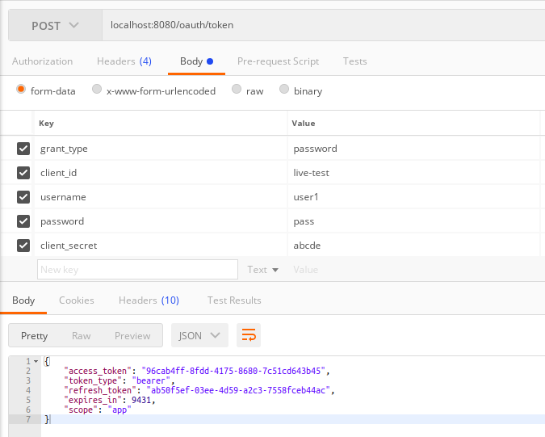
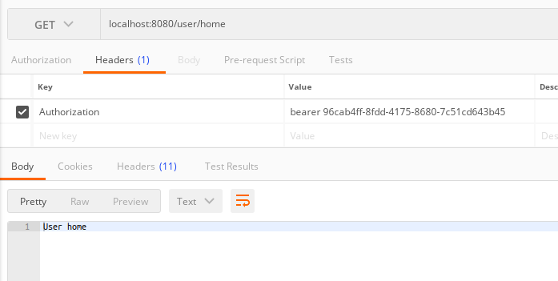
2.Grant different Roles to different users and make sure that only authorized users of a given type can access the resource.

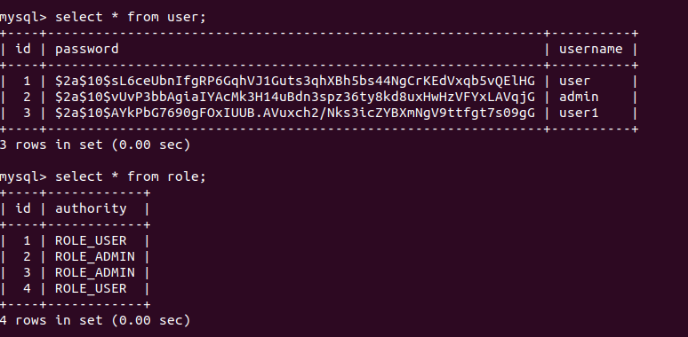
Jdbc token
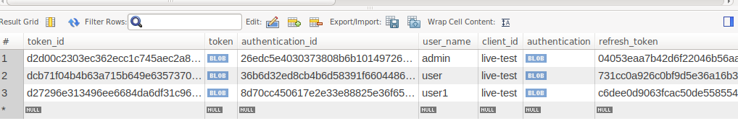
Authenticating admin with role admin
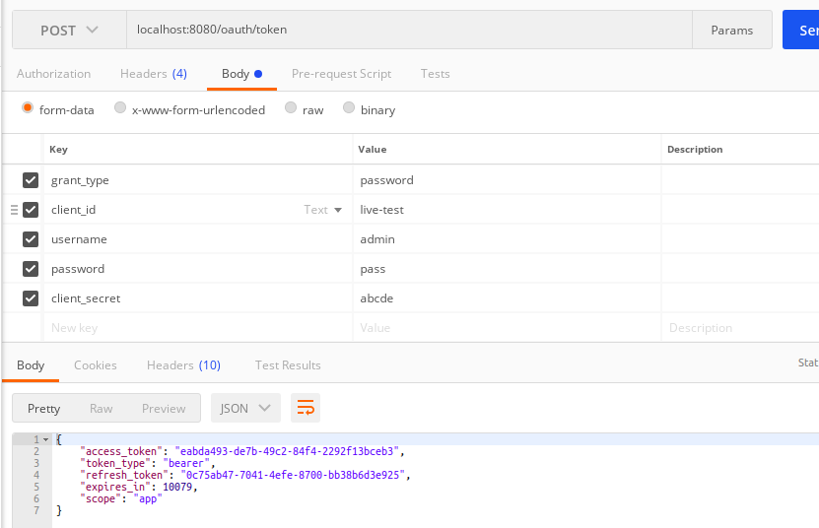
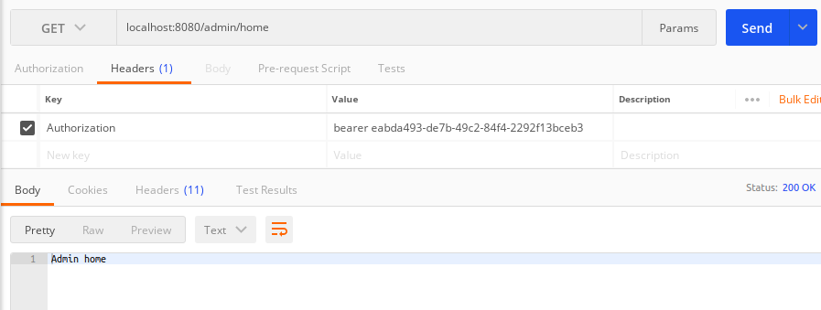
Authenticating user with role user and admin
