Q1.Write a programe do to demonstrate the use of volatile keyword.
package com.Threads;

import java.util.Scanner;
class Processor extends Thread {
private volatile boolean running = true;
public void run() {
while(running) {
System.out.println("Running");
try {
Thread.sleep(50);
} catch (InterruptedException e) {
e.printStackTrace();
}
}
}
public void shutdown() {
running = false;
}
}
public class Driver1 {
public static void main(String[] args) {
Processor pro = new Processor();
pro.start();
Scanner sc=new Scanner(System.in);
sc.nextLine();
pro.shutdown();
}

}
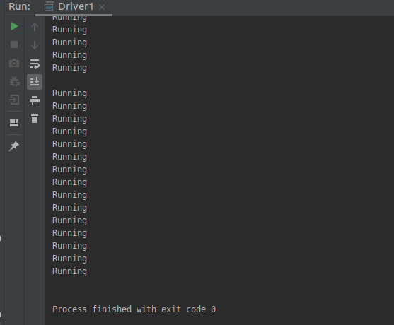
Q2.Write a program to create a thread using Thread class and Runnable interface each.
package com.Threads;

public class Runner extends Thread {
@Override
public void run() {
for(int i=1;i<5;i++){
System.out.println("hello "+i);
}
}
}
class Driver{
public static void main(String[] args) {
Runner runner=new Runner();
runner.run();
Runner runner2=new Runner();
runner2.run();
}
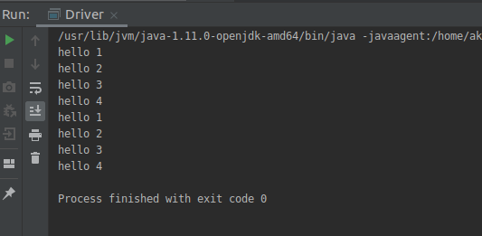
}

Through Runnable Interface:
package com.Threads;
public class Runner implements Runnable{

@Override
public void run() {
for(int i=1;i<5;i++){
System.out.println("hello "+i);
}
}
}
class Driver{
public static void main(String[] args) {
Thread t1=new Thread(new Runner());
Thread t2=new Thread(new Runner()a);
t1.start();
t2.start();
}
}
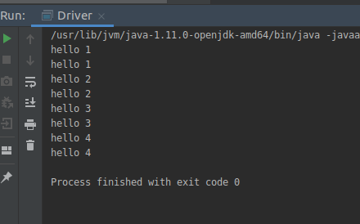

Q3.Write a program using synchronization blockand synchronization method
SYNCHRONIZATION BLOCK
package com.Threads;
class Table{

void printTable(int n){
synchronized(this){//synchronized block
for(int i=1;i<=5;i++){
System.out.println(n*i);
try{
Thread.sleep(400);
}catch(Exception e){System.out.println(e);}
}
}
}//end of the method
}

class MyThread1 extends Thread{
Table t;
MyThread1(Table t){
this.t=t;
}
public void run(){
t.printTable(5);
}

}
class MyThread2 extends Thread{
Table t;
MyThread2(Table t){
this.t=t;
}
public void run(){
t.printTable(100);
}
}

public class TestSynchronizedBlock1{
public static void main(String args[]){
Table obj = new Table();
Table obj1=new Table();
MyThread1 t1=new MyThread1(obj);
MyThread2 t2=new MyThread2(obj1);
t1.start();
t2.start();
}
}

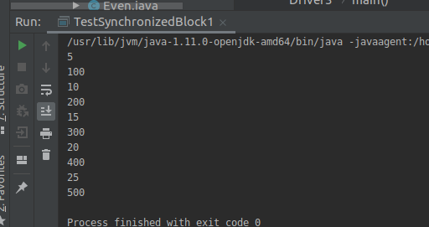
SYNCHRONIZATION METHOD
package com.Threads;
class Increment implements Runnable{
private static int count=0;
public static synchronized void increment(){
count++;
}
public void display(){
System.out.println("Count is "+count);
}

@Override
public void run() {
for(int i=0;i<1000;i++){
increment();
}

}

}
public class Driver4 {
public static void main(String[] args) {
Increment inc=new Increment();
Thread t1=new Thread(new Increment());
Thread t2=new Thread(new Increment());
t1.start();
t2.start();

try {
t1.join();
t2.join();
} catch (InterruptedException e) {
e.printStackTrace();
}
inc.display();
}
}
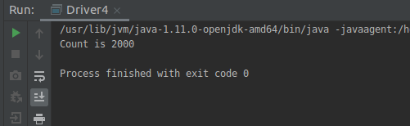

Q4.Write a program to create a Thread pool of 2 threads where one Thread will print even numbers and other will print odd numbers.
package com.Threads;
import java.util.concurrent.Executor;
import java.util.concurrent.ExecutorService;
import java.util.concurrent.Executors;
import java.util.concurrent.TimeUnit;

public class Even implements Runnable {
@Override
public void run() {
System.out.println("Even Numbers");
for(int i=1;i<=10;i++){
if(i%2==0){
System.out.println("Even "+i+",");
// System.out.println(" ");
}
}
}
}
class Odd implements Runnable{
@Override
public void run() {
System.out.println("Odd Numbers");
for(int i=1;i<=10;i++){
if(i%2!=0){
System.out.println("Odd "+i+",");
}
}
}
}
class Driver3{
public static void main(String[] args) {

ExecutorService executorService= Executors.newFixedThreadPool(2);
executorService.submit(new Even());
executorService.submit(new Odd());
executorService.shutdown();
// System.out.println("All tasks submitted");
try {
executorService.awaitTermination(1, TimeUnit.DAYS);
} catch (InterruptedException e) {
}
System.out.println("All tasks completed.");
}
}
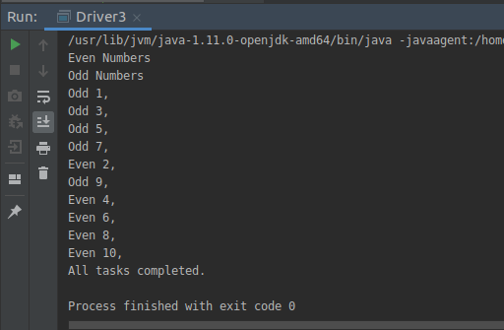

Q5.Write a program to demonstrate wait and notify methods.
package com.Threads;

public class Demo {

public void worker1(){
synchronized (this) {
System.out.println("Worker1 Started");
try {
wait();
} catch (InterruptedException e) {
e.printStackTrace();
}
System.out.println("Worker1 Done");
}
}

public void worker4(){
synchronized (this) {
System.out.println("Worker 4 Started");
System.out.println("Worker 4 Done");
notify();
}
}

public static void main(String[] args) {
Demo demo = new Demo();
new Thread(new Runnable() {
@Override
public void run() {
demo.worker1();
}
}).start();
new Thread(new Runnable() {
@Override
public void run() {
demo.worker4();
}
}).start();
}
}
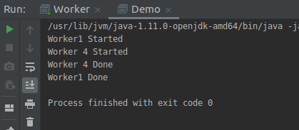

Q6.Write a program to demonstrate sleep and join methods.
package com.Threads;
class SimpleThread implements Runnable {
static int counter = 0;
@Override
public void run() {
try {
Thread.sleep(5000);
System.out.println("Running Thread");
} catch (InterruptedException e) {
e.printStackTrace();
}
}
}
public class Driver5 {
public static void main(String[] args) {
Thread t1=new Thread(new SimpleThread());
Thread t2=new Thread(new SimpleThread());
t1.start();
t2.start();
try {
t1.join();
t2.join();
} catch (InterruptedException e) {
e.printStackTrace();
}
System.out.println("Main Ended");
}

}
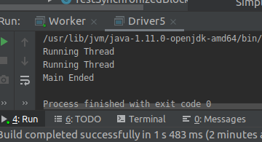

Q7.Run a task with the help of callable and store it's result in the Future.
package com.Threads;
import java.util.Random;
import java.util.concurrent.*;
public class CallableFutureTest {
public static void main(String[] args) throws Exception {
ExecutorService executorService = Executors.newCachedThreadPool();
Future<Integer> future = executorService.submit(new Callable<Integer>() {
@Override
public Integer call() throws Exception {
Random random = new Random();
int duration = random.nextInt(4000);
System.out.println("Starting");
try {
Thread.sleep(duration);
} catch (InterruptedException e) {
e.printStackTrace();
}
System.out.println("ending....");
return duration;
}
});
executorService.shutdown();
try{
System.out.println("The result is "+future.get());
} catch (InterruptedException e) {
e.printStackTrace();
} catch (ExecutionException e) {
e.printStackTrace();
System.out.println(e.getMessage());
}
}
}

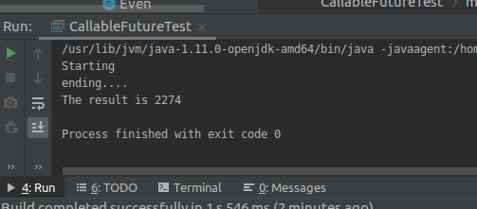

Q8.Write a program to demonstrate the use of semaphore
package com.Threads;
import java.util.concurrent.Semaphore;
class Shared{
static int count=0;
}
class TestSemaphore extends Thread{
Semaphore sem;
public String threadName;
TestSemaphore(Semaphore sem,String threadName){
super(threadName);
this.sem=sem;
this.threadName=threadName;
}

@Override
public void run() {
if(this.getName().equals("A")){
System.out.println("waiting for lock for "+threadName);
try {
sem.acquire();
} catch (InterruptedException e) {
e.printStackTrace();
}
for(int i=0;i<5;i++){
Shared.count++;
System.out.println("the value of shared resource is "+Shared.count+" in "+threadName);
}
System.out.println("lock acquired for "+threadName);
try {
Thread.sleep(1000);
} catch (InterruptedException e) {
e.printStackTrace();
}
sem.release();
System.out.println("lock is released by "+threadName);
}
if(this.getName().equals("B")){
System.out.println("waiting for lock for "+threadName);
try {
sem.acquire();
} catch (InterruptedException e) {
e.printStackTrace();
}
for(int i=0;i<5;i++){
Shared.count--;
System.out.println("the value of shared resource is "+Shared.count+" in"+threadName);
}
System.out.println("lock acquired for "+threadName);
try {
Thread.sleep(1000);
} catch (InterruptedException e) {
e.printStackTrace();
}
sem.release();
System.out.println("lock is released by "+threadName);
}
}
}
public class SemaphoreDemo {
public static void main(String[] args) {
Semaphore sem=new Semaphore(1);
TestSemaphore test1=new TestSemaphore(sem,"A");
TestSemaphore test2=new TestSemaphore(sem,"B");
test1.start();
test2.start();

try {
test1.join();
test2.join();
} catch (InterruptedException e) {
e.printStackTrace();
}
System.out.println("Value of shared resources is "+Shared.count);

}
}
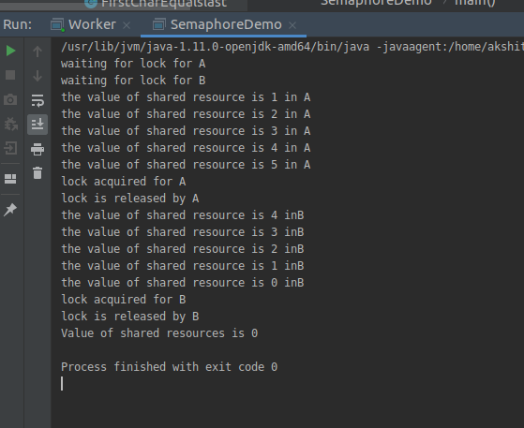
Q9.Write a program to demonstrate the use of CountDownLatch
package com.Threads;

import java.util.concurrent.CountDownLatch;
import java.util.concurrent.ExecutorService;
import java.util.concurrent.Executors;

public class Worker implements Runnable {

private CountDownLatch latch;
public Worker(CountDownLatch latch){
this.latch=latch;
}
@Override
public void run() {
System.out.println("Thread running");
try {
Thread.sleep(2000);
latch.countDown();
} catch (InterruptedException e) {
e.printStackTrace();
}

}

public static void main(String[] args) {

CountDownLatch latch=new CountDownLatch(3);
ExecutorService executor= Executors.newFixedThreadPool(3);
for(int i=0; i < 3; i++) {
executor.submit(new Worker(latch));
}

try {
latch.await();
} catch (InterruptedException e) {
// TODO Auto-generated catch block
e.printStackTrace();
}

System.out.println("Completed.");

}
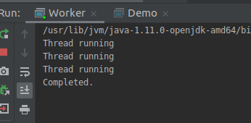
}

Q10.Write a program which creates deadlock between 2 threads
package com.Threads;

class Shareds
{

public synchronized void test1(Shareds s2)
{
System.out.println("test1-begin");
try {
Thread.sleep(1000);
} catch (InterruptedException e) {
e.printStackTrace();
}

s2.test2(this);
System.out.println("test1-end");
}

public synchronized void test2(Shareds s1)
{
System.out.println("test2-begin");
try {
Thread.sleep(1000);
} catch (InterruptedException e) {
e.printStackTrace();
}

s1.test1(this);
System.out.println("test2-end");
}
}

class Thread1 extends Thread
{
private Shareds s1;
private Shareds s2;

public Thread1(Shareds s1, Shareds s2)
{
this.s1 = s1;
this.s2 = s2;
}
@Override
public void run()
{
s1.test1(s2);
}
}

class Thread2 extends Thread
{
private Shareds s1;
private Shareds s2;

public Thread2(Shareds s1, Shareds s2)
{
this.s1 = s1;
this.s2 = s2;
}

@Override
public void run()
{
s2.test2(s1);
}
}

public class Demo6
{
public static void main(String[] args)
{
Shareds s1 = new Shareds();
Shareds s2 = new Shareds();
Thread1 t1 = new Thread1(s1, s2);
t1.start();
Thread2 t2 = new Thread2(s1, s2);
t2.start();
try {
Thread.sleep(2000);
} catch (InterruptedException e) {
e.printStackTrace();
}
}
}

