Create a own library in Bintray/jCenter

Contents

How to create an own library in Bintray/jcenter? 2

# How to create an own library in Bintray/jcenter?

* As do all steps like: create a project, choose module as android library, and then add some functions in library.
* In last commit this code in public github repo.
* Then create an account on Bintray jFrog (link: <https://bintray.com/login?targetUri=/profile/edit>)
* Then do all steps as suggested in this blogs: <http://blogs.quovantis.com/how-to-publish-android-library-on-bintrayjcenter/>
* In this blog first add new repo and add new package of that repo.
* Add some classpath in gradle file like:
* dependencies {

classpath 'com.android.tools.build:gradle:2.3.1'

classpath 'com.jfrog.bintray.gradle:gradle-bintray-plugin:1.7'

classpath 'com.github.dcendents:android-maven-gradle-plugin:1.5'

}

* Then add authentication details in local.properties file:
* bintray.user= “YOUR USERNAME”

bintray.apikey= “YOUR API KEY”

* Need to modify our build.gradle (Module:app) file as below-mentioned steps:
* ext {

bintrayRepo = 'Utility' // your repo name

bintrayName = 'time-utils' // has to be same as your library module name

publishedGroupId = 'com.timeutility' // your module package name

libraryName = ‘time-utils’

artifact = 'time-utils' // has to be same as your library module name

libraryDescription = 'A set of methods used to manipulate time object'

siteUrl = 'https://github.com/androidCode/time-utils'

gitUrl = 'https://github.com/androidCode/time-utils.git'

libraryVersion = '1.0'

developerId = ‘sachit’

developerName = Sachit

developerEmail = 'sachit.wadhawan@quovantis.com'

licenseName = 'The Apache Software License, Version 2.0'

licenseUrl = 'http://www.apache.org/licenses/LICENSE-2.0.txt'

allLicenses = ["Apache-2.0"]

}

android {

// -------- your target version and all required configuration. These are normal as

for other projects and generate by android studio itself

}

dependencies {

// Your dependecies

}

// add it to the bottom of the file

apply from: 'https://raw.githubusercontent.com/numetriclabz/jcenter/master/installv.gradle'

apply from: 'https://raw.githubusercontent.com/numetriclabz/jcenter/master/bintrayv.gradle'

* Then everything is configured, run the command below in your terminal, in root of the project. Below this is command line:
* .\gradlew clean build install bintrayUpload
* I am stuck here, it shows me this type of error: Unauthorized [message:This resource requires authentication]. As below picture:

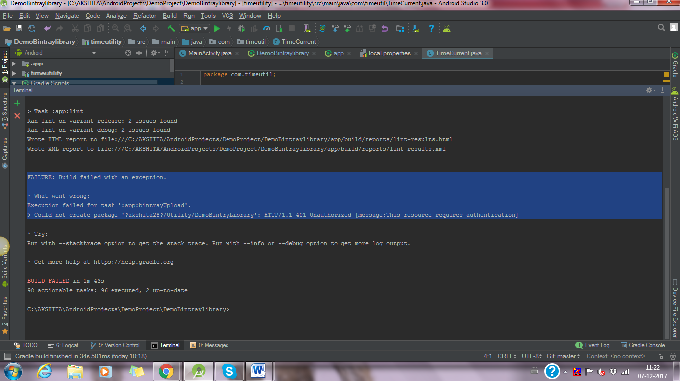

* I also refer some more blogs related to this:
* <https://medium.com/@daniellevass/how-to-publish-your-android-studio-library-to-jcenter-5384172c4739>
* <https://inthecheesefactory.com/blog/how-to-upload-library-to-jcenter-maven-central-as-dependency/en>
* <https://ptyagicodecamp.github.io/how-did-i-publish-android-library-to-jcenter-from-android-studio.html>