# How to create an own library in android?

* This is demo library and it’s only printing the logs message.
* Create a new project as shown in below picture:

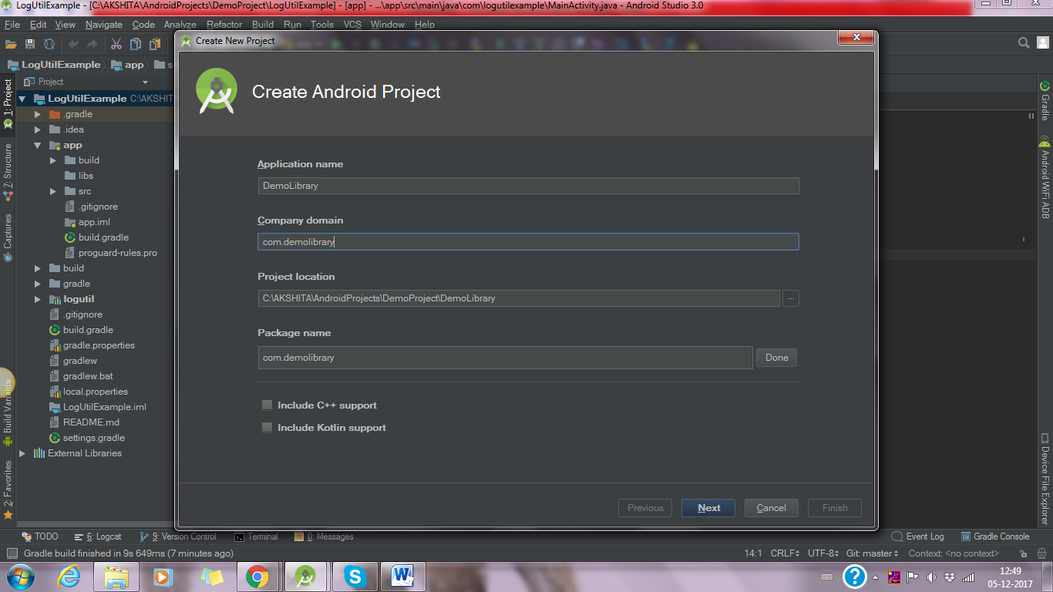

* Select Empty Activity and finish it.
* Now create a module (right click of android app and select New -> Module) as shown in below picture:

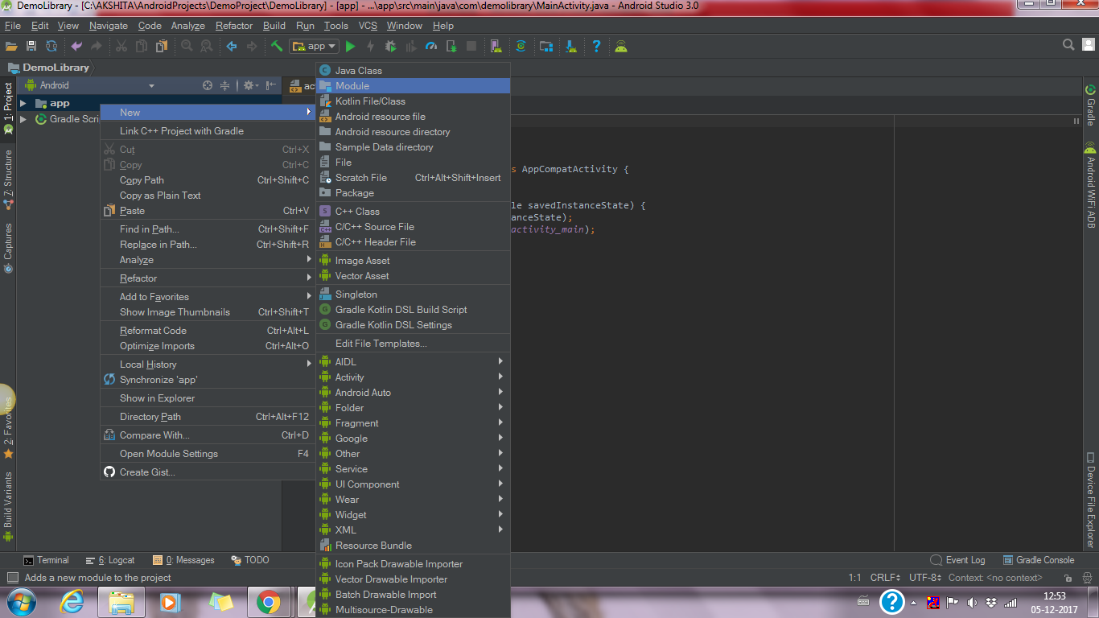

* Now choose Android Library as shown in picture:

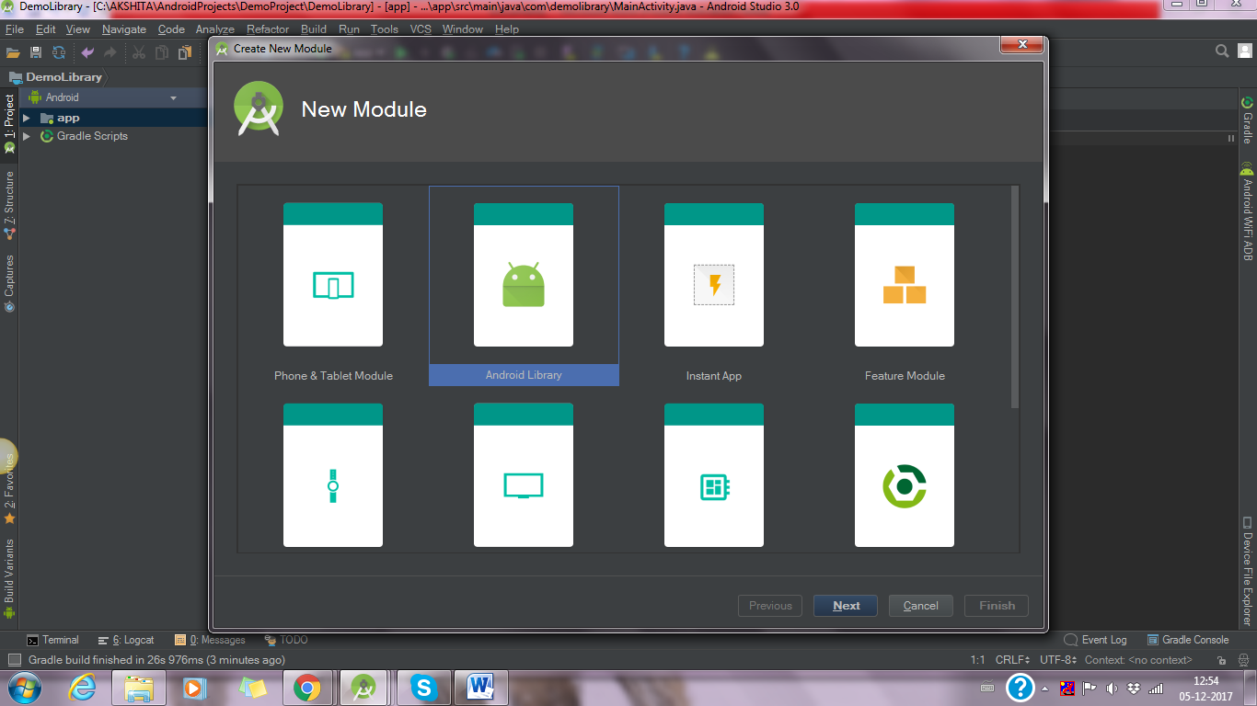

* Click on next and set a name of library what you want as shown in below picture:

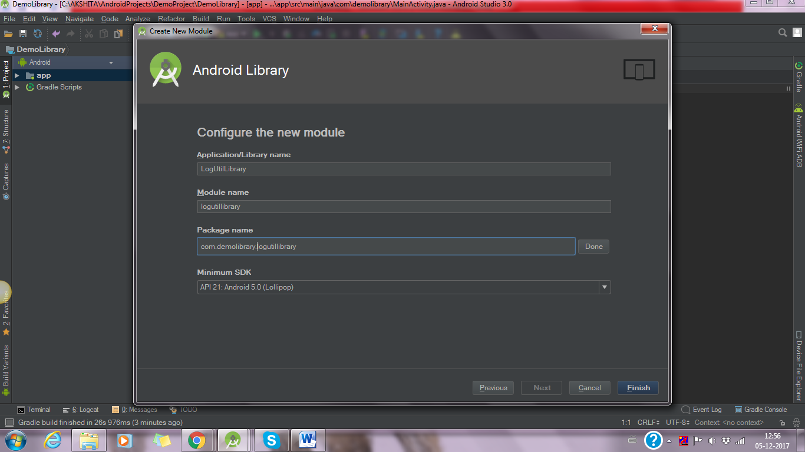

* Now click on finish button. It create a library module and it will be seen as below picture:

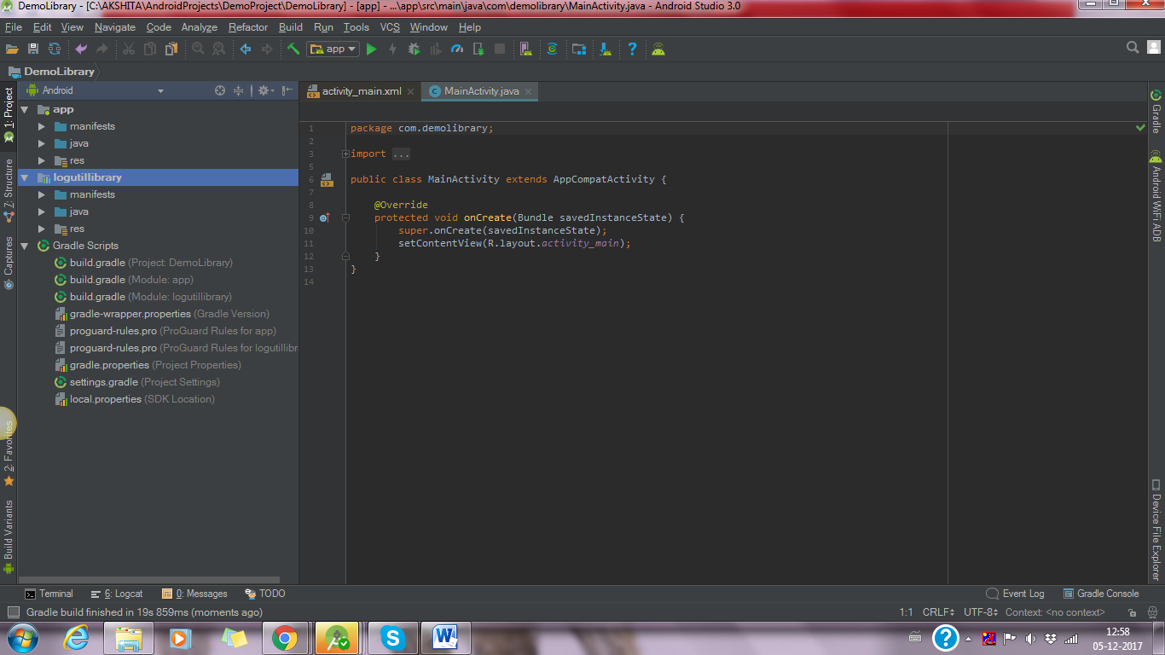

* Now create a class in library folder as shown in below picture:

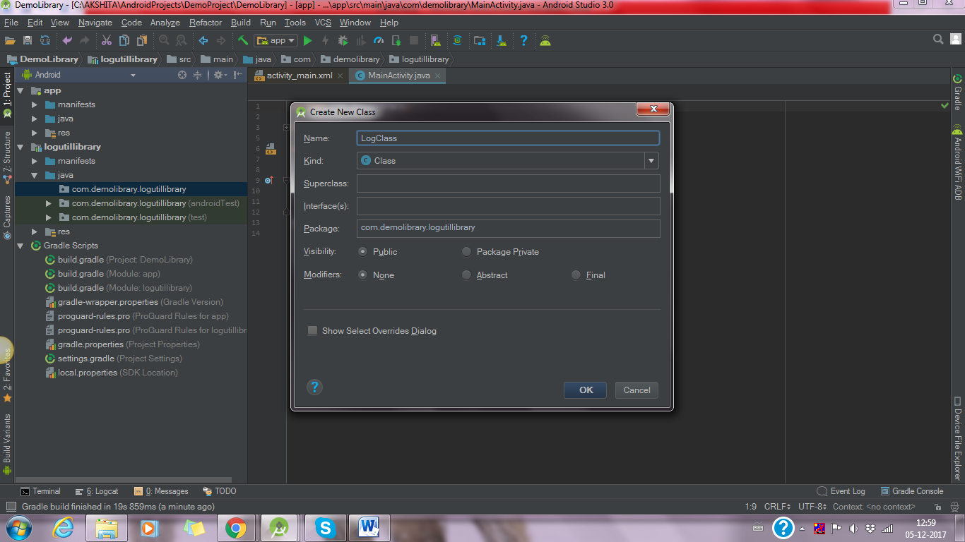

* This class contains all logs method so it prints the message as shown in below picture:

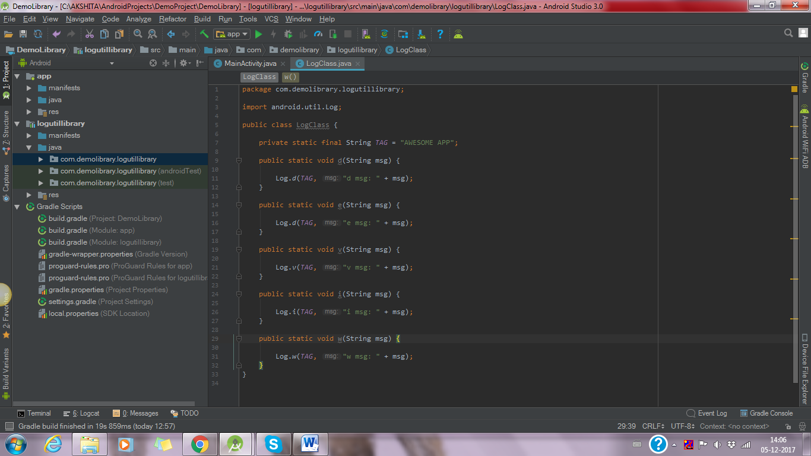

* Add this library in your build.gradle (module:app)

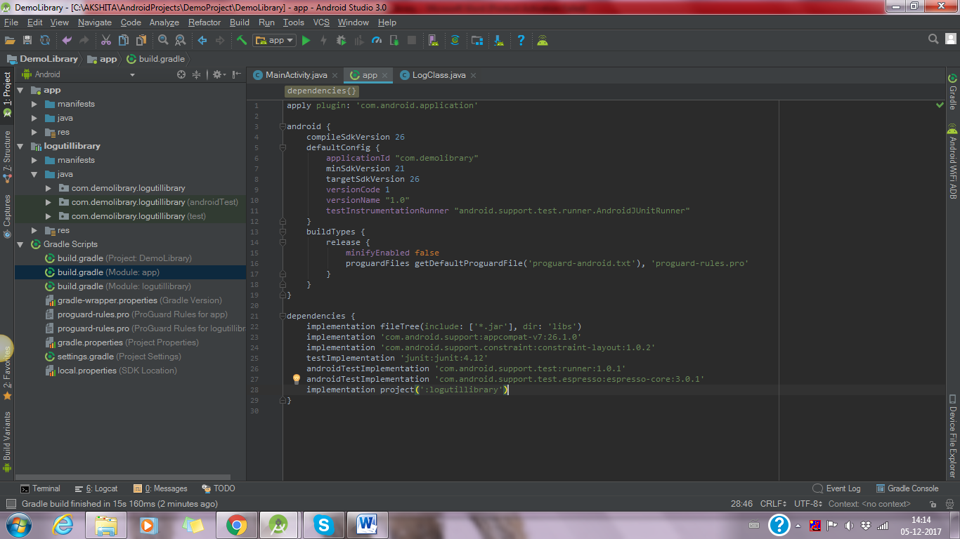

* Now this code pushes in your Github repositories. And then open this link : <https://jitpack.io/>
* It shows like below picture:

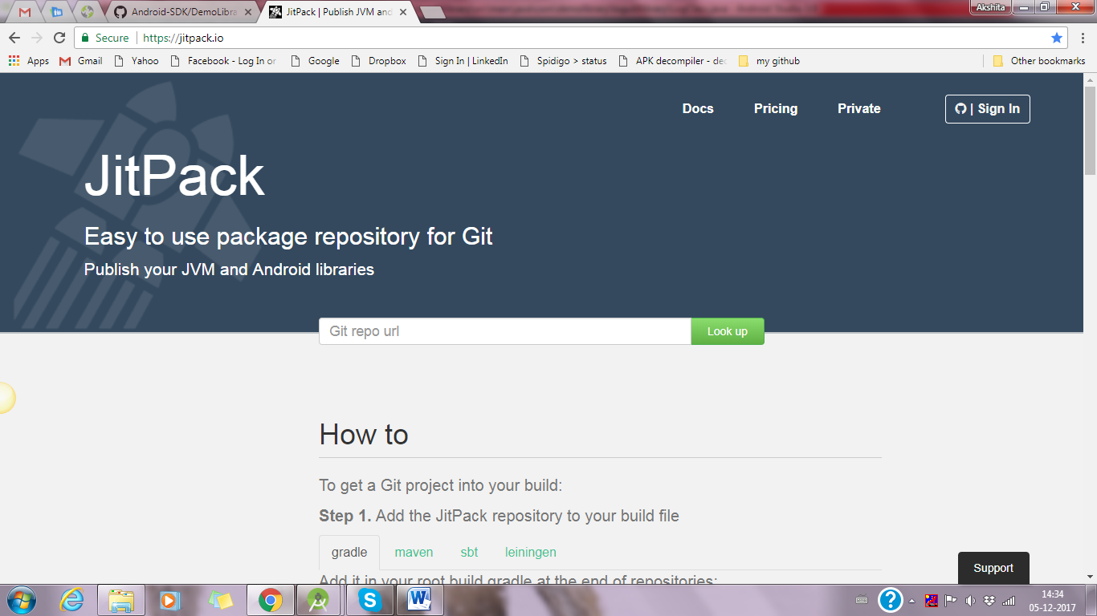

* Add your gitHub URL as shown in below picture and click on Look up. This shows in github repositories “no release found”:

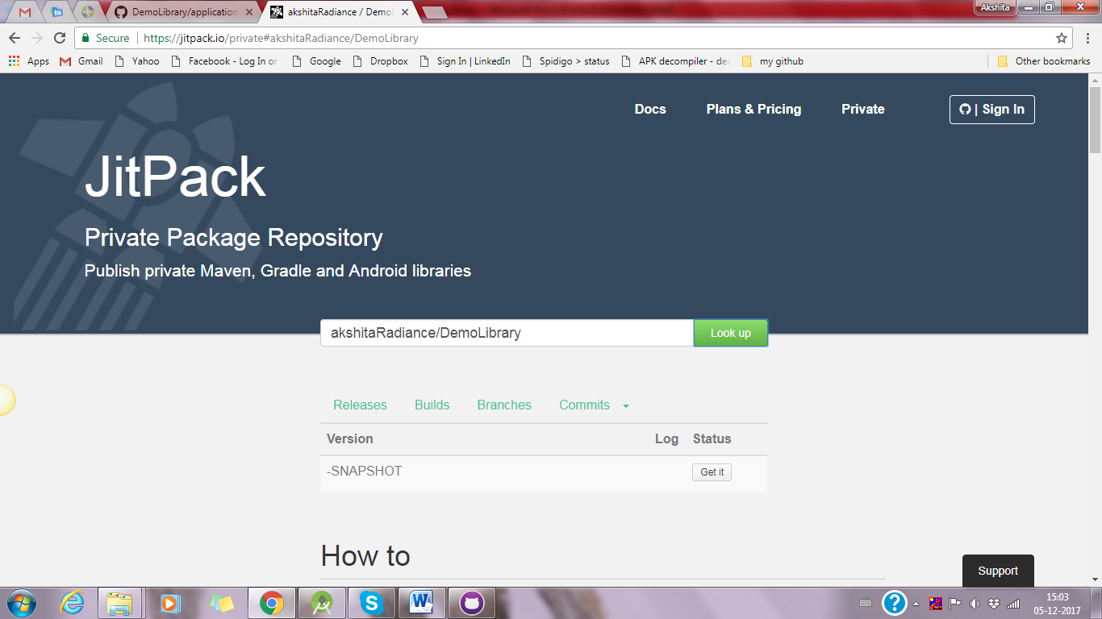

* Now first you release your repositories as shown in below picture:

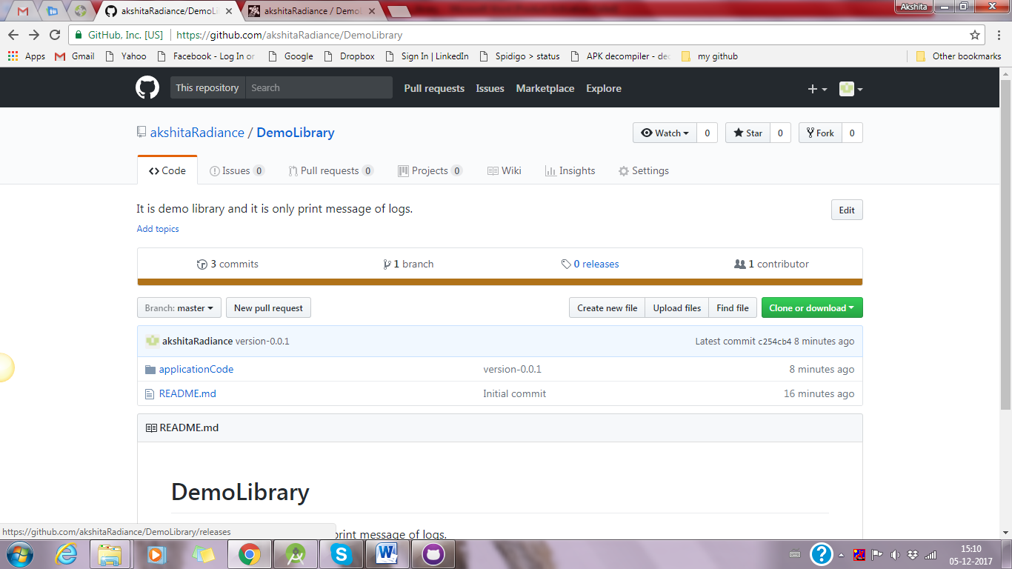

* Create a new release as shown in below picture:

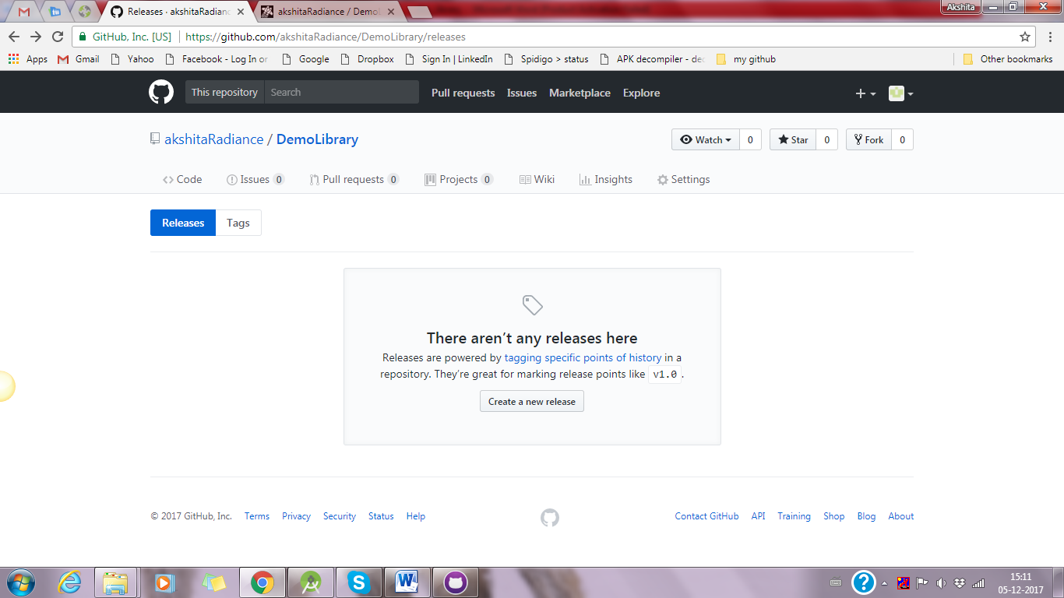

* Fill all necessary details and do publish release as shown in below picture:

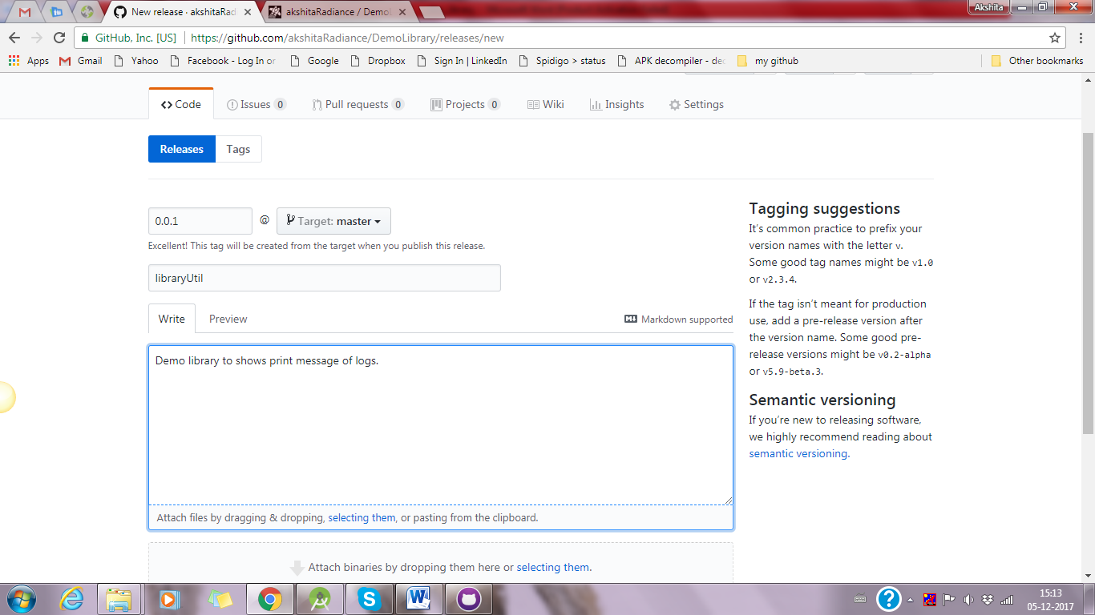

* Then you see release library as given below picture:

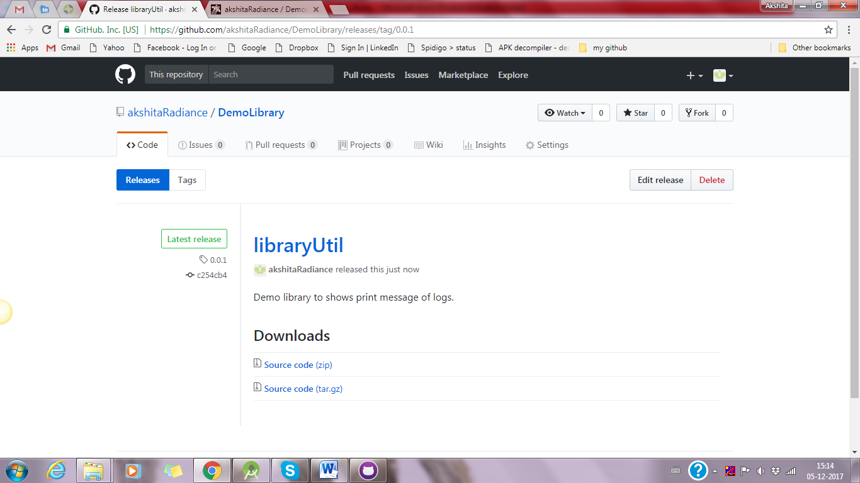

* Now in jitpack.io enter your URL again and refresh it. You can see like below picture:
* In this picture release version 0.0.1 shows some error and 0.0.2 shows that use that it is done with all process and ready to use.

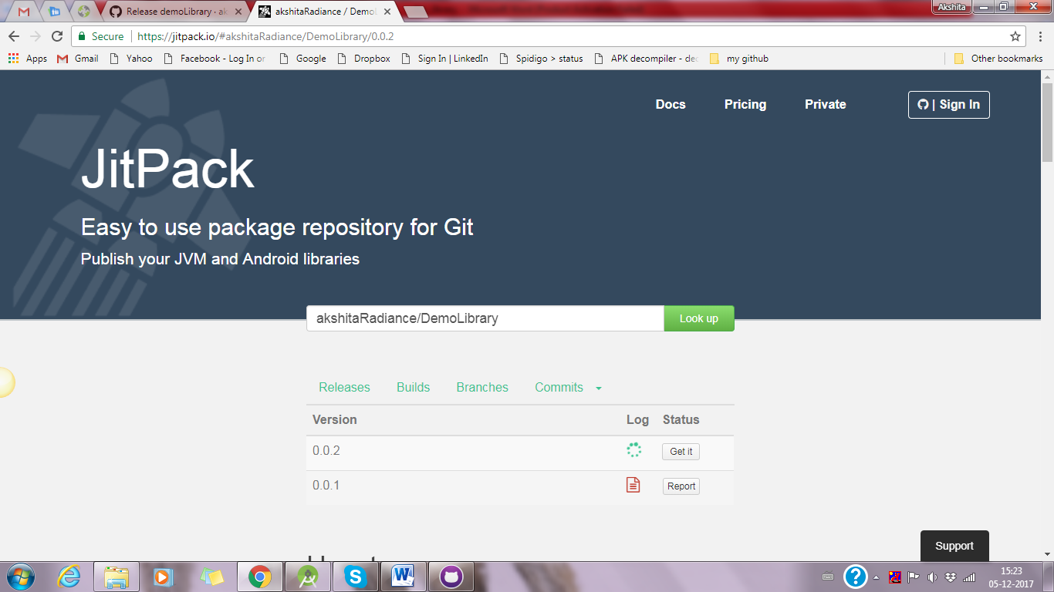

* Click on Get It button and in bottom you can see that link of library as shown in below picture:

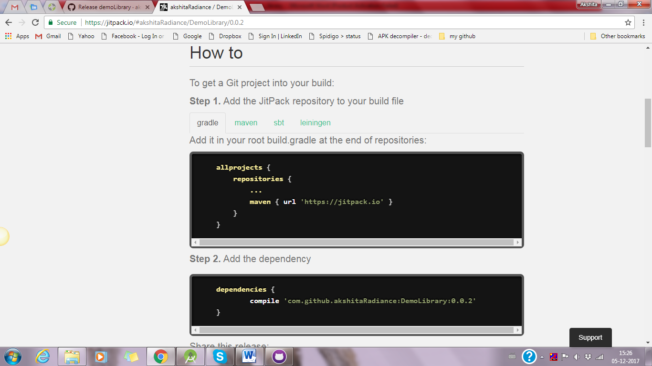

* Now this link use in your any project. And show that link is working properly or not. Given pictures shows all codes and outputs:

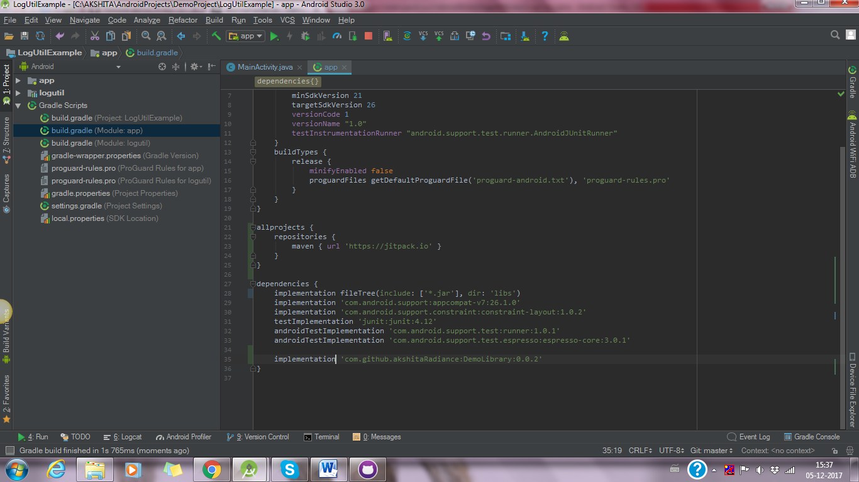

* Shows selected area as output of that logs in below picture:

