Report
Of
Data Analytics: Internship at Edunet Foundation under the VOIS for Tech Program
Submitted
To
School of Computer Science and Engineering
IILM University, Greater Noida, U.P.
In partial fulfilment of the requirement of degree of
B.Tech CSE


By
Name : AKSHITA GUPTA
Roll No. : CS-23411283
Batch: 2026-27

CANDIDATE'S DECLARATION
I, Akshita Gupta (Roll No. CS-23411283), do hereby declare that the internship report titled "Data Analytics: Internship at Edunet Foundation under the VOIS for Tech Program" has been completed by me to fulfil the requirement for the award of the degree of Bachelor of Technology in Computer Science and Engineering. All the references have been quoted and I have not taken as such any material from any other source. I affirm that this report is my own work and has not been submitted to any other institute for any degree requirement and I shall be solely responsible for any kind of copyright violation in this regard.

Name: Akshita Gupta
Roll No.: CS-23411283

ACKNOWLEDGEMENT
I would like to thank the Edunet Foundation for providing me with the opportunity to do this internship in the field of Data Analytics under the VOIS for Tech Program.
The internship provided me with practical exposure related to the data analytics concepts.
I would like to thank the VOIS for Tech team along with my mentors for constantly guiding, helping, and motivating me during the entire process of the internship. The mentor-led online sessions and exercises helped in understanding the application of various data analytics concepts in solving practical problems. The format of the internship consisted of hands-on data analysis, data visualization, dataset analysis, discussion related to various projects, and writing reports, which helped in gaining practical experience.
I also like to thank my college, IILM University, for providing me with this opportunity and helping me gain practical industrial experience through this internship.
My thanks go to each and everyone who helped me in any way during this internship process. This internship has helped me learn more about data analytics and gain confidence in working on practical projects.
Finally, I would like to thank my mentors who helped me during the entire process of learning.

Akshita Gupta
CS-23411283
B.Tech - Computer Science Engineering (Data Science)
IILM University

INTERNSHIP COMPLETION CERTIFICATE
[Attach the Internship Completion Certificate issued by Edunet Foundation / VOIS for Tech Program on this page.]

TABLE OF CONTENTS
Chapter No. | Chapter Name | Page Nos.
 | Cover Page | ----
 | Candidate's Declaration | i
 | Acknowledgment | ii
 | Internship Completion Certificate | iii
1. | Project Description  1.1 Introduction  1.2 Organization Profile  1.3 Problem Statement  1.4 Project Objectives  1.5 Scope of the Project  1.6 Technologies and Tools Used  1.7 System Architecture  1.8 Methodology  1.9 Expected Outcomes  1.10 Certificates of completion and other communication mail proof must be attached | 1-17
2. | Bibliography/References | 18

1. PROJECT DESCRIPTION
1.1 Introduction
The current report highlights the work and experience gained during an internship in the area of Data Analytics conducted in collaboration with the Edunet Foundation as a part of the VOIS for Tech Program. The objective of the internship was to gain exposure to the field of Data Analytics by way of guided virtual learning, practical exercises, e-learning, working with datasets, data visualization, and project-based learning. The internship started on 10 August 2026 and had a framework that was focused on weekly learning sessions, project discussion, project completion, and evaluation.
During the internship, I learned fundamental concepts related to Data Analytics such as data analysis with Python, data visualization, Artificial Intelligence, and Large Language Models. I had to deal with real-world datasets, which allowed me to learn how to analyze, clean, visualize, and interpret data. Practical knowledge was at the centre of the program as opposed to theoretical instruction.
There were two primary data analysis projects completed during the internship process: Car Market Trends Analysis with Car Dekho Data, and Exploring Global Terrorism Patterns and Trends. The projects included the use of real-world datasets, exploratory data analysis, creation of visualizations, discovery of trends and patterns, and drawing relevant conclusions based on the analysis of the data.
Data Analytics has become a critical part of modern-day organizations as it helps in uncovering patterns, spotting trends, solving problems, and making decisions based on data. During the course of this internship, I gained insight into Data Analytics not just theoretically but practically as well, applying the knowledge to actual datasets. This internship was conducted at Edunet Foundation under the VOIS for Tech Program, and it included virtual mentor-led sessions, practicals, e-learning, dataset analysis, project discussions and submission.
The internship helped me gain practical skills in programming languages and tools such as Python, Pandas, NumPy, Matplotlib, and Seaborn, along with exploratory data analysis, data visualization, and data interpretation. It also helped in learning how to work individually with datasets, collaborate with mentors, document data analysis results and make project presentations. To conclude, through this internship program, I managed to combine my academic knowledge with the practical application of Data Analytics.
1.2 Organization Profile
About Edunet Foundation
This internship experience was carried out at Edunet Foundation in the context of the VOIS for Tech Program of the Vodafone Idea Foundation. The internship was focused on Data Analytics, and its goal was the development of practical and marketable technical skills.
According to the offer letter, this program provides access to a number of technical courses available via the VOIS for Tech e-learning platform, project-based learning, mentorship from industry professionals, masterclasses, and a real-world challenge. In this way, the internship gave a structured learning experience in which it was possible to learn something new, apply it to datasets, discuss it with mentors, and develop it into projects.
About VOIS for Tech Program
VOIS for Tech is an e-learning platform designed to assist students in gaining fundamental and market-relevant technical skills. As part of this program, various learning resources, technical courses, practical activities, and mentorship from mentors and subject-matter experts were provided.
This Data Analytics internship was based on the acquisition of practical knowledge, going beyond just theoretical training. Participants of the internship got acquainted with the concepts of Data Analytics and further had an opportunity to put this knowledge into practice through practical activities and projects.
1.3 Problem Statement
Organizations today generate large volumes of raw data that, on their own, do not provide clear insights. The problem addressed through this internship was to learn how such raw, real-world data could be systematically explored, cleaned, analyzed, and visualized using Python-based tools in order to identify meaningful patterns, trends, and relationships. This was examined in practice through two datasets — used-car listings (Car Dekho data) and global terrorism records — where the underlying problem was to understand what factors and trends could be uncovered from unstructured, tabular data and how those findings could be communicated clearly through visualizations and a written report.
1.4 Objectives
The main objectives of the internship were:
- Understanding the basic notions of Data Analytics and the way data may be used to recognize patterns, trends, and signals.
- Getting practical Python skills to manipulate datasets and perform data analysis.
- Learning about data preprocessing and exploratory methods, such as understanding dataset structure, checking data types, recognizing missing values, and studying statistical properties.
- Developing skills in performing exploratory data analysis (EDA) and learning to investigate datasets properly before making any conclusions.
- Learning about the ways data can be visualized and understanding the importance of visual representation of analysis results.
- Working with real datasets from different areas and understanding how Data Analytics can be applied to solve practical tasks.
- Increasing the ability to recognize patterns and trends in data and making valuable observations based on analytical results.
- Getting experience in developing end-to-end projects, starting from analyzing the problem statement and dataset, moving forward to analysis, and finally documenting the results.
- Understanding the way Artificial Intelligence and Large Language Models (LLMs) are applied in data analysis and report preparation.
- Improving analytical and problem-solving skills through practical tasks and projects.
- Developing professional skills such as communicating with mentors, working accurately on assignments, and presenting project results.
- Applying the knowledge gained in developing two major projects: Car Market Trends Analysis with Car Dekho Data and Exploring Global Terrorism Patterns and Trends.
Overall, these objectives helped in moving from theoretical knowledge of Data Analytics to its practical implementation with datasets, visualizations, analyses, and projects.
1.5 Scope
The scope of the internship covered guided virtual learning, e-learning courses, and hands-on practice in Data Analytics over a five-week schedule, moving from foundational concepts to independent project work. It included Python-based data analysis, exploratory data analysis, data visualization, and an introduction to how AI and Large Language Models can support analysis and report writing. The scope was ultimately demonstrated through two end-to-end projects covering different domains — the automobile market and global terrorism records — so as to show that the same analytical workflow can be applied across different types of datasets.
Internship Schedule
The internship started on 10 August 2026 and followed the schedule below:
Week | Major Activities
Week 0 | Orientation, LMS registration, and understanding the internship schedule
Week 1 | Introduction to Data Analytics, key concepts, tools and techniques, overview of AI & LLMs, and hands-on HR data analysis using Python
Week 2 | Agriculture data analysis, dataset analysis, report preparation using LLM assistance, and Data Visualization course with hands-on practice
Week 3 | Business and Operations data analysis, dataset analysis, report preparation using LLM assistance, DIY activities, and project discussion
Week 4 | Project completion and submission, project submission discussion, and final Q&A/doubt-clearing session
Week 5 | AMA (Ask Me Anything) / Q&A session

Weekly mentor-led sessions, task and milestone completion, completion of VOIS for Tech LMS courses, and project documentation submission were necessary parts of the internship.
1.6 Technologies and Tools Used
During the internship, different tools and technologies relevant to Data Analytics and project development were used to support data exploration, analysis, visualization, and documentation.
Python
One of the main programming languages for data analysis, allowing data processing, exploration, analysis, and creation of visualizations.
Pandas
Used to work with structured data — loading CSV files, inspecting DataFrames, investigating columns and data types, filtering, grouping, and calculating summary statistics. It was especially useful for the two major projects.
NumPy
Used to perform numerical operations, providing functions needed for working with numerical data and making calculations required for analysis.
Matplotlib
Used to create graphical representations of analyzed data, to visualize trends and compare data using different chart types.
Seaborn
Used to perform statistical and analytical visualizations, especially relationships between variables — for example, correlation heat maps in the Global Terrorism project.
Google Colab
A notebook-based environment used to write and execute Python code, perform analysis, display visualizations, and document the analysis step-by-step.
AI and Large Language Models
LLM-based assistance was used in certain analyses and report preparation, with emphasis on verification and explanation of results.
VOIS for Tech LMS
The e-learning platform used to access learning materials and certificate courses, including a course on Data Visualization.
Tools Summary
Tool / Technology | Purpose
Python | Data analysis and programming
Pandas | Data loading, manipulation and exploration
NumPy | Numerical operations and calculations
Matplotlib | Data visualization
Seaborn | Statistical visualization and correlation analysis
Jupyter Notebook / Google Colab | Writing, executing and documenting analysis
AI / LLMs | Supporting dataset analysis and report preparation
VOIS for Tech LMS | Courses and structured learning activities

These tools together supported the overall workflow from dataset loading and exploration to analysis, visualization, interpretation, and project documentation.
1.7 System Architecture
As this internship was analytics-based rather than software-development-based, the "system architecture" here refers to the analytical workflow that was followed for every dataset and project. Concepts were taught during mentor-led sessions and then deepened in practice through datasets, moving from unprocessed data to analysis and insight generation. This process can be represented as follows:
Concept Learning → Practical Work → Dataset Analysis → Visualization → Insights → Project Creation
This approach helped enhance technical skills and the ability to independently analyze datasets and derive insights from them.
1.8 Methodology
Within the internship period, a learning trajectory was followed that combined theoretical knowledge with practical activities, delivered via virtual mentor-led sessions and the VOIS for Tech e-learning platform. In each session, the principle of theory first, followed by practice in the form of tasks, was implemented.
Data Analytics Introduction
The basics of Data Analytics — its concepts, techniques, and tools — were introduced, covering how to examine data systematically to find informative patterns and trends and make decisions based on that information. These sessions laid out the basic data analysis workflow used throughout the internship.
Data Analysis Using Python
As part of practical training, data analysis of HR data was carried out using Python, gaining practical experience in loading and examining data with Python-based tools.
AI and Large Language Models
An introduction to Artificial Intelligence and Large Language Models (LLMs) covered their functions and how they may be used as tools to help with data processing and report preparation, while still emphasizing the importance of understanding the data itself.
Agriculture Data Analysis
In the second phase, Agriculture data analysis provided an opportunity to apply the concepts of Data Analytics to a new domain — examining a dataset, finding what information it contains, making relevant observations, and creating a report.
Data Visualization
Learning activities on Data Visualization covered the importance of visualizing analytical results in order to interpret information and understand trends and patterns, including a certificate course on Data Visualization.
Data Analysis of Business and Operations
Analysis of Business and Operations data, along with LLM-assisted report writing and DIY activities, provided further experience in analyzing datasets and writing reports.
Project-Based Learning
An important part of the internship involved project-based learning — using the concepts from sessions to carry out full projects, from understanding the dataset to analysis, visualization, and documentation of results.
Mentor Guidance and Project Discussions
Virtual sessions and mentorship, along with project discussions and doubt-clearing sessions, helped in understanding the expected methodology and improving the work produced.
1.8.1 Project 1 — Car Market Trends Analysis with Car Dekho Data
The first major task done during the internship was Car Market Trends Analysis with Car Dekho Data. The purpose of the project was to analyze a dataset related to automobiles and investigate the factors associated with selling prices and other features, offering an opportunity to practice Exploratory Data Analysis (EDA) on a real-life dataset.
Objectives of the project included: learning the characteristics of the Car Dekho dataset; exploring different variables associated with automobiles; analyzing the distribution of different car features; investigating the factors of fuel type, seller type, transmission, and ownership; revealing patterns among the available data; using Python libraries for analysis and visualization; and generating observations based on the analyzed data.
The dataset used consists of 301 records and 9 columns: Car_Name, Year, Selling_Price, Present_Price, Kms_Driven, Fuel_Type, Seller_Type, Transmission, and Owner. It contains both numeric and categorical variables and is appropriate for practicing different data analytics techniques.
The dataset was loaded into the Python environment using the Pandas library, and the first records were explored to understand its structure. Analysis of vehicle features focused on the categorical variables — the main feature analyzed was fuel type, which contained three categories: Petrol (239 cars), Diesel (60 cars), and CNG (2 cars). This showed that petrol vehicles form the largest share of the dataset, followed by diesel, with CNG the least represented.
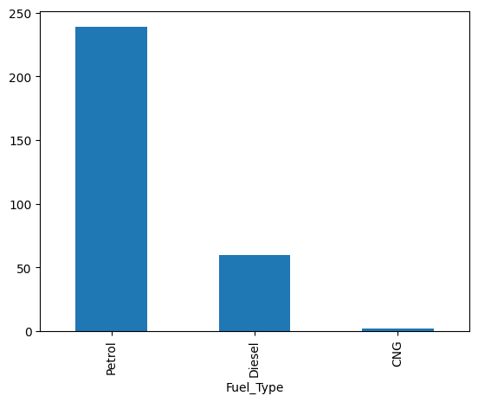
Fig 1.1: Distribution of Cars by Fuel Type
Exploratory Data Analysis was carried out on Selling Price, Present Price, Kilometres Driven, Manufacturing Year, Fuel Type, Seller Type, Transmission, and Number of Owners, allowing the characteristics of the cars and patterns in the dataset to be described.
Key findings: the dataset contains 301 records of used cars across nine variables, combining numeric and categorical types; 239 records are petrol cars, 60 are diesel, and 2 are CNG — the least represented fuel type; and the dataset provides multiple aspects of used cars including price, usage, fuel type, transmission, seller type, and ownership.
Skills used in this project included loading datasets using Python, DataFrame manipulation using Pandas, dataset inspection, data type and structure analysis, descriptive and categorical data analysis, exploratory data analysis, data visualization, and interpretation of analytical findings.
This project helped in gaining practical experience analyzing a structured dataset from beginning to end — inspecting the dataset, identifying relevant variables, performing exploratory analysis, creating visualizations, and interpreting the resulting information. It also illustrated how Exploratory Data Analysis (EDA) is crucial before making any conclusions about a dataset, and how Data Analytics can be applied to the automobile market to study vehicle characteristics and identify patterns.
1.8.2 Project 2 — Analysis of Terrorism Patterns and Trends
The second project done during the internship was the analysis of patterns and trends in global terrorism, requiring analysis of the provided terrorism data to identify patterns across different countries and years. Variables used included incidents, fatalities, injuries, hostages, scores, and country ranks, with Python and visualization techniques used to explore temporal trends and cross-country comparisons.
Objectives included: understanding and analyzing the terrorism dataset; analyzing incidents by year; identifying countries with the highest incident counts; analyzing fatalities and injuries; comparing trends across countries; observing changes in incidents over time; analyzing relationships between numerical variables; and presenting results through appropriate visualizations.
The dataset contains 1,793 records and 9 columns spanning 2012 to 2022:
Column | Description
Country | Name of the country
ISO3C | Three-character country code
Rank | Country ranking
Score | Terrorism-related score
Incidents | Number of incidents
Fatalities | Number of deaths
Injuries | Number of injured people
Hostages | Number of hostages
Year | Year of the recorded data

The dataset was loaded using Python and initially explored in terms of structure, columns, types, and values; no missing values were found in the columns used.
The total number of incidents per year from 2012 to 2022 was calculated and visualized using a line chart:
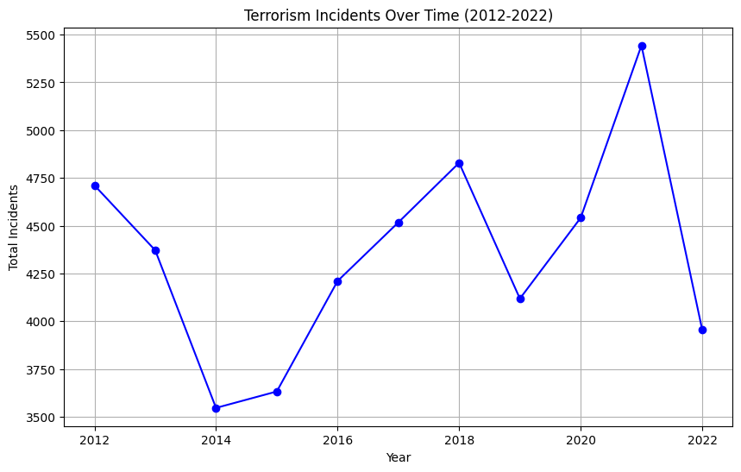
Fig 1.2: Terrorism Incidents over Time
The countries with the highest total number of incidents in the dataset were as follows:
Country | Total Incidents
Iraq | 11,183
Afghanistan | 4,443
Pakistan | 3,358
Somalia | 2,951
India | 2,872
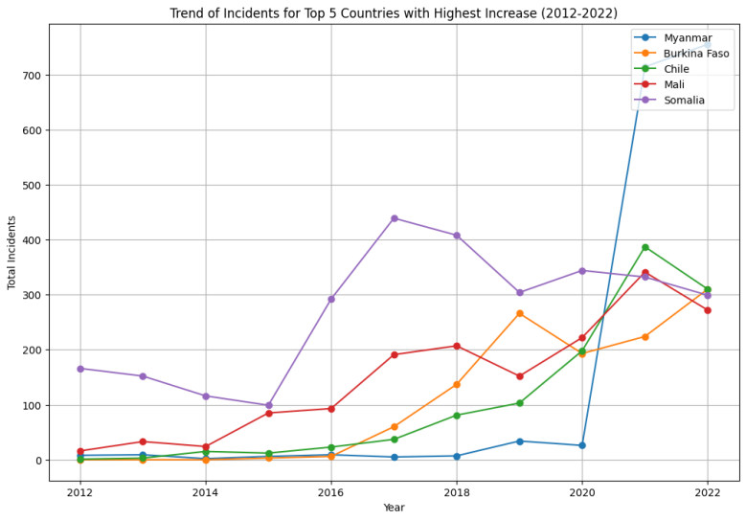
Fatality figures by year were also examined; the years with the most fatalities were 2015, 2016, 2013, 2014, and 2012.
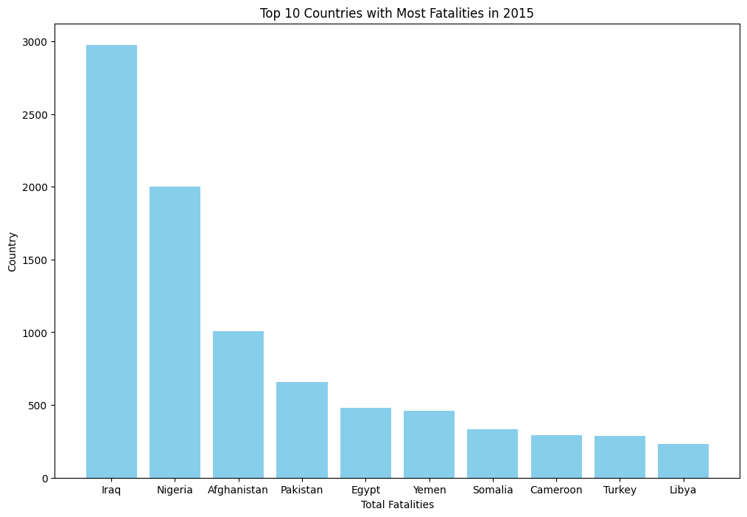
Fig 1.3: Fatalities by Year
A comparison across countries and years was made to observe changes in terrorism incidents, and correlation among incidents, fatalities, injuries, hostages, and score was examined through a correlation matrix and heatmap.
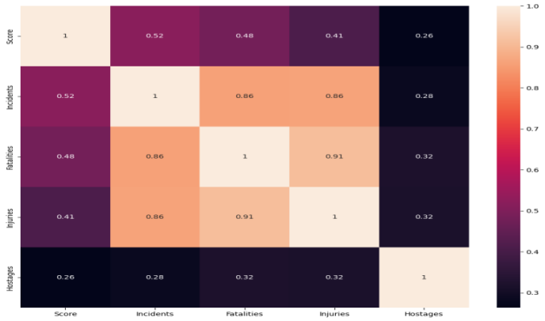
Fig 1.4: Correlation Between Terrorism-related Variables
Key observations: Iraq has the most total incidents, followed by Afghanistan, Pakistan, Somalia, and India; there are significant year-on-year differences in incidents and fatalities; incidents, fatalities, and injuries were seen to be highly correlated; and the country-wise and year-wise analysis helped in observing changes in terrorism incidents over time.
This project helped in developing expertise in data exploration, aggregation, visualization, trend analysis, and correlation analysis.
1.9 Expected Outcomes
The internship provided practical exposure to Data Analytics and helped build an understanding of how analytical concepts can be applied to real-world datasets. By the end of the internship, a better understanding of the complete data analysis process was developed. The major outcomes were:
- A better understanding of Data Analytics concepts and techniques.
- Practical experience in using Python for data analysis.
- The ability to work with datasets using Pandas and NumPy.
- Improved ability to perform Exploratory Data Analysis (EDA).
- The ability to create and interpret data visualizations using Matplotlib and Seaborn.
- Experience in identifying patterns, trends, and relationships within datasets.
- The ability to perform basic correlation analysis and interpret the results.
- Practical experience working on projects from scratch, from dataset exploration to final insights.
- Improved ability to document and present analytical findings.
- Better problem-solving and analytical thinking skills through hands-on project work.
- An understanding of how AI and LLMs can support certain stages of data analysis and report preparation.
- Greater confidence in independently working with datasets and applying the concepts learned during the internship.
Overall, the internship helped bridge the gap between theoretical understanding and practical application of Data Analytics, providing a stronger foundation for future data-driven projects.
1.10 Certificates of Completion and Other Communication Mail Proof
The Internship Completion Certificate issued by Edunet Foundation / VOIS for Tech Program has been attached in Chapter 3 of this report. Copies of communication e-mails / offer letter related to the internship should also be attached here as supporting proof.
1.11 Skills Developed During the Internship
During the internship, both technical and analytical skills were developed through mentor-led sessions, hands-on exercises, courses, and project work.
Technical Skills
- Python for data analysis
- Pandas and NumPy for data manipulation and numerical operations
- Matplotlib and Seaborn for data visualization
- Exploratory Data Analysis (EDA)
- Data cleaning and preprocessing
- Data aggregation and comparison
- Correlation analysis
- Working with structured datasets
Analytical Skills
The internship helped improve the ability to:
- Understand and explore unfamiliar datasets
- Identify important variables
- Find trends and patterns in data
- Compare data across categories and time periods
- Interpret graphs and analytical results
- Convert raw data into meaningful insights
Professional Skills
The internship also helped improve:
- Problem-solving ability
- Project documentation skills
- Communication with mentors
- Ability to work independently
- Time management
- Presentation and reporting skills
1.12 Challenges Faced During the Internship
Several challenges were faced while learning Data Analytics concepts and working on projects, which helped in improving understanding and confidence in handling data-related tasks.
Understanding New Datasets
One of the initial challenges was understanding unfamiliar datasets and determining which columns and variables were relevant for analysis. This was addressed by first examining the structure, data types, and values before starting analysis.
Applying Python for Data Analysis
Working with Python libraries such as Pandas, NumPy, Matplotlib, and Seaborn required practice. Understanding different functions and applying them correctly was initially challenging, but regular hands-on practice helped.
Choosing Appropriate Visualizations
Deciding which type of graph would best represent a particular analysis was another challenge. The Data Visualization training and project work helped in selecting visualizations based on the information to be communicated.
Interpreting Analytical Results
Generating graphs and numerical results was only part of the process — understanding what those results indicated was equally important. Project-based analysis helped improve interpretation of patterns, trends, and relationships.
Working on Projects from Scratch
Developing projects from the beginning required following a complete analytical workflow rather than working with already-prepared results, from exploring the dataset to documenting findings.
Overcoming the Challenges
These challenges were addressed through mentor guidance, virtual sessions, hands-on practice, e-learning courses, and repeated experimentation with the datasets.
1.13 Conclusion
The Data Analytics internship with Edunet Foundation under the VOIS for Tech Program provided valuable practical experience in the field of Data Analytics. The combination of mentor-led sessions, e-learning courses, hands-on activities, and project-based learning helped in understanding how theoretical concepts can be applied to real-world datasets.
During the internship, practical knowledge of Python, Pandas, NumPy, Matplotlib, Seaborn, Exploratory Data Analysis, data visualization, and correlation analysis was gained. Working on different datasets helped in understanding the importance of data exploration and proper interpretation of analytical results.
The two major projects, Car Market Trends Analysis with Car Dekho Data and Exploring Global Terrorism Patterns and Trends, allowed application of the concepts learned throughout the internship — analyzing datasets, identifying patterns and trends, creating visualizations, and presenting meaningful observations.
The internship also improved analytical thinking, problem-solving, project documentation, and communication skills. Regular interaction with mentors and practical work helped build confidence in approaching data-related problems independently. Overall, this internship strengthened the foundation in Data Analytics and provided practical exposure to converting raw data into meaningful information and insights.
4.14 Future Scope
The knowledge and skills gained during this internship can be further developed and applied to more advanced Data Analytics and Machine Learning projects.
Car Market Analysis
- Developing a car price prediction model.
- Performing feature importance analysis to identify factors affecting selling price.
- Creating an interactive dashboard for exploring car market trends.
- Using a larger and more diverse car dataset for improved analysis.
Global Terrorism Analysis
- Creating interactive geographical visualizations.
- Performing more detailed regional and country-wise analysis.
- Applying time-series techniques to study future trends.
- Building interactive dashboards for exploring terrorism-related data.
- Applying Machine Learning techniques for advanced pattern analysis.
Personal Learning and Career Development
Going forward, plans include strengthening skills in advanced Data Analytics, SQL, Power BI, Machine Learning, and statistical analysis, and applying the workflow learned during this internship to larger and more complex datasets. The internship has provided a strong foundation to build upon through additional projects, courses, and practical applications of Data Analytics.

2. REFERENCES
The following resources were referred to during the internship, project work, and preparation of this report:
- VOIS for Tech Learning Platform, used for accessing the assigned learning resources and certificate courses during the internship.
- Car Dekho Dataset, used for the Car Market Trends Analysis project.
- Global Terrorism Dataset, used for the Exploring Global Terrorism Patterns and Trends project.
- Python Documentation — used as a reference while working with Python during the projects.
- Pandas Documentation — used as a reference for data loading, manipulation, filtering, grouping, and analysis.
- NumPy Documentation — used as a reference for numerical operations.
- Matplotlib Documentation — used as a reference for creating data visualizations.
- Seaborn Documentation — used as a reference for statistical visualizations and correlation analysis.
- Internship Mentor-Led Sessions and Practical Demonstrations — used as a primary source of learning throughout the internship.

