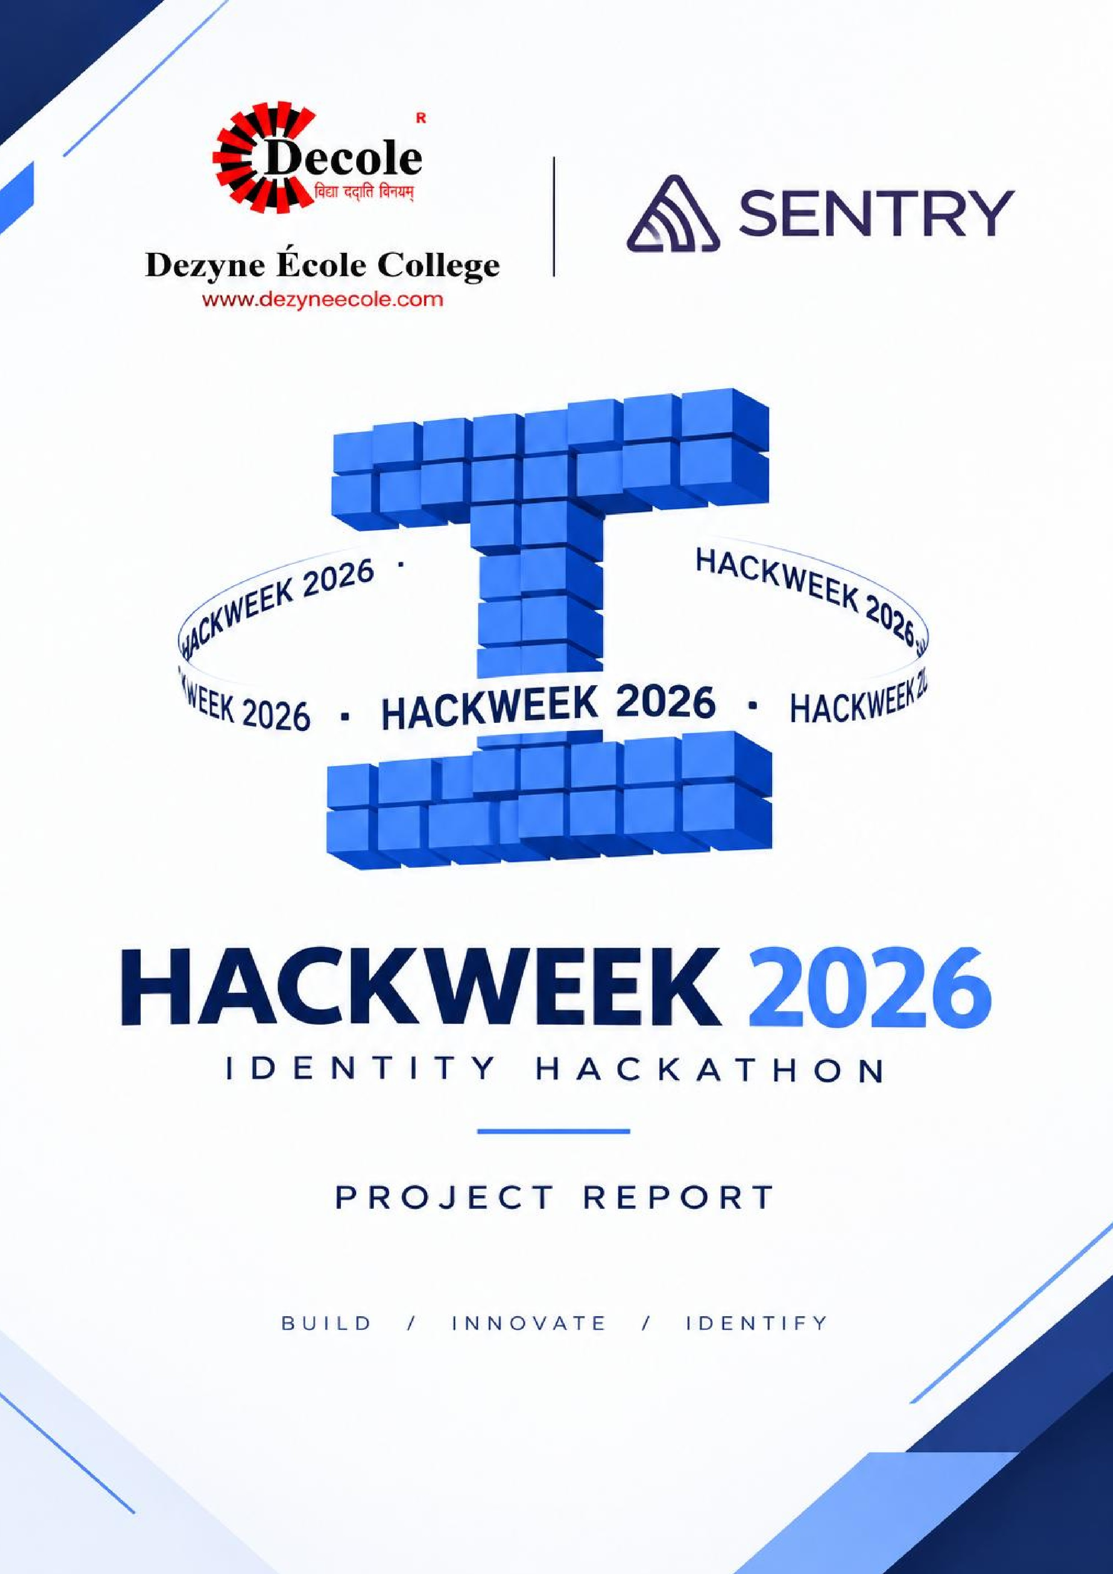

AI Use Declaration
This declaration lists the AI tools used during the development and documentation of SmartAttend - Dual Biometric Attendance Management System. ChatGPT was used to support project planning, understand Java and Spring Boot concepts, troubleshoot coding errors, improve the user interface, and prepare project documentation. The project code, implementation decisions, and final outputs were reviewed and adapted to meet the project requirements.

Declaration What I asked it to do What I wrote, changed or checked myself

AI Use Declaration – SmartAttend

AI Tool Used | Purpose of Use | What We Changed or Checked Ourselves
ChatGPT | Helped with project planning, understanding the attendance management workflow, and organizing the system features. | We selected the features according to our project requirements and reviewed the proposed workflow.
ChatGPT | Assisted with Java, Spring Boot, MySQL, HTML, CSS, and JavaScript development questions and debugging. | We reviewed the suggested code, made changes according to our project structure, and checked the application during development.
ChatGPT | Helped improve login pages, dashboard layouts, and the overall SmartAttend interface. | We adapted the suggested designs to match the SmartAttend theme and our required functionality.
ChatGPT | Assisted in preparing the README, architecture diagram, AI use declaration, testing notes, and presentation script. | We reviewed and edited the documentation to reflect our project, its actual features, and our development work.
Declaration: AI tools were used as supporting resources for learning, problem-solving, and documentation. The project team reviewed and adapted the assistance received and remains responsible for the final implementation and submitted work.
Note: This declaration should include every AI tool actually used. Add other tools if applicable, and ensure that all testing or verification claims reflect work that was genuinely completed.

Name :- Akshita Surana & Jaishree Gahlot
Signature:- 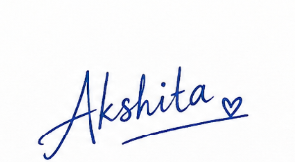 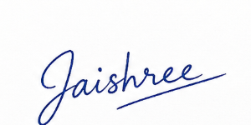

Date: 27-10-2026

