Computer Networks

Assignment 5
Group 12

Ishan Arif Mardani (21CS01023)
Vishnu Tirth Bysani (21CS01077)
Akshit Dudeja (21CS01026)

Q1

In order to execute the TCL script, do the following:
- Ensure that NS2 and NAM are installed on your PC and run the script in the directory of the file.
- Use the following command to execute: ns Q1.tcl

Output -

- Unreliable connection between C to D.

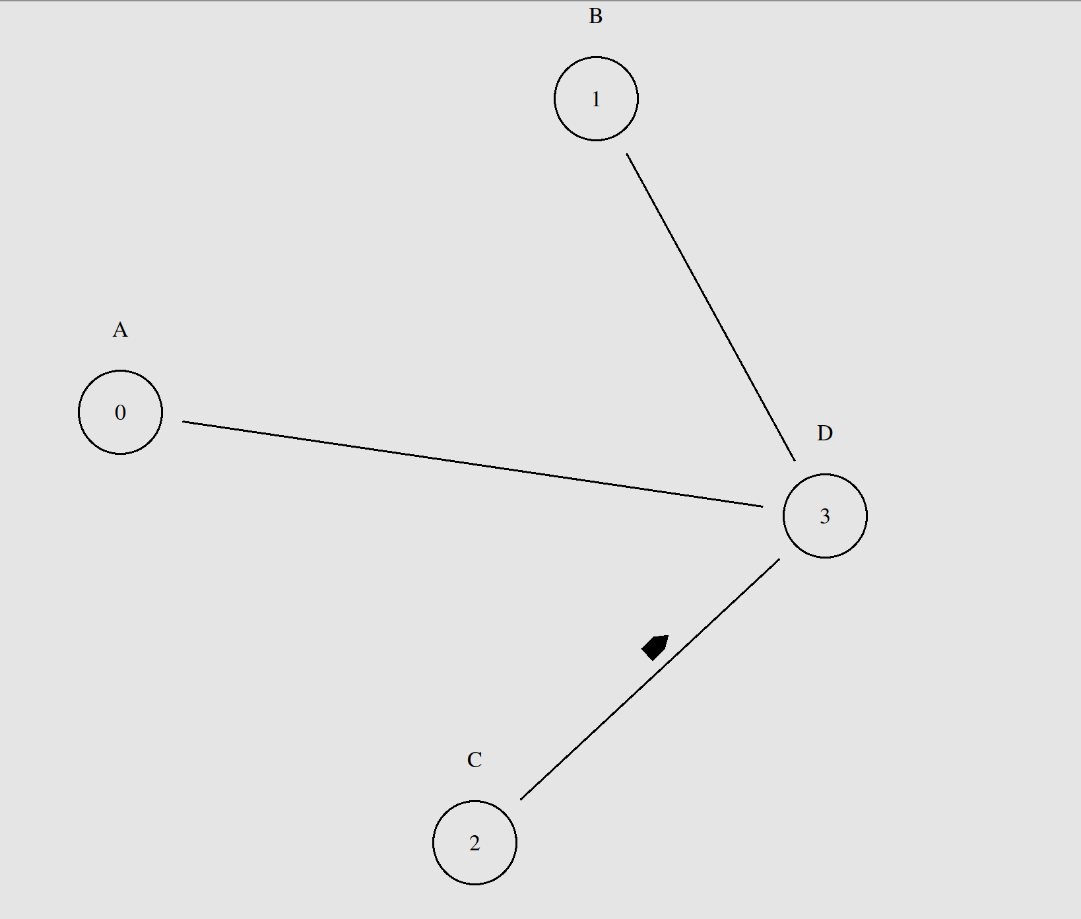
- Reliable connection between D to B.

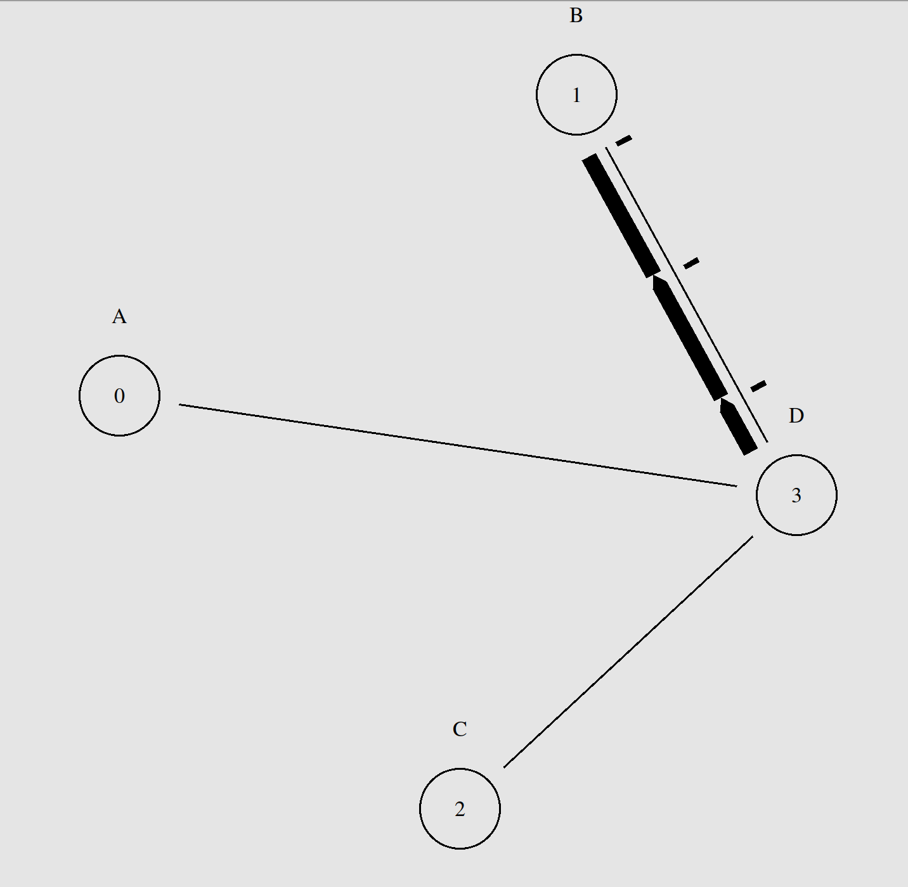

- FTP connection between A to B via D.

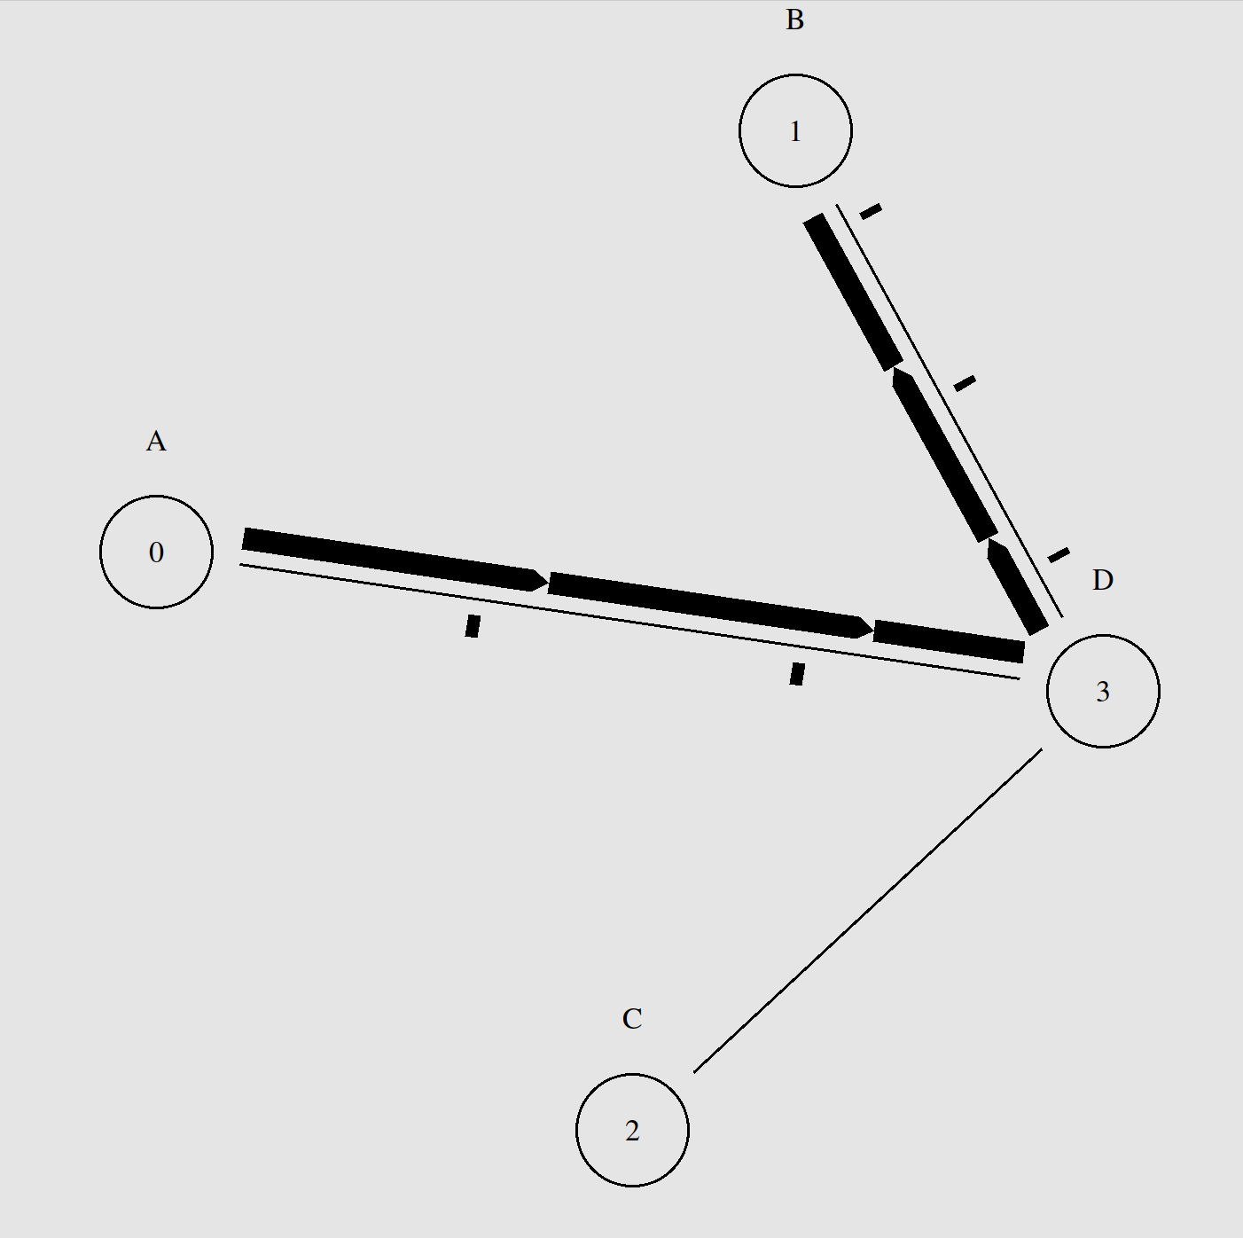

The parameters regarding the following program are:
- From C->D : Duplex Link, Data Rate: 10 Mb, Time: 2 ms
- From B->D : Duplex Link, Data Rate: 10 Mb, Time: 2 ms
- From A->D : Duplex Link, Data Rate: 10 Mb, Time: 2 ms
Also, between C and D, an unreliable connection is present. We have taken traffic type of UDP along with CBR. C is the source and D is the sink.
Also, between D and B, a reliable connection is present. We have taken the traffic type of TCP along with FTP. D is the source and B is the sink.
Also, between A and B (via D), we have taken the traffic type of TCP along with FTP. A is the source and B is the sink.
End-to-end Delay Calculation:
Average end-to-end delay for node 0 is 0.0
Average end-to-end delay for node 1 is 0.005725180671649381
Average end-to-end delay for node 2 is 0.0
Average end-to-end delay for node 3 is 0.004581611527782843
Conclusion:
There is no delay in node 0 and node 2 as they are the sending packets. The code has been attached below for reference. A library called traceanalyzer has been used for the calculation of delay time.

import traceanalyzer as tr
#end-to-end delay
eedelay0=tr.Eedelay('Q1/first.tr','0') eedelay1=tr.Eedelay('Q1/first.tr','1') eedelay2=tr.Eedelay('Q1/first.tr','2') eedelay3=tr.Eedelay('Q1/first.tr','3')
#Calculate the averages arr0 = eedelay0.eedelay_array arr1 = eedelay1.eedelay_array arr2 = eedelay2.eedelay_array arr3 = eedelay3.eedelay_array
print("Average end-to-end delay for node 0 is " , sum (arr0) / len (arr0)) print("Average end-to-end delay for node 1 is " , sum (arr1) / len (arr1)) print("Average end-to-end delay for node 2 is " , sum (arr2) / len (arr2)) print("Average end-to-end delay for node 3 is " , sum (arr3) / len (arr3))

Q2

In order to execute the TCL script, do the following:
- Ensure that NS2 and NAM are installed on your PC and run the script in the directory of the file.
- Use the following command to execute: ns Q2.tcl

Output -

- Unreliable connection between C to B.

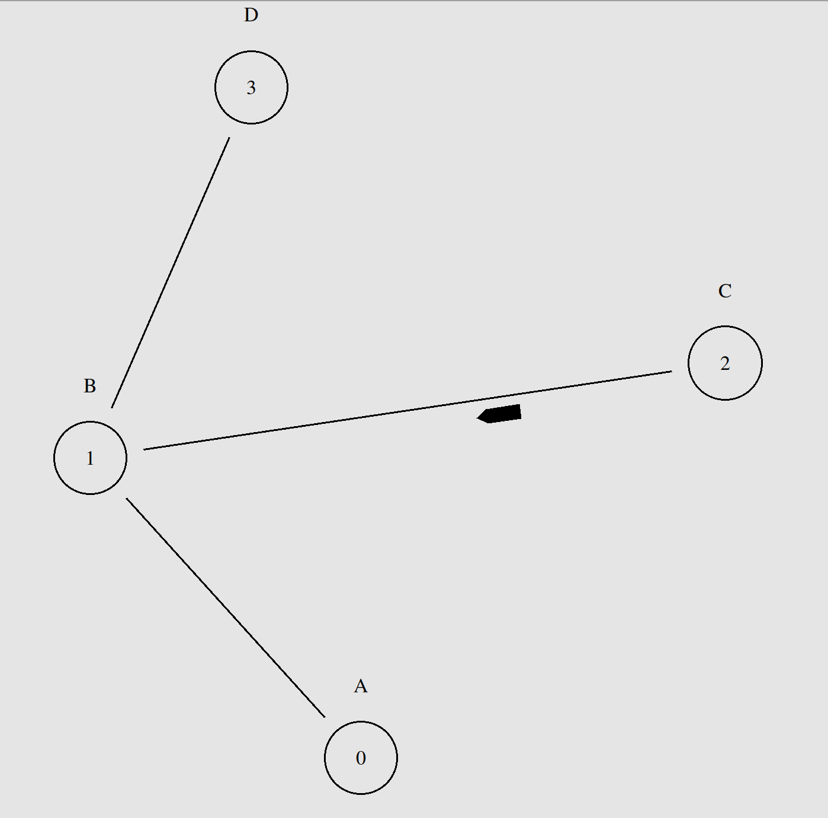
- FTP connection between A to B.

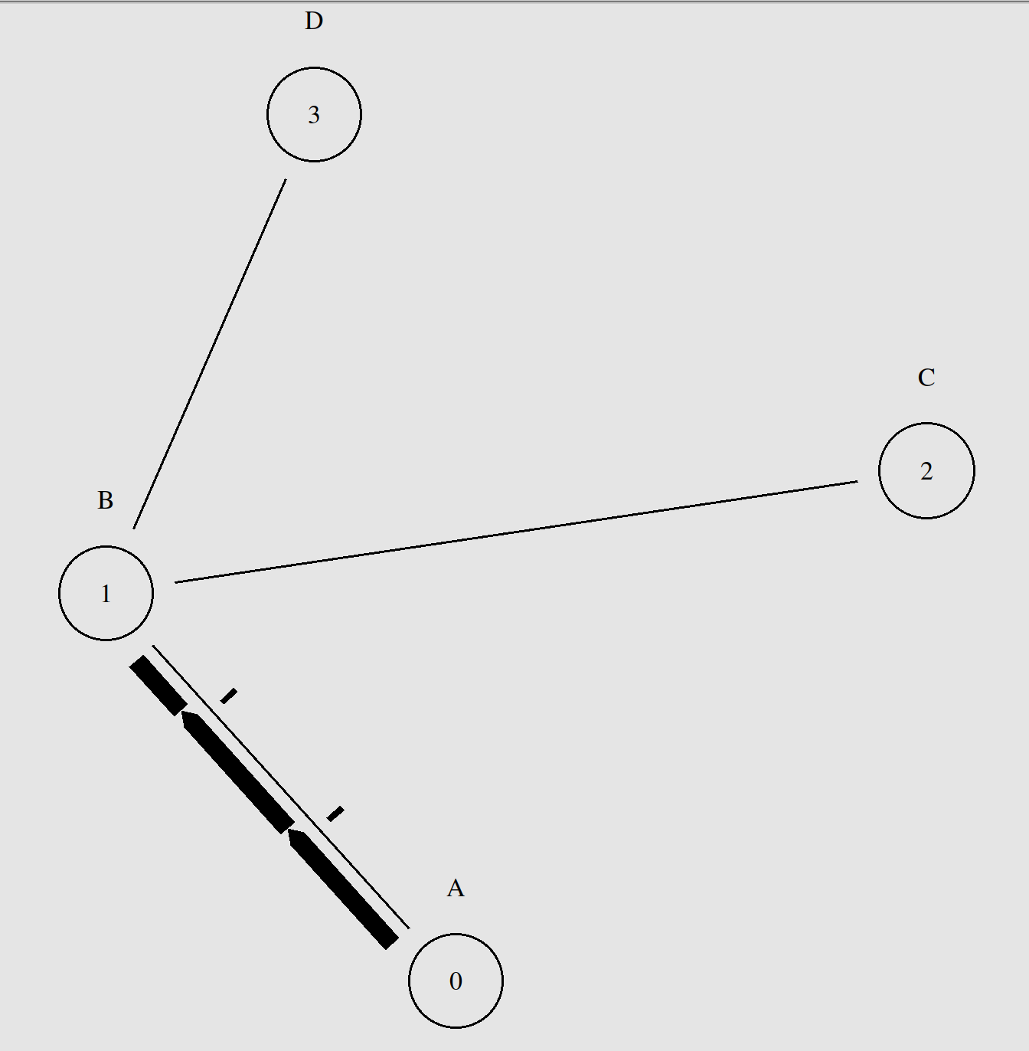

- Reliable connection between B to D.

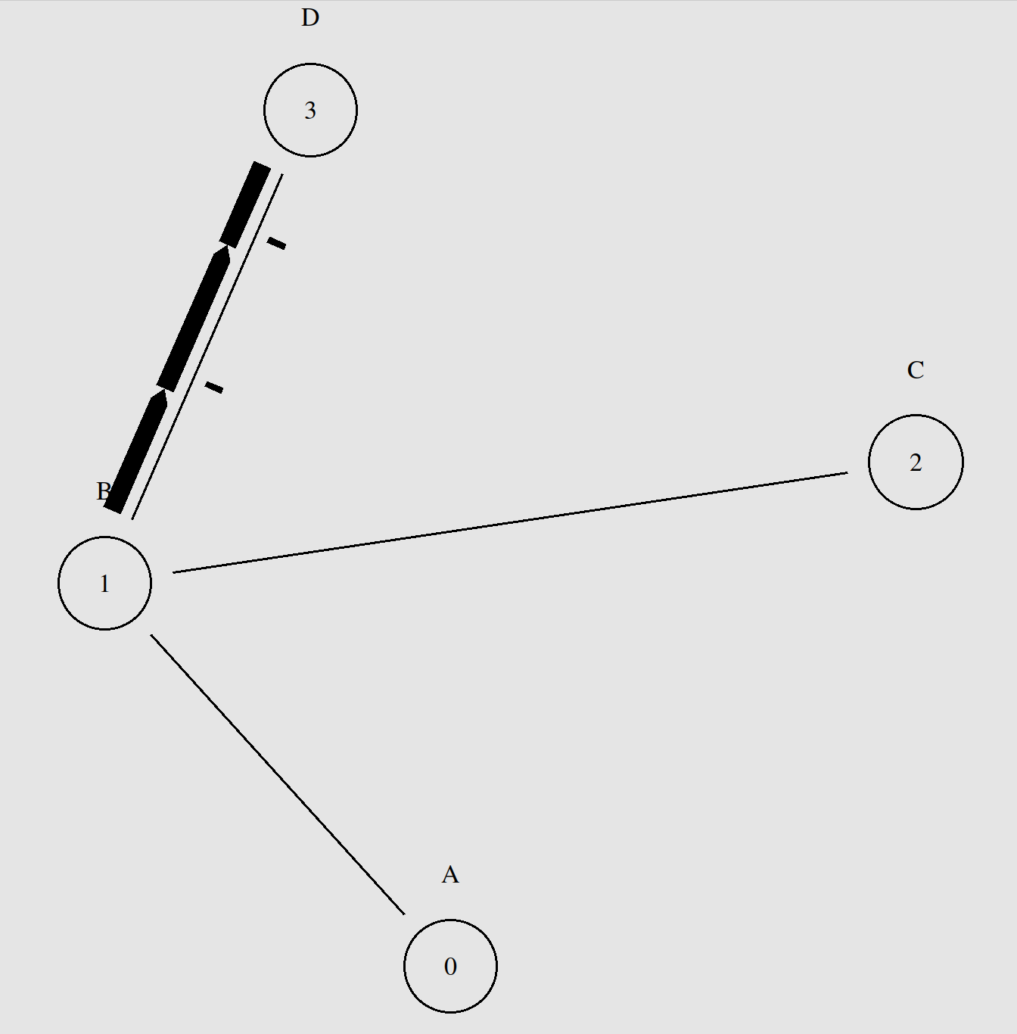

The parameters regarding the following program are:
- From C->B : Duplex Link, Data Rate: 10 Mb, Time: 2 ms
- From A->B : Duplex Link, Data Rate: 10 Mb, Time: 2 ms
- From B->D : Duplex Link, Data Rate: 10 Mb, Time: 2 ms
Also, between C and B, an unreliable connection is present. We have taken traffic type of UDP along with CBR. C is the source and D is the sink.
Also, between A and B, a reliable connection is present. We have taken the traffic type of TCP along with FTP. D is the source and B is the sink.
Also, between B and D (via D), we have taken the traffic type of TCP along with FTP. A is the source and B is the sink.
End-to-end Delay Calculation:
Average end-to-end delay for node 0 is 0.0
Average end-to-end delay for node 1 is 0.004932347886719936
Average end-to-end delay for node 2 is 0.0
Average end-to-end delay for node 3 is 0.013755222454672013

Conclusion:
There is no delay in node 0 and node 2 as they are the sending packets. The code has been attached below for reference. A library called traceanalyzer has been used for the calculation of delay time.

import traceanalyzer as tr
eedelay0=tr.Eedelay('Q2/second.tr','0')
eedelay1=tr.Eedelay('Q2/second.tr','1')
eedelay2=tr.Eedelay('Q2/second.tr','2')
eedelay3=tr.Eedelay('Q2/second.tr','3')

arr0 = eedelay0.eedelay_array
arr1 = eedelay1.eedelay_array
arr2 = eedelay2.eedelay_array
arr3 = eedelay3.eedelay_array

print("\nFor Q2")
print("Average end-to-end delay for node 0 is " , sum (arr0) / len (arr0))
print("Average end-to-end delay for node 1 is " , sum (arr1) / len (arr1))
print("Average end-to-end delay for node 2 is " , sum (arr2) / len (arr2))
print("Average end-to-end delay for node 3 is " , sum (arr3) / len (arr3))

