Computer Networks
Assignment 4
Group 15

Aman Dangi (21CS01027)
Soumyabrata Chaudhuri (21CS01032)
Nishchay Javara (21CS01051)
Siddhesh Parate (21CS01069)

Question 1:

Using select

P = 50%
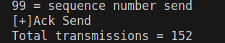

P = 33%
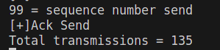

P = 25%
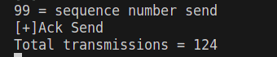

P = 20%
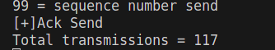

P = 16.66%
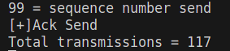

P = 14.28%
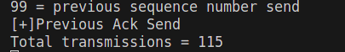

P = 12.5%
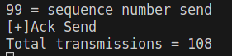

P = 11.11%
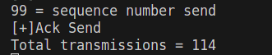

P = 10%
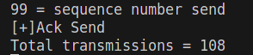

P = 0%
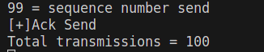

Using poll

P = 50%
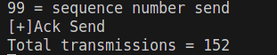

P = 33%
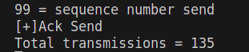

P = 25%
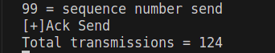

P = 20%
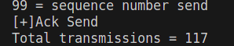

P = 16.66%
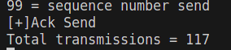

P = 14.28%
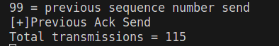

P = 12.5%
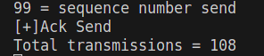

P = 11.11%
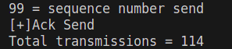

P = 10%
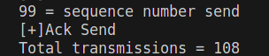

P = 0%
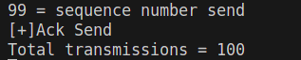

Probability(%) | Select | Poll
50 | 152 | 152
33 | 135 | 135
25 | 124 | 124
20 | 117 | 117
16.66 | 117 | 117
14.28 | 115 | 115
12.5 | 108 | 108
11.11 | 114 | 114
10 | 108 | 108
0 | 100 | 100

