**Cheque Clearing System**

In this project, we tried to automate the cheque clearing system that nowadays is a manual process and takes approximately 3-4 working days.

This project is made by HTML, CSS, Bootstrap, Django, Python ,Sqlite OpenCV etc.

**SAMPLE HOME BRANCH CHEQUES :-**

**PEB- PEC ENGINEERING BANK**

**In order to run this project follow the following steps: -**

1 -> Download the above Contents

2 -> Run cmd and give the following command

**Python manage.py runserver**

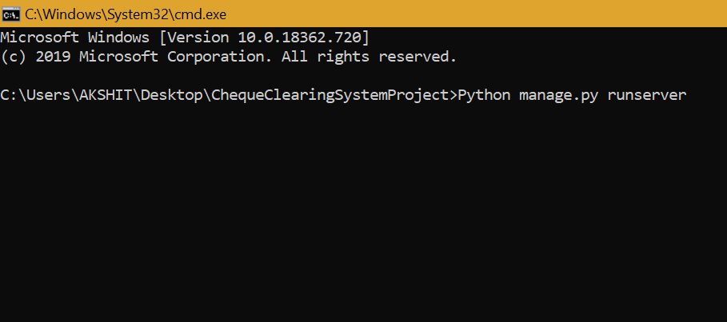

3 -> Then on any web browser type url

[**http://127.0.0.1:8000/main**](http://127.0.0.1:8000/main)

This will take you to the main Registration / Login page.

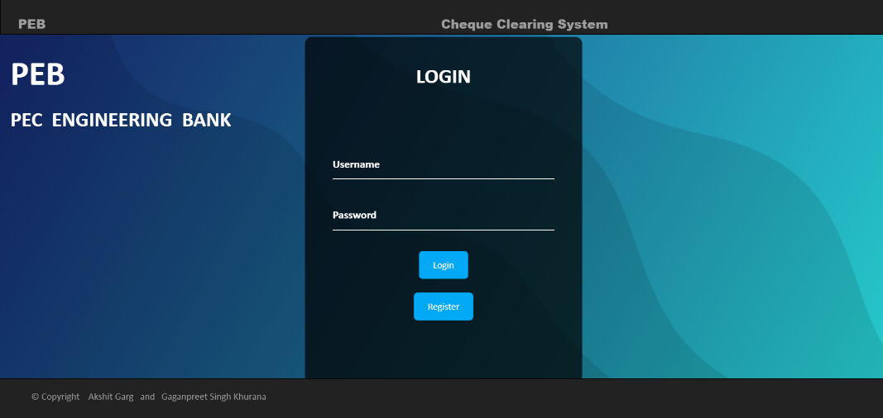

4 -> To explore the database type the following url on any browser

[**http://127.0.0.1:8000/admin**](http://127.0.0.1:8000/admin)

**This Web App basically consists of the following : -**

**1 -> Registration**

Bearer of any bank in order to avail the online services has to

register once, which will enable him to set a unique username

and password that can be used later anytime.

If the details matches with the bank database at the time of

registration than a welcome message is displayed else a “Account

Not Found” is displayed.

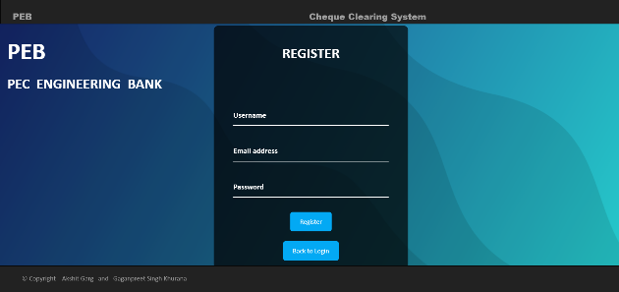 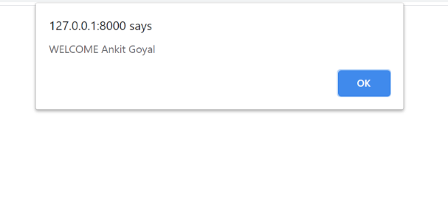

**2-> Details Page**

Whenever Bearer wants to deposit a cheque for clearance he has to

Login with his username and password, add details of cheque and

upload a soft copy of cheque that will be used for further processing.

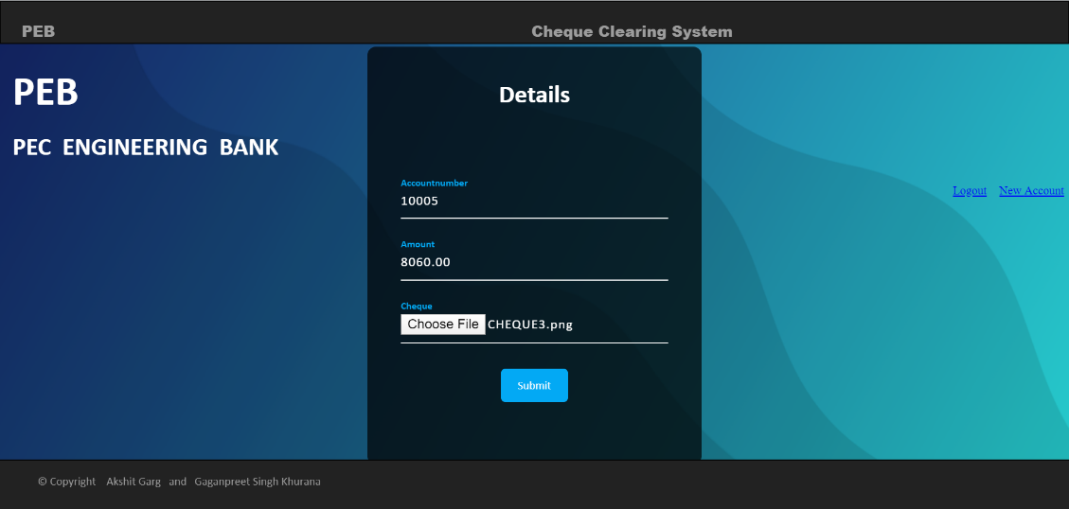

**3 -> Verification**

After this the scanned copy of cheque is sent to payee bank where

It is checked and if the cheque gets cleared the amount is credited

In bearer’s account and it is debited from payee’s account.

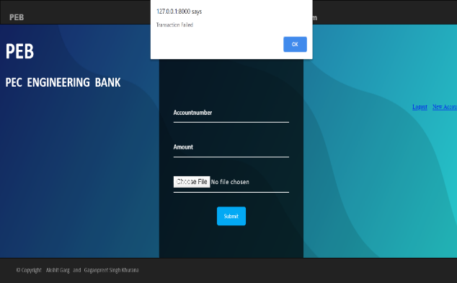 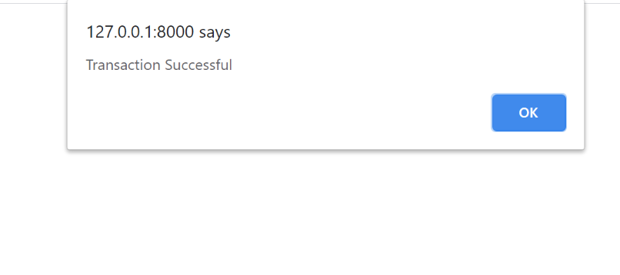

**4 -> Confirmation messages**

At last the confirmation messages which holds the status of the

cheque clearance along with the updated balance is sent to both the

parties.

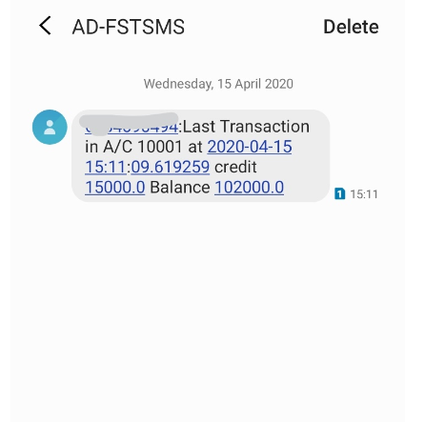 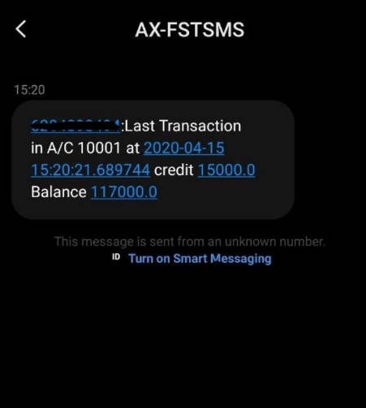

**SPECIAL CHANGES (only for users using windows): -**

In order to run this project, you need to install OpenCV and Tesseract.

Also, the complete path of Tesseract needs to be given in extractDetails.py file as

**Pt.pytesseract.tesseract_cmd=r’C:\Users\Python37-32\Tesseract.exe’**