SOFTWARE MANAGEMENT SYSTEM
A DBMS Capstone Project Report submitted in partial fulfillment of the requirements for the award of the degree of
BACHELOR OF TECHNOLOGY
in
ARTIFICIAL INTELLIGENCE AND MACHINE LEARNING
Submitted By
B.PRASANNA SRI CHANDANA - 25B11AI129
CH.LAKSHMI SAI SRUTHI - 25B11AI209
CH.AKSHITH - 25B11AI019
V.PRAVEEN - 25B11AIC71
Under the esteemed guidance of
Mr. T.Srinivasulu M.Tech, (Ph.D.)
Assistant Professor



DEPARTMENT OF ARTIFICIAL INTELLIGENCE AND MACHINE LEARNING
ADITYA UNIVERSITY
(Formerly Aditya Engineering College (A))
Aditya Nagar, ADB Road, Surampalem, Andhra Pradesh, India
2026 – 2027


Aditya Nagar, ADB Road, Surampalem, Andhra Pradesh, India
DEPARTMENT OF ARTIFICIAL INTELLIGENCE AND MACHINE LEARNING
CERTIFICATE
This is to certify that the DBMS Capstone Project report entitled “SOFTWARE MANAGEMENT SYSTEM” is being submitted by B.SRI CHANDANA(Roll No. 25B11AI129),CH.L.S.SRUTHI (Roll No.25B11AI209) ,CH.AKSHITH (Roll No.25B11AI019) and V.PRAVEEN(Roll No. 25B11AIC71) in partial fulfillment of the requirements for the award of the B.Tech. degree in Artificial Intelligence and Machine Learning. The work documented in this report was carried out as part of the Capstone Project for the course Database Management Systems (2501IT05) during the academic year 2026–2027, and records the database design, implementation, and documentation undertaken by the team.

Project Guide Head of the Department
Mr. T. Srinivasulu, M. Tech, (Ph.D.) Dr. K. Naga Bhargavi, M. Tech, Ph.D. Associate professor Associate Professor & HOD

External Examiner

DECLARATION
We hereby declare that the DBMS Capstone Project entitled “SOFTWARE MANAGEMENT SYSTEM” is a genuine work carried out by us. The database design, SQL implementation, queries and documentation presented in this report are our own work, completed under the guidance of Mr. T. SRINIVASULU Department of ARTIFICIAL INTELLIGENCE & MACHINE LEARNING, Aditya University, Surampalem. We further declare that this work has not been submitted, in full or in part, for the award of any degree of this or any other educational institution.

Project Associates
B.PRASANNA SRI CHANDANA ( 25B11AI129)
CH.LAKSHMI SAI SRUTHI ( 25B11AI209 )
CH.AKSHITH ( 25B11AI019 )
V.PRAVEEN ( 25B11AIC71 )

Date: 28-09-2026
Place: Surampalem

ACKNOWLEDGEMENT
It is with immense pleasure that we express our indebted gratitude to our project guide Mr. T. SRINIVASULU, Department of ARTIFICIAL INTELLIGENCE & MACHINE LEARNING, who guided us throughout the capstone project. We are thankful for the constant encouragement and valuable suggestions received at every review stage.
We are grateful to to Dr. K. NAGA BHARGAVI, Head of the Department, for inspiring us and for arranging the facilities and resources needed for this project.
We extend our sincere thanks to the Management, Dr. M. Sreenivasa Reddy, Deputy Pro-Chancellor, Dr. M. B. Srinivas, Vice-Chancellor, and Dr. A. Ramesh, Pro Vice-Chancellor (Engineering & Sciences), for providing an excellent academic environment.
Not to forget, we thank the Teaching and Non-Teaching Staff, our parents and our friends, who have directly or indirectly supported us in completing this project on time

Project Associates.
B.PRASANNA SRI CHANDANA ( 25B11AI129 )
CH.LAKSHMI SAI SRUTHI ( 25B11AI209 )
CH.AKSHITH ( 25B11AI019 )
V.PRAVEEN ( 25B11AIC71 )

ABSTRACT
Software development involves interconnected information about projects, employees, teams, sprints, tasks and bugs. When these details are maintained in separate files or spreadsheets, duplicate data, inconsistent updates and difficulty in tracking project progress can occur. The Software Project Management System provides a structured relational database for organizing these software-development activities. The selected design contains six core entities — Project, Employee, Team, Sprint, Task and Bug — together with supporting junction and multi-valued tables such as Team_Member, Employee_Skills and Project_Tech.
The design represents relationships among project managers, teams, employees, sprints, tasks and bugs, and identifies derived attributes such as project duration, team size, sprint velocity, task days taken and bug resolution time. The database schema is normalized from 1NF through 3NF to reduce redundancy and dependency problems. SQL DDL definitions use primary keys, foreign keys, UNIQUE, NOT NULL, CHECK and DEFAULT constraints to support data integrity. The resulting design provides a foundation for storing and retrieving software project management information through SQL.

INDEX
Chapter | Title | Page No.
 | Certificate | i
 | Declaration | ii
 | Acknowledgement | iii
 | Abstract | iv
 | List of Figures | v
 | List of Tables | vi
1 | Introduction | 1
 | 1.1 Introduction to the Domain | 1
 | 1.2 Problem Statement | 1
 | 1.3 Motivation and Need for a Database | 1
 | 1.4 Objectives of the Project | 2
 | 1.5 Scope of the Project | 2
 | 1.6 Organization of the Report | 3
2 | System Study and Tools | 4
 | 2.1 Existing System and Its Limitations | 4
 | 2.2 Proposed Database System | 4
 | 2.3 Tools and Technologies Used | 4
 | 2.4 Software and Hardware Requirements | 5
3 | Database Design (Review – I) | 6
 | 3.1 Identified Entities | 6
 | 3.2 Entity Attributes and Attribute Types | 7
 | 3.3 ER Diagram | 9
 | 3.4 Relationships and Cardinality | 10
 | 3.5 Relational Database Schema | 10
 | 3.6 Primary Keys and Foreign Keys | 12
 | 3.7 Normalization up to 3NF | 12
4 | Database Implementation (Review – II) | 14
 | 4.1 Database and Table Creation – DDL | 14
 | 4.2 Sample Data Insertion – DML | 16
 | 4.3 Constraints and Data Integrity | 18
 | 4.4 Data Validation Rules | 19
5 | SQL Operations and Queries | 20
 | 5.1 DQL – Basic Retrieval Queries | 20
 | 5.2 Join Operations | 21
 | 5.3 Aggregate Functions, GROUP BY and HAVING | 23
 | 5.4 Nested and Correlated Subqueries | 24
 | 5.5 Views and Relational Set Operations | 25
 | 5.6 DCL and TCL Operations | 27
6 | Modules and Functionalities | 28
7 | Results – Sample Outputs and Screenshots | 29
8 | Testing and Data Validation | 30
9 | GitHub Repository and Team Contribution | 31
10 | Conclusion and Future Enhancements | 32
 | References | 34
 | Appendix A – Complete SQL Script | 35

LIST OF TABLES
Table No. | Title of the Table
Table 2.3 | Tools and Technologies Used
Table 2.4 | Software and Hardware Requirements
Table 3.1 | Entities Identified for the Selected Domain
Table 3.2 | Attributes of Each Entity
Table 3.4 | Relationships and Cardinality
Table 3.5 | Relational Database Schema
Table 3.6 | Primary Key and Foreign Key Definitions
Table 3.7 | Normalization Steps
Table 4.3 | Constraints and Data Integrity Rules
Table 6.1 | Modules and Their Functionalities
Table 8.1 | Test Cases and Results
Table 9.2 | Team Responsibilities

CHAPTER 1: INTRODUCTION

1.1 Introduction to the Domain
Software development organizations manage multiple software projects simultaneously. Each project involves project managers, development teams, employees, tasks, sprints, bugs, and software releases. These activities generate a large amount of related data that must be stored and managed systematically.
The Software Project Management System is a relational database designed to manage the information related to software projects. It stores project details, employees, teams, sprints, tasks, and bugs. A project can have multiple teams and sprints, while each sprint can contain multiple tasks. Employees can be assigned to different tasks, and bugs can be reported against tasks.
The system connects these entities through primary keys and foreign keys so that project information can be stored without unnecessary duplication and can be retrieved efficiently using SQL queries.

1.2 Problem Statement
At present, software project information may be maintained using separate spreadsheets, documents, or manually managed records. Project managers and team members may maintain different records for projects, employees, tasks, sprints, and bugs. This approach can cause several problems.
- Data redundancy — The same employee, project, or task information may be entered repeatedly in different files.
- Data inconsistency — When project or employee information is updated in one file, other files may still contain outdated information.
- No integrity checking — Invalid records may be entered, such as assigning a task to a non-existing employee or associating a sprint with a non-existing project.
- Difficult retrieval — Finding information such as the tasks assigned to an employee, bugs reported for a task, or sprints belonging to a project can require checking multiple files manually.
The proposed system stores the project information in related relational tables. Primary keys and foreign keys establish relationships between the tables and help maintain data integrity. SQL queries can then be used to retrieve and analyze the required project information efficiently.

Motivation and Need for a Database
A software project produces information from different activities such as project planning, employee assignment, sprint management, task assignment, and bug tracking. Managing all this information using separate files can make the data difficult to maintain and retrieve.
A database management system provides a structured way to store this information. PRIMARY KEY constraints uniquely identify records, while FOREIGN KEY constraints maintain relationships between related tables. NOT NULL, UNIQUE, CHECK and DEFAULT constraints can also be used to control the validity of data.
A relational database also allows multiple related tables to be queried together using joins and aggregate functions. Therefore, project managers can obtain useful information such as project details, employee assignments, sprint information, task status, and bug details using SQL queries.

Objectives of the Project
• To design a normalized relational database for a Software Project Management System containing entities such as Project, Employee, Team, Sprint, Task, and Bug.
• To represent the database design using an ER diagram showing the entities, attributes, relationships, and cardinalities.
• To convert the ER design into a relational schema and normalize the database up to Third Normal Form (3NF).
• To implement the database using MySQL with appropriate PRIMARY KEY, FOREIGN KEY, NOT NULL, UNIQUE, CHECK, and DEFAULT constraints.
• To populate the tables with representative sample data related to software projects, employees, teams, sprints, tasks, and bugs.
• To execute SQL operations covering DDL, DML, DQL, joins, aggregate functions, subqueries, views, set operations, DCL, and TCL.
• To verify data integrity by demonstrating that the database prevents invalid or inconsistent records.

Scope of the Project
The database covers the major activities involved in software project management. It manages projects, employees, teams, sprints, tasks, and bugs.
The system supports the following relationships:
A project can have multiple teams.
A project can have multiple sprints.
A team can contain multiple employees.
A sprint can contain multiple tasks.
Employees can be assigned to tasks.
A task can have multiple bugs associated with it.
An employee can manage projects.
The system also supports multi-valued information such as employee skills and project technologies through separate supporting tables such as Employee_Skills and Project_Tech.
The following are outside the scope of the present work: payroll management, employee attendance, customer relationship management, financial accounting, software deployment automation, and a graphical front-end application. The project mainly focuses on database design, implementation, and SQL-based project management operations.

1.6 Organization of the Report
This report is organized into ten chapters. Chapter 2 presents the system study and the tools used. Chapter 3 covers the complete database design including the ER diagram, relational schema, and normalization, and corresponds to the deliverables of Review – I. Chapter 4 describes the database implementation with DDL and sample data, corresponding to Review – II. Chapter 5 presents the SQL operations and queries executed. Chapter 6 explains the modules and functionalities of the Software Project Management System. Chapter 7 presents the results with sample outputs. Chapter 8 covers testing and data validation. Chapter 9 details the GitHub repository and the contribution of each team member. Chapter 10 concludes the report and outlines future enhancements.

CHAPTER 2: SYSTEM STUDY AND TOOLS

2.1 Existing System and Its Limitations
The existing arrangement for managing software projects is largely file-based. Project managers and team members may maintain separate spreadsheets or documents for projects, employees, teams, sprints, tasks, and bugs. These files are often maintained independently, which can create difficulties in maintaining consistent and up-to-date information.
During the study of the existing system, the following limitations were identified:
- Data redundancy — The same project, employee, or task details may appear in multiple files, resulting in repeated data entry.
- Data inconsistency — When project or employee information is updated in one file, the same change may not be reflected in other files.
- No automatic relationship checking — There is no automatic link between projects, teams, sprints, tasks, and employees. An incorrect employee or project reference may therefore be entered.
- Limited data validation — Important information such as task status, priority, severity, dates, and employee details may be entered without proper database constraints.
- Difficult data retrieval — Information such as the tasks assigned to an employee, bugs associated with a task, or sprints belonging to a project may have to be collected manually from different files.
- Manual report preparation — Project summaries, employee task assignments, sprint information, and bug reports may need to be prepared manually whenever required.

2.2 Proposed Database System
The proposed system is a single relational database in which software project information is organized into related tables. The main entities include Project, Employee, Team, Sprint, Task, and Bug, with supporting tables for relationships such as Team_Member, Employee_Skills, and Project_Tech.
Each type of information is stored in its appropriate table to reduce unnecessary duplication. Primary keys uniquely identify records, while foreign keys establish relationships between projects, employees, teams, sprints, tasks, and bugs.
The database also uses appropriate constraints such as NOT NULL, UNIQUE, CHECK, and DEFAULT to improve data validity and consistency. For example, tasks can be linked to valid sprints and employees through foreign keys, while invalid or incomplete records can be restricted by database constraints.

2.3 Tools and Technologies Used
Table 2.1: Tools and Technologies Used
Category | Tool / Technology Used | Version / Remarks
Database Server | MySQL | 8.0 — relational DBMS used for implementation
Query / Admin Tool | MySQL Workbench | 8.0 CE — script execution and output capture
Online SQL Practice | dbfiddle.dev | Used to verify queries independently
ER Diagram Tool | draw.io (diagrams.net) | Web version — ER and schema diagrams
Version Control | Git and GitHub | Team repository for the SQL script
Documentation | Microsoft Word | 365 — report preparation

2.4 Software and Hardware Requirements
Requirement Type | Specification
Operating System | Windows 10 / 11 (64-bit) or Ubuntu 22.04
Database Server | MySQL 8.0 or above
Client Tool | MySQL Workbench 8.0 CE / MySQL command-line client
Processor | Intel Core i3 or above
RAM | 4 GB minimum, 8 GB recommended
Disk Space | 2 GB free (server, sample data and documentation)

CHAPTER 3: DATABASE DESIGN

3.1 Identified Entities
S.No | Entity Name | Description
1 | Project | A software project managed by the organization. It stores details such as project name, description, start date, end date, status, and project manager
2 | Employee | A member of the software development organization who may manage projects, lead teams, or be assigned to tasks. It stores employee details such as name, designation, email, experience, and salary
3 | Team | A group of employees working together on a software project. Each team is associated with a project and has a team lead.
4 | Team_Member | Supporting table that records the many-to-many relationship between teams and employees. It identifies which employees belong to which teams.
5 | Sprint | A development iteration within a software project. It stores the sprint name, project, start date, end date, goal, and status
6 | Task | A specific unit of work assigned to an employee within a sprint. It contains task title, description, priority, story points, status, due date, and completion date.
7 | Bug
  A software defect reported against a task. It stores details such as bug title, severity, status, reported date, resolved date, reporter, and assigned employee.
8 | Employee_Skills | Supporting table that stores the multi-valued skills of an employee, such as Python, Java, SQL, or React. It is used to represent employee skills separately and satisfy 1NF.
9 | Project_Tech | Supporting table that stores the multi-valued technologies used in a project. It allows multiple technologies to be associated with a single project and supports 1NF.

3.2 Entity Attributes and Attribute Types
The attributes of each entity are listed below with the data type, the key role and the attribute classification. The classification follows the ER model: an attribute is Simple if it cannot be divided further, Composite if it is made up of smaller attributes, Multi-valued if one entity instance may hold several values, and Derived if its value is computed from other stored attributes.
Entity: Project
Attribute | Data Type | Constraint / Note | Attribute Type | Description
project_id | INT | PK | Simple | Project identifier
project_name | VARCHAR(150) | NOT NULL | Simple | Project name
description | TEXT |  | Simple | Project description
start_date | DATE |  | Simple | Start date
end_date | DATE |  | Simple | Planned end date
status | VARCHAR(30) |  | Simple | Planning/Active/Completed
duration_days | INT | Derived | Derived | end_date − start_date
manager_id | INT | FK → Employee | Simple | Project manager
technologies | TEXT | Multi-valued | Multi-valued | Project_Tech table

Entity: Employee
Attribute | Data Type | Constraint / Note | Attribute Type | Description
employee_id | INT | PK | Simple | Employee identifier
first_name | VARCHAR(50) |  | Composite part | First name
last_name | VARCHAR(50) |  | Composite part | Last name
designation | VARCHAR(50) |  | Simple | Developer/QA/Manager/Architect
email | VARCHAR(100) | UNIQUE NOT NULL | Simple | Work email
skills | TEXT | Multi-valued | Multi-valued | Employee_Skills table
experience_years | INT |  | Simple | Years of experience
salary | DECIMAL(10,2) |  | Simple | Monthly salary

Entity: Team
Attribute | Data Type | Constraint / Note | Attribute Type | Description
team_id | INT | PK | Simple | Team identifier
team_name | VARCHAR(100) | NOT NULL | Simple | Team name
project_id | INT | FK → Project | Simple | Assigned project
lead_id | INT | FK → Employee | Simple | Team lead
team_size | INT | Derived | Derived | Count of members

Entity: Sprint
Attribute | Data Type | Constraint / Note | Attribute Type | Description
sprint_id | INT | PK | Simple | Sprint identifier
sprint_name | VARCHAR(100) |  | Simple | e.g. Sprint 1
project_id | INT | FK → Project | Simple | Parent project
start_date | DATE |  | Simple | Sprint start
end_date | DATE |  | Simple | Sprint end
goal | TEXT |  | Simple | Sprint goal description
status | VARCHAR(20) |  | Simple | Planned/Active/Completed
velocity | INT | Derived | Derived | Story points completed

Entity: Task
Attribute | Data Type | Constraint / Note | Attribute Type | Description
task_id | INT | PK | Simple | Task identifier
sprint_id | INT | FK → Sprint | Simple | Sprint assigned to
assigned_to | INT | FK → Employee | Simple | Assigned employee
task_title | VARCHAR(200) | NOT NULL | Simple | Task name
description | TEXT |  | Simple | Task details
priority | VARCHAR(20) |  | Simple | Low/Medium/High/Critical
story_points | INT |  | Simple | Effort estimate
status | VARCHAR(20) |  | Simple | Todo/In Progress/Done
due_date | DATE |  | Simple | Task deadline
completion_date | DATE |  | Simple | Actual finish date
days_taken | INT | Derived | Derived | completion − due

Entity: Bug
Attribute | Data Type | Constraint / Note | Attribute Type | Description
bug_id | INT | PK | Simple | Bug identifier
task_id | INT | FK → Task | Simple | Linked task
reported_by | INT | FK → Employee | Simple | Reporter employee
assigned_to | INT | FK → Employee | Simple | Fixing employee
title | VARCHAR(200) | NOT NULL | Simple | Bug title
severity | VARCHAR(20) |  | Simple | Low/Medium/High/Critical
status | VARCHAR(20) |  | Simple | Open/In Progress/Resolved/Closed
reported_date | DATE |  | Simple | Date reported
resolved_date | DATE |  | Simple | Date resolved
resolution_time | INT | Derived | Derived | resolved − reported (days)

3.3 ER Diagram
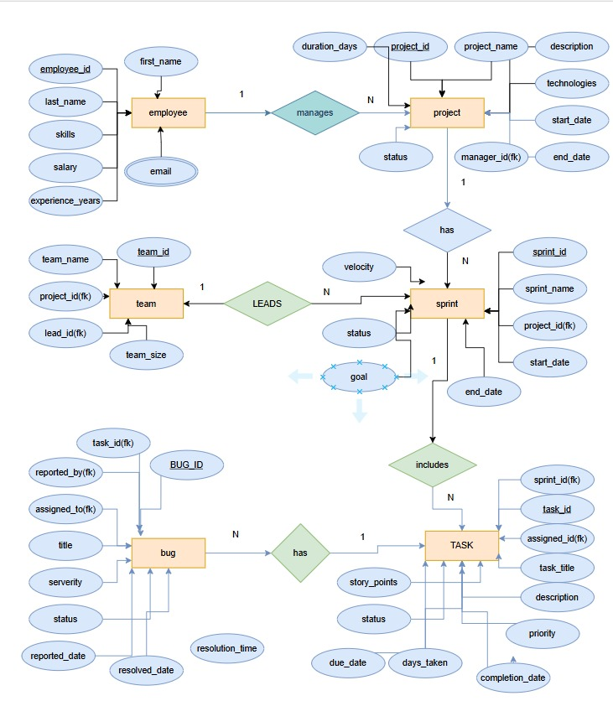

Fig. 3.1: ER Diagram of the Software Project Management System

3.4 Relationships and Cardinality
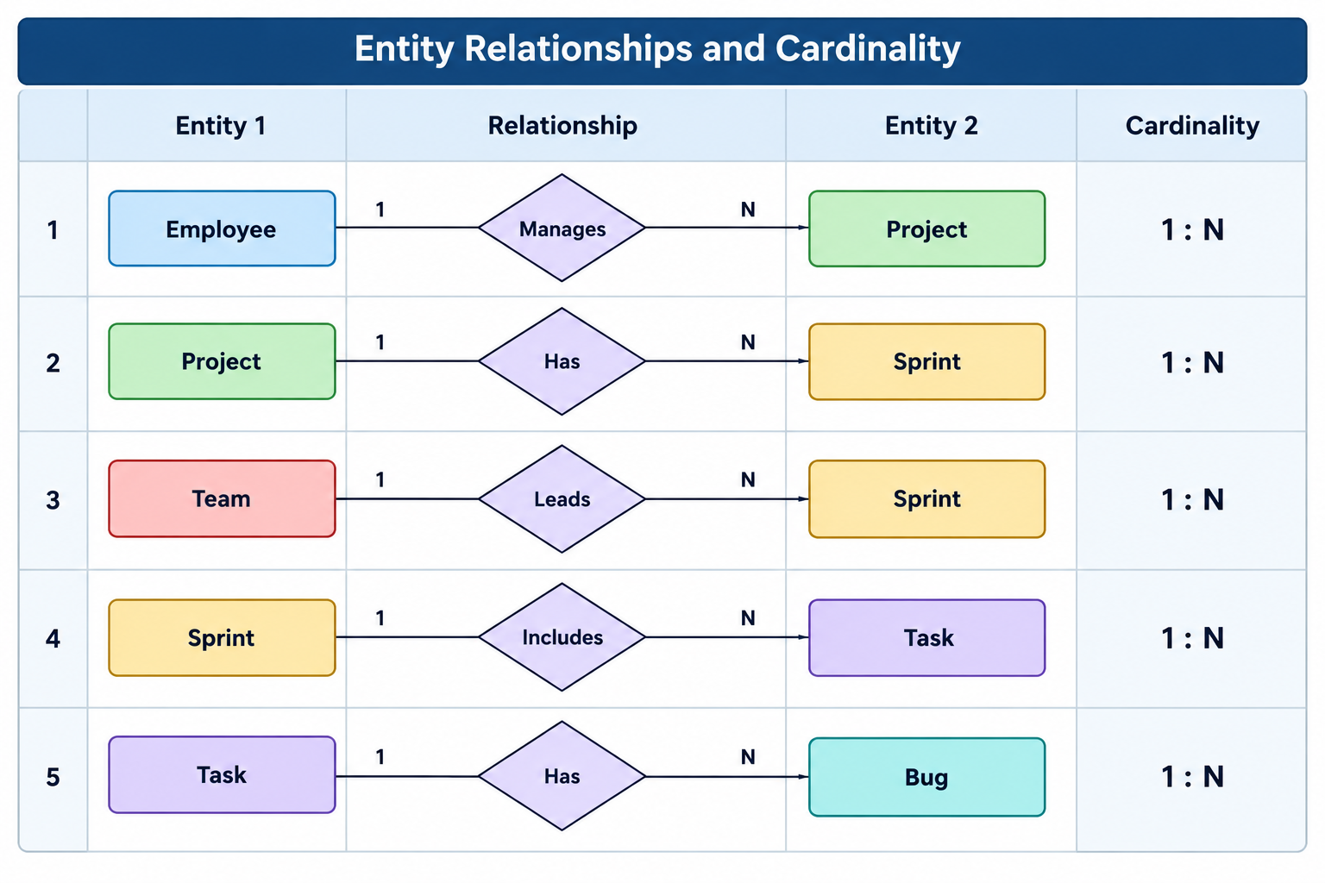
The many-to-many relationship between Team and Employee is resolved using Team_Member. The multi-valued attributes skills and technologies are also separated into Employee_Skills and Project_Tech supporting tables during normalization.

3.5 Relational Database Schema
Table Name | Column Name | Data Type | PK/FK/— | Constraints
Employee | employee_id | NUMBER | PK | GENERATED BY DEFAULT ON NULL AS IDENTITY
Employee | first_name | VARCHAR2(50) | — | NOT NULL
Employee | last_name | VARCHAR2(50) | — | NOT NULL
Employee | designation | VARCHAR2(50) | —
Employee | email | VARCHAR2(100) | — | UNIQUE, NOT NULL
Employee | experience_years | NUMBER | — | DEFAULT 0, CHECK (>= 0)
Employee | salary | NUMBER(10,2) | — | CHECK (> 0)
Project | project_id | NUMBER | PK | GENERATED BY DEFAULT ON NULL AS IDENTITY
Project | project_name | VARCHAR2(150) | — | NOT NULL
Project | description | CLOB | —
Project | start_date | DATE | —
Project | end_date | DATE | — | CHECK (end_date >= start_date)
Project | status | VARCHAR2(30) | — | DEFAULT 'Planning', CHECK (IN list)
Project | manager_id | NUMBER | FK | REFERENCES Employee
Project | duration_days | NUMBER | — | GENERATED ALWAYS AS (end_date-start_date) VIRTUAL
Team | team_id | NUMBER | PK | GENERATED BY DEFAULT ON NULL AS IDENTITY
Team | team_name | VARCHAR2(100) | — | NOT NULL
Team | project_id | NUMBER | FK | REFERENCES Project
Team | lead_id | NUMBER | FK | REFERENCES Employee
Sprint | sprint_id | NUMBER | PK | GENERATED BY DEFAULT ON NULL AS IDENTITY
Sprint | sprint_name | VARCHAR2(100) | —
Sprint | project_id | NUMBER | FK | REFERENCES Project
Sprint | start_date | DATE | —
Sprint | end_date | DATE | —
Sprint | goal | CLOB | —
Sprint | status | VARCHAR2(20) | — | DEFAULT 'Planned', CHECK (IN list)
Task | task_id | NUMBER | PK | GENERATED BY DEFAULT ON NULL AS IDENTITY
Task | sprint_id | NUMBER | FK | REFERENCES Sprint
Task | assigned_to | NUMBER | FK | REFERENCES Employee
Task | task_title | VARCHAR2(200) | — | NOT NULL
Task | description | CLOB | —
Task | priority | VARCHAR2(20) | — | DEFAULT 'Medium', CHECK (IN list)
Task | story_points | NUMBER | — | CHECK (>= 0)
Task | status | VARCHAR2(20) | — | DEFAULT 'Todo', CHECK (IN list)
Task | due_date | DATE | —
Task | completion_date | DATE | —
Task | days_taken | NUMBER | — | GENERATED ALWAYS AS (completion_date-due_date) VIRTUAL
Bug | bug_id | NUMBER | PK | GENERATED BY DEFAULT ON NULL AS IDENTITY
Bug | task_id | NUMBER | FK | REFERENCES Task
Bug | reported_by | NUMBER | FK | REFERENCES Employee
Bug | assigned_to | NUMBER | FK | REFERENCES Employee
Bug | title | VARCHAR2(200) | — | NOT NULL
Bug | severity | VARCHAR2(20) | — | DEFAULT 'Medium', CHECK (IN list)
Bug | status | VARCHAR2(20) | — | DEFAULT 'Open', CHECK (IN list)
Bug | reported_date | DATE | —
Bug | resolved_date | DATE | —
Bug | resolution_time | NUMBER | — | GENERATED ALWAYS AS (resolved_date-reported_date) VIRTUAL
Project_Tech | project_id | NUMBER | PK, FK | REFERENCES Project
Project_Tech | technology | VARCHAR2(50) | PK | NOT NULL
Employee_Skills | employee_id | NUMBER | PK, FK | REFERENCES Employee
Employee_Skills | skill | VARCHAR2(50) | PK | NOT NULL

3.6 Primary Keys and Foreign Keys
Table | Primary Key | Foreign Key(s) | References
Employee | employee_id | — | —
Project | project_id | manager_id | Employee(employee_id)
Team | team_id | project_id, lead_id | Project, Employee
Team_Member | team_id, employee_id | team_id, employee_id | Team, Employee
Sprint | sprint_id | project_id | Project
Task | task_id | sprint_id, assigned_to | Sprint, Employee
Bug | bug_id | task_id, reported_by, assigned_to | Task, Employee
Employee_Skills | employee_id + skill | employee_id | Employee
Project_Tech | project_id + technology | project_id | Project

3.7 Normalization up to 3NF
The initial design held all software project management information in a single unnormalized relation. One row could contain information about a project together with its manager, team members, sprint, tasks, employee skills, technologies, and bugs.
PROJECT_MANAGEMENT (
project_id, project_name, description, start_date, end_date, status, manager_id,
employee_id, first_name, last_name, designation, email, experience_years, salary,
skills, team_id, team_name, lead_id, sprint_id, sprint_name, sprint_start_date,
sprint_end_date, goal, sprint_status, task_id, task_title, task_description,
priority, story_points, task_status, due_date, completion_date,
bug_id, reported_by, assigned_to, bug_title, severity, bug_status,
reported_date, resolved_date, technologies )
First Normal Form (1NF)
The attributes skills and technologies can contain multiple values for one employee or project. 1NF requires every attribute to contain atomic values and eliminates repeating groups.
Therefore, the multi-valued employee skills were moved into a separate Employee_Skills table linked using employee_id, and the multi-valued project technologies were moved into a separate Project_Tech table linked using project_id.
The many-to-many relationship between teams and employees was also represented using the Team_Member junction table.
Second Normal Form (2NF)
After achieving 1NF, the relationship between teams and employees is represented using the composite key (team_id, employee_id) in the Team_Member table.
The employee and team attributes depend on their respective keys rather than on the complete composite key. Therefore, the data was decomposed into Team, Employee, and Team_Member, removing partial dependencies.
Similarly, project, sprint, task, and bug information are maintained in their respective tables so that each non-key attribute depends on the complete key of its own table.
Third Normal Form (3NF)
In the initial design, information belonging to different entities could be repeated. For example, team_name depends on team_id, employee information depends on employee_id, and sprint information depends on sprint_id.
These dependencies are separated into their respective tables. Project, Employee, Team, Sprint, Task, and Bug therefore contain attributes that describe their own entities, while foreign keys are used to establish relationships between them.
Derived attributes such as duration_days, team_size, velocity, days_taken, and resolution_time are calculated from existing data rather than unnecessarily storing the same information.
UNF → 1NF → 2NF → 3NF

Normal Form | Condition Satisfied | Anomaly Removed | Resulting Tables
1NF | All attributes atomic; no repeating groups | Multiple skills and technologies stored in a single cell | Project, Employee, Employee_Skills, Project_Tech
2NF | No partial dependency on part of a composite key | Team and employee details repeated in the many-to-many relationship | Team, Employee, Team_Member
3NF | No transitive dependency on a non-key attribute | Project, team, sprint, task, and bug details repeated across records | Project, Employee, Team, Sprint, Task, Bug, Team_Member

After the third step, the schema consists of nine related tables in which every non-key attribute depends on the key of its respective table. The Team_Member table resolves the many-to-many relationship between Team and Employee, while Employee_Skills and Project_Tech.

CHAPTER 4: DATABASE IMPLEMENTATION

4.1 Database and Table Creation – DDL
The following DDL follows the SQL definitions specified for the Software Project Management System. Tables are created in dependency order so that referenced parent tables exist before foreign keys are applied.
CREATE TABLE Employee (
employee_id INT PRIMARY KEY AUTO_INCREMENT,
first_name VARCHAR(50) NOT NULL,
last_name VARCHAR(50) NOT NULL,
designation VARCHAR(50),
email VARCHAR(100) UNIQUE NOT NULL,
experience_years INT CHECK (experience_years >= 0),
salary DECIMAL(10,2)
);

CREATE TABLE Project (
project_id INT PRIMARY KEY AUTO_INCREMENT,
project_name VARCHAR(150) NOT NULL,
description TEXT,
start_date DATE,
end_date DATE,
status VARCHAR(30) DEFAULT "Planning",
manager_id INT,
FOREIGN KEY (manager_id) REFERENCES Employee(employee_id)
);

CREATE TABLE Team (
team_id INT PRIMARY KEY AUTO_INCREMENT,
team_name VARCHAR(100) NOT NULL,
project_id INT NOT NULL,
lead_id INT,
FOREIGN KEY (project_id) REFERENCES Project(project_id),
FOREIGN KEY (lead_id) REFERENCES Employee(employee_id)
);

CREATE TABLE Team_Member (
team_id INT NOT NULL,
employee_id INT NOT NULL,
joined_date DATE,
PRIMARY KEY (team_id, employee_id),
FOREIGN KEY (team_id) REFERENCES Team(team_id),
FOREIGN KEY (employee_id) REFERENCES Employee(employee_id)
);

CREATE TABLE Sprint (
sprint_id INT PRIMARY KEY AUTO_INCREMENT,
sprint_name VARCHAR(100),
project_id INT NOT NULL,
start_date DATE,
end_date DATE,
goal TEXT,
status VARCHAR(20) DEFAULT "Planned",
FOREIGN KEY (project_id) REFERENCES Project(project_id)
);

CREATE TABLE Task (
task_id INT PRIMARY KEY AUTO_INCREMENT,
sprint_id INT,
assigned_to INT,
task_title VARCHAR(200) NOT NULL,
description TEXT,
priority VARCHAR(20) DEFAULT "Medium",
story_points INT,
status VARCHAR(20) DEFAULT "Todo",
due_date DATE,
completion_date DATE,
FOREIGN KEY (sprint_id) REFERENCES Sprint(sprint_id),
FOREIGN KEY (assigned_to) REFERENCES Employee(employee_id)
);

CREATE TABLE Bug (
bug_id INT PRIMARY KEY AUTO_INCREMENT,
task_id INT,
reported_by INT NOT NULL,
assigned_to INT,
title VARCHAR(200) NOT NULL,
severity VARCHAR(20),
status VARCHAR(20) DEFAULT "Open",
reported_date DATE DEFAULT (CURRENT_DATE),
resolved_date DATE,
FOREIGN KEY (task_id) REFERENCES Task(task_id),
FOREIGN KEY (reported_by) REFERENCES Employee(employee_id),
FOREIGN KEY (assigned_to) REFERENCES Employee(employee_id)
);
Tables_in_Software Management Sysytem
Project
Employee
Team
Team member
Sprint
Task
Bug

4.2 Sample Data Insertion – DML
/* EMPLOYEE */
INSERT INTO Employee
(employee_id, first_name, last_name, designation, email, experience_years, salary)
VALUES
(1,'Ravi','Kumar','Project Manager','ravi.kumar@software.com',8,85000),
(2,'Priya','Sharma','Software Developer','priya.sharma@software.com',4,60000),
(3,'Arjun','Reddy','Team Lead','arjun.reddy@software.com',6,75000),
(4,'Sneha','Patel','UI/UX Designer','sneha.patel@software.com',3,50000),
(5,'Karthik','Varma','Backend Developer','karthik.varma@software.com',5,65000),
(6,'Divya','Nair','QA Engineer','divya.nair@software.com',3,48000);

/* PROJECT */
INSERT INTO Project
(project_id, project_name, description, start_date, end_date, status, manager_id)
VALUES
(1,'EduTrack LMS','Learning Management System',DATE '2026-01-10',DATE '2026-06-30','Completed',1),
(2,'HealthBot AI','AI based healthcare chatbot',DATE '2026-02-15',DATE '2026-08-31','In Progress',3),
(3,'FinancePro ERP','Enterprise finance management system',DATE '2026-03-01',DATE '2026-12-31','Planning',1),
(4,'ShopEasy','Online shopping management system',DATE '2026-04-01',DATE '2026-10-30','In Progress',3),
(5,'TravelMate','Travel booking management system',DATE '2026-05-01',DATE '2026-11-30','Planning',1),
(6,'FitTrack','Fitness tracking application',DATE '2026-06-01',DATE '2026-12-31','Planning',3);

/* TEAM */
INSERT INTO Team
(team_id, team_name, project_id, lead_id)
VALUES
(1,'EduTrack Team',1,3),
(2,'HealthBot Team',2,3),
(3,'FinancePro Team',3,2),
(4,'ShopEasy Team',4,4),
(5,'TravelMate Team',5,1),
(6,'FitTrack Team',6,6);

/* TEAM_MEMBER */
INSERT INTO Team_Member
(team_id, employee_id, joined_date)
VALUES
(1,3,DATE '2026-01-10'),
(2,5,DATE '2026-02-15'),
(3,2,DATE '2026-03-01'),
(4,4,DATE '2026-04-01'),
(5,1,DATE '2026-05-01'),
(6,6,DATE '2026-06-01');

/* SPRINT */
INSERT INTO Sprint
(sprint_id, sprint_name, project_id, start_date, end_date, goal, status)
VALUES
(1,'EduTrack Sprint 1',1,DATE '2026-01-10',DATE '2026-01-24','Design and login development','Completed'),
(2,'HealthBot Sprint 1',2,DATE '2026-02-15',DATE '2026-03-01','Develop chatbot interface','Completed'),
(3,'FinancePro Sprint 1',3,DATE '2026-03-01',DATE '2026-03-15','Develop finance module','Planned'),
(4,'ShopEasy Sprint 1',4,DATE '2026-04-01',DATE '2026-04-15','Develop shopping module','In Progress'),
(5,'TravelMate Sprint 1',5,DATE '2026-05-01',DATE '2026-05-15','Develop booking module','Planned'),
(6,'FitTrack Sprint 1',6,DATE '2026-06-01',DATE '2026-06-15','Develop fitness tracking module','Planned');

/* TASK */
INSERT INTO Task
(task_id, sprint_id, assigned_to, task_title, description, priority, story_points, status, due_date, completion_date)
VALUES
(1,1,4,'Design Login UI','Create login page interface','High',5,'Completed',DATE '2026-01-20',DATE '2026-01-19'),
(2,2,5,'Develop Chatbot API','Create backend API for chatbot','High',8,'Completed',DATE '2026-02-28',DATE '2026-02-27'),
(3,3,2,'Finance Module','Develop finance management module','Medium',8,'Todo',DATE '2026-03-14',NULL),
(4,4,4,'Shopping Cart','Develop shopping cart functionality','High',5,'In Progress',DATE '2026-04-14',NULL),
(5,5,1,'Booking Module','Develop travel booking functionality','Medium',8,'Todo',DATE '2026-05-14',NULL),
(6,6,6,'Fitness Dashboard','Develop fitness tracking dashboard','Medium',5,'Todo',DATE '2026-06-14',NULL);

/* BUG */
INSERT INTO Bug
(bug_id, task_id, reported_by, assigned_to, title, severity, status, reported_date, resolved_date)
VALUES
(1,1,6,4,'Login button not responsive','High','Resolved',DATE '2026-01-18',DATE '2026-01-19'),
(2,2,6,5,'Chatbot API error','High','Resolved',DATE '2026-02-25',DATE '2026-02-27'),
(3,3,6,2,'Finance calculation error','Critical','Open',DATE '2026-03-10',NULL),
(4,4,6,4,'Cart total calculation issue','Medium','Open',DATE '2026-04-10',NULL),
(5,5,6,1,'Booking confirmation error','High','Open',DATE '2026-05-10',NULL),
(6,6,6,6,'Dashboard data not loading','Medium','Open',DATE '2026-06-10',NULL);

COMMIT;

4.3 Constraints and Data Integrity
Constraint / Validation | Applied On | Purpose
PRIMARY KEY | All main tables and supporting tables | Uniquely identifies each record and prevents duplicate records.
AUTO_INCREMENT | Project.project_id, Employee.employee_id, Team.team_id, Sprint.sprint_id, Task.task_id, Bug.bug_id | Automatically generates unique identifiers for records.
PRIMARY KEY (Composite) | Team_Member(team_id, employee_id), Employee_Skills(employee_id, skill), Project_Tech(project_id, technology) | Prevents duplicate combinations in supporting tables.
NOT NULL | Names, required project details, employee details, and foreign key columns | Ensures mandatory information is always supplied.
UNIQUE | Employee.email | Prevents two employees from having the same email address.
UNIQUE | Project.project_name | Prevents duplicate project names.
CHECK | Employee.experience_years >= 0 | Prevents negative experience values.
CHECK | Employee.salary >= 0 | Prevents negative salary values.
DEFAULT | Task.story_points >= 0 | Ensures story points cannot be negative.
FOREIGN KEY | Relationships between Project, Employee, Team, Sprint, Task, and Bug | Prevents orphan records and maintains referential integrity.
FOREIGN KEY | Team_Member.team_id, Team_Member.employee_id | Ensures that only existing teams and employees can be associated.

4.4 Data Validation Rules
To confirm that the constraints of the Software Project Management System work correctly, three invalid statements can be executed deliberately. In each case, the database should reject the statement and no invalid row should be inserted.
(a) Referential integrity — task assigned to an employee who does not exist:
INSERT INTO Task
VALUES (99, 99, 999, 'Test Task',
'Testing invalid employee assignment',
'High', 5, 'To Do', '2026-10-10', NULL);
Expected Error:
ERROR 1452 (23000): Cannot add or update a child row:
a foreign key constraint fails
This occurs because assigned_to = 999 does not exist in the Employee table.
(b) CHECK constraint — negative employee experience:
INSERT INTO Employee
VALUES (99, 'Test', 'User', 'Developer',
'test@example.com', -5, 30000);
Expected Error:
ERROR 3819 (HY000): Check constraint is violated.
This occurs because experience_years cannot be less than zero
(c) UNIQUE constraint — duplicate employee email:
INSERT INTO Employee
VALUES (99, 'Test', 'User', 'Developer',
'existing@example.com', 2, 30000);
Expected Error:
ERROR 1062 (23000): Duplicate entry
'existing@example.com' for key 'Employee.email'
This occurs because the email address already exists in the Employee table.

CHAPTER 5: SQL OPERATIONS AND QUERIES

5.1 DQL – Basic Retrieval Queries

Q1. Display all employees with their email and designation.
SQL:
SELECT employee_id, first_name, last_name, email, designation FROM Employee
ORDER BY employee_id;
OUTPUT:
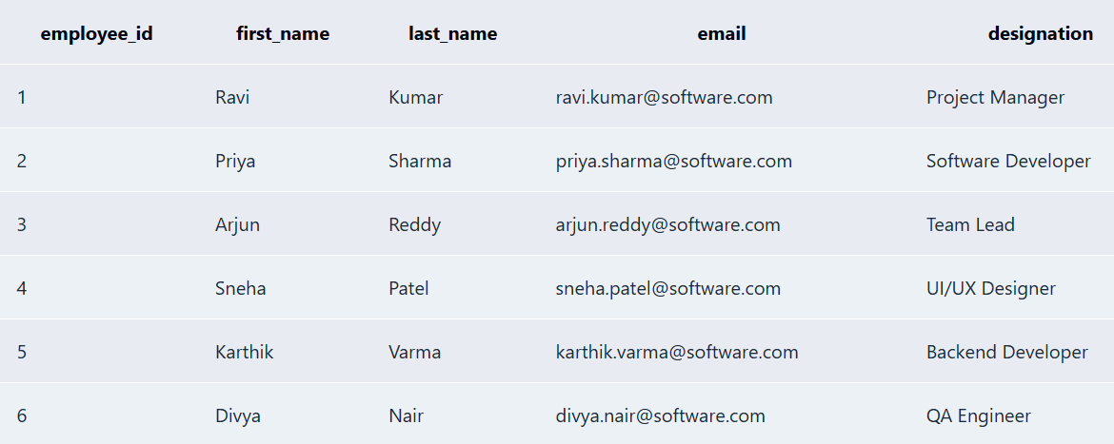
Q2. Display the projects that are currently in progress.
SQL:
SELECT project_id, project_name, status FROM Project
WHERE status = 'In Progress'
ORDER BY project_id;
Output:
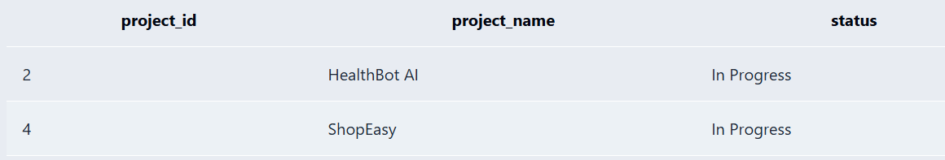

Q3. Display employees having more than 4 years of experience.
SQL:
SELECT employee_id, first_name,last_name,experience_years FROM Employee
WHERE experience_years > 4
ORDER BY experience_years DESC;
Output:
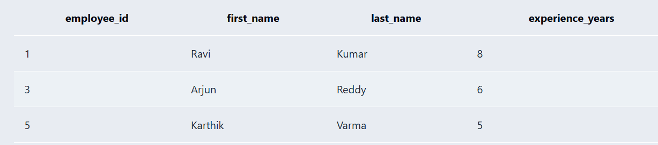

5.2 Join Operations
Q4. Display all projects with their project manager names.
SQL:
SELECT p.project_id, p.project_name, e.first_name || ' ' || e.last_name AS manager_name
FROM Project p
JOIN Employee e
ON p.manager_id = e.employee_id
ORDER BY p.project_id;
Output:
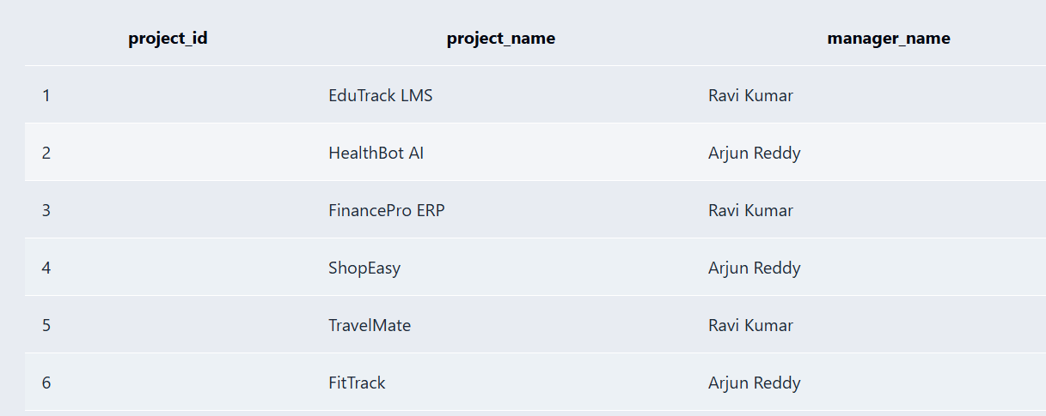

Q5. Display all teams with their project names.
SQL:
SELECT t.team_id, t.team_name, p.project_name FROM Team t
JOIN Project p
ON t.project_id = p.project_id
ORDER BY t.team_id;
Output:
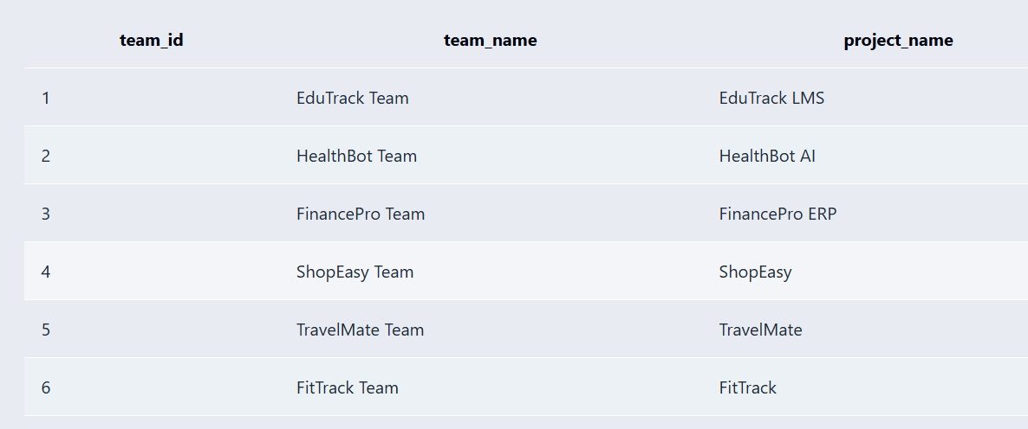
Q6. Display all tasks with the employees assigned to them.
SQL:
SELECT t.task_id, t.task_title, e.first_name || ' ' || e.last_name AS assigned_employee, t.status
FROM Task t JOIN Employee e ON t.assigned_to = e.employee_id
ORDER BY t.task_id;
Output:
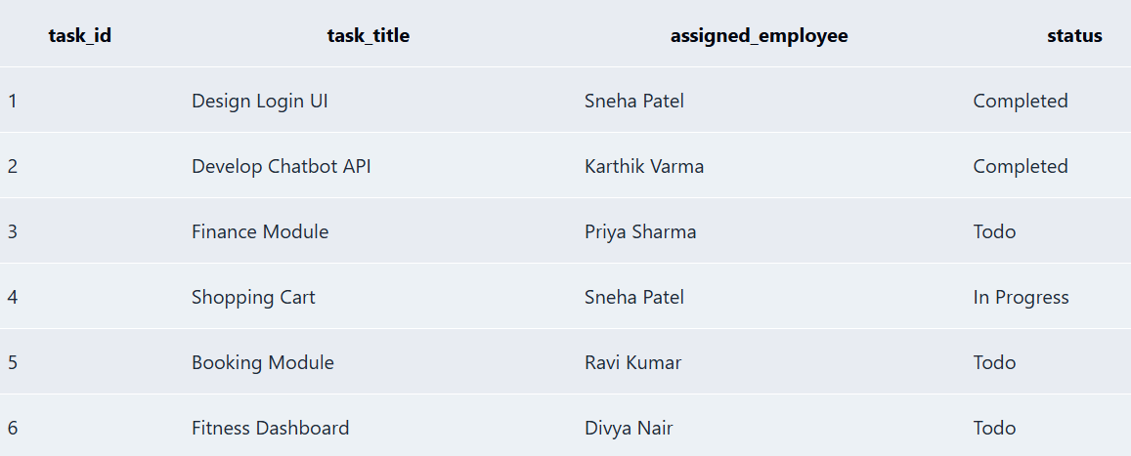

5.3 Aggregate Functions, GROUP BY and HAVING
Q7. Display the number of employees in each designation.
SQL:
SELECT designation,
COUNT(*) AS employee_count
FROM Employee
GROUP BY designation;
Output:
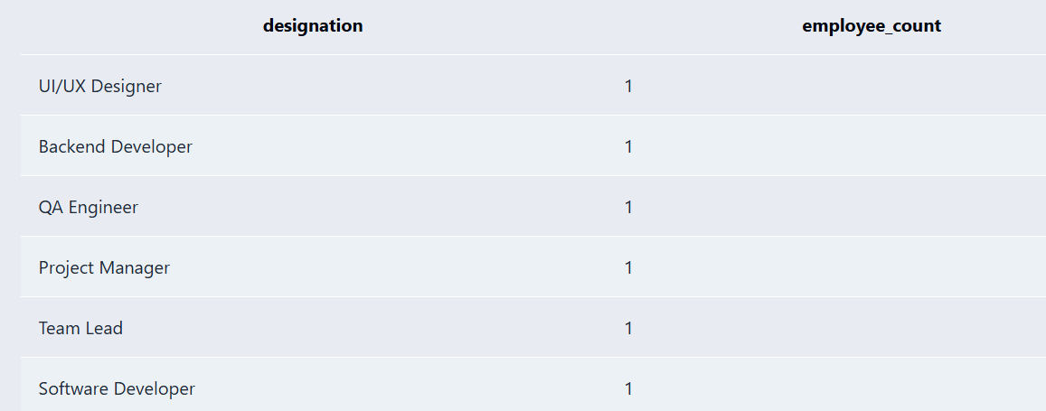
5.4 Nested and Correlated Subqueries
Q8. Display the employees whose salary is greater than the average salary of all employees.
SQL:
SELECT employee_id, first_name,last_name,salary FROM Employee
WHERE salary > ( SELECT AVG(salary) FROM Employee);
Output:
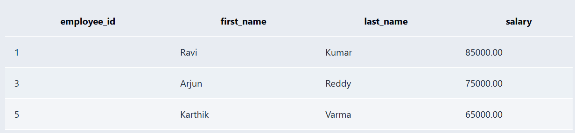

5.5 Views and Relational Set Operations
Q9. Create a view to display project names along with their manager names.
SQL:
CREATE VIEW Project_Manager_View AS SELECT p.project_id, p.project_name, e.first_name || ' ' || e.last_name AS manager_name FROM Project p
JOIN Employee e
ON p.manager_id = e.employee_id;
SELECT * FROM Project_Manager_View;
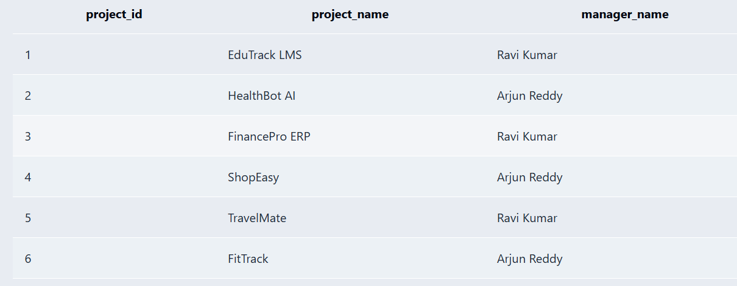

5.6 DCL and TCL Operations
CREATE USER 'project_user'@'localhost'
IDENTIFIED BY 'project@123';
GRANT SELECT ON software_project_management.Project
TO 'project_user'@'localhost';
GRANT SELECT ON software_project_management.Employee
TO 'project_user'@'localhost';
GRANT INSERT, UPDATE ON software_project_management.Task
TO 'project_user'@'localhost';
SHOW GRANTS FOR 'project_user'@'localhost';
REVOKE INSERT, UPDATE ON software_project_management.Task
FROM 'project_user'@'localhost';
FLUSH PRIVILEGES;

CHAPTER 6: MODULES AND FUNCTIONALITIES
Module | Main Functionality
Employee Management | Stores employee identity, designation, work email, experience and salary.
Project Management | Stores project name, description, dates, status and manager.
Team Management | Creates project teams, assigns team leads and maintains membership.
Sprint Management | Stores sprint goals, dates and status for each project.
Task Management | Records tasks, assignments, priorities, story points, status and dates.
Bug Tracking | Records bugs, severity, reporter, assignee, status and resolution date.
Skills & Technology Management | Stores multi-valued employee skills and project technologies in supporting tables.
Reporting | Provides project, task, sprint and bug information using SQL queries and views.

6.1 Employee Management
The Employee entity stores employee_id, name components, designation, email, skills, experience_years and salary. Skills are treated as multi-valued and separated into Employee_Skills.

6.2 Project and Team Management
Project records identify software projects and connect them to their managers. Teams belong to projects and have employee leads. Team_Member resolves the many-to-many relationship between employees and teams.

6.3 Sprint and Task Management
Sprints divide project work into planned periods. Tasks belong to sprints and may be assigned to employees. Priority, story points, status and completion information support task tracking.

6.4 Bug Tracking
Bugs are connected to tasks and employees. A bug stores title, severity, status, reported date and resolved date. Resolution time is derived from these dates.

CHAPTER 7: RESULTS – SAMPLE OUTPUTS AND SCREENSHOTS
The two principal reports produced by the Software Project Management System are shown below. Both reports are generated using SQL SELECT statements with the project management database tables.
Report 1 — Project-wise Manager Report
SELECT p.project_name,e.first_name || ' ' || e.last_name AS manager_name, p.status FROM Project p
JOIN Employee e
ON p.manager_id = e.employee_id
ORDER BY p.project_id;
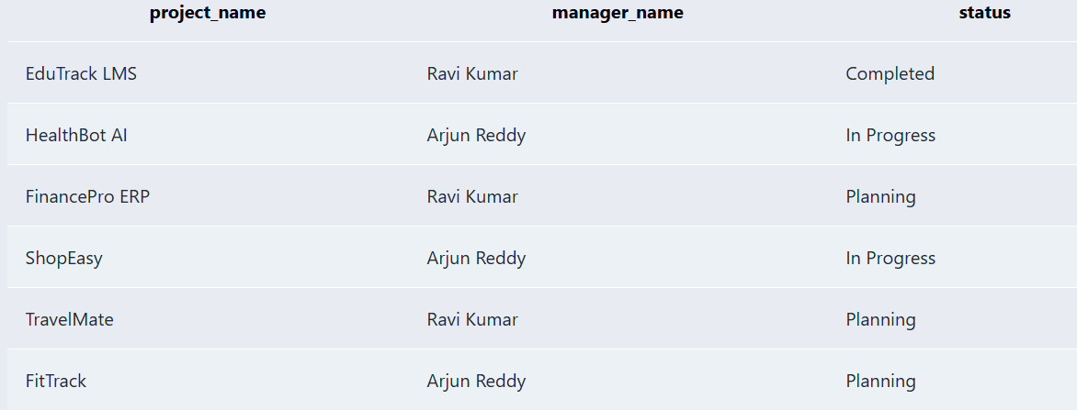
Report 2 — Project-wise Task and Bug Report
SELECT p.project_name, t.task_title, t.status AS task_status, b.title AS bug_title,b.severity,b.status AS bug_status
FROM Project p JOIN Sprint s ON p.project_id = s.project_id JOIN Task t ON s.sprint_id = t.sprint_id
LEFT JOIN Bug b ON t.task_id = b.task_id ORDER BY p.project_id;
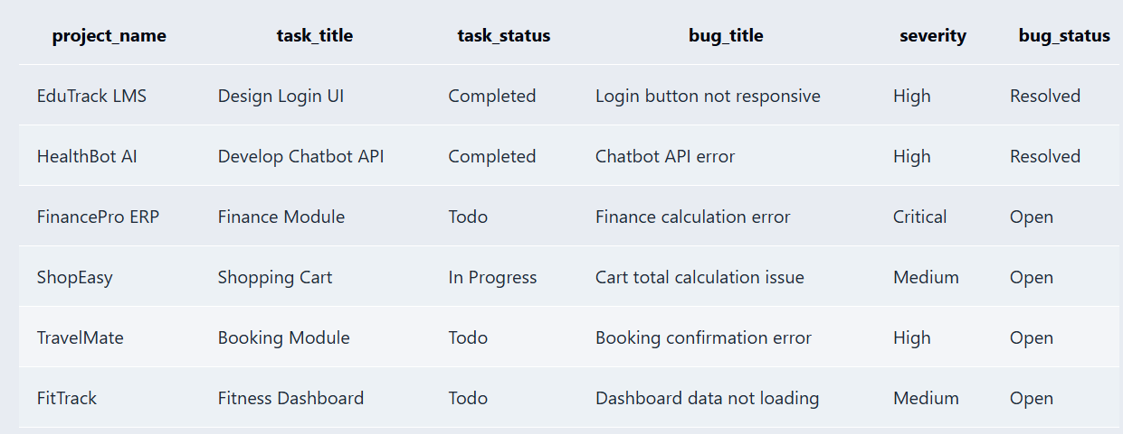

CHAPTER 8: TESTING AND DATA VALIDATION
Test Case | Input / Operation | Expected Result | Result
TC01 | Insert duplicate employee email | UNIQUE constraint rejects duplicate | Pass when constraint is enforced
TC02 | Insert negative experience_years | CHECK constraint rejects value | Pass when constraint is enforced
TC03 | Insert task with invalid sprint_id | FOREIGN KEY rejects orphan task | Pass when constraint is enforced
TC04 | Insert bug with invalid task_id | FOREIGN KEY rejects orphan bug | Pass when constraint is enforced
TC05 | Insert task without task_title | NOT NULL rejects record | Pass when constraint is enforced
TC06 | Query completed tasks | Only Done tasks are returned | Pass
TC07 | Calculate bug resolution time | Difference between resolved and reported dates | Pass for resolved bugs

8.1 Data Validation Rules
- Primary keys provide unique record identifiers.
- Foreign keys protect relationships between parent and child tables.
- UNIQUE prevents duplicate work email values.
- NOT NULL protects mandatory fields.
- CHECK validates non-negative employee experience.
- DEFAULT values provide initial workflow statuses.
- Derived fields are calculated from stored attributes rather than duplicated.

CHAPTER 9: GITHUB REPOSITORY & TEAM CONTRIBUTION

9.1 GitHub Repository
Repository Name: SOFTWARE MANAGEMENT SYSTEM
The GitHub repository contains all the project files, including:
Database SQL code
Table creation scripts
Sample data
SQL queries
ER diagram
Project documentation
PPT/presentation

9.2 Team Responsibilities and Contribution

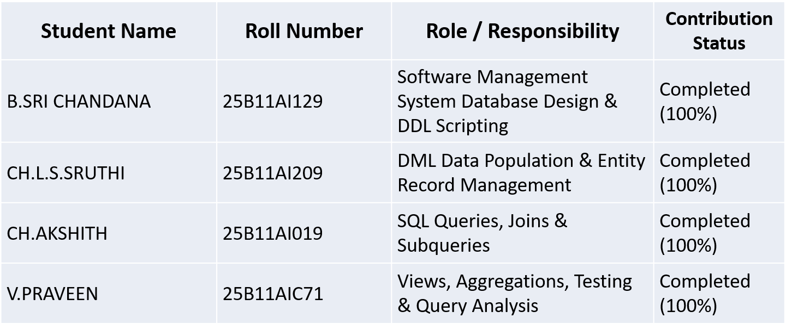

CHAPTER 10: CONCLUSION AND FUTURE ENHANCEMENTS

10.1 Conclusion
The Software Project Management System provides a structured relational model for managing software projects and their connected development information. The design separates Project, Employee, Team, Sprint, Task and Bug data and uses Team_Member to represent team membership. Multi-valued employee skills and project technologies are separated into supporting tables to satisfy atomicity requirements. Primary keys and foreign keys establish identity and relationships, while NOT NULL, UNIQUE, CHECK and DEFAULT constraints support data integrity. Normalization through 3NF reduces unnecessary repetition and supports consistent updates.

10.2 Future Enhancements
- Add user authentication and role-based access control.
- Add project budget and cost tracking.
- Add task dependency management.
- Add release and deployment tracking.
- Add notifications for overdue tasks and unresolved bugs.
- Develop a web or desktop front end for project dashboards.
- Add analytics for sprint velocity, task completion and bug trends.

REFERENCES
- MySQL 8.0 documentation and SQL reference.
- Database Management Systems concepts: relational modelling, keys and normalization.
- draw.io / diagrams.net for ER and relational schema diagrams.
- Git and GitHub documentation for version control and collaboration.
- Capstone Project — Database Design & Implementation source material provided for the Software Project Management System.
- Abraham Silberschatz, Henry F. Korth and S. Sudarshan, “Database System Concepts”, 8th Edition, McGraw-Hill, ISBN: 978-1260230508.
- Raghurama Krishnan and Johannes Gehrke, “Database Management Systems”, 4th Edition, McGraw-Hill, ISBN: 978-1260091195.
- Ramez Elmasri and Shamkant B. Navathe, “Fundamentals of Database Systems”, 7th Edition, Pearson, ISBN: 978-0137504277.
- C. J. Date, “An Introduction to Database Systems”, 9th Edition, Pearson, ISBN: 978-0133970777.
- MySQL 8.0 Reference Manual, Oracle Corporation, https://dev.mysql.com/doc/refman/8.0/en/
- W3Schools SQL Tutorial, https://www.w3schools.com/sql/
- NPTEL Online Course on Database Management Systems, https://onlinecourses.nptel.ac.in/noc22_cs91

APPENDIX A – COMPLETE SQL SCRIPT
The following consolidated script contains the table definitions used in this report. Execute the statements in dependency order in MySQL.
CREATE TABLE Employee (
employee_id INT PRIMARY KEY AUTO_INCREMENT,
first_name VARCHAR(50) NOT NULL,
last_name VARCHAR(50) NOT NULL,
designation VARCHAR(50),
email VARCHAR(100) UNIQUE NOT NULL,
experience_years INT CHECK (experience_years >= 0),
salary DECIMAL(10,2)
);

CREATE TABLE Project (
project_id INT PRIMARY KEY AUTO_INCREMENT,
project_name VARCHAR(150) NOT NULL,
description TEXT,
start_date DATE,
end_date DATE,
status VARCHAR(30) DEFAULT "Planning",
manager_id INT,
FOREIGN KEY (manager_id) REFERENCES Employee(employee_id)
);

CREATE TABLE Team (
team_id INT PRIMARY KEY AUTO_INCREMENT,
team_name VARCHAR(100) NOT NULL,
project_id INT NOT NULL,
lead_id INT,
FOREIGN KEY (project_id) REFERENCES Project(project_id),
FOREIGN KEY (lead_id) REFERENCES Employee(employee_id)
);

CREATE TABLE Team_Member (
team_id INT NOT NULL,
employee_id INT NOT NULL,
joined_date DATE,
PRIMARY KEY (team_id, employee_id),
FOREIGN KEY (team_id) REFERENCES Team(team_id),
FOREIGN KEY (employee_id) REFERENCES Employee(employee_id)
);

CREATE TABLE Sprint (
sprint_id INT PRIMARY KEY AUTO_INCREMENT,
sprint_name VARCHAR(100),
project_id INT NOT NULL,
start_date DATE,
end_date DATE,
goal TEXT,
status VARCHAR(20) DEFAULT "Planned",
FOREIGN KEY (project_id) REFERENCES Project(project_id)
);

CREATE TABLE Task (
task_id INT PRIMARY KEY AUTO_INCREMENT,
sprint_id INT,
assigned_to INT,
task_title VARCHAR(200) NOT NULL,
description TEXT,
priority VARCHAR(20) DEFAULT "Medium",
story_points INT,
status VARCHAR(20) DEFAULT "Todo",
due_date DATE,
completion_date DATE,
FOREIGN KEY (sprint_id) REFERENCES Sprint(sprint_id),
FOREIGN KEY (assigned_to) REFERENCES Employee(employee_id)
);

CREATE TABLE Bug (
bug_id INT PRIMARY KEY AUTO_INCREMENT,
task_id INT,
reported_by INT NOT NULL,
assigned_to INT,
title VARCHAR(200) NOT NULL,
severity VARCHAR(20),
status VARCHAR(20) DEFAULT "Open",
reported_date DATE DEFAULT (CURRENT_DATE),
resolved_date DATE,
FOREIGN KEY (task_id) REFERENCES Task(task_id),
FOREIGN KEY (reported_by) REFERENCES Employee(employee_id),
FOREIGN KEY (assigned_to) REFERENCES Employee(employee_id)
);

