ASSIGNMENT - 6.4

2303A51959 Batch - 10

TASK 1 PROMPT : #Complete the methods to: #1. Display student details
#2. Check if student's marks are above class average

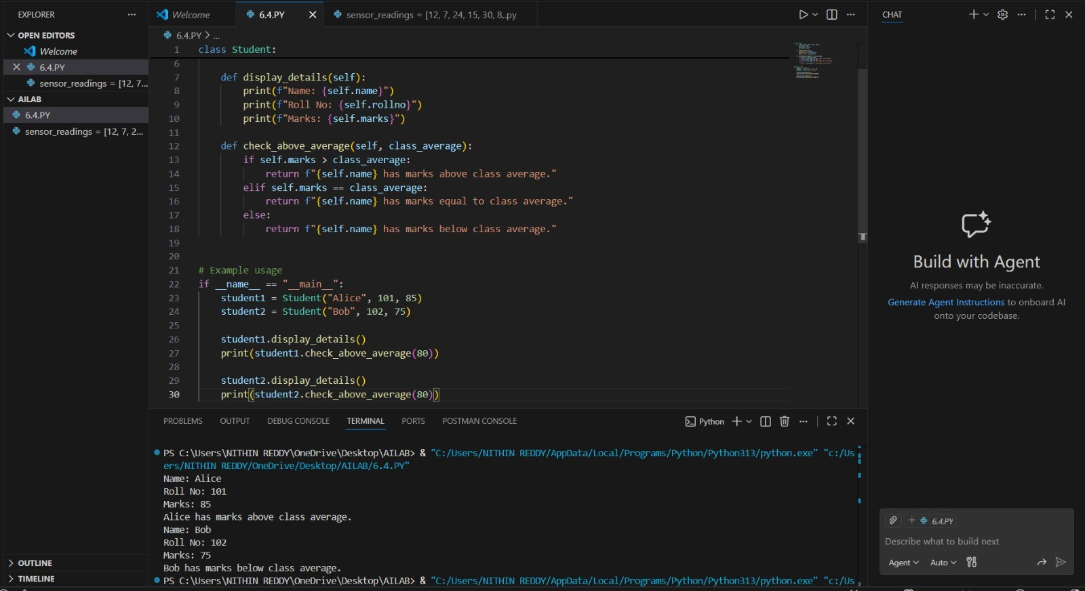

TASK 2 PROMPT :
#Identify even numbers, calculate their square, and print them.

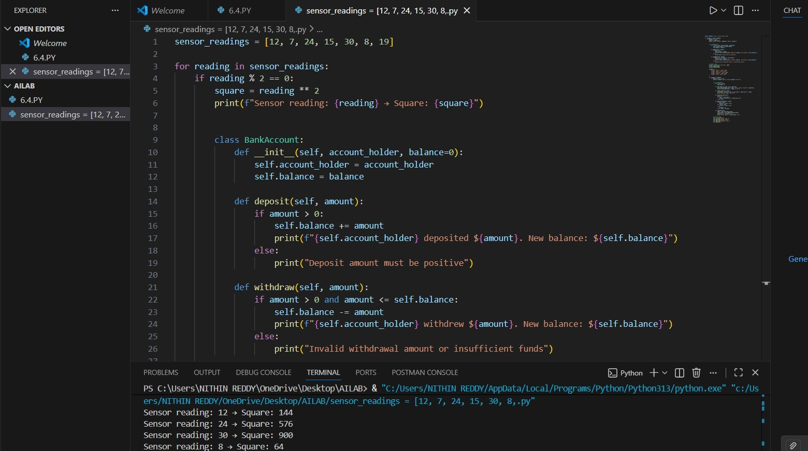

TASK 3 PROMPT :
#Generate deposit and withdrawal methods with balance validation.

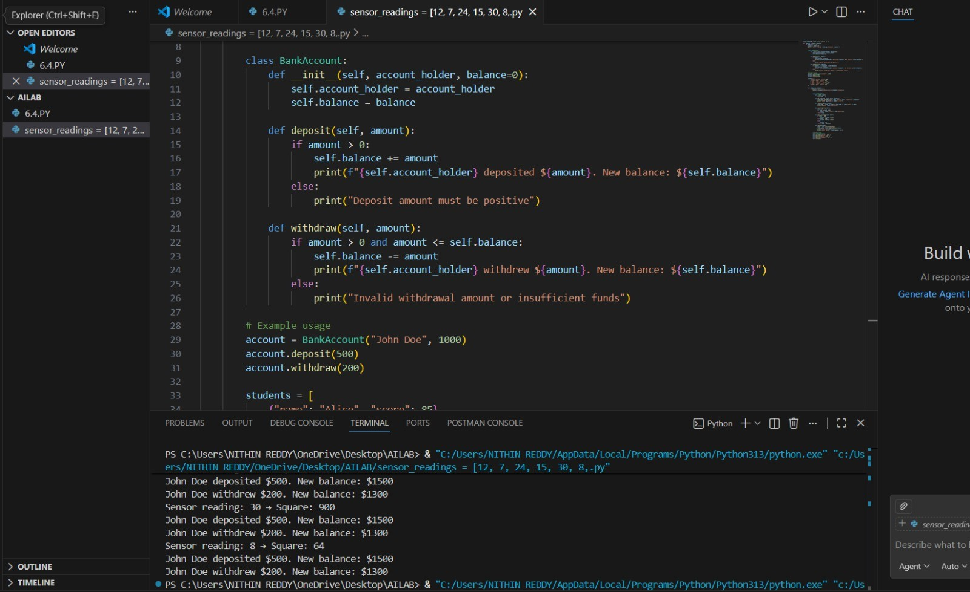

TASK. 4 PROMPT :
#Generate a while loop to print students scoring above 75.

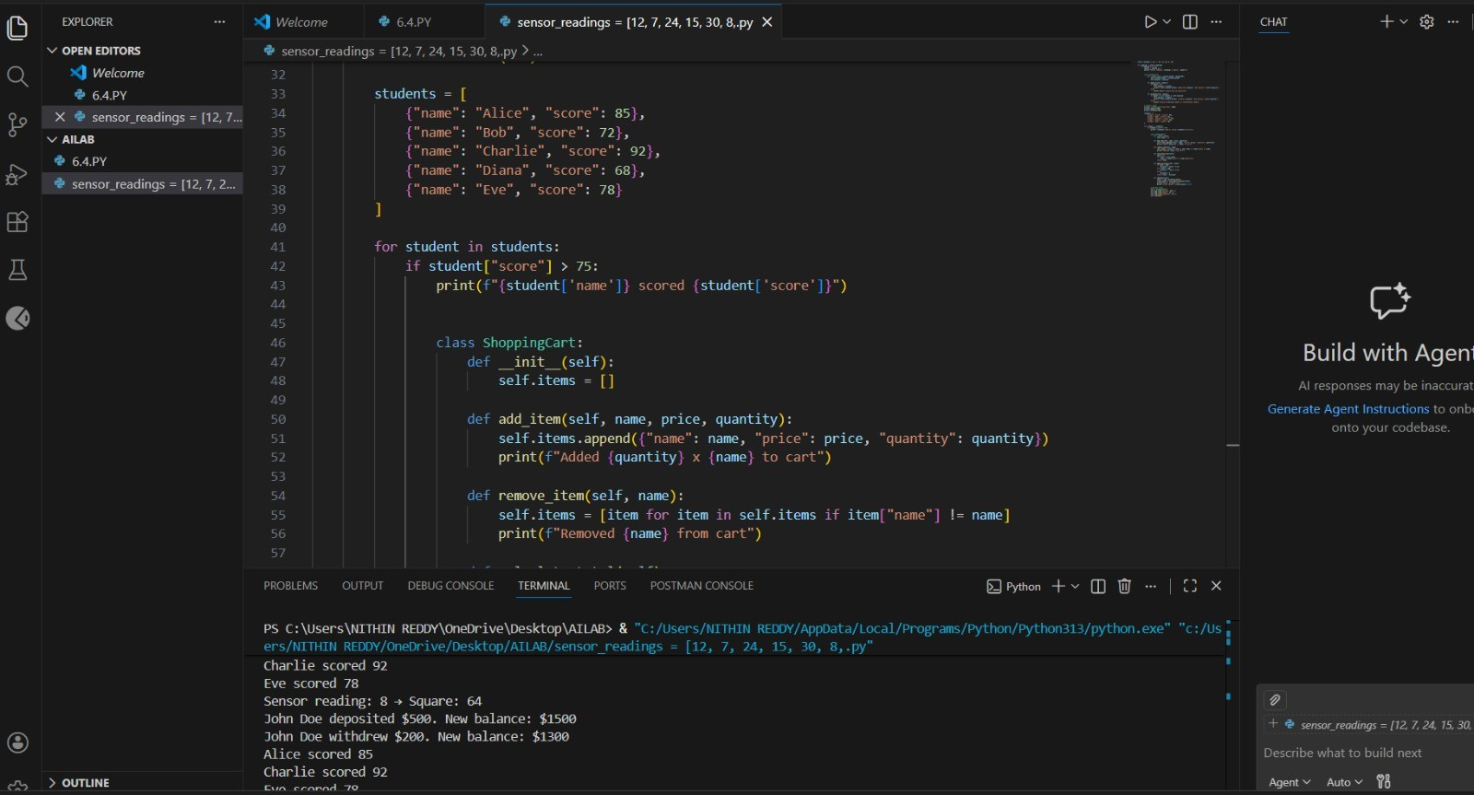

TASK 5 PROMPT :
#Generate methods to add/remove items, calculate total, and apply discount.

