BCSE302L – DATABASE SYSTEMS · BCSE302P – LAB PROJECT
MedMatch
Inter-Hospital Rare Resource Logistics Network
Project Report
Submitted by
Student name | Register number
Akshith M | 24BAI0017
Sanjaay B | 24BCE2181

Course Code: BCSE302L – Database Systems
Faculty Name: ________________________________
Source code: github.com/akshith-types/medmatch
School of Computer Science and Engineering
Vellore Institute of Technology, Vellore
October 2026

Contents
1. Project Title
Cover page
2. Introduction
2.1 Brief description of the project
2.2 Purpose of the database system
3. Objectives
3.1 Main objectives
3.2 Problems addressed
4. Software Requirements
4.1 Hardware and operating system
4.2 Source code and how to run
5. Database Design
5.1 ER diagram
5.2 Relational schema
5.3 Tables, attributes and keys
5.4 Relationships
5.5 Normalization
5.6 NoSQL graph model (Neo4j)
6. Database Creation and Sample Data
6.1 CREATE TABLE statements
6.2 INSERT statements
6.3 Sample records
6.4 Creating the graph in Neo4j
7. Database Operations and Outputs
7.1 SELECT with filtering and sorting
7.2 UPDATE and DELETE
7.3 JOIN
7.4 Aggregate functions
7.5 Subqueries
8. Advanced Database Features
8.1 Functions
8.2 Stored procedures
8.3 Triggers
8.4 Views
8.5 Transaction control
8.6 Concurrency control: strict 2PL and Wait-Die
8.7 Indexing and query optimization
8.8 Graph queries (Neo4j)
9. Project Output Screenshots
9.1 Database structure
9.2 Sample records
9.3 Execution of important queries
9.4 Application screenshots
10. Conclusion
10.1 Summary
10.2 Main features and benefits
10.3 Future enhancements
11. References

2. Introduction

2.1 Brief description of the project
When a hospital urgently needs a rare blood type, an antivenom vial or a matched donor organ, staff today phone nearby facilities one by one to ask whether they have it. This search is slow, and nothing prevents two hospitals from being promised the same last unit at the same time.
MedMatch is a shared reservation network that links the live inventories of independent hospitals. A hospital can search the whole region for a compatible, unexpired unit, reserve it in one atomic transaction, and receive the fastest transport route that keeps the item at the right temperature. Every change is recorded in an append-only audit log.
MedMatch is deliberately not a hospital management system. It does not manage patients, billing or wards; it manages only scarce, time-critical assets shared between facilities.

2.2 Purpose of the database system
The database is the single source of truth for which hospital holds which unit and who has claimed it. Its job is to answer three questions correctly and quickly, even when many hospitals act at the same instant:
- Which compatible units are available right now, and how far away are they?
- Can this hospital have this unit, with the guarantee that no one else gets it too?
- What is the fastest safe way to move it, and what happened to it afterwards?
To do this the project combines a relational database (PostgreSQL) for transactional correctness with a graph database (Neo4j) for route finding.

3. Objectives

3.1 Main objectives
- Design a normalized (3NF / BCNF) relational schema for hospitals, asset types, physical units, requests, transfers, routes and audit records.
- Guarantee that concurrent reservations of the same unit never both succeed, using ACID transactions, strict two-phase locking (SELECT … FOR UPDATE) and Wait-Die deadlock prevention.
- Keep compatibility searches fast with composite B+ tree, hash and partial indexes, and verify the gain with EXPLAIN ANALYZE.
- Enforce business rules inside the database with constraints, triggers, stored functions and procedures.
- Model the transport network as a graph in Neo4j and compute the fastest route, respecting cold-chain requirements.
- Provide a web application to search, reserve, track and audit transfers, and to demonstrate the concurrency behaviour live.

3.2 Problems addressed
Table 1: Problems and solutions
Problem | How MedMatch addresses it
Slow, manual search by phone | One indexed query searches every participating hospital, nearest unit first.
Two hospitals promised the same unit | Row-level locking inside a transaction; exactly one reservation can succeed.
Deadlocks when several units are reserved together | Wait-Die aborts the younger transaction instead of letting a cycle form.
Expired stock offered or wasted | Expiry is checked by the search and by a trigger; soonest-expiring units are listed first.
Items spoiling in transit | Routing on refrigerated (cold-chain) legs only, for items that need it.
No accountability | Triggers log every status change in a table that rejects updates and deletes.

4. Software Requirements
Table 2: Software used
Component | Technology | Purpose
Relational database | PostgreSQL 16 | Tables, constraints, PL/pgSQL functions, procedures, triggers, views, indexes, row-level locking
NoSQL database | Neo4j 5 with APOC plugin | Graph of hospitals and routes; Dijkstra shortest-path queries
Programming language | Python 3.9 or later | Application logic, scripts, lock manager
Web framework | FastAPI + Uvicorn | REST API serving the dashboard
Database drivers | psycopg 3 (with connection pool), neo4j Python driver | Connecting Python to PostgreSQL and Neo4j
Graph library | NetworkX | In-memory Dijkstra fallback when Neo4j is unavailable
Front end | HTML, CSS, JavaScript | Dashboard: search, reserve, transfers, map, concurrency lab, query plans, audit
Containers | Docker Desktop, Docker Compose | Runs PostgreSQL and Neo4j with one command
Tools | psql, Neo4j Browser, VS Code, Git | Querying, inspecting the graph, editing code

4.1 Hardware and operating system
Developed and tested on macOS (Apple Silicon) and Linux. Any machine with 8 GB RAM that can run Docker Desktop is sufficient; Neo4j is limited to a 512 MB heap.

4.2 Source code and how to run
The complete source code, database scripts, demo scripts, this report and the presentation are published at https://github.com/akshith-types/medmatch.
git clone https://github.com/akshith-types/medmatch.git
cd medmatch
./start.sh # starts both databases, creates the schema, loads data, opens http://localho…
./demo.sh # guided 12-step demonstration in the terminal

5. Database Design

5.1 ER diagram
The conceptual model has nine entities. Hospitals take part in transfers twice, once as the requesting hospital and once as the supplying hospital. Asset_Attributes is a weak entity that depends on Emergency_Assets.
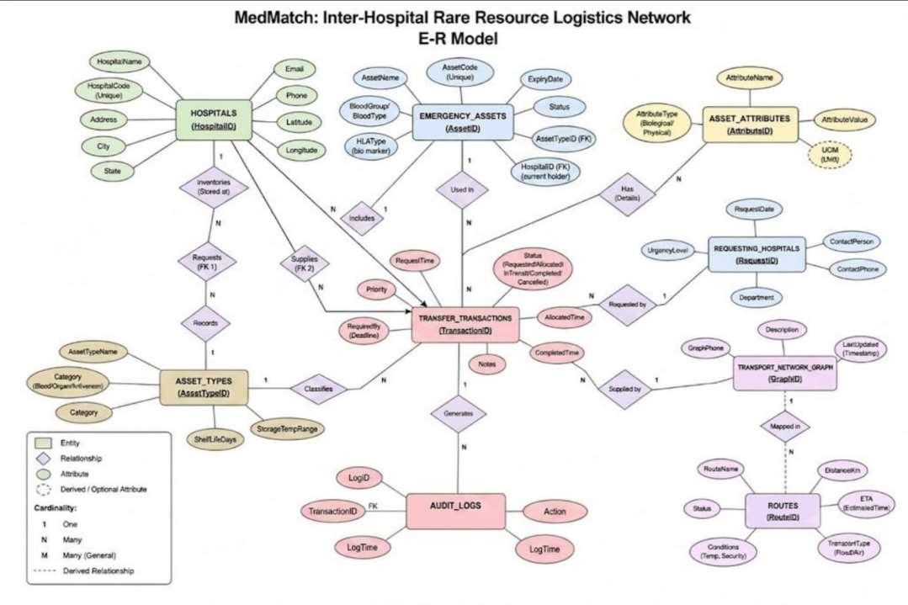
Figure 1: Entity–Relationship model of MedMatch (Chen notation)

5.2 Relational schema
The ER model maps to nine tables with thirteen foreign keys. The diagram below was generated from the live database.
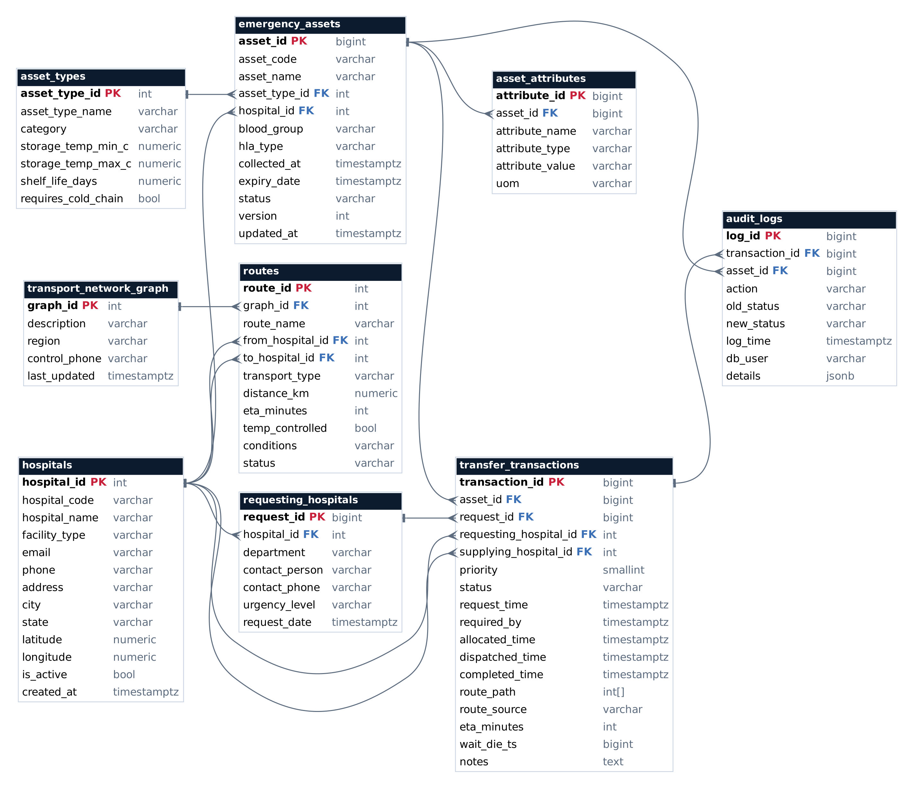
Figure 2: Relational schema with primary keys (PK) and foreign keys (FK)

5.3 Tables, attributes and keys

hospitals
Participating facilities and their locations.
Attribute | Data type | Key / constraint
hospital_id | SERIAL | PK
hospital_code | VARCHAR(12) | UNIQUE, NOT NULL
hospital_name | VARCHAR(150) | NOT NULL
facility_type | VARCHAR(20) | NOT NULL
email | VARCHAR(120) | UNIQUE, NOT NULL
phone | VARCHAR(15) | NOT NULL
address | VARCHAR(250) | NOT NULL
city | VARCHAR(60) | NOT NULL
state | VARCHAR(60) | NOT NULL
latitude | NUMERIC(9,6) | NOT NULL
longitude | NUMERIC(9,6) | NOT NULL
is_active | BOOLEAN | NOT NULL
created_at | TIMESTAMPTZ | NOT NULL

asset_types
One row per kind of asset (e.g. Packed Red Cells, Kidney) with storage temperature, shelf life and whether it needs a cold chain.
Attribute | Data type | Key / constraint
asset_type_id | SERIAL | PK
asset_type_name | VARCHAR(60) | UNIQUE, NOT NULL
category | VARCHAR(15) | NOT NULL
storage_temp_min_c | NUMERIC(5,1) | NOT NULL
storage_temp_max_c | NUMERIC(5,1) | NOT NULL
shelf_life_days | NUMERIC(6,2) | NOT NULL
requires_cold_chain | BOOLEAN | NOT NULL

emergency_assets
One row per physical, reservable unit.
Attribute | Data type | Key / constraint
asset_id | BIGSERIAL | PK
asset_code | VARCHAR(20) | UNIQUE, NOT NULL
asset_name | VARCHAR(100) | NOT NULL
asset_type_id | INT | FK → asset_types, NOT NULL
hospital_id | INT | FK → hospitals, NOT NULL
blood_group | VARCHAR(3)
hla_type | VARCHAR(40)
collected_at | TIMESTAMPTZ | NOT NULL
expiry_date | TIMESTAMPTZ | NOT NULL
status | VARCHAR(12) | NOT NULL
version | INT | NOT NULL
updated_at | TIMESTAMPTZ | NOT NULL

asset_attributes
Extra biological or physical properties of a unit (weak entity of emergency_assets).
Attribute | Data type | Key / constraint
attribute_id | BIGSERIAL | PK
asset_id | BIGINT | FK → emergency_assets, NOT NULL
attribute_name | VARCHAR(60) | NOT NULL
attribute_type | VARCHAR(12) | NOT NULL
attribute_value | VARCHAR(100) | NOT NULL
uom | VARCHAR(20)

requesting_hospitals
The clinical request raised by a hospital department.
Attribute | Data type | Key / constraint
request_id | BIGSERIAL | PK
hospital_id | INT | FK → hospitals, NOT NULL
department | VARCHAR(60) | NOT NULL
contact_person | VARCHAR(100) | NOT NULL
contact_phone | VARCHAR(15) | NOT NULL
urgency_level | VARCHAR(10) | NOT NULL
request_date | TIMESTAMPTZ | NOT NULL

transfer_transactions
The reservation ledger: who supplies what to whom, its status, route and timing.
Attribute | Data type | Key / constraint
transaction_id | BIGSERIAL | PK
asset_id | BIGINT | FK → emergency_assets, NOT NULL
request_id | BIGINT | FK → requesting_hospitals, NOT NULL
requesting_hospital_id | INT | FK → hospitals, NOT NULL
supplying_hospital_id | INT | FK → hospitals, NOT NULL
priority | SMALLINT | NOT NULL
status | VARCHAR(12) | NOT NULL
request_time | TIMESTAMPTZ | NOT NULL
required_by | TIMESTAMPTZ
allocated_time | TIMESTAMPTZ
dispatched_time | TIMESTAMPTZ
completed_time | TIMESTAMPTZ
route_path | INT[]
route_source | VARCHAR(10)
eta_minutes | INT
wait_die_ts | BIGINT
notes | TEXT

audit_logs
Append-only history of every transaction event, written by triggers.
Attribute | Data type | Key / constraint
log_id | BIGSERIAL | PK
transaction_id | BIGINT | FK → transfer_transactions
asset_id | BIGINT | FK → emergency_assets
action | VARCHAR(30) | NOT NULL
old_status | VARCHAR(12)
new_status | VARCHAR(12)
log_time | TIMESTAMPTZ | NOT NULL
db_user | VARCHAR(60) | NOT NULL
details | JSONB

transport_network_graph
The regional transport network that groups the routes.
Attribute | Data type | Key / constraint
graph_id | SERIAL | PK
description | VARCHAR(200) | NOT NULL
region | VARCHAR(60) | NOT NULL
control_phone | VARCHAR(15) | NOT NULL
last_updated | TIMESTAMPTZ | NOT NULL

routes
Road and air legs between hospitals with distance, travel time and cold-chain capability.
Attribute | Data type | Key / constraint
route_id | SERIAL | PK
graph_id | INT | FK → transport_network_graph, NOT NULL
route_name | VARCHAR(120) | NOT NULL
from_hospital_id | INT | FK → hospitals, NOT NULL
to_hospital_id | INT | FK → hospitals, NOT NULL
transport_type | VARCHAR(5) | NOT NULL
distance_km | NUMERIC(7,2) | NOT NULL
eta_minutes | INT | NOT NULL
temp_controlled | BOOLEAN | NOT NULL
conditions | VARCHAR(120)
status | VARCHAR(8) | NOT NULL

5.4 Relationships
Table 3: Relationships and cardinality
Relationship | Type | Implemented by
Hospital holds Emergency_Assets | 1 : N | emergency_assets.hospital_id → hospitals
Asset_Type classifies Emergency_Assets | 1 : N | emergency_assets.asset_type_id → asset_types
Emergency_Asset has Asset_Attributes | 1 : N (weak) | asset_attributes.asset_id → emergency_assets, ON DELETE CASCADE
Hospital raises Requesting_Hospitals | 1 : N | requesting_hospitals.hospital_id → hospitals
Hospital requests Transfer_Transactions | 1 : N | transfer_transactions.requesting_hospital_id → hospitals
Hospital supplies Transfer_Transactions | 1 : N | transfer_transactions.supplying_hospital_id → hospitals
Emergency_Asset is target of Transfer_Transactions | 1 : N (one active) | transfer_transactions.asset_id + partial unique index
Request is fulfilled by Transfer_Transactions | 1 : N | transfer_transactions.request_id → requesting_hospitals
Transfer_Transaction generates Audit_Logs | 1 : N | audit_logs.transaction_id → transfer_transactions
Network contains Routes | 1 : N | routes.graph_id → transport_network_graph
Routes connect Hospitals | M : N (via routes) | routes.from_hospital_id, routes.to_hospital_id → hospitals

5.5 Normalization
The key functional dependency that shaped the design is:
asset_type_id → { category, storage_temp_min_c, storage_temp_max_c, shelf_life_days, requires_c…
If these attributes were stored on every unit, changing the shelf life of one asset type would mean updating thousands of rows (update anomaly), and a new asset type could not be recorded until its first unit existed (insertion anomaly). Moving them to asset_types removes the transitive dependency.
Table 4: Normal forms
Normal form | Requirement | How the schema satisfies it
1NF | Atomic values, no repeating groups | Latitude and longitude are separate columns; variable properties are rows in asset_attributes.
2NF | No partial dependency | Every table has a single-column surrogate primary key.
3NF | No transitive dependency | Type attributes live only in asset_types; hospital details only in hospitals.
BCNF | Every determinant is a candidate key | Determinants are the primary key or a UNIQUE natural key such as asset_code or hospital_code.

Two deliberate exceptions are documented: requesting_hospital_id in transfer_transactions can be derived through request_id, and is kept for fast, indexed filtering; route_path is an integer array holding a read-only snapshot of the chosen route.

5.6 NoSQL graph model (Neo4j)
The transport network is copied from the routes table into Neo4j as a property graph, where finding the fastest route is a built-in algorithm instead of a chain of joins.
Table 5: Graph data model
Element | Label / type | Properties
Node | (:Hospital) | hospital_id, code, name, city, type, lat, lon
Relationship | [:ROUTE_TO] | route_id, mode (ROAD / AIR), distance_km, eta_minutes, temp_controlled
Relationship | [:COLD_ROUTE] | Same properties; created only for temperature-controlled legs

Sample node and relationship (Cypher)
(:Hospital {hospital_id: 4, code: 'RNP01', name: 'Ranipet District Hospital', city: 'Ranipet'})
-[:ROUTE_TO {mode: 'ROAD', distance_km: 28.77, eta_minutes: 41, temp_controlled: true}]->
(:Hospital {hospital_id: 3, code: 'VLR02', name: 'Vellore Regional Blood Centre', city: 'Vellore'…

6. Database Creation and Sample Data

6.1 CREATE TABLE statements
The complete schema (db/01_schema.sql). Comments are removed here for space.
DROP SCHEMA IF EXISTS medmatch CASCADE;
CREATE SCHEMA medmatch;
SET search_path TO medmatch, public;

CREATE TABLE hospitals (
hospital_id SERIAL PRIMARY KEY,
hospital_code VARCHAR(12) NOT NULL UNIQUE,
hospital_name VARCHAR(150) NOT NULL,
facility_type VARCHAR(20) NOT NULL
CHECK (facility_type IN ('GOVERNMENT','PRIVATE','BLOOD_BANK','TRANSPLANT_CENTER')),
email VARCHAR(120) NOT NULL UNIQUE
CHECK (email ~* '^[A-Z0-9._%+-]+@[A-Z0-9.-]+\.[A-Z]{2,}$'),
phone VARCHAR(15) NOT NULL CHECK (phone ~ '^[0-9+ -]{8,15}$'),
address VARCHAR(250) NOT NULL,
city VARCHAR(60) NOT NULL,
state VARCHAR(60) NOT NULL,
latitude NUMERIC(9,6) NOT NULL CHECK (latitude BETWEEN -90 AND 90),
longitude NUMERIC(9,6) NOT NULL CHECK (longitude BETWEEN -180 AND 180),
is_active BOOLEAN NOT NULL DEFAULT TRUE,
created_at TIMESTAMPTZ NOT NULL DEFAULT now()
);

CREATE TABLE asset_types (
asset_type_id SERIAL PRIMARY KEY,
asset_type_name VARCHAR(60) NOT NULL UNIQUE,
category VARCHAR(15) NOT NULL
CHECK (category IN ('BLOOD','ORGAN','ANTIVENOM')),
storage_temp_min_c NUMERIC(5,1) NOT NULL,
storage_temp_max_c NUMERIC(5,1) NOT NULL,
shelf_life_days NUMERIC(6,2) NOT NULL CHECK (shelf_life_days > 0),
requires_cold_chain BOOLEAN NOT NULL DEFAULT TRUE,
CHECK (storage_temp_min_c <= storage_temp_max_c)
);

CREATE TABLE emergency_assets (
asset_id BIGSERIAL PRIMARY KEY,
asset_code VARCHAR(20) NOT NULL UNIQUE,
asset_name VARCHAR(100) NOT NULL,
asset_type_id INT NOT NULL REFERENCES asset_types(asset_type_id) ON DELETE RESTRICT,
hospital_id INT NOT NULL REFERENCES hospitals(hospital_id) ON DELETE RESTRICT,
blood_group VARCHAR(3) CHECK (blood_group IN ('O-','O+','A-','A+','B-','B+','AB-','AB+')),
hla_type VARCHAR(40),
collected_at TIMESTAMPTZ NOT NULL DEFAULT now(),
expiry_date TIMESTAMPTZ NOT NULL,
status VARCHAR(12) NOT NULL DEFAULT 'AVAILABLE'
CHECK (status IN ('AVAILABLE','RESERVED','IN_TRANSIT','DELIVERED','EXPIRED','DISCAR…
version INT NOT NULL DEFAULT 1, -- bumped by trigger on every change
updated_at TIMESTAMPTZ NOT NULL DEFAULT now(),
CHECK (expiry_date > collected_at)
);

CREATE TABLE asset_attributes (
attribute_id BIGSERIAL PRIMARY KEY,
asset_id BIGINT NOT NULL REFERENCES emergency_assets(asset_id) ON DELETE CASCADE,
attribute_name VARCHAR(60) NOT NULL,
attribute_type VARCHAR(12) NOT NULL CHECK (attribute_type IN ('BIOLOGICAL','PHYSICAL')),
attribute_value VARCHAR(100) NOT NULL,
uom VARCHAR(20),
UNIQUE (asset_id, attribute_name)
);

CREATE TABLE requesting_hospitals (
request_id BIGSERIAL PRIMARY KEY,
hospital_id INT NOT NULL REFERENCES hospitals(hospital_id),
department VARCHAR(60) NOT NULL,
contact_person VARCHAR(100) NOT NULL,
contact_phone VARCHAR(15) NOT NULL,
urgency_level VARCHAR(10) NOT NULL CHECK (urgency_level IN ('CRITICAL','HIGH','MEDIUM','LOW')),
request_date TIMESTAMPTZ NOT NULL DEFAULT now()
);

CREATE TABLE transport_network_graph (
graph_id SERIAL PRIMARY KEY,
description VARCHAR(200) NOT NULL,
region VARCHAR(60) NOT NULL,
control_phone VARCHAR(15) NOT NULL,
last_updated TIMESTAMPTZ NOT NULL DEFAULT now()
);

CREATE TABLE routes (
route_id SERIAL PRIMARY KEY,
graph_id INT NOT NULL REFERENCES transport_network_graph(graph_id) ON DELETE CASCA…
route_name VARCHAR(120) NOT NULL,
from_hospital_id INT NOT NULL REFERENCES hospitals(hospital_id),
to_hospital_id INT NOT NULL REFERENCES hospitals(hospital_id),
transport_type VARCHAR(5) NOT NULL CHECK (transport_type IN ('ROAD','AIR')),
distance_km NUMERIC(7,2) NOT NULL CHECK (distance_km > 0),
eta_minutes INT NOT NULL CHECK (eta_minutes > 0),
temp_controlled BOOLEAN NOT NULL DEFAULT FALSE,
conditions VARCHAR(120),
status VARCHAR(8) NOT NULL DEFAULT 'ACTIVE' CHECK (status IN ('ACTIVE','CLOSED')),
CHECK (from_hospital_id <> to_hospital_id),
UNIQUE (from_hospital_id, to_hospital_id, transport_type)
);

CREATE TABLE transfer_transactions (
transaction_id BIGSERIAL PRIMARY KEY,
asset_id BIGINT NOT NULL REFERENCES emergency_assets(asset_id),
request_id BIGINT NOT NULL REFERENCES requesting_hospitals(request_id),
requesting_hospital_id INT NOT NULL REFERENCES hospitals(hospital_id),
supplying_hospital_id INT NOT NULL REFERENCES hospitals(hospital_id),
priority SMALLINT NOT NULL DEFAULT 3 CHECK (priority BETWEEN 1 AND 5),
status VARCHAR(12) NOT NULL DEFAULT 'REQUESTED'
CHECK (status IN ('REQUESTED','ALLOCATED','IN_TRANSIT','COMPLETED','CANCELL…
request_time TIMESTAMPTZ NOT NULL DEFAULT now(),
required_by TIMESTAMPTZ,
allocated_time TIMESTAMPTZ,
dispatched_time TIMESTAMPTZ,
completed_time TIMESTAMPTZ,
route_path INT[], -- hospital_ids along the chosen path
route_source VARCHAR(10), -- 'neo4j' or 'fallback'
eta_minutes INT CHECK (eta_minutes IS NULL OR eta_minutes >= 0),
wait_die_ts BIGINT, -- transaction timestamp used by Wait-Die
notes TEXT,
CHECK (requesting_hospital_id <> supplying_hospital_id),
CHECK (completed_time IS NULL OR completed_time >= request_time)
);

CREATE UNIQUE INDEX uq_one_active_claim_per_asset
ON transfer_transactions(asset_id)
WHERE status IN ('REQUESTED','ALLOCATED','IN_TRANSIT');

CREATE TABLE audit_logs (
log_id BIGSERIAL PRIMARY KEY,
transaction_id BIGINT REFERENCES transfer_transactions(transaction_id),
asset_id BIGINT REFERENCES emergency_assets(asset_id),
action VARCHAR(30) NOT NULL,
old_status VARCHAR(12),
new_status VARCHAR(12),
log_time TIMESTAMPTZ NOT NULL DEFAULT clock_timestamp(),
db_user VARCHAR(60) NOT NULL DEFAULT current_user,
details JSONB
);

6.2 INSERT statements
Master data is inserted with plain INSERT statements (db/04_seed_master.sql); an excerpt is shown below. The 20,000 inventory units are generated by scripts/setup_db.py and bulk-loaded with PostgreSQL COPY, which loads them in about one second.
INSERT INTO hospitals (hospital_code, hospital_name, facility_type, email, phone, address, city, state, latitud…
('VLR01','Vellore City General Hospital', 'GOVERNMENT', 'emergency@vcgh.example.in', '0416-222…
('KPD01','Katpadi Lifeline Hospital', 'PRIVATE', 'desk@katpadilife.example.in', '0416-224…
('VLR02','Vellore Regional Blood Centre', 'BLOOD_BANK', 'bank@vrbc.example.in', '0416-223…
('RNP01','Ranipet District Hospital', 'GOVERNMENT', 'cmo@ranipetdh.example.in', '04172-27…
('ARC01','Arcot Community Hospital', 'PRIVATE', 'care@arcotch.example.in', '04172-23…
('TVM01','Tiruvannamalai Medical College Hospital','GOVERNMENT', 'er@tvmmch.example.in', '04175-23…
('KNC01','Kanchipuram Health Centre', 'PRIVATE', 'help@knchc.example.in', '044-2722…
('CHN01','Chennai Central Transplant Institute', 'TRANSPLANT_CENTER','tx@ccti.example.in', '044-2818…
('CHN02','Chennai South Multispeciality', 'PRIVATE', 'er@csm.example.in', '044-2243…
('CHN03','State Blood Transfusion Centre Chennai', 'BLOOD_BANK', 'sbtc@tn.example.in', '044-2819…
...
INSERT INTO asset_types (asset_type_name, category, storage_temp_min_c, storage_temp_max_c, shelf_life_days, re…
('Whole Blood', 'BLOOD', 2, 6, 35, TRUE),
('Packed Red Cells', 'BLOOD', 2, 6, 42, TRUE),
('Platelets', 'BLOOD', 20, 24, 5, FALSE),
('Fresh Frozen Plasma', 'BLOOD', -30, -18, 365, TRUE),
('Kidney', 'ORGAN', 0, 4, 1.5, TRUE),
('Liver', 'ORGAN', 0, 4, 0.5, TRUE),
('Heart', 'ORGAN', 0, 4, 0.25,TRUE),
('Cornea', 'ORGAN', 2, 8, 14, TRUE),
('Polyvalent Anti-Snake Venom', 'ANTIVENOM', 2, 25, 730, FALSE),
('Scorpion Antivenom', 'ANTIVENOM', 2, 8, 730, TRUE);

INSERT INTO transport_network_graph (description, region, control_phone)
VALUES ('North Tamil Nadu – Bengaluru – Tirupati emergency corridor network', 'Vellore Region', '0416-2200000');

INSERT a new hospital
Adding a new hospital:
Query
INSERT INTO hospitals (hospital_code, hospital_name, facility_type, email, phone,
address, city, state, latitude, longitude)
VALUES ('GDY01', 'Gudiyatham Government Hospital', 'GOVERNMENT',
'er@gdygh.example.in', '04171-220101', 'Station Road',
'Gudiyatham', 'Tamil Nadu', 12.944800, 78.873000)
RETURNING hospital_id, hospital_code, hospital_name;
Output
hospital_id | hospital_code | hospital_name
-------------+---------------+--------------------------------
17 | GDY01 | Gudiyatham Government Hospital
(1 row)

INSERT 0 1

INSERT an emergency asset for it
Adding a unit to its inventory. The default status AVAILABLE and version 1 come from column defaults.
Query
INSERT INTO emergency_assets (asset_code, asset_name, asset_type_id, hospital_id,
blood_group, collected_at, expiry_date)
VALUES ('BLD-GDY01-000001', 'Packed Red Cells', 2,
(SELECT hospital_id FROM hospitals WHERE hospital_code = 'GDY01'),
'B-', now(), now() + INTERVAL '42 days')
RETURNING asset_id, asset_code, status, version;
Output
asset_id | asset_code | status | version
----------+------------------+-----------+---------
20001 | BLD-GDY01-000001 | AVAILABLE | 1
(1 row)

INSERT 0 1

6.3 Sample records

SELECT sample hospital records
Query
SELECT hospital_id, hospital_code, hospital_name, facility_type, city
FROM hospitals ORDER BY hospital_id LIMIT 6;
Output
hospital_id | hospital_code | hospital_name | facility_type | city
-------------+---------------+-----------------------------------------+---------------+----------------
1 | VLR01 | Vellore City General Hospital | GOVERNMENT | Vellore
2 | KPD01 | Katpadi Lifeline Hospital | PRIVATE | Katpadi
3 | VLR02 | Vellore Regional Blood Centre | BLOOD_BANK | Vellore
4 | RNP01 | Ranipet District Hospital | GOVERNMENT | Ranipet
5 | ARC01 | Arcot Community Hospital | PRIVATE | Arcot
6 | TVM01 | Tiruvannamalai Medical College Hospital | GOVERNMENT | Tiruvannamalai
(6 rows)

Table 6: Volume of seed data
Data | Rows
hospitals | 16
asset_types | 10
emergency_assets | 20,000
asset_attributes | 3,475
routes | 112
transfer_transactions (after demo activity) | 7+

6.4 Creating the graph in Neo4j
CREATE CONSTRAINT hospital_id_unique IF NOT EXISTS
FOR (h:Hospital) REQUIRE h.hospital_id IS UNIQUE;

UNWIND $rows AS r
CREATE (:Hospital {hospital_id: r.hospital_id, code: r.code, name: r.name,
city: r.city, type: r.type, lat: r.lat, lon: r.lon});

UNWIND $rows AS r
MATCH (a:Hospital {hospital_id: r.src}), (b:Hospital {hospital_id: r.dst})
CREATE (a)-[:ROUTE_TO {route_id: r.route_id, mode: r.mode, distance_km: r.distance_km,
eta_minutes: r.eta_minutes, temp_controlled: r.temp_controlled}]->(b);

MATCH (a:Hospital)-[r:ROUTE_TO {temp_controlled: true}]->(b:Hospital)
CREATE (a)-[:COLD_ROUTE {route_id: r.route_id, mode: r.mode,
eta_minutes: r.eta_minutes, temp_controlled: true}]->(b);
Output of scripts/load_graph.py on the project machine: “Loaded 16 hospital nodes and 174 relationships into Neo4j” (112 ROUTE_TO + 62 COLD_ROUTE).

7. Database Operations and Outputs
Every output below is the real result of running the query with psql against the project database.

7.1 SELECT with filtering and sorting

SELECT with filtering and sorting
The five O-negative units that expire soonest across the whole network:
Query
SELECT asset_code, asset_name, blood_group, status,
to_char(expiry_date, 'DD-Mon HH24:MI') AS expires
FROM emergency_assets
WHERE blood_group = 'O-' AND status = 'AVAILABLE' AND expiry_date > now()
ORDER BY expiry_date
LIMIT 5;
Output
asset_code | asset_name | blood_group | status | expires
------------------+------------------+-------------+-----------+--------------
BLD-KRG01-008768 | Platelets | O- | AVAILABLE | 21-Oct 01:21
ORG-KNC01-012872 | Kidney | O- | AVAILABLE | 21-Oct 02:56
BLD-CHN03-007579 | Packed Red Cells | O- | AVAILABLE | 21-Oct 04:19
BLD-VLR01-001784 | Whole Blood | O- | AVAILABLE | 21-Oct 05:02
ORG-TPT01-000596 | Kidney | O- | AVAILABLE | 21-Oct 08:12
(5 rows)

7.2 UPDATE and DELETE

UPDATE (trigger bumps version)
The asset guard trigger increments version on every update:
Query
UPDATE emergency_assets SET status = 'DISCARDED'
WHERE asset_code = 'BLD-GDY01-000001'
RETURNING asset_code, status, version;
Output
asset_code | status | version
------------------+-----------+---------
BLD-GDY01-000001 | DISCARDED | 2
(1 row)

UPDATE 1

DELETE the test rows
Query
DELETE FROM emergency_assets WHERE asset_code = 'BLD-GDY01-000001';
DELETE FROM hospitals WHERE hospital_code = 'GDY01';
Output
DELETE 1
DELETE 1

7.3 JOIN

JOIN: transfers with hospital and asset names
A five-table join: each transfer with its asset, asset type, and the hospitals table joined twice (as supplier s and requester r).
Query
SELECT t.transaction_id AS txn, a.asset_code, at.asset_type_name AS type,
s.hospital_code AS from_h, r.hospital_code AS to_h, t.status, t.eta_minutes AS eta
FROM transfer_transactions t
JOIN emergency_assets a ON a.asset_id = t.asset_id
JOIN asset_types at ON at.asset_type_id = a.asset_type_id
JOIN hospitals s ON s.hospital_id = t.supplying_hospital_id
JOIN hospitals r ON r.hospital_id = t.requesting_hospital_id
ORDER BY t.transaction_id;
Output
txn | asset_code | type | from_h | to_h | status | eta
-----+------------------+-----------------------------+--------+-------+------------+-----
1 | BLD-VLR02-010119 | Packed Red Cells | VLR02 | KPD01 | COMPLETED | 11
2 | AVN-ARC01-006088 | Polyvalent Anti-Snake Venom | ARC01 | RNP01 | COMPLETED | 9
3 | ORG-CHN01-009280 | Kidney | CHN01 | CHN02 | IN_TRANSIT | 30
4 | BLD-AMB01-002597 | Whole Blood | AMB01 | TVM01 | ALLOCATED | 229
5 | AVN-VLR01-006507 | Polyvalent Anti-Snake Venom | VLR01 | AMB01 | ALLOCATED | 86
6 | BLD-RNP01-003761 | Platelets | RNP01 | KNC01 | ALLOCATED | 76
7 | BLD-BLR02-006673 | Fresh Frozen Plasma | BLR02 | HSR01 | CANCELLED | 51
(7 rows)

7.4 Aggregate functions

Aggregate: available stock per category
Query
SELECT at.category,
COUNT(*) AS available_units,
COUNT(DISTINCT a.hospital_id) AS hospitals,
ROUND(AVG(EXTRACT(EPOCH FROM a.expiry_date - now()) / 86400), 1) AS avg_days_left
FROM emergency_assets a
JOIN asset_types at ON at.asset_type_id = a.asset_type_id
WHERE a.status = 'AVAILABLE' AND a.expiry_date > now()
GROUP BY at.category
ORDER BY available_units DESC;
Output
category | available_units | hospitals | avg_days_left
-----------+-----------------+-----------+---------------
BLOOD | 11807 | 16 | 41.2
ANTIVENOM | 2507 | 13 | 362.0
ORGAN | 428 | 13 | 3.6
(3 rows)

GROUP BY ... HAVING: hospitals with scarce O-negative
Hospitals with fewer than ten available O-negative units:
Query
SELECT h.hospital_name, COUNT(*) AS o_neg_units
FROM emergency_assets a JOIN hospitals h ON h.hospital_id = a.hospital_id
WHERE a.blood_group = 'O-' AND a.status = 'AVAILABLE' AND a.expiry_date > now()
GROUP BY h.hospital_name
HAVING COUNT(*) < 10
ORDER BY o_neg_units;
Output
hospital_name | o_neg_units
-----------------------------------------+-------------
Ambur Rural Health Hospital | 4
Ranipet District Hospital | 5
Bengaluru Organ Transplant Centre | 5
Kanchipuram Health Centre | 6
Tirupati Toxicology & Snakebite Centre | 7
Arcot Community Hospital | 8
Chennai Central Transplant Institute | 8
Tiruvannamalai Medical College Hospital | 9
(8 rows)

7.5 Subqueries

Subquery: hospitals holding more blood than the network average
Uses an IN subquery to pick blood asset types and a nested aggregate subquery for the network average.
Query
SELECT h.hospital_name, COUNT(*) AS blood_units
FROM emergency_assets a JOIN hospitals h ON h.hospital_id = a.hospital_id
WHERE a.status = 'AVAILABLE'
AND a.asset_type_id IN (SELECT asset_type_id FROM asset_types WHERE category = 'BLOOD')
GROUP BY h.hospital_name
HAVING COUNT(*) > (SELECT AVG(c) FROM (
SELECT COUNT(*) AS c FROM emergency_assets
WHERE status = 'AVAILABLE' GROUP BY hospital_id) per_hospital)
ORDER BY blood_units DESC;
Output
hospital_name | blood_units
----------------------------------------+-------------
Bengaluru East Blood Bank | 1489
Vellore Regional Blood Centre | 1440
State Blood Transfusion Centre Chennai | 1402
(3 rows)

8. Advanced Database Features

8.1 Functions
Table 7: Stored functions
Function | Returns | Purpose
haversine_km(lat1, lon1, lat2, lon2) | NUMERIC | Great-circle distance in km
blood_compatible(donor, recipient) | BOOLEAN | ABO / Rh red-cell compatibility rule
fn_search_assets(type, requester, group, hla, max_km, limit) | TABLE | Compatible, unexpired, available units, nearest first
fn_expire_assets() | INT | Marks stale stock EXPIRED and logs it

blood_compatible
CREATE OR REPLACE FUNCTION blood_compatible(donor VARCHAR, recipient VARCHAR)
RETURNS BOOLEAN LANGUAGE sql IMMUTABLE AS $$
SELECT CASE
WHEN donor IS NULL OR recipient IS NULL THEN FALSE
-- Rh: an Rh- recipient may only receive Rh- blood
WHEN right(recipient,1) = '-' AND right(donor,1) = '+' THEN FALSE
-- ABO: donor antigens must be a subset of recipient antigens
ELSE (replace(replace(donor,'+',''),'-','') = 'O')
OR (replace(replace(recipient,'+',''),'-','') = 'AB')
OR (replace(replace(donor,'+',''),'-','') = replace(replace(recipient,'+',''),'-',''))
END;
$$;
fn_search_assets
CREATE OR REPLACE FUNCTION fn_search_assets(
p_asset_type_id INT,
p_requester_id INT,
p_blood_group VARCHAR DEFAULT NULL, -- recipient blood group
p_hla_type VARCHAR DEFAULT NULL,
p_max_distance_km NUMERIC DEFAULT NULL,
p_limit INT DEFAULT 25
)
RETURNS TABLE (
asset_id BIGINT, asset_code VARCHAR, asset_name VARCHAR, blood_group VARCHAR,
hla_type VARCHAR, expiry_date TIMESTAMPTZ, hours_to_expiry NUMERIC,
hospital_id INT, hospital_name VARCHAR, city VARCHAR, distance_km NUMERIC
)
LANGUAGE sql STABLE AS $$
SELECT a.asset_id, a.asset_code, a.asset_name, a.blood_group, a.hla_type, a.expiry_date,
ROUND((EXTRACT(EPOCH FROM (a.expiry_date - now())) / 3600)::NUMERIC, 1),
h.hospital_id, h.hospital_name, h.city,
haversine_km(r.latitude, r.longitude, h.latitude, h.longitude) AS dist
FROM emergency_assets a
JOIN hospitals h ON h.hospital_id = a.hospital_id
JOIN hospitals r ON r.hospital_id = p_requester_id
WHERE a.asset_type_id = p_asset_type_id
AND a.expiry_date > now()
AND a.status = 'AVAILABLE'
AND a.hospital_id <> p_requester_id
AND h.is_active
AND (p_blood_group IS NULL OR blood_compatible(a.blood_group, p_blood_group))
AND (p_hla_type IS NULL OR a.hla_type = p_hla_type)
AND (p_max_distance_km IS NULL
OR haversine_km(r.latitude, r.longitude, h.latitude, h.longitude) <= p_max_distance_k…
ORDER BY dist, a.expiry_date -- nearest first, then use-soonest (reduces wastage)
LIMIT p_limit;
$$;

Function: fn_search_assets (compatible units, nearest first)
Ranipet needs packed red cells for an O-negative patient:
Query
SELECT asset_code, blood_group, hours_to_expiry, hospital_name, distance_km
FROM fn_search_assets(2, (SELECT hospital_id FROM hospitals WHERE hospital_code = 'RNP01'),
'O-', NULL, NULL, 5);
Output
asset_code | blood_group | hours_to_expiry | hospital_name | distance_km
------------------+-------------+-----------------+---------------------------+-------------
BLD-ARC01-012852 | O- | 217.4 | Arcot Community Hospital | 2.95
BLD-ARC01-006564 | O- | 492.1 | Arcot Community Hospital | 2.95
BLD-ARC01-011460 | O- | 547.9 | Arcot Community Hospital | 2.95
BLD-ARC01-003491 | O- | 591.7 | Arcot Community Hospital | 2.95
BLD-KPD01-013200 | O- | 204.8 | Katpadi Lifeline Hospital | 20.89
(5 rows)

Functions: blood_compatible and haversine_km
Query
SELECT blood_compatible('O-', 'AB+') AS o_neg_to_ab_pos,
blood_compatible('A+', 'O-') AS a_pos_to_o_neg,
haversine_km(12.9165, 79.1325, 13.0827, 80.2707) AS vellore_to_chennai_km;
Output
o_neg_to_ab_pos | a_pos_to_o_neg | vellore_to_chennai_km
-----------------+----------------+-----------------------
t | f | 124.70
(1 row)

8.2 Stored procedures
CREATE OR REPLACE PROCEDURE sp_dispatch_transfer(p_txn BIGINT)
LANGUAGE plpgsql AS $$
DECLARE v_asset BIGINT;
BEGIN
SELECT asset_id INTO v_asset FROM transfer_transactions
WHERE transaction_id = p_txn AND status = 'ALLOCATED' FOR UPDATE;
IF NOT FOUND THEN
RAISE EXCEPTION 'Transaction % is not in ALLOCATED state', p_txn USING ERRCODE = 'P0001';
END IF;
PERFORM 1 FROM emergency_assets WHERE asset_id = v_asset FOR UPDATE;
UPDATE transfer_transactions SET status = 'IN_TRANSIT', dispatched_time = now() WHERE transac…
UPDATE emergency_assets SET status = 'IN_TRANSIT' WHERE asset_id = v_asset;
END $$;

Procedure: CALL sp_dispatch_transfer
Dispatching transfer 4 moves it from ALLOCATED to IN_TRANSIT:
Query
SELECT transaction_id, status FROM transfer_transactions WHERE transaction_id = 4;
CALL sp_dispatch_transfer(4);
SELECT transaction_id, status, dispatched_time IS NOT NULL AS dispatched
FROM transfer_transactions WHERE transaction_id = 4;
Output
transaction_id | status
----------------+-----------
4 | ALLOCATED
(1 row)

CALL
transaction_id | status | dispatched
----------------+------------+------------
4 | IN_TRANSIT | t
(1 row)

sp_complete_transfer moves ownership of the unit to the requesting hospital; sp_cancel_transfer returns the unit to AVAILABLE (or EXPIRED if it has run out of time).

8.3 Triggers
Table 8: Triggers
Trigger | Timing and table | Rule enforced
trg_asset_guard | BEFORE UPDATE on emergency_assets | Only legal status transitions; no reserving expired stock; bumps version
trg_txn_state | BEFORE UPDATE on transfer_transactions | REQUESTED → ALLOCATED → IN_TRANSIT → COMPLETED, or CANCELLED
trg_txn_audit | AFTER INSERT / UPDATE on transfer_transactions | Writes an audit row for every creation and status change
trg_audit_immutable | BEFORE UPDATE / DELETE on audit_logs | Audit log is append-only
trg_route_touch | AFTER INSERT / UPDATE / DELETE on routes | Keeps the network's last_updated current

trg_asset_guard
CREATE OR REPLACE FUNCTION trg_asset_guard_fn() RETURNS TRIGGER LANGUAGE plpgsql AS $$
BEGIN
IF NEW.status IS DISTINCT FROM OLD.status THEN
IF NEW.status = 'RESERVED' AND NEW.expiry_date <= now() THEN
RAISE EXCEPTION 'Asset % has expired and cannot be reserved', OLD.asset_code
USING ERRCODE = 'P0002';
END IF;
IF NOT (
(OLD.status = 'AVAILABLE' AND NEW.status IN ('RESERVED','EXPIRED','DISCARDED')) OR
(OLD.status = 'RESERVED' AND NEW.status IN ('IN_TRANSIT','DELIVERED','AVAILABLE','E…
(OLD.status = 'IN_TRANSIT' AND NEW.status IN ('DELIVERED')) OR
(OLD.status = 'EXPIRED' AND NEW.status IN ('DISCARDED'))
) THEN
RAISE EXCEPTION 'Illegal asset status transition % -> % for %',
OLD.status, NEW.status, OLD.asset_code USING ERRCODE = 'P0003';
END IF;
END IF;
NEW.version := OLD.version + 1;
NEW.updated_at := now();
RETURN NEW;
END $$;

CREATE TRIGGER trg_asset_guard
BEFORE UPDATE ON emergency_assets
FOR EACH ROW EXECUTE FUNCTION trg_asset_guard_fn();
trg_txn_audit
CREATE OR REPLACE FUNCTION trg_txn_audit_fn() RETURNS TRIGGER LANGUAGE plpgsql AS $$
BEGIN
IF TG_OP = 'INSERT' THEN
INSERT INTO audit_logs(transaction_id, asset_id, action, old_status, new_status, details)
VALUES (NEW.transaction_id, NEW.asset_id, 'TXN_CREATED', NULL, NEW.status,
jsonb_build_object('requester', NEW.requesting_hospital_id,
'supplier', NEW.supplying_hospital_id,
'priority', NEW.priority,
'wait_die_ts', NEW.wait_die_ts));
ELSIF NEW.status IS DISTINCT FROM OLD.status THEN
INSERT INTO audit_logs(transaction_id, asset_id, action, old_status, new_status, details)
VALUES (NEW.transaction_id, NEW.asset_id, 'STATUS_CHANGE', OLD.status, NEW.status,
jsonb_build_object('notes', NEW.notes));
END IF;
RETURN NEW;
END $$;

CREATE TRIGGER trg_txn_audit
AFTER INSERT OR UPDATE OF status ON transfer_transactions
FOR EACH ROW EXECUTE FUNCTION trg_txn_audit_fn();

Trigger: automatic audit trail
Audit rows written automatically for transfers 1 (completed), 4 (dispatched) and 7 (cancelled):
Query
SELECT log_id, transaction_id AS txn, action, old_status, new_status
FROM audit_logs WHERE transaction_id IN (1, 4, 7) ORDER BY transaction_id, log_id;
Output
log_id | txn | action | old_status | new_status
--------+-----+---------------+------------+------------
1 | 1 | TXN_CREATED | | ALLOCATED
8 | 1 | STATUS_CHANGE | ALLOCATED | IN_TRANSIT
11 | 1 | STATUS_CHANGE | IN_TRANSIT | COMPLETED
4 | 4 | TXN_CREATED | | ALLOCATED
14 | 4 | STATUS_CHANGE | ALLOCATED | IN_TRANSIT
7 | 7 | TXN_CREATED | | ALLOCATED
13 | 7 | STATUS_CHANGE | ALLOCATED | CANCELLED
(7 rows)

Triggers and constraints rejecting invalid changes
Each of these statements is rejected by a trigger or a CHECK constraint:
Query
DELETE FROM audit_logs WHERE log_id = 1;
UPDATE emergency_assets SET status = 'RESERVED'
WHERE asset_id = (SELECT min(asset_id) FROM emergency_assets WHERE status = 'EXPIRED');
UPDATE emergency_assets SET status = 'AVAILABLE'
WHERE asset_id = (SELECT min(asset_id) FROM emergency_assets WHERE status = 'DELIVERED');
INSERT INTO hospitals (hospital_code, hospital_name, facility_type, email, phone,
address, city, state, latitude, longitude)
VALUES ('X1', 'Test', 'PRIVATE', 'not-an-email', '123', 'a', 'b', 'c', 12, 79);
Output
ERROR: audit_logs is append-only; DELETE is not allowed
CONTEXT: PL/pgSQL function trg_audit_immutable_fn() line 3 at RAISE
ERROR: Asset BLD-CHN03-000006 has expired and cannot be reserved
CONTEXT: PL/pgSQL function trg_asset_guard_fn() line 5 at RAISE
ERROR: Illegal asset status transition DELIVERED -> AVAILABLE for BLD-VLR02-000002
CONTEXT: PL/pgSQL function trg_asset_guard_fn() line 14 at RAISE
ERROR: new row for relation "hospitals" violates check constraint "hospitals_email_check"
DETAIL: Failing row contains (18, X1, Test, PRIVATE, not-an-email, 123, a, b, c, 12.000000, 79.000000,…

8.4 Views
CREATE OR REPLACE VIEW v_hospital_inventory AS
SELECT h.hospital_id, h.hospital_name, h.city, t.category,
COUNT(*) FILTER (WHERE a.status = 'AVAILABLE' AND a.expiry_date > now()) AS available,
COUNT(*) FILTER (WHERE a.status = 'RESERVED') AS reserved,
COUNT(*) FILTER (WHERE a.status = 'AVAILABLE'
AND a.expiry_date BETWEEN now() AND now() + INTERVAL '48 hours') AS exp…
COUNT(*) FILTER (WHERE a.blood_group = 'O-' AND a.status = 'AVAILABLE'
AND a.expiry_date > now()) AS o_negative_a…
FROM hospitals h
JOIN emergency_assets a ON a.hospital_id = h.hospital_id
JOIN asset_types t ON t.asset_type_id = a.asset_type_id
GROUP BY h.hospital_id, h.hospital_name, h.city, t.category;

View: v_hospital_inventory
COUNT … FILTER computes several conditional counts in one pass:
Query
SELECT hospital_name, available, reserved, expiring_48h, o_negative_available
FROM v_hospital_inventory WHERE category = 'BLOOD'
ORDER BY o_negative_available DESC LIMIT 5;
Output
hospital_name | available | reserved | expiring_48h | o_negative_available
----------------------------------------+-----------+----------+--------------+----------------------
State Blood Transfusion Centre Chennai | 1402 | 0 | 140 | 32
Vellore Regional Blood Centre | 1440 | 0 | 131 | 26
Bengaluru East Blood Bank | 1489 | 0 | 128 | 21
Krishnagiri District Hospital | 701 | 0 | 56 | 16
Katpadi Lifeline Hospital | 433 | 0 | 44 | 14
(5 rows)

View: v_transfer_dashboard
A five-table join hidden behind a view:
Query
SELECT transaction_id AS txn, asset_type_name, supplying_hospital,
requesting_hospital, urgency_level, status
FROM v_transfer_dashboard ORDER BY transaction_id;
Output
txn | asset_type_name | supplying_hospital | requesting_hospit…
-----+-----------------------------+--------------------------------------+----------------------------…
1 | Packed Red Cells | Vellore Regional Blood Centre | Katpadi Lifeline Hospital …
2 | Polyvalent Anti-Snake Venom | Arcot Community Hospital | Ranipet District Hospital …
3 | Kidney | Chennai Central Transplant Institute | Chennai South Multispeciali…
4 | Whole Blood | Ambur Rural Health Hospital | Tiruvannamalai Medical Coll…
5 | Polyvalent Anti-Snake Venom | Vellore City General Hospital | Ambur Rural Health Hospital…
6 | Platelets | Ranipet District Hospital | Kanchipuram Health Centre …
7 | Fresh Frozen Plasma | Bengaluru East Blood Bank | Hosur Industrial Hospital …
(7 rows)

v_available_assets lists every reservable unit, and v_scarcity_report uses GROUP BY ROLLUP to give subtotals by asset type, blood group and city.

8.5 Transaction control

Transaction control: BEGIN ... COMMIT
The reservation pattern: lock the row, change it, commit.
Query
BEGIN;
SELECT asset_code, status FROM emergency_assets
WHERE asset_code = 'BLD-VLR02-009601' FOR UPDATE;
UPDATE emergency_assets SET status = 'RESERVED' WHERE asset_code = 'BLD-VLR02-009601';
COMMIT;
SELECT asset_code, status, version FROM emergency_assets WHERE asset_code = 'BLD-VLR02-009601';
Output
BEGIN
asset_code | status
------------------+-----------
BLD-VLR02-009601 | AVAILABLE
(1 row)

UPDATE 1
COMMIT
asset_code | status | version
------------------+----------+---------
BLD-VLR02-009601 | RESERVED | 2
(1 row)

Transaction control: ROLLBACK and SAVEPOINT
ROLLBACK TO SAVEPOINT undoes only the work after the savepoint; ROLLBACK undoes the whole transaction, so the unit keeps its committed status RESERVED.
Query
BEGIN;
UPDATE emergency_assets SET status = 'AVAILABLE' WHERE asset_code = 'BLD-VLR02-009601';
SAVEPOINT before_discard;
UPDATE emergency_assets SET status = 'EXPIRED' WHERE asset_code = 'BLD-VLR02-009601';
ROLLBACK TO SAVEPOINT before_discard;
SELECT asset_code, status FROM emergency_assets WHERE asset_code = 'BLD-VLR02-009601';
ROLLBACK;
SELECT asset_code, status FROM emergency_assets WHERE asset_code = 'BLD-VLR02-009601';
Output
BEGIN
UPDATE 1
SAVEPOINT
UPDATE 1
ROLLBACK
asset_code | status
------------------+-----------
BLD-VLR02-009601 | AVAILABLE
(1 row)

ROLLBACK
asset_code | status
------------------+----------
BLD-VLR02-009601 | RESERVED
(1 row)

8.6 Concurrency control: strict 2PL and Wait-Die
Each reservation runs inside one transaction. Locks are acquired in a growing phase and all released together at COMMIT or ROLLBACK (strict two-phase locking), which guarantees serializable schedules and prevents cascading aborts.
Table 9: Lock compatibility matrix
Held \ Requested | Shared (S) | Exclusive (X)
Shared (S) | Granted | Conflict
Exclusive (X) | Conflict | Conflict

2PL alone does not prevent deadlocks. MedMatch's lock manager applies the Wait-Die rule using the transaction's start timestamp: an older transaction may wait for a younger one; a younger transaction that would wait for an older one is aborted (dies) and restarts with its original timestamp. Waits only go from older to younger, so the wait-for graph can never contain a cycle.
Reservation flow (app/reservations.py)
lock_manager.acquire(ts, f"asset:{asset_id}", EXCLUSIVE) # Wait-Die: wait or die
with conn.transaction(): # BEGIN
row = conn.execute("SELECT ... FROM emergency_assets "
"WHERE asset_id = %s FOR UPDATE", (asset_id,)).fetchone()
validate(row) # still AVAILABLE? not expired? not own stock?
insert request; UPDATE status = 'RESERVED'; insert transfer # trigger writes audit
# COMMIT
lock_manager.release_all(ts) # shrinking phase
Output: race for the last O-negative unit (scripts/concurrency_demo.py)
==============================================================================
SCENARIO 1 — Race for the LAST O-negative unit, NO locking
==============================================================================
0.0 ms Hospital A (Katpadi) read status=AVAILABLE (no lock)
0.0 ms Hospital B (Ranipet) read status=AVAILABLE (no lock)
303.1 ms Hospital A (Katpadi) UPDATE status='RESERVED' succeeded (overwrote blindly)
306.3 ms Hospital A (Katpadi) COMMIT -> transaction #8
307.6 ms Hospital B (Ranipet) UPDATE status='RESERVED' succeeded (overwrote blindly)
310.3 ms Hospital B (Ranipet) INSERT blocked by uq_one_active_claim_per_asset -> ROLLBACK
Hospital A: {'outcome': 'RESERVED', 'transaction_id': 8, 'believed_it_won': True, 'elapsed_ms': 307}
Hospital B: {'outcome': 'BLOCKED_BY_CONSTRAINT', 'believed_it_won': True, 'elapsed_ms': 311}
-> Lost update: True (both read AVAILABLE and both overwrote the row;
only the partial UNIQUE index stopped a double allocation in the ledger)

==============================================================================
SCENARIO 2 — Same race WITH Wait-Die + SELECT ... FOR UPDATE
==============================================================================
0.0 ms Hospital B (Ranipet) lock-manager X lock granted on asset:20003
0.3 ms Hospital A (Katpadi) WAIT (older than holder 1792510377227705)
1.2 ms Hospital B (Ranipet) SELECT ... FOR UPDATE acquired row lock; status=AVAILABLE
308.9 ms Hospital B (Ranipet) COMMIT -> transaction #10
309.0 ms Hospital A (Katpadi) lock-manager X lock granted on asset:20003
310.5 ms Hospital A (Katpadi) SELECT ... FOR UPDATE acquired row lock; status=RESERVED
Hospital A: {'outcome': 'REJECTED', 'code': 'ALREADY_CLAIMED', 'reason': 'DEMO-3356C37F is no longer availab…
Hospital B: {'outcome': 'RESERVED', 'transaction_id': 10, 'restarts': 0, 'elapsed_ms': 309}
-> Winners: 1 (must be exactly 1). Final asset: {'status': 'RESERVED', 'version': 2, 'active_claims': 1}

Output: deadlock detection vs Wait-Die prevention
==============================================================================
SCENARIO 3 — Opposite-order bundle locks, DETECTION only (no Wait-Die)
==============================================================================
0.0 ms T1 (older, wants X then Y) locked asset 20004
0.3 ms T2 (younger, wants Y then X) locked asset 20005
1401.9 ms T2 (younger, wants Y then X) locked asset 20004
1402.5 ms T1 (older, wants X then Y) PostgreSQL DEADLOCK DETECTED -> chosen as victim, rolled back
1416.5 ms T2 (younger, wants Y then X) COMMIT bundle
T1: REJECTED DEADLOCK 1404 ms
T2: RESERVED 1418 ms
-> Deadlock occurred: True; total 1418 ms (PostgreSQL waited deadlock_timeout before killing a victim)

==============================================================================
SCENARIO 4 — Same workload with Wait-Die PREVENTION
==============================================================================
0.0 ms T1 (older, wants X then Y) locked asset 20006
0.5 ms T2 (younger, wants Y then X) locked asset 20007
400.2 ms T1 (older, wants X then Y) WAIT for asset 20007 (older than holder 1792510378964688)
401.3 ms T2 (younger, wants Y then X) DIE on asset:20006 (holder 1792510378964685 is older); restart …
402.2 ms T1 (older, wants X then Y) locked asset 20007
406.4 ms T1 (older, wants X then Y) COMMIT bundle
452.8 ms T2 (younger, wants Y then X) locked asset 20007
T1: RESERVED restarts=0 408 ms
T2: REJECTED ALREADY_CLAIMED restarts=- 454 ms
-> Deadlock occurred: False; total 455 ms

In a stress test, 15 hospitals sent a reservation for the same unit at the same moment: exactly 1 succeeded and 14 were rejected with HTTP 409.

8.7 Indexing and query optimization
CREATE INDEX idx_asset_lookup
ON emergency_assets USING btree (asset_type_id, expiry_date, status);

-- (2) Hash index — equality-only HLA tissue matching (organs).
-- PostgreSQL hash indexes use linear (dynamic) hashing: buckets split
-- incrementally as the table grows, so no full rehash is needed.
CREATE INDEX idx_asset_hla_hash
ON emergency_assets USING hash (hla_type);

-- (3) Partial B+ Tree — only rows that can actually be reserved.
-- Much smaller than a full index because most stock eventually
-- becomes DELIVERED / EXPIRED.
CREATE INDEX idx_asset_available_blood
ON emergency_assets (blood_group, expiry_date)
WHERE status = 'AVAILABLE';
Table 10: Index benchmark (20,000 rows, median of 7 runs of EXPLAIN ANALYZE)
Query | Without index | With index | Speed-up | Plan used
Q1 type + expiry + status | 2.671 ms | 0.105 ms | 25.4× | Bitmap scan on idx_asset_lookup
Q2 exact HLA match | 1.801 ms | 0.026 ms | 69.3× | Bitmap scan on idx_asset_hla_hash
Q3 rare O-negative, by expiry | 2.793 ms | 0.029 ms | 96.3× | Index scan on idx_asset_available_blood
Q4 search joined with hospitals | 2.058 ms | 0.168 ms | 12.2× | Bitmap scan on idx_asset_lookup

EXPLAIN ANALYZE using the partial index
The planner uses the partial index and needs no sort, because the index is already ordered by expiry_date:
Query
EXPLAIN ANALYZE
SELECT asset_id, hospital_id, expiry_date FROM emergency_assets
WHERE status = 'AVAILABLE' AND blood_group = 'O-' AND expiry_date > now()
ORDER BY expiry_date LIMIT 20;
Output
QUERY PLAN …
-------------------------------------------------------------------------------------------------------…
Limit (cost=0.29..63.64 rows=20 width=20) (actual time=0.029..0.095 rows=20 loops=1)
-> Index Scan using idx_asset_available_blood on emergency_assets (cost=0.29..497.63 rows=157 widt…
Index Cond: (((blood_group)::text = 'O-'::text) AND (expiry_date > now()))
Planning Time: 0.476 ms
Execution Time: 0.116 ms
(5 rows)

Relational algebra for Q4 and the heuristic applied
π asset_code, hospital_name ( σ asset_type_id=2 ∧ blood_group='O-' ∧ status='AVAILABLE' ∧ expiry_…
⋈ hospital_id HOSPITALS )
Selection is pushed below the join so only matching units are joined. The B+ tree places the equality column (asset_type_id) before the range column (expiry_date); the hash index serves equality-only HLA matching; and the partial index stores only AVAILABLE rows, keeping the most-used index small.

8.8 Graph queries (Neo4j)
// Fastest refrigerated route by travel time (Dijkstra, APOC)
MATCH (a:Hospital {code:'RNP01'}), (b:Hospital {code:'KNC01'})
CALL apoc.algo.dijkstra(a, b, 'COLD_ROUTE>', 'eta_minutes') YIELD path, weight
RETURN [n IN nodes(path) | n.code] AS route, weight AS minutes;

// Fewest hops, ignoring travel time
MATCH p = shortestPath((a:Hospital {code:'AMB01'})-[:ROUTE_TO*]->(b:Hospital {code:'CHN02'}))
RETURN [n IN nodes(p) | n.code], reduce(t = 0, r IN relationships(p) | t + r.eta_minutes);
Table 11: Normal vs cold-chain routes
Route | Normal (ROUTE_TO) | Cold chain (COLD_ROUTE)
Ranipet → Kanchipuram | 76 min, direct road | 154 min, via Vellore Regional Blood Centre
Krishnagiri → Ambur | 112 min, direct road | 322 min, via Bengaluru and Vellore

Ambur → Chennai South shows why edges are weighted: the fewest-hops route has 2 legs and takes about 298 minutes, while Dijkstra finds a 4-leg route of about 188 minutes.

9. Project Output Screenshots

9.1 Database structure
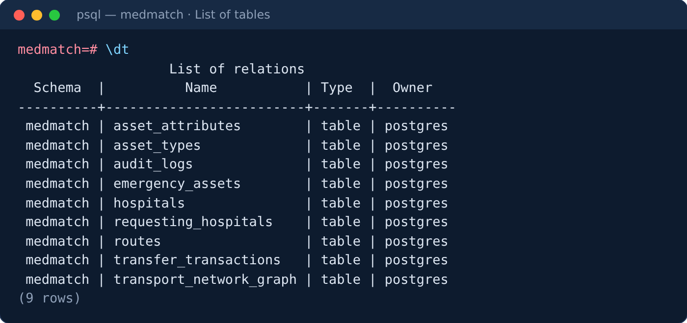
Figure 3: Tables in the medmatch schema (psql \dt)
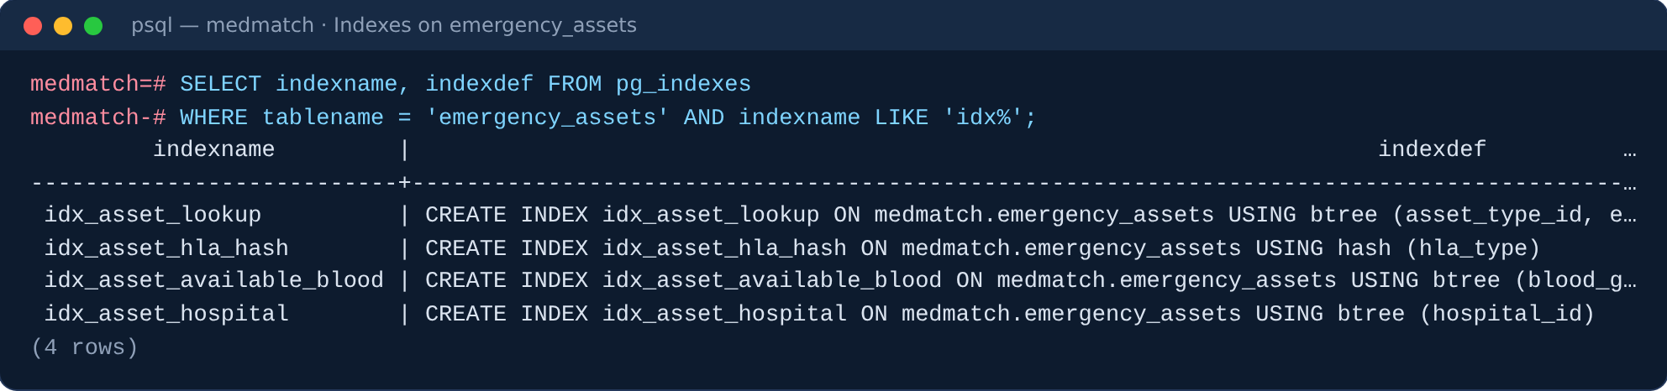
Figure 4: Indexes on emergency_assets

9.2 Sample records
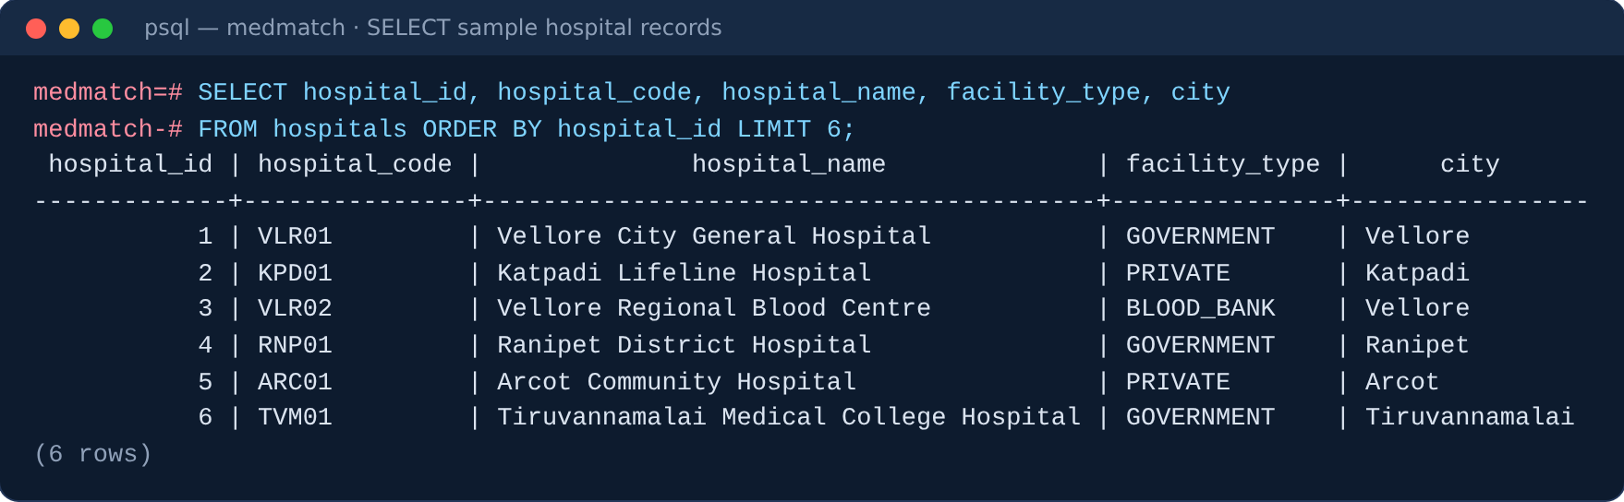
Figure 5: Sample hospital records

9.3 Execution of important queries
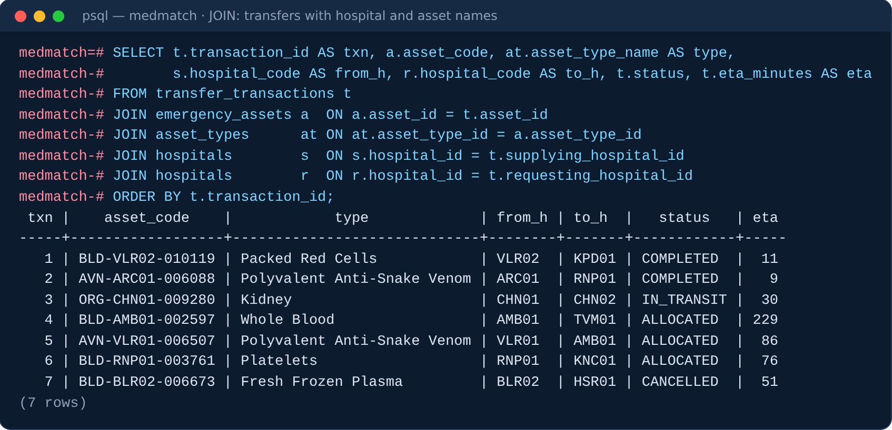
Figure 6: Five-table JOIN over transfers
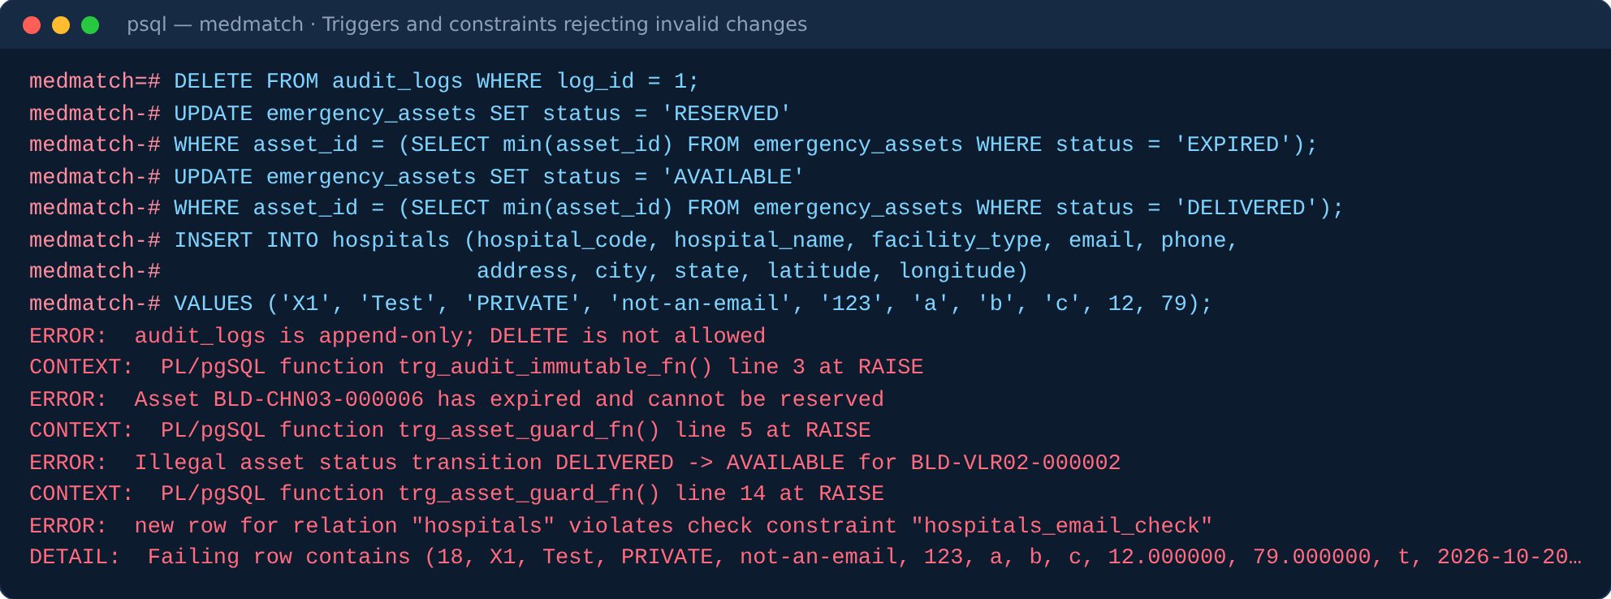
Figure 7: Triggers and constraints rejecting invalid changes
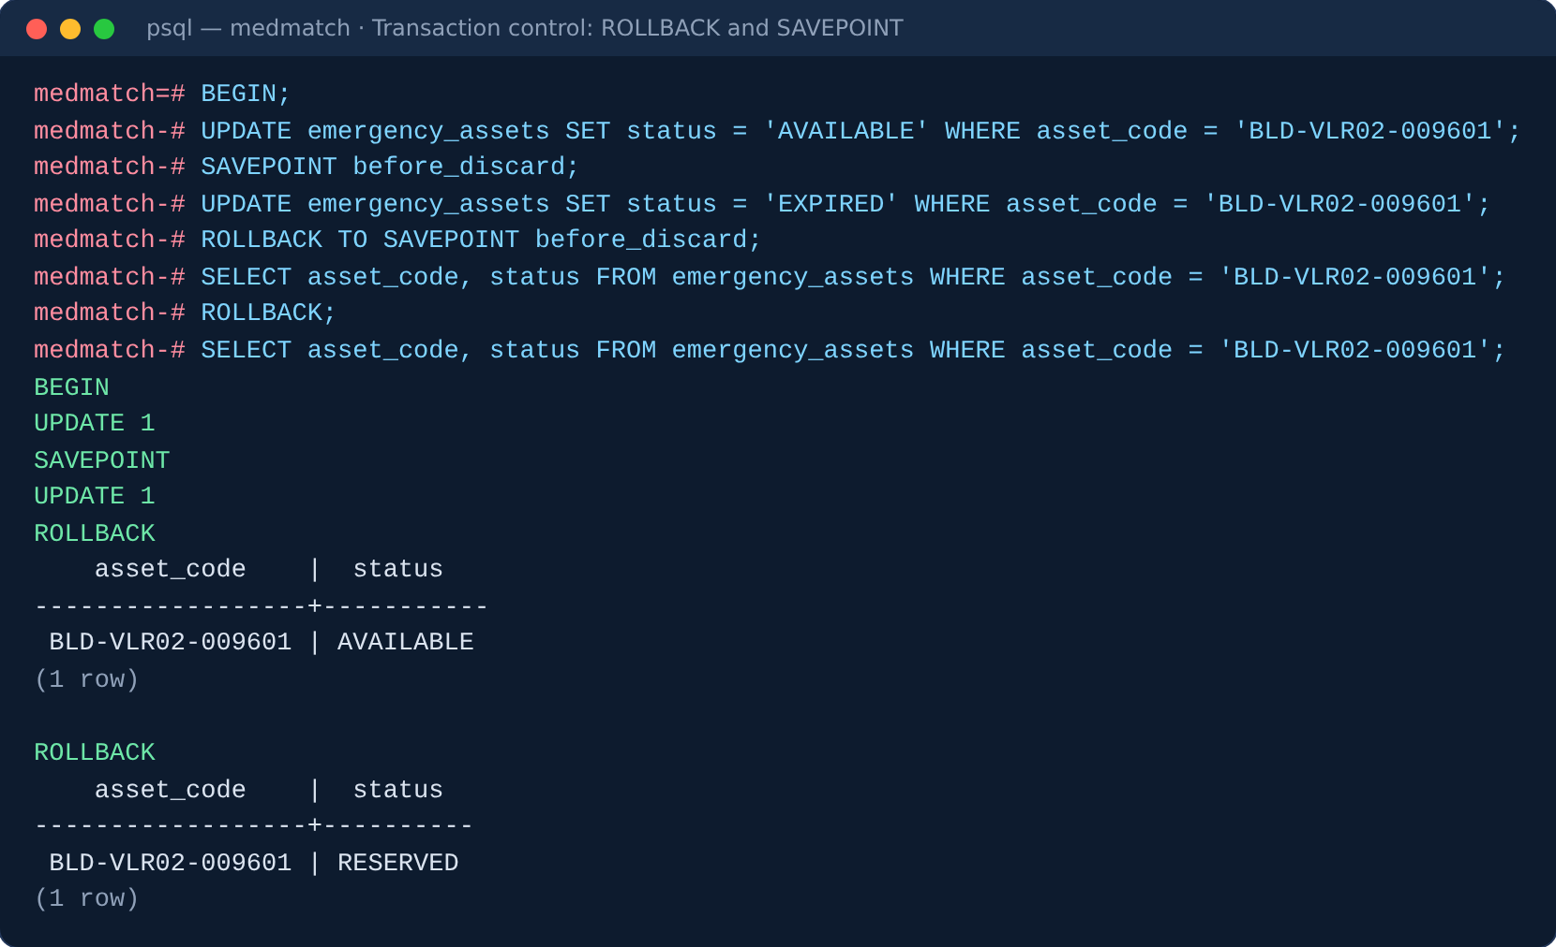
Figure 8: Transaction control with SAVEPOINT and ROLLBACK
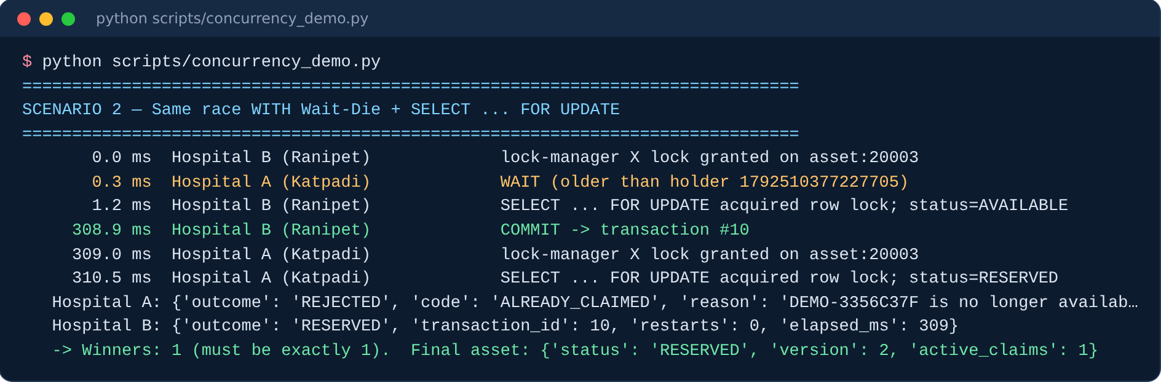
Figure 9: Race for the last unit with locking: exactly one winner
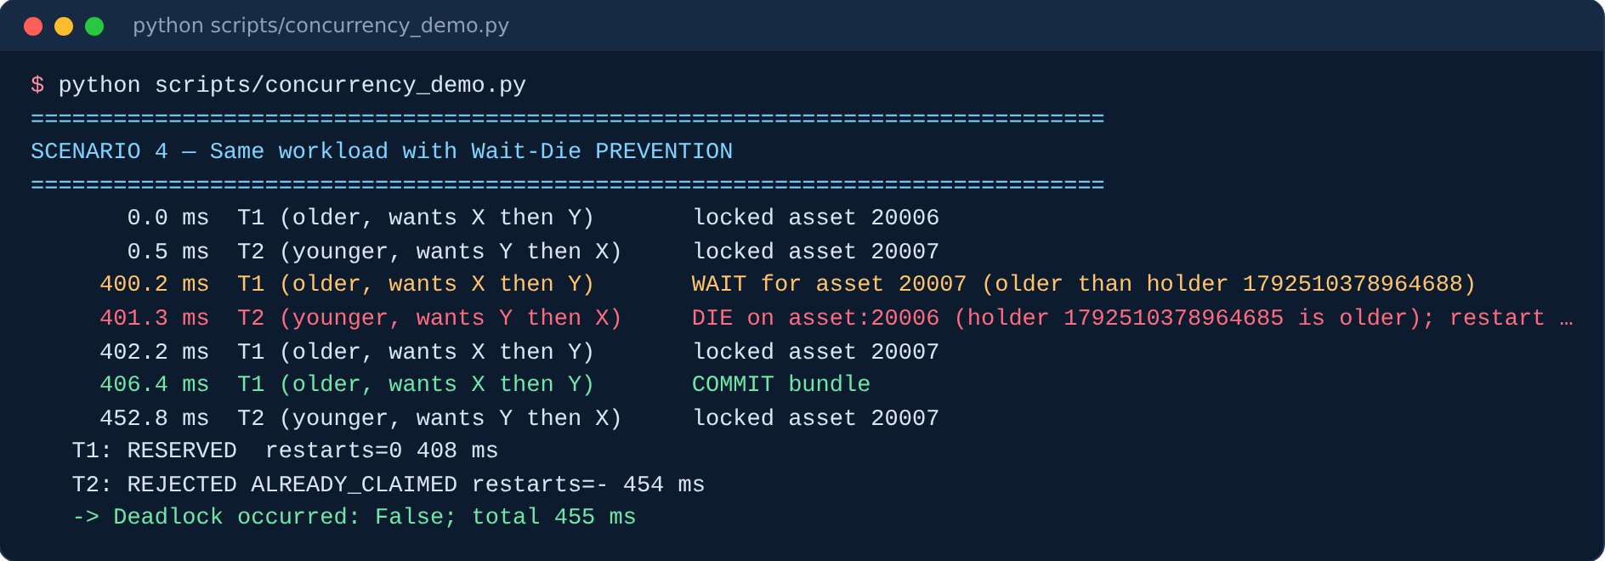
Figure 10: Wait-Die prevents the deadlock
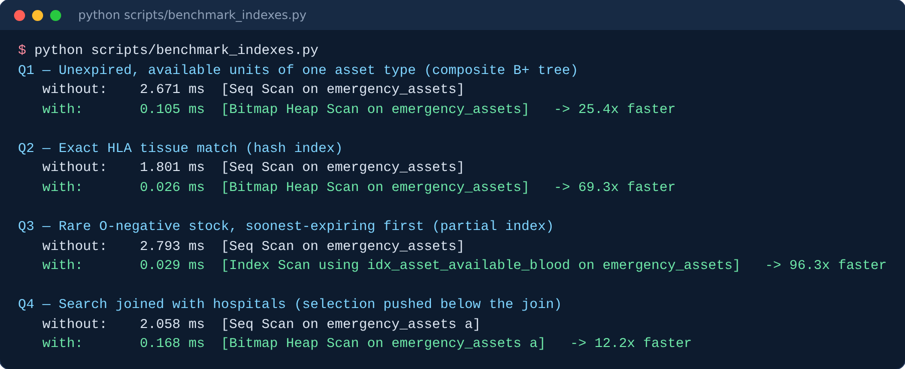
Figure 11: Index benchmark output

9.4 Application screenshots
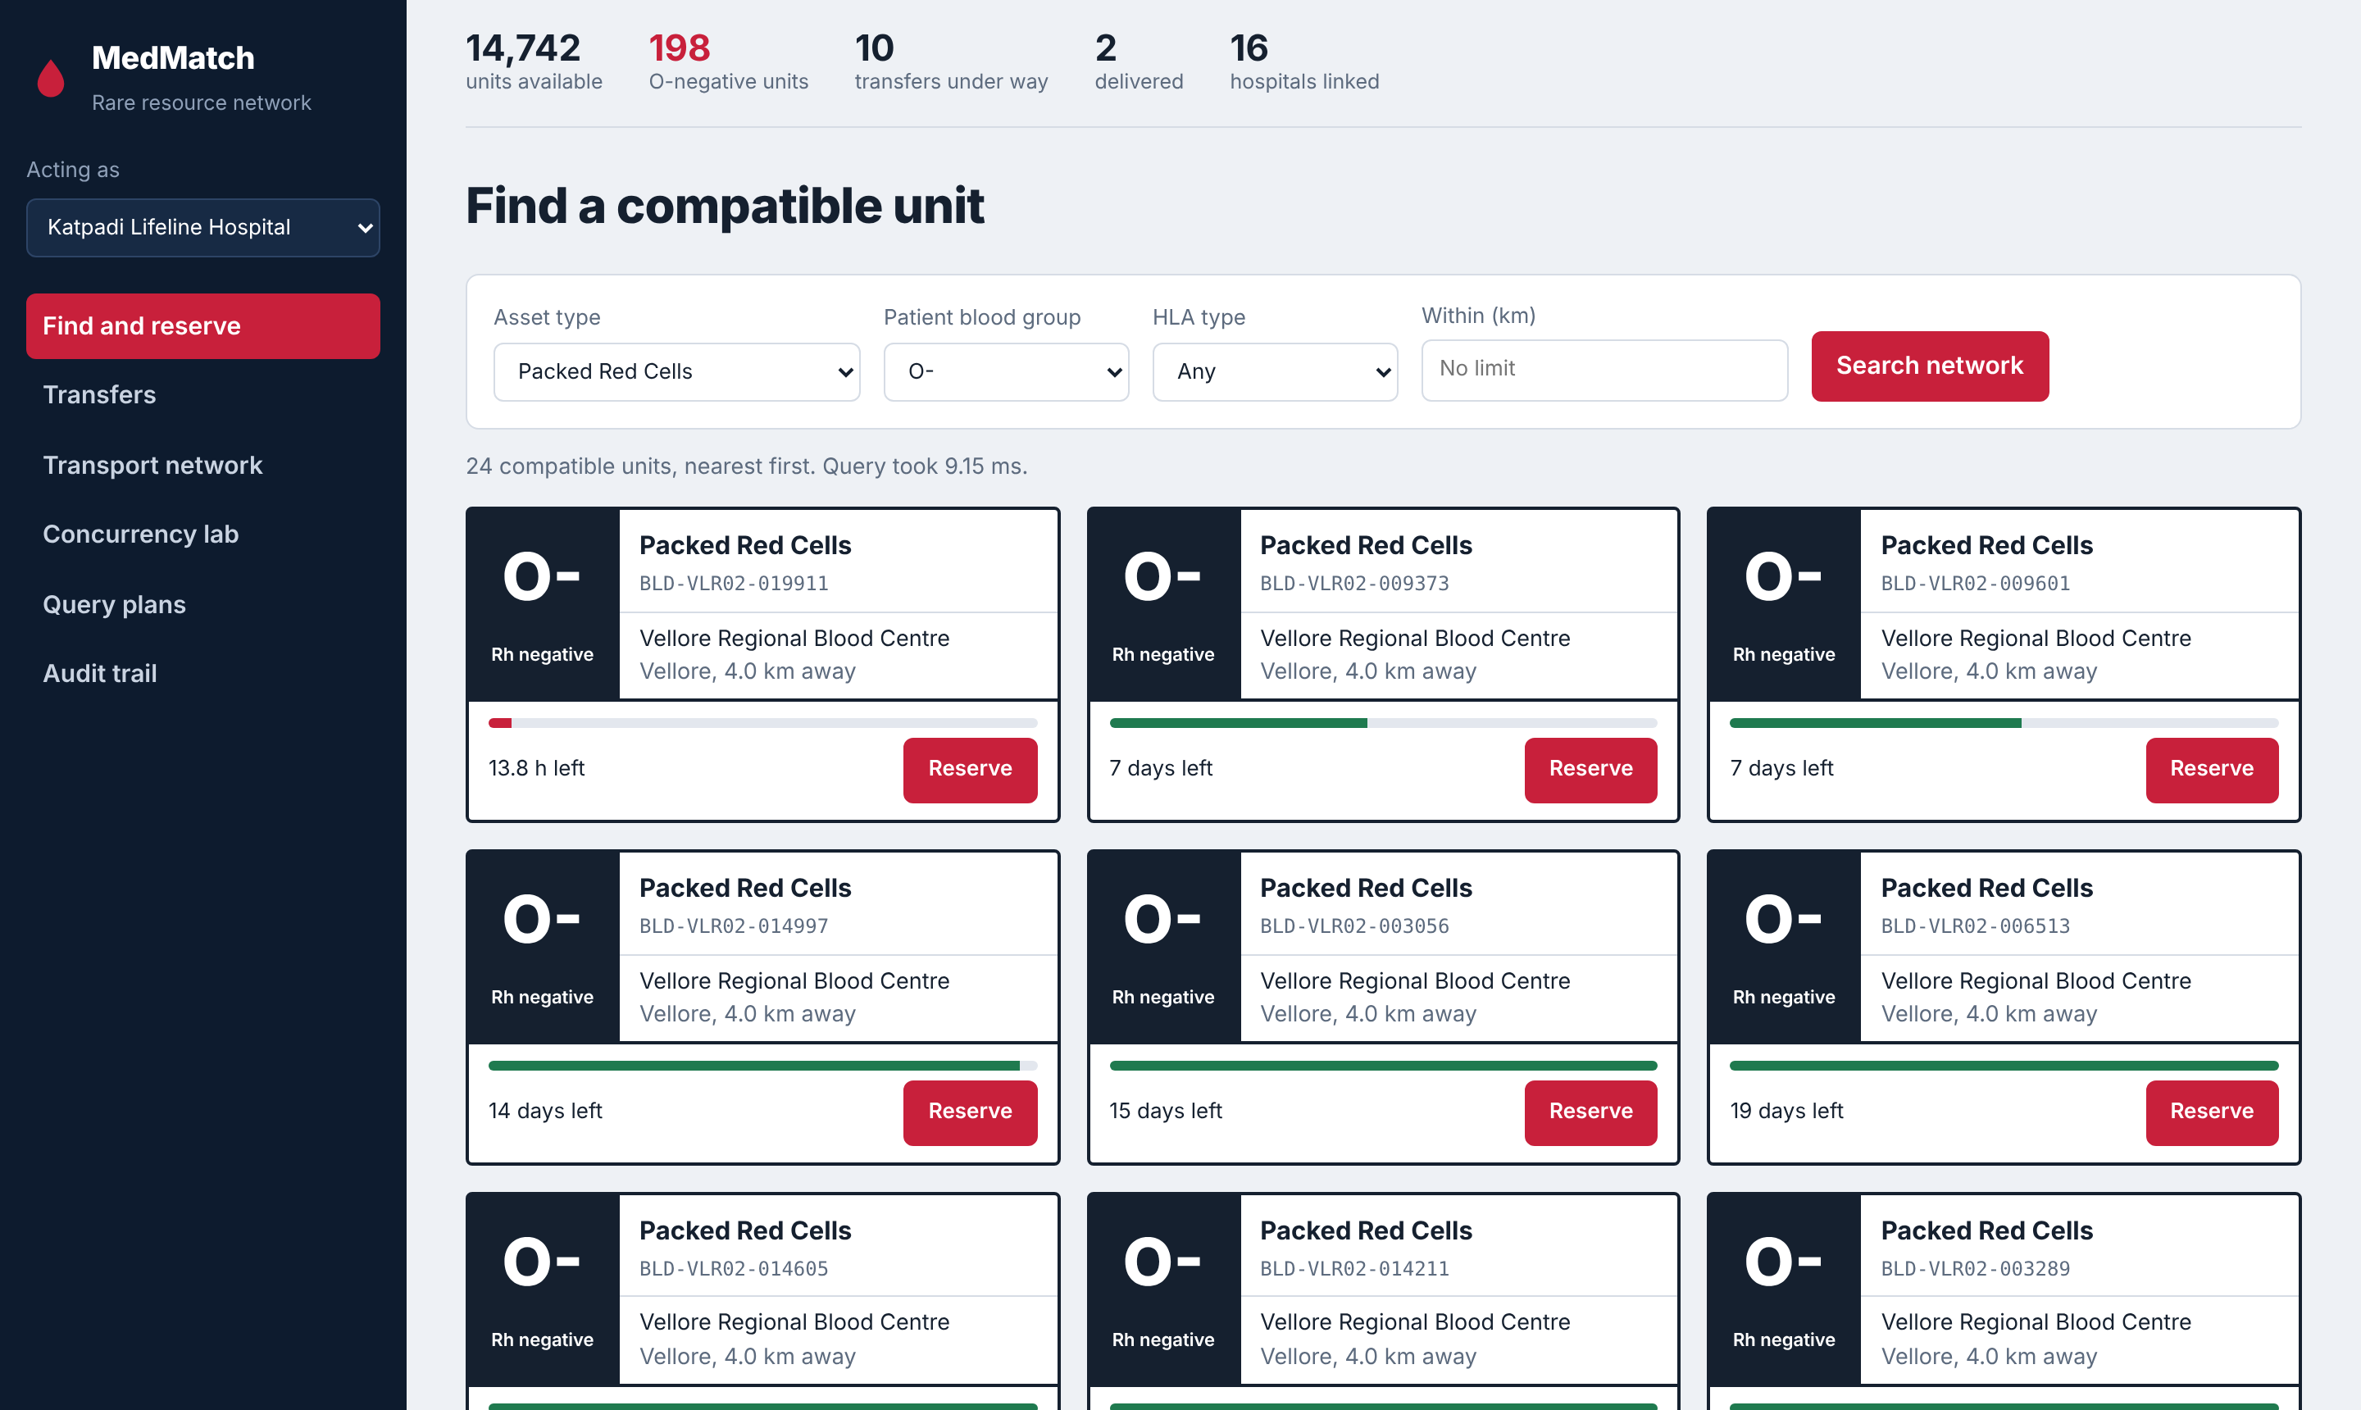
Figure 12: Find and reserve: compatible O-negative units, nearest and soonest-expiring first
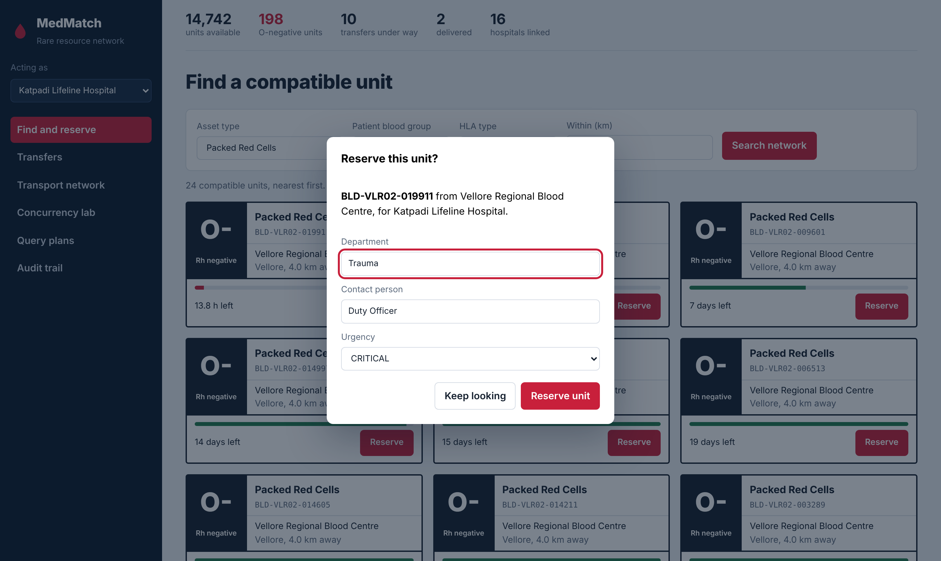
Figure 13: Reservation dialog
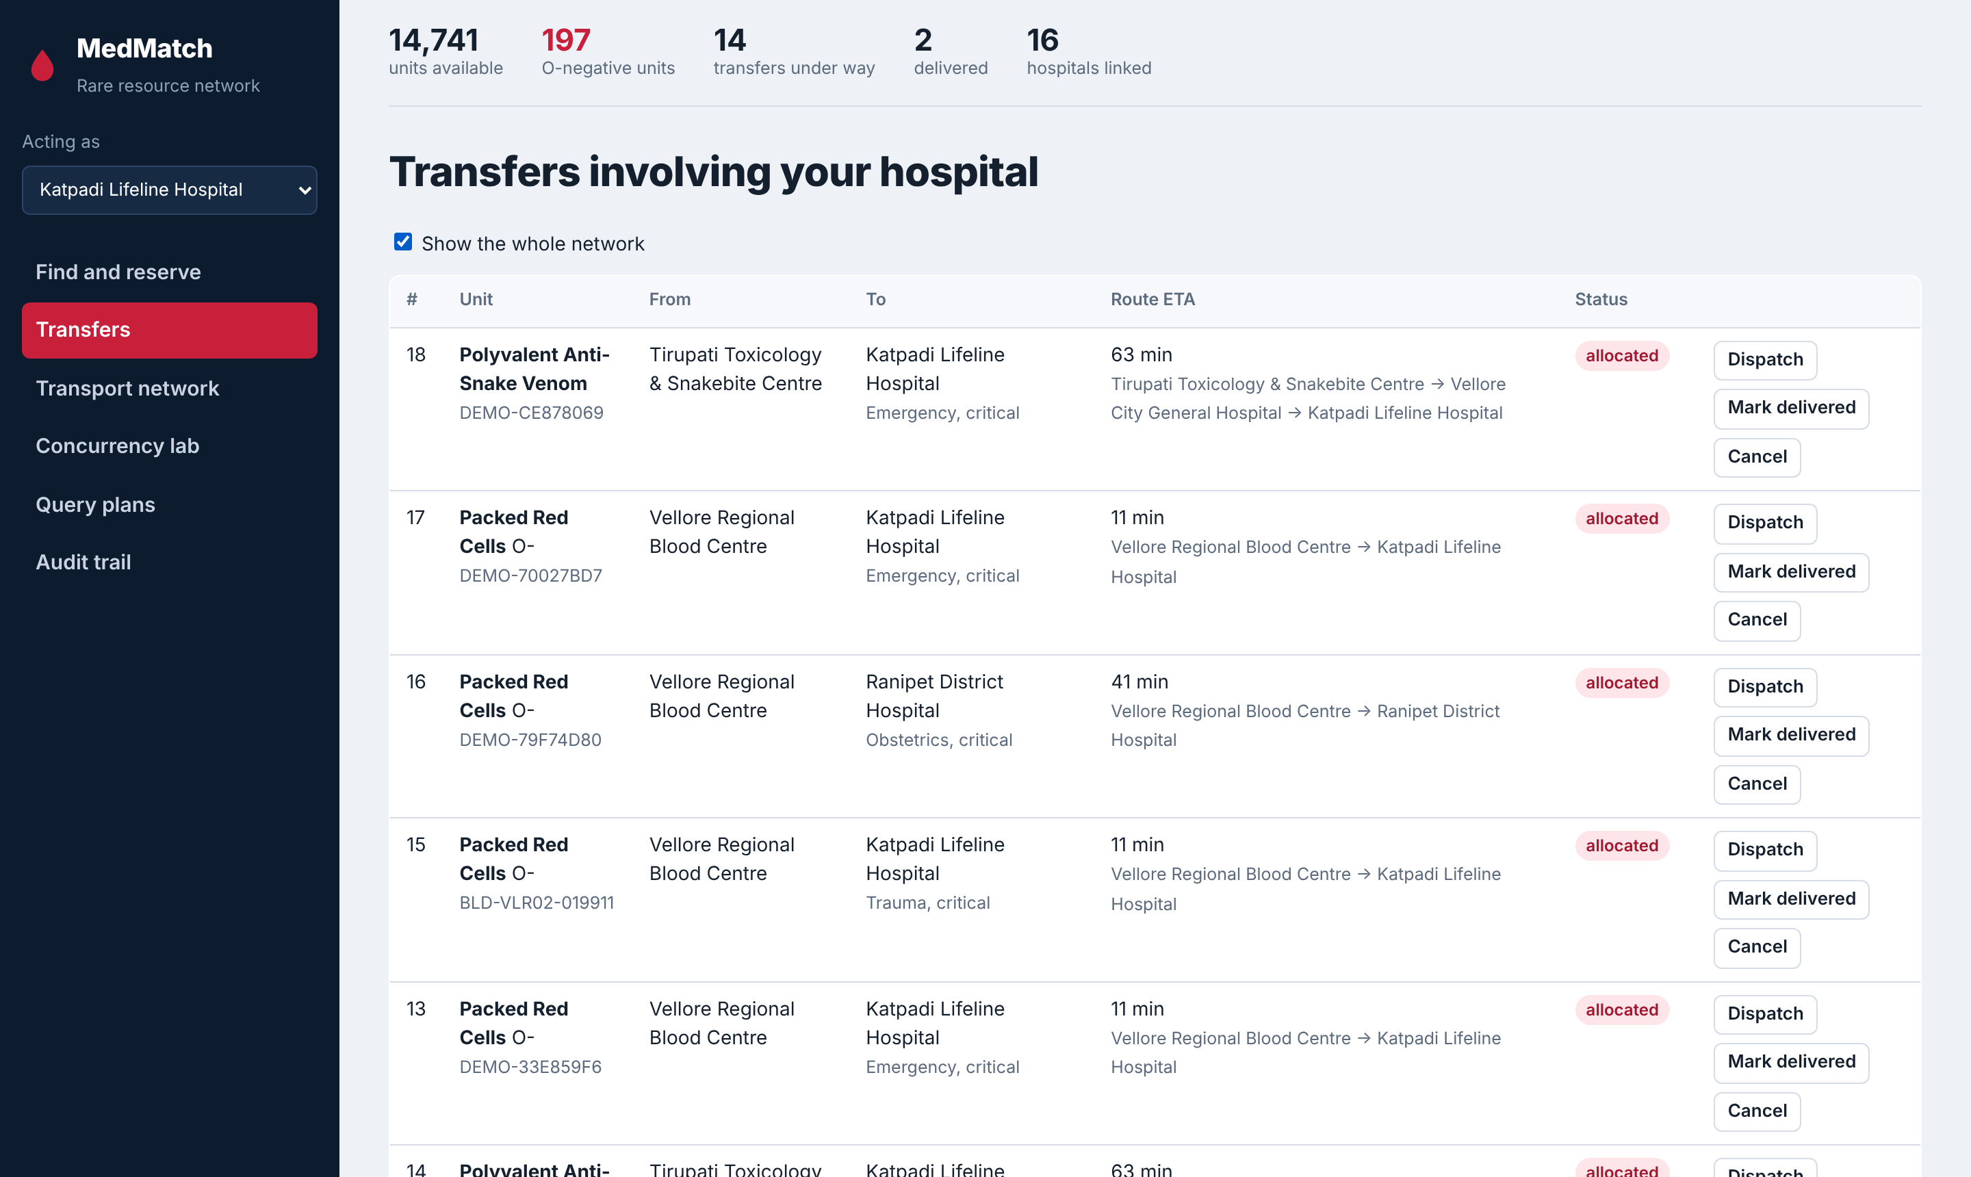
Figure 14: Transfers: route, travel time and status, with dispatch, deliver and cancel actions
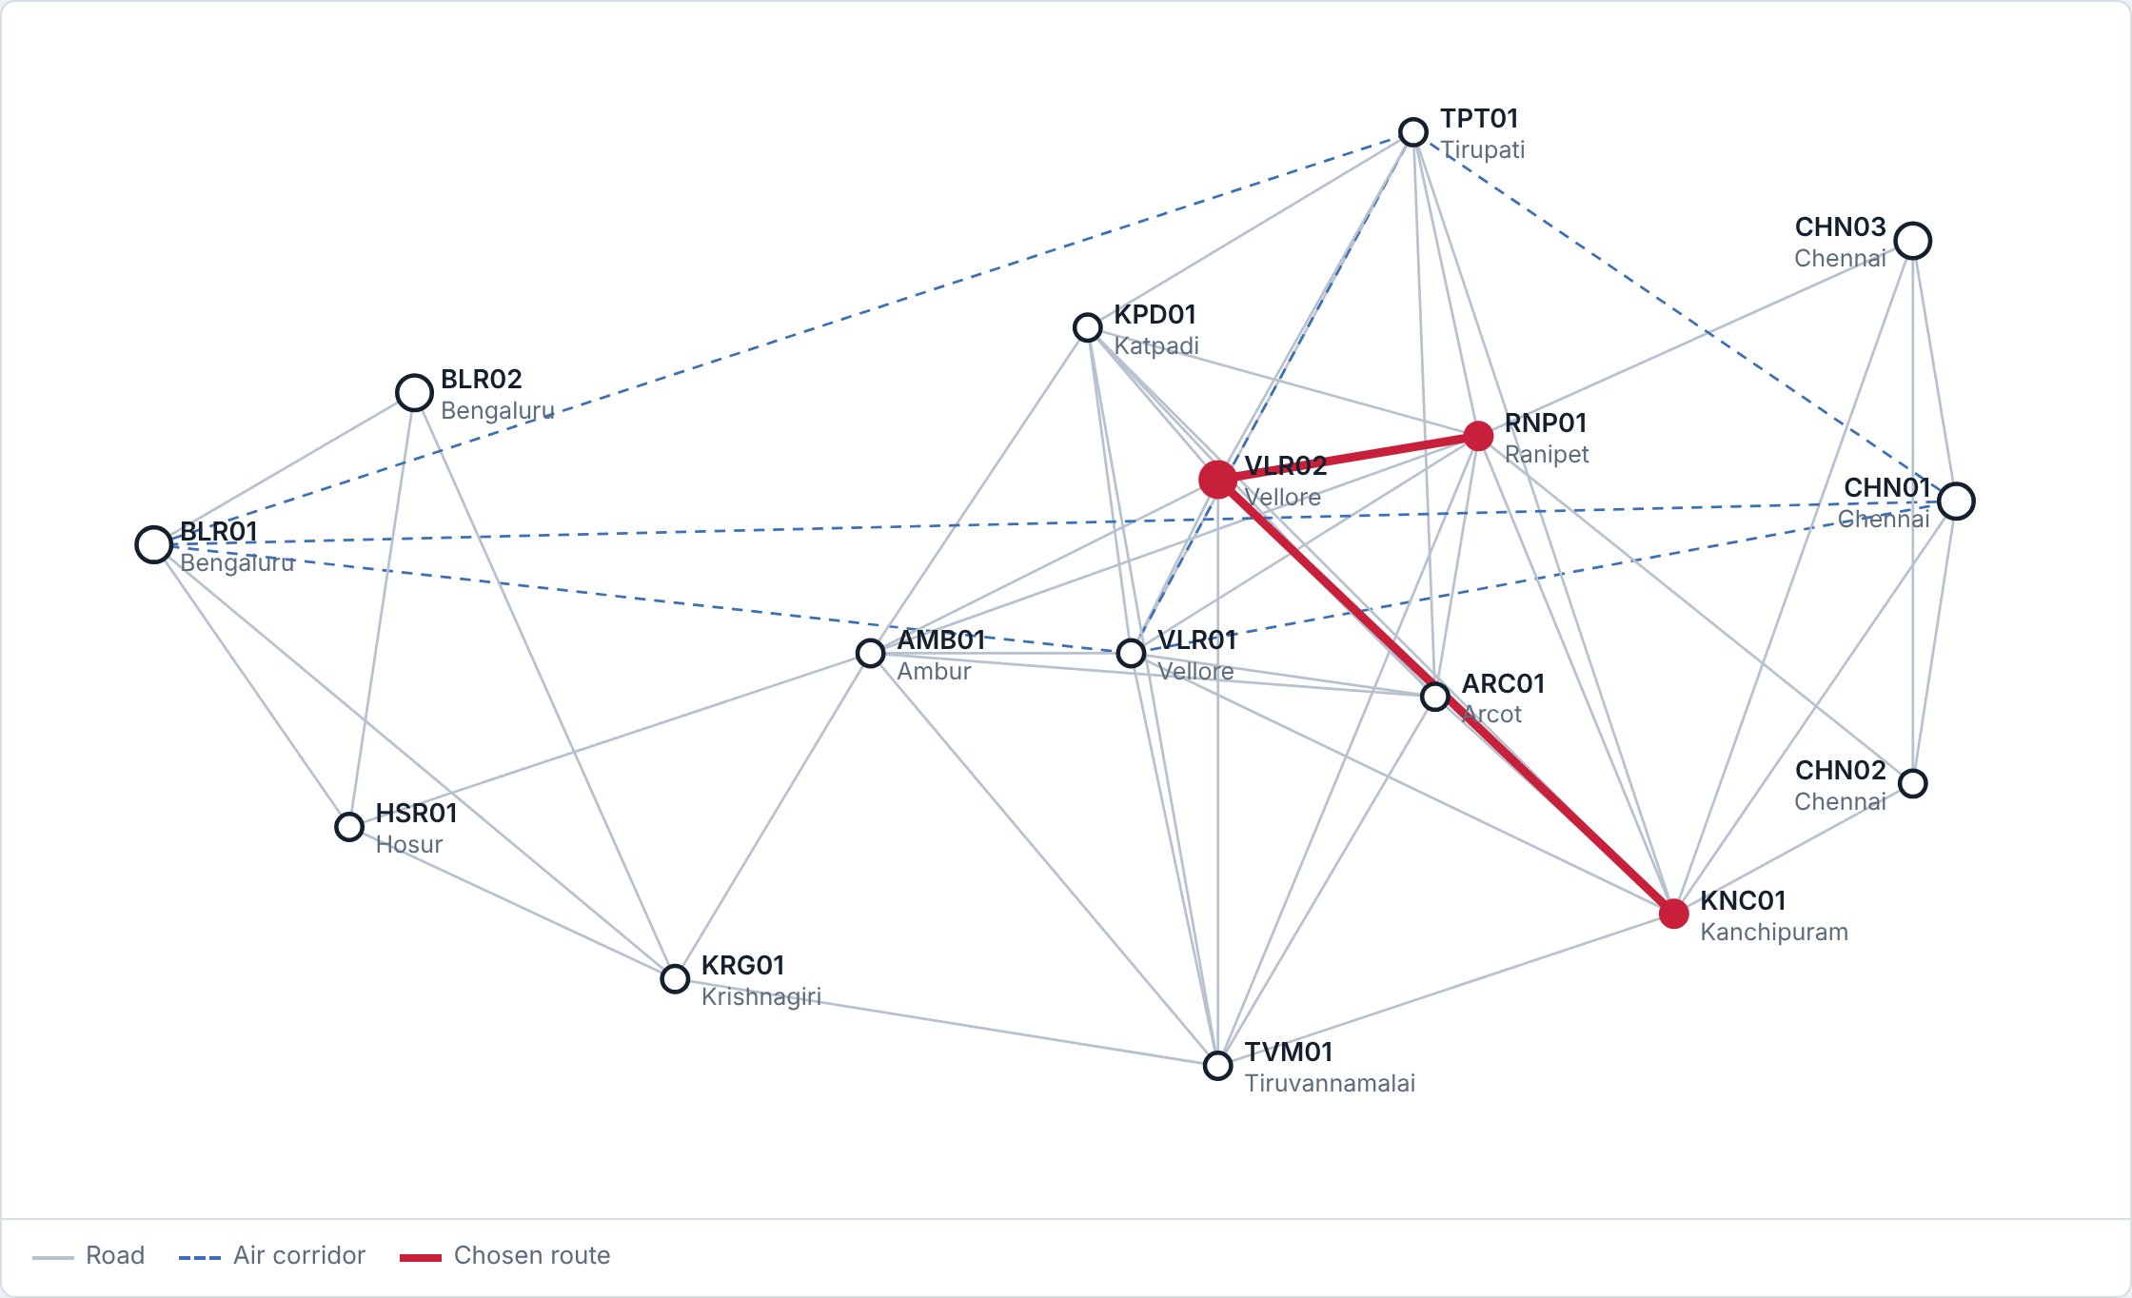
Figure 15: Transport network: cold-chain route from Ranipet to Kanchipuram (154 min)
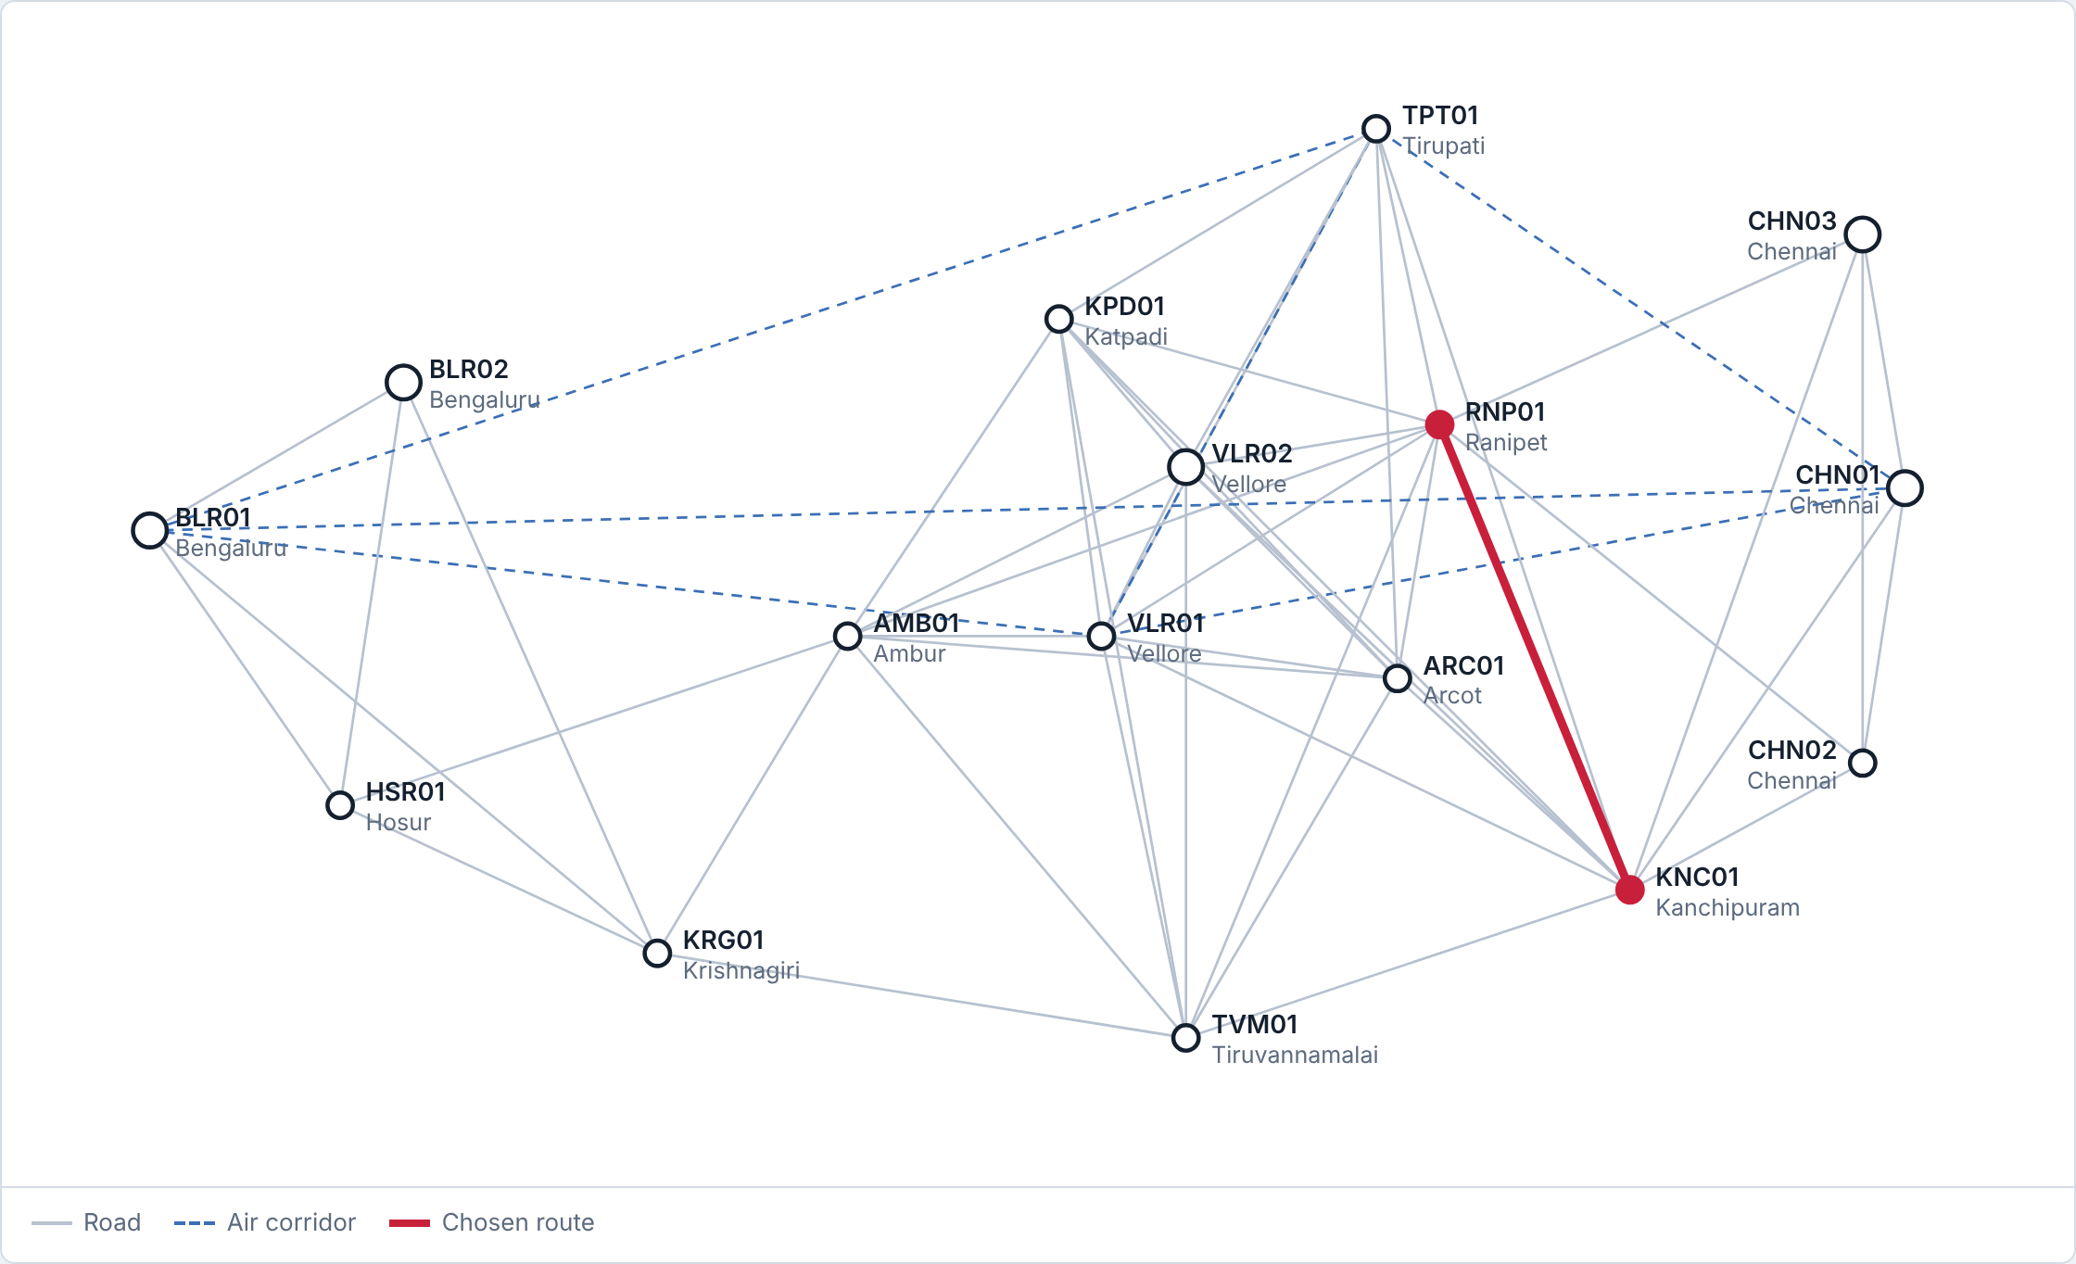
Figure 16: Same pair without the cold-chain requirement: direct road (76 min)
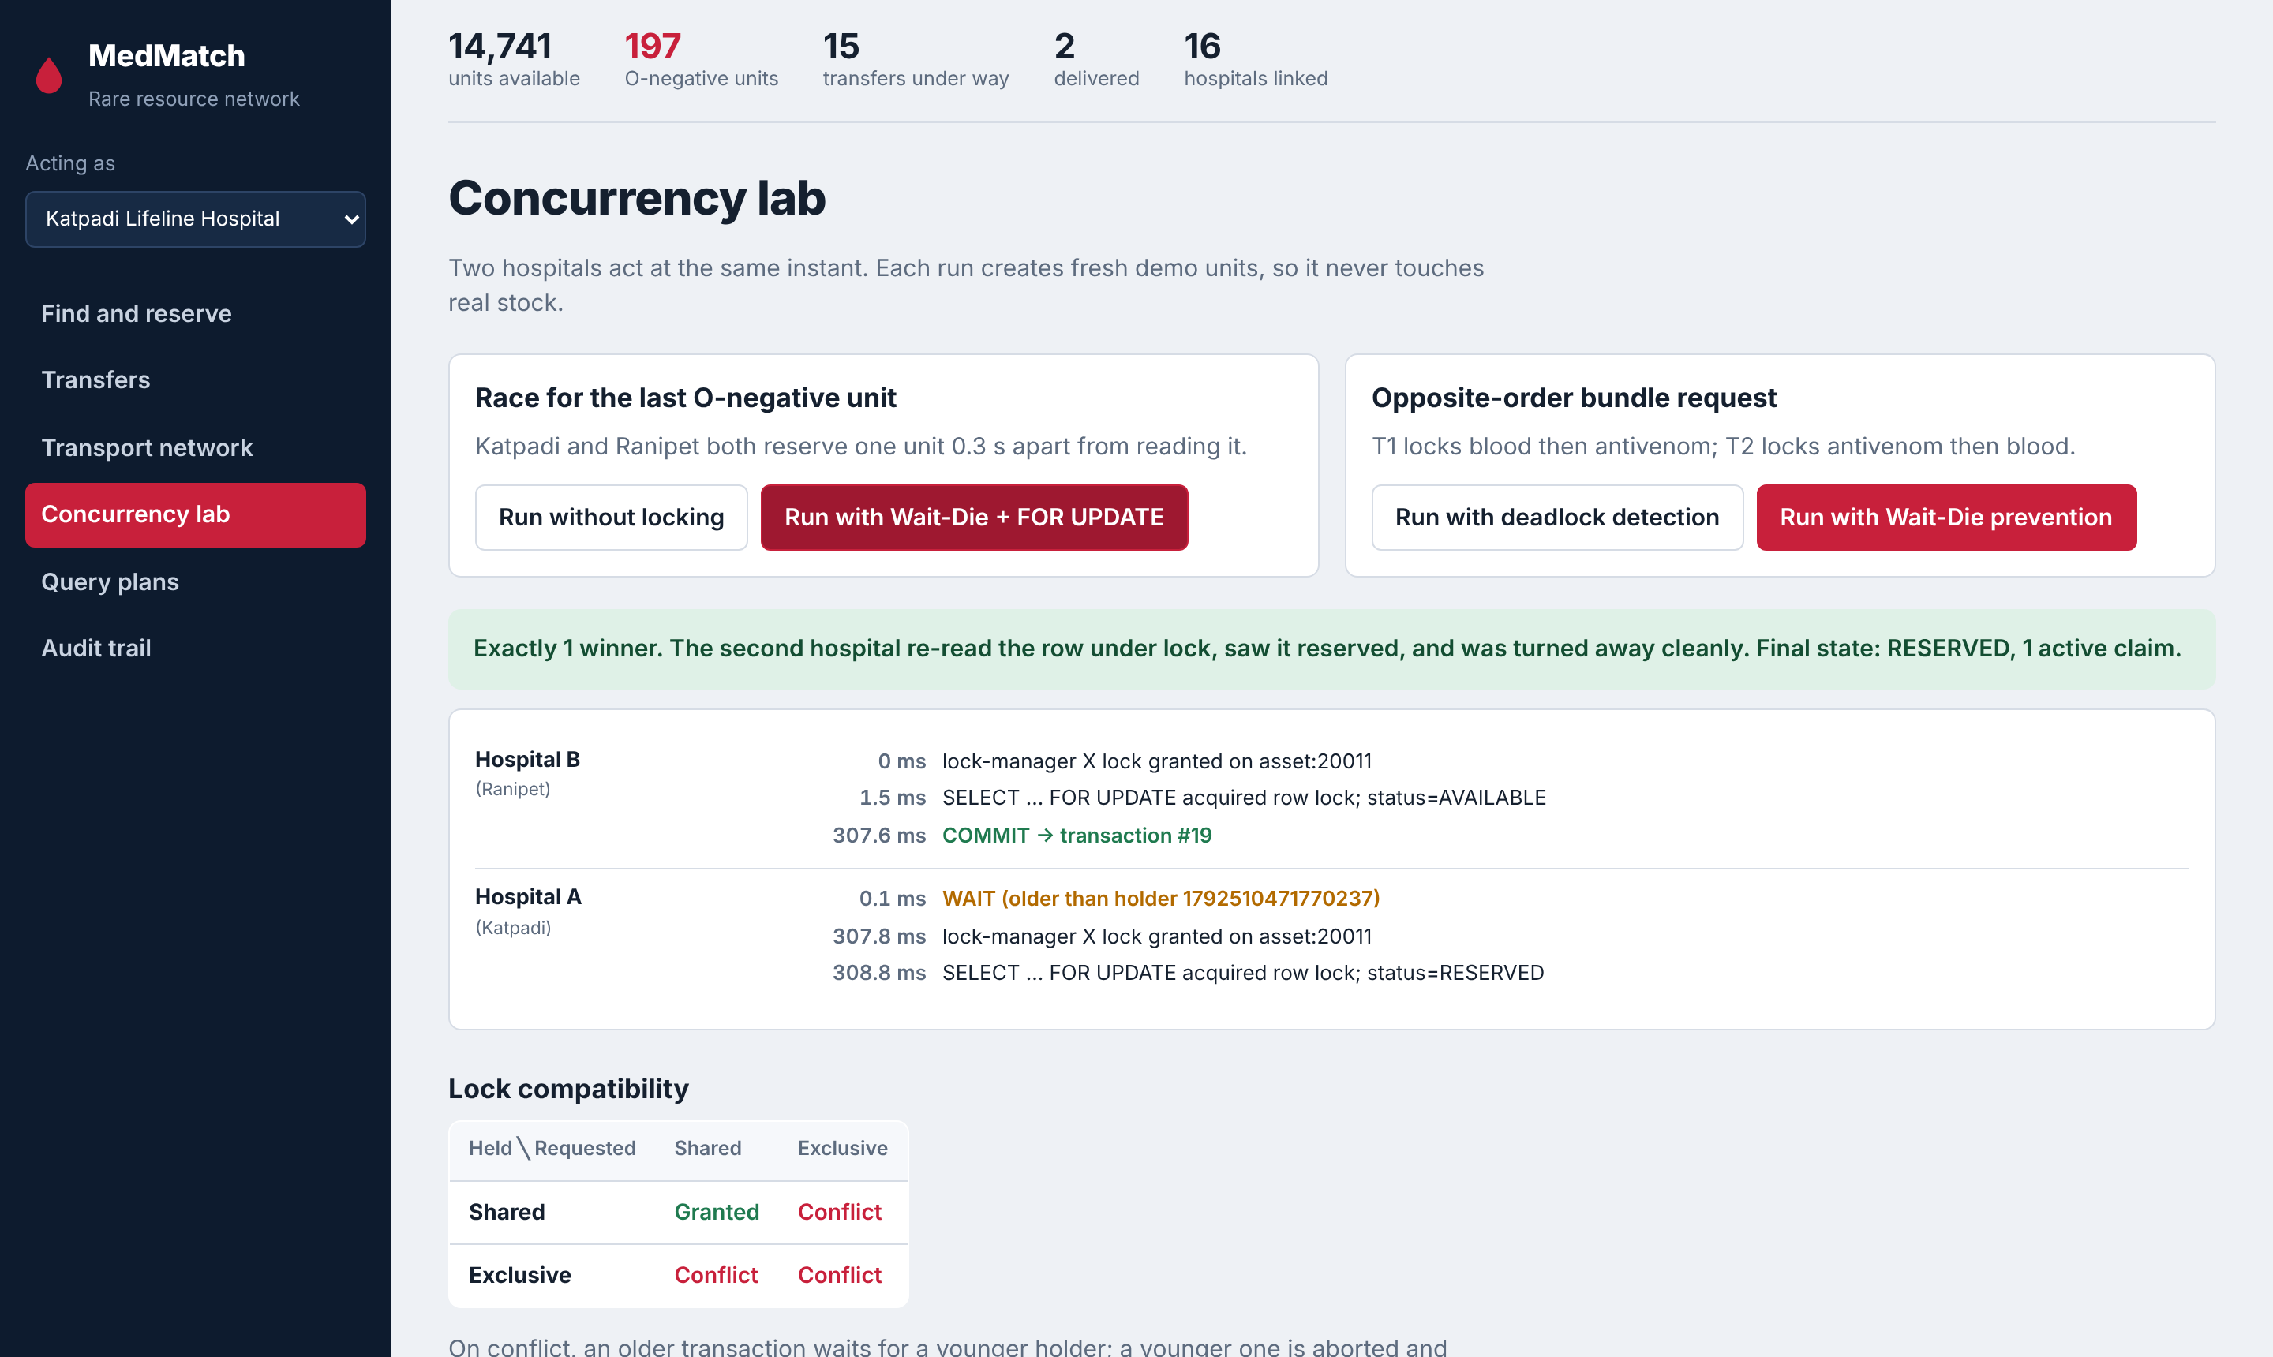
Figure 17: Concurrency lab: race with Wait-Die and SELECT … FOR UPDATE
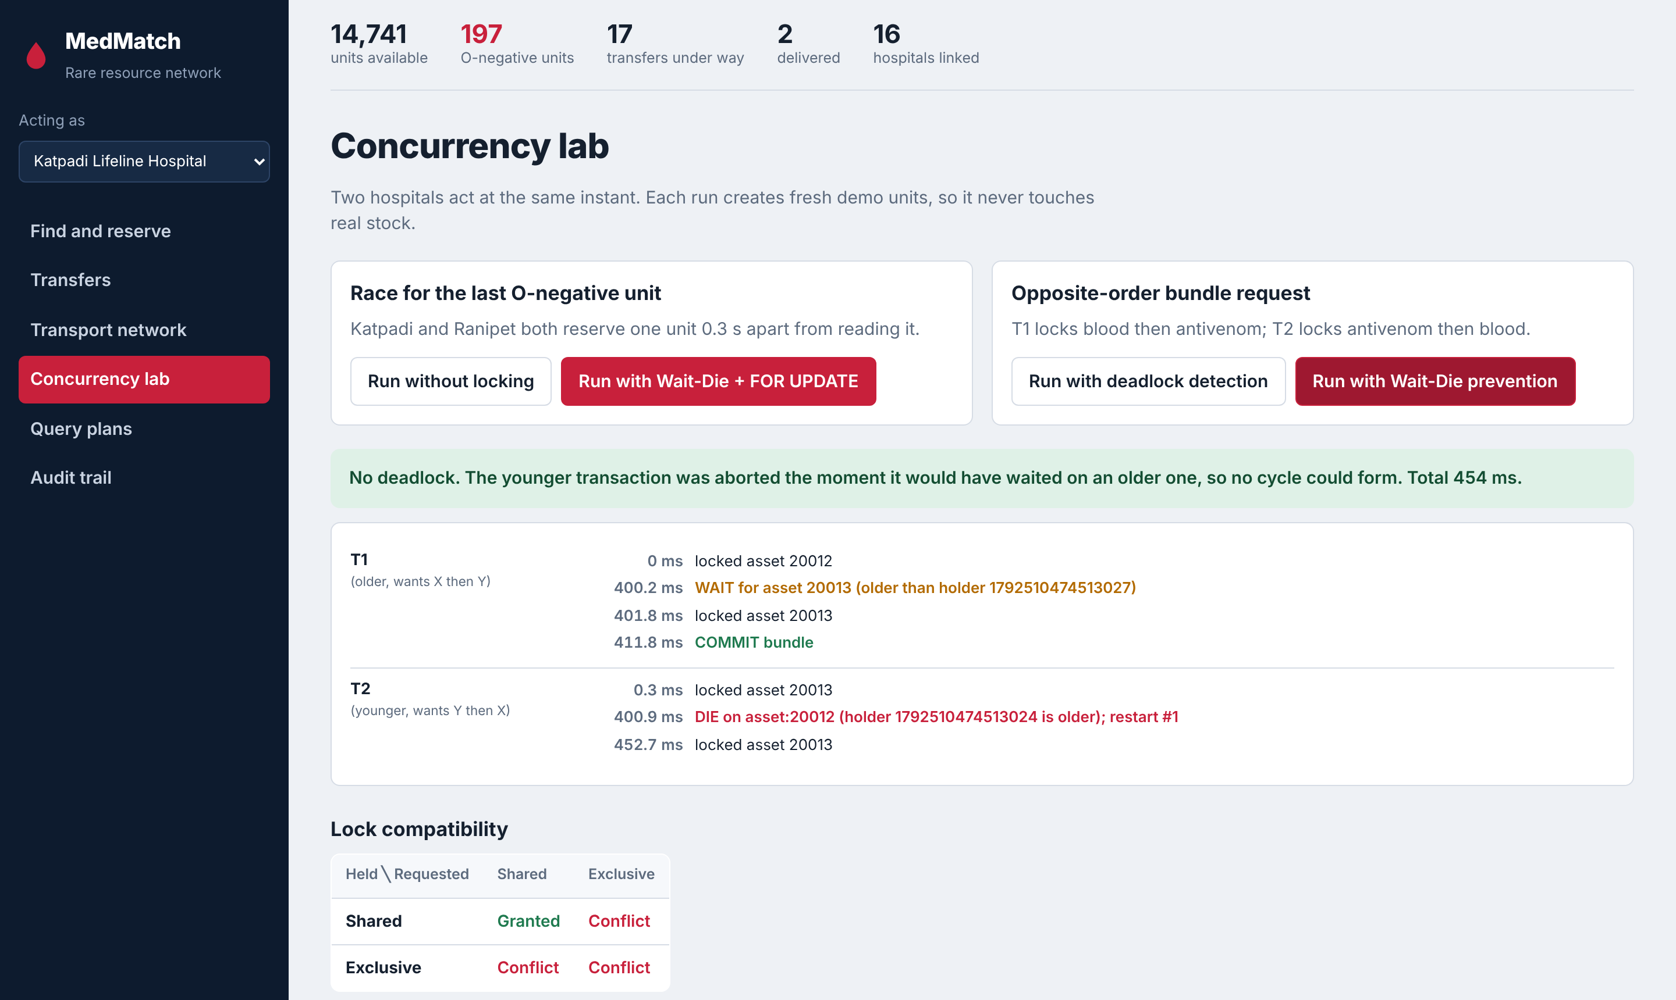
Figure 18: Concurrency lab: deadlock prevented by Wait-Die
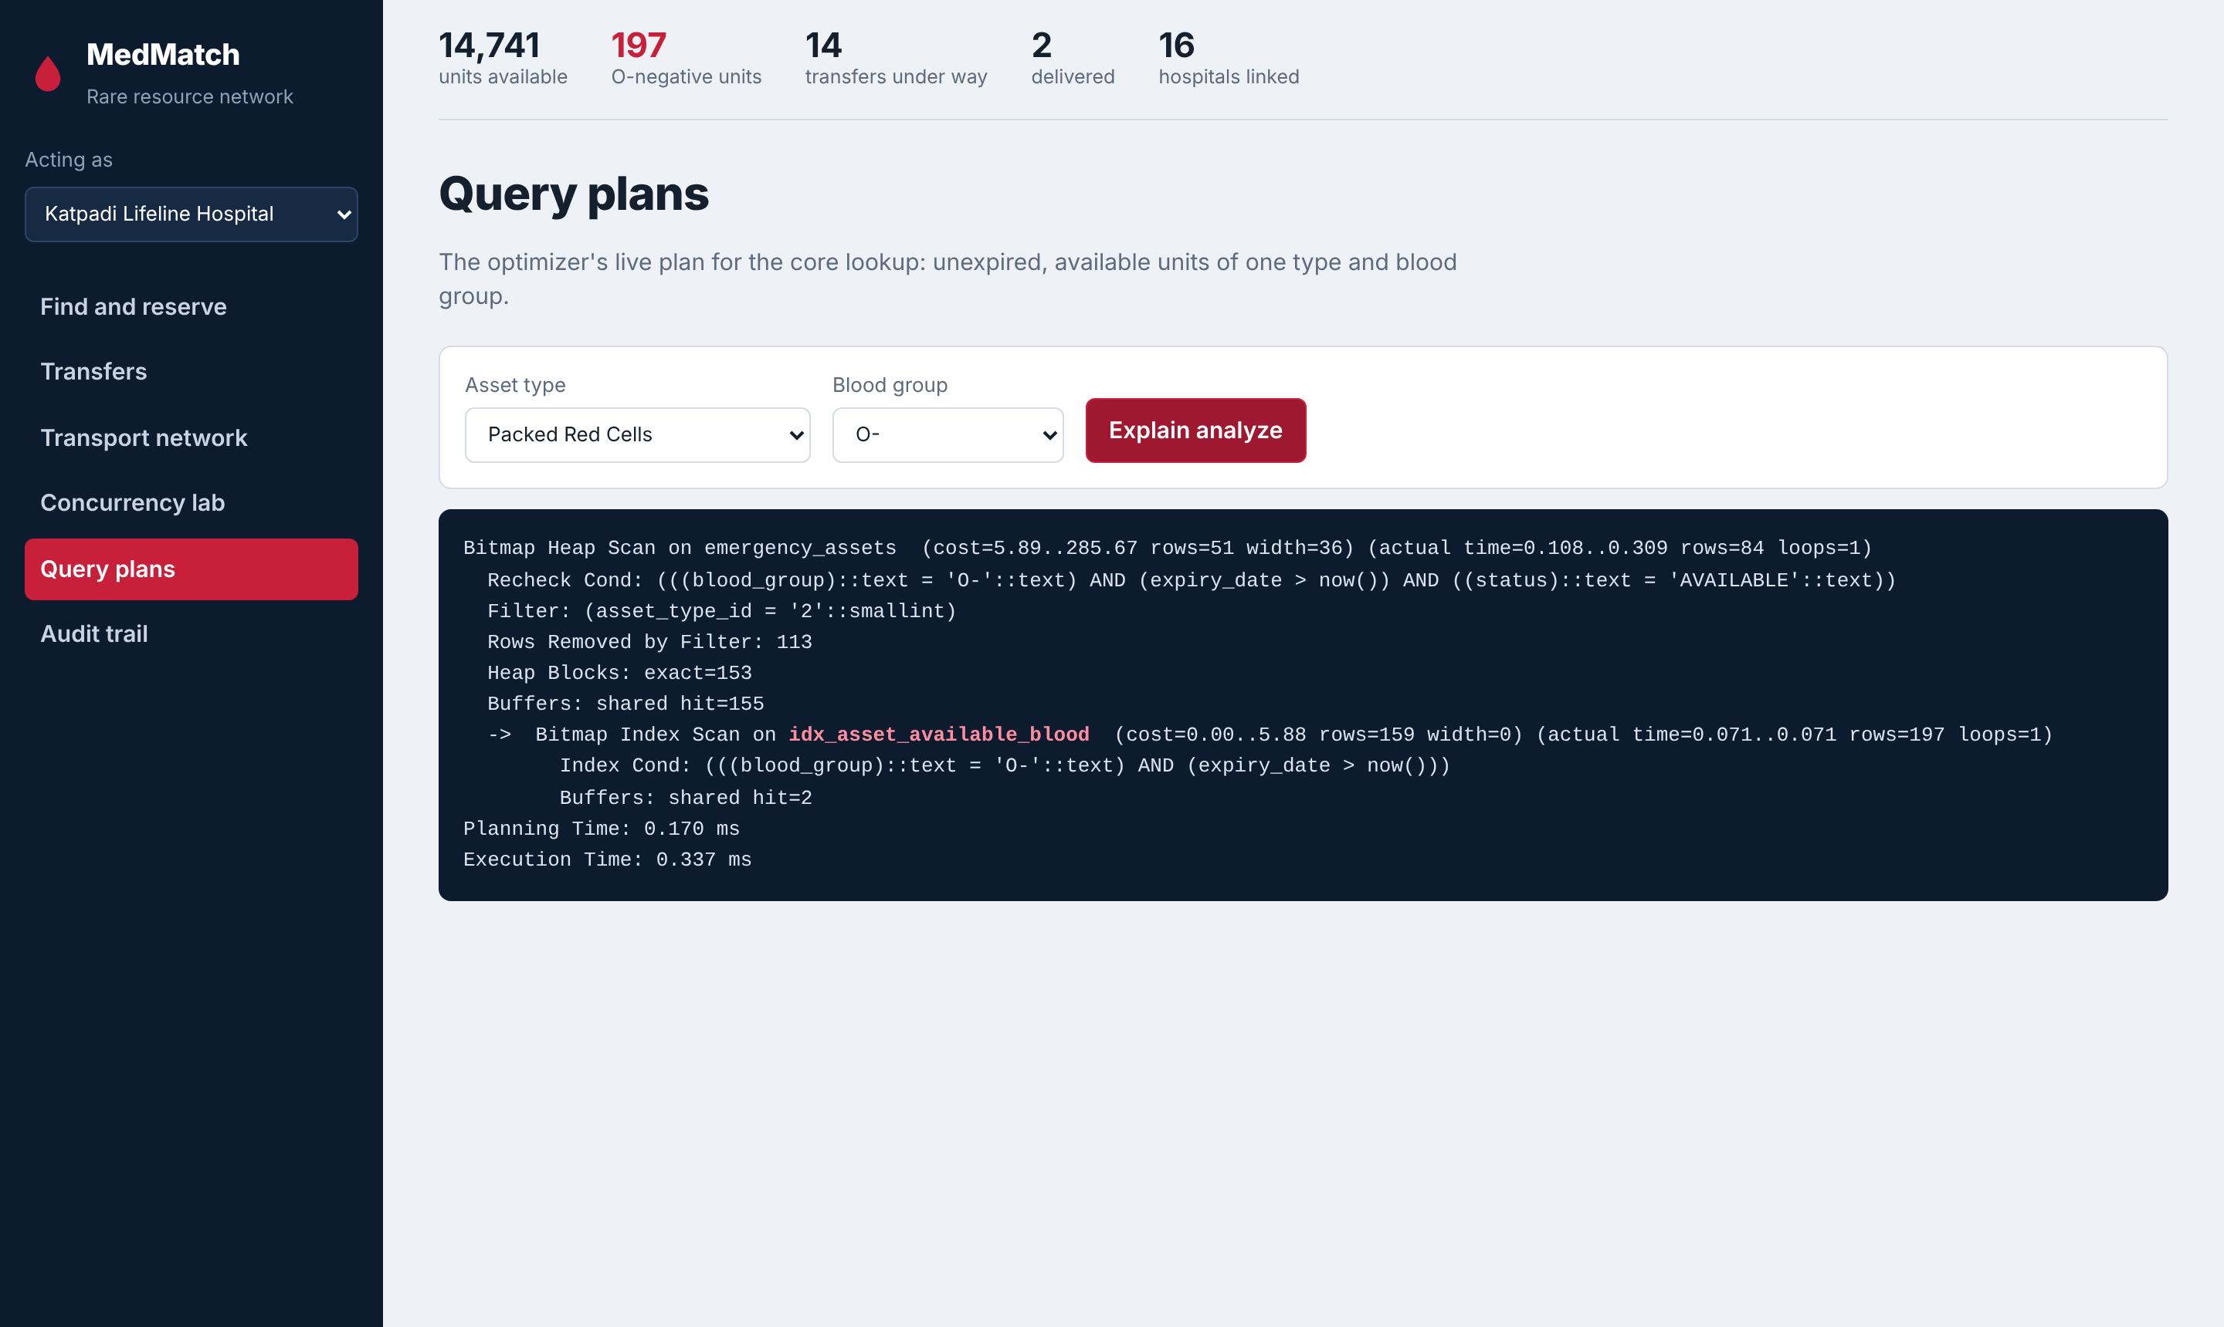
Figure 19: Query plans: live EXPLAIN ANALYZE with the index highlighted
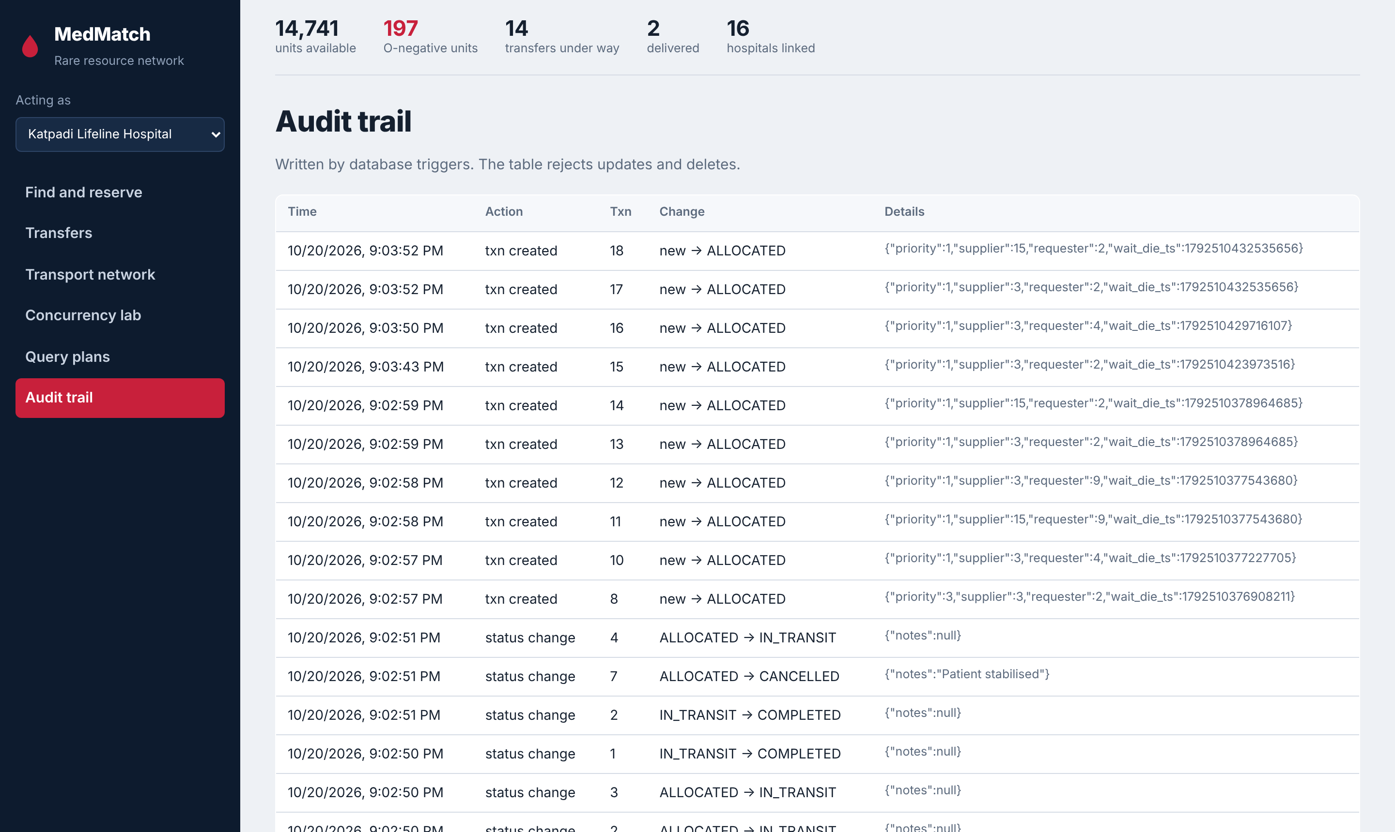
Figure 20: Audit trail written by triggers

10. Conclusion

10.1 Summary
MedMatch delivers a working inter-hospital network for finding, reserving and routing scarce medical assets. The relational schema is normalized to 3NF / BCNF, and its business rules are enforced inside PostgreSQL through constraints, triggers, functions and procedures, so they hold no matter which client connects. Neo4j complements it with fast, cold-chain-aware route finding.

10.2 Main features and benefits
- No double allocation. Strict 2PL with SELECT … FOR UPDATE gave exactly one winner when 15 hospitals competed for one unit.
- No deadlocks. Wait-Die resolved the opposite-order case in about 0.45 s, against about 1.4 s for PostgreSQL's own detection.
- Fast search. Composite B+ tree, hash and partial indexes made the core queries 12× to 96× faster than sequential scans.
- Safe delivery. Items that need refrigeration are routed only over temperature-controlled legs.
- Accountability. Every state change is recorded by triggers in an audit table that cannot be edited.
- Resilience. If Neo4j is unavailable, routing falls back to an in-memory Dijkstra, so reservations never block on the routing tier.

10.3 Future enhancements
- Authentication and per-hospital access control.
- Live traffic and weather data feeding route weights.
- A database-backed lock manager (PostgreSQL advisory locks) so several application servers can share it.
- Notifications to supplying hospitals and transport crews.
- Forecasting demand to pre-position rare stock.
Source code: https://github.com/akshith-types/medmatch

11. References
- A. Silberschatz, H. F. Korth and S. Sudarshan, Database System Concepts, 7th ed., McGraw-Hill, 2019.
- R. Elmasri and S. B. Navathe, Fundamentals of Database Systems, 7th ed., Pearson, 2016.
- PostgreSQL Global Development Group, “PostgreSQL 16 Documentation: Explicit Locking,” https://www.postgresql.org/docs/16/explicit-locking.html
- PostgreSQL Global Development Group, “PostgreSQL 16 Documentation: Index Types,” https://www.postgresql.org/docs/16/indexes-types.html
- PostgreSQL Global Development Group, “PostgreSQL 16 Documentation: Trigger Functions (PL/pgSQL),” https://www.postgresql.org/docs/16/plpgsql-trigger.html
- PostgreSQL Global Development Group, “PostgreSQL 16 Documentation: Transaction Isolation,” https://www.postgresql.org/docs/16/transaction-iso.html
- Neo4j, Inc., “Cypher Manual,” https://neo4j.com/docs/cypher-manual/current/
- Neo4j, Inc., “APOC Documentation: apoc.algo.dijkstra,” https://neo4j.com/docs/apoc/current/
- S. Ramírez, “FastAPI Documentation,” https://fastapi.tiangolo.com/
- D. Varrazzo, “Psycopg 3 Documentation,” https://www.psycopg.org/psycopg3/docs/
- NetworkX Developers, “NetworkX Documentation: Shortest Paths,” https://networkx.org/documentation/stable/
- Akshith M and Sanjaay B, “MedMatch: Inter-Hospital Rare Resource Logistics Network — source code,” GitHub, 2026. https://github.com/akshith-types/medmatch

