Machine Learning Engineer Nanodegree

Capstone Project
Akshith Palkamsetti
June 25th, 2018

I. Definition

Project Overview
Diabetes mellitus commonly referred to as diabetes, is a type of metabolic disorder in which there are high blood sugar levels over a prolonged period. People diagnosed with diabetes face Symptoms such as frequent urination, increased thirst, and increased hunger. If left untreated, diabetes can cause many complications which include cardiovascular disease, stroke, chronic kidney disease, foot ulcers, and damage to the eyes. Diabetes is due to either the pancreas not producing enough insulin or the cells of the body not responding properly to the insulin produced. There are three different types of Diabetes:
- Type 1 DM results from the pancreas's failure to produce enough insulin.
- Type 2 DM begins with insulin resistance, a condition in which cells fail to respond to insulin properly. As the disease progresses a lack of insulin may also develop.
- Gestational diabetes is the third main form, and occurs when pregnant women without a previous history of diabetes develop high blood sugar levels.
The most common cause for Diabetes is excessive body weight and insufficient exercise. As obesity has increased considerably in today's world Diabetes has become a common sight. It is estimated that 415 million people are living with diabetes in the world, which is estimated to be 1 in 11 of the world’s adult population. 46% of people with diabetes are undiagnosed. It would be beneficial if Diabetes can be diagnosed early or we could predict the risk a person has towards getting Diabetes. In this project I will build a model that can classify whether a person has diabetes or not by looking at some attributes.

Problem Statement
The problem is a machine learning classification problem. In this project we will use the Pima Indians diabetes dataset to predict whether a member has Diabetes or not. The Pima or Akimel O'odham (also called as "river people") are a group of Native Americans living in an area consisting of what is now central and southern Arizona. Pima Indians from the Gila River Indian Community in Arizona have a high incidence rate of type 2 diabetes, and kidney disease attributable to diabetes is a major cause of morbidity and mortality in this population. The members of the dataset are females of age 21 and above, who belong to the Pima Indian groups. In this problem we will be considering various potential causes for diabetes and by using Supervised learning algorithms we can predict the likelihood a person having diabetes.

Evaluation Metrics
In this project three tools will be used to evaluate the model. Accuracy, F beta-score (with β = 1) and the confusion matrix.
Accuracy and F-beta score is given by the formula below:
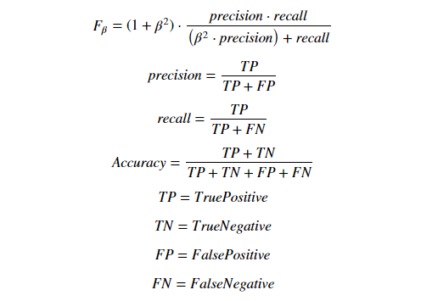

When we replace with β = 1 we get F1-score. It is the harmonic mean of precision and recall. When β<1 focus is more on the precision than on recall and when β>1 focus is more on recall.

A confusion matrix is a table that is often used to describe the performance of a classification model (or "classifier") on a set of test data for which the true values are known.

Below is the representation of the Confusion Matrix:

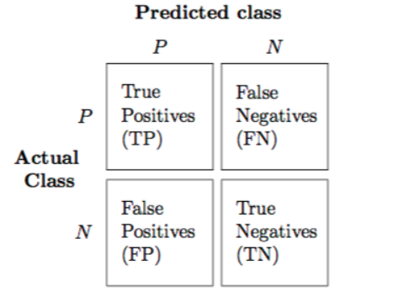

II. Analysis

Data Exploration
National Institute of Diabetes and Digestive and Kidney Diseases provided the Pima Indians Diabetes Database for research purpose to the UCL machine learning dataset web site. The diabetes check has conducted only on female patents in the times of their pregnancy. It contains 9 parameters among that 8 are input parameters and 1 is an output parameter. It contains 768 patient’s instances. I was not able to find the dataset in the UCL repository, hence I decided to use the dataset that can be found at [3] provided by Kaggle.

