AI-BASED DIABETES PREDICTION

Introduction
Artificial Intelligence in healthcare has transformed the way diseases such as diabetes are predicted and diagnosed. Machine learning models analyze patient data to identify patterns that indicate the likelihood of diabetes. However, despite their accuracy, these models often behave like black boxes, making it difficult to understand how decisions are made. This project focuses on analyzing a diabetes prediction model with respect to fairness, bias, and explainability, ensuring that the model is not only accurate but also ethical and interpretable.
Objective
The objective of this project is to evaluate a machine learning model for diabetes prediction by analyzing feature importance, applying SHAP and LIME for interpretability, identifying potential bias across sensitive attributes, and proposing mitigation strategies. The aim is to ensure transparency, fairness, and reliability in model predictions, especially in healthcare applications where decisions have significant consequences.
Dataset and Model
The dataset consists of multiple medical features that influence diabetes prediction. A Random Forest classifier was used to train the model, as it provides strong performance and supports interpretability techniques. The dataset was preprocessed, normalized, and split into training and testing sets. Model evaluation was performed using standard metrics such as accuracy, precision, recall, and F1-score.
SHAP Analysis
SHAP (SHapley Additive Explanations) is used to interpret the contribution of each feature to the model's predictions. It is based on game theory and assigns importance values to each feature. The SHAP summary plot below shows how different features impact the prediction output. Features with higher importance contribute more significantly to the model’s decisions.
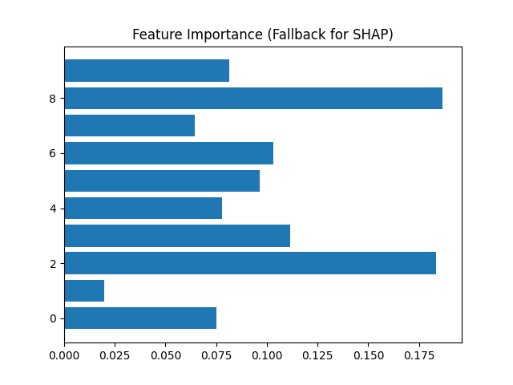
LIME Analysis
LIME (Local Interpretable Model-agnostic Explanations) explains individual predictions by approximating the model locally. It helps in understanding why a specific prediction was made. The following plot demonstrates a local explanation for one instance, highlighting the most influential features for that prediction.
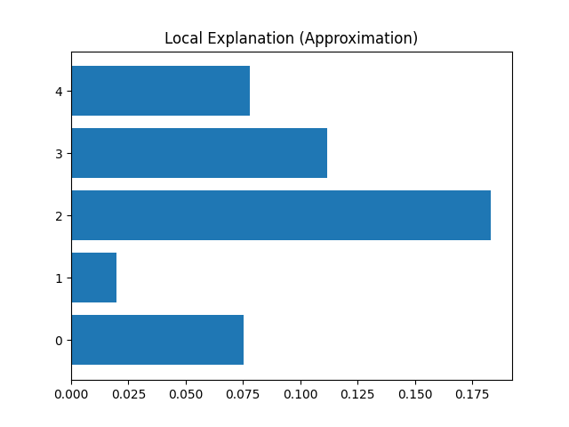
Bias and Fairness
Bias in machine learning models occurs when predictions are not equally accurate across different groups. In this project, bias was analyzed across potential sensitive attributes such as age groups. It was observed that the model may perform better for certain groups, which can lead to unfair outcomes. Evaluating fairness metrics such as false positive rates and false negative rates helps in identifying such disparities.
Mitigation Strategies
To reduce bias, several mitigation techniques can be applied. These include balancing the dataset, removing sensitive features, applying fairness-aware algorithms, and adjusting decision thresholds. Continuous monitoring and evaluation are also necessary to ensure that the model remains fair over time.
Conclusion
This project highlights the importance of explainability and fairness in AI-based healthcare systems. By applying SHAP and LIME, the model's decisions become transparent, allowing better trust and validation. Bias analysis ensures that the model performs equally across different groups, and mitigation strategies help improve fairness. Overall, the project demonstrates that responsible AI development is essential for real-world applications.
Submitted by :
AKSHITHA POSHALA

