AI Research Report on the Semiconductor Industry
India’s Semiconductor Mission and the Growth of India’s Chip Industry
VAC Capstone 12 | SemiResearch AI — AI-Powered Semiconductor Research & Verification Workspace
Research cut-off: 18 October 2026

Abstract
This capstone investigates how multiple AI tools can be combined to produce an evidence-based semiconductor research report. The study focuses on India’s Semiconductor Mission (ISM), major manufacturing and packaging projects, and the opportunities and risks affecting India’s ambition to become a semiconductor hub. Perplexity and Gemini were used for independent research, NotebookLM for source-grounded analysis of selected official material, and ChatGPT for prompt engineering, comparison, synthesis and content-generation assistance. Important factual claims were checked against Government of India / PIB and ISM sources before inclusion. The workflow also records outdated, conflicting, incorrect and unsupported AI claims instead of accepting AI output as fact.

Objective
To demonstrate a transparent multi-AI workflow that combines research, source verification, hallucination analysis, visual communication and automation to produce reliable final outputs.

Research Questions
- What are the main objectives, policies, and incentives of India’s Semiconductor Mission?
- What semiconductor manufacturing, assembly, testing, packaging, and chip-design projects have been announced or developed in India?
- What opportunities, challenges, and risks affect India’s ambition to become a semiconductor hub?

1. Methodology and AI Workflow
The same research scope was examined through multiple AI systems so that differences could be detected rather than hidden. Perplexity and Gemini provided independent research outputs. NotebookLM was then restricted to selected official sources for grounded analysis. ChatGPT organized the comparison, identified conflicts, supported verification, and synthesized only retained findings. AI agreement alone was not considered proof.
Tool | Role | Evidence treatment
Perplexity | Independent research and source discovery | Claims required verification
Gemini | Independent second research output | Compared with other tools
NotebookLM | Grounded analysis of selected official sources | Used to trace claims to supplied sources
ChatGPT | Prompt engineering, comparison, synthesis, drafting | Not treated as factual authority

Verification Workflow
Structured Prompt → Perplexity + Gemini → NotebookLM official-source grounding → Cross-tool comparison → Official-source verification → Error classification → Human review → Verified findings → Report / charts / presentation.

Prompt Engineering
The initial broad prompt was improved to require the three research questions, reliable sources, dates and investment values, explicit project-status labels, citations, and identification of uncertain claims. This made the outputs easier to compare and reduced ambiguity between announced, approved, under-construction and operational projects.

Research Sources
- India Semiconductor Mission (MeitY), official website.
- PIB: Semicon 2.0 update (PRID 2284796).
- PIB: Building India’s Semiconductor Ecosystem / Jewar update (PRID 2278446).
- PIB: SEMICON India 2026 / roadmap update (PRID 2311726).
- PIB: Precision Manufacturing Ecosystem update (PRID 2312207).

2. RQ1 — Objectives, Policies and Incentives
India’s semiconductor policy is intended to strengthen domestic semiconductor and display manufacturing, improve supply-chain resilience, attract investment and develop a broader design and manufacturing ecosystem. The Semicon India Programme 1.0 has an outlay of ₹76,000 crore. Official material used in this study also records Semicon 2.0, approved on 15 July 2026 with an outlay of ₹1,27,500 crore and six pillars. The verified research consistently identified fiscal support of up to 50% for eligible semiconductor projects under the programme framework.

Key policy findings
- Semicon India Programme 1.0: ₹76,000 crore outlay.
- Semicon 2.0: approved 15 July 2026; ₹1,27,500 crore outlay; six-pillar framework.
- Policy support covers semiconductor manufacturing as well as ecosystem development and design capability.
- Project status and dates must be checked against the latest official update because approvals and commissioning milestones change rapidly.

Design ecosystem
The official-source-grounded research identified 24 design projects, access to EDA tools for more than 105 startups/MSMEs, 23 tape-outs reported by June 2026, and approximately 70,000 people trained by September 2026. These indicators show that the mission is not limited to fabrication plants; it also includes chip design, skills and startup support.

Interpretation
The policy approach combines large-scale capital support with ecosystem-building measures. This is important because a semiconductor hub requires design talent, materials, equipment, packaging, testing, logistics and reliable infrastructure in addition to wafer fabrication.

3. RQ2 — Manufacturing, Packaging and Chip-Design Growth
The verified official information used in this project records 12 approved semiconductor manufacturing proposals with investment exceeding approximately ₹1.64 lakh crore. The portfolio comprises 1 silicon fab, 2 compound/specialty semiconductor fabs and 9 packaging / ATMP / OSAT projects. This composition shows a strong early emphasis on assembly, testing and packaging while large wafer-fabrication capacity continues to develop.
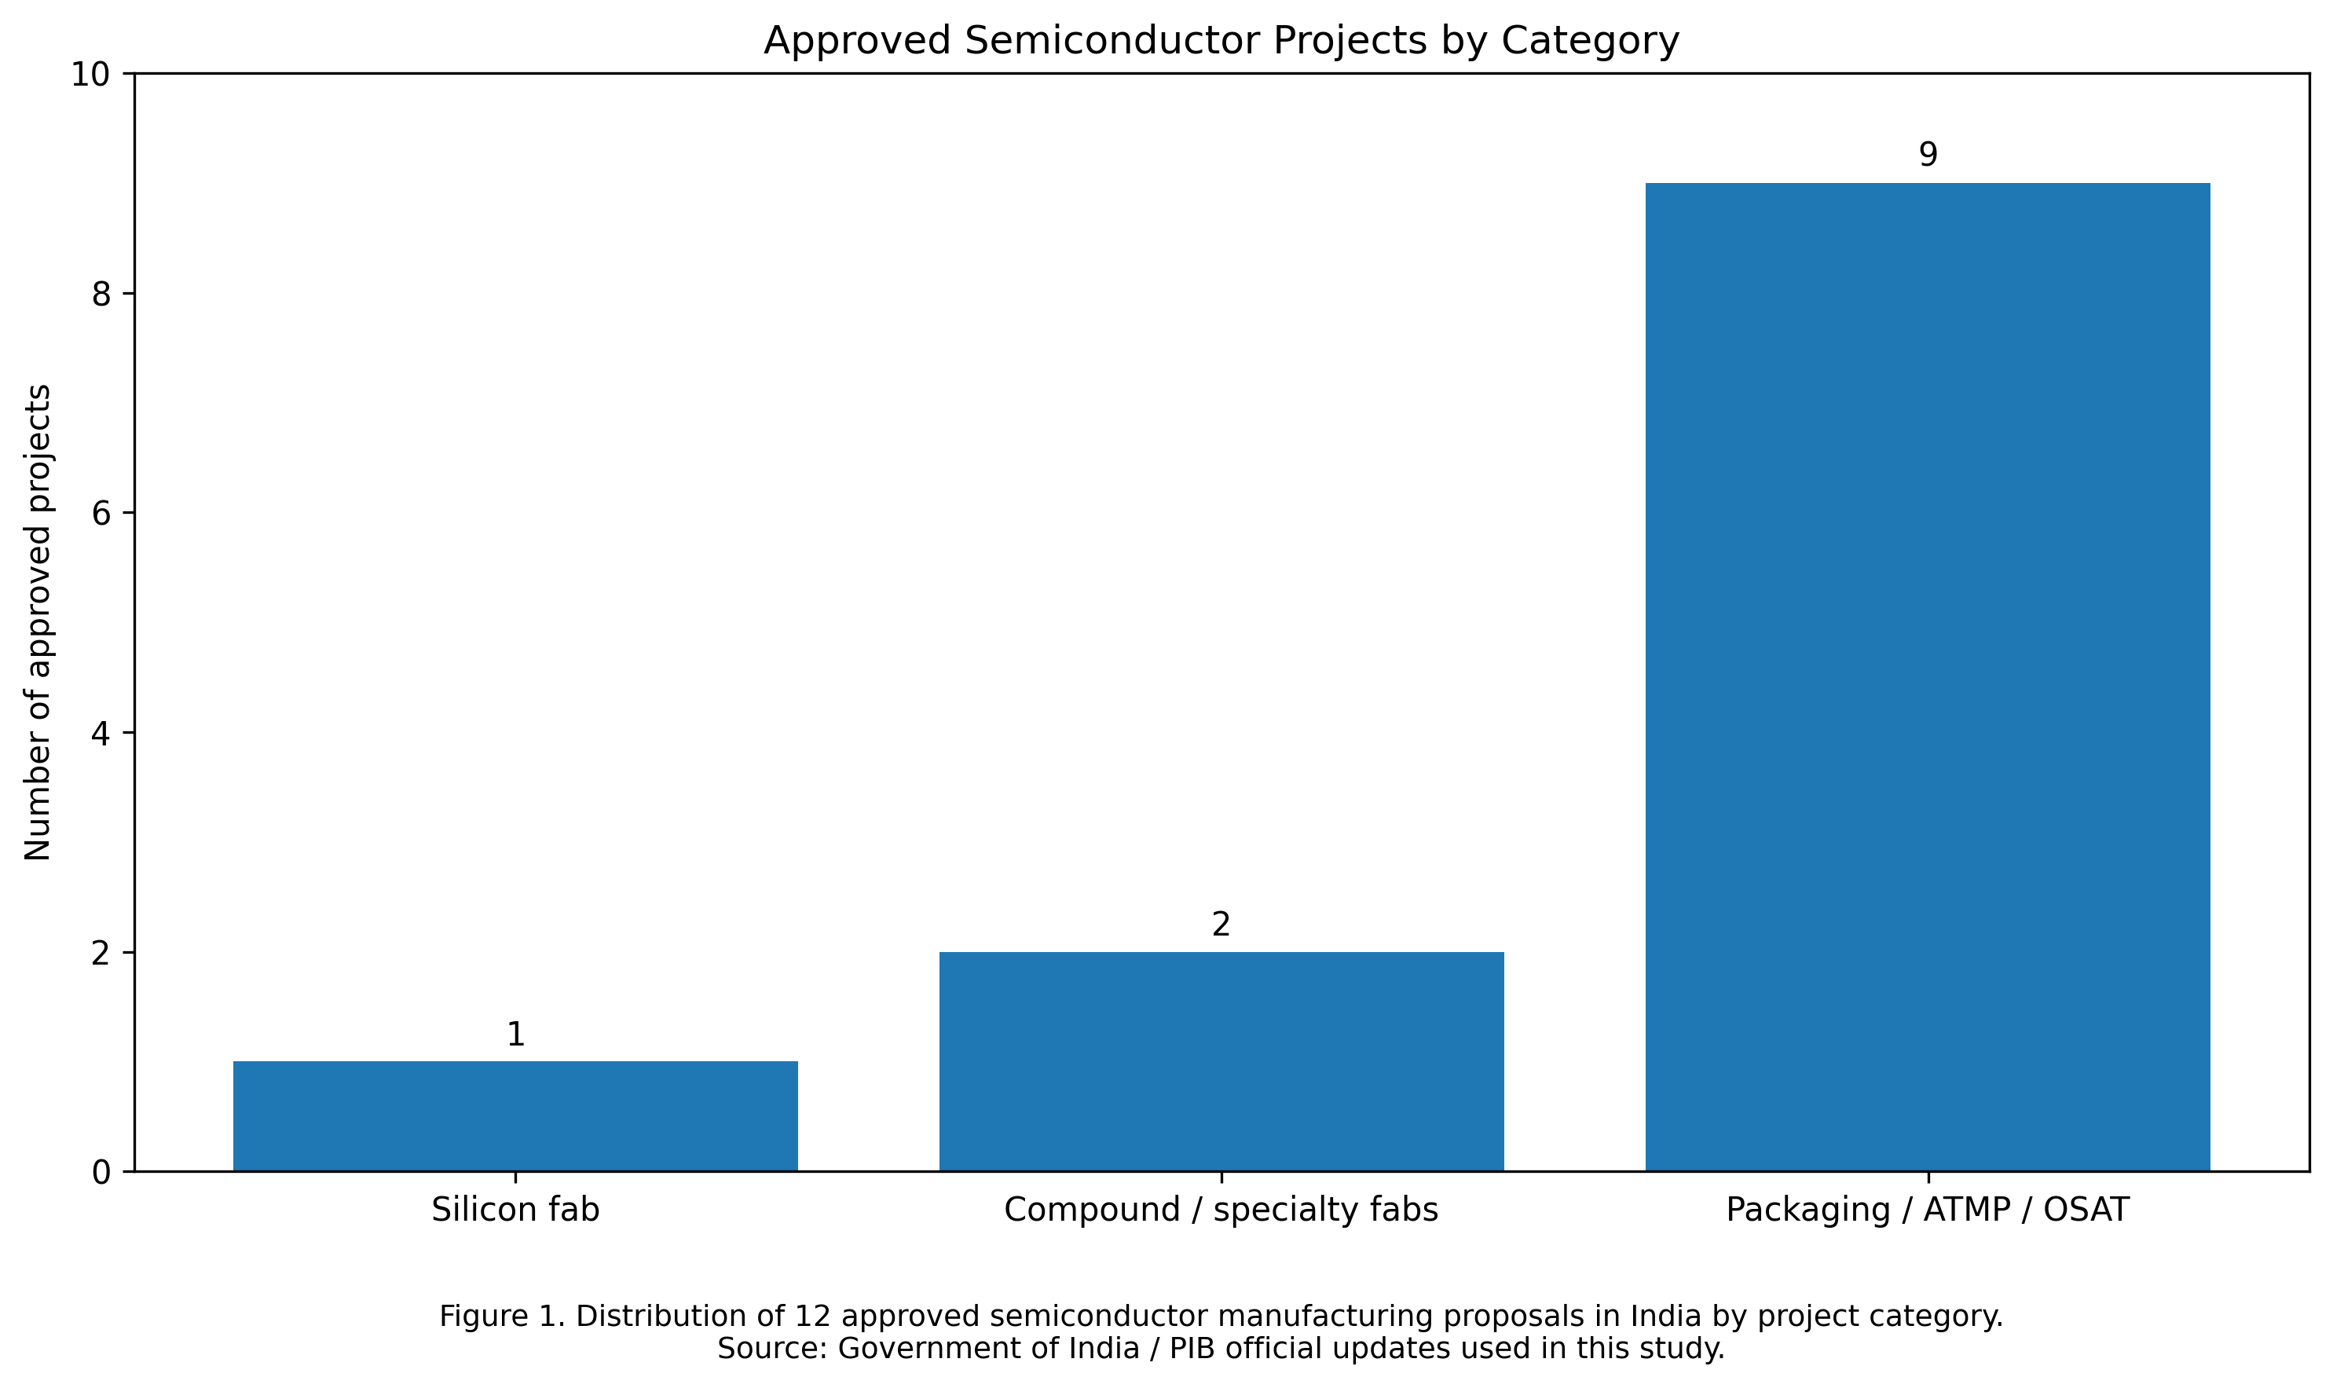
Figure 1. Distribution of 12 approved semiconductor manufacturing proposals by project category. Source: Government of India / PIB and ISM official information used in this study.

Selected verified project examples
Project / Unit | Verified status used in report | Investment / note
Micron, Sanand | Commercial production (Feb 2026) | ₹22,516 crore
Kaynes, Sanand | Commercial production (Mar 2026) | ₹3,307 crore
CG Semi | Commercial / inaugurated 4 Jul 2026 | ~₹7,600 crore
CDIL, Mohali | Commercial lines 17 Sep 2026 | ₹117 crore
Suchi, Surat | Commercial lines 17 Sep 2026 | Status updated from earlier AI output
Tata Electronics, Dholera | Under construction / development | ~₹91,000 crore
TSAT, Assam | Under construction / development | ~₹27,000 crore
India Chip / HCL-Foxconn, Jewar | Under construction / development | ~₹3,706 crore

4. Commercial Progress and Project Status
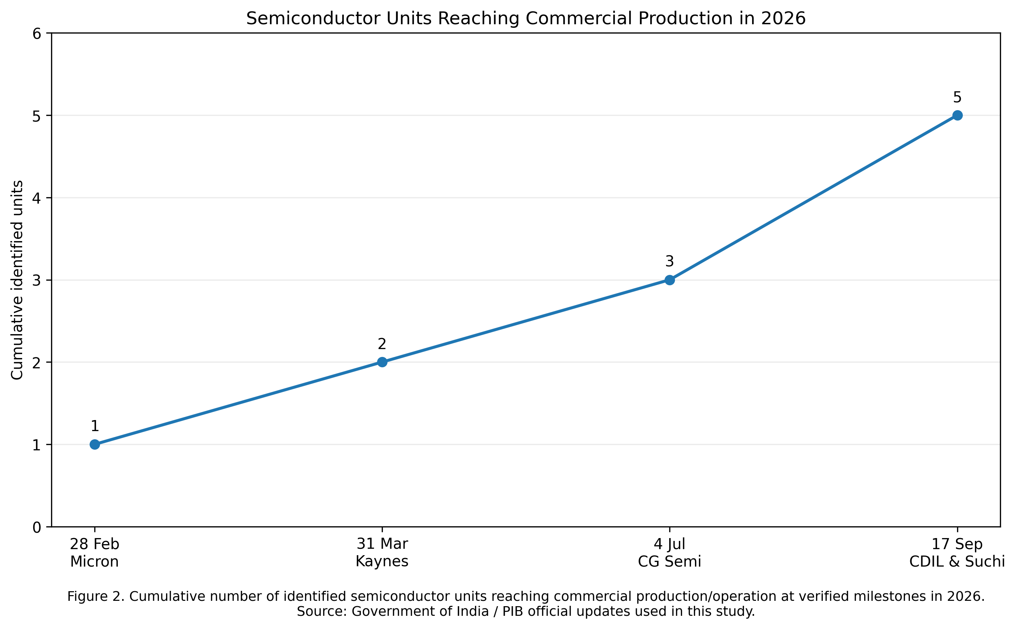
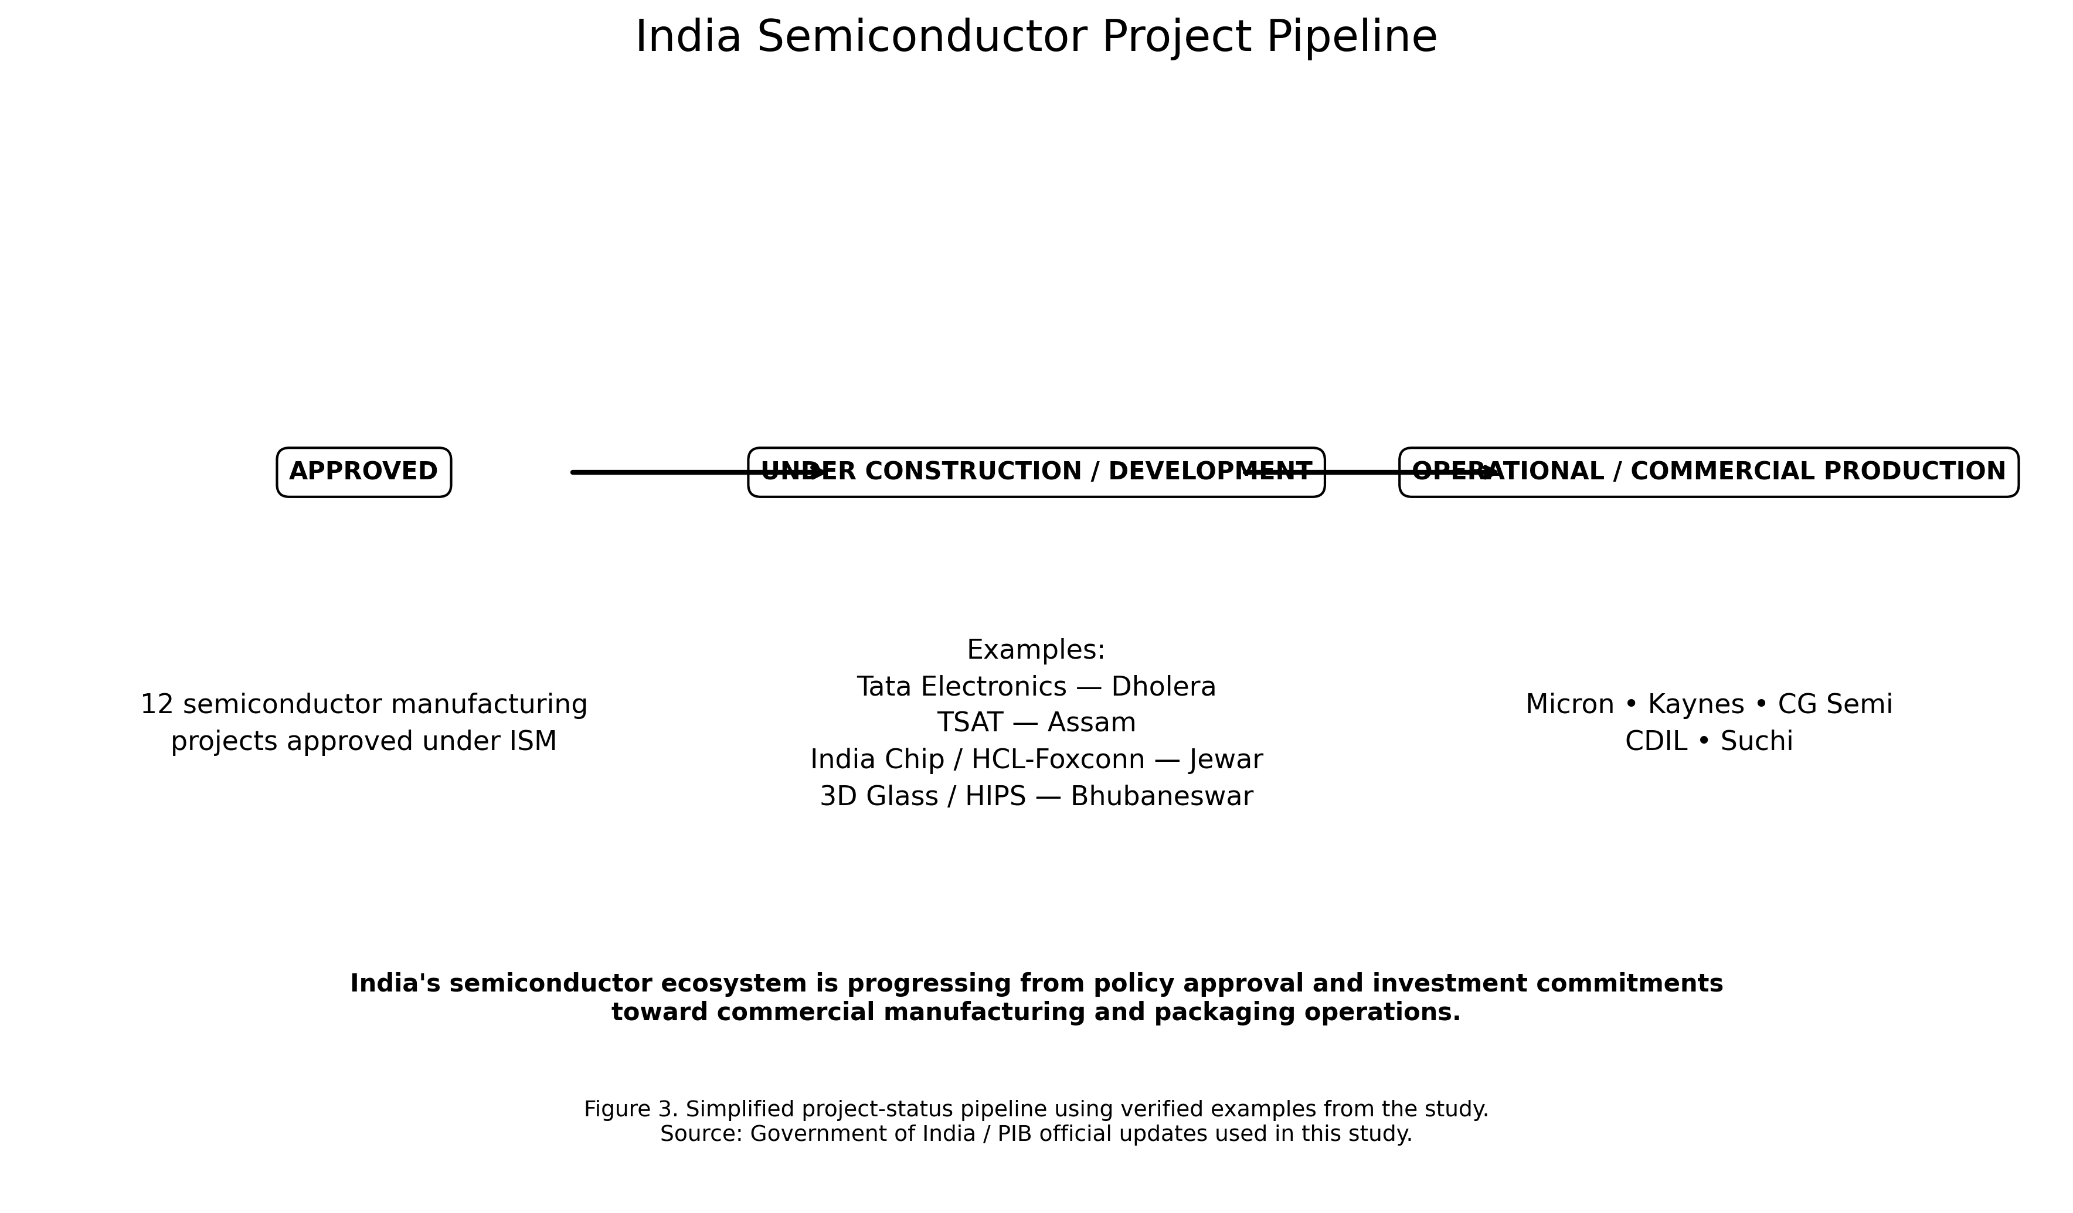

5. RQ3 — Opportunities, Challenges and Risks

Opportunities
- Large domestic electronics demand can support local semiconductor consumption.
- India has a significant semiconductor-design talent base and an expanding design-support ecosystem.
- Global supply-chain diversification creates opportunities for India to attract manufacturing, packaging, equipment and materials investment.
- Early commercial progress in ATMP/OSAT and discrete semiconductor activities can build operating experience while major fabs develop.
- Government fiscal support and state-level incentives can lower the entry barrier for capital-intensive projects.

Challenges and Risks
- Semiconductor fabs require very high capital expenditure, reliable power, water, logistics and specialist infrastructure.
- Execution delays can separate announced investment from actual production.
- Specialist manufacturing talent and experienced technical leadership remain critical constraints.
- Equipment, materials and upstream supply chains are globally concentrated, creating external dependencies.
- Fast-changing project status can make research outdated quickly if dates are not recorded.
- AI systems may mix approvals, construction milestones and production targets, creating misleading conclusions unless checked.

Overall assessment
India has moved beyond policy announcements toward measurable commercial activity, particularly in packaging and related manufacturing. However, becoming a major semiconductor hub depends on sustained execution, successful commissioning of large projects, deeper supply-chain capability and continued workforce development. The evidence therefore supports cautious progress rather than a claim that the ecosystem is already mature.

6. AI Comparison, Verification and Hallucination Analysis
AI claim / conflict | Classification | Verified action
Suchi shown only as approved | Outdated | Updated to commercial lines on 17 Sep 2026
CDIL shown only as approved/expanding | Outdated | Updated to commercial lines on 17 Sep 2026
3 vs 5 operational units | Time-sensitive discrepancy | Used later official milestone; not labelled hallucination
3D Glass investment ~₹1,500 crore | Incorrect numerical claim | Corrected to ₹1,943 crore
SiCSem investment “not publicly confirmed” | Incomplete / outdated | Replaced with official ₹2,066 crore figure
Tata Dholera late-2026 production target | Not established sufficiently | Excluded production date; retained verified project status

Before vs After
Before: general prompt → AI answer → possible direct use. After: structured prompt → multiple AI research tools → official-source grounding → conflict detection → verification → error classification → human review → verified final finding. This process improved traceability and prevented several outdated or unsupported claims from entering the final report.

Responsible AI
AI tools assisted research, comparison and content creation but were not treated as the final authority. Important claims were cross-checked with reliable original sources. Hallucinations, outdated information and unsupported claims were documented. Human review determined which information was retained. No sensitive personal data was required for this public-industry research.

7. Copyright, Citation Practice, Limitations and Conclusion

Copyright and citation practice
External information is cited and paraphrased where appropriate. AI outputs are not used as factual citations; the original reliable source is the evidence. Charts and project visuals were created specifically for this capstone from verified research data. Long passages and third-party graphics are not reproduced unnecessarily.

Limitations
- The semiconductor industry changes rapidly; project status may change after the research cut-off.
- AI outputs may contain outdated, incomplete, numerically incorrect or unsupported claims.
- Selected official sources may not establish every project-level detail.
- Human verification reduces error but cannot guarantee that later announcements will not supersede the findings.
- The study focuses on India’s Semiconductor Mission and India’s chip-industry growth rather than the complete global semiconductor industry.

Conclusion
The capstone demonstrates that multiple AI tools are most useful when assigned different roles and combined with source verification. Perplexity and Gemini broadened discovery, NotebookLM grounded analysis in selected official documents, and ChatGPT supported structured comparison and synthesis. The final evidence indicates substantial policy support, 12 approved manufacturing proposals, growing design capability and five identified commercial/operational milestones by September 2026. At the same time, major fabrication capacity is still developing and execution risks remain. The central lesson is that AI-generated research becomes more reliable when claims are compared, dated, verified and reviewed by a human before publication.

References
[1] India Semiconductor Mission (MeitY), https://ism.gov.in/
[2] Press Information Bureau, PRID 2284796, Semicon 2.0.
[3] Press Information Bureau, PRID 2278446, Building India’s Semiconductor Ecosystem / Jewar.
[4] Press Information Bureau, PRID 2311726, SEMICON India 2026 / roadmap.
[5] Press Information Bureau, PRID 2312207, Precision Manufacturing Ecosystem.
Research cut-off / access context: 18 October 2026.

