mysql> create database akshitha;

Query OK, 1 row affected (0.01 sec)

mysql> use akshitha;

Database changed

mysql> create table department(d_id varchar(30) primary key,d_name varchar(30));

Query OK, 0 rows affected (0.04 sec)

mysql> create table year(yearno int primary key);

Query OK, 0 rows affected (0.03 sec)

mysql> create table students(s_id varchar(30) primary key,sname varchar(30),dept_name varchar(30),dp_id varchar(30),foreign key(dp_id) references department

(d_id),y_no int,foreign key(y_no) references year(yearno));

Query OK, 0 rows affected (0.04 sec)

mysql> insert into department values('1Z','CSE');

Query OK, 1 row affected (0.01 sec)

mysql> insert into department values('2Z','IT');

Query OK, 1 row affected (0.01 sec)

mysql> insert into department values('3Z','CSE');

Query OK, 1 row affected (0.01 sec)

mysql> select * from department;

+------+--------+

| d_id | d_name |

+------+--------+

| 1Z | CSE |

| 2Z | IT |

| 3Z | CSE |

+------+--------+

3 rows in set (0.00 sec)

mysql> insert into year values(1);

Query OK, 1 row affected (0.01 sec)

mysql> insert into year values(2);

Query OK, 1 row affected (0.01 sec)

mysql> insert into year values(3);

Query OK, 1 row affected (0.01 sec)

mysql> select * from year;

+--------+

| yearno |

+--------+

| 1 |

| 2 |

| 3 |

+--------+

3 rows in set (0.00 sec)

mysql> insert into students values('s1','A','CSE','1Z',1);

Query OK, 1 row affected (0.03 sec)

mysql> insert into students values('s2','B','CSE','1Z',1);

Query OK, 1 row affected (0.01 sec)

mysql> insert into students values('s3','B','CSE','1Z',1);

Query OK, 1 row affected (0.01 sec)

mysql> insert into students values('s4','B','CSE','1Z',1);

Query OK, 1 row affected (0.01 sec)

mysql> insert into students values('s5','B','CSE','1Z',1);

Query OK, 1 row affected (0.01 sec)

mysql> insert into students values('s6','C','IT','2Z',2);

Query OK, 1 row affected (0.01 sec)

mysql> insert into students values('s7','D','IT','2Z',3);

Query OK, 1 row affected (0.01 sec)

mysql> insert into students values('s8','A','IT','2Z',2);

Query OK, 1 row affected (0.01 sec)

mysql> insert into students values('s9','B','IT','2Z',2);

Query OK, 1 row affected (0.01 sec)

mysql> insert into students values('s0','E','IT','2Z',1);

Query OK, 1 row affected (0.01 sec)

mysql> insert into students values('s91','AA','ECE','3Z',1);

Query OK, 1 row affected (0.01 sec)

mysql> insert into students values('s92','AA','ECE','3Z',2);

Query OK, 1 row affected (0.03 sec)

mysql> insert into students values('s93','BB','ECE','3Z',3);

Query OK, 1 row affected (0.01 sec)

mysql> insert into students values('s94','CC','ECE','3Z',2);

Query OK, 1 row affected (0.01 sec)

mysql> insert into students values('s95','DD','ECE','3Z',1);

Query OK, 1 row affected (0.01 sec)

mysql> select * from students;

+------+-------+-----------+-------+------+

| s_id | sname | dept_name | dp_id | y_no |

+------+-------+-----------+-------+------+

| s0 | E | IT | 2Z | 1 |

| s1 | A | CSE | 1Z | 1 |

| s2 | B | CSE | 1Z | 1 |

| s3 | B | CSE | 1Z | 1 |

| s4 | B | CSE | 1Z | 1 |

| s5 | B | CSE | 1Z | 1 |

| s6 | C | IT | 2Z | 2 |

| s7 | D | IT | 2Z | 3 |

| s8 | A | IT | 2Z | 2 |

| s9 | B | IT | 2Z | 2 |

| s91 | AA | ECE | 3Z | 1 |

| s92 | AA | ECE | 3Z | 2 |

| s93 | BB | ECE | 3Z | 3 |

| s94 | CC | ECE | 3Z | 2 |

| s95 | DD | ECE | 3Z | 1 |

+------+-------+-----------+-------+------+

15 rows in set (0.00 sec)

mysql> select s_id from students where dept_name='CSE';

+------+

| s_id |

+------+

| s1 |

| s2 |

| s3 |

| s4 |

| s5 |

+------+

5 rows in set (0.00 sec)

mysql> select s_id,sname from students where dept_name='CSE';

+------+-------+

| s_id | sname |

+------+-------+

| s1 | A |

| s2 | B |

| s3 | B |

| s4 | B |

| s5 | B |

+------+-------+

5 rows in set (0.00 sec)

mysql> select dept_name from students;

+-----------+

| dept_name |

+-----------+

| IT |

| CSE |

| CSE |

| CSE |

| CSE |

| CSE |

| IT |

| IT |

| IT |

| IT |

| ECE |

| ECE |

| ECE |

| ECE |

| ECE |

+-----------+

15 rows in set (0.00 sec)

mysql> select s_id,sname from students order by dp_id;

+------+-------+

| s_id | sname |

+------+-------+

| s1 | A |

| s2 | B |

| s3 | B |

| s4 | B |

| s5 | B |

| s0 | E |

| s6 | C |

| s7 | D |

| s8 | A |

| s9 | B |

| s91 | AA |

| s92 | AA |

| s93 | BB |

| s94 | CC |

| s95 | DD |

+------+-------+

15 rows in set (0.00 sec)

mysql> select s_id,sname from students order by dp_id,sname;

+------+-------+

| s_id | sname |

+------+-------+

| s1 | A |

| s2 | B |

| s3 | B |

| s4 | B |

| s5 | B |

| s8 | A |

| s9 | B |

| s6 | C |

| s7 | D |

| s0 | E |

| s91 | AA |

| s92 | AA |

| s93 | BB |

| s94 | CC |

| s95 | DD |

+------+-------+

15 rows in set (0.00 sec)

use chatgpt and ask like "this is my table in mysql how can i create same in mongodb"

//Creating a database called gen_ai in mongodb and Adding collections called Department,Year and Students using mango db atlas

**#Department collection**

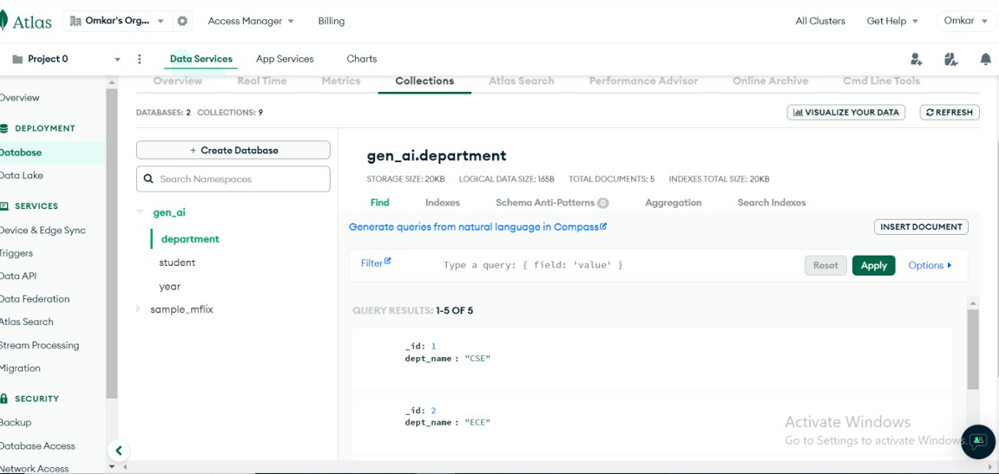

**#Year Collection**

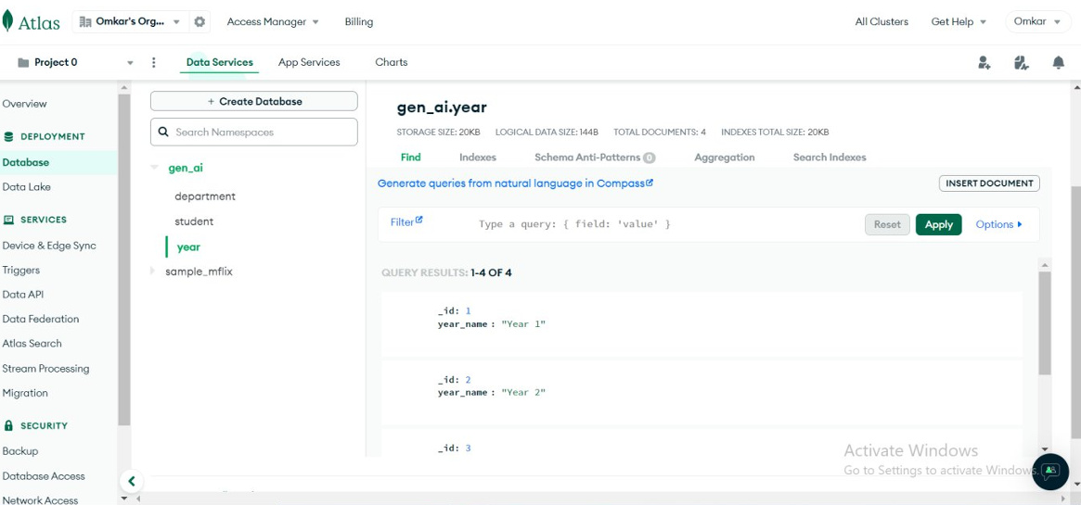

**#student collection**

