VULNERABILITY ASSESSMENT AND PENETRATION TESTING (VAPT) REPORT
Project Title
Vulnerability Assessment and Penetration Testing on DVWA (Damn Vulnerable Web Application)

Submitted By
Name: Akshitha
Department: Information Science and Engineering
College: Canara Engineering College, Mangalore
Table of Contents
- Abstract
- Introduction
- Objectives
- Scope of the Project
- Tools and Technologies Used
- Test Environment
- Methodology
- Vulnerability Assessment
  - SQL Injection
  - Brute Force Attack
  - Command Injection
  - File Upload Vulnerability
  - File Inclusion Vulnerability
- Risk Assessment
- Recommendations
- Conclusion
- References

Abstract
This project presents a Vulnerability Assessment and Penetration Testing (VAPT) conducted on Damn Vulnerable Web Application (DVWA), an intentionally vulnerable web application designed for security learning. The assessment was performed in a controlled environment using Kali Linux running in Oracle VirtualBox. Various vulnerabilities including SQL Injection, Brute Force, Command Injection, File Upload, and File Inclusion were successfully demonstrated. The project also provides mitigation strategies to improve web application security.

Introduction
Vulnerability Assessment and Penetration Testing (VAPT) is a systematic approach to identifying, evaluating, and exploiting security vulnerabilities in computer systems and web applications. Vulnerability Assessment identifies weaknesses, whereas Penetration Testing attempts to exploit those weaknesses to understand their impact.
DVWA provides a safe environment for learning and demonstrating common web vulnerabilities without affecting production systems.

Objectives
- Learn the fundamentals of Vulnerability Assessment and Penetration Testing.
- Perform penetration testing in a controlled environment.
- Identify common web application vulnerabilities.
- Understand how attackers exploit insecure applications.
- Recommend mitigation techniques based on industry best practices.

Scope of the Project
This project focuses on testing a local DVWA installation using Kali Linux. The assessment includes:
- SQL Injection
- Brute Force Authentication
- Command Injection
- File Upload
- File Inclusion

Tools and Technologies Used
Tool | Purpose
Kali Linux | Penetration Testing Operating System
Oracle VirtualBox | Virtualization Platform
DVWA | Vulnerable Web Application
Apache2 | Web Server
MariaDB | Database
PHP | Server-side Scripting
Firefox | Web Browser

Test Environment
Component | Configuration
Host OS | Windows 11
Virtual Machine | Oracle VirtualBox
Guest OS | Kali Linux
Web Server | Apache2
Database | MariaDB
Browser | Firefox
PHP Version | 8.4.23
Application | DVWA

Methodology
The penetration testing methodology followed these phases:
- Environment Setup
- Application Configuration
- Vulnerability Identification
- Exploitation
- Result Analysis
- Mitigation Recommendations

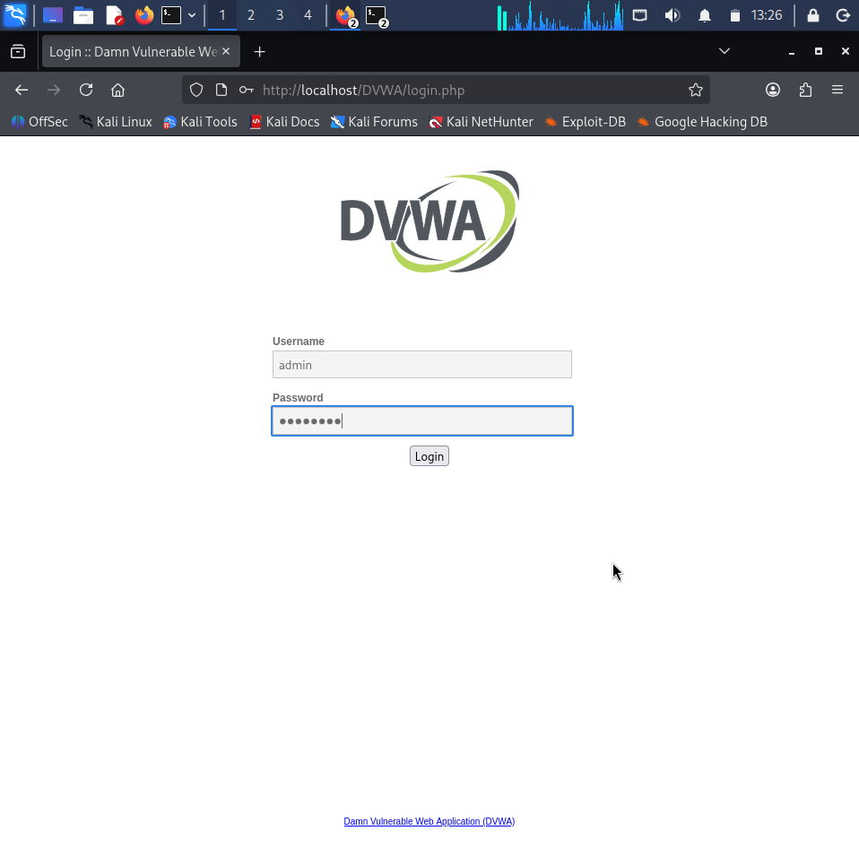
Vulnerability 1 – SQL Injection
Objective
To determine whether SQL queries can be manipulated through unsanitized user input.
Test Procedure
- Open SQL Injection module.
- Enter:
1
- Observe the returned user details.
- Enter:
1' OR '1'='1
- Submit the query.
Observation
The application returned multiple database records instead of a single user.

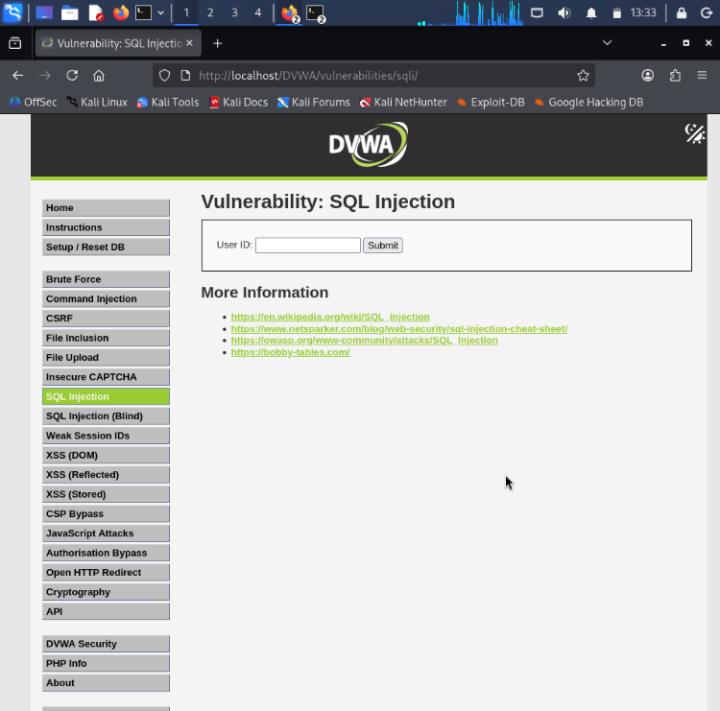

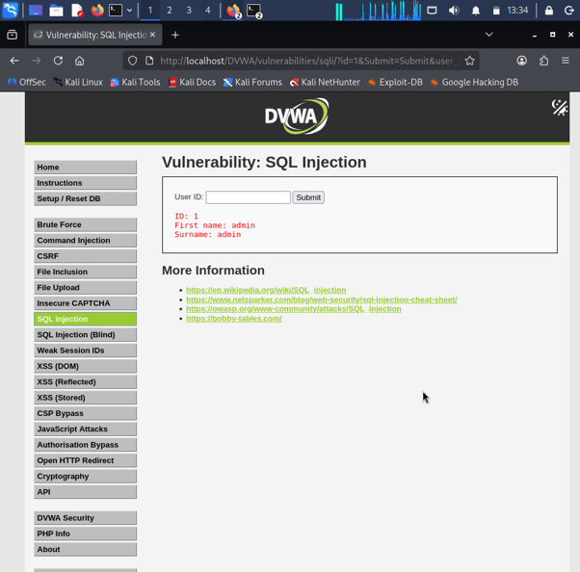

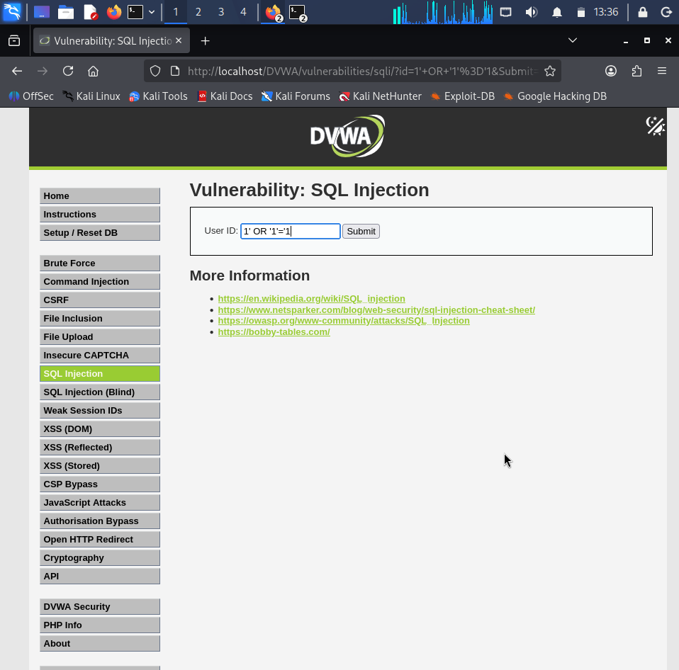

Impact
- Unauthorized access to database information.
- Disclosure of confidential records.
- Authentication bypass.
- Possible database manipulation.
Risk Level
High
Recommendation
- Use Prepared Statements.
- Validate user inputs.
- Apply parameterized queries.
- Implement least privilege database accounts.

Vulnerability 2 – Brute Force Attack
Objective
To test authentication security against repeated login attempts.
Test Procedure
Successful Login
Username
admin
Password
password
Failed Login
Username
admin
Password
12345
Observation
Valid credentials successfully authenticated.
Invalid credentials were rejected.
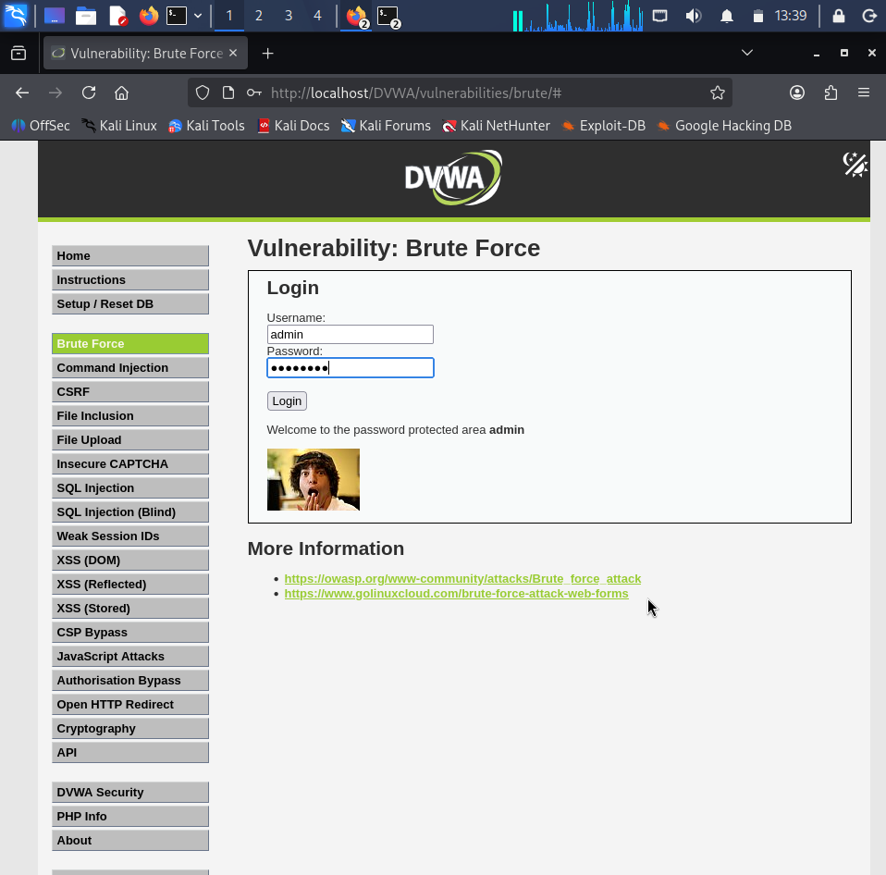

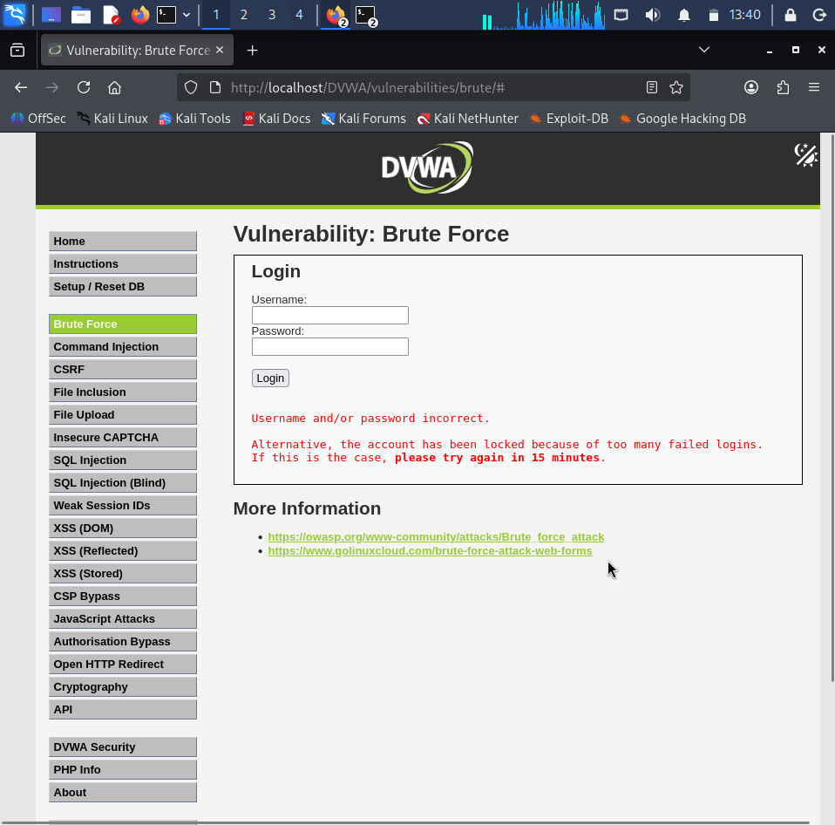

Impact
Weak passwords may be guessed by attackers.
Risk Level
Medium
Recommendation
- Multi-Factor Authentication
- Strong Password Policy
- CAPTCHA
- Account Lockout

Vulnerability 3 – Command Injection
Objective
To determine whether operating system commands can be executed.
Payload Used
127.0.0.1 && whoami
Observation
The application executed the command successfully and displayed:
www-data
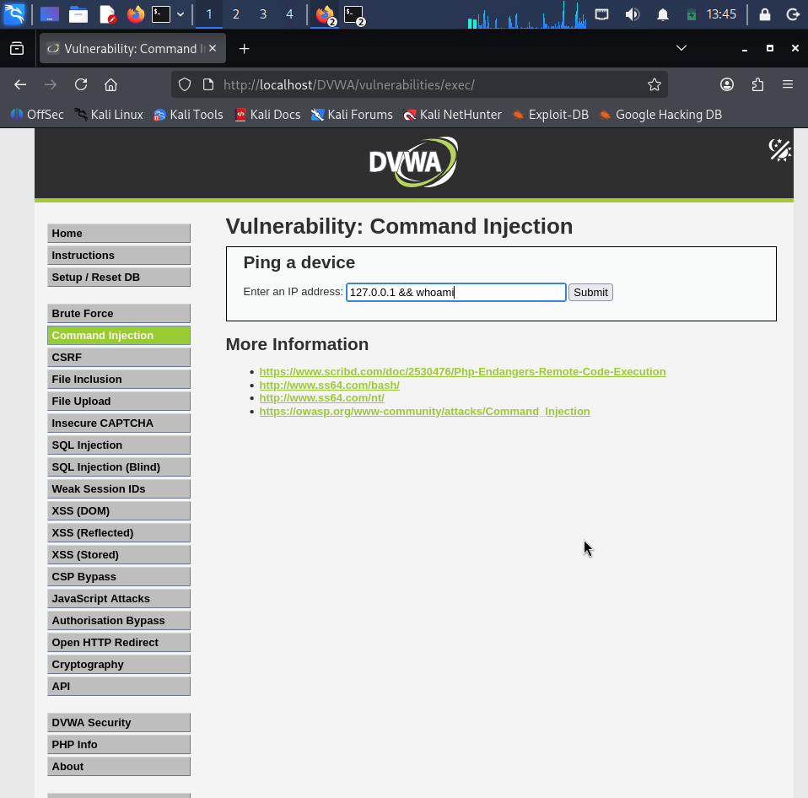

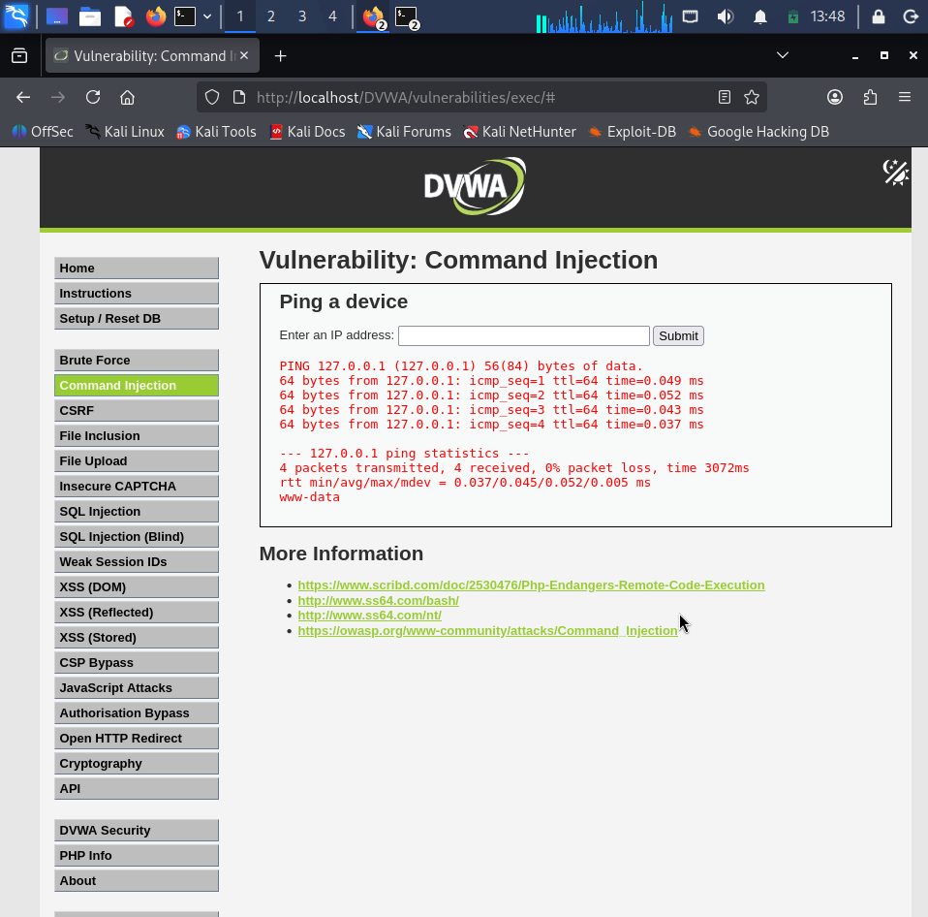

Impact
Attackers may execute arbitrary operating system commands.
Risk Level
Critical
Recommendation
- Validate user input.
- Avoid direct system() execution.
- Use allowlists.
- Run applications with minimum privileges.

Vulnerability 4 – File Upload
Objective To evaluate file upload restrictions Procedure Uploadedtest.txt
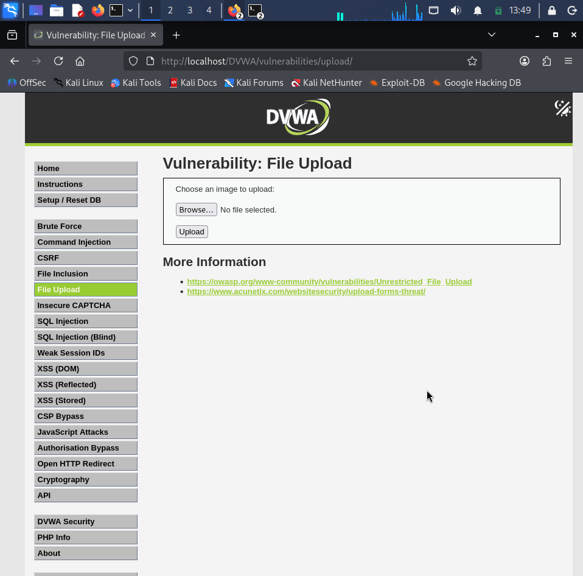

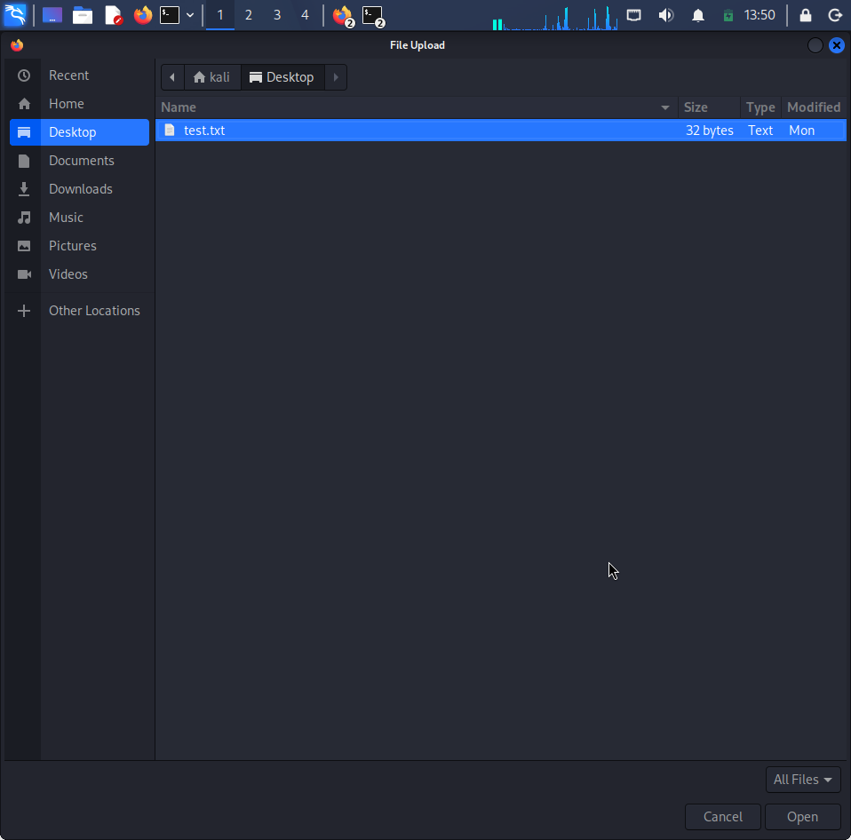

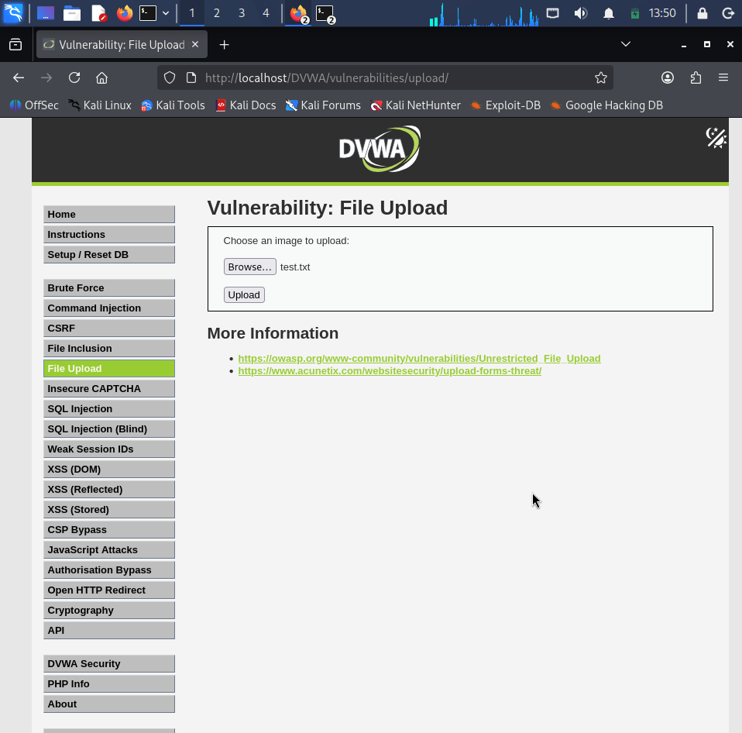
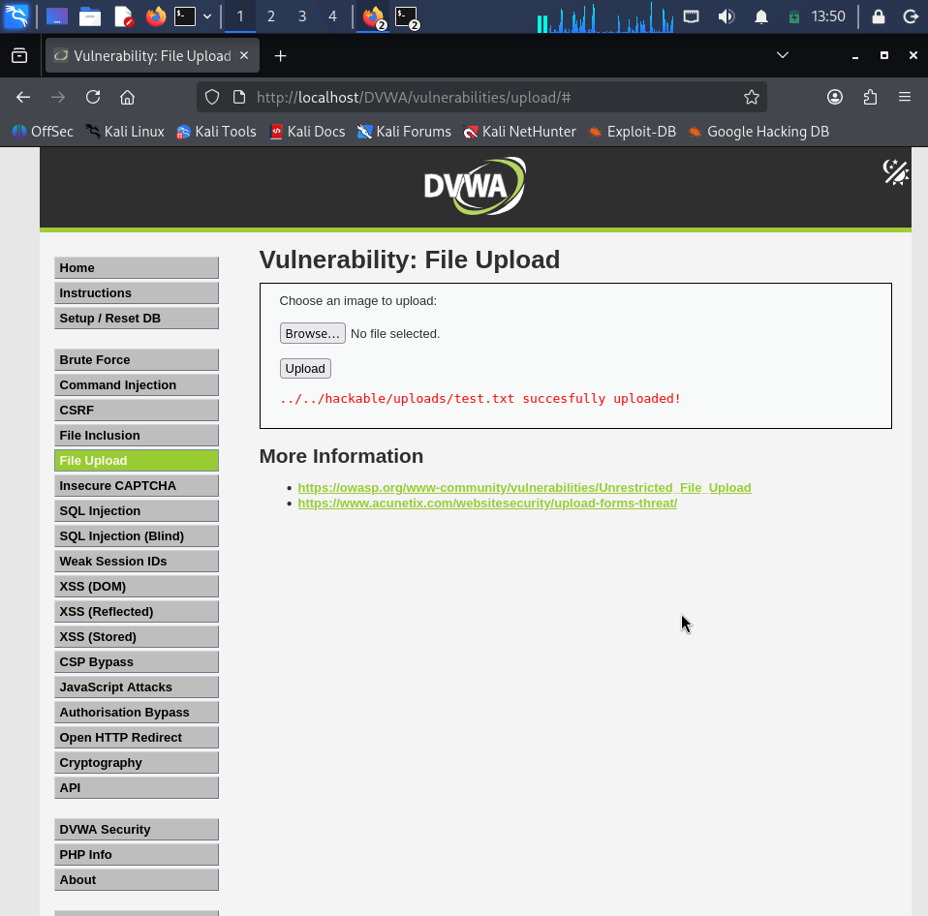
The upload completed successfully.
Impact
Improper validation may allow malicious file uploads.
Risk Level
High
Recommendation
- Restrict file types.
- Validate MIME types.
- Rename uploaded files.
- Store uploads outside the web root.

Vulnerability 5 – File Inclusion
Objective
To test Local File Inclusion vulnerability.
Procedure
Accessed:
file1.php
Tested:
?page=../../../../etc/passwd
Observation
Normal file inclusion worked.
The Local File Inclusion test displayed a blank page due to PHP version limitations.

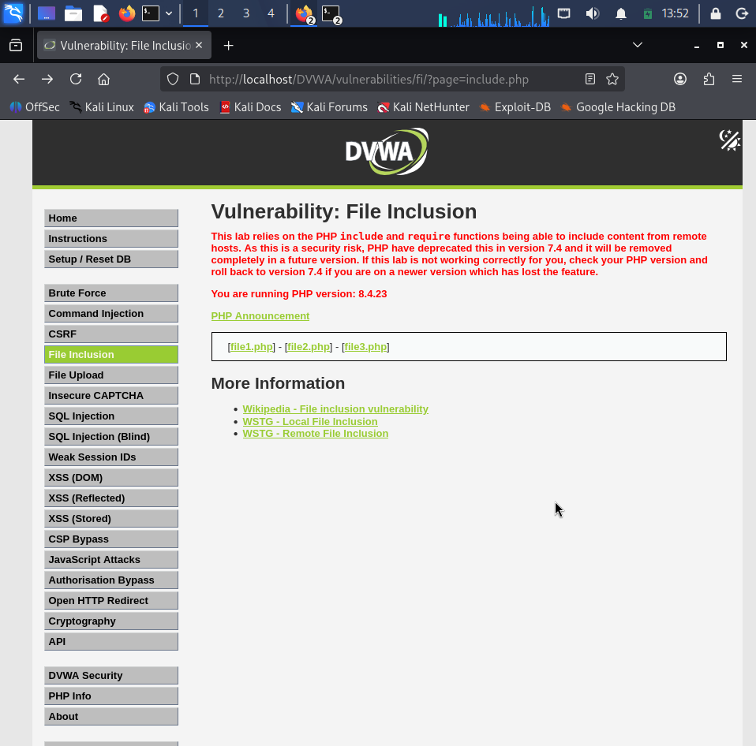
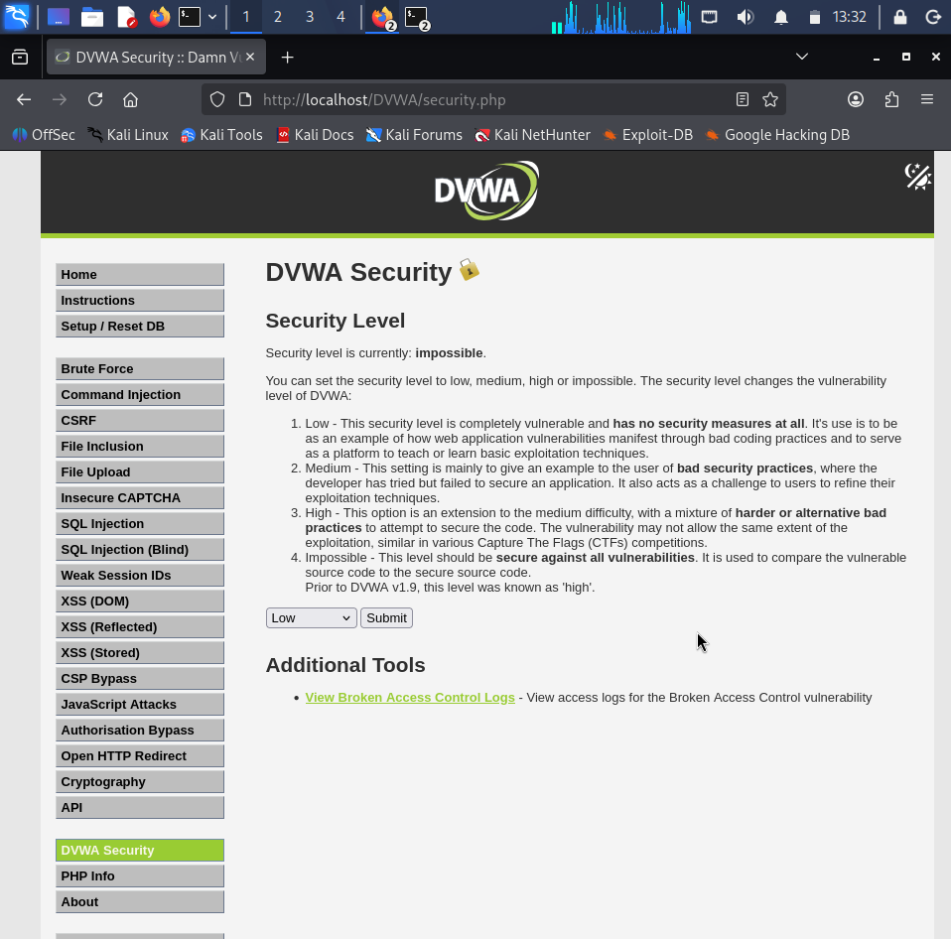
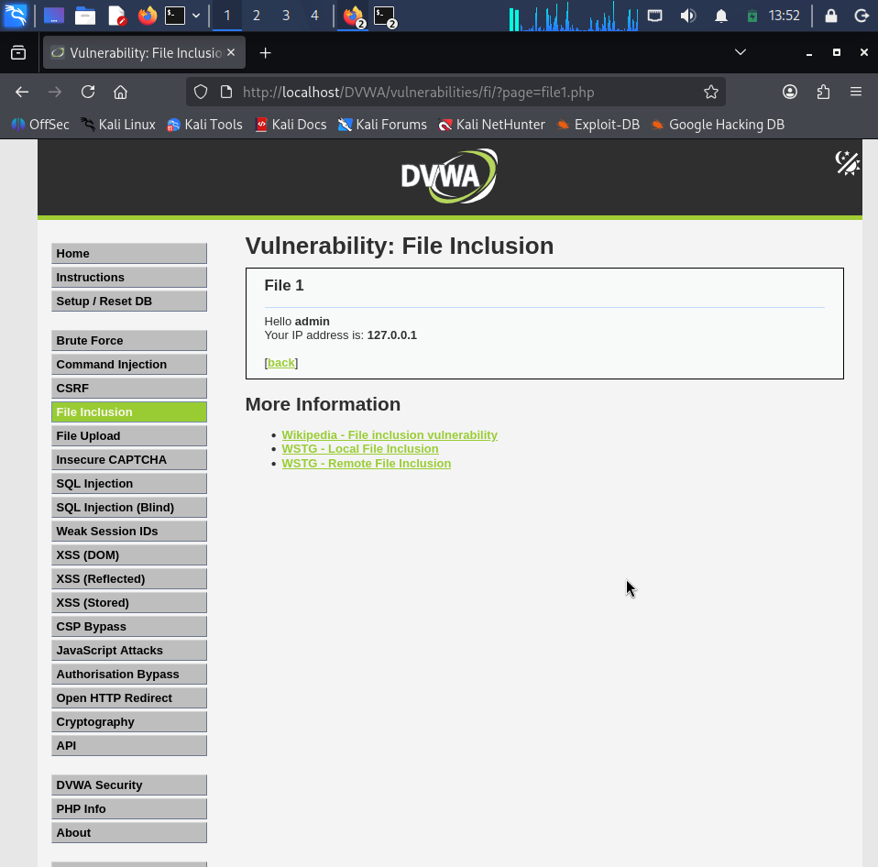
Impact
Improper file inclusion can expose sensitive server files.
Risk Level
High
Recommendation
- Never include files directly from user input.
- Maintain an allowlist of permitted files.
- Disable unnecessary PHP inclusion features.

Risk Assessment Summary
Vulnerability | Severity | Status
SQL Injection | High | Vulnerable
Brute Force | Medium | Demonstrated
Command Injection | Critical | Vulnerable
File Upload | High | Demonstrated
File Inclusion | High | Tested

Overall Recommendations
- Validate all user input.
- Implement Prepared Statements.
- Use secure authentication.
- Disable unnecessary PHP configurations.
- Apply least privilege.
- Perform regular vulnerability assessments.
- Keep software updated.

Conclusion
The Vulnerability Assessment and Penetration Testing conducted on DVWA successfully demonstrated several common web application vulnerabilities. The assessment provided practical experience in exploiting security flaws and understanding their potential impact. The project highlights the importance of secure coding practices, proper input validation, authentication mechanisms, and regular security testing to reduce the risk of cyberattacks.

References
- OWASP Top 10
- OWASP Testing Guide
- DVWA Documentation
- Kali Linux Documentation
- Apache HTTP Server Documentation
- MariaDB Documentation

