A COURSE-BASED PROJECT
On
GLOBAL CYBER ATTACKS ANALYSIS
USING PYSPARK

Submitted in partial fulfillment of Big Data Analytics Lab

GRIET Lab On Board(G-LOB)

By

P.Kavyanjali 23241A6754
K.Vedhanjali 23241A6761
D.Akshitha 24245A6704


Department of Data science
GOKARAJU RANGARAJU INSTITUTE OF ENGINEERING AND TECHNOLOGY
(Autonomous)
Bachupally, Kukatpally, Hyderabad, Telangana, India,500090
2025-26

i



GOKARAJU RANGARAJU INSTITUTE OF ENGINEERING AND TECHNOLOGY
(Autonomous)

Hyderabad-500090

CERTIFICATE

This is to certify that the GLOB entitled “GLOBAL CYBER ATTACKS ANALYSIS
USINGPYSPARK” is submitted by D.Akshitha(24245A6704), P.Kavyanjali (23241A6754), K.Vedhanjali (23241A6761) in partial fulfillment of the award of degree in BACHELOR OF TECHNOLOGY in Computer Science and Engineering (Data Science) during Academic year 2025-26.

Internal Guide
Ms. S. Srilatha (Assistant Professor)
Dr. M. Kiran Kumar (Professor)

ii

ABSTARCT

In the modern digital era, cyber attacks are increasing rapidly in frequency, scale, and complexity. Organizations generate huge amounts of security log data every day, making it difficult to analyze using traditional systems. This project, Global Cyber Attacks Analysis using Apache Spark, focuses on processing and analyzing large-scale cyber security data efficiently using distributed computing techniques.Apache Spark is used as the core processing framework because of its high-speed in-memory computation and ability to handle big datasets. The project uses a cyber attack dataset containing parameters such as connection time, bytes transferred, Kali Linux traces, servers corrupted, pages corrupted, attacker location, and typing speed. By applying Spark DataFrame operations and analytical methods, the system identifies top attacking countries, attack distribution patterns, suspicious behavior, and performance metrics.Various visualizations such as bar charts, pie charts, typing speed analysis, and correlation heatmaps are generated to better understand attack trends. The project demonstrates how big data tools can help in cyber threat detection, monitoring, and decision making.This system can be useful in banking, government organizations, IT companies, cloud platforms, and security operation centers for improving cyber defense strategies.

iii
TABLE OF CONTENTS

Chapter No. | Chapter Name | Minimum  Number of Pages (tentative)
1 | INTRODUCTION | 1
 | 1.1 Introduction to the Project Work
 | 1.2 Significance of the Project
2 | LITERATURE SURVEY | 3
 | 2.1 Existing Approaches

 | 2.2 Drawbacks of Existing Approaches
3 | PROPOSED METHOD | 5
 | 3.1 Problem Statement
 | 3.2 Objectives of the Project
3.3 Explanation of:
• Architecture Diagram
• Software and Hardware Requirements
4 | RESULTS AND DISCUSSIONS | 9
 | 4.1 Description about Dataset
 | 4.2 Detailed explanation about the Experimental Results (using Graphs, Screen Shots)
5 | CONCLUSION AND FUTURE ENHANCEMENTS | 16
 | 5.1 Conclusion
 | 5.2 Future Enhancement
6 | REFERENCES | 18

iv
1. INTRODUCTION

1.1 Introduction to the Project Work
In today’s digital world, cyber attacks have become a major threat to organizations, governments, businesses, and individuals. Attackers use different techniques such as data theft, malware injection, server hacking, and unauthorized access to damage systems and steal sensitive information. Every day, large amounts of security logs and network data are generated, which need to be analyzed quickly and accurately.
Traditional data processing systems are not efficient enough to handle huge volumes of cyber security data. To overcome this problem, this project titled Global Cyber Attacks Analysis using Apache Spark uses big data technology for fast and scalable analysis.
Apache Spark is a powerful distributed computing framework that processes large datasets using in-memory computation. In this project, a cyber attack dataset is analyzed containing details such as session connection time, bytes transferred, Kali Linux traces, servers corrupted, pages corrupted, attacker location, and typing speed. By using Spark DataFrames and visualization tools, the project identifies attack patterns, top attacking countries, and suspicious behavior.
The project helps in understanding how big data analytics can be applied in cyber security for better monitoring and threat detection.

1.2 Significance of the Project
This project is significant because cyber attacks are increasing rapidly across the world, causing financial loss, privacy breaches, and service disruption. Organizations require advanced tools to analyze security data and detect threats in real time.
The importance of this project includes:
- Efficient Big Data Processing
Apache Spark can process large cyber security datasets much faster than traditional systems.
- Threat Detection
Helps identify suspicious activities, attacker locations, and attack intensity.
- Better Decision Making
Provides charts and analytics that help security teams take preventive action.
- Scalability
Can be extended to handle millions of records in real-world environments.
- Real-Time Security Applications
Can be integrated with streaming systems for live attack monitoring.
- Industrial Relevance
Useful in banking, government, telecom, e-commerce, and cloud security sectors.
- Learning Value
Demonstrates practical use of Big Data, Apache Spark, and cyber analytics concepts.

2 . LITERATURE SURVEY

2.1 Existing Approaches

Manual Log Analysis

Earlier cyber security systems depended on manual inspection of server logs, firewall records, and access reports to identify suspicious activities. Administrators reviewed system events to detect repeated login failures, unusual traffic, or unauthorized access.

Relational Database Systems

Relational database management systems were used to store structured security data. These systems supported SQL queries, reporting, and historical record maintenance for analyzing incidents and user activities.

Rule-Based Detection Systems

Rule-based systems compared incoming traffic and system events with predefined attack signatures. If a known malicious pattern was detected, alerts were generated automatically.

Centralized Security Monitoring Platforms

Security platforms were developed to collect logs from multiple sources such as servers, applications, firewalls, and routers. These systems helped in event correlation, reporting, and incident management.

Hadoop-Based Big Data Processing

Apache Hadoop introduced distributed storage and parallel processing for handling very large cyber security datasets. It enabled batch analysis of logs across multiple systems.

Machine Learning Approaches

Machine learning methods were applied to classify attacks, detect anomalies, and identify suspicious behavior using historical security data.

2.2 Drawbacks of Existing Approaches

Slow Manual Analysis
Manual inspection of logs is time consuming and impractical when millions of records are generated daily. It also depends heavily on human expertise.

Scalability Issues in Databases
Traditional databases may experience slower performance when processing very large cyber security datasets and high-speed incoming data.

Limited Detection in Rule-Based Systems
Rule-based methods mainly detect known attacks and may fail to identify new or unknown threats.

High Cost of Security Platforms
Many centralized monitoring systems require expensive licenses, complex setup, and skilled administrators.

Slower Hadoop Processing
Hadoop is effective for batch processing but slower for iterative and real-time analytics because it relies on disk-based execution.

Complexity of Machine Learning Models
Machine learning systems need quality training data, tuning, and high computational resources. Incorrect models may generate false alerts.

Lack of Real-Time Response
Many traditional approaches focus on historical analysis and cannot provide immediate threat detection or instant preventive action.
3.PROPOSED METHOD
3.1 Problem Statement
In the present digital era, organizations across the world depend heavily on computer networks, cloud platforms, online transactions, and data-driven services. As the use of technology increases, cyber attacks have also grown rapidly in frequency, scale, and complexity. Attackers target systems through unauthorized access, malware injection, phishing, ransomware, server breaches, and data theft. These attacks can lead to financial losses, privacy violations, service downtime, and damage to organizational reputation.
Every cyber attack generates a large amount of digital evidence in the form of server logs, firewall records, intrusion alerts, network traffic data, user login histories, and system activity reports. Large enterprises may generate millions of such records daily. Extracting useful information from this data is essential for identifying suspicious behavior, understanding attack patterns, and improving security measures.
Traditional approaches such as manual log inspection and conventional database systems are not efficient enough to handle these massive datasets. Manual analysis requires significant time and skilled manpower, while relational databases often experience performance limitations when data volume grows. Rule-based systems mainly detect previously known threats and may fail to recognize new or modified attacks.
Another major challenge is the need for timely threat detection. Delayed analysis can allow attackers to continue malicious activities before preventive action is taken. Organizations require systems that can quickly process large-scale security data and generate meaningful insights for immediate response.
Therefore, there is a strong need for a scalable, high-speed, and intelligent analytical system capable of processing cyber attack data efficiently. The proposed project addresses this problem by using Apache Spark, a distributed in-memory computing framework. Spark enables faster processing of large datasets and helps identify top attacking countries, suspicious behavior, server damage trends, and other critical security indicators.
This project aims to overcome the limitations of traditional methods and provide an efficient platform for cyber attack analysis using modern big data technology.
3.2 Objectives of the Project
- To develop an efficient cyber attack analysis system using Apache Spark for processing and analyzing large volumes of cyber security data in a faster and more reliable manner.
- To process large-scale cyber security datasets using distributed computing techniques, where data is divided and processed in parallel for better performance.
- To reduce execution time by utilizing Spark’s in-memory processing capability, which is faster than traditional disk-based processing methods.
- To analyze cyber attack records and identify important attack patterns, trends, and suspicious activities present in the dataset.
- To determine the top attacking countries based on server corruption values and geographical attack data available in the dataset.
- To study attacker behavior using typing speed and other behavioral parameters in order to understand manual and automated attacks.
- To analyze the usage of Kali Linux traces and identify how often penetration testing tools are involved in cyber attacks.
- To generate visual reports such as bar charts, pie charts, correlation heatmaps, and other graphical outputs for easy understanding of results.
- To improve scalability compared to traditional single-system data processing methods by handling larger datasets efficiently.
- To provide meaningful insights for cyber security analysts and system administrators for monitoring threats and planning preventive actions.
- To demonstrate the practical application of Big Data technologies such as Apache Spark in the field of cyber security analytics.
- To support faster and better decision-making by transforming raw cyber attack data into useful information.
- To build a flexible system that can be extended for real-time streaming analytics and live attack monitoring in the future.
- To gain practical knowledge of PySpark, data analytics, distributed computing, and visualization tools through project implementation.

3.3.1 Architecture Diagram
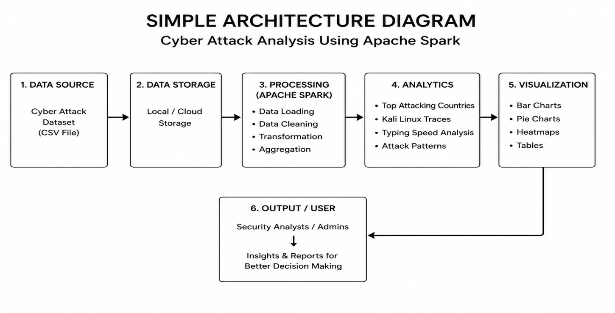The architecture diagram represents the workflow of the Cyber Attack Analysis using Apache Spark system. It shows how raw cyber security data is collected, processed, analyzed, and converted into meaningful outputs for users.
1. Data Source : The first stage is the data source, where the cyber attack dataset is provided in CSV format. This file contains records related to attacks such as location, typing speed, corrupted servers, connection details, and other parameters.
2. Data Storage : After collecting the dataset, it is stored in local storage or cloud storage. This allows the system to access the data whenever required for processing and analysis.
3. Processing (Apache Spark) : This is the core stage of the system. Apache Spark loads the dataset and performs data cleaning, transformation, filtering, and aggregation operations. Spark uses distributed in-memory processing, which makes the execution faster than traditional systems.

4. Analytics : In this stage, useful insights are extracted from the processed data. The system identifies top attacking countries, Kali Linux traces, typing speed analysis, and common attack patterns.

5. Visualization : The analyzed results are presented in the form of graphs and charts such as bar charts, pie charts, heatmaps, and tables. Visualization helps users understand the results clearly and quickly.

6. Output / User : The final results are delivered to security analysts or administrators. These outputs help them monitor threats, understand attacker behavior, and make better security decisions.
3.3.2 Software and Hardware Requirements

Hardware Requirements
- Processor: Intel Core i3 / i5 / i7 or AMD equivalent
- RAM: Minimum 4 GB (8 GB recommended)
- Hard Disk: Minimum 20 GB free space
- Monitor: Standard display monitor
- Keyboard and Mouse
- Internet Connection (for Google Colab / package installation)
- System Type: 64-bit Computer System

Software Requirements
- Operating System: Windows / Linux / macOS
- Python 3.x
- Apache Spark
- PySpark Library
- Jupyter Notebook / Google Colab
- Pandas Library
- NumPy Library
- Matplotlib Library
- Seaborn Library
- Java JDK (required for Spark local setup)
- Web Browser (Chrome / Edge / Firefox)

4.RESULTS AND DISCUSSIONS
4.1 Dataset Details
The dataset used in this project is a Cyber Attack Dataset stored in CSV format and named hack_data_100_rows.csv. It contains 100 records representing simulated cyber attack activities collected for analysis purposes. The dataset is used to study attacker behavior, attack patterns, and system impact using Apache Spark.
The dataset includes various attributes related to cyber attacks such as connection time, data transfer details, attacker location, typing speed, corrupted servers, corrupted web pages, and traces of Kali Linux usage. These parameters help in understanding how attacks are performed and from which regions they originate.
The dataset is structured and suitable for big data analytics using Spark DataFrames. It is used to perform grouping, filtering, aggregation, statistical analysis, and data visualization.

Dataset Features
- File Format: CSV
- File Name: hack_data_100_rows.csv
- Number of Records: 100 Rows
- Type of Data: Structured Data
- Usage: Cyber Attack Analysis and Visualization

Main Attributes in Dataset
- Session_Connection_Time
- Bytes_Transferred
- Kali_Trace_Used
- Servers_Corrupted
- Pages_Corrupted
- WPM_Typing_Speed
- Location

IMPLEMENTATION:
# Install Libraries (Run in Colab if needed)
!pip install pyspark pandas matplotlib seaborn
from pyspark.sql import SparkSession
from pyspark.sql.functions import sum, avg, col
import pandas as pd
import matplotlib.pyplot as plt
import seaborn as sns
# Start Spark Session
spark = SparkSession.builder \
.appName("Cyber Attack Analysis") \
.getOrCreate()
print("Spark Started Successfully")
# Load Dataset
df = spark.read.csv("/content/hack_data_100_rows.csv",
header=True,
inferSchema=True)
print("Dataset Preview")
df.show(10)
print("Schema")
df.printSchema()
# Top Attacking Countries
country_attack = df.groupBy("Location") \
.agg(sum("Servers_Corrupted").alias("Total_Attacks")) \
.orderBy(col("Total_Attacks").desc())
country_attack.show()
# Convert to Pandas
pdf = country_attack.toPandas()
# Bar Chart
plt.figure(figsize=(12,6))
plt.bar(pdf["Location"], pdf["Total_Attacks"])
plt.title("Top Countries for Cyber Attacks")
plt.xlabel("Country")
plt.ylabel("Total Attacks")
plt.xticks(rotation=45)
plt.show()
# Pie Chart
plt.figure(figsize=(8,8))
plt.pie(pdf["Total_Attacks"],
labels=pdf["Location"],
autopct='%1.1f%%')
plt.title("Attack Distribution by Country")
plt.show()
# Typing Speed Analysis
typing_df = df.select("Location", "WPM_Typing_Speed").toPandas()
plt.figure(figsize=(12,6))
sns.boxplot(x="Location",
y="WPM_Typing_Speed",
data=typing_df)

plt.title("Typing Speed Analysis")
plt.xticks(rotation=45)
plt.show()
# Correlation Heatmap
full_df = df.toPandas()
plt.figure(figsize=(10,6))
sns.heatmap(full_df.corr(numeric_only=True),
annot=True,
cmap="coolwarm")

plt.title("Correlation Heatmap")
plt.show()
df.groupBy("Kali_Trace_Used").count().show()
df.select(avg("WPM_Typing_Speed")).show()
# Stop Spark
spark.stop()

4.2 Detailed explanation about the Experimental Results

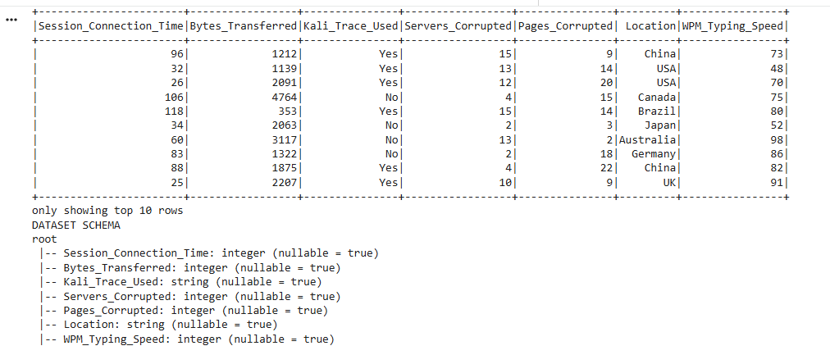

Fig 1: top 10 rows of Dataset

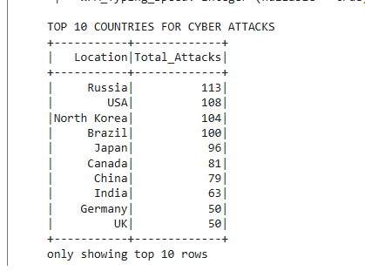

Fig 2:Top 10 countries for Cyber Attacks

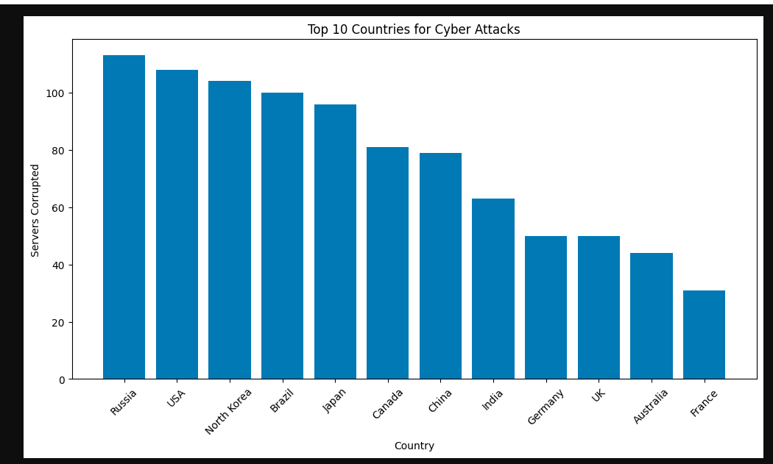

Fig 3: Bar chart of top 10 countries for Cyber Attacks

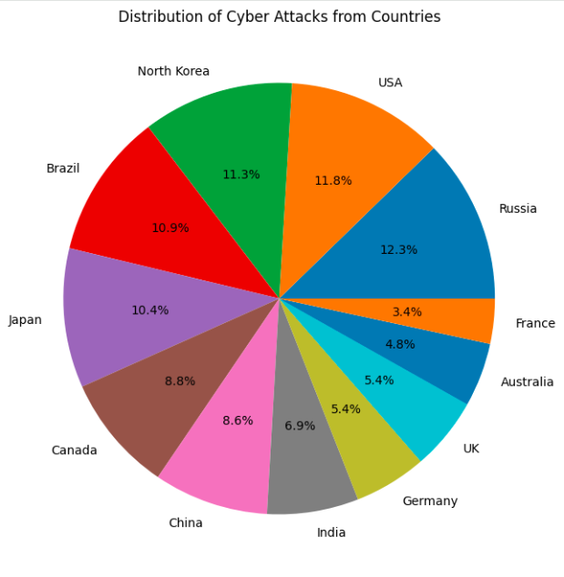

Fig 4: Distribution of Cyber Attacks from Countries

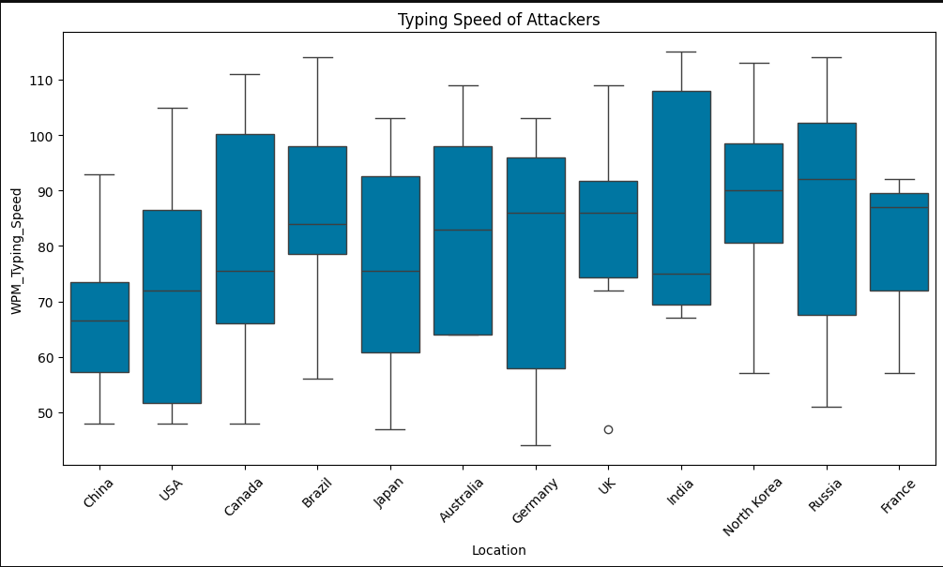

Fig 5 : Typing Speed of Attackers

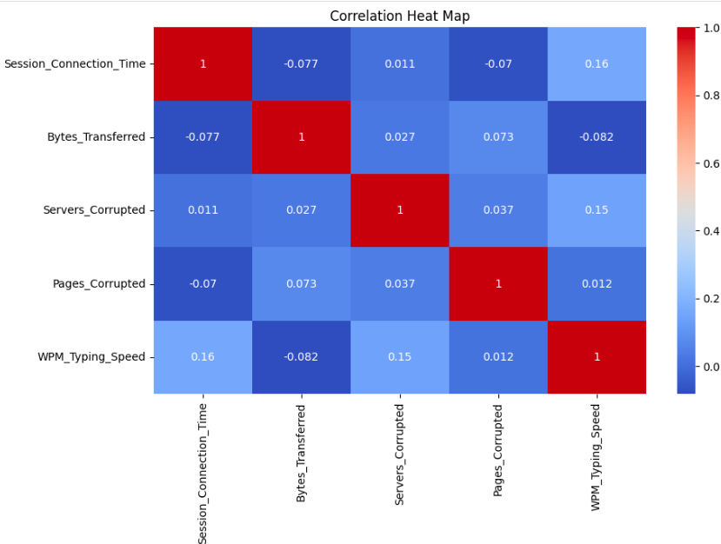

Fig 6 : Correlation Heat Map

5.CONCLUSION AND FUTURE ENHANCEMENTS

5.1 Conclusion

The project Global Cyber Attacks Analysis using Apache Spark was successfully designed and implemented for analyzing cyber security data using big data technologies. The system efficiently processed the cyber attack dataset and extracted useful insights related to attack trends, attacker locations, suspicious behavior, and system damage.
Apache Spark was used as the core processing engine because of its distributed architecture and in-memory computation capabilities. This significantly improved processing speed compared to traditional data analysis methods. The system handled the dataset effectively and performed operations such as filtering, grouping, sorting, aggregation, and statistical analysis.
The project successfully identified top attacking countries based on corrupted server values and provided a clear understanding of geographical cyber threat distribution. It also analyzed typing speed patterns and Kali Linux traces to study attacker behavior. These parameters helped in understanding whether attacks were manual or tool-assisted.
Various visual outputs such as bar charts, pie charts, and correlation heatmaps were generated successfully. These visualizations simplified complex data and made the results easier to understand for users and analysts.
The project also demonstrated the practical use of Apache Spark, PySpark, and data visualization libraries in solving real-world cyber security problems. It provided hands-on knowledge of big data analytics and showed how modern tools can improve cyber defense systems.
Overall, the project achieved its objectives successfully and proved that Apache Spark is an efficient platform for large-scale cyber attack analysis. The system can help organizations monitor threats, detect suspicious activities, and support better decision-making for cyber security management

5.2 Future Enhancements
The proposed system can be further enhanced by integrating real-time data processing using Apache Spark Streaming, which will allow the analysis of live cyber security logs and network events as they occur. Machine learning and deep learning algorithms can be incorporated to automatically detect anomalies, predict future attacks, and classify malicious activities with higher accuracy. The project can also be extended to work with larger real-world datasets collected from enterprise environments for more practical and reliable threat analysis.
Interactive dashboards can be developed using tools such as Power BI, Tableau, or Grafana to provide live monitoring and user-friendly visualization of cyber threats. Geo-mapping features can be added to display attack origins on a world map for better understanding of global threat distribution. The system can also be integrated with cloud platforms such as AWS, Microsoft Azure, or Google Cloud to support scalable storage and processing.
In future versions, multiple data sources such as firewall logs, server logs, IDS alerts, application logs, and network packet captures can be combined to provide a more comprehensive security monitoring system. Automated alert notifications through email, SMS, or mobile applications can be implemented to inform administrators instantly about suspicious activities. Security features such as role-based authentication and secure report access can also be added.
Further improvements may include integration with SIEM platforms, automated blocking of malicious IP addresses, generation of PDF or Excel reports, and predictive analytics for identifying upcoming threats. These enhancements would transform the current project into a complete intelligent cyber defense system suitable for real-world industrial applications.

6.REFERENCES

[1] M. Zaharia, M. Chowdhury, M. J. Franklin, S. Shenker, and I. Stoica, “Spark: Cluster Computing with Working Sets,” Proceedings of the 2nd USENIX Conference on Hot Topics in Cloud Computing, 2010.
[2] B. Chambers and M. Zaharia, Spark: The Definitive Guide: Big Data Processing Made Simple, O’Reilly Media, 2018.
[3] H. Karau, A. Konwinski, P. Wendell, and M. Zaharia, Learning Spark: Lightning-Fast Big Data Analysis, O’Reilly Media, 2015.
[4] T. Drabas and D. Lee, Learning PySpark: Building Python-Based Distributed Data Analytics Solutions with Spark, Packt Publishing, 2017.
[5] V. Ankam, Big Data Analytics with Spark: A Hands-On Approach, Apress, 2016.
[6] Apache Software Foundation, “Apache Spark Documentation.”
Link: https://spark.apache.org/docs/
[7] Apache Software Foundation, “PySpark Documentation.”
Link: https://spark.apache.org/docs/latest/api/python/
[8] Python Software Foundation, “Python Documentation.”
Link: https://docs.python.org/3/
[9] S. Bhatt, P. K. Manadhata, and L. Zaddach, “Big Data Analytics in Cybersecurity,” Springer International Publishing, pp. 1–22, 2014.
[10] A. Chuvakin, K. Schmidt, and C. Phillips, Logging and Log Management: The Authoritative Guide to Understanding the Concepts Surrounding Logging and Log Management, Syngress Publishing, 2013.

