**UML Diagram**

Team No:35 (Freight Forwarding System)

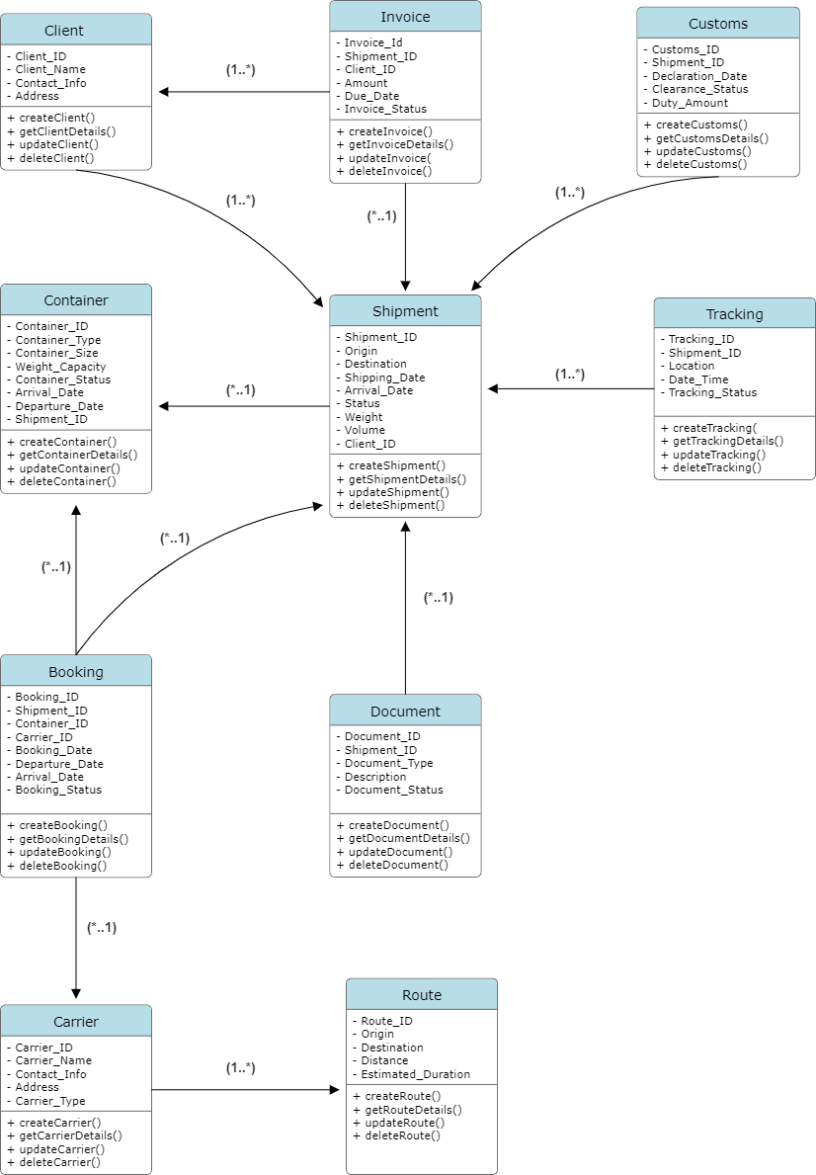

**Classes, Attributes, and Relationships**

**Attributes: Methods:** Shipment_ID: Integer + createsShipment()

Origin: String + getShipmentDetails()

Destination: String + updateShipment()

Shipping_Date: Date + deleteShipment()

Arrival_Date: Date

Shipment_Status:String

Weight:Double

Volume:Double

Client_ID: Integer

**Container**

**Attributes: Methods:**

Container_ID: Integer + createContainer()

Container_Type:String + getContainerDetails()

Container_Size:String + updateContainer()

Weight_Capacity:Double + deleteContainer()

Container_Status:String

Arrival_Date:date

Departure_Date:date

Shipment_ID: Integer

**Carrier**

**Attributes: Methods:**

Carrier_ID: Integer + createCarrier()

Carrier_Name: String + getCarrierDetails()

Contact_Info: String + updateCarrier()

Address:String + deleteCarrier()

Carrier_Type:String

**Booking**

**Attributes: Methods:**

Booking_ID: Integer + createBooking()

Shipment_ID: Integer + getBookingDetails()

Container_ID:Integer + updateBooking()

Carrier_ID: Integer + deleteBooking()

Booking_Date: Date

Departure_Date: Date

Arrival_Date: Date

Booking_Status:String

**Route**

**Attributes: Methods:**

Route_ID: Integer + createRoute()

Origin: String + getRouteDetails()

Destination:Double + updateRoute()

Distance:Double + deleteRoute()

Estimated_Duration:Time

**Invoice**

**Attributes: Methods:**

Invoice_ID: Integer + createInvoice()

Shipment_ID: Integer + getInvoiceDetails()

Client_ID:Integer + updateInvoice()

Amount: Float + deleteInvoice()

Due_Date: Date

Invoice_Status: String

**Tracking**

**Attributes: Methods:**

Tracking_ID: Integer + createTracking()

Shipment_ID: Integer + getTrackingDetails()

Location: String + updateTracking()

Date_Lime:DateTime + deleteTracking()

Tracking_Status: String

**Customs**

**Attributes: Methods:**

Customs_ID: Integer + createCustoms()

Shipment_ID: Integer + getCustomsDetails()

Declaration_Date: Date + updateCustoms()

Clearance_Status: String + deleteCustoms()

Duty_Amount:Double

**Document**

**Attributes: Methods:**

Document_ID: Integer + createDocument()

Shipment_ID: Integer + getDocumentDetails()

Document_Type: String + updateDocument()

Description:String + deleteDocument()

Document_status:String

**Client**

**Attributes: Methods:**

Client_ID: Integer + createClient()

Client_Name: String + getClientDetails()

Contact_Info: String + updateClient()

Address:String + deleteClient()

**Relationships:**

**Client and Shipment: One client can have multiple shipments (one-to-many).**

**Shipment and Container: One shipment can be associated with multiple containers (one-to-many).**

**Booking and Shipment: Each booking is linked to a single shipment (many-to-one).**

**Booking and Container: Each booking is linked to a single container (many-to-one).**

**Booking and Carrier: Each booking is linked to a single carrier (many-to-one).**

**Invoice and Shipment: Each invoice is linked to a single shipment (many-to-one).**

**Invoice and Client: Each invoice is linked to a single client (many-to-one).**

**Tracking and Shipment: Each tracking record is linked to a single shipment (many-to-one).**

**Customs and Shipment: Each customs record is linked to a single shipment (many-to-one).**

**Document and Shipment: Each document is linked to a single shipment (many-to-one).**

**Carrier and Route: Each carrier record is linked to a single route(many to one).**