**UML Diagram**

Team No:35 (Freight Forwarding System)

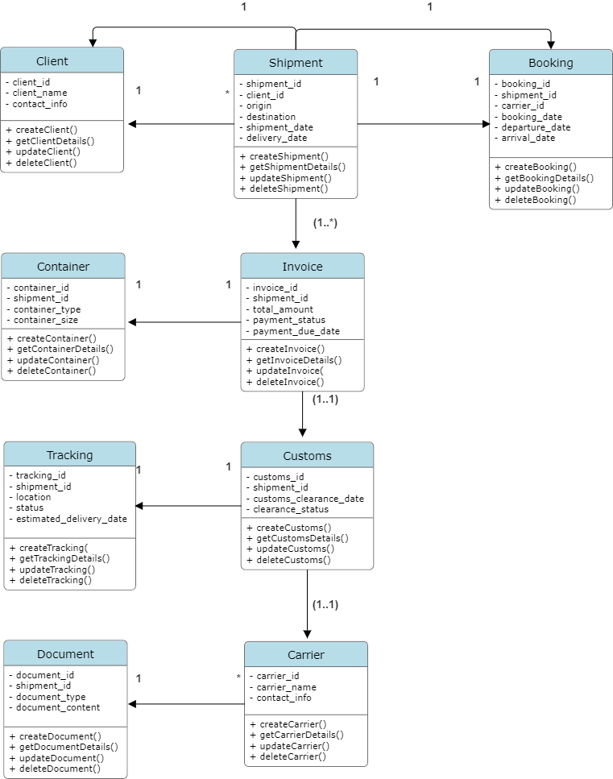

**Classes, Attributes, and Relationships**

**Client**

**Attributes:**

client_id: Integer

client_name: String

contact_info: String

**Methods:**

+ createClient()

+ getClientDetails()

+ updateClient()

+ deleteClient()

**Shipment**

**Attributes:**

shipment_id: Integer

client_id: Integer

origin: String

destination: String

shipment_date: Date

delivery_date: Date

**Methods:**

+ createShipment()

+ getShipmentDetails()

+ updateShipment()

+ deleteShipment()

**Container**

**Attributes:**

container_id: Integer

shipment_id: Integer

container_type: String

container_size: String

**Methods:**

+ createContainer()

+ getContainerDetails()

+ updateContainer()

+ deleteContainer()

**Carrier**

**Attributes:**

carrier_id: Integer

carrier_name: String

contact_info: String

**Methods:**

+ createCarrier()

+ getCarrierDetails()

+ updateCarrier()

+ deleteCarrier()

**Booking**

**Attributes:**

booking_id: Integer

shipment_id: Integer

carrier_id: Integer

booking_date: Date

departure_date: Date

arrival_date: Date

**Methods:**

+ createBooking()

+ getBookingDetails()

+ updateBooking()

+ deleteBooking()

**Route**

**Attributes:**

route_id: Integer

booking_id: Integer

origin: String

destination: String

transit_points: String

**Methods:**

+ createRoute()

+ getRouteDetails()

+ updateRoute()

+ deleteRoute()

**Invoice**

**Attributes:**

invoice_id: Integer

shipment_id: Integer

total_amount: Float

payment_status: String

payment_due_date: Date

**Methods:**

+ createInvoice()

+ getInvoiceDetails()

+ updateInvoice()

+ deleteInvoice()

**Tracking**

**Attributes:**

tracking_id: Integer

shipment_id: Integer

location: String

status: String

estimated_delivery_date: Date

**Methods:**

+ createTracking()

+ getTrackingDetails()

+ updateTracking()

+ deleteTracking()

**Customs**

**Attributes:**

customs_id: Integer

shipment_id: Integer

customs_clearance_date: Date

clearance_status: String

**Methods:**

+ createCustoms()

+ getCustomsDetails()

+ updateCustoms()

+ deleteCustoms()

**Document**

**Attributes:**

document_id: Integer

shipment_id: Integer

document_type: String

document_content: String

**Methods:**

+ createDocument()

+ getDocumentDetails()

+ updateDocument()

+ deleteDocument()

**Relationships**

**Client to Shipment: One-to-many (1 to *)**

**- A client can have multiple shipments, but each shipment is associated with only one client.**

**Shipment to Booking: One-to-one (1 to 1)**

**- Each shipment can have one booking, and each booking is associated with one shipment.**

**Shipment to Container: One-to-many (1 to *)**

**- Each shipment can have multiple containers, but each container is associated with only one shipment.**

**Shipment to Invoice: One-to-one (1 to 1)**

**- Each shipment has one invoice, and each invoice is associated with one shipment.**

**Shipment to Tracking: One-to-one (1 to 1)**

**- Each shipment has one tracking record, and each tracking record is associated with one shipment.**

**Shipment to Customs: One-to-one (1 to 1)**

**- Each shipment has one customs clearance record, and each customs clearance record is associated with one shipment.**

**Shipment to Document: One-to-many (1 to *)**

**- Each shipment can have multiple documents, but each document is associated with only one shipment.**

**Carrier to Booking: One-to-many (1 to *)**

**- A carrier can have multiple bookings, but each booking is associated with only one carrier.**