

A Course End Project Report on
HOTEL RESERVATION SYSTEM
A9513 – PYTHON PROGRAMING LABORATORY
Submitted by
THAMMADI ANANYA SHARON
25881A0572
YARAPU AKSHITHA
26885A0508
Course Facilitator
Ms. P.S. Madhavi
Assistant Professor
Department of Computer Science and Engineering
Vardhaman College of Engineering, Hyderabad


Autonomous Institute, Affiliated to JNTUH,
Approved by AICTE, Accredited by NAAC with A++ Grade Kacharam, Shamshabad, Hyderabad- 501 218, Telangana, India.

DEPARTMENT OF COMPUTER SCIENCE AND ENGINEERING

This is to certify that the Course End Project titled “Social Media Analyser” is carried out by THAMMADI ANANYA SHARON and YARAPU AKSHITHA with Roll Numbers 25881A0572 and 26885A0508 towards A9513 – PYTHON PROGRAMING LABORATORY course in partial fulfilment of the requirements for the award of degree of Bachelor of Technology in Computer Science and Engineering during the Academic year 2025-26.

Signature of the Course Faculty  Ms Pallamoni S Madhavi  Assistant Professor, CSE | Signature of the HOD  Dr. Y.Vijayalata  Professor,Head of the Department & Dean(StudentMentoring), Department of Computer Science and Engineering

Contents
- Introduction 3
- Literature Review……………………………………………………………………..4
- Objective……………………………………………………………………………...6
- Methodology………………………………………………………………………….7
  - Architectural Diagram………………………………………………………...7
  - Hardware and Software Requirements………………………………………..9
  - Working Principle……………………………………………………………10
  - Software Implementation…………………………………………………….11
- Results and Discussion………………………………………………………………40
- Mapping POs ,PSOs and SDGs……………………………………………………...43
  - Program Outcomes (POs) Mapping………………………………………….
  - Program Specific Outcomes (PSOs) Mapping……...……………………….44
  - Sustainable Development Goals (SDGs) Mapping………………………….44
- Conclusion…………………………………………………………………………..45
8 Bibliography………………………………………………………………………..46

Abstract

The Grand Palace Hotel – Hotel Reservation System is a Python-based application developed to simplify and organize the hotel reservation process for customers. The system provides a user-friendly graphical interface through which customers can create an account, log in, explore hotels, view available rooms, check hotel facilities and ratings, and make reservations. The application is designed to provide a convenient and efficient way for customers to select hotels according to their preferences.
The system includes hotels located in Gachibowli, Madhapur, Banjara Hills, and Secunderabad. Customers can search and filter hotels based on factors such as price, rating, and facilities. The application uses SQLite to store and manage customer accounts, hotel details, room information, and reservation records. Customers can view their own reservations and billing details and can also cancel their bookings when required.
The system maintains proper relationships between users, customers, hotels, rooms, and reservations to ensure organized data management. A TXT-based hotel customer reservation summary is also generated automatically. This summary provides the hotel name, locality, number of unique customers, and total number of active reservations for each hotel. It is updated whenever the application starts, a reservation is made, or a reservation is cancelled.
Overall, the Grand Palace Hotel – Hotel Reservation System demonstrates the practical use of Python, Tkinter, and SQLite in developing a database-driven reservation application. The project provides an effective and accessible solution for managing customer hotel bookings while maintaining organized reservation information and generating useful hotel-wise summaries.
Keywords: Hotel Reservation System, Python, Tkinter, SQLite, Hotel Booking, Customer Management, Room Reservation, Database Management, Billing, Hotel Summary

1. Introduction
The Grand Palace Hotel – Hotel Reservation System is a Python-based application developed to provide a simple and user-friendly platform for hotel room reservations. The system is designed for customers who want to create an account, log in, explore available hotels, view hotel details, check room availability, and make reservations. It provides an organized way to manage the complete hotel booking process through a graphical user interface developed using Python Tkinter.
The system contains information about hotels located in four different localities: Gachibowli, Madhapur, Banjara Hills, and Secunderabad. Customers can browse hotels based on their locality and use filters such as price, rating, and available facilities. Each hotel contains information about its rating, facilities, rooms, room types, prices, and capacity. This allows customers to compare available options and select a hotel and room according to their requirements.
The application uses SQLite as its database to store user accounts, customer details, hotel information, room details, and reservations. The system maintains a connection between customers and their reservations so that users can view only their own booking information. Customers can also view their reservations, billing details, and cancel their bookings when required. The system therefore provides a structured and secure approach to handling customer reservation information.
In addition, the system automatically generates a hotel customer reservation summary in a TXT file. The summary contains the hotel name, locality, number of unique customers, and total number of active reservations for each hotel. The summary is updated when the application starts and whenever a reservation is successfully created or cancelled. Overall, the Grand Palace Hotel Reservation System demonstrates how Python, Tkinter, and SQLite can be combined to develop a practical, database-driven hotel reservation application.

Literature Review

This project brings together several basic topics that are studied in a first-year Python programming course. The following sections describe the concepts that are relevant to the Hotel Reservation System and how each of them is used in the application.

Hotel Reservation Management
Hotel reservation systems are developed to simplify the process of searching for hotels, selecting rooms, and making reservations. Computerized reservation systems provide a more organized approach to maintaining booking information compared with manual methods. The proposed Grand Palace Hotel Reservation System implements these concepts through a customer-oriented reservation interface.

Customer Registration and Login
Customer authentication is an important part of a reservation system because it allows users to create accounts and access their personal reservation information. The proposed system implements customer registration and login, allowing each customer to access their own profile, reservations, and billing information.

Hotel Search and Filtering
Hotel search functionality helps customers identify suitable hotels according to their requirements. Factors such as locality, price, rating, and facilities can assist customers in comparing available hotels. The proposed system implements hotel selection based on locality and provides filtering according to price, rating, and facilities.

Room Management and Booking
Room information is essential for a hotel reservation system because customers need to know the available room types, prices, capacity, and booking status. The proposed system stores room information and allows customers to select an available room and make a reservation according to their requirements.

Reservation and Billing Management
Reservation management involves recording customer bookings, reservation dates, number of nights, and total booking amounts. Billing information is generated from the reservation details. The proposed system implements reservation and billing functionality so that customers can view their booking and payment-related information.

Reservation Cancellation
A reservation system should provide customers with the ability to cancel an existing booking when necessary. The proposed system implements cancellation functionality and updates the reservation status accordingly. This helps maintain accurate and up-to-date reservation records.

SQLite Database Management
Database management is required to store and organize information about users, customers, hotels, rooms, and reservations. The proposed system uses SQLite to maintain these records and establish relationships between the different entities. This provides persistent and structured storage for the reservation application.

Hotel Customer Reservation Summary
The proposed system also implements an automatically updated TXT-based hotel customer reservation summary. The summary records the hotel name, locality, number of unique customers, and total active reservations. It is refreshed when the application starts and after reservation or cancellation operations, providing a simple overview of hotel-wise reservation activity.

3 Objectives

Customer Management
- To provide customer registration and login functionality.
- To maintain customer profile information securely.
- To allow customers to access only their own reservation details.

Hotel Search and Selection
- To allow customers to select hotels based on locality.
- To provide hotel information such as rating and facilities.
- To enable filtering of hotels based on price, rating, and facilities.

Room Management
- To display available rooms for each hotel.
- To provide room details such as room type, price, capacity, and status.
- To allow customers to select a suitable room for reservation.

Reservation Management
- To enable customers to make hotel room reservations.
- To store reservation dates, number of nights, and booking amount.
- To allow customers to view their existing reservations.
Billing Management
- To calculate the total reservation amount based on room price and number of nights.
- To provide customers with their billing information.
- To maintain billing details along with reservation records.

Reservation Cancellation
- To allow customers to cancel their own reservations.
- To update the reservation status after cancellation.
- To ensure that cancelled reservations are not counted as active bookings.

Database Management
- To use SQLite for storing customer, hotel, room, and reservation information.
- To maintain relationships between users, customers, hotels, rooms, and reservations.
- To ensure organized and consistent reservation data.

Hotel Reservation Summary
- To generate a hotel-wise reservation summary in a TXT file.
- To display the locality, unique customers, and total active reservations for each hotel.
- To automatically update the summary after booking or cancellation.

4 Methodology

4.1 Architectural Diagram
The system follows a three-layer architecture: User Layer, Application Layer, and Data Layer.The User Layer uses Tkinter for registration, login, hotel search, booking, billing, and cancellation.The Application Layer handles user, hotel, room, reservation, billing, cancellation, and summary management.The Data Layer uses SQLite for storing system data and generates a TXT hotel customer reservation summary.The flow of data through the application is shown in Figure 1.

Figure 1: Ar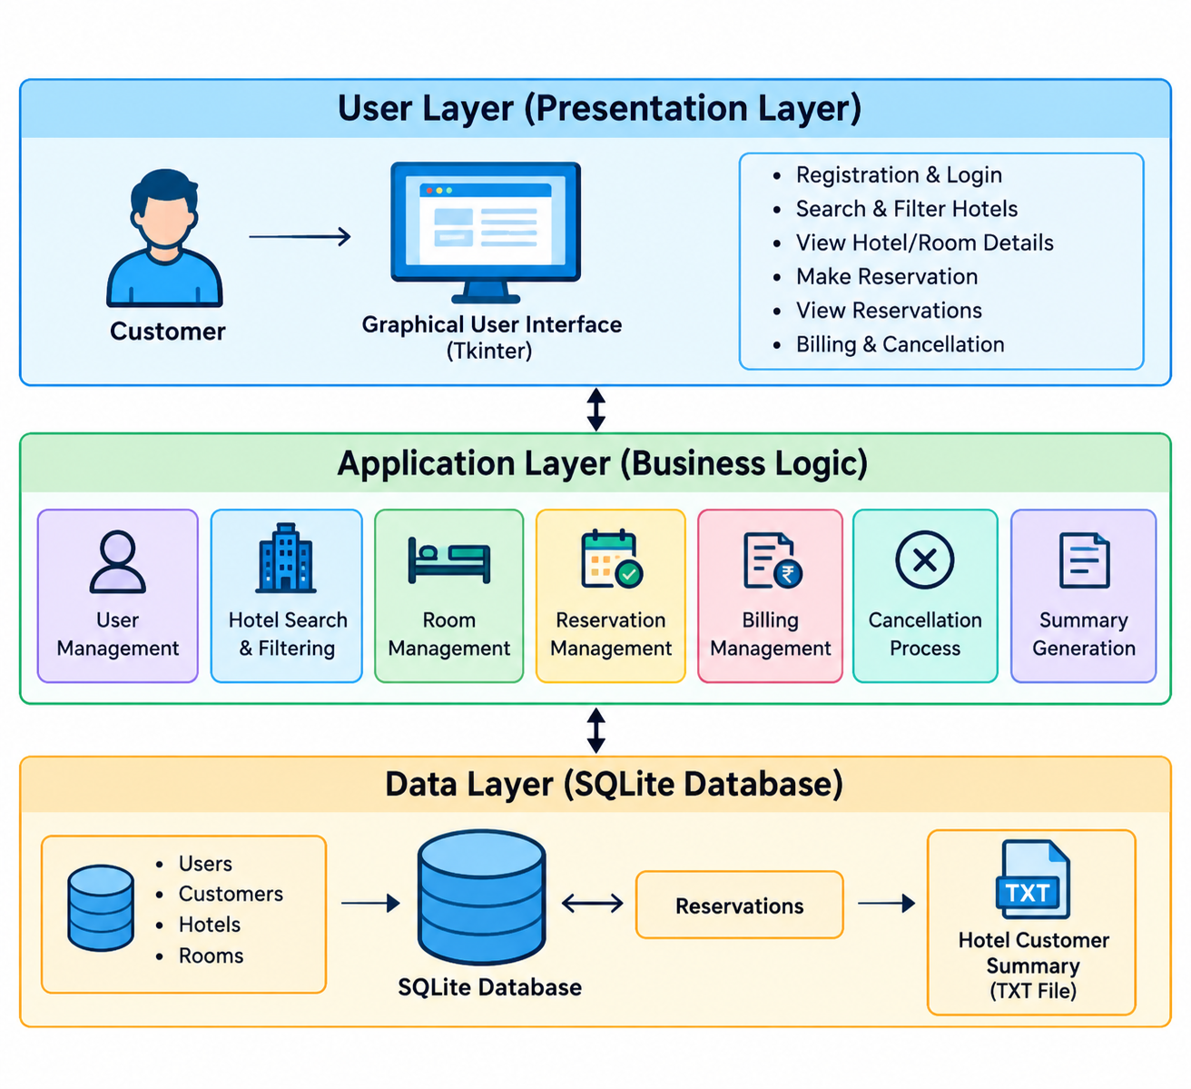
Figure 1: Architecture of the Hotel Reservation System

1. User Layer (Presentation Layer)
The User Layer is the front-end part of the system through which customers interact with the application. It is developed using Python Tkinter and provides options such as registration, login, hotel search, hotel and room details, reservation, billing, and cancellation.

2. Application Layer (Business Logic)
The Application Layer handles the main processing of the system. It manages user management, hotel search and filtering, room management, reservation management, billing management, cancellation, and summary generation according to the customer's actions.

3. Data Layer (SQLite Database)
The Data Layer is responsible for storing and retrieving system information using SQLite. It maintains data related to users, customers, hotels, rooms, and reservations, while maintaining the required relationships between them.

4. Hotel Customer Summary
The system generates a TXT-based hotel customer reservation summary from the reservation data. It contains information such as the hotel name, locality, unique customers, and total active reservations, and is updated after relevant reservation activities.

4.2 Hardware and Software Requirements
The application is a small desktop program and does not need any special hardware. The software and hardware that are sufficient to run it are given in Table 1 and Table 2.
Table 1: Software Requirements
  Requirement
  Specification
  OperatingSystem
  Windows 10 / Windows 11
  Programming Language
  Python 3.x
  GUI Framework
  Tkinter / ttk
  Database
  SQLite3
  Development Environment
  VS Code/PyCharm /IDLE
  Database Module
  Python sqlite3 module

Table 2: Hardware Requirements
  Requirement
  Requirement
  Processor
  Intel Core i3 or equivalent
  RAM
  4 GB or above
  Storage
  500 MB free space
  Display
  1366 × 768 resolution or above
  Keyboard
  Standard keyboard

4.3 Working Principle
- Start the Application
The customer opens the Hotel Reservation System. The system connects to the SQLite database and loads the required hotel and room information.
- Create an Account
A new customer enters their name, email, phone number, address, username, and password. The system stores the customer and login details in the database.
- Login
The customer enters their username and password. The system verifies the details and allows access after successful authentication.
- Select Locality
The customer selects one of the available localities:
  - Gachibowli
  - Madhapur
  - Banjara Hills
  - Secunderabad
- View Hotels
The system displays the hotels available in the selected locality along with their ratings and facilities.
- Filter Hotels
The customer can filter the available hotels according to price, rating, and facilities to find a suitable hotel.
- View Hotel Details
The customer selects a hotel to view its description, rating, facilities, and available rooms.
- Select a Room
The customer selects an available room. The system displays the room type, price, capacity, and availability.
- Enter Reservation Details
The customer enters the required check-in and check-out dates. The system calculates the number of nights.
- Calculate Billing Amount
The system calculates the total amount based on the room price and number of nights.
- Confirm Reservation
The customer confirms the booking. The reservation is stored in the SQLite database and the selected room status is changed to Booked.
- View Reservation
The customer can open My Reservations to view their own booking details and billing information.
- Cancel Reservation
If required, the customer selects their reservation and chooses Cancel Reservation. The system verifies that the reservation belongs to the logged-in customer.
- Update Cancellation
After cancellation, the reservation status changes from Booked to Cancelled, and the corresponding room becomes Available again.
- Update Summary File
The system automatically updates hotel_customer_summary.txt after booking or cancellation. The file contains the hotel name, locality, unique customer count, and total booked reservations.

Software Implementation

- import tkinter as _error_tk
- from tkinter import ttk as _error_ttk
- import traceback as _error_traceback

- def _show_startup_error(exc_text):
- root = _error_tk.Tk()
- root.title("Grand Palace Hotel - Startup Error")
- root.geometry("900x600")
- root.minsize(700, 450)
- frame = _error_ttk.Frame(root, padding=15)
- frame.pack(fill="both", expand=True)
- _error_ttk.Label(frame, text="Grand Palace Hotel Reservation System", font=("Segoe UI", 16, "bold")).pack(anchor="w")
- _error_ttk.Label(frame, text="The project could not start. The full error is shown below.", font=("Segoe UI", 10)).pack(anchor="w", pady=(6, 10))
- box_frame = _error_ttk.Frame(frame)
- box_frame.pack(fill="both", expand=True)
- box = _error_tk.Text(box_frame, wrap="word", font=("Consolas", 10))
- box.pack(side="left", fill="both", expand=True)
- scroll = _error_ttk.Scrollbar(box_frame, orient="vertical", command=box.yview)
- scroll.pack(side="right", fill="y")
- box.configure(yscrollcommand=scroll.set)
- box.insert("1.0", exc_text)
- box.configure(state="disabled")
- _error_ttk.Button(frame, text="Close", command=root.destroy).pack(anchor="e", pady=(10, 0))
- root.mainloop()

- try:
- import sqlite3
- import os
- import hashlib
- import secrets
- import tkinter as tk
- from tkinter import ttk, messagebox
- from datetime import datetime

- BASE_DIR = os.path.dirname(os.path.abspath(__file__))
- DB_NAME = os.path.join(BASE_DIR, "hotel.db")
- SUMMARY_TXT_NAME = os.path.join(BASE_DIR, "hotel_customer_summary.txt")

- BG = "#0B1220"
- SIDEBAR = "#101A2E"
- CARD = "#162238"
- CARD2 = "#1B2A42"
- GOLD = "#D4AF37"
- GOLD_LIGHT = "#F0D77A"
- CREAM = "#F5EEDC"
- WHITE = "#FFFFFF"
- TEXT = "#DCE4F2"
- MUTED = "#91A0B8"
- GREEN = "#38C172"
- RED = "#E55353"
- BLUE = "#4D9DE0"
- FONT = "Segoe UI"

- def db():
- conn = sqlite3.connect(DB_NAME)
- conn.execute("PRAGMA foreign_keys = ON")
- return conn

- def update_hotel_customer_summary():
- """Rebuild the hotel-wise customer reservation summary as a text file.
- The summary contains counts only; no customer personal details are stored.
- """
- source = db()
- src = source.cursor()
- src.execute("SELECT id, hotel_name, locality FROM hotels ORDER BY hotel_name")
- hotels = src.fetchall()

- lines = [
- "HOTEL CUSTOMER RESERVATION SUMMARY",
- "=" * 70,
- "",
- f"Updated: {datetime.now().strftime('%Y-%m-%d %H:%M:%S')}",
- "",
- ]

- for hotel_id, hotel_name, locality in hotels:
- src.execute("""SELECT COUNT(DISTINCT customer_id), COUNT(*)
- FROM reservations
- WHERE hotel_id=? AND status='Booked'""", (hotel_id,))
- unique_customers, total_reservations = src.fetchone()
- lines.extend([
- f"Hotel Name : {hotel_name}",
- f"Locality : {locality}",
- f"Unique Customers : {unique_customers or 0}",
- f"Total Reservations: {total_reservations or 0}",
- "-" * 70,
- ])

- source.close()
- with open(SUMMARY_TXT_NAME, "w", encoding="utf-8") as f:
- f.write("\n".join(lines))

- def initialize_database():
- conn = db()
- cur = conn.cursor()

- cur.execute("""CREATE TABLE IF NOT EXISTS customers(
- id INTEGER PRIMARY KEY AUTOINCREMENT,
- name TEXT NOT NULL,
- phone TEXT NOT NULL,
- email TEXT,
- address TEXT)""")

- # Each customer profile belongs to one login account. Existing customer rows
- # are preserved; their user_id can remain NULL until linked to an account.
- ccols = [r[1] for r in cur.execute("PRAGMA table_info(customers)").fetchall()]
- if "user_id" not in ccols:
- cur.execute("ALTER TABLE customers ADD COLUMN user_id INTEGER")

- cur.execute("""CREATE TABLE IF NOT EXISTS users(
- id INTEGER PRIMARY KEY AUTOINCREMENT,
- username TEXT NOT NULL UNIQUE,
- password_hash TEXT NOT NULL,
- salt TEXT NOT NULL,
- created_at TEXT DEFAULT CURRENT_TIMESTAMP)""")
- cur.execute("CREATE UNIQUE INDEX IF NOT EXISTS idx_customers_user_id ON customers(user_id) WHERE user_id IS NOT NULL")

- cur.execute("""CREATE TABLE IF NOT EXISTS hotels(
- id INTEGER PRIMARY KEY AUTOINCREMENT,
- hotel_name TEXT NOT NULL,
- locality TEXT NOT NULL,
- city TEXT NOT NULL,
- address TEXT,
- rating REAL DEFAULT 0,
- description TEXT,
- contact TEXT)""")

- cur.execute("""CREATE TABLE IF NOT EXISTS hotel_specs(
- hotel_id INTEGER PRIMARY KEY,
- wifi INTEGER DEFAULT 0,
- parking INTEGER DEFAULT 0,
- restaurant INTEGER DEFAULT 0,
- pool INTEGER DEFAULT 0,
- gym INTEGER DEFAULT 0,
- ac INTEGER DEFAULT 0,
- FOREIGN KEY(hotel_id) REFERENCES hotels(id) ON DELETE CASCADE)""")

- cur.execute("""CREATE TABLE IF NOT EXISTS rooms(
- id INTEGER PRIMARY KEY AUTOINCREMENT,
- hotel_id INTEGER,
- room_number TEXT NOT NULL,
- room_type TEXT NOT NULL,
- price REAL NOT NULL,
- capacity INTEGER DEFAULT 2,
- status TEXT DEFAULT 'Available',
- UNIQUE(hotel_id, room_number),
- FOREIGN KEY(hotel_id) REFERENCES hotels(id) ON DELETE CASCADE)""")

- # Upgrade the original single-hotel database without deleting existing data.
- cols = [r[1] for r in cur.execute("PRAGMA table_info(rooms)").fetchall()]
- if "hotel_id" not in cols:
- cur.execute("ALTER TABLE rooms ADD COLUMN hotel_id INTEGER")
- if "capacity" not in cols:
- cur.execute("ALTER TABLE rooms ADD COLUMN capacity INTEGER DEFAULT 2")

- cur.execute("""CREATE TABLE IF NOT EXISTS reservations(
- id INTEGER PRIMARY KEY AUTOINCREMENT,
- customer_id INTEGER NOT NULL,
- room_id INTEGER NOT NULL,
- hotel_id INTEGER,
- check_in TEXT NOT NULL,
- check_out TEXT NOT NULL,
- nights INTEGER NOT NULL,
- total REAL NOT NULL,
- status TEXT DEFAULT 'Booked',
- created_at TEXT DEFAULT CURRENT_TIMESTAMP,
- FOREIGN KEY(customer_id) REFERENCES customers(id),
- FOREIGN KEY(room_id) REFERENCES rooms(id),
- FOREIGN KEY(hotel_id) REFERENCES hotels(id))""")

- rcols = [r[1] for r in cur.execute("PRAGMA table_info(reservations)").fetchall()]
- if "hotel_id" not in rcols:
- cur.execute("ALTER TABLE reservations ADD COLUMN hotel_id INTEGER")

- # Always make sure the demonstration database contains several hotels.
- # This also repairs databases created by an earlier version of the program.
- sample_hotels = [
- ("Grand Palace Hotel", "Gachibowli", "Hyderabad", "Financial District Road, Gachibowli", 4.6,
- "Premium business and leisure hotel with modern rooms and hospitality.", "+91 90000 00001", (1,1,1,1,1,1)),
- ("City Comfort Residency", "Madhapur", "Hyderabad", "Main Road, Madhapur", 4.2,
- "Comfortable rooms for business and short stays.", "+91 90000 00002", (1,1,1,0,0,1)),
- ("Royal Residency", "Banjara Hills", "Hyderabad", "Road No. 12, Banjara Hills", 4.5,
- "Elegant rooms with family-friendly facilities.", "+91 90000 00003", (1,1,1,1,1,1)),
- ("Green View Hotel", "Secunderabad", "Hyderabad", "Station Road, Secunderabad", 4.0,
- "Affordable accommodation with essential facilities.", "+91 90000 00004", (1,1,1,0,0,0)),
- ("Airport Comfort Inn", "Secunderabad", "Hyderabad", "Airport Road Extension, Secunderabad", 4.3,
- "Convenient stay with essential guest facilities and comfortable rooms.", "+91 90000 00005", (1,1,1,0,0,1)),
- ("Lake View Grand Hotel", "Gachibowli", "Hyderabad", "Nanakramguda Road, Gachibowli", 4.4,
- "Modern city hotel suited for business travellers and families.", "+91 90000 00006", (1,1,1,1,1,1)),
- ("Pearl City Inn", "Madhapur", "Hyderabad", "Kavuri Hills Road, Madhapur", 3.9,
- "Budget-friendly rooms with convenient city access.", "+91 90000 00007", (1,1,1,0,0,1)),
- ("Heritage Heights Hotel", "Banjara Hills", "Hyderabad", "Road No. 10, Banjara Hills", 4.1,
- "Comfortable central-city accommodation with dining facilities.", "+91 90000 00008", (1,1,1,0,1,1)),
- ("Metro Star Residency", "Secunderabad", "Hyderabad", "MG Road, Secunderabad", 4.0,
- "Practical hotel for business and short city stays.", "+91 90000 00009", (1,1,0,0,0,1)),
- ("City Pearl Palace", "Gachibowli", "Hyderabad", "Old Mumbai Highway, Gachibowli", 4.3,
- "Contemporary accommodation with convenient guest facilities.", "+91 90000 00010", (1,1,1,1,0,1)),
- ]

- # Do not delete existing hotels/rooms/reservations during startup.
- # Foreign-key relationships are preserved and all required sample hotels
- # are inserted below when they are missing.

- for h in sample_hotels:
- cur.execute("SELECT id FROM hotels WHERE hotel_name=? AND locality=?", (h[0], h[1]))
- existing = cur.fetchone()
- if existing:
- h_id = existing[0]
- else:
- cur.execute("""INSERT INTO hotels
- (hotel_name, locality, city, address, rating, description, contact)
- VALUES (?,?,?,?,?,?,?)""", h[:7])
- h_id = cur.lastrowid

- cur.execute("SELECT 1 FROM hotel_specs WHERE hotel_id=?", (h_id,))
- if not cur.fetchone():
- cur.execute("INSERT INTO hotel_specs VALUES (?,?,?,?,?,?,?)", (h_id, *h[7]))

- cur.execute("SELECT id FROM hotels ORDER BY id LIMIT 1")
- first_hotel = cur.fetchone()
- hid = first_hotel[0]

- # Assign old rooms to the first hotel.
- cur.execute("UPDATE rooms SET hotel_id=? WHERE hotel_id IS NULL", (hid,))
- cur.execute("UPDATE reservations SET hotel_id=(SELECT hotel_id FROM rooms WHERE rooms.id=reservations.room_id) WHERE hotel_id IS NULL")

- cur.execute("SELECT COUNT(*) FROM rooms")
- if cur.fetchone()[0] == 0:
- room_data = [
- (hid, "101", "Single", 1500, 1), (hid, "102", "Single", 1500, 1),
- (hid, "201", "Double", 2500, 2), (hid, "202", "Double", 2500, 2),
- (hid, "301", "Deluxe", 4000, 3), (hid, "302", "Deluxe", 4000, 3),
- (hid, "401", "Suite", 6000, 4), (hid, "402", "Suite", 6000, 4),
- ]
- cur.executemany("INSERT INTO rooms(hotel_id,room_number,room_type,price,capacity) VALUES(?,?,?,?,?)", room_data)

- # Give every hotel useful rooms. Use hotel-specific room numbers so this
- # also works with older databases where room_number was globally UNIQUE.
- for row in cur.execute("SELECT id FROM hotels ORDER BY id").fetchall():
- hotel_id = row[0]
- cur.execute("SELECT COUNT(*) FROM rooms WHERE hotel_id=?", (hotel_id,))
- if cur.fetchone()[0] == 0:
- prefix = f"H{hotel_id}-"
- rooms = [
- (hotel_id, f"{prefix}101", "Standard", 1800, 2),
- (hotel_id, f"{prefix}201", "Deluxe", 3000, 3),
- (hotel_id, f"{prefix}301", "Suite", 5000, 4),
- ]
- for room in rooms:
- # INSERT OR IGNORE protects against an old database whose
- # room_number column is globally UNIQUE.
- cur.execute("""INSERT OR IGNORE INTO rooms
- (hotel_id,room_number,room_type,price,capacity)
- VALUES(?,?,?,?,?)""", room)

- conn.commit()
- conn.close()
- update_hotel_customer_summary()

- class LoginWindow:
- def __init__(self, root):
- self.root = root
- self.root.title("Hotel Finder - User Login")
- self.root.geometry("520x680")
- self.root.configure(bg=BG)
- self.root.resizable(True, True)
- self.build_login()

- def build_login(self):
- main = tk.Frame(self.root, bg=BG)
- main.pack(fill="both", expand=True)
- tk.Label(main, text="♛", font=(FONT, 55), fg=GOLD, bg=BG).pack(pady=(35,0))
- tk.Label(main, text="HOTEL FINDER", font=(FONT, 28, "bold"), fg=GOLD_LIGHT, bg=BG).pack()
- tk.Label(main, text="MULTI-HOTEL RESERVATION SYSTEM", font=(FONT, 11, "bold"), fg=CREAM, bg=BG).pack()
- tk.Label(main, text="Login with your own account", font=(FONT, 10), fg=MUTED, bg=BG).pack(pady=(5,30))
- card = tk.Frame(main, bg=CARD, highlightbackground=GOLD, highlightthickness=1)
- card.pack(padx=50, fill="x")
- tk.Label(card, text="USER LOGIN", font=(FONT,15,"bold"), fg=CREAM, bg=CARD).pack(pady=(25,20))
- tk.Label(card, text="Username", fg=MUTED, bg=CARD).pack(anchor="w", padx=35)
- self.username = tk.Entry(card, font=(FONT,12), bg=CARD2, fg=WHITE, insertbackground=WHITE, relief="flat")
- self.username.pack(padx=35,pady=(5,15),ipady=8,fill="x")
- tk.Label(card, text="Password", fg=MUTED, bg=CARD).pack(anchor="w", padx=35)
- self.password = tk.Entry(card, show="•", font=(FONT,12), bg=CARD2, fg=WHITE, insertbackground=WHITE, relief="flat")
- self.password.pack(padx=35,pady=(5,20),ipady=8,fill="x")
- tk.Button(card, text="LOGIN", command=self.login, font=(FONT,11,"bold"), bg=GOLD, fg="#111111", activebackground=GOLD_LIGHT, relief="flat").pack(padx=35,pady=(0,10),fill="x",ipady=8)
- tk.Button(card, text="CREATE NEW ACCOUNT", command=self.register, font=(FONT,10,"bold"), bg=CARD2, fg=CREAM, activebackground=SIDEBAR, relief="flat").pack(padx=35,pady=(0,25),fill="x",ipady=7)
- tk.Label(main, text="Your username and password are stored securely in hotel.db.", font=(FONT,9), fg=MUTED, bg=BG).pack(pady=18)
- self.password.bind("<Return>", lambda e: self.login())

- def hash_password(self, password, salt=None):
- salt = salt or secrets.token_hex(16)
- hashed = hashlib.pbkdf2_hmac("sha256", password.encode("utf-8"), salt.encode("utf-8"), 120000).hex()
- return hashed, salt

- def register(self):
- username = self.username.get().strip()
- password = self.password.get()
- if len(username) < 3:
- messagebox.showwarning("Create Account", "Username must contain at least 3 characters.")
- return
- if len(password) < 4:
- messagebox.showwarning("Create Account", "Password must contain at least 4 characters.")
- return
- conn = db()
- cur = conn.cursor()
- cur.execute("SELECT id FROM users WHERE LOWER(username)=LOWER(?)", (username,))
- if cur.fetchone():
- conn.close()
- messagebox.showerror("Create Account", "That username already exists. Please choose another username.")
- return
- password_hash, salt = self.hash_password(password)
- cur.execute("INSERT INTO users(username,password_hash,salt) VALUES(?,?,?)", (username, password_hash, salt))
- user_id=cur.lastrowid
- conn.commit()
- conn.close()
- messagebox.showinfo("Account Created", "Account created successfully. Now complete your customer profile.")
- self.password.delete(0, tk.END)
- self.complete_profile(user_id, username)

- def login(self):
- username = self.username.get().strip()
- password = self.password.get()
- if not username or not password:
- messagebox.showwarning("Login", "Enter your username and password.")
- return
- conn = db()
- cur = conn.cursor()
- cur.execute("SELECT id, password_hash, salt FROM users WHERE LOWER(username)=LOWER(?)", (username,))
- row = cur.fetchone()
- if row:
- user_id, stored_hash, salt = row
- password_hash, _ = self.hash_password(password, salt)
- if secrets.compare_digest(password_hash, stored_hash):
- cur.execute("SELECT id FROM customers WHERE user_id=?", (user_id,))
- customer_row = cur.fetchone()
- conn.close()
- if not customer_row:
- self.complete_profile(user_id, username)
- return
- self.root.destroy()
- root = tk.Tk()
- HotelApp(root, user_id, customer_row[0], username)
- root.mainloop()
- return
- conn.close()
- messagebox.showerror("Login Failed", "Invalid username or password.")

- def complete_profile(self, user_id, username):
- win = tk.Toplevel(self.root)
- win.title("Complete Your Profile")
- win.geometry("460x500")
- win.configure(bg=BG)
- win.transient(self.root)
- win.grab_set()
- tk.Label(win, text="COMPLETE YOUR PROFILE", font=(FONT,16,"bold"), fg=GOLD_LIGHT, bg=BG).pack(pady=(25,20))
- card=tk.Frame(win,bg=CARD,highlightbackground=GOLD,highlightthickness=1); card.pack(fill="both",expand=True,padx=30,pady=10)
- fields={}
- for label in ["Full Name","Phone","Email","Address"]:
- tk.Label(card,text=label,fg=MUTED,bg=CARD).pack(anchor="w",padx=25,pady=(12,4))
- e=tk.Entry(card,font=(FONT,11),bg=CARD2,fg=WHITE,insertbackground=WHITE,relief="flat")
- e.pack(fill="x",padx=25,ipady=7); fields[label]=e
- def save():
- name=fields["Full Name"].get().strip(); phone=fields["Phone"].get().strip()
- if not name or not phone:
- messagebox.showwarning("Required","Full name and phone are required.",parent=win); return
- conn=db(); cur=conn.cursor(); cur.execute("INSERT INTO customers(user_id,name,phone,email,address) VALUES(?,?,?,?,?)",(user_id,name,phone,fields["Email"].get().strip(),fields["Address"].get().strip())); cid=cur.lastrowid; conn.commit(); conn.close(); win.destroy(); self.root.destroy(); root=tk.Tk(); HotelApp(root,user_id,cid,username); root.mainloop()
- tk.Button(card,text="SAVE PROFILE",command=save,font=(FONT,10,"bold"),bg=GOLD,fg="#111111",relief="flat",cursor="hand2").pack(fill="x",padx=25,pady=25,ipady=8)

- class HotelApp:
- def __init__(self, root, user_id, customer_id, username):
- self.root = root
- self.user_id = user_id
- self.customer_id = customer_id
- self.username = username
- self.root.title("Hotel Finder - Multi-Hotel Reservation System")
- self.root.geometry("1280x800")
- self.root.minsize(1080,700)
- self.root.configure(bg=BG)
- self.current_page = None
- self.create_style()
- self.build_interface()
- self.show_finder()

- def create_style(self):
- style = ttk.Style()
- try: style.theme_use("clam")
- except: pass
- style.configure("Treeview", background=CARD, foreground=TEXT, fieldbackground=CARD, rowheight=34, font=(FONT,10), borderwidth=0)
- style.configure("Treeview.Heading", background=SIDEBAR, foreground=GOLD_LIGHT, font=(FONT,10,"bold"), padding=8)
- style.map("Treeview", background=[("selected", "#33476A")], foreground=[("selected", WHITE)])
- style.configure("TCombobox", fieldbackground=CARD2, background=CARD2, foreground=WHITE, arrowcolor=GOLD, padding=7)

- def build_interface(self):
- header = tk.Frame(self.root,bg=BG,height=85); header.pack(side="top",fill="x")
- tk.Label(header,text="♛",font=(FONT,32),fg=GOLD,bg=BG).pack(side="left",padx=(25,8))
- tf=tk.Frame(header,bg=BG); tf.pack(side="left")
- tk.Label(tf,text="HOTEL FINDER",font=(FONT,18,"bold"),fg=GOLD_LIGHT,bg=BG).pack(anchor="w")
- tk.Label(tf,text="MULTI-HOTEL RESERVATION SYSTEM",font=(FONT,8),fg=MUTED,bg=BG).pack(anchor="w")
- tk.Label(header,text="User • ● Online",font=(FONT,10),fg=GREEN,bg=BG).pack(side="right",padx=30)
- body=tk.Frame(self.root,bg=BG); body.pack(fill="both",expand=True)
- self.sidebar=tk.Frame(body,bg=SIDEBAR,width=235); self.sidebar.pack(side="left",fill="y"); self.sidebar.pack_propagate(False)
- self.create_sidebar()
- self.content=tk.Frame(body,bg=BG); self.content.pack(side="left",fill="both",expand=True,padx=20,pady=15)

- def create_sidebar(self):
- tk.Label(self.sidebar,text="HOTEL SEARCH",font=(FONT,9,"bold"),fg=MUTED,bg=SIDEBAR).pack(anchor="w",padx=25,pady=(25,12))
- self.nav_button("⌂ Hotel Finder",self.show_finder)
- tk.Label(self.sidebar,text="MY BOOKING",font=(FONT,9,"bold"),fg=MUTED,bg=SIDEBAR).pack(anchor="w",padx=25,pady=(25,12))
- self.nav_button("▤ My Reservations",self.show_reservations)
- self.nav_button("✕ Cancel Reservation",self.show_cancel_reservation)
- self.nav_button("₹ My Bill / Invoice",self.show_billing)
- tk.Label(self.sidebar,text="SYSTEM",font=(FONT,9,"bold"),fg=MUTED,bg=SIDEBAR).pack(anchor="w",padx=25,pady=(25,12))
- self.nav_button("↻ Refresh",self.refresh_current)
- self.nav_button("⇥ Logout",self.logout,danger=True)
- tk.Label(self.sidebar,text="",bg=SIDEBAR).pack(expand=True)
- tk.Label(self.sidebar,text="Multi-Hotel Platform",font=(FONT,9,"bold"),fg=GOLD,bg=SIDEBAR).pack()
- tk.Label(self.sidebar,text="Locality • Choice • Booking",font=(FONT,8),fg=MUTED,bg=SIDEBAR).pack(pady=(2,20))

- def nav_button(self,text,command,danger=False):
- tk.Button(self.sidebar,text=text,command=command,anchor="w",font=(FONT,10,"bold"),fg=RED if danger else TEXT,bg=SIDEBAR,activeforeground=GOLD_LIGHT,activebackground=CARD,relief="flat",bd=0,cursor="hand2").pack(fill="x",padx=10,pady=2,ipady=9)

- def clear_content(self):
- for w in self.content.winfo_children(): w.destroy()

- def page_title(self,title,subtitle=""):
- f=tk.Frame(self.content,bg=BG); f.pack(fill="x",pady=(5,18))
- tk.Label(f,text=title,font=(FONT,23,"bold"),fg=CREAM,bg=BG).pack(anchor="w")
- if subtitle: tk.Label(f,text=subtitle,font=(FONT,10),fg=MUTED,bg=BG).pack(anchor="w",pady=(3,0))

- def card(self,parent):
- return tk.Frame(parent,bg=CARD,highlightbackground="#243552",highlightthickness=1)

- def gold_button(self,parent,text,command):
- return tk.Button(parent,text=text,command=command,font=(FONT,10,"bold"),bg=GOLD,fg="#111111",activebackground=GOLD_LIGHT,relief="flat",cursor="hand2",padx=15,pady=8)

- def dark_button(self,parent,text,command):
- return tk.Button(parent,text=text,command=command,font=(FONT,10,"bold"),bg=CARD2,fg=CREAM,activebackground="#2B3E5D",relief="flat",cursor="hand2",padx=15,pady=8)

- def show_finder(self):
- self.current_page="finder"; self.clear_content()
- self.page_title("Hotel Finder","Select a locality and specifications to find suitable hotels")
- filter_card=self.card(self.content); filter_card.pack(fill="x",pady=(0,15))
- tk.Label(filter_card,text="Locality",fg=MUTED,bg=CARD).grid(row=0,column=0,padx=12,pady=12)
- conn=db(); cur=conn.cursor(); cur.execute("SELECT DISTINCT locality FROM hotels ORDER BY locality"); localities=["All Localities"]+[r[0] for r in cur.fetchall()]
- conn.close()
- locality=ttk.Combobox(filter_card,values=localities,state="readonly",width=18); locality.set("All Localities"); locality.grid(row=0,column=1,padx=5)
- tk.Label(filter_card,text="Max Price/Night",fg=MUTED,bg=CARD).grid(row=0,column=2,padx=12)
- budget=tk.Entry(filter_card,bg=CARD2,fg=WHITE,insertbackground=WHITE,relief="flat",width=12); budget.grid(row=0,column=3,padx=5,ipady=6)
- tk.Label(filter_card,text="Required Facility",fg=MUTED,bg=CARD).grid(row=0,column=4,padx=12)
- facility=ttk.Combobox(filter_card,values=["Any","Wi-Fi","Parking","Restaurant","Pool","Gym","AC"],state="readonly",width=14); facility.set("Any"); facility.grid(row=0,column=5,padx=5)
- tk.Label(filter_card,text="Minimum Rating",fg=MUTED,bg=CARD).grid(row=0,column=6,padx=12)
- rating=ttk.Combobox(filter_card,values=["Any","3.0","3.5","4.0","4.5"],state="readonly",width=10); rating.set("Any"); rating.grid(row=0,column=7,padx=5)
- results=tk.Frame(self.content,bg=BG); results.pack(fill="both",expand=True)
- canvas=tk.Canvas(results,bg=BG,highlightthickness=0); scroll=ttk.Scrollbar(results,orient="vertical",command=canvas.yview); inner=tk.Frame(canvas,bg=BG)
- inner.bind("<Configure>",lambda e:canvas.configure(scrollregion=canvas.bbox("all"))); canvas.create_window((0,0),window=inner,anchor="nw"); canvas.configure(yscrollcommand=scroll.set); canvas.pack(side="left",fill="both",expand=True); scroll.pack(side="right",fill="y")

- def run_search():
- for w in inner.winfo_children(): w.destroy()
- conn=db(); cur=conn.cursor()
- sql="""SELECT h.id,h.hotel_name,h.locality,h.city,h.address,h.rating,h.description,h.contact,
- s.wifi,s.parking,s.restaurant,s.pool,s.gym,s.ac FROM hotels h LEFT JOIN hotel_specs s ON h.id=s.hotel_id WHERE 1=1"""
- params=[]
- if locality.get() != "All Localities":
- sql += " AND LOWER(TRIM(h.locality))=LOWER(TRIM(?))"; params.append(locality.get())
- if budget.get().strip():
- try: max_price=float(budget.get()); sql += " AND EXISTS (SELECT 1 FROM rooms rr WHERE rr.hotel_id=h.id AND rr.price<=?)"; params.append(max_price)
- except ValueError: messagebox.showerror("Invalid Budget","Enter a valid maximum price."); conn.close(); return
- if rating.get() != "Any": sql += " AND h.rating>=?"; params.append(float(rating.get()))
- fmap={"Wi-Fi":"wifi","Parking":"parking","Restaurant":"restaurant","Pool":"pool","Gym":"gym","AC":"ac"}
- if facility.get() in fmap: sql += f" AND s.{fmap[facility.get()]}=1"
- sql += " ORDER BY h.rating DESC,h.hotel_name"
- cur.execute(sql,params); rows=cur.fetchall(); conn.close()
- if not rows: tk.Label(inner,text="No hotels match the selected specifications.",font=(FONT,12,"bold"),fg=MUTED,bg=BG).pack(pady=50); return
- for i,row in enumerate(rows): self.hotel_result_card(inner,row,i)
- self.gold_button(filter_card,"SEARCH HOTELS",run_search).grid(row=0,column=8,padx=15)
- self.dark_button(filter_card,"RESET",lambda: self.show_finder()).grid(row=0,column=9,padx=5)
- run_search()

- def hotel_result_card(self,parent,row,index):
- hid,name,locality,city,address,rating,desc,contact,wifi,parking,restaurant,pool,gym,ac=row
- frame=self.card(parent); frame.grid(row=index,column=0,sticky="ew",padx=5,pady=8); parent.columnconfigure(0,weight=1)
- left=tk.Frame(frame,bg=CARD); left.pack(side="left",fill="both",expand=True,padx=20,pady=16)
- tk.Label(left,text=name,font=(FONT,17,"bold"),fg=GOLD_LIGHT,bg=CARD).pack(anchor="w")
- tk.Label(left,text=f"{locality}, {city} • ★ {rating:.1f}",font=(FONT,10,"bold"),fg=CREAM,bg=CARD).pack(anchor="w",pady=(4,2))
- tk.Label(left,text=address,font=(FONT,9),fg=MUTED,bg=CARD).pack(anchor="w")
- tk.Label(left,text=desc or "",font=(FONT,9),fg=TEXT,bg=CARD,wraplength=700,justify="left").pack(anchor="w",pady=(8,4))
- specs=[]
- for label,val in [("Wi-Fi",wifi),("Parking",parking),("Restaurant",restaurant),("Pool",pool),("Gym",gym),("AC",ac)]:
- if val: specs.append(label)
- tk.Label(left,text="Facilities: "+(", ".join(specs) if specs else "Basic"),font=(FONT,9,"bold"),fg=GREEN,bg=CARD).pack(anchor="w")
- right=tk.Frame(frame,bg=CARD); right.pack(side="right",padx=20,pady=18)
- conn=db(); cur=conn.cursor(); cur.execute("SELECT MIN(price),MAX(price) FROM rooms WHERE hotel_id=?",(hid,)); pr=cur.fetchone(); conn.close()
- if pr[0] is not None: tk.Label(right,text=f"₹{pr[0]:,.0f} - ₹{pr[1]:,.0f}",font=(FONT,15,"bold"),fg=CREAM,bg=CARD).pack(pady=(0,8))
- self.gold_button(right,"VIEW & BOOK",lambda h=hid:self.show_hotel_detail(h)).pack()

- def show_hotel_detail(self,hotel_id):
- self.current_page="hotel_detail"; self.clear_content(); conn=db(); cur=conn.cursor()
- cur.execute("""SELECT h.hotel_name,h.locality,h.city,h.address,h.rating,h.description,h.contact,
- s.wifi,s.parking,s.restaurant,s.pool,s.gym,s.ac FROM hotels h JOIN hotel_specs s ON h.id=s.hotel_id WHERE h.id=?""",(hotel_id,)); h=cur.fetchone()
- if not h: conn.close(); return
- self.page_title(h[0],f"{h[1]}, {h[2]} • ★ {h[4]:.1f}")
- info=self.card(self.content); info.pack(fill="x",pady=(0,15)); tk.Label(info,text=h[5] or "",font=(FONT,10),fg=TEXT,bg=CARD,wraplength=900,justify="left").pack(anchor="w",padx=20,pady=12); tk.Label(info,text=f"Address: {h[3]} Contact: {h[6]}",fg=MUTED,bg=CARD).pack(anchor="w",padx=20,pady=(0,12))
- specs=[("Wi-Fi",h[7]),("Parking",h[8]),("Restaurant",h[9]),("Pool",h[10]),("Gym",h[11]),("AC",h[12])]
- tk.Label(info,text="Facilities: "+" • ".join(x for x,v in specs if v),fg=GREEN,bg=CARD,font=(FONT,10,"bold")).pack(anchor="w",padx=20,pady=(0,15))
- tk.Label(self.content,text="Available Rooms",font=(FONT,15,"bold"),fg=CREAM,bg=BG).pack(anchor="w",pady=(5,8))
- table=self.card(self.content); table.pack(fill="both",expand=True); cols=("ID","Room","Type","Capacity","Price/Night","Status")
- tree=ttk.Treeview(table,columns=cols,show="headings")
- for c in cols: tree.heading(c,text=c); tree.column(c,anchor="center",width=120)
- tree.pack(fill="both",expand=True,padx=15,pady=15)
- cur.execute("SELECT id,room_number,room_type,capacity,price,status FROM rooms WHERE hotel_id=? ORDER BY room_number",(hotel_id,));
- for r in cur.fetchall(): tree.insert("","end",values=(r[0],r[1],r[2],r[3],f"₹{r[4]:,.0f}",r[5]))
- conn.close()
- def book():
- sel=tree.selection()
- if not sel: messagebox.showwarning("Select Room","Select an available room first."); return
- vals=tree.item(sel[0])["values"]
- if vals[5] != "Available": messagebox.showwarning("Unavailable","Selected room is not available."); return
- self.show_reservations(preselected_hotel=hotel_id,preselected_room=int(vals[0]))
- self.gold_button(table,"BOOK SELECTED ROOM",book).pack(pady=(0,15))

- def show_hotels(self):
- self.current_page="hotels"; self.clear_content(); self.page_title("Hotels & Specifications","Add hotels and define the facilities shown to users")
- form=self.card(self.content); form.pack(fill="x",pady=(0,15))
- fields=[("Hotel Name",0),("Locality",1),("City",2),("Address",3),("Rating",4),("Contact",5),("Description",6)]
- ent={}
- for label,row in fields:
- tk.Label(form,text=label,fg=MUTED,bg=CARD).grid(row=row,column=0,padx=15,pady=5,sticky="w")
- e=tk.Entry(form,bg=CARD2,fg=WHITE,insertbackground=WHITE,relief="flat"); e.grid(row=row,column=1,padx=5,pady=5,ipady=5,sticky="ew"); ent[label]=e
- form.columnconfigure(1,weight=1)
- checks={}; names=["Wi-Fi","Parking","Restaurant","Pool","Gym","AC"]
- for i,n in enumerate(names):
- v=tk.IntVar(value=0); tk.Checkbutton(form,text=n,variable=v,bg=CARD,fg=TEXT,selectcolor=CARD2,activebackground=CARD,activeforeground=WHITE).grid(row=0,column=2+i%3,padx=5,pady=5); checks[n]=v
- def add():
- try:
- name=ent["Hotel Name"].get().strip(); locality=ent["Locality"].get().strip(); city=ent["City"].get().strip(); rating=float(ent["Rating"].get() or 0)
- if not name or not locality or not city or rating<0 or rating>5: raise ValueError
- conn=db(); cur=conn.cursor(); cur.execute("INSERT INTO hotels(hotel_name,locality,city,address,rating,description,contact) VALUES(?,?,?,?,?,?,?)",(name,locality,city,ent["Address"].get(),rating,ent["Description"].get(),ent["Contact"].get())); hid=cur.lastrowid
- cur.execute("INSERT INTO hotel_specs VALUES(?,?,?,?,?,?,?)",(hid,checks["Wi-Fi"].get(),checks["Parking"].get(),checks["Restaurant"].get(),checks["Pool"].get(),checks["Gym"].get(),checks["AC"].get())); conn.commit(); conn.close(); messagebox.showinfo("Success","Hotel added successfully."); self.show_hotels()
- except ValueError: messagebox.showerror("Invalid Details","Enter hotel name, locality, city and a rating from 0 to 5.")
- self.gold_button(form,"+ ADD HOTEL",add).grid(row=7,column=0,columnspan=2,pady=12)
- table=self.card(self.content); table.pack(fill="both",expand=True); cols=("ID","Hotel","Locality","City","Rating","Facilities","Contact")
- tree=ttk.Treeview(table,columns=cols,show="headings")
- for c in cols: tree.heading(c,text=c); tree.column(c,anchor="center",width=120)
- tree.pack(fill="both",expand=True,padx=15,pady=15)
- conn=db(); cur=conn.cursor(); cur.execute("""SELECT h.id,h.hotel_name,h.locality,h.city,h.rating,h.contact,s.wifi,s.parking,s.restaurant,s.pool,s.gym,s.ac FROM hotels h JOIN hotel_specs s ON h.id=s.hotel_id ORDER BY h.id""")
- for r in cur.fetchall():
- fac=", ".join(n for n,v in zip(names,r[6:]) if v); tree.insert("","end",values=(r[0],r[1],r[2],r[3],f"★ {r[4]:.1f}",fac,r[5]))
- conn.close()

- def show_customers(self):
- self.current_page="customers"; self.clear_content(); self.page_title("Guest Management","Register and manage customers")
- form=self.card(self.content); form.pack(fill="x",pady=(0,15)); entries={}
- for i,label in enumerate(["Name","Phone","Email","Address"]):
- tk.Label(form,text=label,fg=MUTED,bg=CARD).grid(row=i,column=0,padx=15,pady=7,sticky="w"); e=tk.Entry(form,bg=CARD2,fg=WHITE,insertbackground=WHITE,relief="flat"); e.grid(row=i,column=1,padx=5,pady=7,ipady=6,sticky="ew"); entries[label]=e
- form.columnconfigure(1,weight=1)
- def add():
- if not entries["Name"].get().strip() or not entries["Phone"].get().strip(): messagebox.showwarning("Required","Name and phone are required."); return
- conn=db(); conn.execute("INSERT INTO customers(name,phone,email,address) VALUES(?,?,?,?)",tuple(entries[x].get().strip() for x in ["Name","Phone","Email","Address"])); conn.commit(); conn.close(); self.show_customers()
- self.gold_button(form,"+ ADD GUEST",add).grid(row=0,column=2,rowspan=2,padx=20)
- table=self.card(self.content); table.pack(fill="both",expand=True); cols=("ID","Name","Phone","Email","Address"); tree=ttk.Treeview(table,columns=cols,show="headings")
- for c in cols: tree.heading(c,text=c); tree.column(c,width=150)
- tree.pack(fill="both",expand=True,padx=15,pady=15); conn=db(); cur=conn.cursor(); cur.execute("SELECT id,name,phone,email,address FROM customers ORDER BY id DESC")
- for r in cur.fetchall(): tree.insert("","end",values=r)
- conn.close()

- def show_rooms(self):
- self.current_page="rooms"; self.clear_content(); self.page_title("Room Management","Manage rooms belonging to each hotel")
- form=self.card(self.content); form.pack(fill="x",pady=(0,15)); conn=db(); cur=conn.cursor(); cur.execute("SELECT id,hotel_name FROM hotels ORDER BY hotel_name"); hotels=cur.fetchall(); conn.close()
- tk.Label(form,text="Hotel",fg=MUTED,bg=CARD).grid(row=0,column=0,padx=12,pady=12); hotel=ttk.Combobox(form,values=[f"{x[0]} - {x[1]}" for x in hotels],state="readonly",width=28); hotel.grid(row=0,column=1,padx=5)
- tk.Label(form,text="Room No.",fg=MUTED,bg=CARD).grid(row=0,column=2,padx=10); number=tk.Entry(form,bg=CARD2,fg=WHITE,insertbackground=WHITE,relief="flat",width=10); number.grid(row=0,column=3,padx=5,ipady=6)
- tk.Label(form,text="Type",fg=MUTED,bg=CARD).grid(row=0,column=4,padx=10); rtype=ttk.Combobox(form,values=["Single","Double","Standard","Deluxe","Suite","Family"],state="readonly",width=12); rtype.grid(row=0,column=5,padx=5)
- tk.Label(form,text="Capacity",fg=MUTED,bg=CARD).grid(row=0,column=6,padx=10); cap=tk.Entry(form,bg=CARD2,fg=WHITE,insertbackground=WHITE,relief="flat",width=7); cap.grid(row=0,column=7,padx=5,ipady=6)
- tk.Label(form,text="Price",fg=MUTED,bg=CARD).grid(row=0,column=8,padx=10); price=tk.Entry(form,bg=CARD2,fg=WHITE,insertbackground=WHITE,relief="flat",width=10); price.grid(row=0,column=9,padx=5,ipady=6)
- def add():
- try:
- hid=int(hotel.get().split(" - ")[0]); c=int(cap.get()); p=float(price.get()); rn=number.get().strip(); rt=rtype.get()
- if not rn or not rt or c<1 or p<=0: raise ValueError
- conn=db(); conn.execute("INSERT INTO rooms(hotel_id,room_number,room_type,price,capacity) VALUES(?,?,?,?,?)",(hid,rn,rt,p,c)); conn.commit(); conn.close(); self.show_rooms()
- except: messagebox.showerror("Error","Enter valid room details and select a hotel.")
- self.gold_button(form,"+ ADD ROOM",add).grid(row=0,column=10,padx=15)
- table=self.card(self.content); table.pack(fill="both",expand=True); cols=("ID","Hotel","Room","Type","Capacity","Price","Status"); tree=ttk.Treeview(table,columns=cols,show="headings")
- for c in cols: tree.heading(c,text=c); tree.column(c,anchor="center",width=120)
- tree.pack(fill="both",expand=True,padx=15,pady=15); conn=db(); cur=conn.cursor(); cur.execute("SELECT r.id,h.hotel_name,r.room_number,r.room_type,r.capacity,r.price,r.status FROM rooms r JOIN hotels h ON r.hotel_id=h.id ORDER BY h.hotel_name,r.room_number")
- for r in cur.fetchall(): tree.insert("","end",values=(r[0],r[1],r[2],r[3],r[4],f"₹{r[5]:,.0f}",r[6]))
- conn.close()

- def show_reservations(self,preselected_hotel=None,preselected_room=None):
- self.current_page="reservations"; self.clear_content();
- self.page_title("My Reservations","Book a room and view only reservations belonging to your account")
- form=self.card(self.content); form.pack(fill="x",pady=(0,15)); conn=db(); cur=conn.cursor()
- cur.execute("SELECT id,hotel_name,locality FROM hotels ORDER BY hotel_name"); hotels=cur.fetchall(); conn.close()
- tk.Label(form,text="Hotel",fg=MUTED,bg=CARD).grid(row=0,column=0,padx=12,pady=10)
- hotel=ttk.Combobox(form,values=[f"{x[0]} - {x[1]} ({x[2]})" for x in hotels],state="readonly",width=32); hotel.grid(row=0,column=1,padx=5)
- tk.Label(form,text="Room",fg=MUTED,bg=CARD).grid(row=0,column=2,padx=12)
- room=ttk.Combobox(form,state="readonly",width=34); room.grid(row=0,column=3,padx=5)
- tk.Label(form,text="Check-in",fg=MUTED,bg=CARD).grid(row=1,column=0,padx=12,pady=10)
- cin=tk.Entry(form,bg=CARD2,fg=WHITE,insertbackground=WHITE,relief="flat"); cin.insert(0,datetime.now().strftime("%Y-%m-%d")); cin.grid(row=1,column=1,padx=5,ipady=6)
- tk.Label(form,text="Check-out",fg=MUTED,bg=CARD).grid(row=1,column=2,padx=12)
- cout=tk.Entry(form,bg=CARD2,fg=WHITE,insertbackground=WHITE,relief="flat"); cout.grid(row=1,column=3,padx=5,ipady=6)
- total_label=tk.Label(form,text="TOTAL: ₹0",font=(FONT,13,"bold"),fg=GOLD_LIGHT,bg=CARD); total_label.grid(row=2,column=1,columnspan=2,pady=10)
- rooms_cache=[]
- def load_rooms(event=None):
- nonlocal rooms_cache
- if not hotel.get(): return
- hid=int(hotel.get().split(" - ")[0]); conn=db(); cur=conn.cursor()
- cur.execute("SELECT id,room_number,room_type,price,capacity,status FROM rooms WHERE hotel_id=? AND status='Available' ORDER BY room_number",(hid,))
- rooms_cache=cur.fetchall(); conn.close()
- room["values"]=[f"{r[0]} - Room {r[1]} - {r[2]} - ₹{r[3]:,.0f} (up to {r[4]})" for r in rooms_cache]; room.set("")
- hotel.bind("<<ComboboxSelected>>",load_rooms)
- if preselected_hotel:
- for x in hotels:
- if x[0]==preselected_hotel: hotel.set(f"{x[0]} - {x[1]} ({x[2]})"); break
- load_rooms()
- if preselected_room:
- for r in rooms_cache:
- if r[0]==preselected_room: room.set(f"{r[0]} - Room {r[1]} - {r[2]} - ₹{r[3]:,.0f} (up to {r[4]})"); break
- def calculate(show_error=True):
- try:
- rid=int(room.get().split(" - ")[0]); selected=next(r for r in rooms_cache if r[0]==rid)
- start=datetime.strptime(cin.get(),"%Y-%m-%d"); end=datetime.strptime(cout.get(),"%Y-%m-%d"); nights=(end-start).days
- if nights<=0: raise ValueError("Check-out must be after check-in.")
- total=nights*selected[3]; total_label.config(text=f"{nights} NIGHT(S) • TOTAL: ₹{total:,.2f}"); return nights,total,selected
- except Exception as e:
- if show_error: messagebox.showerror("Invalid Booking",str(e))
- return None
- def book():
- if not hotel.get() or not room.get(): messagebox.showwarning("Required","Select a hotel and available room."); return
- result=calculate()
- if not result: return
- nights,total,selected=result; hid=int(hotel.get().split(" - ")[0]); rid=selected[0]
- conn=db(); cur=conn.cursor()
- # Re-check ownership and room availability in the database before inserting.
- cur.execute("SELECT status,hotel_id FROM rooms WHERE id=?",(rid,)); room_row=cur.fetchone()
- if not room_row or room_row[0] != "Available" or room_row[1] != hid:
- conn.close(); messagebox.showerror("Room Unavailable","That room is no longer available. Please select another room."); self.show_reservations(); return
- cur.execute("INSERT INTO reservations(customer_id,room_id,hotel_id,check_in,check_out,nights,total,status) VALUES(?,?,?,?,?,?,?, 'Booked')",(self.customer_id,rid,hid,cin.get(),cout.get(),nights,total))
- res_id=cur.lastrowid; cur.execute("UPDATE rooms SET status='Booked' WHERE id=? AND status='Available'",(rid,)); conn.commit(); conn.close()
- update_hotel_customer_summary()
- messagebox.showinfo("Reservation Confirmed",f"Booking #{res_id} created successfully.\n\nTotal: ₹{total:,.2f}"); self.show_reservations()
- self.dark_button(form,"CALCULATE",calculate).grid(row=3,column=1,pady=10); self.gold_button(form,"CONFIRM BOOKING",book).grid(row=3,column=3,pady=10)
- table=self.card(self.content); table.pack(fill="both",expand=True); cols=("ID","Hotel","Room","Check-in","Check-out","Nights","Amount","Status"); tree=ttk.Treeview(table,columns=cols,show="headings",height=9)
- for c in cols: tree.heading(c,text=c); tree.column(c,anchor="center",width=115)
- tree.pack(fill="both",expand=True,padx=15,pady=15)
- conn=db(); cur=conn.cursor()
- cur.execute("""SELECT r.id,h.hotel_name,rm.room_number,r.check_in,r.check_out,r.nights,r.total,r.status
- FROM reservations r JOIN hotels h ON r.hotel_id=h.id JOIN customers c ON r.customer_id=c.id JOIN rooms rm ON r.room_id=rm.id
- WHERE c.user_id=? ORDER BY r.id DESC""",(self.user_id,))
- for r in cur.fetchall(): tree.insert("","end",values=(*r[:6],f"₹{r[6]:,.2f}",r[7]))
- conn.close()
- def cancel():
- sel=tree.selection()
- if not sel: messagebox.showwarning("Select Booking","Select one of your reservations first."); return
- rid=int(tree.item(sel[0])["values"][0]); status=tree.item(sel[0])["values"][7]
- if status!="Booked": messagebox.showwarning("Already Cancelled","This reservation is already cancelled."); return
- if not messagebox.askyesno("Cancel Reservation",f"Cancel your reservation #{rid}?"): return
- conn=db(); cur=conn.cursor()
- cur.execute("""SELECT r.room_id FROM reservations r JOIN customers c ON r.customer_id=c.id
- WHERE r.id=? AND c.user_id=? AND r.status='Booked'""",(rid,self.user_id)); x=cur.fetchone()
- if not x:
- conn.close(); messagebox.showerror("Access Denied","This reservation does not belong to your account."); return
- cur.execute("UPDATE reservations SET status='Cancelled' WHERE id=? AND customer_id=? AND status='Booked'",(rid,self.customer_id))
- cur.execute("UPDATE rooms SET status='Available' WHERE id=?",(x[0],)); conn.commit(); conn.close(); update_hotel_customer_summary(); self.show_reservations()
- action_row=tk.Frame(table,bg=CARD); action_row.pack(fill="x",padx=15,pady=(0,15))
- self.gold_button(action_row,"CANCEL MY SELECTED BOOKING",cancel).pack(side="left")
- tk.Label(action_row,text="Select a Booked reservation above, then click Cancel.",fg=MUTED,bg=CARD,font=(FONT,9)).pack(side="left",padx=12)

- def show_cancel_reservation(self):
- """Show a dedicated page for cancelling the logged-in customer's bookings."""
- self.current_page="cancel"
- self.clear_content()
- self.page_title("Cancel Reservation", "Select one of your active bookings and cancel it")

- card=self.card(self.content)
- card.pack(fill="both", expand=True)

- info=tk.Frame(card,bg=CARD)
- info.pack(fill="x",padx=15,pady=(15,5))
- tk.Label(info,text="Your active reservations",font=(FONT,13,"bold"),fg=GOLD_LIGHT,bg=CARD).pack(anchor="w")
- tk.Label(info,text="Only reservations belonging to your account are shown.",font=(FONT,9),fg=MUTED,bg=CARD).pack(anchor="w",pady=(3,10))

- table_frame=tk.Frame(card,bg=CARD)
- table_frame.pack(fill="x",padx=15,pady=5)
- cols=("ID","Hotel","Room","Check-in","Check-out","Nights","Amount","Status")
- tree=ttk.Treeview(table_frame,columns=cols,show="headings",height=6)
- widths={"ID":70,"Hotel":180,"Room":110,"Check-in":110,"Check-out":110,"Nights":80,"Amount":110,"Status":100}
- for c in cols:
- tree.heading(c,text=c)
- tree.column(c,anchor="center",width=widths.get(c,110))
- yscroll=ttk.Scrollbar(table_frame,orient="vertical",command=tree.yview)
- tree.configure(yscrollcommand=yscroll.set)
- tree.pack(side="left",fill="both",expand=True)
- yscroll.pack(side="right",fill="y")

- conn=db(); cur=conn.cursor()
- cur.execute("""SELECT r.id,h.hotel_name,rm.room_number,r.check_in,r.check_out,r.nights,r.total,r.status
- FROM reservations r
- JOIN hotels h ON r.hotel_id=h.id
- JOIN rooms rm ON r.room_id=rm.id
- JOIN customers c ON r.customer_id=c.id
- WHERE c.user_id=?
- ORDER BY r.id DESC""",(self.user_id,))
- rows=cur.fetchall()
- conn.close()
- for r in rows:
- tree.insert("","end",values=(*r[:6],f"₹{r[6]:,.2f}",r[7]))

- def cancel_selected():
- selected=tree.selection()
- if not selected:
- messagebox.showwarning("Select Booking","Please select a Booked reservation to cancel.")
- return
- values=tree.item(selected[0],"values")
- rid=int(values[0])
- status=str(values[7])
- if status != "Booked":
- messagebox.showwarning("Already Cancelled","This reservation is already cancelled.")
- return
- if not messagebox.askyesno("Confirm Cancellation",f"Are you sure you want to cancel reservation #{rid}?"):
- return

- conn=db(); cur=conn.cursor()
- # DB-level ownership check: a customer can cancel only their own booking.
- cur.execute("""SELECT r.room_id
- FROM reservations r
- JOIN customers c ON r.customer_id=c.id
- WHERE r.id=? AND c.user_id=? AND r.status='Booked'""",(rid,self.user_id))
- booking=cur.fetchone()
- if not booking:
- conn.close()
- messagebox.showerror("Cancellation Failed","This reservation is not available for cancellation.")
- self.show_cancel_reservation()
- return

- cur.execute("UPDATE reservations SET status='Cancelled' WHERE id=? AND status='Booked'",(rid,))
- if cur.rowcount != 1:
- conn.rollback()
- conn.close()
- messagebox.showerror("Cancellation Failed","The reservation could not be cancelled.")
- self.show_cancel_reservation()
- return
- cur.execute("UPDATE rooms SET status='Available' WHERE id=?",(booking[0],))
- conn.commit(); conn.close()
- update_hotel_customer_summary()
- messagebox.showinfo("Reservation Cancelled",f"Reservation #{rid} has been cancelled successfully.")
- self.show_cancel_reservation()

- action=tk.Frame(card,bg=CARD)
- action.pack(fill="x",padx=15,pady=(8,15))
- self.gold_button(action,"CANCEL SELECTED RESERVATION",cancel_selected).pack(side="left")
- self.dark_button(action,"BACK TO MY RESERVATIONS",self.show_reservations).pack(side="left",padx=10)

- def show_billing(self):
- self.current_page="billing"; self.clear_content(); self.page_title("My Bill / Invoice","Generate an invoice only for one of your reservations")
- top=self.card(self.content); top.pack(fill="x",pady=(0,15))
- tk.Label(top,text="My Reservation ID",fg=MUTED,bg=CARD).pack(side="left",padx=20)
- rid=tk.Entry(top,bg=CARD2,fg=WHITE,insertbackground=WHITE,relief="flat"); rid.pack(side="left",padx=5,pady=12,ipady=6)
- area=self.card(self.content); area.pack(fill="both",expand=True); text=tk.Text(area,bg=CARD,fg=CREAM,font=("Courier New",11),relief="flat"); text.pack(fill="both",expand=True,padx=25,pady=25); text.config(state="disabled")
- def generate():
- try: reservation_id=int(rid.get())
- except: messagebox.showerror("Error","Enter a valid reservation ID."); return
- conn=db(); cur=conn.cursor(); cur.execute("""SELECT r.id,h.hotel_name,h.locality,c.name,c.phone,c.email,rm.room_number,rm.room_type,rm.price,r.check_in,r.check_out,r.nights,r.total,r.status
- FROM reservations r JOIN hotels h ON r.hotel_id=h.id JOIN customers c ON r.customer_id=c.id JOIN rooms rm ON r.room_id=rm.id
- WHERE r.id=? AND c.user_id=?""",(reservation_id,self.user_id)); d=cur.fetchone(); conn.close()
- if not d: messagebox.showerror("Not Found","That reservation was not found in your account."); return
- invoice=f"""============================================================\n {d[1].upper()}\n {d[2]} • HOTEL RESERVATION\n============================================================\n RESERVATION INVOICE\n\nReservation ID : #{d[0]}\nStatus : {d[13]}\nHotel : {d[1]}\nLocality : {d[2]}\n\nGuest Name : {d[3]}\nPhone : {d[4]}\nEmail : {d[5] or 'N/A'}\n\nRoom Number : {d[6]}\nRoom Type : {d[7]}\nCheck-in : {d[9]}\nCheck-out : {d[10]}\nNumber of Nights: {d[11]}\n\nRoom Rate : ₹{d[8]:,.2f} / night\nTOTAL AMOUNT : ₹{d[12]:,.2f}\n\n============================================================\n Thank you for your booking!\n============================================================\n"""
- text.config(state="normal"); text.delete("1.0",tk.END); text.insert("1.0",invoice); text.config(state="disabled")
- def save():
- content=text.get("1.0",tk.END).strip()
if not content: messagebox.showwarning("No Invoice","Generate an invoice first."); return
- filename=f"invoice_{rid.get()}.txt"
- try:
- with open(os.path.join(BASE_DIR,filename),"w",encoding="utf-8") as f: f.write(content)
- messagebox.showinfo("Saved",f"Invoice saved as:\n{os.path.join(BASE_DIR,filename)}")
- except Exception as e: messagebox.showerror("Error",str(e))
- self.gold_button(top,"GENERATE MY INVOICE",generate).pack(side="left",padx=10); self.dark_button(top,"SAVE INVOICE",save).pack(side="left",padx=5)

- def show_dashboard(self):
- self.show_finder()

- def refresh_current(self):
- pages={"finder":self.show_finder,"reservations":self.show_reservations,"cancel":self.show_cancel_reservation,"billing":self.show_billing,"hotel_detail":self.show_finder}
- pages.get(self.current_page,self.show_finder)()

- def logout(self):
- if not messagebox.askyesno("Logout","Are you sure you want to logout?"): return
- self.root.destroy(); root=tk.Tk(); LoginWindow(root); root.mainloop()

- if __name__ == "__main__":
- initialize_database()
- root=tk.Tk()
- LoginWindow(root)
- root.mainloop()
- except SystemExit:
- raise
- except Exception:
- _show_startup_error(_error_traceback.format_exc())

5. Results and Discussion

The developed Hotel Reservation System successfully provides a customer-oriented platform for hotel registration, login, hotel and room selection, reservation, billing, and cancellation. The system stores application data in the SQLite database and automatically creates the required .db file during execution, while the hotel_customer_summary.txt file is generated and updated with hotel-wise customer and reservation information. The implemented system simplifies the reservation process, maintains customer and booking records systematically, updates room availability after reservations and cancellations, and provides an organized way to manage reservation information. Overall, the results demonstrate that the system meets the main requirements of a user-friendly hotel reservation application with reliable database storage and automatic summary generation.

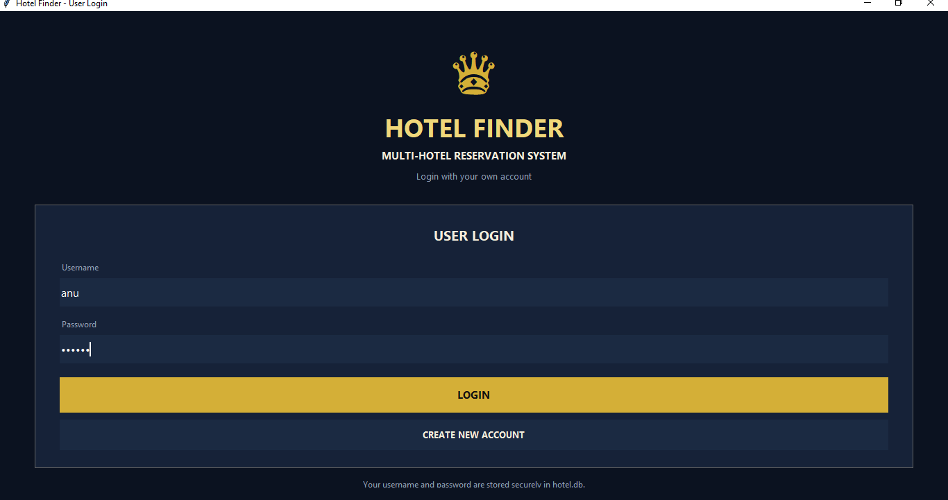

Figure 2: Login OR Create New Account
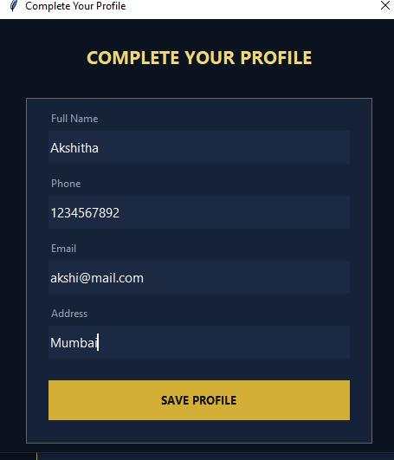
Figure 2: Login

Figure 3: Profile

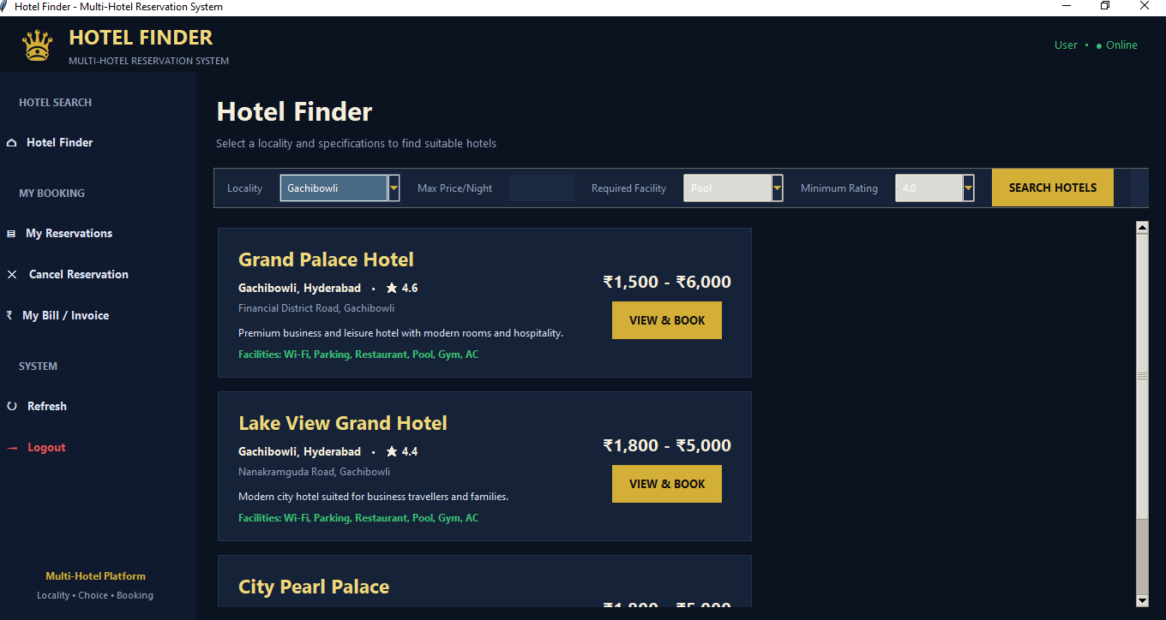

Figure 3:Profile

Figure 4: Hotel Finding with Specifications and Locality

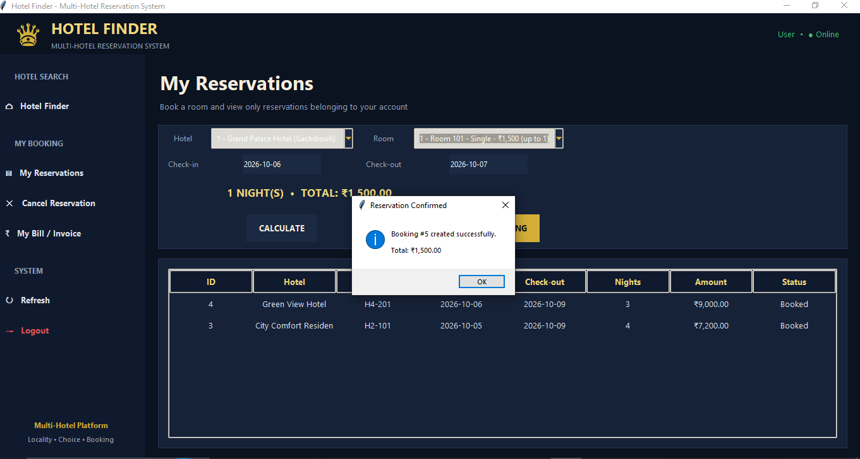
Figure 5:Reservation Conformation
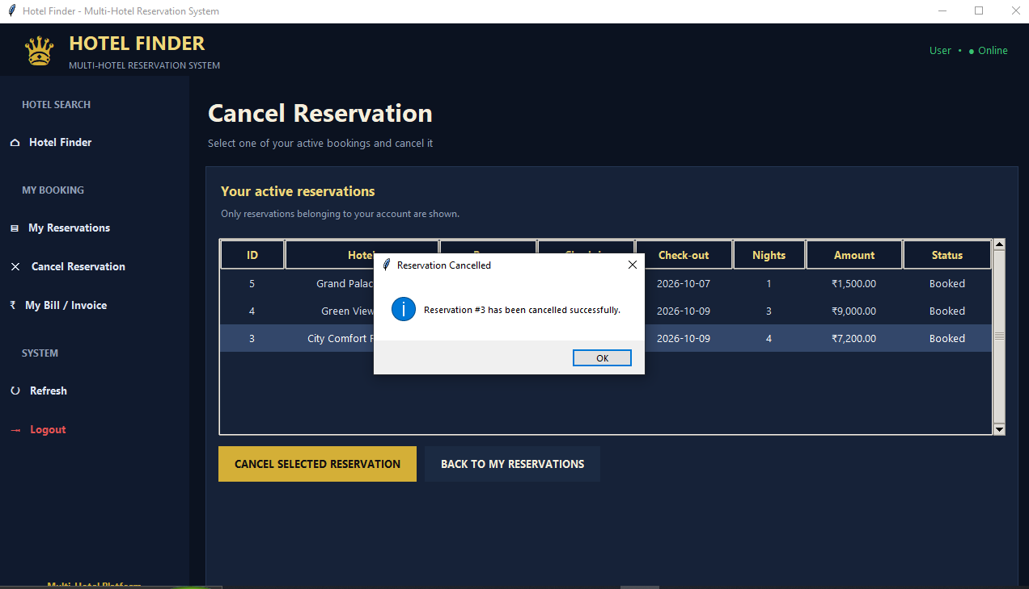
Figure 6: Reservation Cancellation
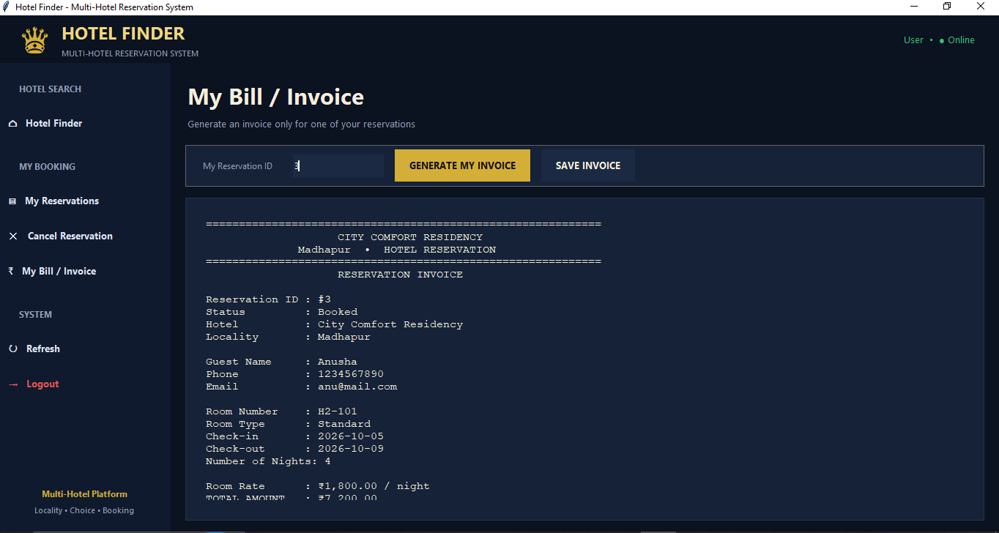
Figure 7: Bills and Invoice

6.Mapping Pos,PSOs and SDGs

Program Outcomes (POs) Mapping
Table 1: Mapping of Program Outcomes (POs) to Project Relevance

PO Serial No. | PO Name | Relevance
PO1 | Engineering Knowledge | Applies programming, database, and software engineering concepts.
PO2 | Problem Analysis | Analyzes hotel search, reservation, billing, and cancellation requirements.
PO3 | Design/Development of Solutions | Develops a complete customer-oriented hotel reservation system.
PO4 | Conduct Investigations | Uses reservation and database information to understand system requirements.
PO5 | Modern Tool Usage | Uses Python, Tkinter, SQLite, and file handling technologies.
PO6 | Engineer and Society | Provides a convenient digital platform for hotel reservation services.
PO7 | Environment and Sustainability | Reduces paper-based reservation and record-keeping.
PO8 | Ethics | Provides controlled access to customer and reservation information.
PO9 | Individual and Team Work | Supports organized development and integration of different system modules.
PO10 | Communication | Presents hotel, customer, reservation, and billing information clearly.
PO11 | Project Management | Involves planning and integration of database, GUI, and reservation modules.
PO12 | Life-long Learning | Provides practical experience with programming, databases, and software development

Program Specific Outcomes (PSO) Mapping

Table 2: Mapping of Program Specific Outcomes (POS) to Project

  PSO Serial No.
  PSO Name
  Relevance
  PSO1
  Programming and Software Development
  Programming and Software Development
  PSO2
  Database Management
  Database Management
  PSO3
  Application Development and Modern Tools
   | Application Development and Modern Tools | .

Sustainable Development Goals (SDGs) Mapping
Table 3: Mapping of Sustainable Development Goals (SDGs) to Project Relevance

  SDG
  Sustainable Development Goal
  Relevance to the Project
  SDG8
   | Decent Work and Economic Growth | .
  Supports the hospitality sector by providing a digital system for hotel reservations and customer management.
  SDG7
   | Industry, Innovation and Infrastructure | .
  Uses software, database technology, and digital tools to modernize hotel reservation processes.
  SDG12 |  | .
   | Responsible Consumption and Production | .
  Reduces paper-based booking records through digital reservations and electronic record management.

Conclusion

The Grand Palace Hotel Reservation System successfully provides a user-friendly platform for customers to search for hotels based on locality and specifications, view available rooms, and make reservations. The system simplifies the hotel selection process by providing information about hotel ratings and facilities, helping customers choose a suitable hotel according to their requirements.
The system uses Python and Tkinter to provide the graphical user interface and SQLite to store and manage customer, hotel, room, and reservation information. It also supports important functions such as user registration and login, profile management, reservation management, billing, and reservation cancellation. The database automatically stores the required information, while the text summary file provides an updated hotel-wise reservation summary.
Overall, the project demonstrates the practical implementation of Python programming, GUI development, database management, and file handling in a real-world hotel reservation application. The system reduces manual record management and provides an organized and convenient method for handling hotel reservations. It can also serve as a foundation for further improvements and additional features in future versions.
.

Bibliography

Online Resources
[1] Python Software Foundation – Python Documentation
https://docs.python.org/3/
[2] Python Software Foundation – Tkinter GUI Programming
https://docs.python.org/3/library/tkinter.html
[3] SQLite – SQLite Documentation and Database Management
https://www.sqlite.org/docs.html
[4] GeeksforGeeks – Python Tkinter Tutorial
https://www.geeksforgeeks.org/python-tkinter-tutorial/
[5] GeeksforGeeks – Python SQLite Database Connection
https://www.geeksforgeeks.org/python-sqlite/
[6] TutorialsPoint – Python GUI Programming with Tkinter
https://www.tutorialspoint.com/python/python_gui_programming.htm

Research article references
[1] Ramakrishnan, R., & Gehrke, J. (2003). Database Management Systems. McGraw-Hill Education.
(Database concepts and relational database management relevant to customer, hotel, room, and reservation data.)
[2] Elmasri, R., & Navathe, S. B. (2016). Fundamentals of Database Systems. Pearson Education.
(Relational database design, tables, keys, relationships, and database operations.)
[3] Griffiths, A., & Griffiths, P. (2020). Python GUI Programming with Tkinter.
(Graphical user interface development concepts relevant to the hotel reservation application.)
[4] SQLite Consortium. (2024). SQLite: Database Management and Embedded SQL. SQLite Documentation.
(SQLite database implementation relevant to storing and managing hotel reservation information.)

