Akshith(basic user) created a new request for creating an account.(The admin can view the request by logging into admin portal) as shown below
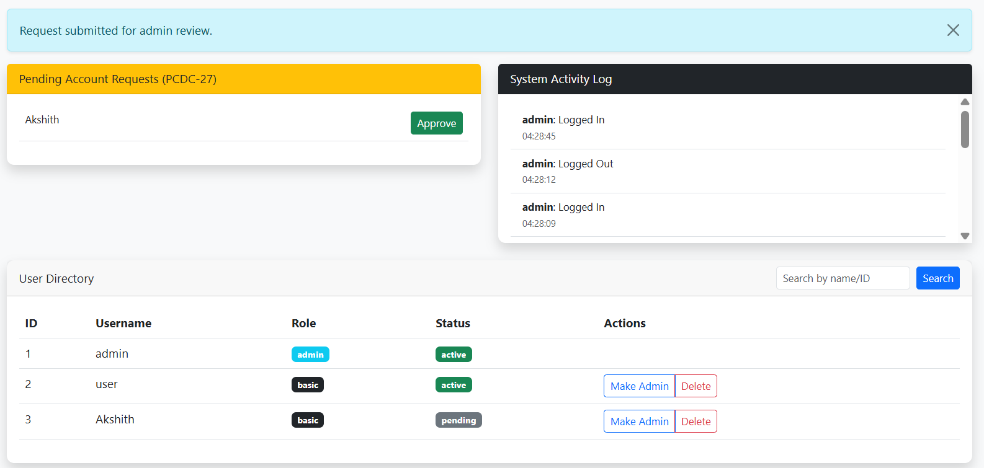

After the admin approves request, the status changes from pending to approved and the pending requests becomes zero as shown below
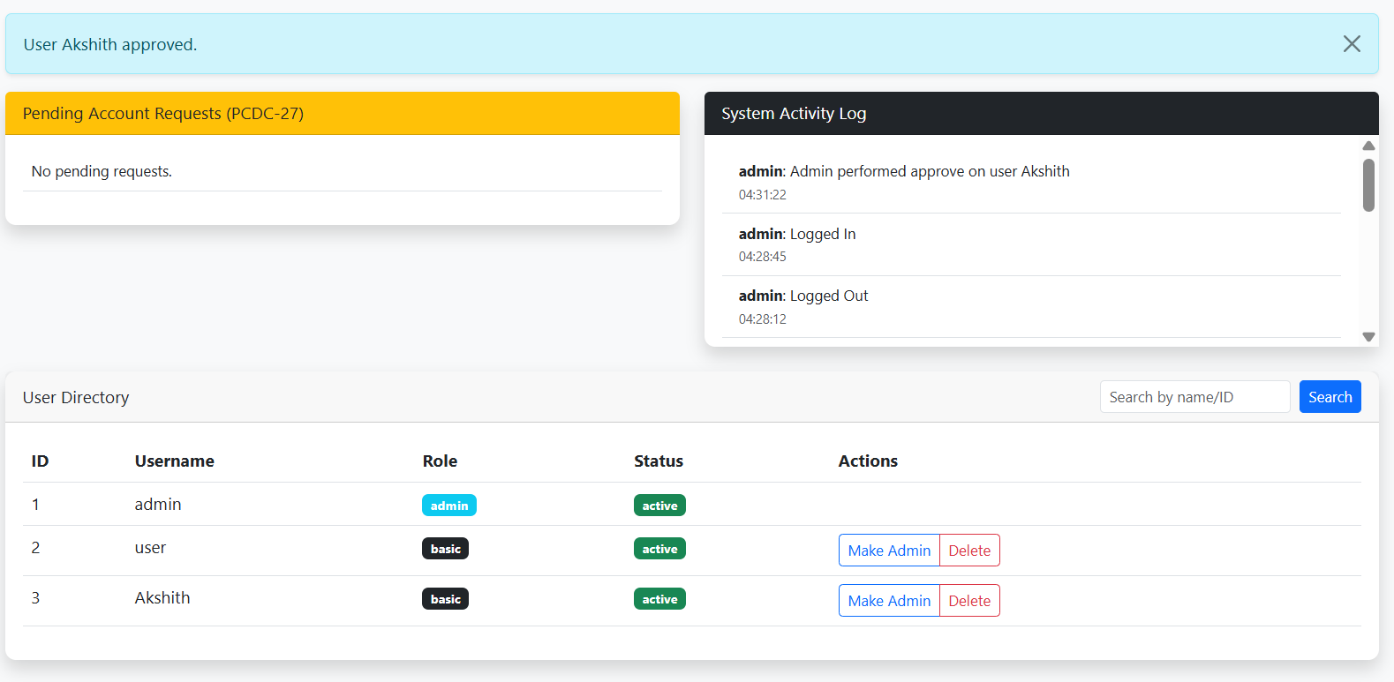
Promoted a basic user(Akshith) to admin and the activity log shows all the actions performed as shown
