Recursion- Recursion is a programming concept where a function calls itself to solve a problem.

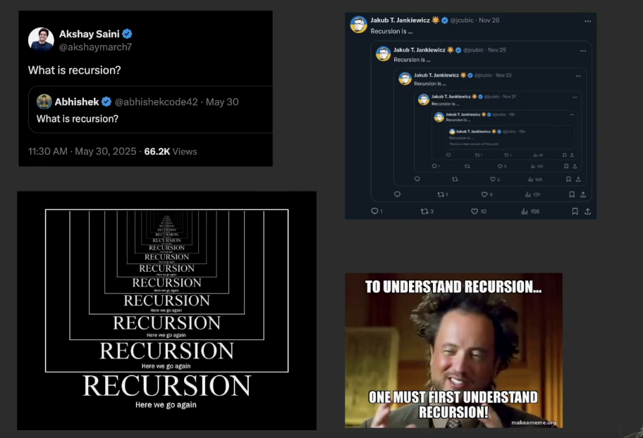

Trivia - Google – recursion.

Stack overflow

