1. **Different Ways of Writing CSS in React:**

* **External CSS File (index.css or similar):**  
  Write all your CSS in a separate .css file and import it into your React components. This is a simple and traditional approach.
* **Preprocessors (SASS/SCSS):**  
  SCSS (Sassy CSS) or SASS are CSS preprocessors that provide features like variables, nesting, mixins, and functions. These tools make CSS more maintainable and scalable, especially for medium-sized projects. However, for very large and complex applications, they may become harder to manage compared to component-based styling approaches.
* **CSS-in-JS (e.g., Styled Components):**  
  This method involves writing CSS directly in your JavaScript files. Libraries like **Styled Components** or **Emotion** allow you to scope styles to components and utilize JavaScript logic inside styles, promoting better encapsulation.
* **Component Libraries & UI Frameworks:**  
  Use UI libraries like **Bootstrap**, **Chakra UI**, **Grommet**, or **Material UI**. These libraries come with pre-built, customizable components and help in building consistent UIs quickly. They are widely adopted by large tech companies for rapid development.
* **Utility-First CSS Frameworks (e.g., Tailwind CSS):**  
  Tailwind CSS provides utility classes that you can directly use in your JSX to style elements. It allows for fast development and a consistent design system, and is highly popular for modern React projects.

1. How do we configure tailwind?

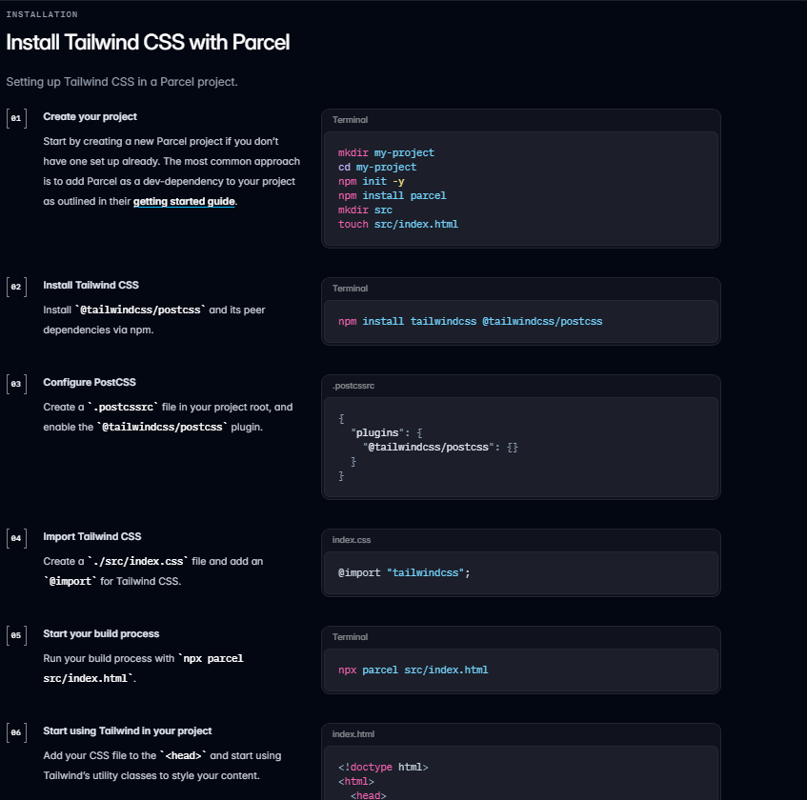

1. Why do we have .postcssrc file?

The .postcssrc file is used to configure **PostCSS**, a tool that processes your CSS and applies various plugins to it. When using bundlers like **Parcel** or **Vite**, this configuration helps the bundler understand how to handle PostCSS plugins such as **Tailwind CSS**. Tailwind uses PostCSS to transform the utility classes written in your HTML or JavaScript/JSX files into actual CSS styles. The .postcssrc file typically includes plugins like tailwindcss and autoprefixer, which are essential for Tailwind to function correctly during the build process.

**In short:**  
.postcssrc tells the bundler how to process your CSS using PostCSS plugins like Tailwind.