BIG DATA ANALYTICS & DBMS MINI PROJECT
From Transactions to Loyalty: Identifying and Retaining High-Value Customers Using RFM Segmentation, Churn Prediction and Big Data Analytics

Business question: How can a company identify and retain its most valuable customers?

Table 1: Project details
Item | Details
Student / Team | Akshith Kompelly [
Programme / Class | PGDM (Marketing) - Badruka School of Management, Hyderabad
Faculty | Dr. Butchi Babu Muvva
Course | Big Data Analytics & DBMS
Tools used | PostgreSQL, DBeaver, Python, Databricks, Delta Lake, Power BI, GitHub
Dataset | UCI Online Retail (541,909 invoice lines)
GitHub repository | https://github.com/<your-username>/mini-bigdata-analytics-project
Submission date | 28-29 October 2026

Abstract / Executive Summary
Most retailers earn a large part of their money from a small group of customers. If those customers leave, profit falls quickly, yet many companies treat all customers the same. This project answers one question: how can a company identify and retain its most valuable customers? We used the public UCI Online Retail dataset, which has 541,909 invoice lines from a UK online gift retailer between 1 December 2010 and 9 December 2011.
The data was stored and checked in PostgreSQL (queried through DBeaver), cleaned and analysed in Python, processed again in Databricks using Delta Lake tables, and presented in a Power BI dashboard. After cleaning, 4,334 identifiable customers, 18,402 orders and £8,737,228 of sales remained.
Key findings
- Sales are very concentrated: the top 20% of customers produce 75% of revenue, and the top 1% alone produce 32%.
- RFM (Recency, Frequency, Monetary) scoring found 742 'Champions' (17% of customers) who bring 62% of revenue.
- 1,505 customers (35%) bought only once; on average only about 20% of a new cohort buys again in the next month.
- A Random Forest model predicts customers who will not return in the next three months with an AUC of 0.71 (logistic regression 0.72) - useful for ranking, but only moderately accurate.
- 'Cant Lose Them' (205 customers, £535,114) and 'At Risk' (578 customers, £548,942) are valuable customers who have gone quiet and should get win-back actions first.
Recommendations
- Protect Champions with a VIP programme and early access instead of discounts.
- Run a personal outreach and win-back offer for 'Cant Lose Them' customers, with a simple survey to learn why they stopped.
- Build a second-purchase journey for new customers, because the biggest drop happens after the first order.
- Use the churn score to decide whom to contact, and test every campaign against a control group.

1. Introduction and Business Problem

1.1 Background
Acquiring a new customer usually costs far more than keeping an existing one. For online retailers, customers can leave without notice because competitors are only one click away. A business therefore needs to know three things: who its best customers are, which of them are drifting away, and what it should do about it. Big data tools help because transaction systems create thousands of rows every day and manual analysis in a spreadsheet does not scale.

1.2 Problem statement
The company in this dataset sells gift and home-decoration items to individuals and wholesale buyers. It has transaction records but no clear view of customer value. The problem is: without customer segmentation and early warning of churn, marketing money is spread evenly, valuable customers may leave unnoticed, and growth depends on constantly finding new buyers.

1.3 Why this problem matters
- Revenue is concentrated, so losing a few customers can hurt sales sharply.
- Retention marketing is cheaper and more predictable than acquisition.
- Segment-specific actions (VIP, win-back, onboarding) give better returns than one offer for everyone.

1.4 Intended users
- Marketing managers: decide who gets which campaign.
- Customer relationship / account managers: get a worklist of valuable customers to call.
- Finance and management: see revenue at risk and the value of retention.
- Students and faculty: a complete example of a database-to-dashboard analytics workflow.

1.5 Project proposal (summary)
Table 2: Proposal summary
Item | Content
Title | From Transactions to Loyalty: Identifying and Retaining High-Value Customers Using RFM Segmentation, Churn Prediction and Big Data Analytics
Problem | How can a company identify and retain its most valuable customers?
Topic area | Retail sales and customer behaviour / e-commerce analytics (from the suggested list)
Approach | SQL -> Python -> Databricks/Delta -> Power BI -> recommendations
Output | Database, notebooks, dashboard, GitHub repository, 30-page report, presentation

2. Objectives, Scope and Limitations

2.1 Objectives
- Prepare a reliable customer-level dataset from raw invoice lines using SQL, Python and Spark.
- Measure customer value with RFM scores and group customers into clear segments.
- Check the segments with an independent method (K-Means clustering).
- Measure retention using monthly cohorts.
- Predict which customers are likely to stop buying and estimate revenue at risk.
- Build a Power BI dashboard that managers can use to monitor value and risk.
- Recommend practical retention actions for each segment.

2.2 Scope
The project covers customers that have a CustomerID in the dataset. It covers one year of data and analyses sales, returns, countries, products and customer behaviour. Everything is done on a laptop or free cloud workspace, so a small-to-medium dataset (about half a million rows) is used. The same code can scale to larger data in Spark.

2.3 Assumptions
- Revenue = Quantity x UnitPrice in pounds sterling (GBP).
- Analysis date (snapshot) is 10 December 2011, the day after the last invoice.
- A customer is treated as 'churned' for modelling if they do not buy in the three months after the observation window.
- 'High value' customer means the top 20% by total spend (spend of £2,029 or more).

2.4 Limitations
- 15% of sales revenue (£1,510,680) has no CustomerID (guest checkouts) and cannot be analysed at customer level.
- The dataset covers only 13 months, so yearly seasonality and long-term loyalty cannot be seen.
- There is no information on customer age, gender, marketing channel or profit margin; 'value' means revenue, not profit.
- Sales are gross of returns in the customer revenue figures; returns are analysed separately.
- The churn model uses only purchase behaviour, so accuracy is moderate.
- The dataset is small for 'big data'. We describe the processing we actually performed and do not claim large-scale distributed performance.

3. Dataset and Data Dictionary

3.1 Source and collection
The data is the Online Retail dataset from the UCI Machine Learning Repository (Chen, Sain and Guo, 2012). It records all transactions of a UK-based, registered online retailer that mainly sells unique all-occasion gifts; many customers are wholesalers. The file given by faculty is Online_Retail_data_for_project.xlsx (sheet 'Online Retail'). It was converted to CSV for loading.
Table 3: Dataset overview
Property | Value
Records (rows) | 541,909
Fields (columns) | 8
Period | 01-Dec-2010 08:26 to 09-Dec-2011 12:50
Invoices | 25,900
Customers (with ID) | 4,372
Products (StockCode) | 4,070
Countries | 38

3.2 Data dictionary
Table 4: Field descriptions
Field | Type | Meaning
InvoiceNo | Text | Invoice number; starts with C when it is a cancellation / return
StockCode | Text | Product code (some codes are fees such as POST or BANK CHARGES)
Description | Text | Product name
Quantity | Integer | Units per line; negative for returns
InvoiceDate | Date-time | Date and time of the invoice
UnitPrice | Decimal | Price per unit in GBP
CustomerID | Number | Unique customer identifier (missing for guest orders)
Country | Text | Customer's country
Revenue (derived) | Decimal | Quantity x UnitPrice

3.3 Data quality assessment
Table 5: Data quality issues found
Issue | Count | Treatment
Missing CustomerID | 135,080 lines | Excluded from customer analysis (reported as guest sales)
Missing Description | 1,454 lines | Kept where other fields valid; labelled UNKNOWN
Exact duplicate rows | 5,268 lines | Removed
Cancellation lines (InvoiceNo starts with C) | 9,288 lines | Moved to a separate returns table
Quantity <= 0 | 10,624 lines | Removed from sales
UnitPrice <= 0 | 2,517 lines | Removed from sales
Non-product codes (POST, D, M, BANK CHARGES...) | 2,909 lines | Removed

After all rules, 391,150 sales lines, 18,402 invoices, 4,334 customers, 3,659 products and 37 countries remained, with total sales of £8,737,228.

3.4 Dataset limitations
The dataset is anonymised and public, with no personal or sensitive information beyond a numeric customer ID and country. It is historical (2010-2011), so absolute numbers are not current, but the method applies to any retailer.

4. Methodology and Workflow
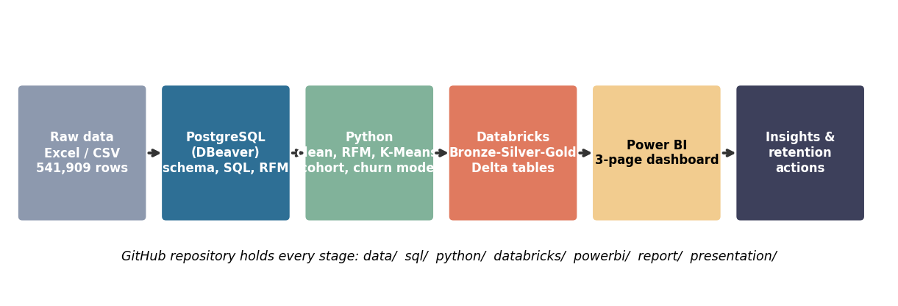
Figure 1: End-to-end workflow
The same business logic (cleaning rules and RFM definition) was implemented in more than one tool. This lets us cross-check results and shows what each tool is good at.
Table 6: What each tool contributes
Tool | Role in this project
PostgreSQL | Relational storage with keys; staging table, clean tables, SQL validation and RFM in SQL
DBeaver | Client used to connect to PostgreSQL, run saved SQL scripts and export results
Python (pandas, scikit-learn) | Detailed cleaning, statistics, charts, K-Means, cohorts and the churn model
Databricks + Delta Lake | Spark transformations in Bronze-Silver-Gold layers; Delta features (history, time travel, MERGE)
Power BI | Interactive dashboard for managers: KPIs, segments, risk and actions
GitHub | Version control and sharing of all code, evidence and the report

4.1 Analytical methods
- RFM analysis: Recency = days since last purchase; Frequency = number of invoices; Monetary = total spend. Each is scored 1-5 by quintile.
- Segmentation rules: combine R and the average of F and M into eight named segments.
- K-Means: unsupervised check on log-scaled, standardised RFM values.
- Cohort analysis: group customers by month of first purchase and track the share who buy in later months.
- Churn model: features are computed from purchases before 1 Sep 2011; target is no purchase between 1 Sep and 9 Dec 2011.
- Revenue at risk: historic spend x predicted churn probability.

5. PostgreSQL and DBeaver Implementation

5.1 Database design
A database named retail_clv and a schema named retail were created. Raw data is first loaded into a staging table exactly as received. Clean data is then split into dimension and fact tables, which is a simple star-style design.
Table 7: Tables and keys
Table | Primary key | Foreign keys | Rows
stg_online_retail | - | - | 541,909
dim_customer | customer_id | - | 4,372
dim_product | stock_code | - | 4,070
fact_invoice | invoice_no | customer_id -> dim_customer | 18,402
fact_invoice_line | line_id | invoice_no -> fact_invoice; stock_code -> dim_product | 391,150
fact_return_line | line_id | - | 8,506
customer_rfm (analysis) | customer_id | - | 4,334

Data types were chosen for the content: NUMERIC for prices, INTEGER for quantities, TIMESTAMP for invoice time and TEXT for codes (some stock codes contain letters). CHECK constraints make sure that quantity and price are positive in the sales table. Indexes were added on customer, date, invoice and stock code to speed up joins.
CREATE TABLE fact_invoice_line (
line_id BIGSERIAL PRIMARY KEY,
invoice_no TEXT NOT NULL REFERENCES fact_invoice(invoice_no),
stock_code TEXT NOT NULL REFERENCES dim_product(stock_code),
quantity INTEGER NOT NULL CHECK (quantity > 0),
unit_price NUMERIC(12,3) NOT NULL CHECK (unit_price > 0));

5.2 Connecting DBeaver and importing data
- Install PostgreSQL, then open DBeaver -> New Database Connection -> PostgreSQL (host localhost, port 5432, database retail_clv).
- Run sql/01_create_schema.sql to create the schema and tables.
- Right-click stg_online_retail -> Import Data -> CSV -> select data/online_retail_raw.csv. Row count must be 541,909.
- Run sql/02_load_and_clean.sql to validate, clean and fill the dimension and fact tables.

5.3 Validation queries
The first step after import is to check the data. One query counts missing values, cancellations and invalid numbers in a single pass.
SELECT COUNT(*) AS total_rows,
COUNT(*) FILTER (WHERE customer_id IS NULL) AS missing_customer,
COUNT(*) FILTER (WHERE invoice_no LIKE 'C%') AS cancellation_lines,
COUNT(*) FILTER (WHERE quantity <= 0) AS non_positive_qty
FROM stg_online_retail;
Result: 541,909 rows, 135,080 missing customer IDs, 9,288 cancellation lines and 10,624 non-positive quantities. Exact duplicates were 5,268. These numbers match the Python profile exactly (Table in section 3.3).

5.4 Analysis queries (filter, sort, aggregate, join)
Saved in sql/03_analysis_queries.sql. Selected outputs are shown below.
Table 8: Q1 - Largest single invoices (filter + sort)
Invoice | Customer | Date | Value (£)
581483 | 16446 | 09-Dec-2011 | 168,470
541431 | 12346 | 18-Jan-2011 | 77,184
556444 | 15098 | 10-Jun-2011 | 38,970
567423 | 17450 | 20-Sep-2011 | 31,698

Interesting finding: the two largest invoices (customers 16446 and 12346) were fully cancelled later - the returns query (Q6) shows a return rate of 100% for both. Gross revenue therefore overstates the true value of these two customers, and we flag them in the discussion.
Table 9: Q4 - Revenue by country (aggregation + window function)
Country | Revenue (£) | % of total
United Kingdom | 7,242,855 | 82.9
Netherlands | 283,889 | 3.2
EIRE | 257,013 | 2.9
Germany | 205,381 | 2.4
France | 183,802 | 2.1

Table 10: Q7 - Customer quintiles by spend (Pareto check)
Spend quintile | Customers | Revenue (£) | % revenue
1 (top 20%) | 867 | 6,518,379 | 74.6
2 | 867 | 1,195,858 | 13.7
3 | 867 | 586,295 | 6.7
4 | 867 | 305,889 | 3.5
5 (bottom 20%) | 866 | 130,807 | 1.5

The SQL result confirms that the top 20% of customers produce 74.6% of sales, the same as the Python Pareto calculation.
Table 11: Q8 - Repeat vs one-time customers
Type | Customers | Revenue (£)
Repeat (2+ orders) | 2,829 | 8,110,622
One-time | 1,505 | 626,606

5.5 RFM in SQL
RFM was also calculated in SQL using window functions. NTILE(5) splits customers into five equal groups; ordering recency in descending order makes score 5 mean 'most recent'. A CASE statement assigns the segment.
NTILE(5) OVER (ORDER BY recency DESC) AS r,
NTILE(5) OVER (ORDER BY frequency) AS f,
NTILE(5) OVER (ORDER BY monetary) AS m
Table 12: Segments from SQL (customer_rfm table)
Segment | Customers | % customers | % revenue | Avg spend (£)
Champions | 741 | 17.1 | 61.4 | 7,237
Loyal Customers | 809 | 18.7 | 18.3 | 1,979
Cant Lose Them | 210 | 4.8 | 6.3 | 2,621
At Risk | 499 | 11.5 | 5.7 | 989
Hibernating / Lost | 1,025 | 23.7 | 3.2 | 273
Need Attention | 493 | 11.4 | 2.5 | 445
Potential Loyalists | 249 | 5.7 | 1.7 | 601
New / Promising | 308 | 7.1 | 0.9 | 262

The SQL and Python segments are very close. Small differences (for example 741 vs 742 Champions) appear because customers with identical values are split into score groups in a different order by NTILE and by the pandas ranking method. This is explained again in the validation chapter.

6. Python Analytics

6.1 Data profiling and cleaning
The notebook Customer_Retention_Analytics.ipynb loads the CSV with pandas and checks shape, types, missing values and duplicates. 5,268 exact duplicates were dropped. Cancellations (8,668 product lines) were separated. Rows with zero or negative quantity or price, and non-product codes, were removed. Guest rows (no CustomerID) were set aside: they hold 131,419 lines and £1,510,680 (14.7% of sales).
Table 13: Cleaning funnel
Step | Rows
Raw data | 541,909
After removing exact duplicates | 536,641
Valid product sales lines (no returns, positive qty and price, no fees) | 522,569
With a CustomerID (final analysis set) | 391,150

6.2 Descriptive statistics
Table 14: Key descriptive statistics (clean data)
Measure | Value
Total sales | £8,737,228
Orders | 18,402
Customers | 4,334
Average order value | £474
Median order value | £301
Items per order (average) | 279
Median customer spend | £663
Mean customer spend | £2,016
Median recency (days) | 50
Median orders per customer | 2
Share of sales from the UK | 82.9%

The mean spend per customer is three times the median. This is a sign of a skewed distribution: a few very large customers pull the average up. The average order is about 279 items, which shows that many buyers are small businesses or wholesalers.
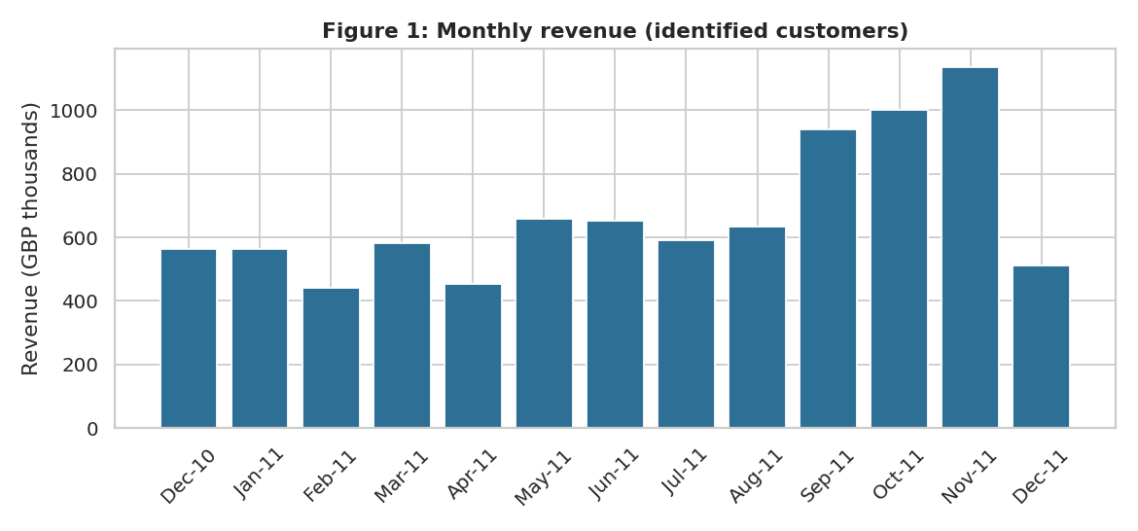
Figure 2: Monthly revenue (identified customers)
Revenue is flat around £450k-£650k per month until August 2011 and then rises sharply from September, peaking in November 2011 (£1.14M). This is the Christmas buying season for gift items. December 2011 is incomplete (data ends on 9 December).
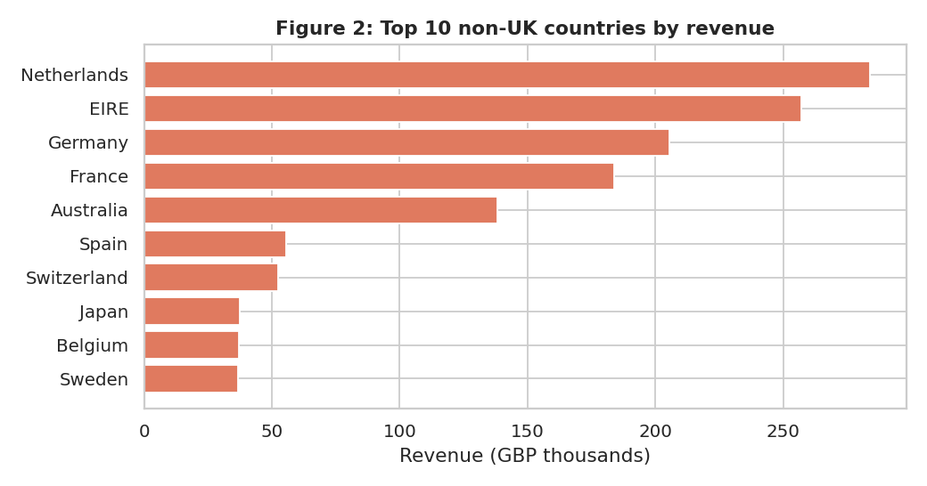
Figure 3: Top 10 non-UK countries by revenue
The UK gives 83% of sales. Among other countries the Netherlands, EIRE (Ireland), Germany and France lead. A few customers dominate some countries; for example the largest customer overall (ID 14646) is in the Netherlands.
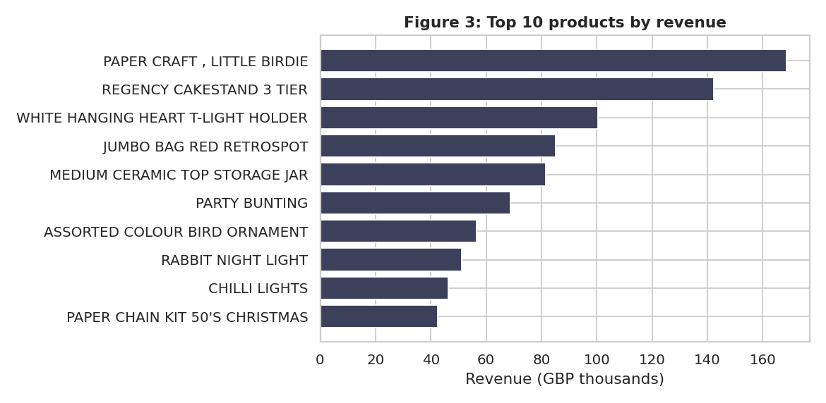
Figure 4: Top 10 products by revenue
Home decoration and party items lead the list. Several top products (cake stand, hanging heart holder, jumbo bag) are everyday gift items that appear in many baskets.

6.3 RFM analysis
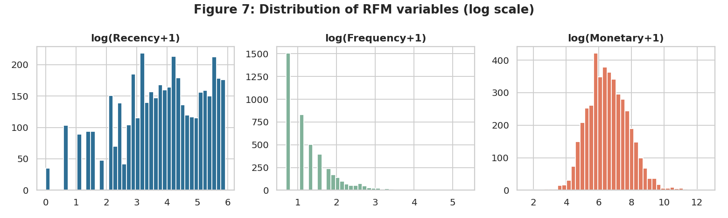
Figure 5: Distribution of Recency, Frequency and Monetary (log scale)
All three measures are right-skewed, so quintile scores (based on rank) are better than fixed money thresholds. Quintile scoring also makes the result easy to explain to managers.
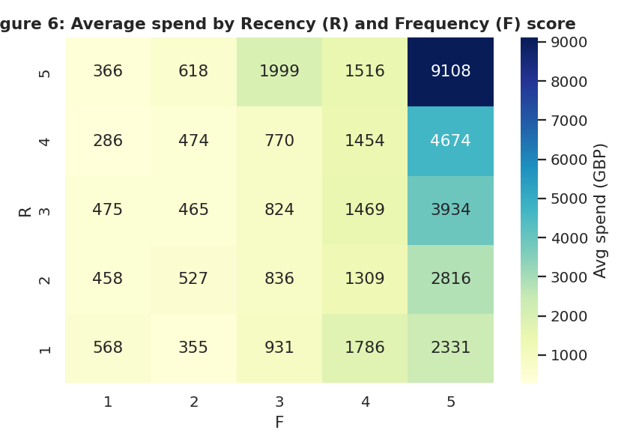
Figure 6: Average spend by Recency (R) and Frequency (F) score
Spending is highest where both recency and frequency scores are 5, and falls quickly in the lower-left corner (customers who bought long ago and rarely). Recency and frequency together separate good and weak customers clearly.

6.4 Customer segments
Table 15: RFM segment summary (Python)
Segment | Customers | % cust. | Revenue (£) | % revenue | Avg recency | Avg orders | Avg spend (£)
Champions | 742 | 17.1 | 5,382,784 | 61.6 | 11 | 13.0 | 7,254
Loyal Customers | 802 | 18.5 | 1,560,659 | 17.9 | 31 | 4.5 | 1,946
At Risk | 578 | 13.3 | 548,942 | 6.3 | 166 | 2.3 | 950
Cant Lose Them | 205 | 4.7 | 535,114 | 6.1 | 125 | 5.2 | 2,610
Hibernating / Lost | 951 | 21.9 | 244,248 | 2.8 | 221 | 1.1 | 257
Need Attention | 494 | 11.4 | 225,455 | 2.6 | 52 | 1.5 | 456
Potential Loyalists | 279 | 6.4 | 168,266 | 1.9 | 16 | 2.3 | 603
New / Promising | 283 | 6.5 | 71,758 | 0.8 | 18 | 1.2 | 254

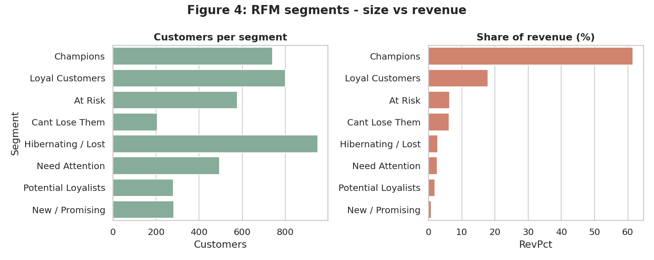
Figure 7: RFM segments - size vs revenue share
Champions are 17% of customers but 62% of revenue. They last bought about 11 days before the snapshot and place 13 orders on average. Hibernating / Lost customers are the largest group by count (22%) but give only 2.8% of revenue.
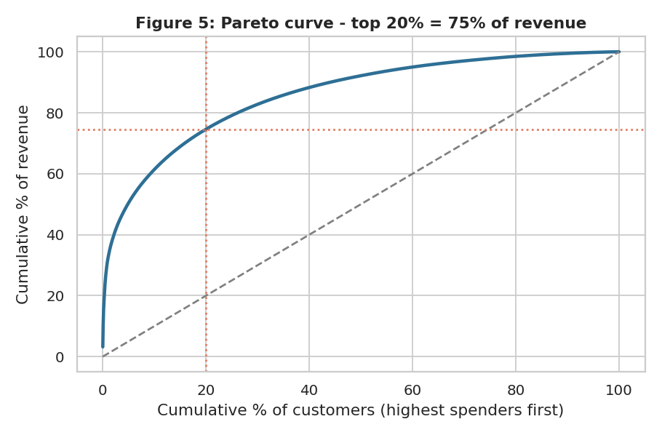
Figure 8: Pareto curve of revenue concentration
The top 10% of customers give 61% of revenue and the top 20% give 75%. This is stronger than the classic 80/20 rule and shows high dependence on a small group.

6.5 K-Means validation
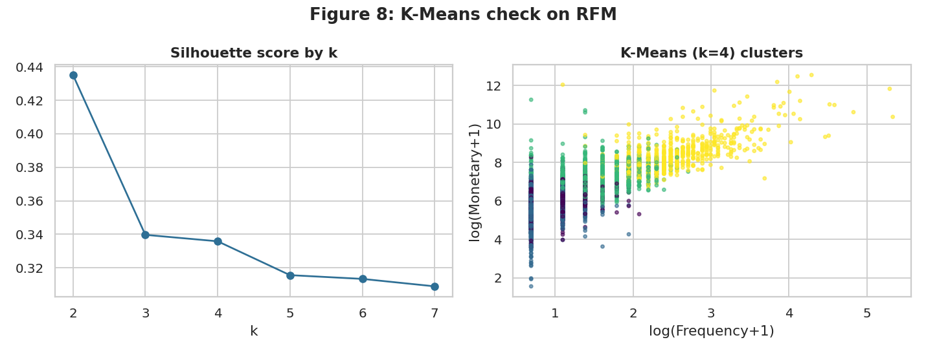
Figure 9: K-Means check on RFM (silhouette and clusters)
Silhouette scores were highest for k = 2 (0.435) and fell as k increased, which means the data forms a continuous cloud and not clearly separate groups. We used k = 4 because it is more useful for business action. The cluster with high frequency (about 14 orders) and high spend (about £8,154) contains 686 customers and 64% of revenue - very close to the Champions segment (62%). So the rule-based RFM segments and the algorithm agree about who the best customers are.

6.6 Cohort retention
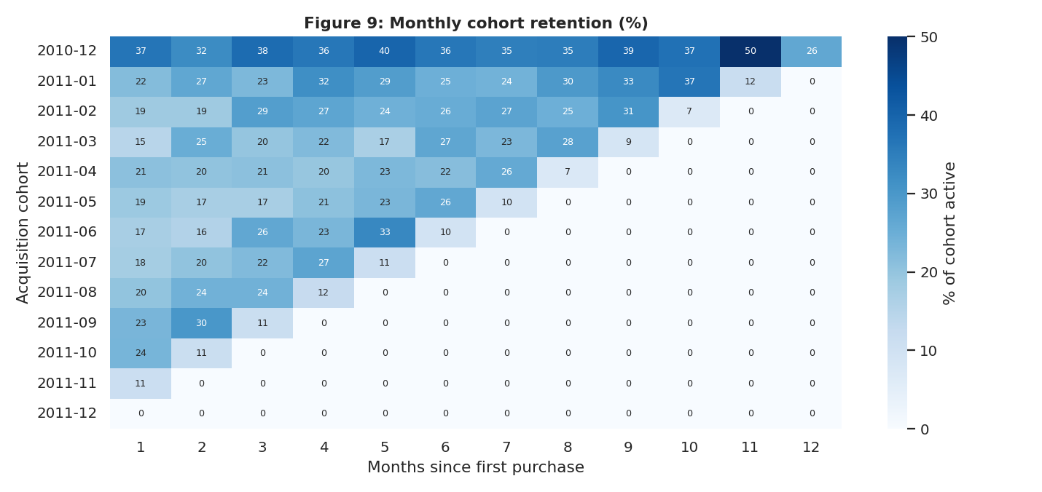
Figure 10: Monthly cohort retention (%)
On average 20% of a monthly cohort buys again in the following month, and 23% are active three months later. The December 2010 cohort is the strongest (884 customers; 26% still active after 12 months), probably because it includes many wholesale accounts that were already customers before the data starts. Retention flattens at about 20-25%: the largest loss happens right after the first purchase. This points to onboarding and second-purchase offers as an early priority.

6.7 Churn prediction
To find customers likely to leave, we used purchases before 1 September 2011 to build features and checked who did not buy between 1 September and 9 December 2011. 3,314 customers were in the model and 41% of them did not return. Features: recency, frequency, monetary, items, distinct products, tenure, average order value, average gap between orders and return rate. Data was split 70/30 with stratification.
Table 16: Model performance on the 30% test set
Model | AUC | Precision (churn) | Recall (churn) | Accuracy
Logistic regression (log-scaled inputs) | 0.72 | - | - | -
Random Forest (300 trees) | 0.71 | 0.56 | 0.73 | 0.65

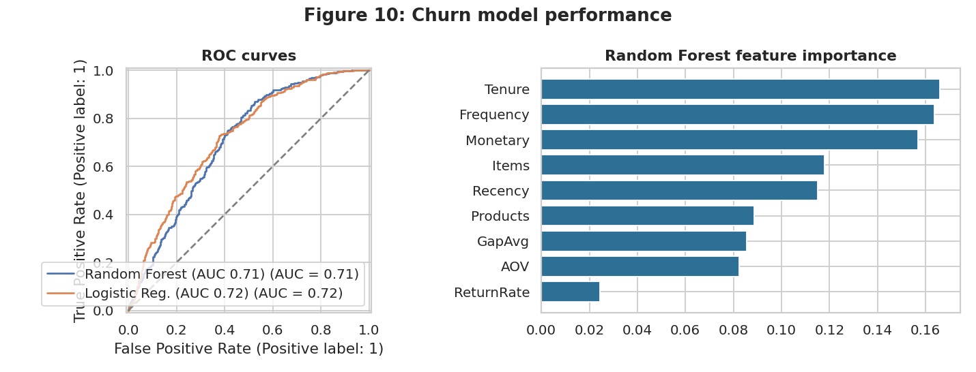
Figure 11: Churn model: ROC curves and feature importance
Both models rank customers only moderately well (AUC about 0.71-0.72). At a 0.5 threshold the Random Forest finds 73% of customers who actually left, but 44% of its churn alerts are false alarms. This is honest, realistic performance for a model that sees only purchase history. Tenure, frequency and monetary value are the most important features. We therefore use the score to rank customers for action, not as a precise forecast.
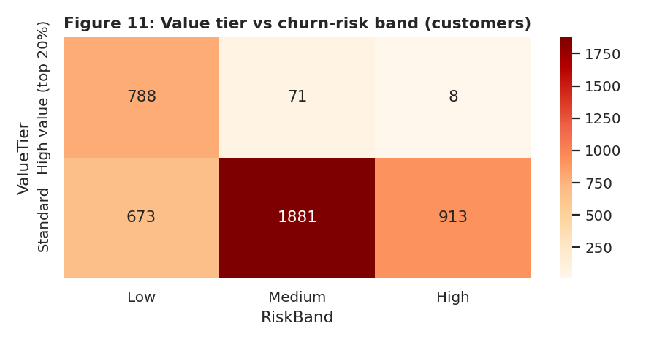
Figure 12: Value tier vs churn-risk band
Only 8 high-value customers fall in the 'High' risk band; most high-value customers are low or medium risk because they bought recently. The bigger retention issue is therefore with customers who are already valuable but quiet (segments 'Cant Lose Them' and 'At Risk').
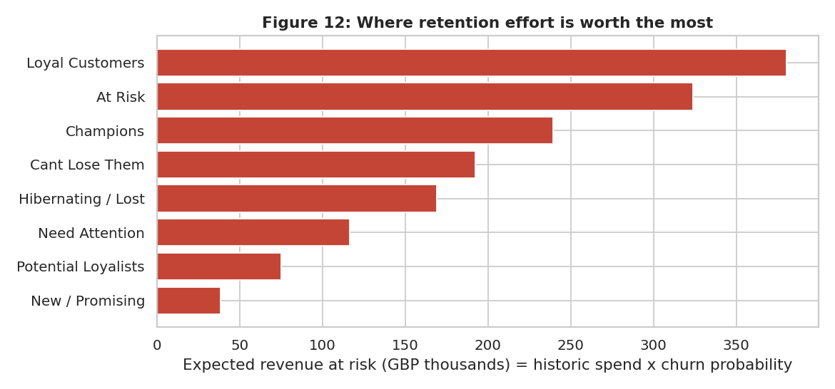
Figure 13: Expected revenue at risk by segment
Expected revenue at risk (historic spend x churn probability) is largest for Loyal Customers (£380,526) because the group is big, then At Risk (£323,956), Champions (£239,335) and Cant Lose Them (£192,257). Even a small churn probability on a Champion matters because each Champion is worth about £7,254.

6.8 Python outputs
The notebook exports dim_customer.csv, fact_sales.csv and summary tables, which are used for Power BI and are available in the powerbi/ folder of the repository.

7. Databricks and Delta Lake

7.1 Purpose
Databricks provides Apache Spark, which processes data in parallel and is the usual tool when data is too large for one computer. Delta Lake adds reliability on top of files: transactions, version history and schema checks. Our dataset is small, so we use Databricks to demonstrate the workflow and not for speed. We make no claim about performance gains.

7.2 Medallion design
Table 17: Delta tables
Layer | Table | Content
Bronze | retail_bronze | Raw CSV loaded with an explicit schema (541,909 rows)
Silver | retail_silver | Cleaned sales lines with Revenue and InvoiceMonth (expected 391,150 rows)
Gold | retail_gold_customer_rfm | One row per customer: R, F, M, scores, Segment, RetentionAction

7.3 Loading and transformations
The CSV was uploaded to a Unity Catalog Volume and read with spark.read using a defined schema (StructType) so that dates and numbers have the correct types. The Silver table applies the same rules as SQL and Python: dropDuplicates, filter out cancellations, filter Quantity > 0 and UnitPrice > 0, filter non-product codes, keep rows with CustomerID, and compute Revenue = Quantity x UnitPrice.
silver = (spark.table("default.retail_bronze").dropDuplicates()
.filter(~F.col("InvoiceNo").startswith("C"))
.filter((F.col("Quantity") > 0) & (F.col("UnitPrice") > 0))
.filter(~F.col("StockCode").isin(NON_PRODUCT))
.filter(F.col("CustomerID").isNotNull())
.withColumn("Revenue", F.round(F.col("Quantity") * F.col("UnitPrice"), 2)))
silver.write.format("delta").mode("overwrite").saveAsTable("default.retail_silver")

7.4 Filters and aggregations
The notebook calculates headline KPIs, monthly revenue, and revenue by country excluding the UK (a filter followed by groupBy and aggregation). RFM is computed with Spark window functions (ntile over ordered windows) and stored as the Gold Delta table.
[INSERT SCREENSHOT: Databricks notebook cells with monthly revenue and segment summary output.]

7.5 Delta Lake features demonstrated
Table 18: Delta features in the notebook
Feature | How it is shown | Why it matters
Delta tables | saveAsTable with format delta for all three layers | Reliable storage with a transaction log
ACID update | ALTER TABLE ADD COLUMNS and UPDATE to add RetentionAction | Update succeeds fully or not at all
History | DESCRIBE HISTORY shows each write as a version | Audit trail of changes
Time travel | SELECT ... VERSION AS OF 0 reads the table before the update | Recover or compare old data
MERGE (upsert) | Update RetentionAction for two VIP customers | Apply corrections without rewriting the table
Schema enforcement | Append with wrong columns is rejected | Protects data quality

[INSERT SCREENSHOTS: DESCRIBE HISTORY output, VERSION AS OF 0 output, and MERGE result from your Databricks run.]

7.6 Validation
The Silver table should have 391,150 lines, 18,402 invoices, 4,334 customers and revenue of about £8,737,228, which are the same values obtained in PostgreSQL and Python. Gold segment counts should be within a few customers of the SQL result (see section 9).

7.7 Limits of the Databricks work
- Only a small dataset was used; the workflow would be the same for millions of rows but we did not test large-scale performance.
- Some commands (for example OPTIMIZE) depend on the compute type; the notebook handles this with try/except.
- Machine-learning model training was done in Python (scikit-learn), not in Spark.

8. Power BI Dashboard and Insights

8.1 Data model
Two tables are loaded: fact_sales (391,150 lines) and dim_customer (4,334 customers with RFM scores, segment, churn probability, risk band and value tier). A calculated dim_date table links to the invoice date. dim_customer has a one-to-many relationship with fact_sales through CustomerID.

8.2 KPI definitions
Table 19: Dashboard KPIs
KPI | Definition | Value
Total Revenue | Sum of Quantity x UnitPrice | £8,737,228
Total Customers | Distinct CustomerID | 4,334
Total Orders | Distinct InvoiceNo | 18,402
Average Order Value | Revenue / Orders | £474
Repeat Rate % | Customers with 2+ orders / all customers | 65%
High Value Revenue Share | Spend of top-20% customers / total | 75%
Expected Revenue At Risk | Sum of spend x churn probability | £1,534,524

8.3 Dashboard pages
- Page 1 - Executive Overview: six KPI cards, monthly revenue, revenue by country, revenue by segment; slicers for country, segment and month.
- Page 2 - Customer Segments: customers and revenue by segment, frequency vs spend scatter, R-F heat matrix, top 20 customers table.
- Page 3 - Retention and Risk: high-risk customers, average churn probability, revenue at risk by segment, cohort matrix and recommended action table.
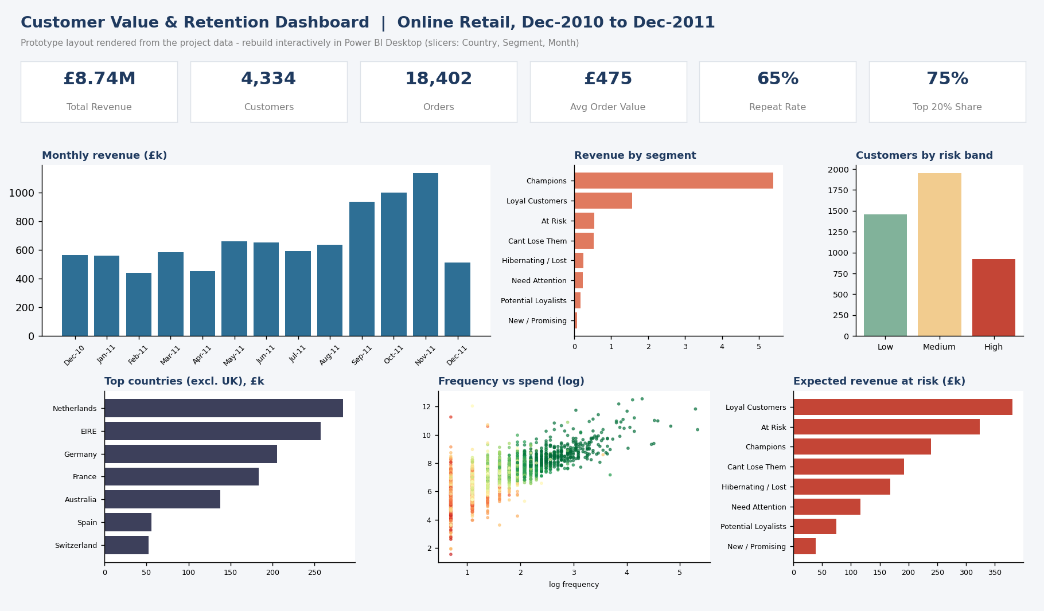
Figure 14: Dashboard layout prototype (rendered from the project data)

8.4 What the dashboard shows
- Sales growth in the last quarter: September-November 2011 months are about 1.5-2 times the average of the first eight months.
- Segment view: Champions give 62% of sales from 17% of customers, so any change in their behaviour is visible immediately.
- Risk view: about 921 customers are in the high-risk band, but most are low-value; managers can filter by segment to see valuable customers only.
- Country slicer: removing the UK reveals which export markets are worth account-management attention.

8.5 Design choices
Few colours, one idea per visual, titles that state the measure, and slicers placed in the same position on each page. Segment names are consistent with the report and SQL scripts. DAX measures are stored in powerbi/DAX_measures.dax.
Expected Revenue At Risk =
SUMX ( dim_customer, dim_customer[Monetary] * dim_customer[ChurnProb] )

9. Integration and Validation
A key idea of the project is that the same answer should be reached through different tools. We compared the main counts and totals across the stages.
Table 20: Cross-tool reconciliation
Check | PostgreSQL | Python | Databricks (expected)
Raw rows | 541,909 | 541,909 | 541,909
Exact duplicates | 5,268 | 5,268 | 5,268
Clean sales lines | 391,150 | 391,150 | 391,150
Invoices | 18,402 | 18,402 | 18,402
Customers with sales | 4,334 | 4,334 | 4,334
Total revenue (£) | 8,737,227.64 | 8,737,227.64 | 8,737,227.64
Top-20% revenue share | 74.6% | 74.6% | -

9.1 Issues found and resolved
- Cancelled big orders: customers 16446 and 12346 placed very large orders that were fully returned. They appear as high-value customers by gross spend. We kept them in the main analysis for transparency and flag them; a business rule could exclude fully returned orders.
- Segment counts differ slightly: SQL NTILE and pandas rank-based quintiles split tied values differently, so a few customers move between neighbouring segments (for example Champions 741 vs 742; At Risk 499 vs 578 because of boundary customers). The patterns and revenue shares are the same.
- Customers in dim_customer (4,372) vs analysed (4,334): 38 customers have only returns or non-product lines and no valid sales; they are excluded from RFM.
- Stock-code text: some codes contain letters, so StockCode is stored as TEXT; Excel would show some as numbers if opened and re-saved.
- Date format: timestamps were kept in a standard format to avoid day-month confusion between tools.
The only real limitation of the checks is that Databricks values in the last column are the values expected from identical logic; the student should confirm them against the actual notebook run and paste the screenshots.

10. Results, Discussion and Recommendations

10.1 Major findings
Table 21: Summary of findings
# | Finding | Evidence
1 | Revenue is highly concentrated: top 20% of customers = 75% of sales | SQL Q7, Figure 5
2 | Champions (742 customers) bring 62% of revenue | Segment table, K-Means
3 | 35% of customers bought only once | SQL Q8
4 | Only about 20% of a new cohort buys again next month | Cohort heat-map
5 | Strong seasonality: Sep-Nov 2011 sales far above the rest of the year | Monthly revenue chart
6 | 783 valuable-but-quiet customers hold £1,084,057 of past spend | Segment table
7 | Purchase history alone predicts churn only moderately (AUC about 0.71) | Model results

10.2 Discussion
The data show a typical wholesale-style retailer: a small number of large repeat buyers create most of the money, and a long tail of occasional buyers adds little. This has two implications. First, retention effort should be targeted rather than spread equally. Second, because many customers buy only once, growth also depends on turning first-time buyers into second-time buyers.
The weak-to-moderate model accuracy is itself a lesson: RFM-type behaviour is a strong signal for ranking customers, but adding information such as product category mix, discount response, delivery problems and customer service contacts would be needed for precise prediction. We also note that gross revenue treats a fully returned order as value, so a company should track net revenue per customer.

10.3 Retention action plan by segment
Table 22: Recommended actions
Segment | Goal | Action | KPI to track
Champions | Keep and reward | VIP programme, early access to new and seasonal ranges, referral rewards, named account manager for the largest | Orders per quarter, churn rate
Loyal Customers | Grow value | Bundles and cross-sell based on Champion best-sellers; loyalty points | Average order value
Potential Loyalists | Convert | Second and third purchase offers; membership invitation | Share with 3+ orders
New / Promising | Onboard | Welcome email series, product education, small second-order incentive | 30-day repeat rate
Need Attention | Remind | Time-limited reminders with personalised recommendations | Reactivation rate
Cant Lose Them | Win back first | Personal call, tailored offer, ask for feedback | Win-back rate, revenue recovered
At Risk | Win back | Win-back email series and survey on reasons for leaving | Win-back rate
Hibernating / Lost | Low-cost | One cheap reactivation email; then suppress to save marketing cost | Cost per reactivated customer

10.4 Practical recommendations
- Start with the 'Cant Lose Them' and top 'At Risk' customers: this is a short list (a few hundred customers) with high past value. Contact them within the next month.
- Protect the Champions: they are the business. Reward loyalty with service and access rather than heavy discounts, which would reduce margin on customers who already buy.
- Fix the first-to-second purchase gap with an onboarding journey, because cohort retention drops mostly after the first order.
- Prepare for seasonality: build inventory and campaigns for September to November and use the season to recruit customers who can be retained afterwards.
- Use the churn score as a ranking tool, and measure each campaign with a control group so that the real effect of retention actions is known.
- Improve data: capture CustomerID on every order (14.7% of sales are anonymous) and track net revenue after returns.

10.5 Illustrative value of retention
As an illustration, the expected revenue at risk across all segments is about £1,534,524 over the next three months based on historic spend and the model's churn probabilities. If a targeted programme saved even 10% of this, it would protect over £140,000 of revenue. This is an estimate that depends on model accuracy and on the assumption that future spend resembles past spend, and it should be tested through a pilot campaign.

11. Conclusion and Future Improvements

11.1 What was achieved
- Built an end-to-end workflow across PostgreSQL, DBeaver, Python, Databricks with Delta Lake, Power BI and GitHub on one dataset.
- Cleaned 541,909 raw lines into 391,150 valid sales lines for 4,334 customers and checked results across tools.
- Identified high-value customers using RFM and confirmed the finding with K-Means and a Pareto analysis.
- Measured retention with cohorts, predicted churn and estimated revenue at risk.
- Produced a segment-wise retention plan that a marketing team can act on.

11.2 Answer to the business question
A company can identify its most valuable customers by scoring each customer on how recently, how often and how much they buy, and can retain them by watching changes in these scores, ranking customers by churn risk and giving each segment a different action: reward Champions, win back valuable quiet customers, and convert new buyers into repeat buyers.

11.3 Limitations
One year of data, no profit or demographic information, 15% of sales without a customer ID, and a moderate churn model. The dataset is small for big-data claims.

11.4 Future improvements
- Add customer lifetime value (CLV) models such as BG/NBD with Gamma-Gamma.
- Use product category and basket analysis for personalised recommendations.
- Use net revenue and profit margin instead of gross revenue.
- Automate the pipeline (scheduled Databricks jobs writing Delta tables read by Power BI).
- Run an A/B test of a win-back campaign to measure true uplift.

12. Team Contribution and Learning
.]
Table 23: Team contribution
Member | Contribution | Learning
Akshith Kompelly | Problem definition, data understanding, project coordination, report and presentation | End-to-end analytics workflow; RFM and retention thinking

Learning summary: the project showed that the hardest part of analytics is not the model but preparing clean data and agreeing on definitions (for example what counts as a sale or a customer). Running the same logic in SQL, Python and Spark was a useful discipline, because small differences immediately showed where rules were unclear.

13. References and Supporting Evidence

13.1 References
- Chen, D., Sain, S. L. and Guo, K. (2012). Data mining for the online retail industry: A case study of RFM model-based customer segmentation using data mining. Journal of Database Marketing & Customer Strategy Management, 19(3), 197-208.
- Dua, D. and Graff, C. UCI Machine Learning Repository - Online Retail dataset. https://archive.ics.uci.edu/ml/datasets/online+retail
- PostgreSQL Global Development Group. PostgreSQL documentation (window functions, NTILE). https://www.postgresql.org/docs/
- Pedregosa, F. et al. (2011). Scikit-learn: Machine learning in Python. Journal of Machine Learning Research, 12, 2825-2830.
- Databricks. Delta Lake documentation. https://docs.databricks.com/delta/
- Microsoft. Power BI documentation and DAX reference. https://learn.microsoft.com/power-bi/
- Faculty guidelines: Big Data Analytics & DBMS Project - Student Guidelines, Dr. Butchi Babu Muvva (2026).

13.2 GitHub repository structure
mini-bigdata-analytics-project/
README.md
data/ online_retail_raw.csv (or sample), online_retail_clean.csv, data_dictionary.md
sql/ 01_create_schema.sql 02_load_and_clean.sql 03_analysis_queries.sql 04_rfm_segmentation.sql
python/ Customer_Retention_Analytics.ipynb, customer_analysis.py
databricks/ Customer_Retention_Databricks_Delta.py (+ screenshots)
powerbi/ Customer_Retention_Dashboard.pbix, CSV inputs, DAX_measures.dax, screenshots/
figures/ all charts used in the report
report/ final report (PDF/DOCX)
presentation/ final slides
Repository link: https://github.com/<your-username>/mini-bigdata-analytics-project

13.3 Appendix - recommended evidence screenshots
- DBeaver connection + query results (Q3, Q7, segment summary).
- Databricks notebook cells with output, DESCRIBE HISTORY, time travel and MERGE.
- Power BI: all three dashboard pages with slicers in use.
- GitHub repository page showing folders and commit history.

