ALFIDO TECH INTERNSHIP REPORT
Task 3 – System Programming / File I/O & Processes in C++
Submitted By:
Name: Akshith Reddy
Internship Domain-C++/C Programming

1. Objective
The objective of this task is to build small system utilities demonstrating file handling, command execution, and logging processes using C++ programming language.
The implemented programs are:
- File Handler
- Command Runner
- Log Writer

2. Technologies Used
The following technologies and tools were used:
- Programming Language: C++
- IDE Used: Visual Studio Code
- Compiler: MinGW g++ Compiler
- Git Version Control
- GitHub Repository

3. File Handler Implementation
File handling is used to create files, write data, and read stored information.
Functions Implemented:
- Create file using output stream
- Write data to file
- Read file using input stream
Algorithm:
- Open file for writing
- Store text in file
- Close file
- Reopen file for reading
- Display file content
Time Complexity:
- Write Operation → O(n)
- Read Operation → O(n)
Sample Output:
Reading file content:
Hello from Alfido Internship Task 3

4. Command Runner Implementation
Command Runner executes operating system commands directly from the C++ program.
Functions Implemented:
- Execute system command
- Verify successful execution
Algorithm:
- Call system() function
- Execute command in terminal
- Return status code
- Display success or failure
Time Complexity:
- Depends on operating system command
Sample Output:
Running system command...
Directory files displayed
Command executed successfully

5. Log Writer Implementation
Log Writer stores timestamped log entries into a log file.
Functions Implemented:
- Open log file
- Append log entry
- Save current system time
Algorithm:
- Open log file in append mode
- Get current time
- Write timestamp into log file
- Close file
Time Complexity:
- Append Operation → O(1)
Sample Output:
Log written successfully
Generated log file:
Log Entry: Tue Mar 16 20:30:10 2026

6. Program Execution Commands
File Handler:
g++ filehandler.cpp -o filehandler
Run:
./filehandler

Command Runner:
g++ commandrunner.cpp -o commandrunner
Run:
./commandrunner

Log Writer:
g++ logwriter.cpp -o logwriter
Run:
./logwriter

7. Source Code Files
The project consists of:
- filehandler.cpp
- commandrunner.cpp
- logwriter.cpp
- README.md

8. GitHub Repository
Repository Link:
https://github.com/akshithreddythalakatla/Alfido

9. Screenshots
Include screenshots of:
- Source code files

CommandRunner.cpp
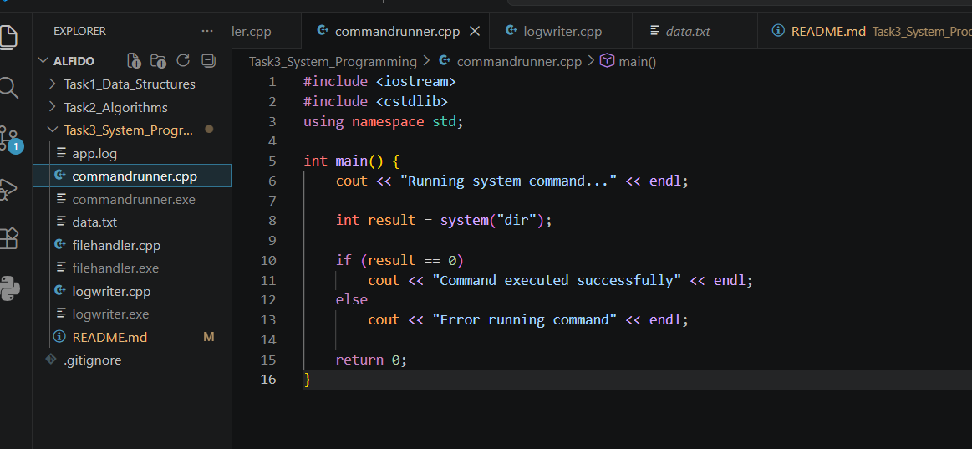

Filehandler.cpp
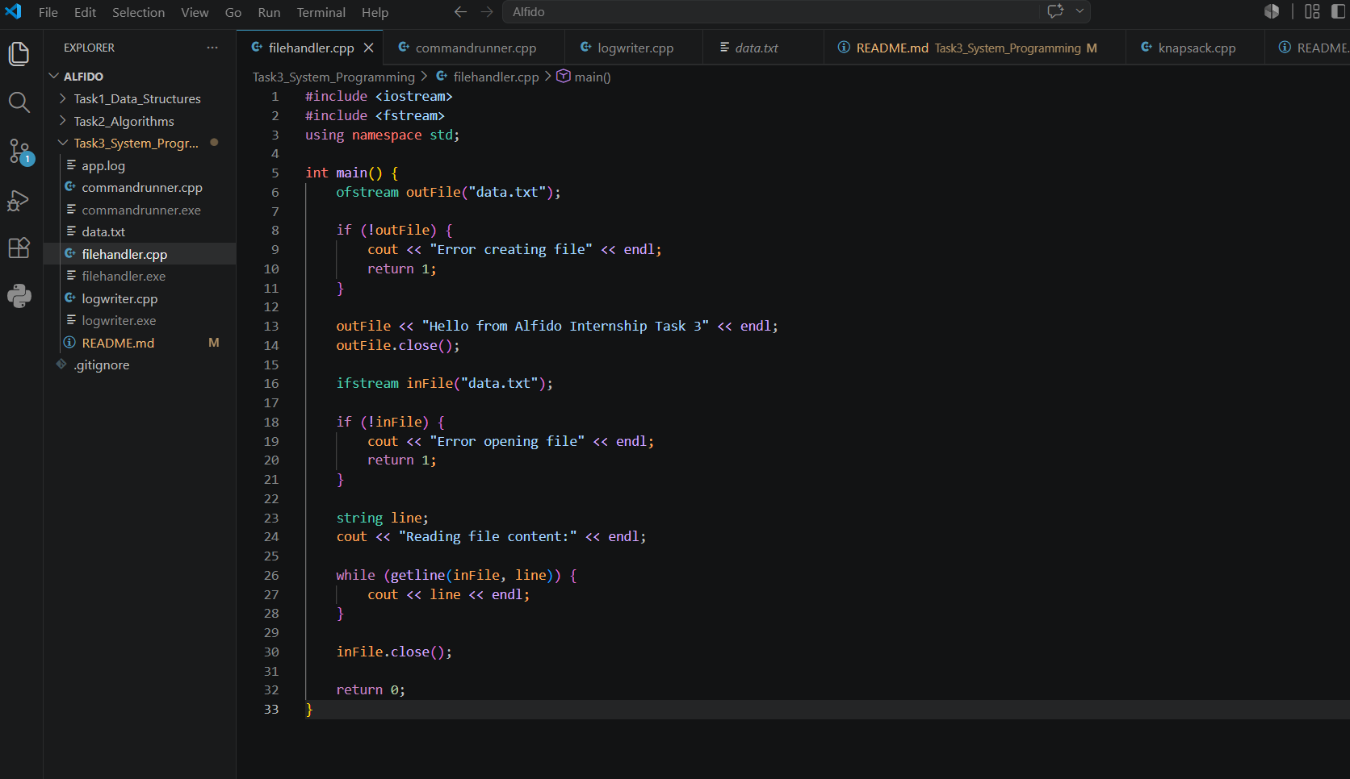

Logwriter.cpp
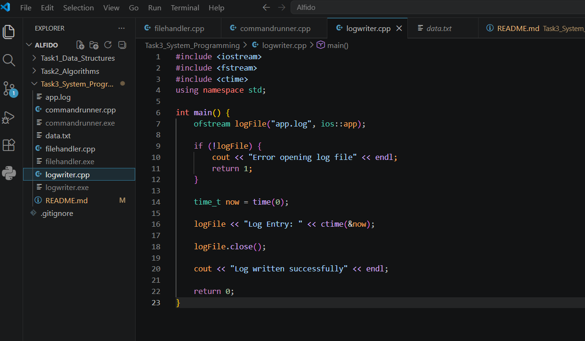

- Terminal output
CommandRunner.cpp
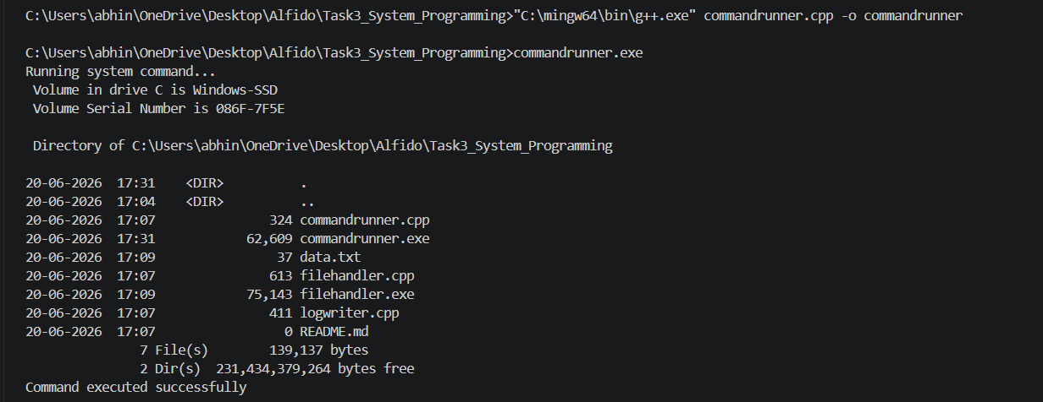

Logwriter.cpp
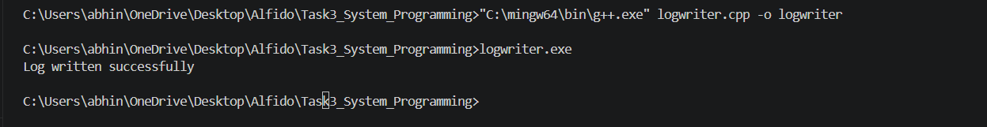
FileHandler.cpp
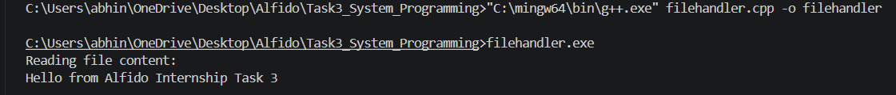
- Generated data.txt file
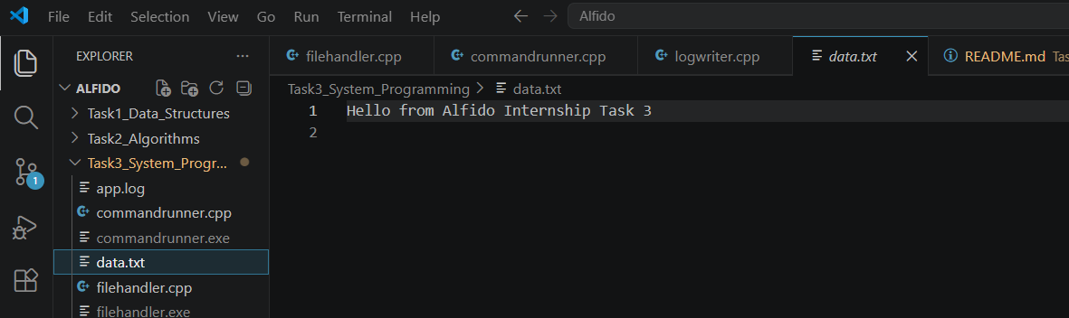

- Generated app.log file

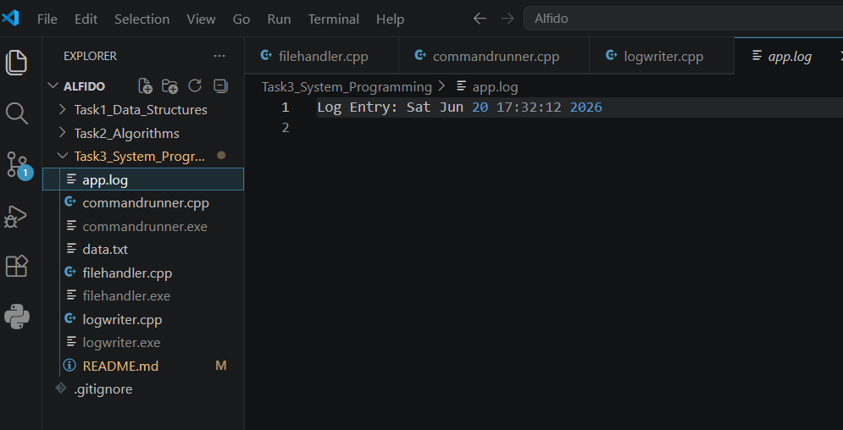

10. Conclusion
This project successfully implemented system programming utilities using C++.
The task improved understanding of file handling, operating system command execution, process interaction, and log management.
Task completed successfully as part of internship work at Alfido Tech.

