ALFIDO TECH INTERNSHIP REPORT
Task 2 – Algorithms & Problem Solving in C++
Submitted By:
Name: Akshith Reddy
Internship Domain-C++/C Programming

1. Objective
The objective of this task is to solve algorithmic problems demonstrating searching, sorting, and greedy approaches using C++ programming language.
The implemented algorithms are:
- Binary Search
- Merge Sort
- Knapsack Problem

2. Technologies Used
The following tools were used:
- Programming Language: C++
- IDE Used: Visual Studio Code
- Compiler: MinGW g++ Compiler
- Git Version Control
- GitHub Repository

3. Binary Search Implementation
Binary Search is used to search an element in a sorted array by repeatedly dividing the search space into halves.
Algorithm:
- Find middle element
- Compare with target value
- Move left or right accordingly
Time Complexity:
- Best Case → O(1)
- Worst Case → O(log n)
Sample Output:
Element found at index 2

4. Merge Sort Implementation
Merge Sort uses divide and conquer to sort an array.
Algorithm:
- Divide array into two halves
- Recursively sort both halves
- Merge sorted arrays
Time Complexity:
- Best Case → O(n log n)
- Worst Case → O(n log n)
Sample Output:
Sorted array: 3 9 10 27 38 43 82

5. Knapsack Problem Implementation
Knapsack problem finds maximum profit using greedy selection.
Algorithm:
- Calculate profit to weight ratio
- Select items based on available capacity
Time Complexity:
- O(n)
Sample Output:
Maximum profit = 160

6. Program Execution Commands
Binary Search:
g++ binarysearch.cpp -o binarysearch
Run:
./binarysearch

Merge Sort:
g++ mergesort.cpp -o mergesort
Run:
./mergesort

Knapsack:
g++ knapsack.cpp -o knapsack
Run:
./knapsack

7. Source Code Files
The project consists of:
- binarysearch.cpp
- mergesort.cpp
- knapsack.cpp
- README.md

8. GitHub Repository
Repository Link: https://github.com/akshithreddythalakatla/Alfido

9. Screenshots
Include screenshots of:
- Source code files
Binarysearch.cpp-
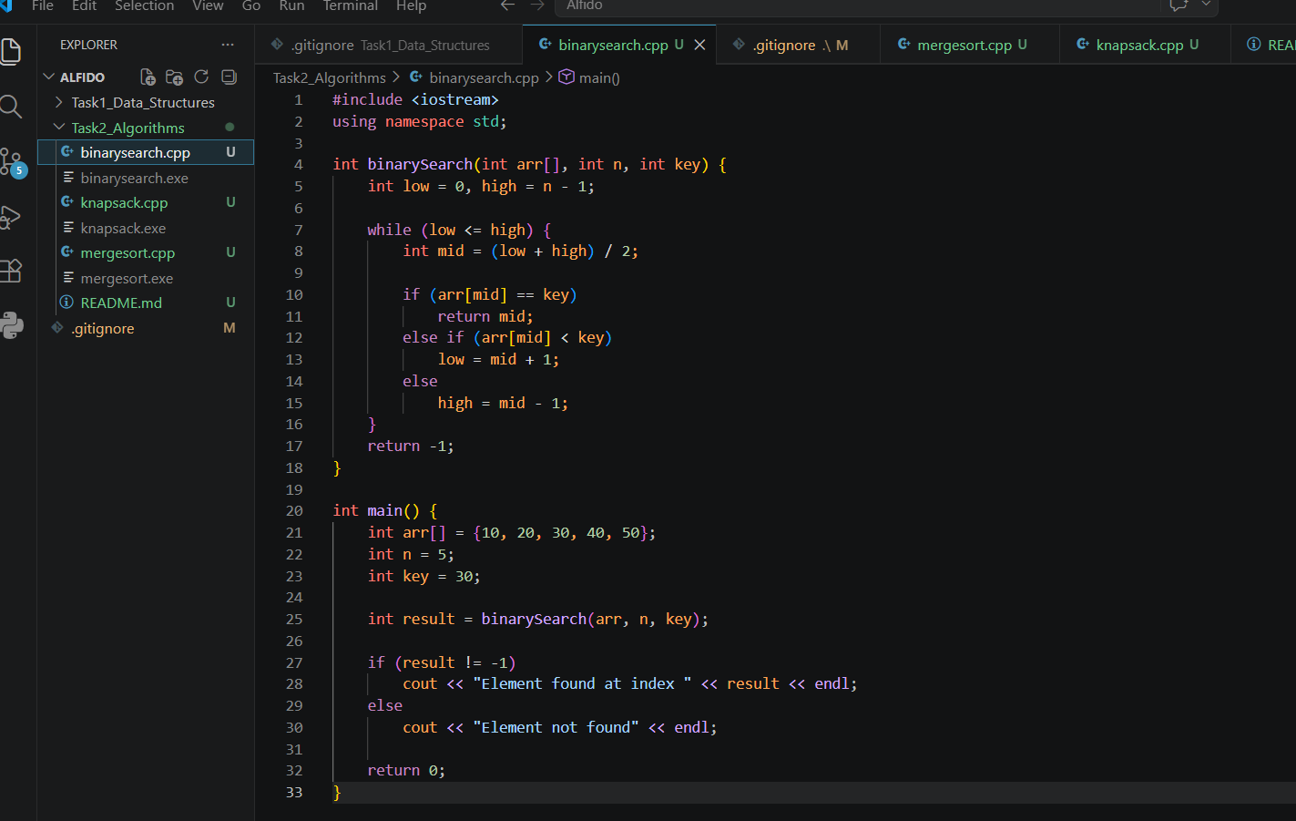

Knapsack.cpp-
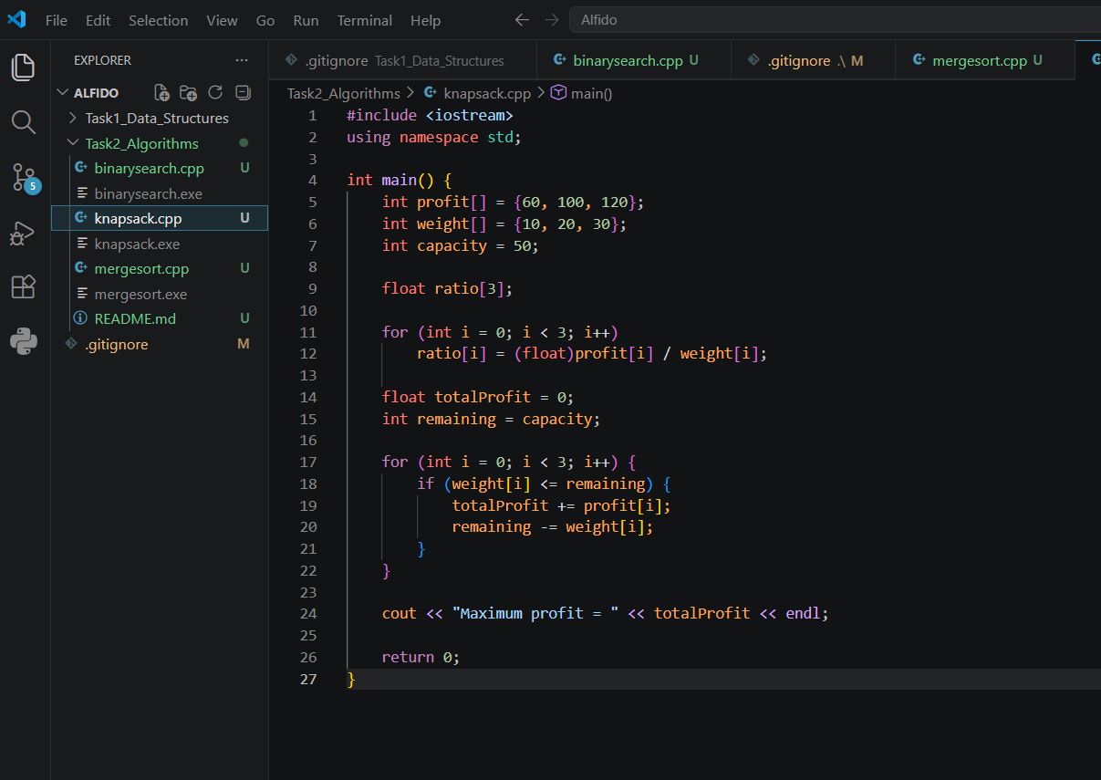
Mergesort.cpp-
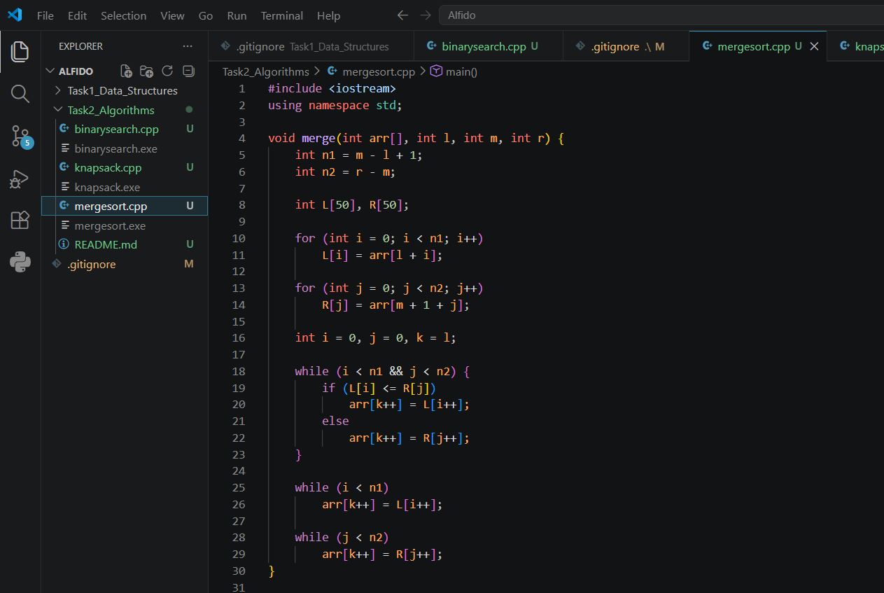
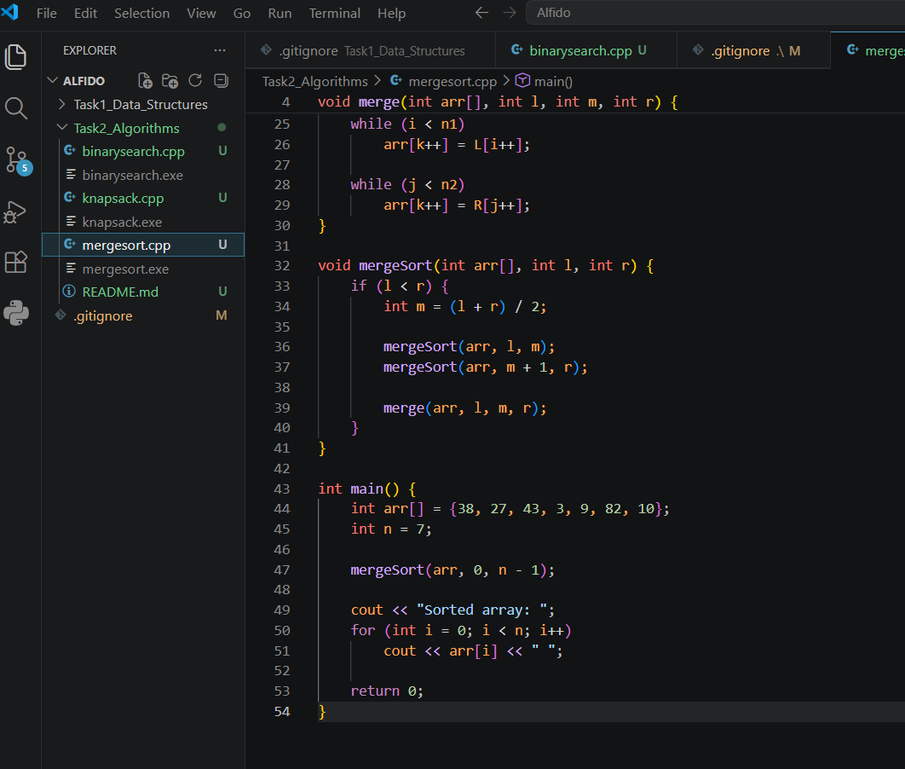

- Terminal output
Binarysearch.cpp
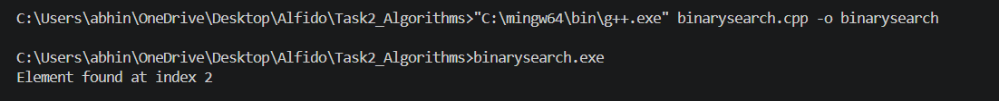
Knapsack.cpp
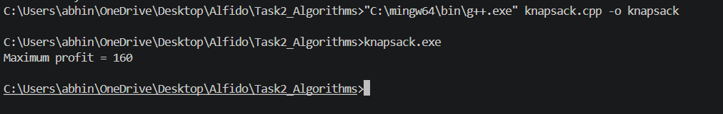
Mergesort.cpp

10. Conclusion
This project successfully implemented three algorithmic problems using searching, sorting, and greedy techniques.
The task improved understanding of divide and conquer algorithms, searching algorithms, sorting algorithms, and optimization problems.
Task completed successfully as part of Alfido Tech Internship.

