ALFIDO TECH INTERNSHIP REPORT -Task1
Task 1 – Data Structures Implementation in C++
Submitted By:
Name: Akshith Reddy
Internship Domain: C/C++ Programming

1. Objective
The objective of this task is to implement core data structures from scratch using C++ programming language.
This task helps in understanding the working principles of data structures and their operations such as insertion, deletion, searching, and displaying elements.
The data structures implemented in this project are:
- Stack
- Linked List

2. Technologies Used
The following technologies and tools were used during implementation:
- Programming Language: C++
- IDE Used: Visual Studio Code
- Compiler: MinGW g++ Compiler
- Version Control System: Git
- Repository Hosting Platform: GitHub

3. Stack Implementation
Stack is a linear data structure that follows the LIFO (Last In First Out) principle.
Operations Implemented
- Push Operation
- Pop Operation
- Search Operation
- Display Operation
Algorithm
- Create an array to store stack elements.
- Maintain a variable called top.
- Insert elements using push operation.
- Remove elements using pop operation.
- Search elements by traversing the stack.
- Display all stack elements.
Time Complexity Analysis
- Push → O(1)
- Pop → O(1)
- Search → O(n)
- Display → O(n)

4. Linked List Implementation
Linked List is a linear data structure where elements are stored in nodes connected using pointers.
Operations Implemented
- Insert Operation
- Delete Operation
- Search Operation
- Display Operation
Algorithm
- Create a node structure containing data and next pointer.
- Insert new nodes into the linked list.
- Delete nodes by searching for a target value.
- Traverse the linked list to search elements.
- Display all linked list elements.
Time Complexity Analysis
- Insert → O(1)
- Delete → O(n)
- Search → O(n)
- Display → O(n)

5. Program Execution Commands
Stack Program
Compile Command:
g++ stack.cpp -o stack
Run Command:
./stack

Linked List Program
Compile Command:
g++ linkedlist.cpp -o linkedlist
Run Command:
./linkedlist

6. Sample Input and Output
Stack Program Output
10 pushed into stack
20 pushed into stack
30 pushed into stack
Display:
30 20 10
Search:
20 found in stack
Pop Operation:
30 popped from stack
Final Display:
20 10

Linked List Program Output
Insert 10
Insert 20
Insert 30
Display:
30 20 10
Search:
20 found
Delete:
Delete 20
Final Display:
30 10

7. Source Code Files
The project consists of the following source files:
- stack.cpp
- linkedlist.cpp
- README.md
All source files are uploaded to GitHub repository.

8. GitHub Repository
The source code and project files are uploaded to GitHub repository.
Repository Link: https://github.com/akshithreddythalakatla/Alfido

9. Screenshots
The following screenshots are included as proof of implementation:
- Stack source code screenshot
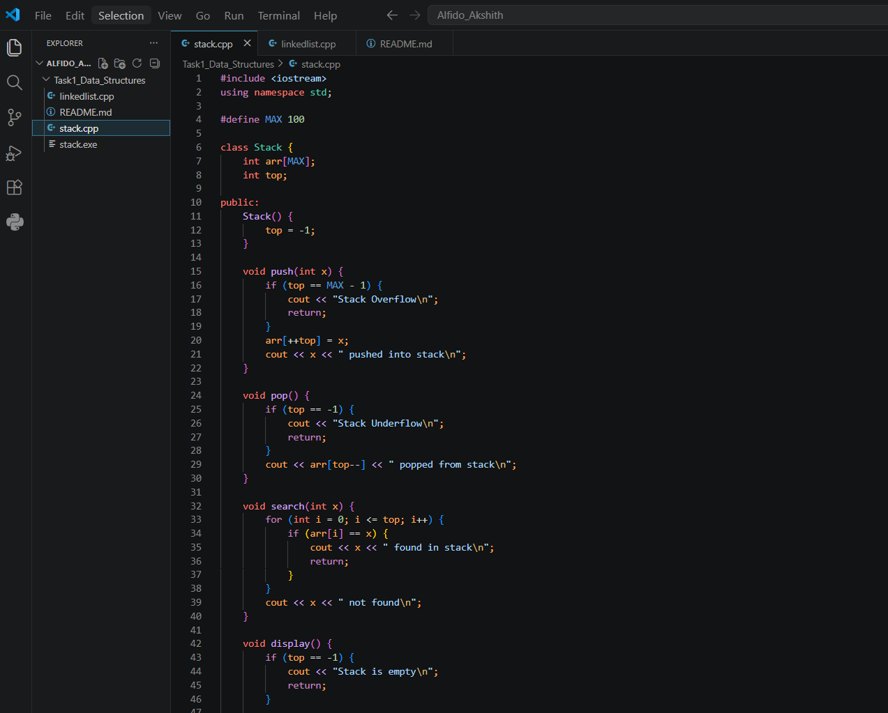
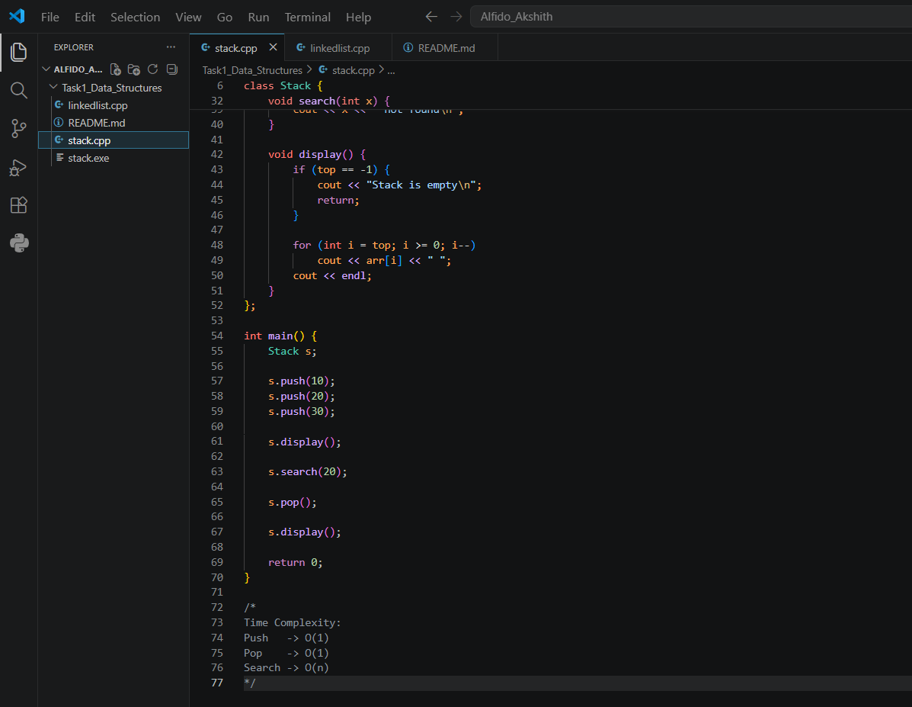

- Stack program execution output screenshot
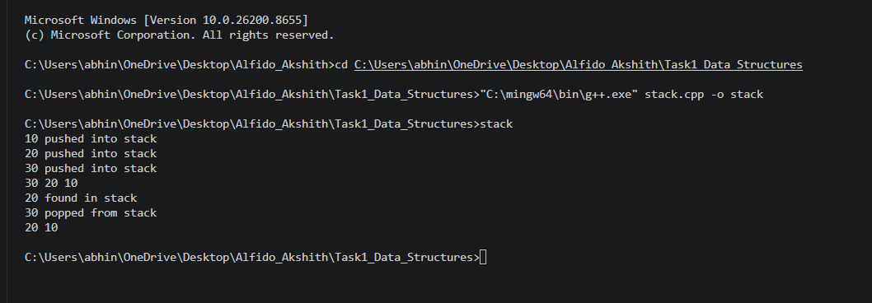
- Linked List source code screenshot
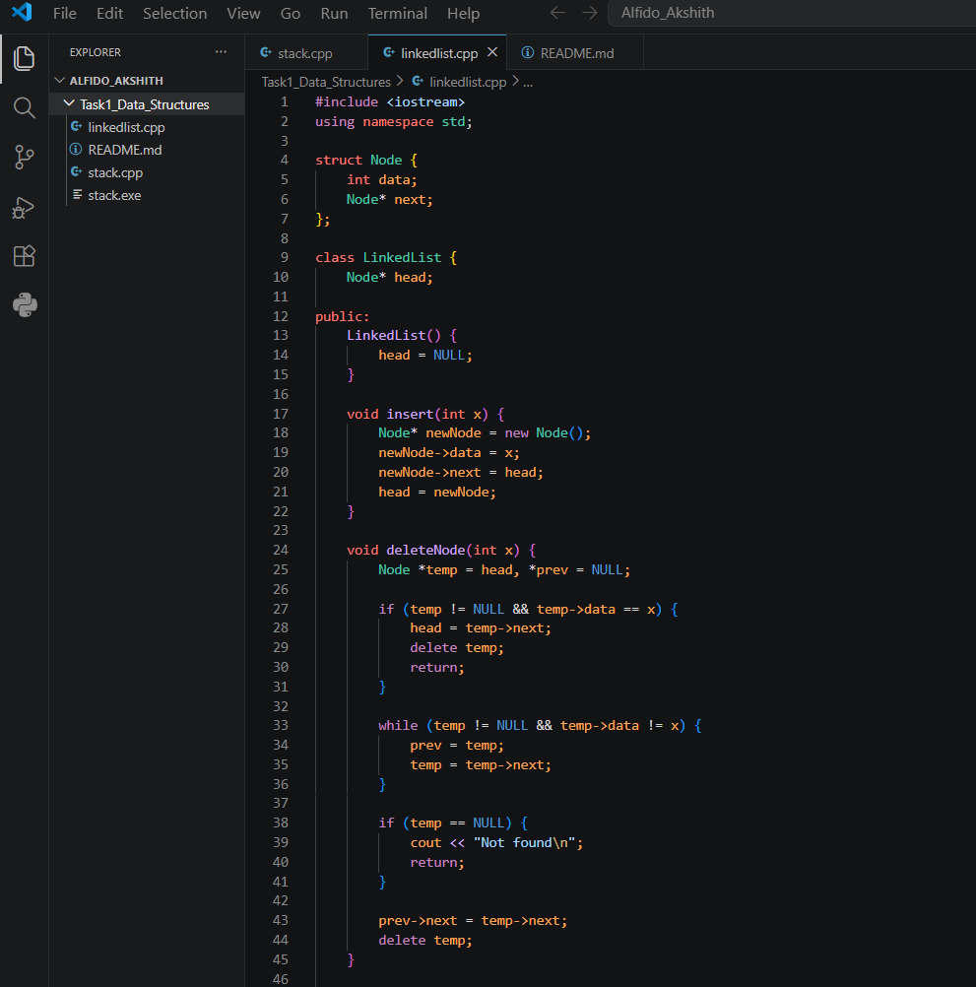
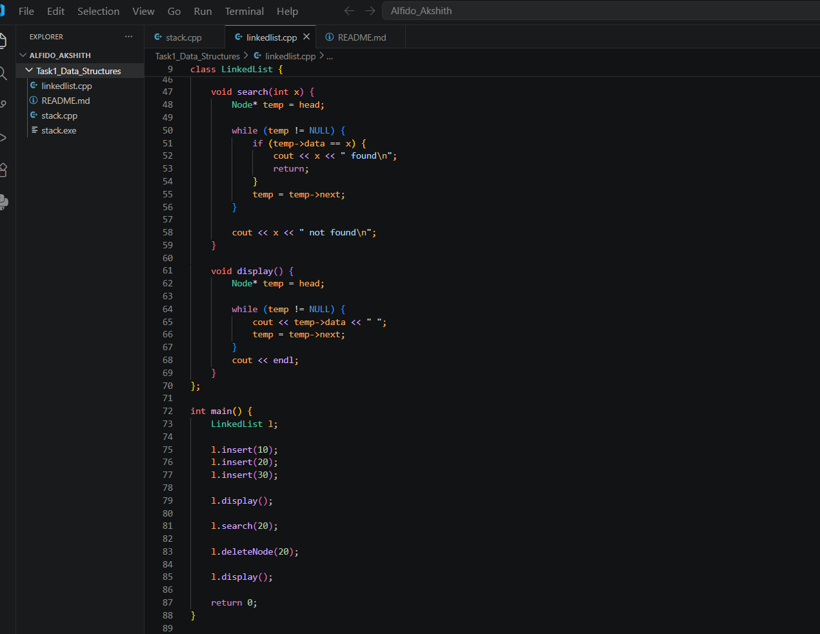

- Linked List execution output screenshot
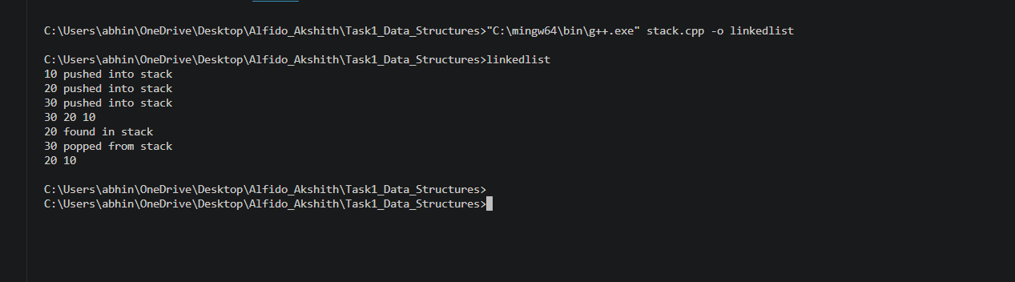

10. Conclusion
This project successfully implemented two important data structures using C++ programming language.
The task improved understanding of arrays, pointers, memory allocation, insertion, deletion, searching operations, and time complexity analysis.
The implementation was tested successfully and uploaded to GitHub for submission.
Task completed successfully as part of internship work at Alfido Tech.

