**Questions:**

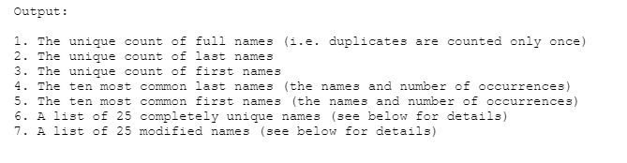

**Solutions:**

* Environment
  + Language: Python 3
  + Libraries: Pandas, NumPy
* Data Processing:
  + Read into dataframe
  + Processed data to extract just names:

# below line parses the entire df, removes everything after the '--' & writes data to a new column called split

df['split'] = df['original'].map(lambda x: x.split('--', 1)[0])

# below line displays only every 2nd row in the df

df.iloc[::2]

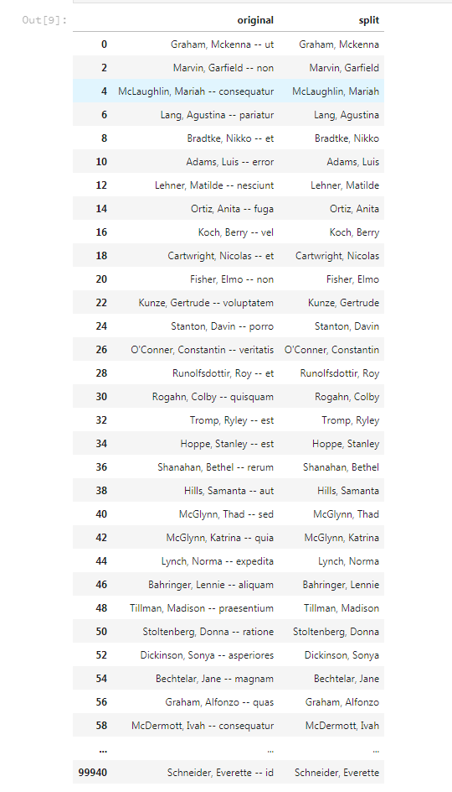

* Validation:

# below to show if the data in the column contains the specified character

# useing this column in the future to check if any non name rows get selected in new_df

df['required'] = df.split.str.contains(',') == True

# rename column split to column full_name

new_df = new_df.rename(columns = {'split':'full_name'})

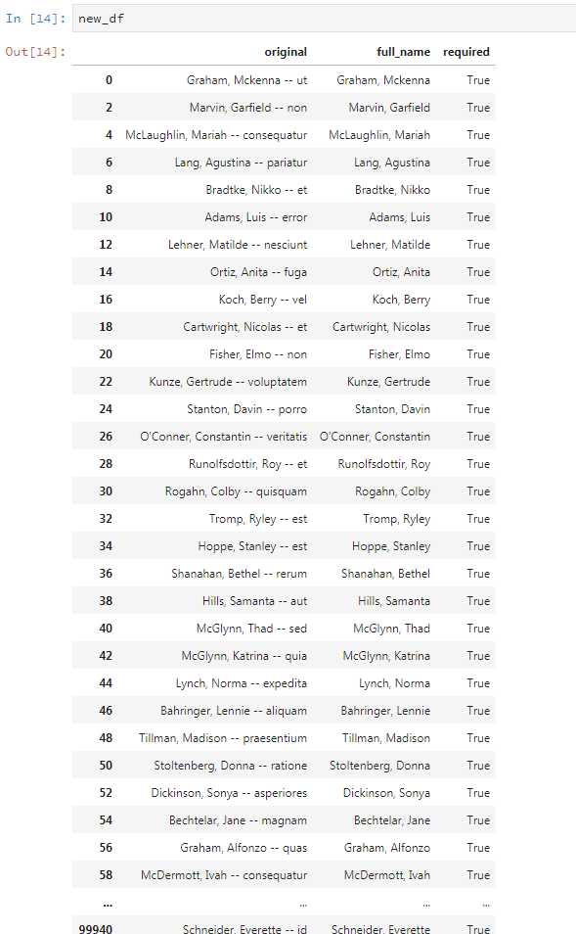

* First & Last Names:

# parse full_name into first and last

new_df['last'] = new_df['full_name'].map(lambda x: x.split(',', 1)[0])

new_df['first'] = new_df['full_name'].map(lambda x: x.split(',', -1)[-1])

# removing the test column from new_df

del new_df['required']

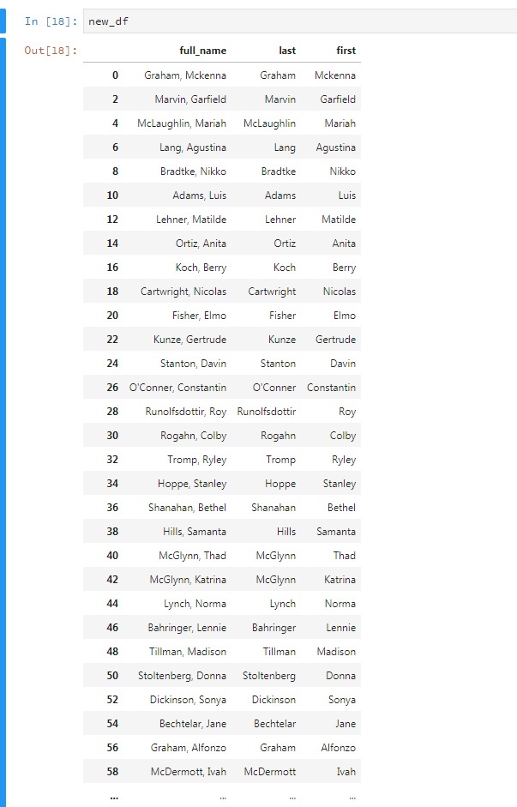

* Answers:
  + Q1 – Q3:

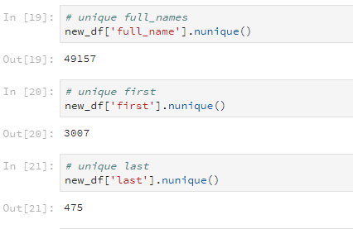

* + Q4 – Q5:

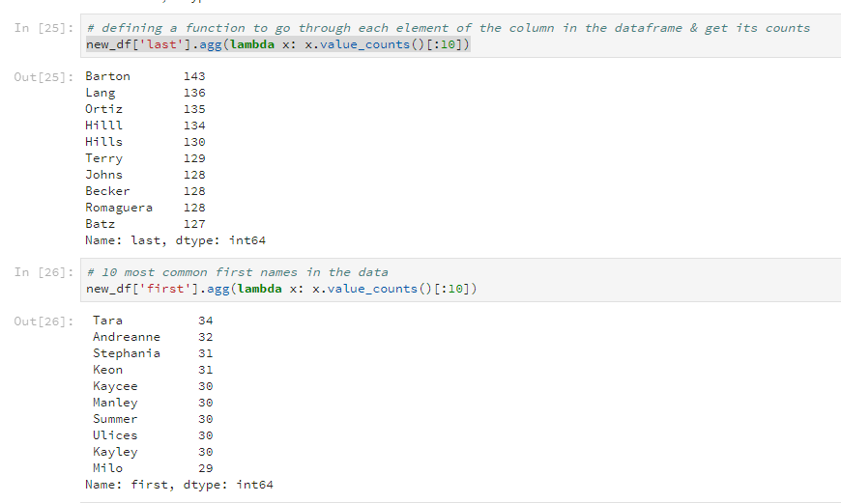

* + Q6:

Approach: pick N names from the list of full names & first & last names lists for use as follows:

Full Names:

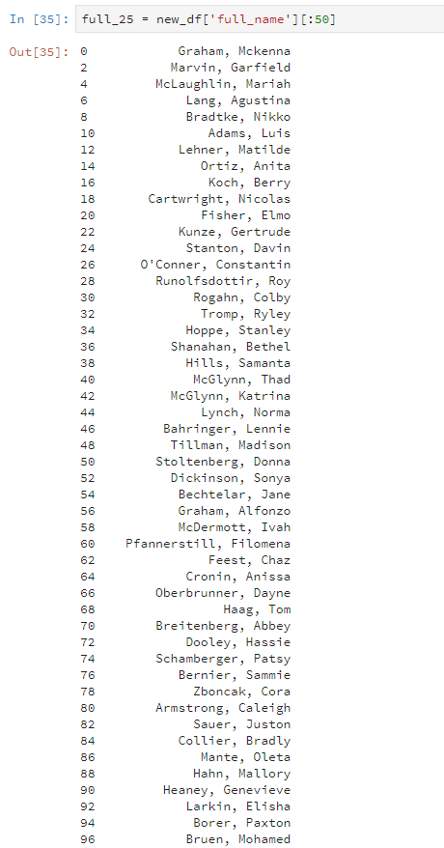

First & Last Names: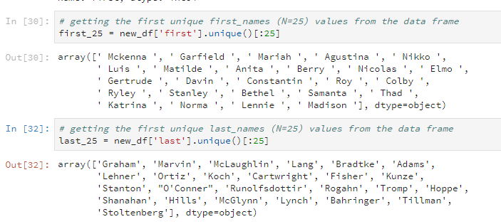

Unique Names:

# unique_list.append(full_25[0])

for i in full_25:

# i_last = i.map(lambda x: x.split(',', 1)[0]) #condition to split the ith elements last name

# i_first = i.map(lambda x: x.split(',', 1)[-1].lstrip()) #condition to split the ith elements first name

last_list = full_25.map(lambda x: x.split(',', 1)[0])

first_list = full_25.map(lambda x: x.split(',', 1)[-1].lstrip())

if i.split(',', 1)[0] not in last_list:

# if i.split(',', 1)[-1].lstrip() not in first_list:

unique_list.append(i)

My approach was to pass the list to this function, and for this parameter, check the list of first & last names & append to the unique names list if it doesn’t exist. Couldn’t get it to work but, I believe I was on the approaching the right way. Happy to discuss further