Compiler Design Lab

Name – Akshit Jain
Reg. no.- 21BRS1088

1)

Code -
//21BRS1088
#include <stdio.h>
#include <string.h>
#include <stdbool.h>
void detectComments(char *code) {
int i = 0;

while (code[i] != '\0') {
if (code[i] == '/' && code[i + 1] == '/') {
// Single-line comment
while (code[i] != '\n' && code[i] != '\0') {
putchar(code[i]);
i++;
}
putchar('\n');

}
else if (code[i] == '/' && code[i + 1] == '*') {
// Multi-line comment
i += 2;
while (!(code[i] == '*' && code[i + 1] == '/')) {
putchar(code[i]);
i++;

}
i += 2;

} else {
i++;
}
}

}
int main() {

char code[1000];
char delimiter[] = "$$$";
int count;
printf("End code with %s \n",delimiter);
printf("Enter the C code \n");

char line[100];
while (fgets(line, sizeof(line), stdin) != NULL) {
if (strstr(line, delimiter) != NULL) {
break;
}
strcat(code, line);
}
printf("\nComments:\n");
detectComments(code);
return 0;
}

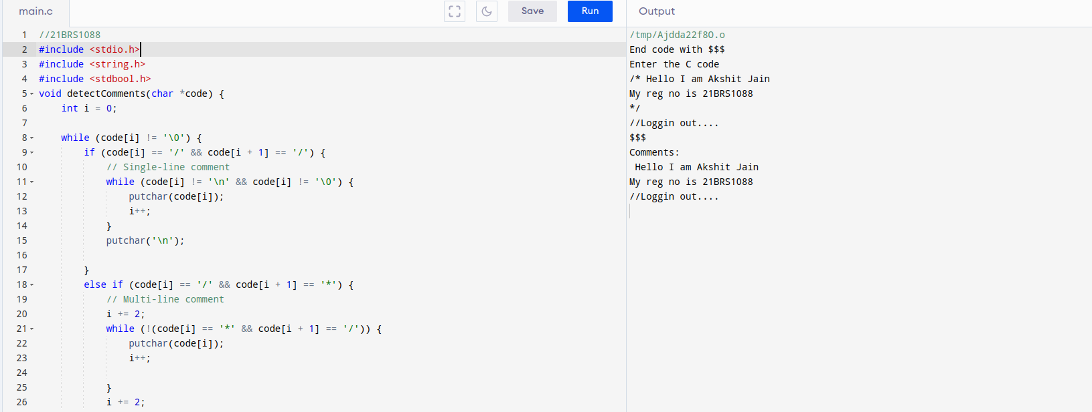

Output -
