Scenario 1)

You are a Project Coordinator at GreenTech Innovations, a company that specializes in developing sustainable energy solutions. Your team has been working on a project to implement a new solar panel system for a client, and you've just received an email from the client's project manager, Rachel Lee.

Subject: Concerns about Project Timeline

Hi [Your Name],

I hope this email finds you well. I'm reaching out to express some concerns about the project timeline for the solar panel system installation. As you know, we're on a tight schedule to get this project completed by the end of the quarter. However, I've noticed that there have been some delays in the delivery of the solar panels, and I'm worried that this might impact our ability to meet the deadline.

Could you please provide me with an update on the current status of the project and let me know if there are any potential roadblocks that we should be aware of? I'd appreciate it if you could also provide a revised project timeline that takes into account any delays or changes.

Looking forward to hearing back from you soon.

Best,  
Rachel

Your task is to respond to Rachel's email, addressing her concerns and providing the necessary updates and information. Please write your response, and I'll review and provide feedback.

My Answer

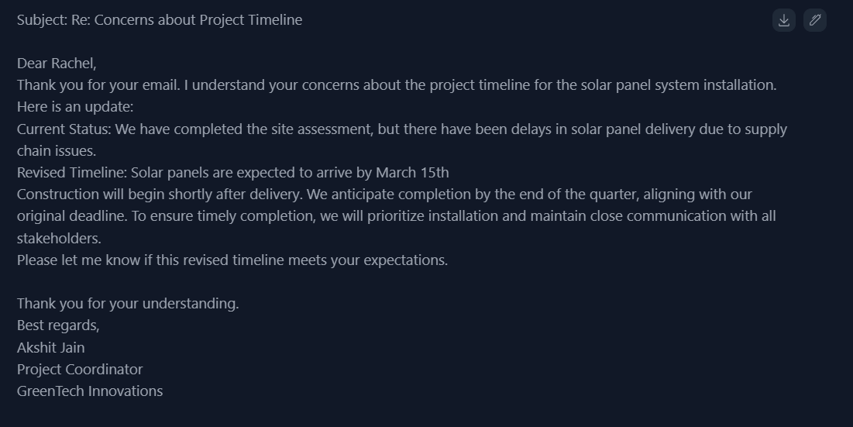

Feedback

Here's the detailed feedback on your email:

Clarity  
Your message is clear and concise, effectively conveying the current status and revised timeline of the project. You've done a great job of breaking down the information into easily digestible parts, making it simple for Rachel to understand the updates. However, it would be beneficial to provide a bit more context about the supply chain issues that caused the delay, as this could help Rachel understand the reason behind the delay and show that you're empathizing with her concerns. For instance, you could mention that the delay was due to unforeseen circumstances, such as a shortage of materials or transportation disruptions, and that you're working closely with the supplier to resolve the issue.

Precision  
You've included the necessary details about the project's current status and the revised timeline, which is great for precision. The specific dates you've provided, such as the expected arrival of the solar panels on March 15th, help to give Rachel a clear understanding of what to expect. However, it might be helpful to provide a bit more information about what "prioritizing installation" entails, as this could give Rachel a better understanding of the steps you're taking to ensure the project stays on track. For example, you could mention that you'll be allocating additional resources to the installation team or working extended hours to complete the project as quickly as possible.

Tone  
Your tone is professional and polite, which is suitable for a client-facing email. You've acknowledged Rachel's concerns and shown appreciation for her understanding, which demonstrates empathy and a customer-centric approach. However, the tone could be slightly warmer and more personalized. For instance, you could express your commitment to delivering the project on time and to the client's satisfaction, and offer a personal point of contact for any further questions or concerns.

Structure  
Your email is well-organized, with a clear introduction, body, and conclusion. You've used a logical flow to present the information, making it easy to follow. However, it might be beneficial to use a more formal greeting and closing, as this would enhance the professional tone of the email. For example, you could use a greeting like "Dear Rachel Lee" and a closing like "Best regards, Akshit Jain, Project Coordinator, GreenTech Innovations".

Actionability  
You've provided a clear call to action, asking Rachel to let you know if the revised timeline meets her expectations. This shows that you're proactive and willing to adapt to her needs. However, it might be helpful to offer a bit more guidance on what the next steps would be if the revised timeline is not acceptable to Rachel. For example, you could mention that you're open to discussing alternative solutions or adjustments to the project scope, and provide a specific point of contact for further discussion.

Now, let's redraft the email to illustrate how to write it based on the feedback:

Subject: Re: Concerns about Project Timeline

Dear Rachel Lee,

Thank you for reaching out and expressing your concerns about the project timeline for the solar panel system installation. I understand the importance of meeting the deadline, and I appreciate your diligence in monitoring the project's progress.

Here's an update on the current status: we've completed the site assessment, but unfortunately, we've experienced delays in solar panel delivery due to unforeseen supply chain issues, including a shortage of materials and transportation disruptions. Our team is working closely with the supplier to resolve the issue as quickly as possible.

Regarding the revised timeline, we expect the solar panels to arrive by March 15th. Construction will begin shortly after delivery, and we anticipate completion by the end of the quarter, aligning with our original deadline. To ensure timely completion, we'll prioritize installation by allocating additional resources to the installation team and working extended hours if necessary. We'll maintain close communication with all stakeholders to keep everyone informed of our progress.

Please let me know if this revised timeline meets your expectations. If not, I'm open to discussing alternative solutions or adjustments to the project scope. Please don't hesitate to reach out to me directly if you have any further questions or concerns.

Thank you for your understanding, and I look forward to hearing back from you soon.

Best regards,  
Akshit Jain  
Project Coordinator  
GreenTech Innovations

Scenario 2)

You are a Project Manager at GreenTech Innovations, and you've been working on a project to develop a new sustainable energy solution for a client. The project is nearing completion, but you've just received an email from the client's project manager, expressing concerns about the project's budget and requesting a detailed breakdown of the costs. The client is considering reducing the project's scope to stay within budget, and they need your input on the potential impact of such a reduction on the project's timeline and deliverables. Please write an email responding to the client's concerns and providing the necessary information.

My Answer

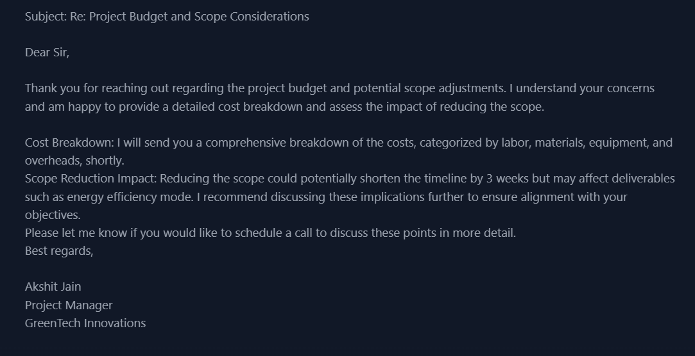

Feedback

Clarity  
Your message is clear and concise, effectively conveying the main points regarding the project budget and scope considerations. You've done a great job of breaking down the information into easily digestible parts, making it simple for the client to understand the updates. However, it would be beneficial to provide a bit more context about the potential impact of reducing the scope on the energy efficiency mode. For instance, you could mention that the reduction in scope might affect the system's ability to optimize energy consumption during peak hours, and that this could have a significant impact on the client's energy costs.

Precision  
You've included the necessary details about the cost breakdown and the potential impact of reducing the scope, which is great for precision. However, it might be helpful to provide a bit more information about what the comprehensive cost breakdown will include, such as a detailed list of expenses, invoices, and payment schedules. Additionally, you could provide more specific details about the potential timeline reduction, such as the exact number of weeks or days that the project timeline could be shortened.

Tone  
Your tone is professional and polite, which is suitable for a client-facing email. You've acknowledged the client's concerns and shown appreciation for their interest in discussing the project's budget and scope. However, the tone could be slightly warmer and more personalized. For instance, you could express your commitment to delivering the project on time and to the client's satisfaction, and offer a personal point of contact for any further questions or concerns.

Structure  
Your email is well-organized, with a clear introduction, body, and conclusion. You've used a logical flow to present the information, making it easy to follow. However, it might be beneficial to use a more formal greeting, such as "Dear [Client's Name]" instead of "Dear Sir". Additionally, you could consider adding a brief summary or overview of the project's current status to provide context for the discussion.

Actionability  
You've provided a clear call to action, asking the client if they would like to schedule a call to discuss the points in more detail. This shows that you're proactive and willing to adapt to their needs. However, it might be helpful to offer a bit more guidance on what the next steps would be if the client decides to reduce the scope. For example, you could mention that you would work with the client to identify the specific components of the project that could be reduced or modified, and that you would provide a revised project plan and timeline.

Now, let's redraft the email to illustrate how to write it based on the feedback:

Subject: Re: Project Budget and Scope Considerations

Dear [Client's Name],

Thank you for reaching out regarding the project budget and potential scope adjustments. I understand your concerns and am happy to provide a detailed cost breakdown and assess the impact of reducing the scope.

As of now, the project is progressing as planned, with all major milestones on track to be completed on time. However, I understand that budget constraints can be a challenge, and I'm committed to working with you to find a solution that meets your needs.

Cost Breakdown: I will send you a comprehensive breakdown of the costs, categorized by labor, materials, equipment, and overheads, shortly. This will include a detailed list of expenses, invoices, and payment schedules, to ensure transparency and accuracy.

Scope Reduction Impact: Reducing the scope could potentially shorten the timeline by 3-4 weeks, depending on the specific components that are modified or removed. However, this might affect deliverables such as energy efficiency mode, which could impact the system's ability to optimize energy consumption during peak hours. I recommend discussing these implications further to ensure alignment with your objectives.

Please let me know if you would like to schedule a call to discuss these points in more detail. If you decide to reduce the scope, I will work with you to identify the specific components that can be modified or removed, and provide a revised project plan and timeline.

Thank you for your understanding, and I look forward to hearing back from you soon.

Best regards,  
Akshit Jain  
Project Manager  
GreenTech Innovations

Scenario 3

You are a Project Manager at GreenTech Innovations, and you've been working on a project to develop a new sustainable energy solution for a client. The project is nearing completion, but you've just received an email from the client's project manager, expressing concerns about the project's quality and requesting a detailed report on the testing and validation procedures that have been performed. The client is considering conducting their own independent testing and validation, and they need your input on the potential risks and benefits of this approach. Please write an email responding to the client's concerns and providing the necessary information.

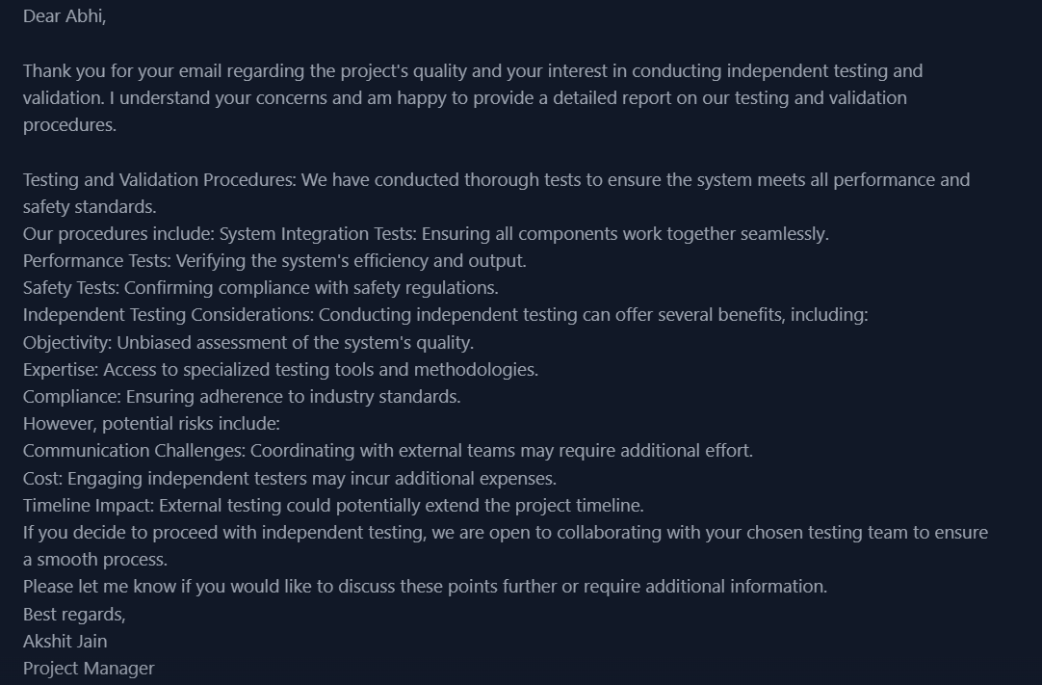

Feedback

Clarity  
Your message is clear and concise, effectively conveying the main points regarding the project's quality and testing procedures. You've done a great job of breaking down the information into easily digestible parts, making it simple for Abhi to understand the updates. However, it would be beneficial to provide a bit more context about the testing and validation procedures, such as the specific standards or regulations that the system is being tested against. For instance, you could mention that the system is being tested to meet the requirements of the International Electrotechnical Commission (IEC) or the National Electrical Code (NEC).

Precision  
You've included the necessary details about the testing and validation procedures, which is great for precision. However, it might be helpful to provide more specific information about the types of tests that were conducted, such as the specific performance metrics that were measured or the safety protocols that were verified. Additionally, you could provide more details about the potential risks and benefits of independent testing, such as the potential costs or timeline impacts.

Tone  
Your tone is professional and polite, which is suitable for a client-facing email. You've acknowledged Abhi's concerns and shown appreciation for their interest in ensuring the project's quality. However, the tone could be slightly warmer and more personalized. For instance, you could express your commitment to delivering a high-quality project and offer a personal point of contact for any further questions or concerns.

Structure  
Your email is well-organized, with a clear introduction, body, and conclusion. You've used a logical flow to present the information, making it easy to follow. However, it might be beneficial to use a more formal greeting, such as "Dear Abhi [Last Name]" instead of just "Dear Abhi". Additionally, you could consider adding a brief summary or overview of the project's current status to provide context for the discussion.

Actionability  
You've provided a clear call to action, asking Abhi if they would like to discuss the points further or require additional information. This shows that you're proactive and willing to adapt to their needs. However, it might be helpful to offer a bit more guidance on what the next steps would be if Abhi decides to proceed with independent testing. For example, you could mention that you would work with Abhi to identify the specific testing requirements and develop a plan for coordinating with the independent testing team.

Now, let's redraft the email to illustrate how to write it based on the feedback:

Subject: Re: Project Quality and Testing Procedures

Dear Abhi,

Thank you for your email regarding the project's quality and your interest in conducting independent testing and validation. I understand your concerns and am happy to provide a detailed report on our testing and validation procedures.

As of now, the project is progressing as planned, with all major milestones on track to be completed on time. Our testing and validation procedures have been designed to ensure that the system meets all performance and safety standards, including those specified by the International Electrotechnical Commission (IEC) and the National Electrical Code (NEC).

Our procedures include:

System Integration Tests: Ensuring all components work together seamlessly, including the verification of communication protocols and data exchange between subsystems.

Performance Tests: Verifying the system's efficiency and output, including the measurement of key performance metrics such as energy production and consumption.

Safety Tests: Confirming compliance with safety regulations, including the verification of electrical and mechanical safety protocols.

Regarding independent testing, we understand that this can offer several benefits, including objectivity, expertise, and compliance with industry standards. However, we also want to highlight the potential risks, including communication challenges, additional costs, and potential impacts on the project timeline.

If you decide to proceed with independent testing, we are open to collaborating with your chosen testing team to ensure a smooth process. We would work with you to identify the specific testing requirements and develop a plan for coordinating with the independent testing team. We would also provide any necessary documentation and support to ensure that the testing is conducted efficiently and effectively.

Please let me know if you would like to discuss these points further or require additional information. We are committed to delivering a high-quality project that meets your needs and expectations.

Best regards,  
Akshit Jain  
Project Manager  
GreenTech Innovations

Scenario 4

You are a Project Manager at GreenTech Innovations, and you've been working on a project to develop a new sustainable energy solution for a client. The project is nearing completion, but you've just received an email from the client's project manager, expressing concerns about the project's warranty and maintenance requirements. The client is considering purchasing an extended warranty and maintenance package, and they need your input on the potential benefits and costs of this option. Please write an email responding to the client's concerns and providing the necessary information.

Answer

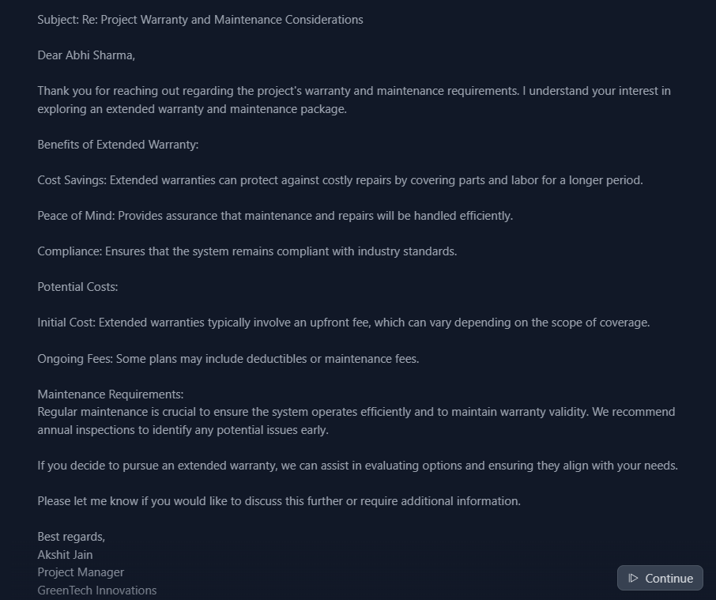

Feedback  
Clarity  
Your message is clear and concise, effectively conveying the main points regarding the project's warranty and maintenance requirements. You've done a great job of breaking down the information into easily digestible parts, making it simple for Abhi to understand the updates. However, it would be beneficial to provide a bit more context about the potential costs and benefits of the extended warranty and maintenance package. For instance, you could mention that the extended warranty could provide coverage for up to 5 years, and that the maintenance package could include regular inspections and repairs to ensure the system operates efficiently.

Precision  
You've included the necessary details about the benefits and potential costs of the extended warranty and maintenance package, which is great for precision. However, it might be helpful to provide more specific information about the costs, such as the exact upfront fee and any ongoing fees or deductibles. Additionally, you could provide more details about the maintenance requirements, such as the frequency and scope of the annual inspections.

Tone  
Your tone is professional and polite, which is suitable for a client-facing email. You've acknowledged Abhi's concerns and shown appreciation for their interest in exploring an extended warranty and maintenance package. However, the tone could be slightly warmer and more personalized. For instance, you could express your commitment to delivering a high-quality project and offer a personal point of contact for any further questions or concerns.

Structure  
Your email is well-organized, with a clear introduction, body, and conclusion. You've used a logical flow to present the information, making it easy to follow. However, it might be beneficial to use a more formal greeting, such as "Dear Abhi Sharma, Project Manager" instead of just "Dear Abhi Sharma". Additionally, you could consider adding a brief summary or overview of the project's current status to provide context for the discussion.

Actionability  
You've provided a clear call to action, asking Abhi if they would like to discuss the points further or require additional information. This shows that you're proactive and willing to adapt to their needs. However, it might be helpful to offer a bit more guidance on what the next steps would be if Abhi decides to pursue an extended warranty and maintenance package. For example, you could mention that you would work with Abhi to evaluate the options and ensure they align with their needs, and that you would provide a detailed proposal outlining the costs and benefits of the package.

Now, let's redraft the email to illustrate how to write it based on the feedback:

Subject: Re: Project Warranty and Maintenance Considerations

Dear Abhi Sharma, Project Manager,

Thank you for reaching out regarding the project's warranty and maintenance requirements. I understand your interest in exploring an extended warranty and maintenance package, and I'm happy to provide more information on the benefits and potential costs.

As we near the completion of the project, it's essential to consider the long-term maintenance and support requirements of the system. Our standard warranty provides coverage for up to 2 years, but we also offer extended warranty options that can provide coverage for up to 5 years. The extended warranty package includes regular inspections and repairs to ensure the system operates efficiently and effectively.

The benefits of the extended warranty package include:

Cost savings: By covering parts and labor for a longer period, the extended warranty can protect against costly repairs and reduce the overall cost of ownership.

Peace of mind: The extended warranty provides assurance that maintenance and repairs will be handled efficiently, reducing downtime and minimizing the impact on your operations.

Compliance: The extended warranty ensures that the system remains compliant with industry standards, reducing the risk of non-compliance and associated penalties.

However, there are also potential costs to consider, including:

Initial cost: The extended warranty typically involves an upfront fee, which can vary depending on the scope of coverage.

Ongoing fees: Some plans may include deductibles or maintenance fees, which can add to the overall cost of the package.

In terms of maintenance requirements, we recommend annual inspections to identify any potential issues early and ensure the system operates efficiently. The inspections will be conducted by our experienced technicians, and we will provide a detailed report outlining any findings and recommendations.

If you decide to pursue an extended warranty and maintenance package, we can assist in evaluating the options and ensuring they align with your needs. We will provide a detailed proposal outlining the costs and benefits of the package, and we will work with you to ensure a smooth implementation.

Please let me know if you would like to discuss this further or require additional information. I'm committed to delivering a high-quality project that meets your needs and expectations, and I'm happy to provide any support or guidance you may need.

Best regards,  
Akshit Jain  
Project Manager  
GreenTech Innovations

Scenario 5)

You are a Project Manager at GreenTech Innovations, and you've been working on a project to develop a new sustainable energy solution for a client. The project is nearing completion, but you've just received an email from the client's project manager, expressing concerns about the project's training and support requirements. The client is considering purchasing a training package, and they need your input on the potential benefits and costs of this option. Please write an email responding to the client's concerns and providing the necessary information.

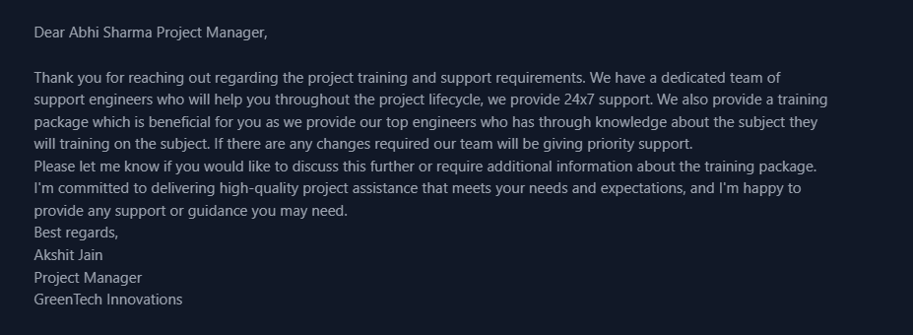

Feedback

Clarity  
Your message is clear and concise, effectively conveying the main points regarding the project training and support requirements. You've done a great job of highlighting the benefits of the training package and the support provided by your team. However, it would be beneficial to provide a bit more context about the training package, such as the specific topics that will be covered, the duration of the training, and the format (e.g., online, in-person, etc.).

Precision  
You've included the necessary details about the support provided by your team, which is great for precision. However, it might be helpful to provide more specific information about the training package, such as the cost, the qualifications of the trainers, and the expected outcomes. Additionally, you could provide more details about the priority support that will be provided if changes are required.

Tone  
Your tone is professional and polite, which is suitable for a client-facing email. You've acknowledged Abhi's concerns and shown appreciation for their interest in the training package. However, the tone could be slightly warmer and more personalized. For instance, you could express your enthusiasm for the project and your commitment to ensuring that Abhi's team is fully equipped to use the new system.

Structure  
Your email is well-organized, with a clear introduction, body, and conclusion. You've used a logical flow to present the information, making it easy to follow. However, it might be beneficial to use a more formal greeting, such as "Dear Abhi Sharma, Project Manager at [Client Company]" instead of just "Dear Abhi Sharma Project Manager". Additionally, you could consider adding a brief summary or overview of the project's current status to provide context for the discussion.

Actionability  
You've provided a clear call to action, asking Abhi if they would like to discuss the training package further or require additional information. This shows that you're proactive and willing to adapt to their needs. However, it might be helpful to offer a bit more guidance on what the next steps would be if Abhi decides to purchase the training package. For example, you could mention that you would work with Abhi to schedule the training sessions, provide any necessary materials or equipment, and ensure that the training is tailored to their specific needs.

Now, let's redraft the email to illustrate how to write it based on the feedback:

Subject: Re: Project Training and Support Requirements

Dear Abhi Sharma, Project Manager at [Client Company],

Thank you for reaching out regarding the project training and support requirements. I'm excited to hear that you're interested in learning more about our training package, which is designed to ensure that your team is fully equipped to use the new system.

Our training package is a comprehensive program that covers all aspects of the system, including its features, functionality, and maintenance requirements. The training will be provided by our top engineers, who have in-depth knowledge of the subject matter and extensive experience in training clients. The training will be tailored to your specific needs and will include hands-on exercises, case studies, and interactive sessions to ensure that your team is fully engaged and empowered to use the system effectively.

The benefits of our training package include:

Improved system adoption and utilization

Enhanced user experience and productivity

Reduced errors and downtime

Increased confidence and competence in using the system

In addition to the training package, we also provide 24x7 support to ensure that you have access to our team of expert support engineers whenever you need them. Our support team is dedicated to providing prompt and effective assistance, and we prioritize support requests to ensure that any issues are resolved quickly and efficiently.

If you're interested in purchasing our training package, please let me know and we can discuss the details further. We can provide a customized quote, outline the training schedule, and ensure that the training is tailored to your specific needs.

I'm committed to delivering high-quality project assistance that meets your needs and expectations, and I'm happy to provide any support or guidance you may need. Please don't hesitate to contact me if you have any questions or require additional information.

Best regards,  
Akshit Jain  
Project Manager  
GreenTech Innovations