

**Faculty of Science**

**School of Computer Science**

**2019-2020**

**A**

**PROJECT REPORT**

**ON**

**Gas Booking System**

**BY**

Nikita Agarwal MCA_02

                                    Payal khot  MCA_20

  Kushagara Mishra MCA_34

   Pratiksha Vidhale MCA_52

**IN PARTIAL FULFILLMENT OF**

**MASTERS OF COMPUTER APPLICATIONS**

**Dr. Vishwanath Karad MIT- World Peace University**



**Faculty of Science**

**School of Computer Science**

**CERTIFICATE**

This is to certify that **Miss.Nikita Agarwal,** Student of MCA (Science) Semester V has successfully completed a mini project in partial fulfilment of MCA (Science) Degree under Dr. Vishwanath Karad MIT-World Peace University, for the academic year 2019-2020.

(Project Guide)                         Head of School

**Dr. C.H. Patil       Dr. C. H. Patil**

Associate Dean                                     Seal

**Dr. Shubhalaxmi Joshi**

Date:

Examiners:

1.

2.



**Faculty of Science**

**School of Computer Science**

**CERTIFICATE**

This is to certify that **Miss.Payal khot,** Student of MCA (Science) Semester V has successfully completed a mini project in partial fulfilment of MCA (Science) Degree under Dr. Vishwanath Karad MIT-World Peace University, for the academic year 2019-2020.

(Project Guide)                         Head of School

**Dr. C.H. Patil       Dr. C. H. Patil**

Associate Dean                                     Seal

**Dr. Shubhalaxmi Joshi**

Date:

Examiners:

1.

2.



**Faculty of Science**

**School of Computer Science**

**CERTIFICATE**

This is to certify that Kushagara Mishra**,** Student of MCA (Science) Semester V has successfully completed a mini project in partial fulfilment of MCA (Science) Degree under Dr. Vishwanath Karad MIT-World Peace University, for the academic year 2019-2020.

(Project Guide)                         Head of School

**Dr. C. H. Patil       Dr. C. H. Patil**

Associate Dean                                     Seal

**Dr. Shubhalaxmi Joshi**

Date:

Examiners:

1.



**Faculty of Science**

**School of Computer Science**

**CERTIFICATE**

This is to certify that **Miss.Pratiksha Vidhale,** Student of MCA (Science) Semester V has successfully completed a mini project in partial fulfilment of MCA (Science) Degree under Dr. Vishwanath Karad MIT-World Peace University, for the academic year 2019-2020.

(Project Guide)                         Head of School

**Dr. C.H. Patil       Dr. C. H. Patil**

Associate Dean                                     Seal

**Dr. Shubhalaxmi Joshi**

Date:

Examiners:

1.

2.

**ACKNOWLEDGEMENT**

I wish to express my deep sense of gratitude and honour towards the faculty for giving us a chance and platform to work on such projects.

I also wish to thank everyone in the organization that helped me during project development time to time. I also express my honour and gratitude to **Mrs. Surbhi Thatte** and constant encouragement for completing my project work successfully.

I also want  to thank  **Dr. C. H. Patil** for constant encouragement and help for completing my project work successfully.

                                                                Student Signature

**INDEX**

|  |  |  |
| --- | --- | --- |
| **Sr. No.** | **Contents** | **Page No.** |
| **Chapter 1** | **INTRODUCTION** |  |
| * 1. Existing System |  |
| 1.2 Need of New System |  |
| **Chapter 2** | **PROPOSED SYSTEM** |  |
| 2.1 Proposed System |  |
| 2.2 Objectives of System |  |
| 2.3 User Requirements |  |
| **Chapter 3** | **ANALYSIS AND DESIGN** |  |
| 3.1 Entity Relationship Diagram |  |
| 3.2 UML Diagram (Use case Diagram, Activity Diagram, Sequence Diagram) |  |
| 3.3 Screen Shots |  |
| **Chapter 4** | **TESTING** |  |
| 4.1 Testing & Characteristics of Testing |  |
| 4.2  Test Cases |  |
| **Chapter 5** | **CONCLUSION** |  |
| 5.1 Limitations & Drawbacks |  |
| 5.2 Future Enhancement |  |
| 5.3 Conclusion |  |
| 5.4 References & Bibliography |  |

**Introduction**

The system will help the customers by providing a simple user interactive interface for booking the gas through online which will save their time and money. It also gives the agencies ease by helping them make the booking process faster and easier to maintain.

There are various steps to book a gas like issuing an entry book, to travel agency from that to go to the delivery centre, our system makes this whole process at one place. Basically, there are two types of users for the cylinders domestic and other is commercial.It collect customer, stock, booking information and the information is very useful for the system to work on it.

**Existing System**

In the existing manual system, all the documents are prepared manually by writing in books which takes a longer time and is not so reliable. There are many drawbacks of the existing system such as requirement of large number of human resource and papers along with higher chance of losing data and tearing books. To overcome these drawbacks, a computerized management system is required.

**Modules Used**

Each module has certain specific functions and all the modules are interlinked to each other.

The proposed Gas Agency application modules are:

1.Admin module: Admin module allows system administrator to set up back-end of the system and perform basic system configuration, mainly manages the customer data.

2.Login module: The Login Module is a portal module that allows users to type a user name and password to log in. You can add this module on any module tab to allow users to log in

to the system.

3.Registration Module: Registration is a simple, flexible module for allowing and tracking user registrations for booking, or just about anything you want people to sign up for.

3.Nearest gas Agency: The admin provides the nearest gas agency available in the area of the customer and the admin adds and changes the agency according to the changes.

4.New Connection: A customer need to enter the details like name, address, city, pin code, email, type of gas and profile photo for a connection. Once the connection is done the profile is made that can be changed by admin only if needed.

5.Booking: The customer needs to book a gas by entering the booking date , delivery date, type of cylinder, and submit it for booking.The booking will be rejected or approved by admin until then it is kept in pending mode.

**Fact Gathering Study**

The fact gathering technique is used to find out the requirement of the system. The technique used are as follow: -

 • Questionery

• Record review

**Questionery:**

By this technique we came to know about the system and what they need. This help to understand all the process, which occurs in the system. They try to help up by giving answer regarding our question and all possible information they know about the system. By this technique we came to know about following: - ⮚ How all process are performed.

⮚ How should system work.

⮚ This gives idea how system should be developed to perform different task.

**Record review :**

This technique is used to review the records, which they maintain. By this we can understand how entry should be done in each process. We saw all the entry, which they have all ready entered in the different register, which they maintain and also saw the reports they have generated. This give idea about how entry is done and verified in register. Through this we came to know about following: -

⮚ How record entry should be done in each process.

⮚ How reports are generated for different activity they perform.

**Requirement Analysis**

Today life is very fast and work with the computer is speedy. The existing system was manually on paper. So it is time consuming as compared with our system a man cannot do work as fast as computer. In existing system paper work is more where as in our system on computer, so most of the work is done on computer and it provide facilities to change if any mistake occurred. So we can say that in existing system paper work is more. All the information is on paper in existing system so, there are possibilities of loss, theft, burning and damaging data on paper. Where as in computer system all data are saved and backup of data is also taken if user want. So there are less chances of data loss then the existing system. Existing system is inconvenient for user because it cannot give fast and proper information in proper time and it take long time to give information to the user. In our system the information is generated very quickly and prepared accordingly to the user request. Computer system provide very easy and flexible report generation whereas report generation on paper is time consuming and it is difficult to change if any mistake occurred in between while in computerized system reports are generated automatically.

**Proposed System**

In the proposed gas agency system, we use the internet to provide the gas service at home. The user can book the gas from our system. This project will also display the status of the current booking. If a user wants he/ she can store the information of the booking so that from the next time they can book the gas in one click. The information will be safe as it will need an ID and password to access the system. The gas agency will also maintain the user information through this scheme.

**Scope**

As this is a generic software it can be used by a wide variety of outlets to automate the process of manually maintaining the information and records related.

**Goal**

The main goal of the project is to maintain records of sales and dates and the people can easily book gas without making a phone call to agency each time.

**Advantages Of Proposed System**

The system is very simple in design and to implement. The system requires very low system resources and the system will work in almost all configurations.

* Ensure data accuracy’s.
* Administrator controls the entire system.
* Reduce the damages of the machines.
* Minimize manual data entry.
* Greater efficiency.
* User friendly and interactive.
* Minimum time required.

**SOFTWARE**

Font end : Visual Studio Code, HTML, CSS

Back end : Python

Framework : Django

**Modules screenshot:**

Main Page:

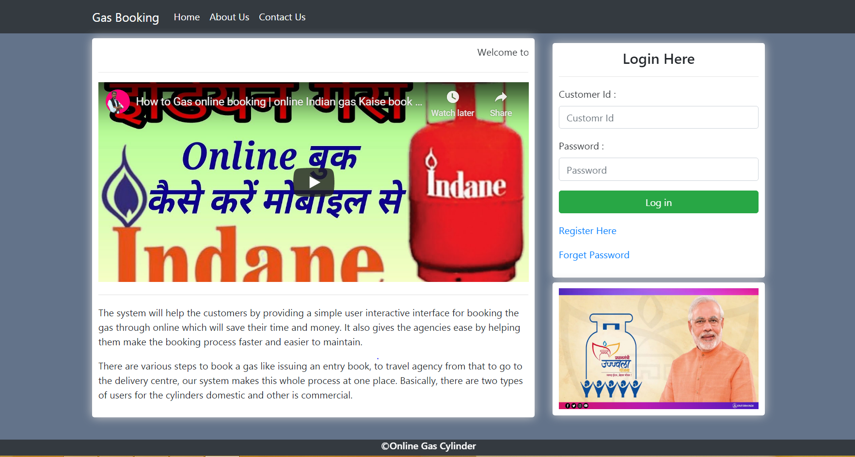

Registration:

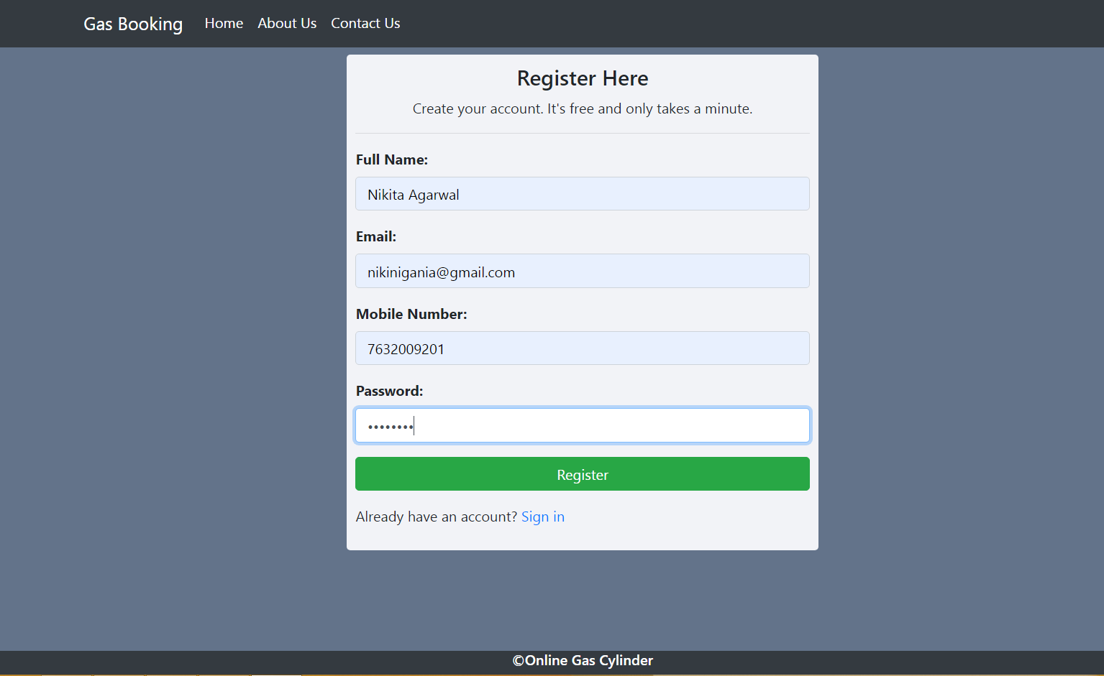

Login:

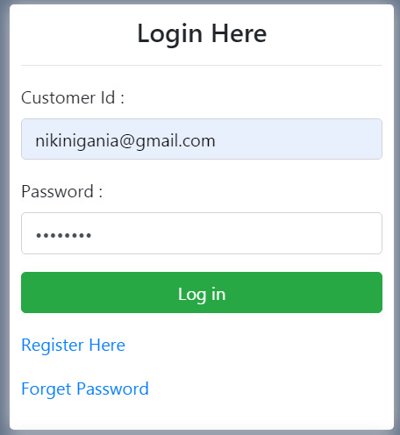

Home Page: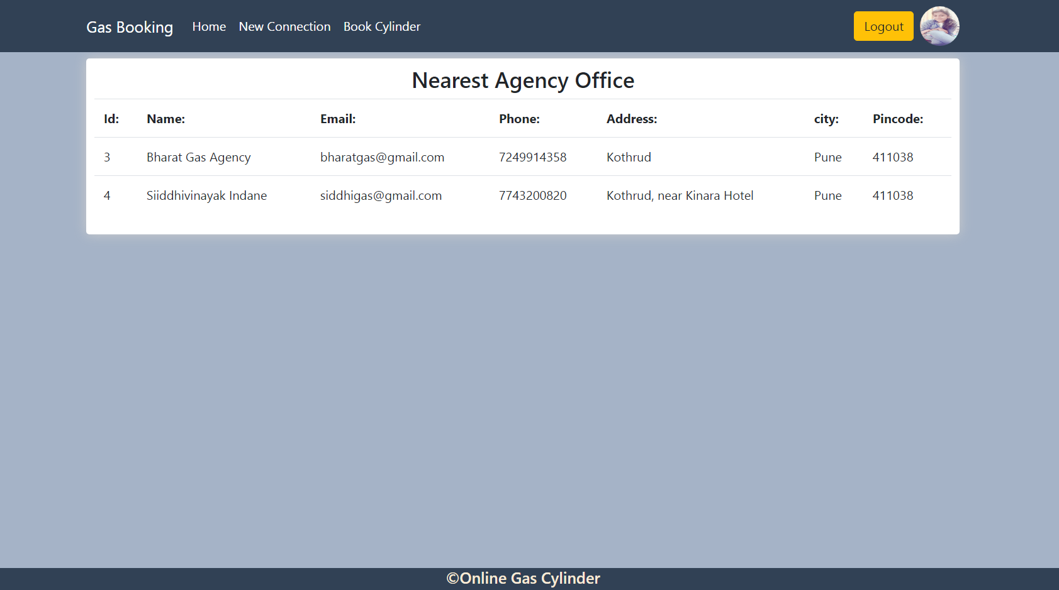New Connection:  
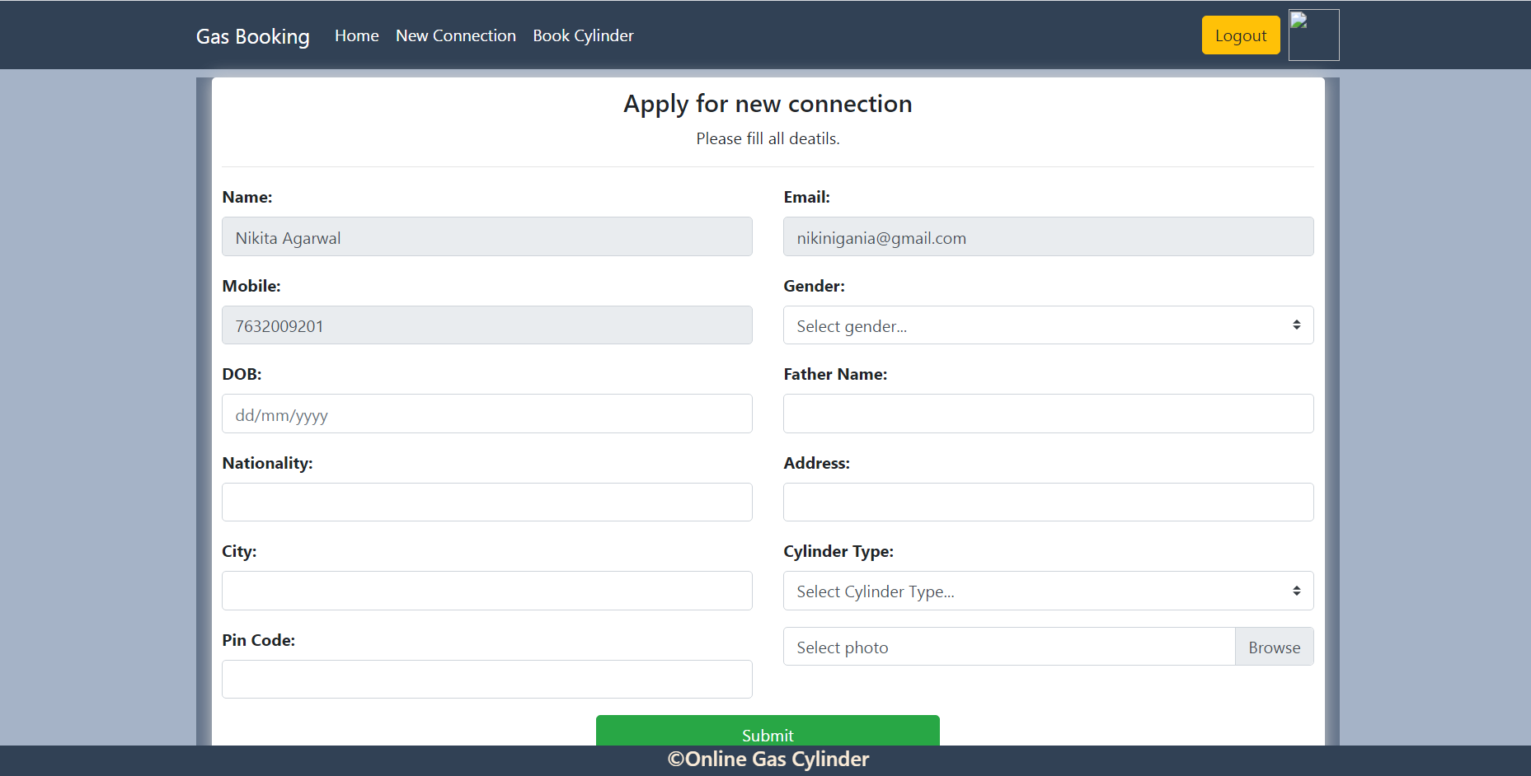

After Connection:

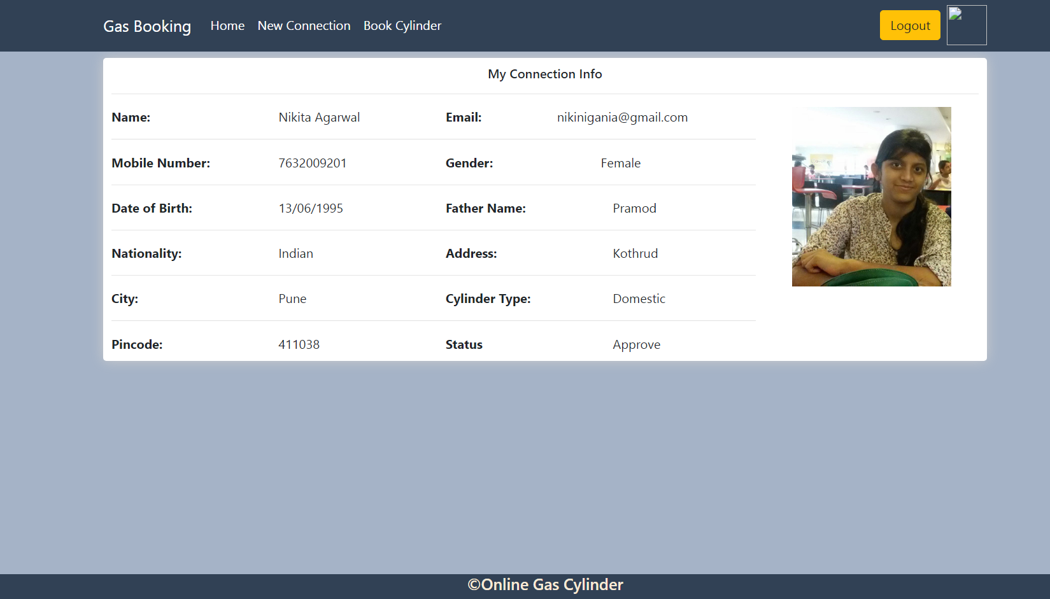

Book Cylinder:

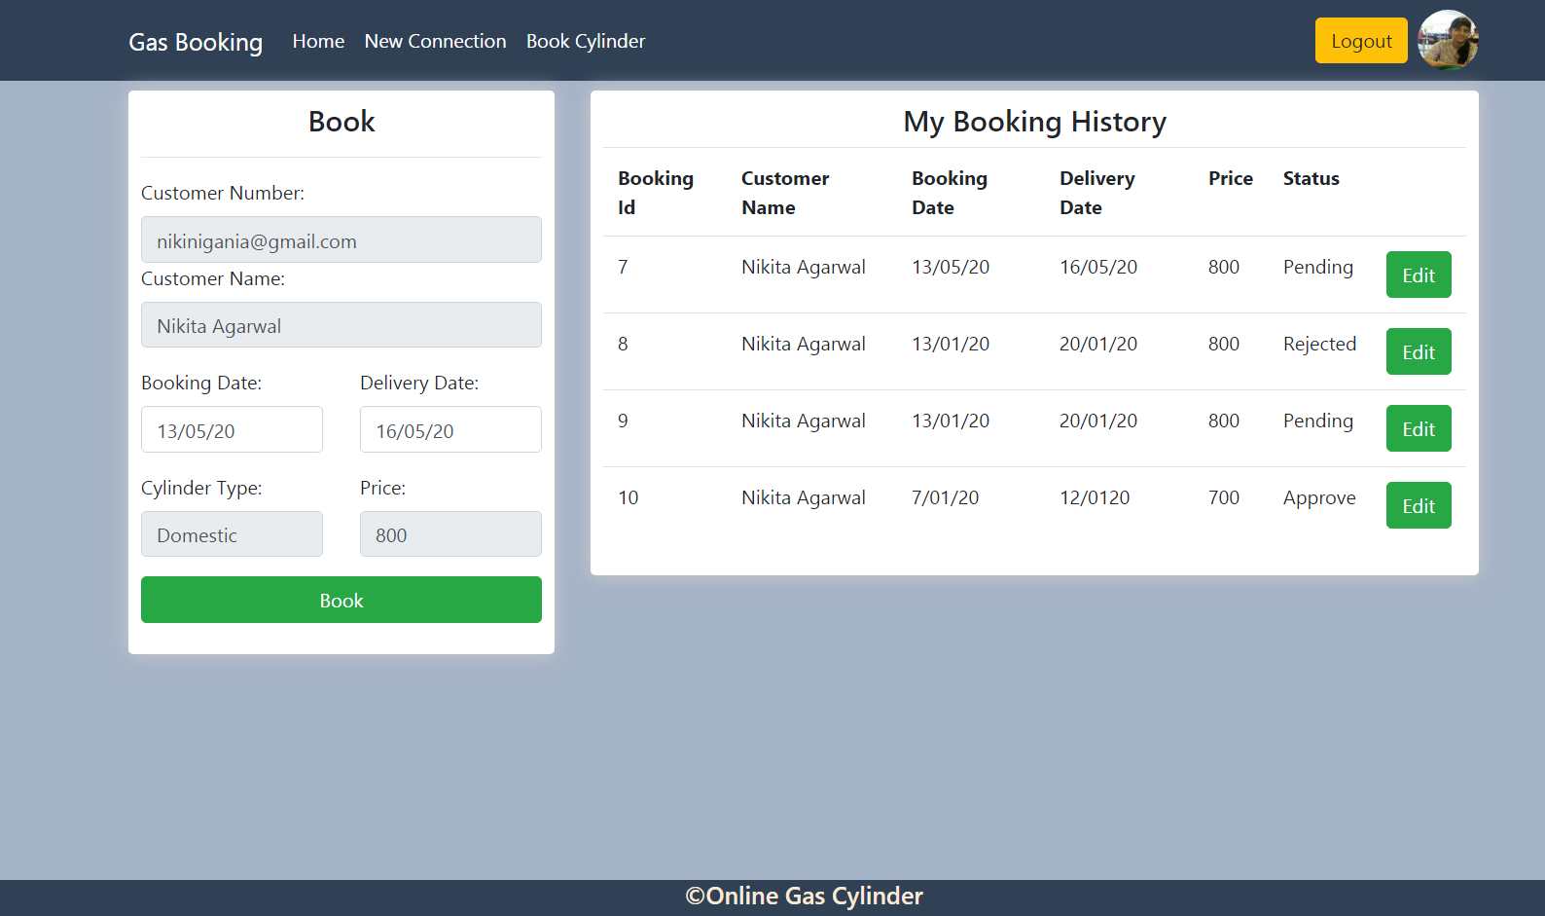

Admin:

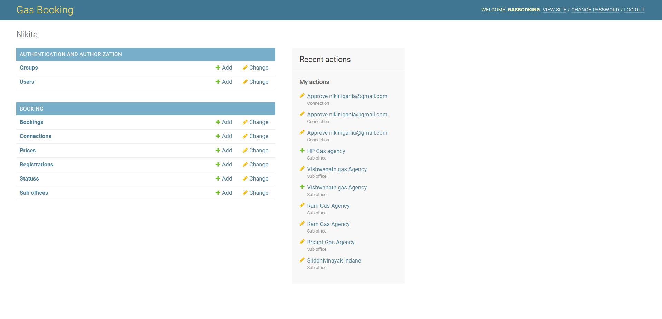

Change Bookings by Admin:

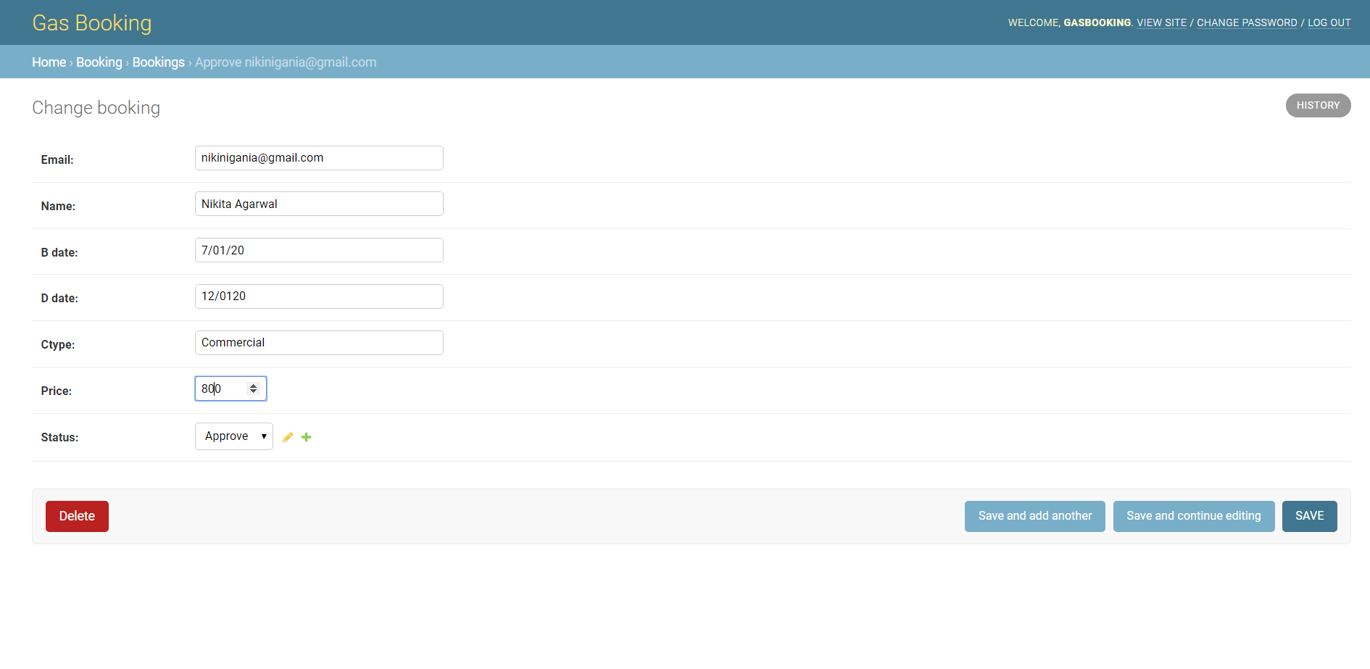Add Bookings by Admin:

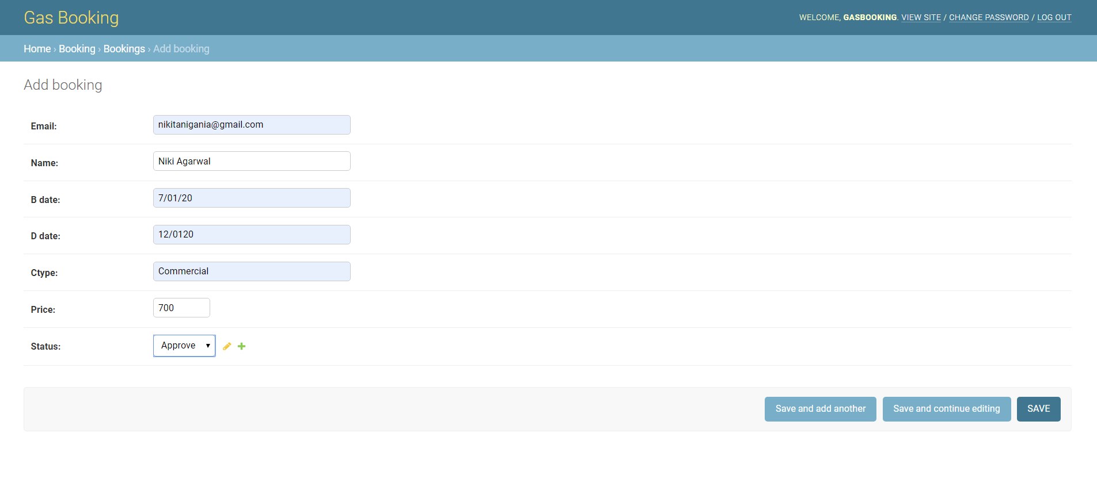

Change Connections by Admin: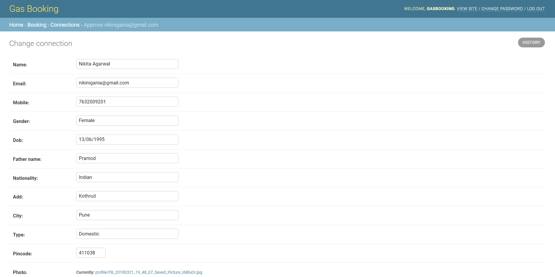

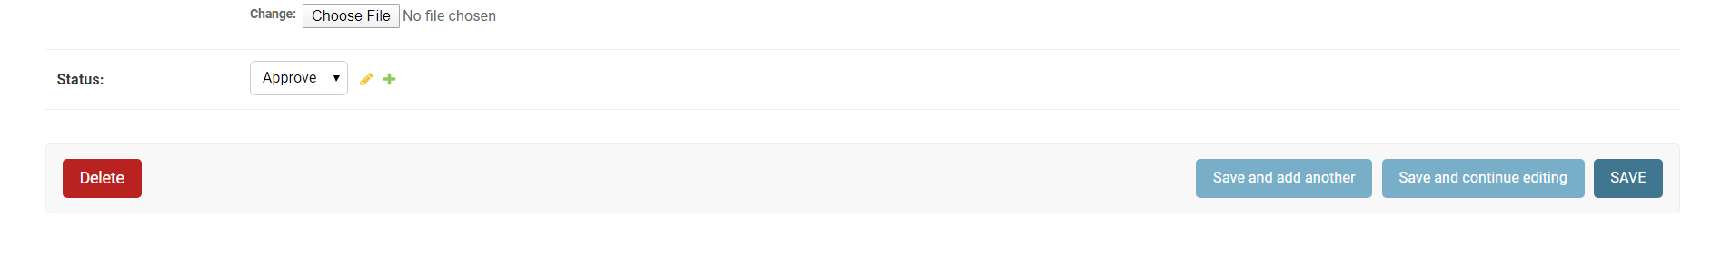

Add Connection by Admin:

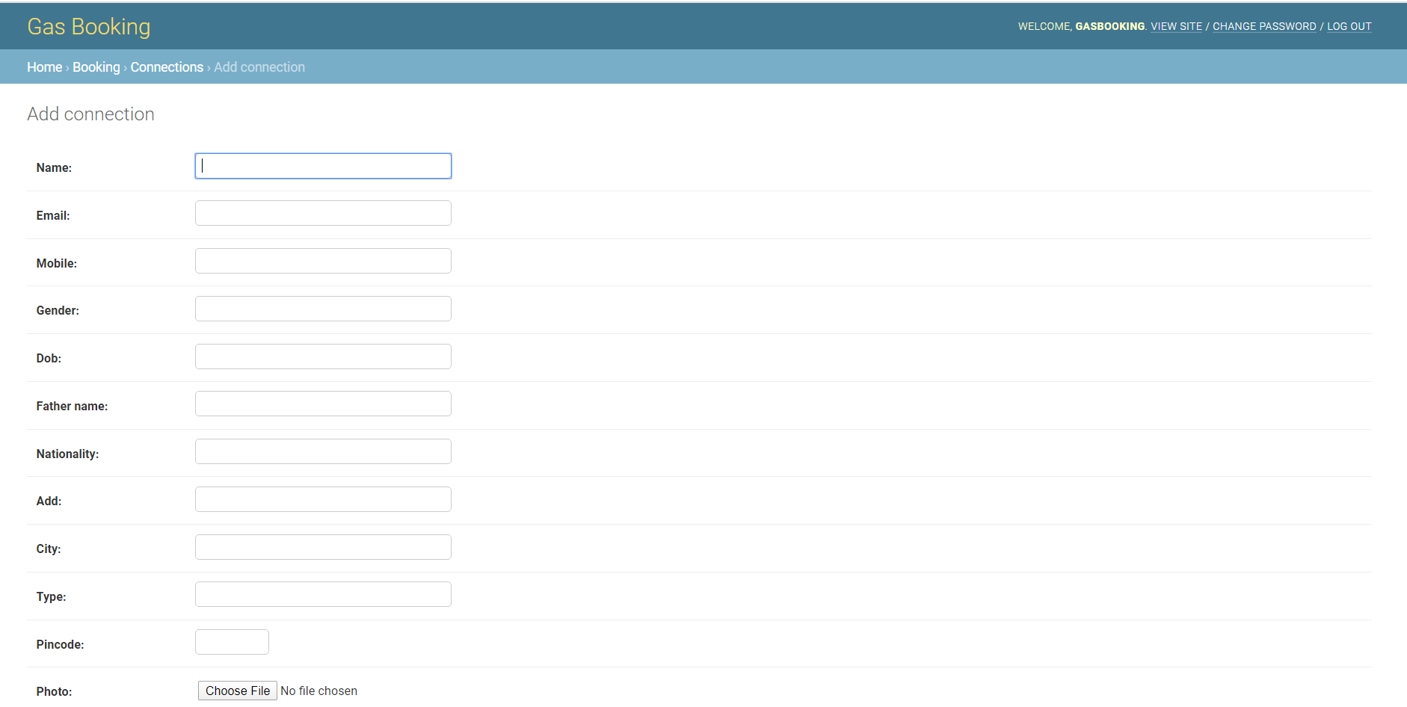

Change Price by Admin:

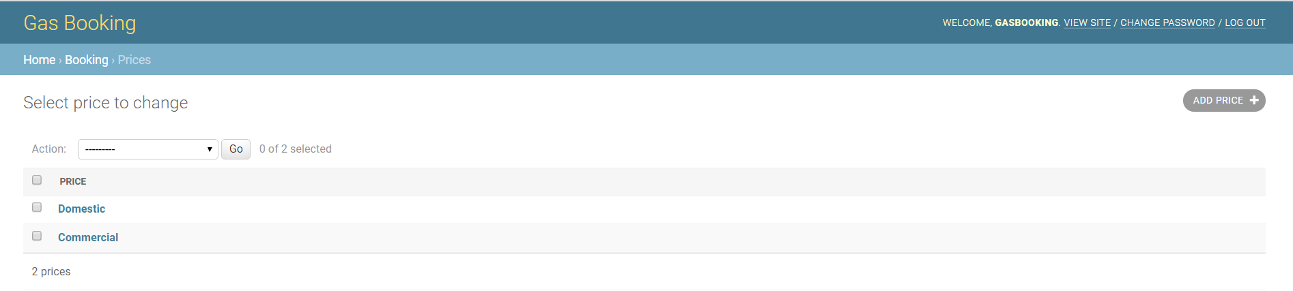

Delete Connection:

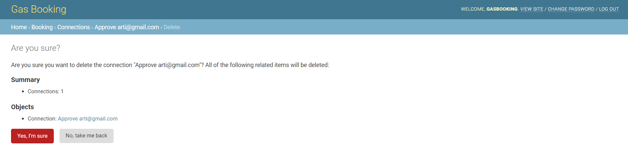

Add Price by Admin:

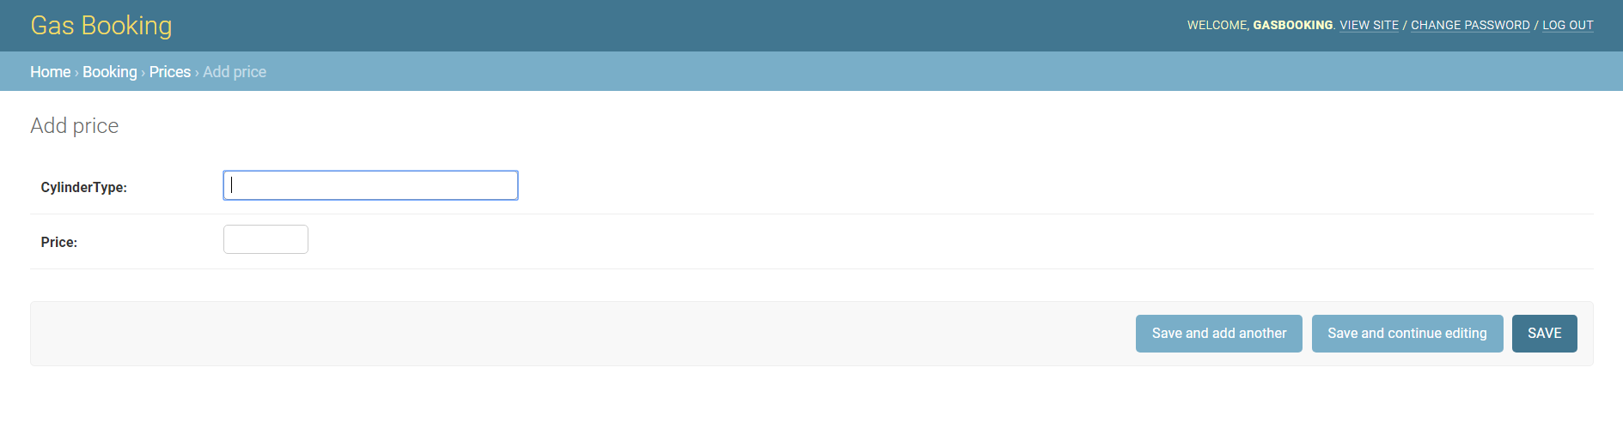

Change Registration by Admin:

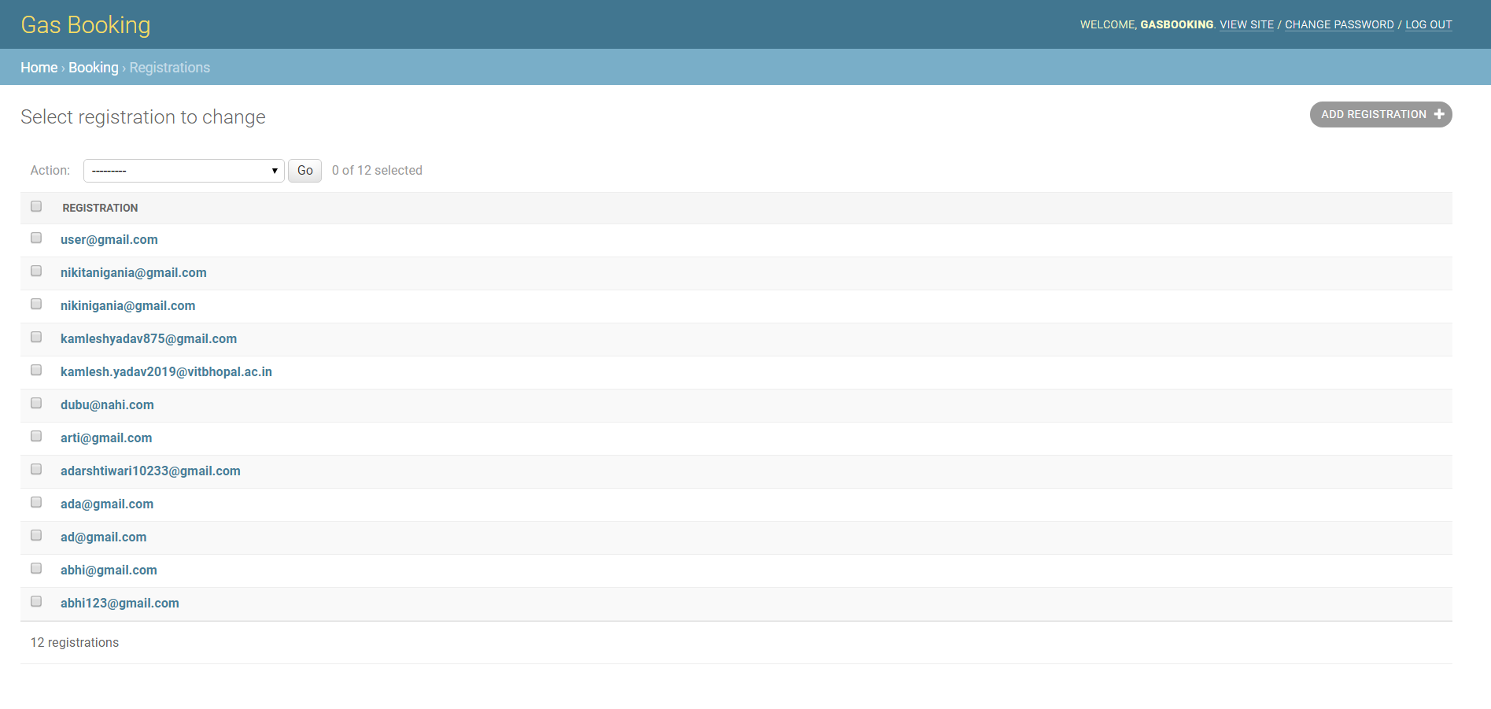

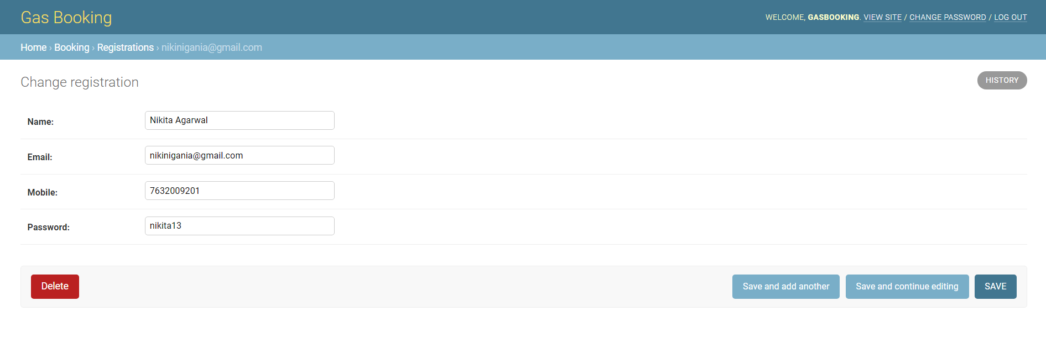

Status Change by admin:

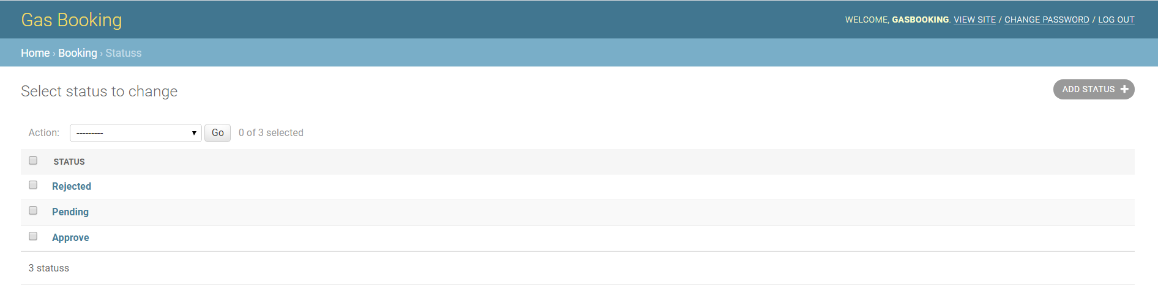

Add Status by Admin:

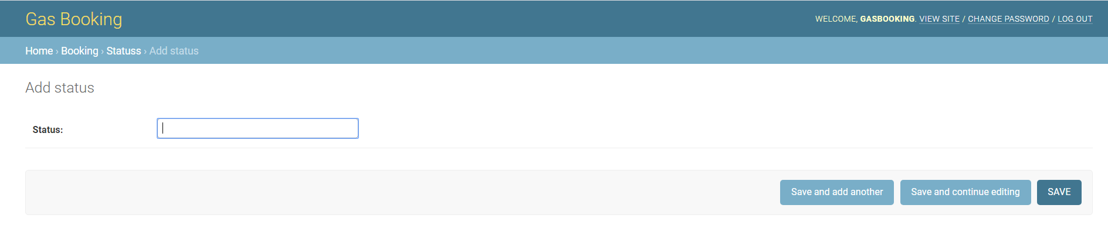

Change Sub Offices by Admin:

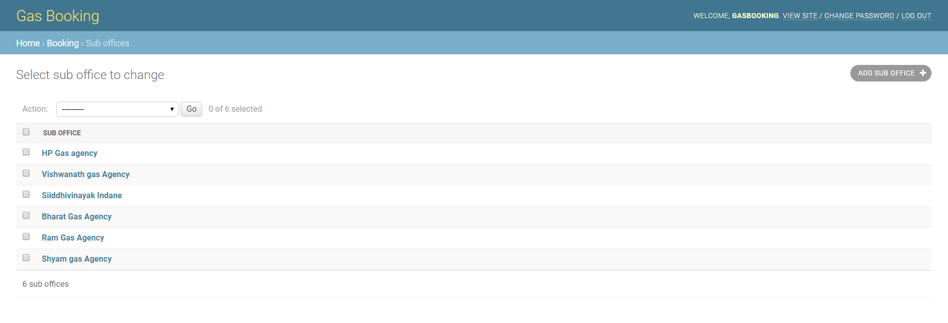

Add Sub Offices by Admin:

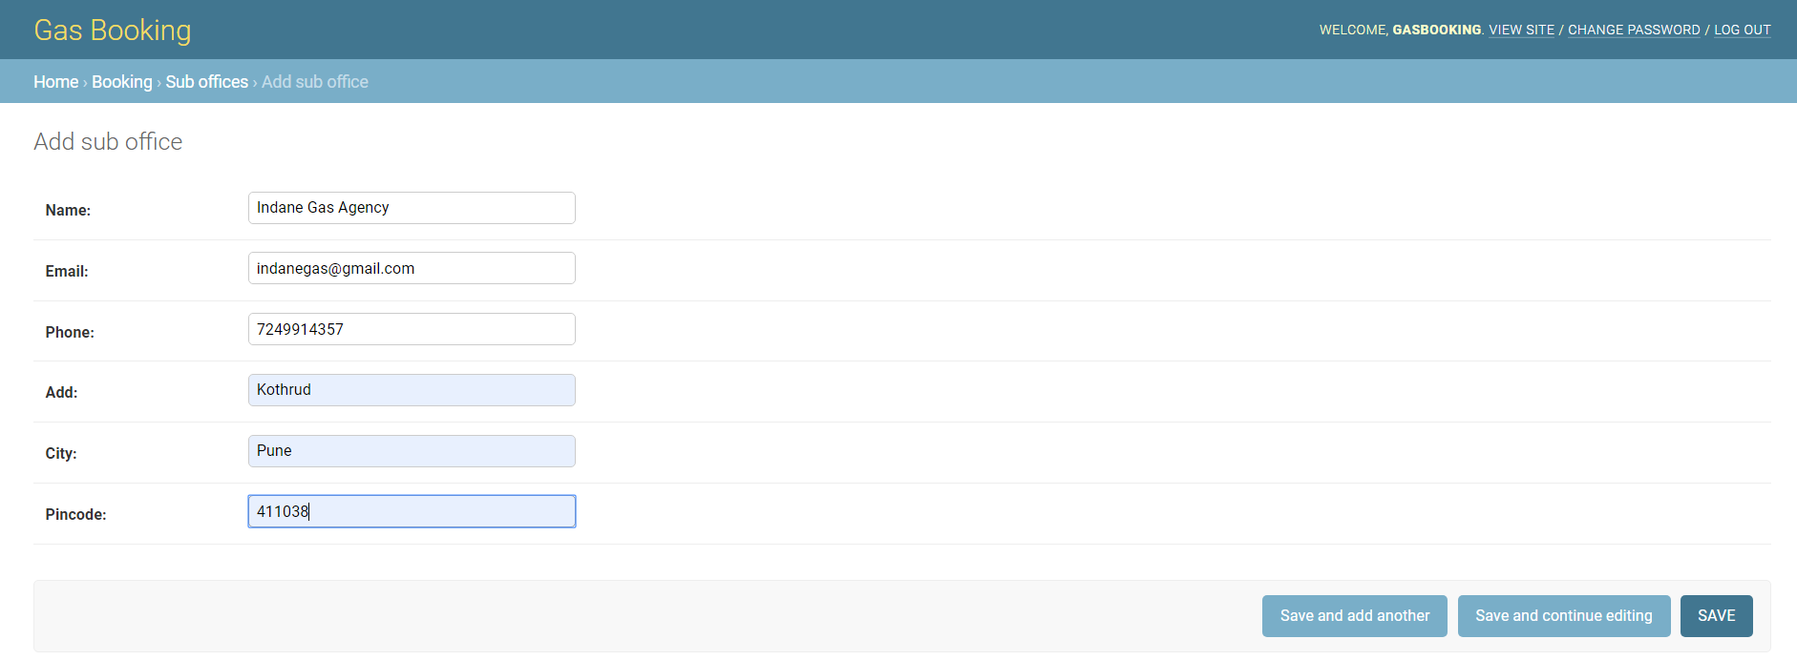

Change Admin Password:

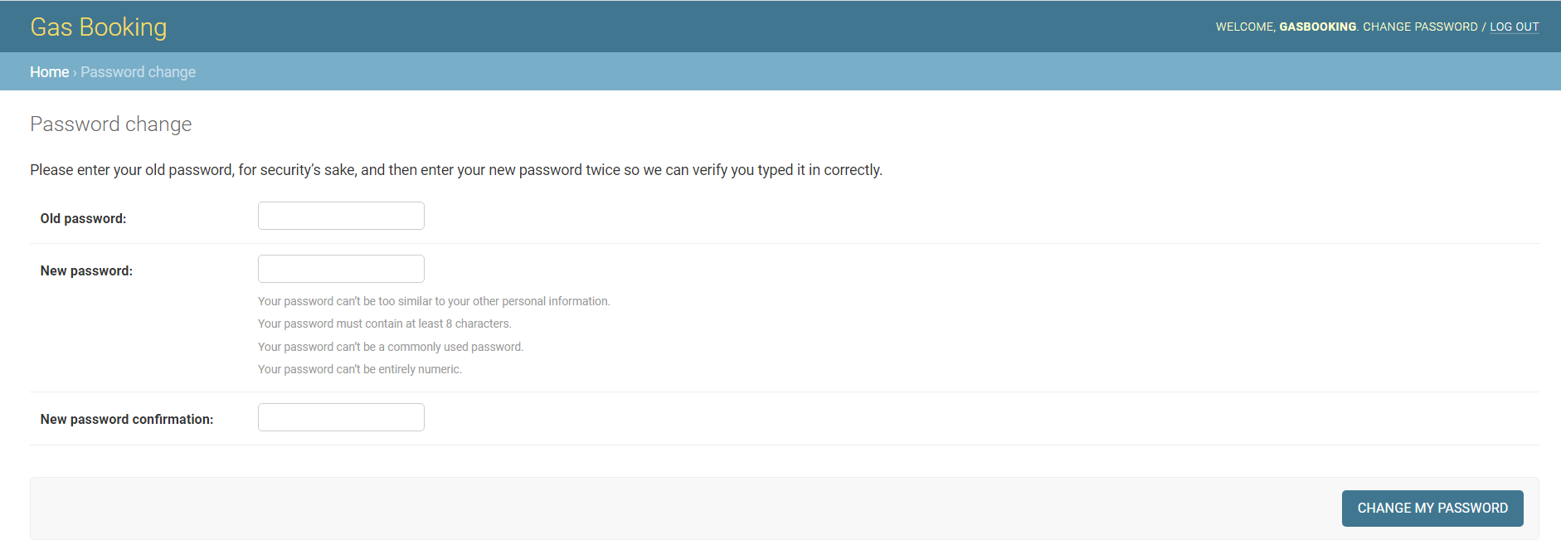

Change Group:

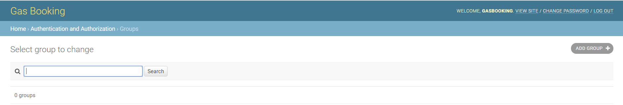

Add Group:

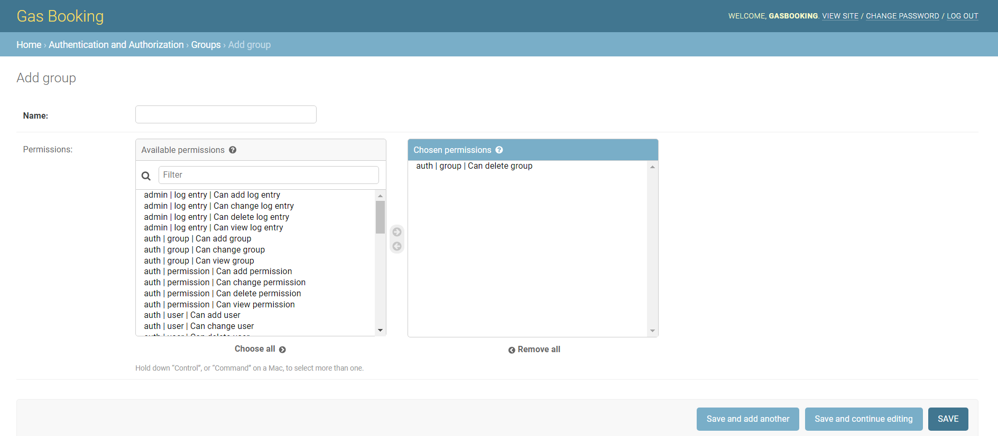

Change User:

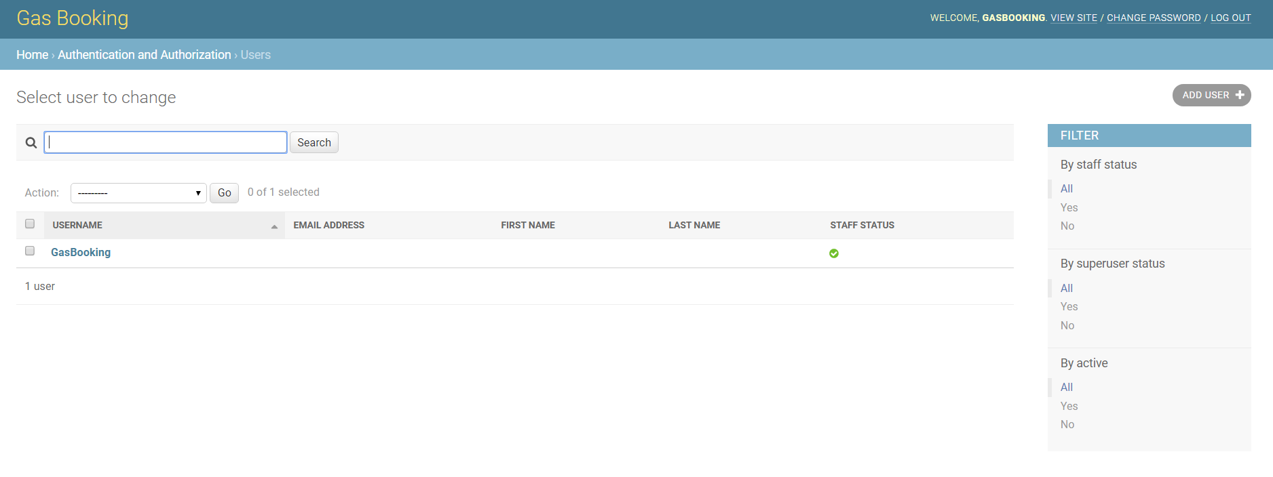

Add User:

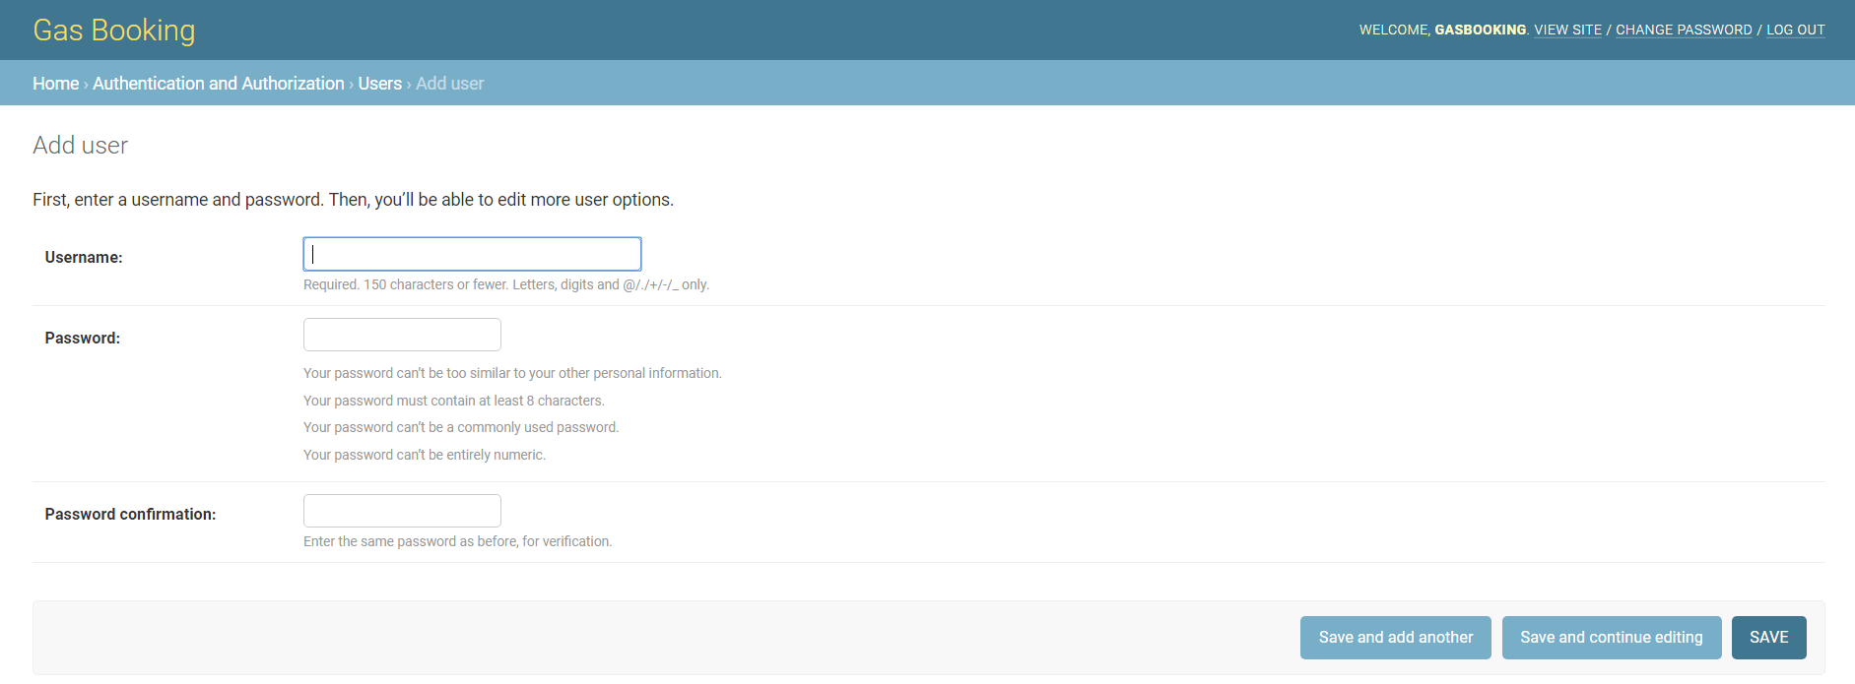

Logout Page:

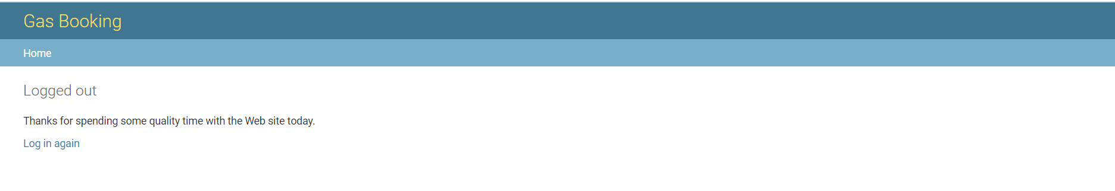

**Limitations Of Existing System**

* Lack of security of data.
* Time consuming.
* Consumes large volume of paper work.
* Manual work
* No direct role for the higher officials.

To avoid all these limitations and make the system working more accurately it needs to be computerized.

**Conclusion**

The design of the Gas Agency Booking system is done by taking into consideration all the needs of the agency. The intention of this whole system is to computerize the entire existing system and solve all problems of the Existing System. This system is useful for all gas agencies. This system will is designed to save time and will reduce the complexity and is also user friendly.

In future we are going to make this project large that every big firm can use this project. In future we will contact to large number of shops and will gather all

information from them and will build a project that will help them all. Number of facility  will increase in project and we will try to make this project much simple as possible. We will also try to produce a project that will give simple interface to user.