TEXT RECOGNITION SOFTWARE

The character recognition program is written in VB 6.0.
It recognizes the text entered by the user in a picture box. The software has the capability of artificial intelligence that is it can learn more and more characters and can be used for other languages also.

The characters are converted into 10X10 matrices i.e., Hundred elements.

The data is stored in a text file in Binary mode and the program uses “BRUTE FORCE ALGORITHM” to match the characters from the text file.

Brute force algorithm: It is the most commonly and extensively used algorithm for pattern matching.

The brute force algorithm consists in checking, at all positions in the text between 0 and n-m, whether an occurrence of the pattern starts there or not. Then, after each attempt, it shifts the pattern by exactly one position to the right.

The brute force algorithm requires no preprocessing phase, and a constant extra space in addition to the pattern and the text. During the searching phase the text character comparisons can be done in any order. The time complexity of this searching phase is O (mn) (when searching for a^{m-1}b in a^{n} for instance). The expected number of text character comparisons is 2n.

Difference between the Brute Force Algorithm and Greedy algorithm:

Algorithm types--brute-force and greedy. Brute-force algorithms are distinguished not by their structure or form, but by the way in which the problem to be solved is approached. A brute-force algorithm solves a problem in the most simple, direct or obvious way. As a result, such an algorithm can end up doing far more work to solve a given problem than a more clever or sophisticated algorithm might do. On the other hand, a brute-force algorithm is often easier to implement than a more sophisticated one and, because of this simplicity, sometimes it can be more efficient.

Often a problem can be viewed as a sequence of decisions to be made. For example, consider the problem of finding the best way to place electronic components on a circuit board. To solve this problem we must decide where on the board to place each component. Typically, a brute-force algorithm solves such a problem by exhaustively enumerating all the possibilities. I.e., for every decision we consider each possible outcome.

A greedy algorithm is one that makes the sequence of decisions (in some order) such that once a given decision has been made, that decision is never reconsidered. For example, if we use a greedy algorithm to place the components on the circuit board, once a component has been assigned a position it is never again moved. Greedy algorithms can run significantly faster than brute force ones. Unfortunately, it is not always the case that a greedy strategy leads to the correct solution.

User Interface:
The user interface comprises of mainly three picture boxes.
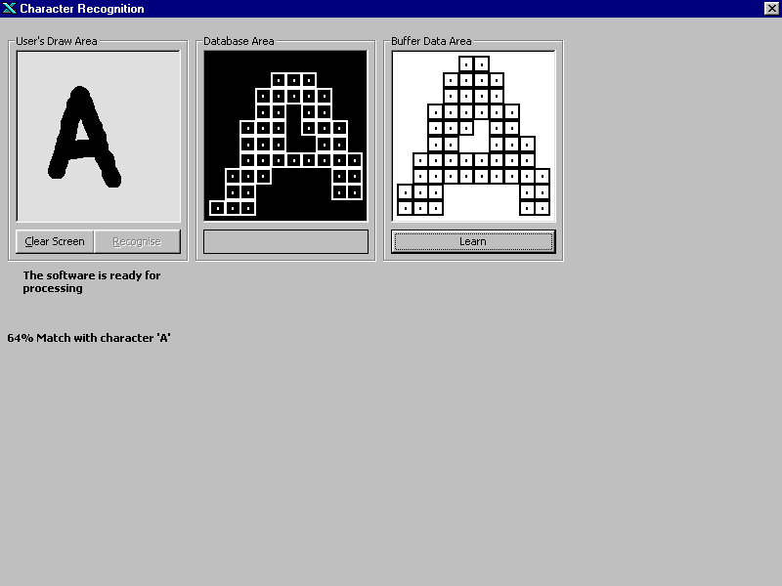

The first picture is the user’s draw area which accepts the inputs from the users using the VB’s graphic command: Pset(x,y) which sets the pixel at the specified point (x,y).

The second picture box is the database area which shows the patterns read from the database file which in this case is ‘DATA.rec’. It again uses the function PSet(x,y)

The third picture box is the bit-wise representation of the user’s draw area.
There are following command buttons on the screen:

The recognize button: This button calls the function for the pattern matching which matches the pattern from the database file and compares it to the user’s draw area using the Brute Force Algorithm.

The Clear Screen Button: This button clears the user’s screen area.

The Learn Button: This button calls the routine which opens the text file for binary for appending an entry in the file.

The Enter Button: This button converts the drawn graphic into binary mode and writes it to the file.

Applications: This program is highly beneficial for basic Optical Character Recognition features and artificial intelligence since it can learn any type of characters. It has high scopes in field of Virtual Phone books which can scan the visiting cards and can store the information in the database.

DEFINITION: Optical character recognition (OCR) is the translation of optically scanned bitmaps of printed or written text characters into character codes, such as ASCII. This is an efficient way to turn hard-copy materials into data files that can be edited and otherwise manipulated on a computer.
Suppose you wanted to digitize the novel Moby Dick overnight. You could stay up all night typing and still not finish. Or you could use a high-end scanner and in minutes scan all of author Herman Melville's works into a computer using optical character recognition (OCR) technology.

This is the technology long used by libraries and government agencies to make lengthy documents quickly available electronically. Advances in OCR technology have spurred its increasing use by enterprises.

For many document-input tasks, OCR is the most cost-effective and speedy method available. And each year, the technology frees acres of storage space once given over to file cabinets and boxes full of paper documents.

Before OCR can be used, the source material must be scanned using an optical scanner (and sometimes a specialized circuit board in the PC) to read in the page as a bitmap (a pattern of dots). Software to recognize the images is also required.

The OCR software then processes these scans to differentiate between images and text and determine what letters are represented in the light and dark areas.

Older OCR systems match these images against stored bitmaps based on specific fonts. The hit-or-miss results of such pattern-recognition systems helped establish OCR's reputation for inaccuracy.
Today's OCR engines add the multiple algorithms of neural network technology to analyze the stroke edge, the line of discontinuity between the text characters, and the background. Allowing for irregularities of printed ink on paper, each algorithm averages the light and dark along the side of a stroke, matches it to known characters and makes a best guess as to which character it is. The OCR software then averages or polls the results from all the algorithms to obtain a single reading.

Technological Progress
Advances are being made to recognize characters based on the context of the word in which they appear, as with the Predictive Optical Word Recognition algorithm from Peabody, Mass.-based ScanSoft Inc. The next step for developers is document recognition, in which the software will use knowledge of the parts of speech and grammar to recognize individual characters.

Today, OCR software can recognize a wide variety of fonts, but handwriting and script fonts that mimic handwriting are still problematic.

Developers are taking different approaches to improve script and handwriting recognition. OCR software from ExperVision Inc. in Fremont, Calif., first identifies the font and then runs its character-recognition algorithms.

Advances have made OCR more reliable; expect a minimum of 90% accuracy for average-quality documents. Despite vendor claims of one-button scanning, achieving 99% or greater accuracy takes clean copy and practice setting scanner parameters and requires you to "train" the OCR software with your documents.

The first step toward better recognition begins with the scanner. The quality of its charge-coupled device light arrays will affect OCR results. The more tightly packed these arrays, the finer the image and the more distinct colors the scanner can detect.

Smudges or background color can fool the recognition software. Adjusting the scan's resolution can help refine the image and improve the recognition rate, but there are trade-offs.

For example, in an image scanned at 24-bit color with 1,200 dots per inch (dpi), each of the 1,200 pixels has 24 bits' worth of color information. This scan will take longer than a lower-resolution scan and produce a larger file, but OCR accuracy will likely be high.

A scan at 72 dpi will be faster and produce a smaller file—good for posting an image of the text to the Web—but the lower resolution will likely degrade OCR accuracy.

Most scanners are optimized for 300 dpi, but scanning at a higher number of dots per inch will increase accuracy for type less than 6 points in size.

Bilevel (black and white only) scans are the rule for text documents. Bilevel scans are faster and produce smaller files, because unlike 24-bit color scans, they require only one bit per pixel. Some scanners can also let you determine how subtle to make the color differentiation.

Which method will be more effective depends on the image being scanned. A bilevel scan of a shopworn page may yield more legible text. But if the image to be scanned has text in a range of colors, as in a brochure, text in lighter colors may drop out.

