A Project Report on

“Segmentation of Optical Character Recognition”

ABSTRACT

OCR system converts scanned input document into editable text document. This report presents the detailed description about the characteristics of Devanagari Script .How it is different from the other roman scripts. And what makes the OCR for any roman script different from the OCR for Devanagari script. The various stages of an OCR system are: upload a scanned image from the computer, segmentation process in which we extract the text zone from the image, recognition of the text and the last which is post processing process in which the output of the previous stage goes through the error detection and correction phase. This report explains about the user interface provided with the OCR with the help of which a user can very easily add or modify the segmentation done by the OCR system.
CONTENTS

- Introduction
- About Devanagari Script
- About OCR
- Benefits/Applications
- Software Architecture
- System Analysis
- Feasibility Study
- Software Engineering Paradigm Applied
- Development Requirements
- Technology Utilized
- Software Requirement Specifications
- System Design Phase
- Module Specifications
- Packages and Functions Used in Coding
- Coding
- Verification and Validation
- Testing (Testing Techniques &Testing Strategy)
- Maintenance
- Assumptions Made
- Result
- Summary And Conclusion
- References

INTRODUCTION

Optical Character Recognition (OCR) is a process that translates images of typewritten scanned text into machine-editable text, or pictures of characters into a standard encoding scheme representing them in ASCII or Unicode. An OCR system enable us to feed a book or a magazine article directly into a electronic computer file, and edit the file using a word processor. Though academic research in the field continues, the focus on OCR has shifted to implementation of proven techniques. Optical character recognition (using optical techniques such as mirrors and lenses) and digital character recognition (using scanners and computer algorithms) were originally considered separate fields. Because very few applications survive that use true optical techniques, the OCR term has now been broadened to include digital image processing as well. Early systems required training (the provision of known samples of each character) to read a specific font. "Intelligent" systems with a high degree of recognition accuracy for most fonts are now common. Some systems are even capable of reproducing formatted output that closely approximates the original scanned page including images, columns and other non-textual components. However, this approach is sensitive to the size of the fonts and the font type. For handwritten input, the task becomes even more formidable. Soft computing has been adopted into the process of character recognition for its ability to create input output mapping with good approximation. The alternative for input/output mapping may be the use of a lookup table that is totally rigid with no room for input variations.

A performance of 93% at character level is obtained. We present a complete method for segmentation of text printed in Devanagari. Our segmentation approach is a hybrid approach, wherein we try to recognize the parts of the conjunct that form part of a character class. We use a set of lters that are robust and two distance based classiers to classify the segmented images into known classes. We present a two level partitioning scheme and search algorithm for the correction of optically read Devanagari characters of text recognition system for Devanagari script. The methodology described here makes use of the structural properties of the script that are unique to Indian scripts.

An OCR has a variety of commercial and practical applications in reading forms, manuscripts and their archival etc. Such a system facilitates a keyboard less user-computer interaction. Also the text which is either printed or hand-written can be directly transferred to the machine. The challenge of building an OCR system that can match the human performance also provides a strong motivation for research in this field.

We start with the binary image of a document and the image is segmented into sub images corresponding to characters and symbols by the initial segmentation process. Then the initial hypotheses for each sub image are generated based on the features extracted from these sub images. These are composed into words which are varied and corrected if necessary.

Development of OCRs for Indian script is an active area of research today. Indian scripts present great challenges to an OCR designer due to the large number of letters in the alphabet, the sophisticated ways in which they combine, and the complicated graphemes they result in. The problem is compounded by the unstructured manner in which popular fonts are designed. There is a lot of common structure in the different Indian scripts. In this project, we argue that semi-automatic tool can ease the development of recognizers for new font styles and new scripts. We present an OCR for printed Hindi text in devnagari script. Text written in Devnagari script, there is no separation between the characters. Preprocessing task considered in this paper is conversion of gray scale images to binary images, image rectification, and segmentation of text into lines, words and basic symbols. Basic symbols are identified as the fundamental unit of segmentation in this paper which are recognized by neural classifier.

Hindi is one of the most spoken languages in India. About 300 million people speak Hindi in India. One of the important reasons for poor recognition rate in optical character recognition (OCR) system for difficult symbols of devnagari is the error in character segmentation. Soft computing has been adopted into the process of character recognition for its ability to create input output mapping with good approximation. The alternative for input/output mapping may be the use of a lookup table that is totally rigid with no room for input variations.

The present Project is an attempt to understand the concept of OCR and thereby propounding a monumental effort towards the establishment of OCR that is capable of recognizing devnagari script.

ABOUT THE DEVANAGARI SCRIPT
Devanagari is used in many Indian languages like Hindi, Nepali, Marathi, Sindhi etc . More than 300 million people around the world use Devanagari script. This script forms the foundation of Indian languages. So Devanagari script plays a very major role in the development of litterature and manuscripts. There is so much of litterature from the old age manuscripts, vedas and scriptures and since these are so old so are not easily accessible to everyone . The need and urge to read these oldage scriptures led to the digital conversion of these by scanning the books. But the scanned copy is not in an editable form so to make them into an editable form OCR system for Devanagari text was introduced . This editable form out of output text can be input to various other systems like it can be sysnthesized with the voice to hear the enchatment of scriptures etc .

Devanagari script is written in left to right and top to bottom format. It consists of 11 vowels and 33 basic consonants. Each vowel except the first one have corresponding modifier that is used to modify a consonant. All words in Devanagari script have a continuous line of black pixels for whole word. This line is called “Shirorekha”. Based on shirorekha each character can be divided in three parts. The components in the part above shirorekha are called upper modifiers. In second part there are characters and in third part there are modifiers of vowels called lower modifiers. Moreover, some characters combine to form a new character set called joint characters. A character may be in shadow of another character, either due to the lower modifier or due to the shapes of two adjacent characters.

- Words showing header lines
- Words with lower modifiers
- Words with shadow characters
- Words with composite characters
- Characters with different height and width.
Devanagari owes its complexity to its rich set of conjuncts. Optical Character Recognition for Devanagari is fairly complex given its rich set of conjuncts. The language is partly phonetic in that a word written in Devanagari can only be pronounced in one way, but not all possible pronunciations can be written perfectly. A syllable ("akshar") is formed by a vowel alone or any combination of consonants with a vowel.

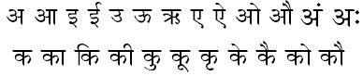
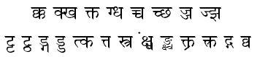
Figure 1. Some of the vowels and consonants with modifiers and compound characters .

ABOUT THE OCR
In the past few decades, significant work have been done in OCR area. Devanagari Optical Character Recognition is regarded as one of the most challenging steps in the digitization of Indian literature. OCR refers to the process by which scanned images are electronically read. The objective here is to convert the text image into an editable text form. Text document scanned using the scanner is turned into bitmap files. OCR software identifies the bitmap to corresponding alphabets and numbers. Once recognized, the characters are converted into ASCII/UNICODE. Text generated by OCR is often input into text search databases. It is used in reading forms, manuscripts and their archival, also applied by library searches.

A word of Devanagari script is first of all segmented into composite characters and then each character is decomposed into set of symbols. A symbol may represent a composite Devanagari character, a modifier symbol – upper or lower, or a Devanagari alphabet. These decomposed symbols are recognized using the prototypes (explained later) and are composed for obtaining valid words. The symbols that can not be recognized as the valid symbols are rejection and substitution errors. During the training phase, we provide OCR with image and corresponding text. The OCR segments the image and extracts the prototype for the decomposed symbols for the recognition stage.

Devanagari word is written into the three strips namely: a core strip, a top strip, and a bottom strip as shown in figure 2. The core strip and top strip are differentiated by the header, while the lower modifier is attached to the core character. We use height of the core characters to locate lower modifiers.

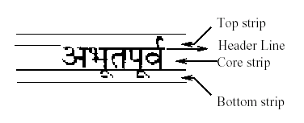
Fig 2. Three strips of Devanagari word

Several times OCR makes errors in recognizing the actual text written, these errors can be due to number of reasons like: Due to climatic effects and poor storage conditions of books, the pages may turn yellow or torn which makes difficult for the machine to read such an image correctly, or it could be due to the presence of background noise introduced at the time of scanning. This noise can cause two or more characters to merge to appear as a single character, or a character could be fragmented into more than one sub-image. This may lead OCR system to incorrectly recognize a character. Another common problem faced is due to the segmentation of conjunct and shadow characters and problem arising due to lower and upper modifiers. Some characters have upper and lower modifiers. These modifiers make Optical Character Recognition (OCR) with Devanagari script very challenging. It is further complicated by compound characters that make character separation and identification very difficult.
OCR for Devnagari script becomes even more difficult when compound character and modifier characteristics are combined in 'noisy' situations. The image below illustrates a Devanagari document with background noise. We can clearly see that compound characters and modifiers are difficult to detect in this image because the image background is not uniform in color, and marks are present that must be distinguished from characters.
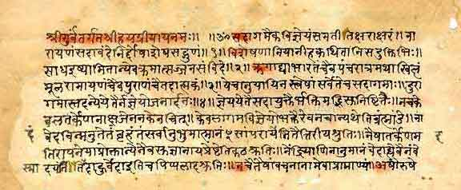

BENEFITS AND APPLICATIONS

BENEFITS

Save data entry costs - automatic recognition by OCR/ICR/OMR/barcode engines ensure lower manpower costs for data entry and validation
Lower licensing cost - since the product enables distributed capture licensing costs for OCR/ICR engine is much lower. For instance 5 workstations may be used for scanning and indexing but only one OCR/ICR license may be required
Export the recognized data in XML or any other standard format for integration with any application or database

APPLICATIONS

Industries and Institutions in which control of large amounts of paper work is critical
    - Banking, Credit cards, Insurance industries

Libraries and archives
    - For conservation and preservation of vulnerable documents and for the provision of access to source documents

OCR fonts are used for several purposes where automated systems need a standard character shape defined to properly read text without the use of barcodes. Some examples of OCR font implementations include bank checks, passports, serial labels and postal mail.

SOFTWARE ARCHITECTUTE

The overall architecture of the OCR consists of three main phases- Segmentation, Recognition and Post-processing. We explain each of these phases below.

- Segmentation
Segmentation in the context of character recognition can be defined as the process of extracting from the preprocessed image the smallest possible character units which are suitable for recognition. It consist of the following steps :

  - Locate the Header Line
An image is stored in the form of a two dimensional array in computer. A black pixel is represented by 1 and a white pixel by a 0. The array is scanned row by row and the number of black pixels is recorded for each row resulting in horizontal histogram. The row with the maximum number of black pixels is the position of the header line called as Shirorekha. This position is identified as hLinePos.
- Separate the Character boxes
Characters are present below the header line. To identify the character boxes, we make a vertical histogram of the image starting from the hLinePos to boundary of the word i.e. the row where there are no black pixels. The boundaries for characters are identified as the columns that have no black pixels.
- Separate the upper modifier symbols
To identify the upper modifier symbols, we make a vertical histogram of the image starting from the top row of the image to the hLinePos.
- Separate the lower modifiers
We did not attempt lower modifier separation due to lack of time.

  - Feature Extraction
Feature extraction refers to the process of characterizing the images generated from the segmentation procedure based on certain specific parameters. We did not explore this further.

- Classification
Classification involves labeling each of the symbols as one of the known characters, based on the characteristics of that symbols. Thus, each character image is mapped to a textual representation.

- Post-processing
The output of the classification process goes through an error detection and correction phase. This phase consists of the following three steps:
- Select an appropriate partition of the dictionary based on the characteristics of the input word, select the candidate words from the selected partition to match the input word with.
- Match the input word with the selected words.
- In case the input word is found in the dictionary, no more processing is done and the word is assumed to be correct. If the word is not found, there are two options available. We can generate aliases for the input word or restrict to an exact match.

Diagrammatic presentation of the stages of OCR

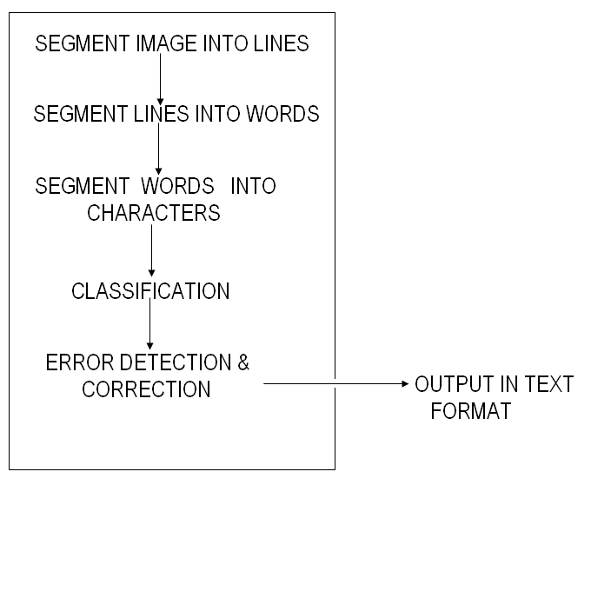
Input Image

SYSTEM ANALYSIS
System Analysis by definition is a process of systematic investigation for the purpose of gathering data, interpreting the facts, diagnosing the problem and using this information to either build a completely new system or to recommend the improvements to the existing system.
A satisfactory system analysis involves the process of examining a business situation with the intent of improving it through better methods and procedures. In its core sense, the analysis phase defines the requirements of the system and the problems which user is trying to solve irrespective of how the requirements would be accomplished. There are 2 methods to perform System Requirement Analysis:
STRUCTURED ANALYSIS

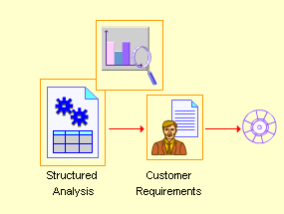

FEASIBILITY STUDY
A feasibility study determines whether the proposed solution is feasible based on the priorities of the requirements of the organization. A feasibility study culminates in a feasibility report that recommends a solution. It helps you to evaluate the cost-effectiveness of a proposed system.
During this phase, various solutions to the existing problems were examined.
For each of these solutions the Cost and Benefits were the major criteria to be examined before deciding on any of the proposed systems.
These Solutions would provide coverage of the following:
- Specification of information to be made available by the system.
- A clear cut description of what tasks will be done manually and what needs to be handled by the automated system.
- Specifications of new computing equipment needed.
A system that passes the feasibility tests is considered a feasible system. Let us see some feasible tests in my project.

TECHNICAL FEASIBILITY
It is related to the software and equipment specified in the design for implementing a new system. Technical feasibility is a study of function, performance and constraints that may affect the ability to achieve an acceptable system. During technical analysis, the analyst evaluates the technical merits of the system, at the same time collecting additional information about performance, reliability, maintainability and productivity. Technical feasibility is frequently the most difficult areas to assess.

Assessing System Performance:
It involves ensuring that the system responds to user queries and is efficient, reliable, accurate and easy to use. Since we have the excellent network setup which is supported and excellent configuration of servers with 80 GB hard disk and 512 MB RAM, it satisfies the performance requirement.
After the conducting the technical analysis we found that our project fulfills all the technical pre-requisites, the network environments if necessary are also adaptable according to the project and

ECONOMIC FEASIBILITY
This feasibility has great importance as it can outweigh other feasibilities because costs affect organization decisions. The concept of Economic Feasibility deals with the fact that a system that can be developed and will be used on installation must be profitable for the Organization. The cost to conduct a full system investigation, the cost of hardware and software, the benefits in the form of reduced expenditure are all discussed during the economic feasibility.
Cost of No Change The cost will be in terms of utilization of resources leading to the cost to the company. Since our cost of project is our efforts, which is obviously less than the long-term gain for the company, the project should be made.

COST- BENEFIT ANALYSIS
A cost-benefit analysis is necessary to determine economic feasibility. The primary objective of the cost benefit analysis is to find out whether it is economically worthwhile to invest in the project. If the returns on the investment are good, then the project is considered economically worthwhile. Cost benefit analysis is performed by first listing all the costs associated with the project cost which consists of both direct costs and indirect costs.

OPERATIONAL FEASIBILITY
Operation feasibility is a measure of how people feel about the system. Operational Feasibility criteria measure the urgency of the problem or the acceptability of a solution. Operational Feasibility is dependent upon determining human resources for the project. It refers to projecting whether the system will operate and be used once it is installed. If the ultimate users are comfortable with the present system and they see no problem with its continuance, then resistance to its operation will be zero.

Our Project is operationally feasible since there is no need for special training of staff member and whatever little instructing on this system is required can be done so quite easily and quickly as it is essentially This project is being developed keeping in mind the general people who one have very little knowledge of computer operation, but can easily access their required database and other related information. The redundancies can be decreased to a large extent as the system will be fully automated.
SOFTWARE ENGINEERING PARADIGM APPLIED
Software Engineering is a planned and systematic approach to the development of software. It is a discipline that consists of methods, tools and techniques used for developing and maintaining software.
To solve actual problems in an industry setting, a software engineer or team of engineers must incorporate a development strategy that encompasses the process, methods and tool layers and generic phases. This strategy is often referred to as a process model or Software Engineering paradigm.
For developing a software product, user requirements are identified and the design is made based on these requirements. The design is then translated into a machine executable language that can be interpreted by a computer. Finally, the software product is tested and delivered to the customer.

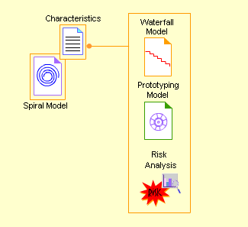
The Spiral model incorporates the best characteristics of both the waterfall and prototyping model. In addition, the Spiral model also contains a new component called Risk Analysis, which is not there in waterfall and prototype model.
In the Spiral model, the basic structure of the software product is developed first. After the basic structure is developed, new features such as user interface and data administration are added to the existing software product. This functionality of the Spiral model is similar to a spiral where the circles of the spiral increase in diameter. Each circle represents a more complete version of the software product.

DEVELOPMENT REQUIREMENTS
SOFTWARE REQUIREMENTS

During the solution development the following softwares were used:
- Microsoft Visual Studio
- JDK1.4
- Swings
- JNI-Java Native Interface (initial phase only)
- JCreator

HARDWARE REQUIREMENTS

During the solution development the following hardaware specificationswere used:
- 2.4GHZ P-IV Processor
- Minimum 256MB Ram

INPUT REQUIREMENTS

OCR system needs textual scanned Image as the input.

TECHNOLOGIES UTILIZED
SWINGS
Swing is a GUI toolkit for Java. Swing is one part of the Java Foundation Classes (JFC). Swing includes graphical user interface (GUI) widgets such as text boxes, buttons, split-panes, and tables.
Swing widgets provide more sophisticated GUI components than the earlier Abstract Windowing Toolkit. Since they are written in pure Java, they run the same on all platforms, unlike the AWT which is tied to the underlying platform's windowing system. Swing supports pluggable look and feel– not by using the native platform's facilities, but by roughly emulating them. This means we can get any supported look and feel on any platform. The disadvantage of lightweight components is possibly slower execution. The advantage is uniform behavior on all platforms.
JNI (JAVA NATIVE INTERFACE)
The Java Native Interface (JNI) is a powerful feature of the Java platform. Applications that use the JNI can incorporate native code written in programming languages such as C and C++, as well as code written in the Java programming language. The JNI allows programmers to take advantage of the power of the Java platform, without having to abandon their investments in legacy code. Because the JNI is a part of the Java platform, programmers can address interoperability issues once, and expect their solution to work The JNI is a powerful feature that allows us to take advantage of the Java platform, but still utilize code written in other languages. As a part of the Java virtual machine implementation, the JNI is a two-way interface that allows Java applications to invoke native code and vice versa.

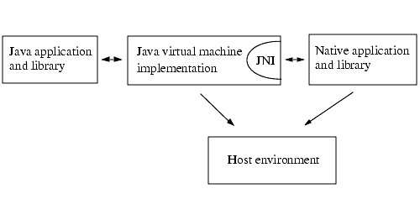

SOFTWARE REQUIREMENTS SPECIFICATIONS 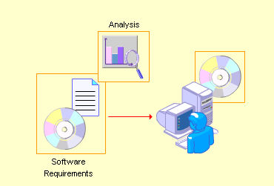
A key feature in the development of any software is analysis of the requirements that must be satisfied by software. A thorough understanding of these requirements is essential for the successful development and implementation of software.
The software requirement specification is produced at the culmination of the analysis task. The function and performance allocated to software as part of system engineering are refined by establishing a complete information description, a detailed functional and behavioral description, an indication of performance requirements and design constraints, appropriate validation criteria.
The Software Requirements Specifications basically states the goals and objectives of the software. It provides a detailed description of the functionality that software must perform.

SYSTEM DESIGN PHASE

Design is an activity of translating the specifications generated in the software requirements analysis into specific design. The design involves designing a system that satisfies customer requirements.
In order to transform requirements into a working system, we must satisfy both the customer and the system builders on development team. The customer understands what the system is to do. At the same time, the system builders must understand how the system is to work. For this reason, system design is really a two-part process. First, we produce a system specification that tells the customer exactly what the system will do. This specification is sometimes called a conceptual system design.

TECHNICAL DESIGN:
The technical design explains the system to those hardware and software experts who will implement it. The design describes the hardware configuration, the software needs, the communication interfaces, the input and output of the system and anything else that translates the requirements into a solution to the customer’s problem. The design description is a technical picture of the system specification. Thus we include the following items in the technical design:
- The System Architecture: A description of the major hardware components and their functions.
- The System Software Structure: The hierarchy and function of the software components.
- The data structure and flow through the system.

DESIGN APPROACH
Modular approach has been taken into consideration. Design is the determination of the modules and inter modular interfaces that satisfy a specified set of requirements. A design module is a functional entity with a well-defined set of inputs and outputs. Therefore, each module can be viewed as a component of the whole system, just as each room is a component of a house. A module is well defined if all the inputs to the module are essential to the function of the module and all outputs are produced by some action of the module. Thus if one input will be left out, the module will not perform its full function. There are no unnecessary inputs; every input is used in generating the output. Finally, the module is well defined only when each output is a result of the functioning of the module and when no input becomes an output without having the transformed in some way by the module.

Modularity: Modularity is a characteristic of good system design. High level modules give us the opportunity to view the problem as whole and hide details that may distract us. By being able to reach down to a lower level for more detail when we want to, modularity provides the flexibility , trace the flow of data through the system, and target the pockets of complexity.
These all are interrelated with each other and also self sufficient among themselves and help in running the system in an efficient and complete manner.

Level of Abstraction: Abstraction an information hiding allows us to examine the way in which modules are related to one another in the overall design the degree to which the modules are independent of one another is a measure of how good the system design is. Independence is desirable for two reasons.
First it is easier to understand how a module works if its function is not tied to others. It is much easier to modify a module if it is independent of others. Often a change in requirements or in a design decision means that certain modules must be modified. Each change affects data or function or both. If the modules depend heavily on each other, a change to one module may mean changes module that are affected by the change.

Coupling: Coupling is a measure of how modules depend on each other. Two modules are highly coupled if there is a great deal of dependence between them. Loosely couple modules have no interconnection at all. Coupling depends on several things:
- The references made from one module to another.
- The amount of data passed from one module to another.
- The amount of control one module has over the other.
- The degree of complexity in the interface between one module and another.

Thus, coupling really represents a range of dependence, from complete dependence to complete independence. We want to minimize the dependence among modules for several reasons. First, if an element is affected by a system action, we always want to know which module causes an effect at a given time. Second, modularity helps in tracking the cause of the system errors. If an error occurs during the performance of particular function, independence of modules allows us to isolate the defective module more easily.

Cohesion: cohesion refers to the internal “glue” with which a module is constructed. The more cohesive a module, the more related are the internal parts of the module to each other and to the functionality of the module. In other words, a module is cohesive if all elements of the module are directed towards and essential for performing the same function.
For example the various triggers written for the Subscription entry form are performing the functionality of the module like querying the old data, saving the new data, updating records etc. So it’s a highly cohesive system.

Scope of control and effect: Finally we want to be sure that the modules in our design do not affect other modules over which they have the control. The modules controlled by the given module are collectively referred to as the scope of effect. No module should be in scope of effect if it not in scope control.
Thus in order to make the system easier to construct, test, correct, and maintain our goals had been:
- Low coupling of modules
- High cohesive modules
- Scope of effect of a module limited to its scope of control
It was decided to store data in different tables in SQL Server. The tables were normalized and various modules identified so as to store data properly create designed reports and on screen queries were written. A menu driven (user friendly) package has been designed containing understandable and presentable menus. Table structures are enclosed. Input and output details were made which are enclosed herewith.
The specifications in our design include
- User interface Design screens and their description
- Entity Relationship Diagrams
MODULE SPECIFICATIONS

0. MAIN :-

Input : none
Output : none
Subordinates : - Choose a file
- Loading a file
- Line Segmentation
- Edit line segmentation
- Word segmentation
- Edit word segmentation
- Clear

1. CHOOSE_FILE

Input event : open button click
Output : a file is choosed and textfield is set.
Subordinates : none
Purpose : selects a file from given menu.

2. LOAD_FILE

Input event : file is choosed.
Output : shows image in the panel.
Subordinates : none
Purpose : shows the selected image file

- LINE_SEGMENTATION

Input event : line button click
Output : display the line segmentation.
Subordinates : imagescan.c
Purpose : do the line segmentation of image.

- EDIT_LINE_SEGMENTATION

Input event : click of mouse in white space or on some line
Output : display edited line segmentation and stores new array
Subordinates : none
Purpose : change the drawn line according to the user.

- WORD_SEGMENTATION

Input event : word button click
Output : display the word segmentation.
Subordinates : wordsegmentor.c
Purpose : do the word segmentation of image

- EDIT_WORD_SEGMENTATION

Input event : click of mouse in white space or on some line
Output : display edited word segmentation and stores new array
Subordinates : none
Purpose : change the drawn line according to the user.

- CLEAR

Input event : click on clear button
Subordinates : none
Purpose : to clear the panel for loading new image

Design is flexible and accommodates other expected needs of the customer and suitable changes can be made at a later date. After thoroughly examining the requirements only that design has been suggested which can meet current and probably the future desires of the customer.

PACKAGES USED

import java.awt.*;// this package is a abstract window toolkit for
applets design for interaction with user.

import java.awt.event.*; //This package is supporting handled event are those generated by mouse, keyboard and other control such as push button etc

import javax.swing.*; //swing is a set of class that provide a more powerful and flexible component than in AWT.

import javax.swing.JOptionPane; //It is a subpackage of swing class which contain option panel

import java.io.*;//This package is used for INPUT from user and OUTPUT by program or console stream

import java.util.*; //This package contain some of the most exciting enhancement like : collection and t contain a wide assortment of classes and interface that support broad range of functionality

import java.awt.image.*; //This package use to support graphic images pictures.

DESIGNING PANEL FRAME BUTTONS AND SCROLLBARS

//... create Button and its listeners
JButton openButton = new JButton("Open");
JButton lineButton = new JButton("line segment");

JButton wordButton=new JButton("word segment");
JButton charButton=new JButton("char segment");
JButton clearButton=new JButton("clear");

//setting tool tips for various buttons
openButton.setToolTipText("click here to choose a file");
lineButton.setToolTipText("click here for line segmentation");
wordButton.setToolTipText("click here for word segmentation");
charButton.setToolTipText("click here for char segmentation");
clearButton.setToolTipText("click here to clear the panel");

//adding mouse listener to various buttons
openButton.addActionListener(new OpenAction());
lineButton.addActionListener(new LineAction());
wordButton.addActionListener(new wordAction());
charButton.addActionListener(new charAction());
clearButton.addActionListener(new clearAction());

//... Create contant pane, layout components
JPanel content = new JPanel();
JMenuBar bar=new JMenuBar();
setJMenuBar(bar);
JMenu helpmenu=new JMenu("Help");
helpmenu.setMnemonic('H');
JMenuItem aboutopen=new JMenuItem("About open");
JMenuItem lineseg=new JMenuItem("Line segmentation");

// Create JPanel canvas to hold the picture
imagepanel = new DrawingPanel();

// Create JScrollPane to hold the canvas containing the picture
JScrollPane scroller = new JScrollPane(
JScrollPane.VERTICAL_SCROLLBAR_ALWAYS,
JScrollPane.HORIZONTAL_SCROLLBAR_ALWAYS);
scroller.setPreferredSize(new Dimension(500,300));
scroller.setViewportView(imagepanel);
scroller.setViewportBorder(
BorderFactory.createLineBorder(Color.black));

// Add scroller pane to Panel
content.add(scroller,"Center");

// Set window characteristics
this.setTitle("File Browse and View");
this.setDefaultCloseOperation(JFrame.EXIT_ON_CLOSE);
this.setContentPane(content);
this.pack();

IMPORTANT METHODS

public int wordseg(int lineno, int w, int h, int vHisto[])
//this above method is used for word by word segmentation

public int lineseg(int w, int h, int hHisto[])
//this above method is used for Line by Line segmentation
Horizontally

public int hline(int ln, int wn, int w, int h, int hHisto[])
//this above method is used for Line by Line selection
Horizontally

public void ccharseg(int ln, int wn, int w, int h, int vHisto[])
//this above method is used for vertically selecting single character segmentation

public boolean accept (File f)
// this function is internally used for the Filtering action

public String getDescription ()
// this function is internally used for the Filter Option drop down menu

CODING

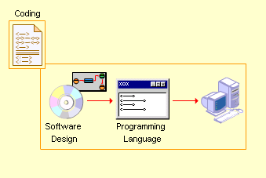

The coding step of the development phase translates the software design into a programming language that can be executed by a computer.

CODING EFFICIENCY

Efficiency means
▪ How cryptic the coding is.
▪ Avoiding dead-code
▪ Remove unnecessary code and redundant processing
▪ Spend time documenting
▪ Spend adequate time analyzing business requirements, process flows, data-structures and data-model
▪ Quality assurance is key: plan and execute a good test plan and testing methodology
A good way to see which code is more efficient is to compile is the code and generate the assembler code.
See which one produces the most lines of code (LOC). The one with the least LOC is the one that is more efficient and will most probably run faster. Counting the number of lines of code tells you nothing. Many times the compiler will do optimizations that are intended to improve performance (speed) at the expense of space.
How code efficiency is achieved in the project?
We have made use of general procedures which we have used across a number of forms. The code written for the auto generation procedure is very efficient.

OPTIMIZATION OF CODE
Code optimization involves the application of rules and algorithms to program code with the goal of making it faster, smaller, more efficient, and so on. Often these types of optimizations conflict with each other, for instance, faster code usually ends up larger, not smaller. There are two goals for optimizing code:
- Optimizing for time efficiency (runtime savings)
- Optimizing for memory conservation
In some cases both optimizations go hand in hand, in other cases you trade in one for the other. Using less memory means to transfer less memory which reduces the time needed for memory transfers. But often memory is used to store pre calculated values to avoid the actual calculation at runtime. In this case you trade space consumption for runtime efficiency.

TESTING (TESTING TECHNIQUES AND TESTING STRATEGIES)
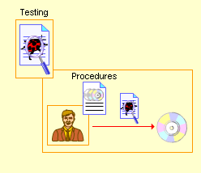

All software intended for public consumption should receive some level of testing. Without testing, you have no assurance that software will behave as expected. The results in public environment can be truly embarrassing. Testing is a critical element of software quality assurance and represents the ultimate review of specification, designing, and coding. Testing is done throughout the system development at various stages. If this is not done, then the poorly tested system can fail after installation. Testing is a very important part of SDLC and takes approximately 50%of the time.
The first step in testing is developing a test plan based on the product requirements. The test plan is usually a formal document that ensures that the product meets the following standards:
- Is thoroughly Tested- Untested code adds an unknown element to the product and increases the risk of product failure
- Meets product requirements- To meet customer needs, the product must provide the features and behavior described in the product specification.
- Does not contain defects- Features must work within established quality standards and those standards should be clearly stated within the test plan.

TESTING TECHNIQUES
Black box Testing: aims to test a given program’s behavior against its specification or component without making any reference to the internal structures of the program or the algorithms used. Therefore the source code is not needed, and so even purchased modules can be tested. We study the system by examining its inputs and related outputs. The key is to devise inputs that have a higher likelihood of causing outputs that reveal the presence of defects. We use experience and knowledge of the domain to identify such test cases. Failing this a systematic approach may be necessary. Equivalence partitioning is where the input to a program falls into a number of classes. e.g. positive numbers vs. negative numbers. Programs normally behave the same way for each member of a class. Partitions exist for both input and output. Partitions may be discrete or overlap. Invalid data (i.e. outside the normal partitions) is one for which partitions should be tested. Test cases are chosen to exercise each portion. Also test boundary cases (atypical, extreme, zero) should be considered since these frequently show up defects. For completeness, test all combinations of partitions. Black box testing is rarely exhaustive (because one doesn't test every value in an equivalence partition) and sometimes fails to reveal corruption defects caused by weird combination of inputs. Black box testing should not be used to try and reveal corruption defects caused, Example, by assigning a pointer to point to an object of the wrong type. Static inspection (or using a better programming language) is preferred.

White box Testing: was used as an important primary testing approach. Code is tested using code scripts, drivers, stubs, etc. which are employed to directly interface with it and drive the code. The tester can analyze the code and use the knowledge about the structure of a component to derive test data. This testing is based on the knowledge of structure of component (e.g. by looking at source code). The advantage is that structure of code can be used to find out how many test cases needed to be performed. Knowledge of the algorithm (examination of the code) can be used to identify the equivalence partitions. Path testing is where the tester aims to exercise every independent execution path through the component. All conditional statements tested for both true and false cases. If a unit has n control statements, there will be up to 2n possible paths through it. This demonstrates that it is much easier to test small program units than large ones. Flow graphs are a pictorial representation of the paths of control through a program (ignoring assignments, procedure calls and I/O statements). We use a flow graph to design test cases that execute each path. Static tools may be used to make this easier in programs that have a complex branching structure. Dynamic program analyzers instrument a program with additional code. Typically this will count how many times each statement is executed. At end, print out report showing which statements have and have not been executed.

Possible methods:

Usual method is to ensure that every line of code is executed at least once.

Test capabilities rather than components (e.g. concentrate on tests for data loss over ones for screen layout).

Test old in preference to new (users less affected by failure of new capabilities).
- Test typical cases rather than boundary ones (ensure normal operation works properly).
Debugging: Debugging is a cycle of detection, location, repair and test. Debugging is a hypothesis testing process. When a bug is detected, the tester must form a hypothesis about the cause and location of the bug. Further examination of the execution of the program (possible including many returns of it) will usually take place to confirm the hypothesis. If the hypothesis is demonstrated to be incorrect, a new hypothesis must be formed. Debugging tools that show the state of the program are useful for this, but inserting print statements is often the only approach. Experienced debuggers use their knowledge of common and/or obscure bugs to facilitate the hypothesis testing process. After fixing a bug, the system must be reset to ensure that the fix has worked and that no other bugs have been introduced. In principle, all tests should be performed again but this is often too expensive to do.

TEST PLANNING:

Testing needs to be planned to be cost and time effective. Planning is setting out standards for tests. Test plans set the context in which individual engineers can place their own work. Typical test plan contains:
- Overview of Testing Process.
- Recording procedures so that tests can be audited.
- Hardware and Software Requirements.
- Constraints.

Testing Done in our System
The best testing is to test each subsystem separately as we have done in our project. It is best to test a system during the implementation stage in form of small sub steps rather then large chunks. We have tested each module separately i.e. have completed unit testing first and system testing was done after combining /linking all different Modules with different menus and thorough testing was done. Once each lowest level unit has been tested, units are combined with related units and retested in combination. This proceeds hierarchically bottom-up until the entire system is tested as a whole. Hence we have used the Top Up approach for testing our system.

Typical levels of testing in our system:

Unit -procedure, function, method

Module -package, abstract data type

Sub-system - collection of related modules, method-message paths

Acceptance Testing - whole system with real data(involve customer, user , etc)

Beta Testing is acceptance testing with a single client. It is conducted at the developer’s site by a customer. The software is used in a natural setting with the developer “looking over the shoulder” of the user and recording errors and usage problems. conducted in a controlled environment. Usually comes in after the completion of basic design of the program. The project guide who looks over the program or other knowledgeable officials may make suggestions and give ideas to the designer for further improvement. They also report any minor or major problems and help in locating them and may further suggest ideas to get rid of them. Naturally a number of bugs are expected after the completion of a program and are most likely to be known to the developers only after the alpha testing.
involves distributing the system to potential customers to use and provide feedback. It is conducted at one or more customer sites by the end-user of the software. Unlike alpha testing, the developer is generally not present. Therefore, the beta test is a “live” application of the software in an environment that cannot be controlled by the developer. The customer records all problems (real or imagined) that are encountered during beta testing and reports these to the developer at regular intervals. As a result of problems reported during beta test, software engineers make modifications and then prepare for release of the software product to the entire customer base.
In, this project, This exposes system to situations and errors that might not be anticipated by us.

IMPLEMENTATION
Implementation includes all those activities that take place to convert from old system to the new one. The new system may be completely new. Successful Implementation may not guarantee improvement in the organization using the new system, improper installation will prevent it. Implementation uses the design document to produce code. Demonstration that the program satisfies its specifications validates the code. Typically, sample runs of the program demonstrating the behavior for expected data values and boundary values are required. Small programs are written using the model: It may take several iterations of the model to produce a working program. As programs get more complicated, testing and debugging alone may not be enough to produce reliable code. Instead, we have to write programs in a manner that will help insure that errors are caught or avoided.
.

Incremental program development:

As program becomes more complex, changes have a tendency to introduce unexpected effects. Incremental programming tries to isolate the effects of changes. We add new features in preference to adding new functions, and add new function rather than writing new programs. The program implementation model becomes:

define types/compile/fix;

add load and dump functions/compile/test;

add first processing function/compile/test/fix;

add features/compile/test/fix;

add second processing function/compile/test/fix;

keep adding features/and compiling/and testing/ and fixing.

MAINTAINENCE
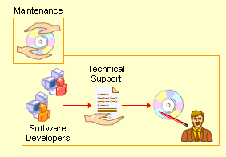
The maintenance starts after the final software product is delivered to the client. The maintenance phase identifies and implements the change associated with the correction of errors that may arise after the customer has started using the developed software. This also maintains the change associated with changes in the software environment and customer requirements. Once the system is a live one, Maintenance phase is important. Service after sale is a must and users/ clients must be helped after the system is implemented. If he/she faces any problem in using the system, one or two trained persons from developer’s side can be deputed at the client’s site, so as to avoid any problem and if any problem occurs immediate solution may be provided.
The maintenance provided with our system after installation is as follows:
First of all there was a Classification of Maintenance Plan which meant that the people involved in providing the after support were divided. The main responsibility was on the shoulders of the Project Manager who would be informed in case any bug appeared in the system or any other kind of problem rose causing a disturbance in functioning. The Project leader in turn would approach us to solve the various problems at technical level. (E.g. The form isn’t accepting data in a proper format or it is not saving data in the database.)

COST ESTIMATION

The cost estimation depends upon the following:
- Project complexity
- Project size
- Degree of structural uncertainty
- Human, technical, environmental, political – can affect the ultimate cost of software and effort applied to develop it.
- Delay estimation until late in the project.
- Base estimates on similar projects that have already been completed.
- Use relatively simple decomposition techniques to generate project cost and effort estimates.
- Use one or more empirical models for software cost and effort estimation.
Project complexity, project size and the degree of structural uncertainty all affect the reliability of estimates. For complex, custom systems, a large cost estimation error can make the difference between profit and loss. A model is based on experience and takes the form:
D = f (V_{i})
Where d is one of a number of estimated values (e.g. effort, cost, project duration) and (V_{i}) are selected independent parameters (e.g. estimated LOC (Line of Code) or FP (Functional parameters))

ASSUMPTIONS MADE
- The input scanned document is assumed to be only in jpg, gif or jpeg format.

- The input scanned document only consists of text in black written on a white background, it contains no graphical images.

- After loading the image, first Line segmentation is performed and then only word segmentation can be performed, that is first the line segmentation button has to be clicked .Trying to do word segmentation will not affect the original document.

- Lines can be dragged, dropped, added or deleted only after default line segmentation has been performed on the click of Line Segmentation button.

- For loading another image, the clear button is pressed and then the image is loaded.

RESULTS

A sample text, its line segmentation, word segmentation and character segmentation are shown next. These are actual screen dumps.

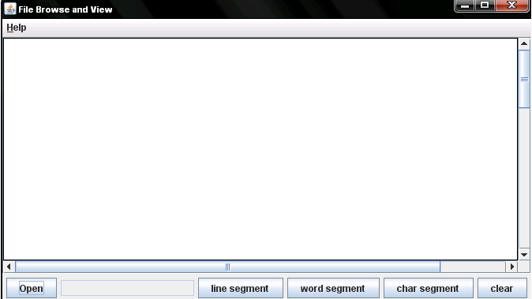

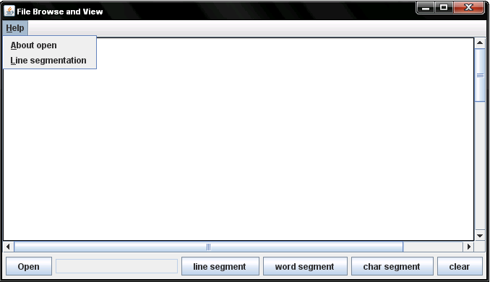

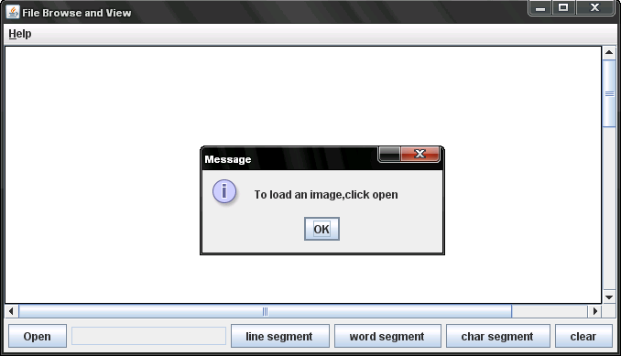

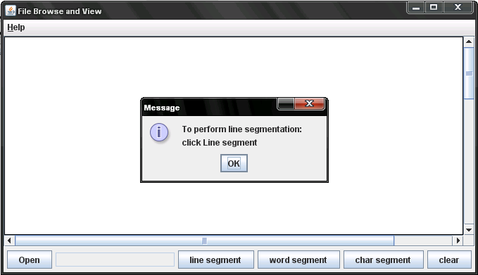

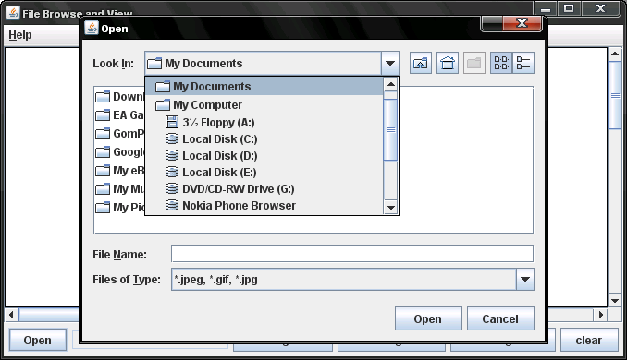

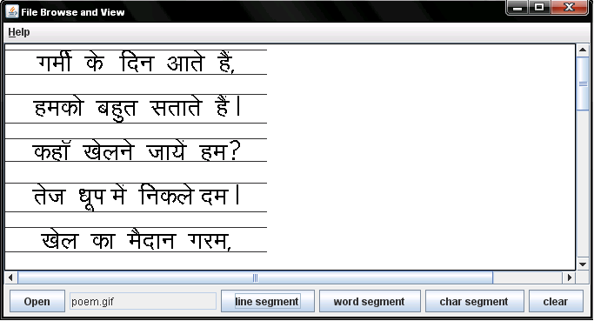

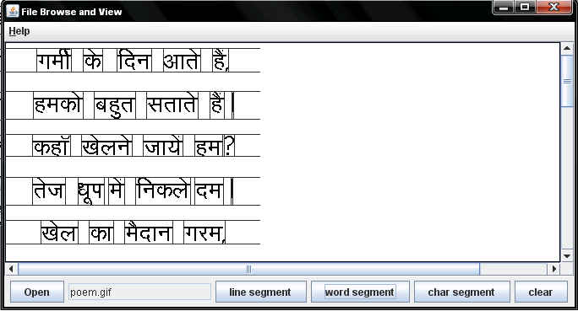

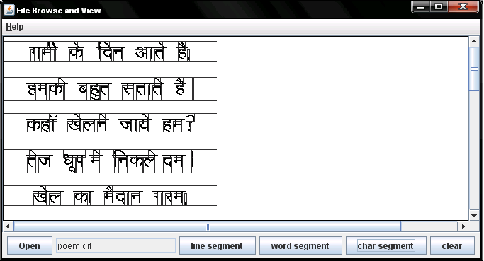

SUMMARY AND CONCLUSION

A Devanagari document system has been developed which uses various knowledge sources to improve the performance. The composite characters are first segmented into its constituent symbols which helps in reducing the size of the set, in addition to being a natural way of dealing with Devanagari script. The automated trainer makes two passes over the text image to learn the features of all the symbols of the script. A character pair expert resolves confusion between two candidate characters. The composition processor puts the symbols back together to get the words which are then passed through the dictionary. The dictionary corrects only those characters which cause a mismatch and have been recognized with low confidence. The preliminary results on testing of the system showa performance of more than 95% on printed texts onindividual fonts. Further testing is currently underway for multi-font and handprinted texts. Most of the errors are due to inaccurate segmentation of symbols within a word. We are using only upto word level knowledge in our system. The domain knowledge and sentence level knowledge could be integrated to further enhance the performance in addition to making it more robust. The method utilizes an initial stage in which successive columns (vertical strips) of the scanned array are ORed in groups of one pitch width to yield a coarse line pattern (CLP) that crudely shows the distribution of white and black along the line. The CLP is analyzed to estimate baseline and line skew parameters by transforming the CLP by different trial line skews within a specified range. For every transformed CLP (XCLP), the number of black elements in each row is counted and the row-to-row change in this count is also calculated. The XCLP giving the maximum negative change (decrease) is assumed to have zero skew. The skew corrected row that gives the maximum gradient serves as the estimated baseline. Successive pattern fields of the scanned array having unit pitch width are superposed (after skew correction) and summed. The resulting sum matrix tends to be sparse in the inter-character area. Thus, the column having minimum sum is recorded as an "average", or coarse, X-direction segmentation position. Each character pattern is examined individually, with the known baseline (corrected for skew) and average segmentation column as references. A number of neighboring columns (3 columns, for example) to the left and right of the average segmentation columns are included in the view that is analyzed for full segmentation by conventional algorithm.
REFERENCES

- http://en.wikipedia.org/wiki/Optical_character_recognition

- G. Nagy. At the frontiers of OCR. Proceedings of the IEEE, 80(7):1093--1100, July 1992.

- S. Tsujimoto and H. Asada. Major components of a complete text reading system. Proceedings of the IEEE, 80(7):1133--1149, July 1999.

- Y. Tsujimoto and H. Asada. Resolving Ambiguity in Segmenting Touching Characters. In ICDAR [ICD91], pages 701--709.

- R. A. Wilkinson, J. Geist, S. Janet, P. J. Grother, C. J. C. Burges, R. Creecy, B. Hammond, J. J. Hull, N. J. Larsen, T. P. Vogl, and C. L. Wilson. The first census optical character recognition systems conference. Technical Report NISTIR-4912, National Institute of Standards and Technology, U.S. Department of Commerce, September 2001

