PROJECT DOCUMENTATION

Student Performance
Analytics System
Python with AI | EWB Courses

Student Name | [Aksh Kantiwal]
E-mail | [akshkantiwal6@gmail.com]
GitHub Repository | [https://github.com/akshkantiwal6/Student-Performance-Analytics]

1. Project Title
Student Performance Analytics System. This project uses Python, NumPy and Pandas to process student marks and attendance and present a clear summary of student and class performance.

2. Objective
The objective is to build a simple data-analysis program that reads student records from a CSV file, calculates total and average marks, assigns grades, identifies pass/fail results, compares subjects, ranks top performers and highlights students who may need additional support.

3. Technologies Used
- Python — program logic, conditions, loops and functions.
- Pandas — reading the CSV dataset, organizing records in a DataFrame, filtering and grouping data.
- NumPy — numerical calculations, arrays and the basic artificial-neuron calculation demonstration.
- CSV — storage format for the student dataset.
- Visual Studio Code and PowerShell — development and execution environment.

4. Dataset Description
The project uses students.csv, a sample dataset containing 20 student records. The dataset includes Student_ID, Name, Department, Python, Mathematics, AI and Attendance. Subject marks and attendance are represented on a 0–100 scale. The data is for demonstrating the program and should not be treated as real institutional student records.

5. Implementation
- Load the dataset: Pandas reads students.csv into a DataFrame.
- Check and prepare data: The program handles missing values, converts subject marks to numeric values and checks that marks and attendance are within 0–100.
- Calculate results: Reusable functions in functions.py calculate total marks, average marks, grades, pass/fail status and performance status.
- Analyze the class: Pandas and NumPy are used to calculate class statistics, subject averages, department summaries and the top five students.
- Identify students needing attention: The program filters students whose performance status is Needs Improvement.
- Demonstrate a basic artificial neuron: Normalized subject marks are combined with manually chosen weights and a bias using NumPy. This is a mathematical demonstration, not a trained machine-learning model.

Grading and Result Rules
Grades are assigned using the student's average: A+ for 90 and above, A for 80–89.99, B for 70–79.99, C for 60–69.99, D for 40–59.99, and F below 40. A student passes when every subject mark is at least 40; otherwise the result is Fail.
Performance status is marked Needs Improvement when the average is below 50 or attendance is below 75. It is marked Excellent when the average is at least 85 and attendance is at least 90. All other students are marked Satisfactory.

6. Key Features
- Student-wise total marks, average, grade and result.
- Class size, class average, highest and lowest student averages.
- Pass/fail counts and performance-status counts.
- Department-wise student counts, average marks and pass/fail counts.
- Subject-wise average marks and identification of the strongest and weakest subject.
- Top five students ranked by average marks.
- List of students marked as needing improvement.
- Basic NumPy artificial-neuron score demonstration.

7. Output / Screenshots

- Student Performance Report

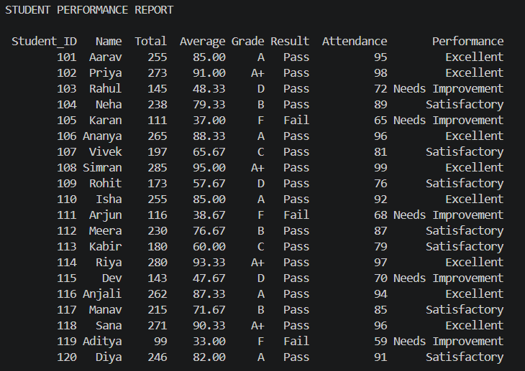

- Class and Department Summary
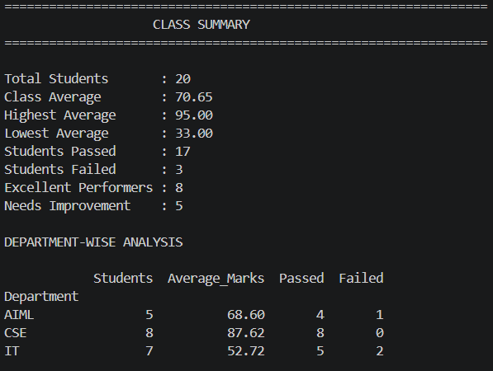

- Subject Analysis and Top 5 Students
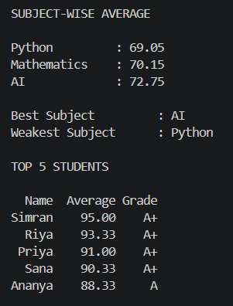

- Artificial Neuron Demo
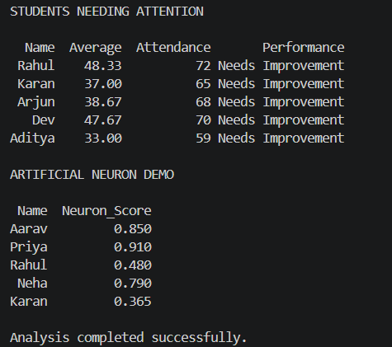

8. Final Outcome
The program successfully reads the student dataset and generates individual and overall performance summaries. In the current 20-record dataset, the class average is 70.65, the highest student average is 95.00, and the lowest is 33.00. The program reports 17 students as Pass and 3 as Fail. The subject averages are Python 69.05, Mathematics 70.15 and AI 72.75, making AI the strongest subject by average in this sample. These figures describe the current dataset and may change if the data is edited.

9. Challenges & Learning
Challenges: Handles missing data, calculating grades, and analyzing student performance.
Learning: Learned Python functions, NumPy calculations, Pandas data analysis, and basic artificial neuron concepts.
10. GitHub Repository
[https://github.com/akshkantiwal6/Student-Performance-Analytics]
Project Files
- main.py — main program and analysis output.
- functions.py — reusable calculation functions.
- students.csv — sample student dataset.
- README.md — repository overview and run instructions.
- Project_Documentation.docx — project report.

