Explainable and Drift-Aware Predictive Maintenance for IoT-Monitored Industrial Equipment
Project Report
Based on the NASA C-MAPSS turbofan engine dataset
Data Science Tutorial
Group 2
Members
Shrestha Akshovya (2317160)
Nguyen Thien Phu (2317167)
Obeid Christina (2317166)
Abdullah Al Mahmud (2317139)
Osama Bin Hasan (2317191)
Hoque Enamul (2317193)
October 2026

Summary
Machines are often repaired only after they break, or serviced on a fixed schedule even when they are healthy. Both waste time and money. In this project we built a system that reads sensor data and warns when an engine is likely to fail within the next 30 cycles. It also shows which sensors caused each warning, and it checks whether it still works when operating conditions change.
We tested it on NASA's engine dataset. Machine learning gave better warnings than two simple rules: an age rule and a single-sensor rule. The best models caught 97% of the failing cycles, and the first warning came a median of 35 cycles before failure. When we used the model on engines with different operating conditions, it almost stopped raising alerts. A drift check found the problem, and a simple fix brought the performance back without retraining.
The data is simulated, so our results show that the method works. They are not a promise of the same accuracy on real power grid equipment.

1. Introduction

1.1 Why maintenance matters
Engines, turbines and transformers have to be maintained so that they keep working safely. There are three common ways to do it.
- Reactive: fix the machine after it breaks. This causes unplanned downtime and expensive emergency repairs.
- Scheduled: service the machine at fixed times. This wastes effort on healthy machines and can still miss early failures.
- Predictive: use sensor data to see when a machine is getting worse and act only when needed. This is what our project is about.
Modern machines have sensors that record temperatures, pressures and speeds at every cycle. A cycle is one run of the machine. The number of cycles left before a machine fails is called its remaining useful life.

1.2 Our goals
- Predict: warn when an engine will fail within the next 30 cycles.
- Explain: show which sensors caused each warning, so engineers can trust and check it.
- Adapt: keep working when the operating conditions change.

1.3 Choice of data
We first tried the ETDataset, which has real transformer temperature data. It has no records of real failures, so we had to invent a target from the temperature itself, and that made the comparison with simple rules unfair. We then switched to NASA's C-MAPSS dataset, where engines are run until they really fail. It is simulated jet engine data, not power grid data. We use it as an example of any machine that has sensors. What we show is the method, not the exact accuracy for a power grid.

2. The Data

2.1 NASA C-MAPSS
C-MAPSS is a public NASA dataset of simulated engines. Every training engine starts with a different amount of wear and runs until it fails, so we always know how many cycles it had left. We used two parts of it. FD001 has one operating condition and is our main data. FD002 has six operating conditions and is used to test what happens when conditions change.
Table 1. The two parts of the dataset we used
Part | Training engines | Training rows | Operating conditions
FD001 | 100 | 20,631 | 1
FD002 | 260 | 53,759 | 6

2.2 What each record contains
Each row is one engine at one cycle. It holds:
- the engine number and the cycle number;
- three operating settings (such as altitude, speed and throttle);
- 21 sensor readings (temperatures, pressures, speeds and similar).
Seven of the 21 sensors never change in FD001, so they tell us nothing. We removed them and kept 14. In FD001 the shortest engine lasted 128 cycles, the median was 199 cycles and the longest was 362 cycles. Engines live for very different lengths of time, so age alone is not a reliable warning sign.

2.3 What the sensors look like
Figure 1 shows three sensors for five engines. Time runs from left to right, towards failure.
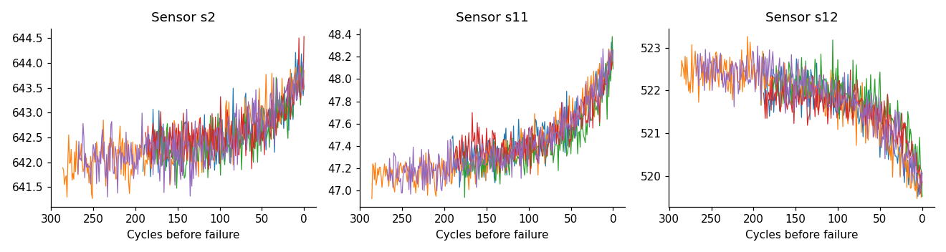
Figure 1. Sensors 2, 11 and 12 for five engines, counting down to failure
The sensors move steadily up or down as an engine gets closer to failing. This steady pattern is what a model can learn from, so early warning is possible. The readings are also noisy, so we smooth them before modelling.

3. What We Did

3.1 The question we asked
We turned the problem into one yes or no question: will this engine fail in the next 30 cycles? If the answer is yes, that cycle counts as an alert. We chose 30 cycles because it gives maintenance teams enough time to plan an inspection. This number is our own choice and could be changed.
Only 15% of the cycles are alerts. This matters, because a model that never raises an alert would still be 85% correct, but it would be useless. For this reason we do not judge the models by plain accuracy.

3.2 What the model sees
For each cycle, the model gets 43 inputs built from the 14 sensors:
- the current reading of each sensor (14 inputs);
- the average of each sensor over the last 10 cycles, which reduces noise (14 inputs);
- the change of each sensor over the last 10 cycles, which shows the trend (14 inputs);
- the age of the engine in cycles (1 input).
Every input uses only the present and the past, never the future. The sensors are put on a common scale using training data only.

3.3 How we tested
We tested in three ways.
- Engines the model never saw. We split the 100 FD001 engines into 70 for training, 15 for tuning and 15 for testing.
- Repeated testing. We repeated the test five times with different groups of engines. This is more reliable when there are few engines.
- NASA's own test engines. NASA provides 100 separate test engines with the true remaining life at their last cycle.
We always keep each engine completely in training or completely in testing. Cycles from the same engine look almost identical, so mixing them would give scores that look better than they really are.

3.4 The five methods we compared
Two methods are simple rules that need no machine learning. Three are machine learning models. The rules show what is possible without machine learning, so a model is only worth using if it clearly beats them.
Table 2. The methods compared
Method | Idea
Age rule | Raise an alert when the engine is old. This is like scheduled maintenance.
Sensor rule | Raise an alert when one key sensor (sensor 15, smoothed) is high.
Logistic Regression | A simple model that draws one straight boundary between healthy and about to fail.
Random Forest | Many decision trees that vote together.
XGBoost | Decision trees built one after another, each fixing the mistakes of the last.

3.5 How we measured success
- Precision: of the alerts we raised, how many were right.
- Recall: of the real failures, how many we caught.
- PR-AUC: one overall score that combines precision and recall over all alert thresholds. Higher is better. A random guess scores about 0.15 here.
- Cost: a missed alert counts as 10 and a false alarm counts as 1. These numbers are our assumption.
The alert threshold (how high the score must be before we raise an alert) was chosen on the tuning engines and then kept fixed for the final test.

3.6 Explaining the alerts
We used a method called SHAP. For each prediction it shows how much every input pushed the risk up or down. This lets us see which sensors matter most overall, and why a single alert was raised.

3.7 Testing changing conditions
A model is trained on past data, but it is used on new data. If the new data is different, the model can fail without anyone noticing. This is called drift. We tested it on purpose: we trained the model on FD001 (one operating condition) and used it on FD002 (six operating conditions). We measured how different the two datasets are, and then tried a fix: grouping the engines into the six operating conditions and scaling each sensor separately within each condition.

4. Results

4.1 Which method is best
Table 3 shows the PR-AUC score of each method. The first column is the score on the 15 engines kept for testing. The second is the average over the five repeated tests.
Table 3. Overall score (PR-AUC) of each method, higher is better
Method | 15 test engines | Five repeated tests
Random guess | 0.15 | 0.15
Age rule | 0.71 | 0.53
Sensor rule | 0.88 | 0.91
Logistic Regression | 0.95 | 0.96
Random Forest | 0.94 | 0.95
XGBoost | 0.94 | 0.96

All three machine learning models score between 0.94 and 0.96. The best simple rule scores 0.88 to 0.91 and the age rule scores 0.53 to 0.71. The order is the same in both tests, so the result is stable. On NASA's own 100 test engines the order was also the same: 0.94 to 0.95 for machine learning, 0.89 for the sensor rule and 0.51 for the age rule.
Logistic Regression, the simplest model, is as good as XGBoost. This means the signal in this data is clear and a complex model adds little.

4.2 Precision and recall
Figure 2 shows how precision and recall trade off for each method. Each point on a curve is a different alert threshold. A curve that is further up and to the right is better, because it means fewer false alarms and more failures caught.
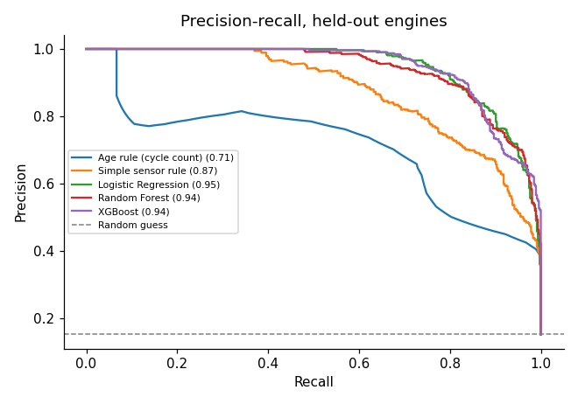
Figure 2. Precision and recall for each method on the test engines
The machine learning curves stay close to the top right for most of the range. The sensor rule drops earlier, and the age rule is clearly the lowest.

4.3 Alerts, false alarms and cost
Table 4 shows what each method would do on the 15 test engines, which contain 465 alert cycles. Counts are per cycle.
Table 4. Alerts, false alarms and cost on the test engines
Method | Precision | Recall | False alarms | Missed | Cost
Age rule | 0.57 | 0.75 | 260 | 117 | 1,430
Sensor rule | 0.71 | 0.83 | 159 | 79 | 949
Logistic Regression | 0.75 | 0.93 | 147 | 34 | 487
Random Forest | 0.63 | 0.97 | 270 | 13 | 400
XGBoost | 0.64 | 0.97 | 257 | 14 | 397
No model | n/a | 0.00 | 0 | 465 | 4,650

XGBoost caught 97% of the failing cycles and missed only 14 of 465, with 257 false alarms. Its total cost was 397, which is under a third of the age rule (1,430) and far below doing nothing (4,650).
The first warning from XGBoost came between 22 and 113 cycles before failure, with a median of 35 cycles. Every one of the 15 test engines received a warning.

4.4 Which sensors matter
Figure 3 shows which inputs matter most for the XGBoost model. A name such as s15_m10 means sensor 15 averaged over 10 cycles, s4_now means the current value of sensor 4, and cycle means the age of the engine.
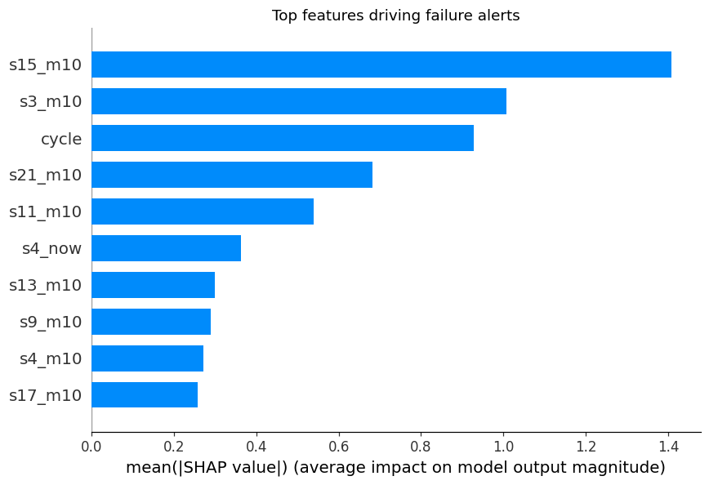
Figure 3. The inputs that matter most for the alerts
The averages of sensors 15, 3, 21 and 11, together with the age of the engine, matter most. Figure 4 shows the direction. Each dot is one cycle. Dots to the right push the risk up, and the colour shows whether the sensor value was high or low.
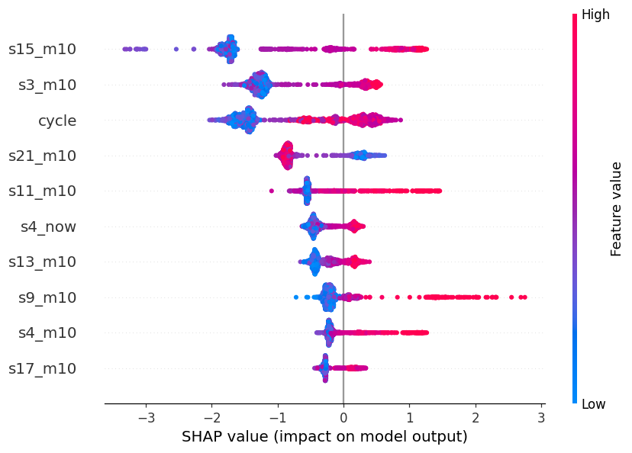
Figure 4. How high and low sensor values push the risk up or down
For most of the important inputs, high values push the risk up. This fits the idea that engines near failure show extreme readings. The explanation also works for a single alert. For example, engine 13 at cycle 162 got a risk of about 1.00, and it failed one cycle later. The main reasons were very high readings of sensors 9, 15, 4, 14 and 11. This shows what the model uses, not what physically causes the failure.

4.5 When conditions change
FD002 has six operating conditions, so its sensor readings are very different from FD001, even for healthy engines. We measured the difference on a scale from 0 (same) to 1 (completely different). It was 0.80. After scaling each operating condition separately, it fell to 0.04.
Table 5. The FD001 model used on all 260 FD002 engines
Situation | PR-AUC | Recall
FD001 test engines (no change) | 0.94 | 0.97
FD002, normal scaling | 0.30 | 0.04
FD002, scaled per operating condition | 0.94 | 0.94

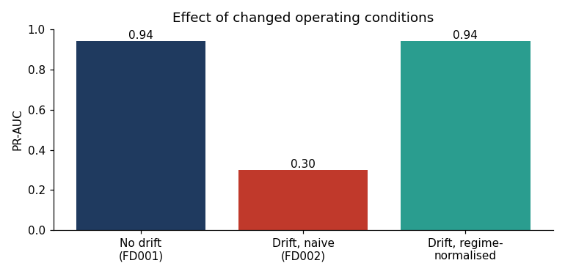
Figure 5. Score of the same model with no change, with changed conditions, and after the fix
With normal scaling the model's recall fell to 0.04, so it almost never raised an alert. Its precision still looked acceptable (0.61), so this failure is easy to miss unless drift is checked. Scaling each operating condition separately brought the PR-AUC back to 0.94 with the same model and no retraining.
We also trained a new model on FD002 engines. On 78 FD002 engines kept for testing it scored 0.96, compared with 0.94 for the original model after the fix and 0.28 without it. So most of the problem was the scaling, not the model.

5. What We Found
1. Machine learning beats the simple rules. The models scored 0.94 to 0.96, against 0.88 to 0.91 for the best sensor rule and 0.53 to 0.71 for the age rule.
2. Warnings come early and cost less. The first warning came a median of 35 cycles before failure, and the total cost was under a third of the age rule's cost.
3. A simple model is enough. Logistic Regression was as good as XGBoost.
4. The alerts can be explained. Smoothed readings of sensors 15, 3, 21 and 11, and the age of the engine, drive the predictions.
5. Drift is a real danger, but it can be fixed. Under new operating conditions the recall fell from 0.97 to 0.04. Checking for drift found the problem, and scaling each operating condition separately fixed it.

6. Limitations
- The data is simulated jet engine data, not real power grid equipment.
- There are only 100 engines in the main dataset, and only 15 were kept for the main test. We added repeated testing and NASA's test engines to reduce this risk.
- The 30-cycle window and the cost values (10 and 1) are our own choices. Other values could change the results.
- False alarms and misses are counted per cycle, not per engine.
- We tested only one kind of change (operating conditions), and we did not train a deep learning model such as an LSTM.

7. Conclusion
We built an early-warning system for equipment failure. Machine learning predicted failures better than simple rules, gave warnings about 35 cycles ahead, and cost much less than scheduled maintenance. We could explain each alert, and we found and fixed a drift problem that would otherwise have gone unnoticed. The predictions should guide inspections, and engineers should make the final decision.
Next steps are to repeat the work on real transformer sensor data with real failure records, to compare an LSTM model, to run the drift check automatically, and to set the warning window and the costs together with maintenance engineers.

