Jeeseop,

I’ll tune in here and Dan can correct me if I’m wrong.

1st:

You have the correct sequence to change control mode using console.  256 is position impedance mode.  I’ve attached an excel spreadsheet to make the conversion easier for you.  The blue digits are what you want to change.  Column N will show you the value to enter into parameter 4.  Column P will show you what a current parameter 4 is set to.  Many of the values outside of the drive code may or may not be used by the hdt motor controller code.

We generally set parameter 4 to 0 for position mode, 256 for position impedance mode, 517 for velocity mode, 773 for velocity impedance,  1029 for effort mode, 1285 for current mode, and 1541 for open loop.

Effort mode is something to be careful with.  I would highly recommend that you lower the current limit (parameter 181) and velocity limit (parameter 180) on whichever actuator you try it on.  I would not start with the larger actuators.  You should have the best results with the wrist joints since they have the least amount of weight to influence the strain gauges.  I would also advise checking the torque sensor output to make sure you still have a healthy calibration.  You have instructions on how to go about re-biasing the load cell if anything is inaccurate.

2nd:

                Here’s a table regarding how our control modes operate.

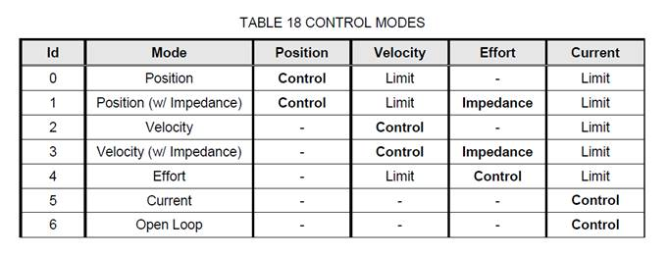

Position mode: uses commanded velocity to get to commanded position.  The position values could be anything from -2pi to 2pi depending on the joint and the position limits (parameters 178 for high and 179 for low).  The velocity is commanded in radians.

                Velocity mode: disregards the position (this will not pay attention to position limits or collision avoidance).  Commanded radians and current limit are the only inputs in this mode.

Open loop: uses current commands.  Anything from +/-10 will be taken as an input, but it will respect the current limit of the actuator.   This input translates to commanded motor amps for each joint.  This is an inefficient mode and will heat up motors quite quickly when using higher inputs.

Position Impedance: uses an impedance PID loop which feeds into a position PID which feed into a velocity PID.  Velocity impedance is essentially the same thing without the position loop in the middle.

3rd:

The adroit driver interacts with a socketcan interface.  Any usb adapter with a socketcan driver should work.  We haven’t tested that one specifically.

I hope that answered most of your questions.  We have made progress on the left arm and should have news for you shortly.  Apologies for the delay, we’re trying our best to get it back to you.

Thanks,

Mike

Question mail:

Dear Mr. Wahl

I am the maintainer of the HDT saffir arm in Virginia Tech.

I have questions about the system.

**1st.**

I tried to change the control mode of the system using console.

These sequences under here are described in the supplemental instructions for SAFFIR arm that I received.

(The instruction file is also attached below)

1. Change the drive state to INIT

> cs # 0

1. Read existing offset

> r # 4

1. Interpret the bitmask to derive current control mode. Convert back to integer and write

> w # 4 (new param)

1. Commit changes

> c #

If I run the second line, every joints shows me the param:4 data:256.

I cannot find any CtlModeType that matchs 256(bitmask: 2^8).

There are only 7 ctrlmodetypes in the instruction.

Is that 256 means control mode is in POS_IMPEDANCE MODE?

And if I change that value to 512, it means that control mode is VELOCITY_MODE?

If my understanding is not correct, can you show me the example sequence that can change the joint mode to EFFORT_MODE?

**2nd**

Can I ask how the system is using commanded pos,vel,effort in each Control Modes?

I thought that POSITION_MODE is using commanded Position and commanded Velocity for moving the joints.

I want to know what kind of value is necessary for making joint move in each Control Mode.

And can I also receive how the feedback loop is constructed in each Control Mode?

**3rd**.

https://ssl.gstatic.com/ui/v1/icons/mail/images/cleardot.gif

I want to know if I can use the PCAN-USB pro FD version model for the HDT arm.

I attached the model picture under this email.

link of the product: <https://www.peak-system.com/PCAN-USB-Pro-FD.366.0.html?&L=1>

We bought this model because the previous version is no longer manufactured.

But I couldn't make a connection through this device.

Thanks,