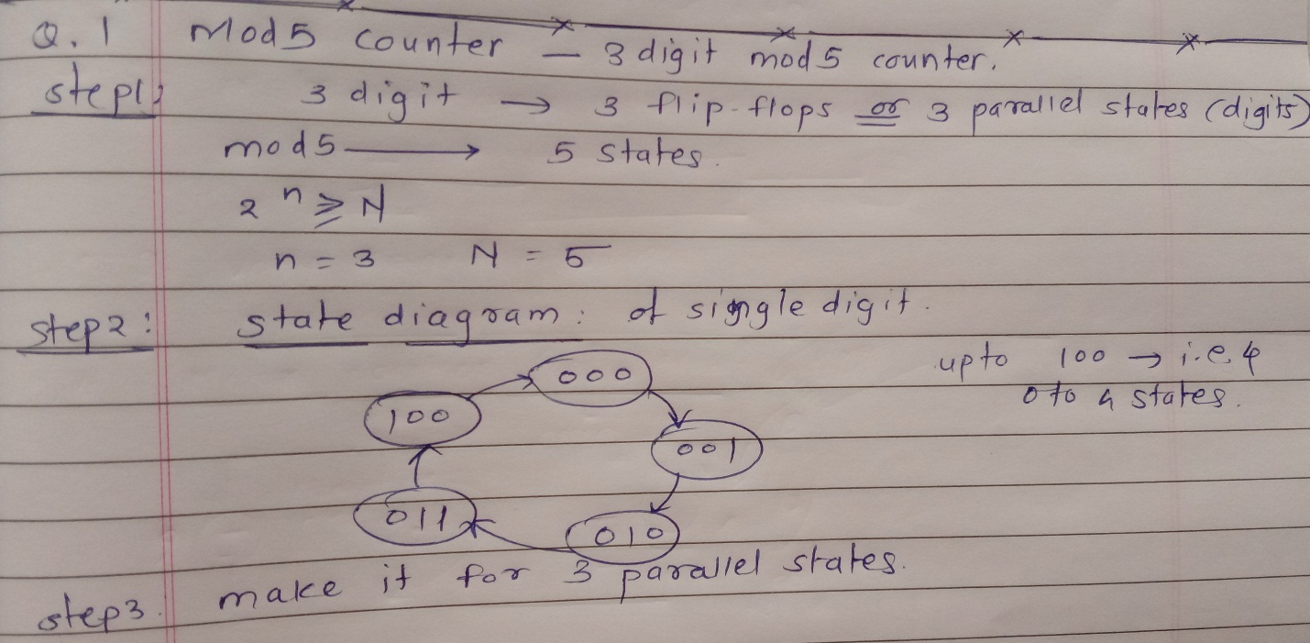

Output:

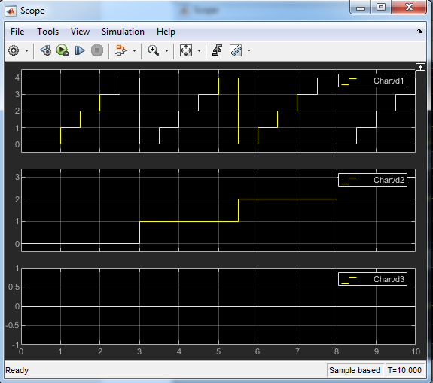

States checking Table:

|  |  |  |
| --- | --- | --- |
| D3 | D2 | D1 |
| 0 | 0 | 0 |
| 0 | 0 | 1 |
| 0 | 0 | 2 |
| 0 | 0 | 3 |
| 0 | 0 | 4 |
| 0 | 1 | 0 |
| 0 | 1 | 1 |
| 0 | 1 | 2 |
| 0 | 1 | 3 |
| 0 | 1 | 4 |
| 0 | 2 | 0 |
| 0 | 2 | 1 |
| 0 | 2 | 2 |
| 0 | 2 | 3 |
| 0 | 2 | 4 |
| 0 | 3 | 0 |
| 0 | 3 | 1 |
| 0 | 3 | 2 |
| 0 | 3 | 3 |
| 0 | 3 | 4 |
| 0 | 4 | 0 |
| 0 | 4 | 1 |
| 0 | 4 | 2 |
| 0 | 4 | 3 |
| 0 | 4 | 4 |
| 1 | 0 | 0 |
| 1 | 0 | 1 |
| 1 | 0 | 2 |
| 1 | 0 | 3 |
| 1 | 0 | 4 |
| 1 | 1 | 0 |

…