Kp=200 and Ki=100:

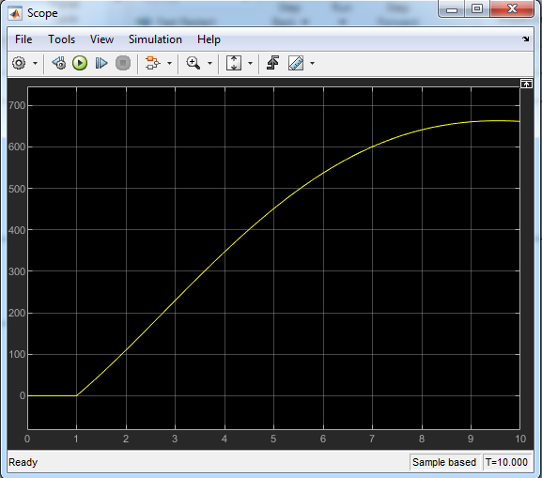

Not Satisfy : 1)Rise time < 5 s (2)Overshoot< 10% (3)Steady-state error < 2%

Kp=500 and Ki = 60

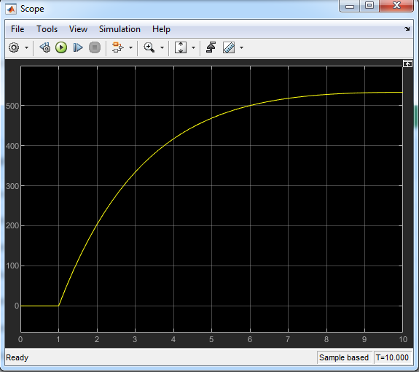

Not Satisfy : 1)Rise time < 5 s (2)Overshoot< 10% (3)Steady-state error < 2%

Kp= 800 and Ki = 40

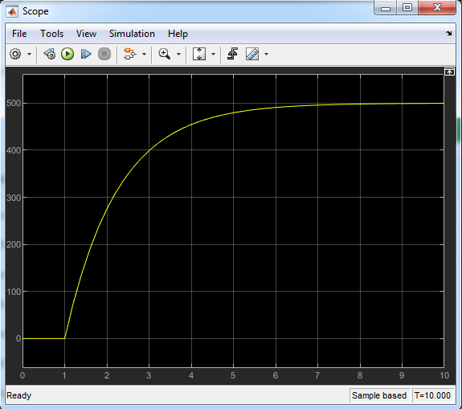

Satisfied : 1)Rise time < 5 s (2)Overshoot< 10% (3)Steady-state error < 2%