Open loop Motor position controller:

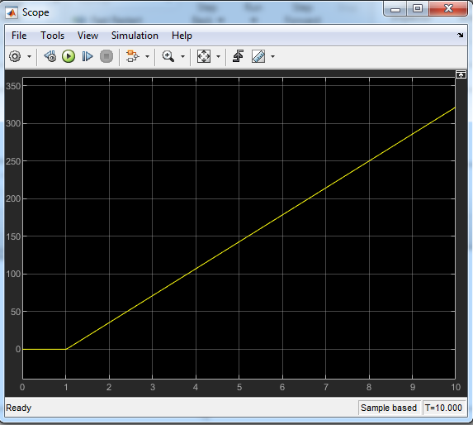

Closed loop motor position controller:

1. With no noise signal:

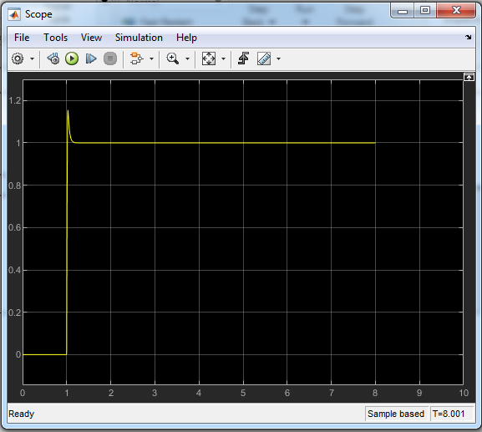

2)With noise signal initializes at 0.03:

