|  |  |
| --- | --- |
| **NAME**: AKSHATA SHEKHAR KAMBLE**TITLE**: ANTILOCK BREAKING SYSTEM |  |
|  |  |

Contents

**Name: ANTILOCK BREAKING SYSTEM 1**

**Introduction.........................................................3**

**Literature review....................................................3**

**Market Analysis......................................................3**

**Evolution............................................................3**

**4W and 1H analysis.................................................4-7**

**SWOT analysis .......................................................8**

**Requirements.........................................................9**

**Block diagram.......................................................10**

**Flow chart.......................................................11-12**

**Testing.............................................................13**

**INTRODUCTION:**

The antilock breaking system is basically used to severe the breaking conditions of any vehicle. ABS system is used to provide “lateral stability” in vehicle. It also provide “longitudinal parameters” where the final goal is “lateral stability”. It prevents the wheels of moving vehicle from locking position or in case of braking. It also prevents wheels of vehicle from breaking during rotating conditions.ABS systems are also called as “Anti-speed system”.

**LITERATURE REVIEW:**

ABS includes components such as, Wheel speed sensor, a hydraulic modulator and electronic control unit and actuators in hydraulic modulator.

I am getting the resources from AAEL module, IEEE paper of Antilock breaking system.pdf from<https://www.researchgate.net/publication/289251560_ANTILOCK_BRAKING_SYSTEM_ABS>

<https://en.wikipedia.org/wiki/Anti-lock_braking_system>

**MARKET ANALYSIS:**

The global anti-lock braking system market size evaluated as $37.69 billion in 2018 and projected to reach $80.65 billion by 2026,registering CAGR of 9.6% from 2019 to 2026.Asia-pasafic accounted as highest share in 2018 and is anticipated to maintain this lead throughout the antilock braking system market forcast.

**EVOLUTION:**

1. Back 1920’s:First applied the concepts of braking to “aircraft brakes” by French automobile and aircraft pioneer Gabriel voisin.
2. In 1936:Bosch company awarded with patent ”Apparatus of for preventing lock braking of wheels in motor vehicle”
3. 1950’s: aircraft technology was aplied to motorcycles.
4. 1960’s: Experiment of aircraft done on passenger cars.
5. 1970’s: computer sensors and actuators are developed for ABS.
6. 1972: WABCO partners with Mercedes BENZ developing first ABS for TRUCK’s.
7. 1981:100000 Bosch ABS are installed.
8. 1993:“Lincoln” became first company provide standard four-wheel anti-lock brakes and dual air bags.

**ANALYSIS:**

**What is ABS?**

ABS stands for antilock breaking system.ABS works in closed loop with series of inputs and outputs. The input from “Wheel speed sensor” and output is” brake system pressure control” by ECU commands. In slippery surfaces or in rotating positions of wheel the tire is get locked. This locking position sometimes causes accident. The remedy for this problem is in the development of ABS control system.

**What subsystems used in ABS?**

**1. Encoders:**

Wheel speed sensor is used as encoder for acceleration and deceleration purpose. Continuous rotation of wheel generates magnetic field and fluctuations in this magnetic field generates voltages. When rotation speed is decreased then obtained fluctuations are get disturbed.

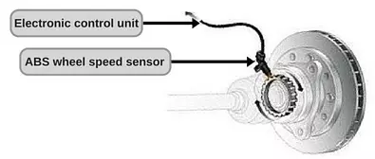

**2. ABS ECU:**

It will reads all the inputs of wheel sensors and calculate a parameter called as “slip”

**Slip = wheel speed ~ vehicle speed**

**3. Hydraulic Modulators:**

It depends on signal from ECU through valves. It controls wheel-brake pressure for braking. Valve and pumps are part of Hydraulic modulator. Valve is brake controlling line. It is used to control pressure which is applied to break pedals. Pumps are used to restore the pressure which is released by valve.

**4. Master cylinder:**

When pedal is pressed, piston moves to left. When it crosses bypass port, liquid is forced to flow through wheel cylinders. When pedal is released, piston is moved back to current position.

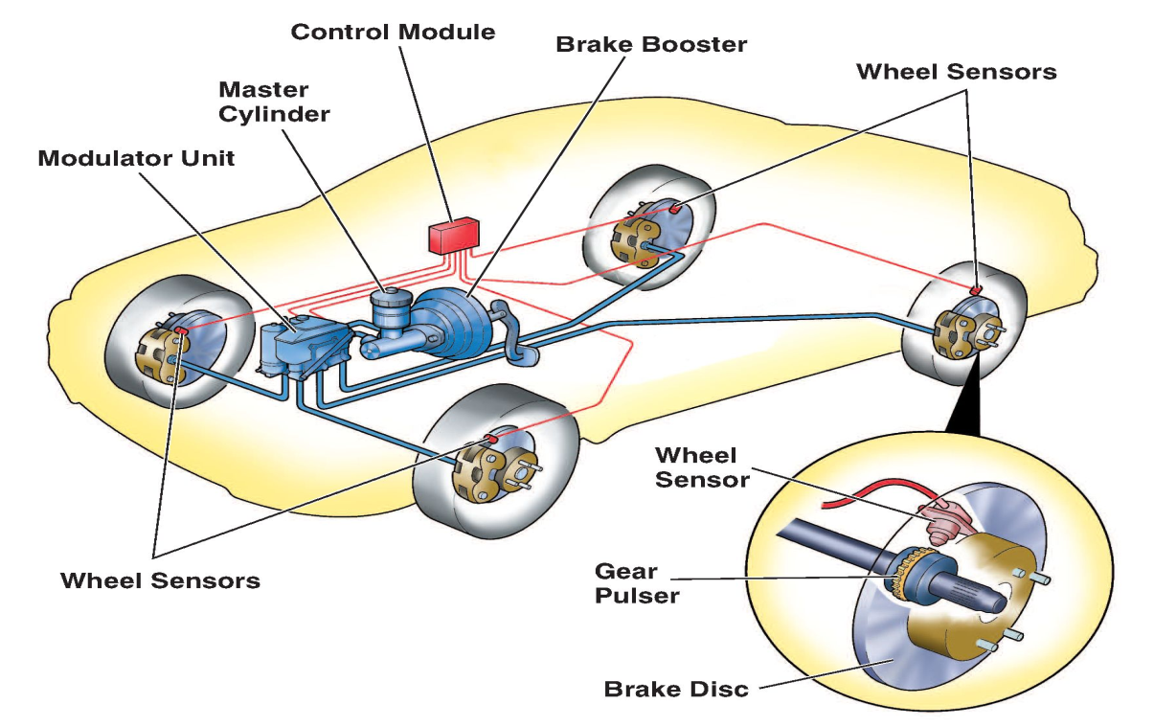

***Fig. Components of ABS***

**What are types of mechanisms?**

The working is depends on 3 basic mechanisms

**1) Breaking mechanism:**

When the car fully in speed and we want to stop it we are going to use breaking mechanism. when brake pedal is pressed, brake sensors are activated .Brake pads on wheel disc is get activated and press against the disc. Then the disc stops the rotation of wheel and vehicle is stopped.

**2) Steering mechanism:**

Steering mechanism depends on wheel rolling. The wheel is always going through road so, velocity of speed of wheel is always “0”with respect to road contact point.

Having 2 types motions:

1] Rotate along axis:

2] Along the direction of car:

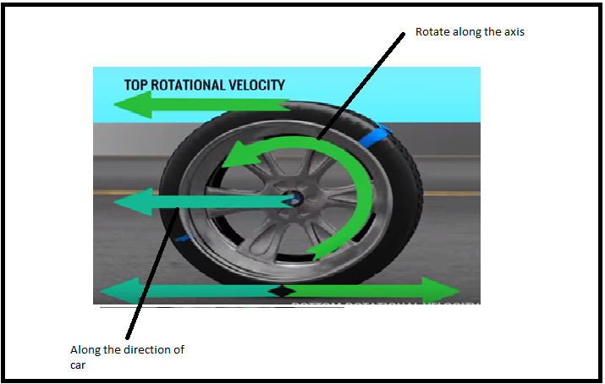

***Fig. Motion of wheel***

Because of 2 motions there are having 2 types of velocities:

1] Translational velocity

2] Rotational velocity

Translational and Rotational velocities at contact point = 0.At the time when we turn the car Rotational velocity is “Inclined”, but translational velocity is “constant”.

**3) Steer with Break mechanism:**

Due to brake pads activated wheel stops spinning, even though wheels are turned but they not rotating ,so no rotational velocity is possible and wheel is get locked. This is the normal case of braking which causes accident.

**Where ABS module is located?**

ABS module is located in engine compartment or in drivers side. Speed sensors are located on wheel hubs. The ECU is located usually right next to the batteries look for a big bunch of wires going from the ICE.

**When the ABS mechanism is used?**

1. In Rapid deceleration like slipping of wheel is not possible in car.

2. During acceleration pressure reduces, and vice versa. This process is very fast because of ABS. It provides maximum braking power.

3. To regulate the brake feature ABS plays important role.

4. In locking wheel conditions.

**Why the ABS is used?**

When the vehicle taking turn from corner, the rotational velocity is “Inclined” but Translational velocity remains “constant” so, resultant velocity is not equal to “0” the wheel is get locked and car slips .

**How to solve problem?**

ABS includes speed sensors attached to wheels. When sensor detects the wheel is locked up then modulator unit partially releases brake pad on that wheel during braking. Here the wheels have “Intermittent Rotational Velocity”, this allows the drivers to steer the vehicle even in braking. The antilock systems have maximum fictional force so minimum braking distance.

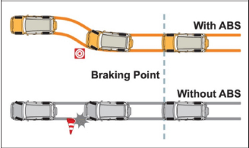

***Fig. Effect of ABS***

**How intermittent brakes reduces the braking distance?**

For this purpose “coefficient of friction” is considered. In perfect rolling condition “coefficient of friction”=0 and in “maximum slipping”-“sliding friction” comes in picture. During the braking mechanism “coefficient of friction”=”sliding friction”. In ABS the algorithm is formed to keep slip=0.2 and friction value is maximum so it will reduces “Braking distance”.

**SWOT Analysis:**

**Strengths:**

1. ABS provides lock up and skidding on slippery surfaces. It was also useful on ice surface.
2. It insures low insurance cost because it will testing device and determines how that device is effective.
3. Now the ABS technology becomes “standard on every vehicle so it results in “High resale value”.
4. It is similar in infrastructure of traction control system.
5. ABS electronically controls the front to rear brake bias.

**Weaknesses**:

1. Sometimes the errors are found in braking distance for regular conditions because noise in ABS system causes the driver to not break the vehicle at same rate.
2. The sensors on each wheel are very expansive.
3. Sometimes a compensating brake sensor causes vehicle to vibrate and making noise. This is because disorientation of ABS.

**Opportunities**:

1. ABS technique is used for perfect breaking conditions in cars
2. It also used in motorcycles for easy pick up.

**Threats**:

1. The most common ABS problems occur when sensors become destroyed with debris.

**Formula**:

**Slip** **=** **1 – (omega(w)/omega(v))**

**Test cases:**

|  |  |  |  |  |
| --- | --- | --- | --- | --- |
| **TEST CASE ID** | **Purpose of the Test** | **Expected output** | **Actual output** | **Validation** |
| TC_1 | Omega(w) == omega(v) | Normal wheeling. | Slip=0 | pass |
| TC_2 | Omega(w)== 0 | Wheel locked. | Slip=1 | Pass |
| TC_3 | Omega(w)/omega(v)==0.8 | ABS ON | Slip=0.2 | Pass |