Lab1

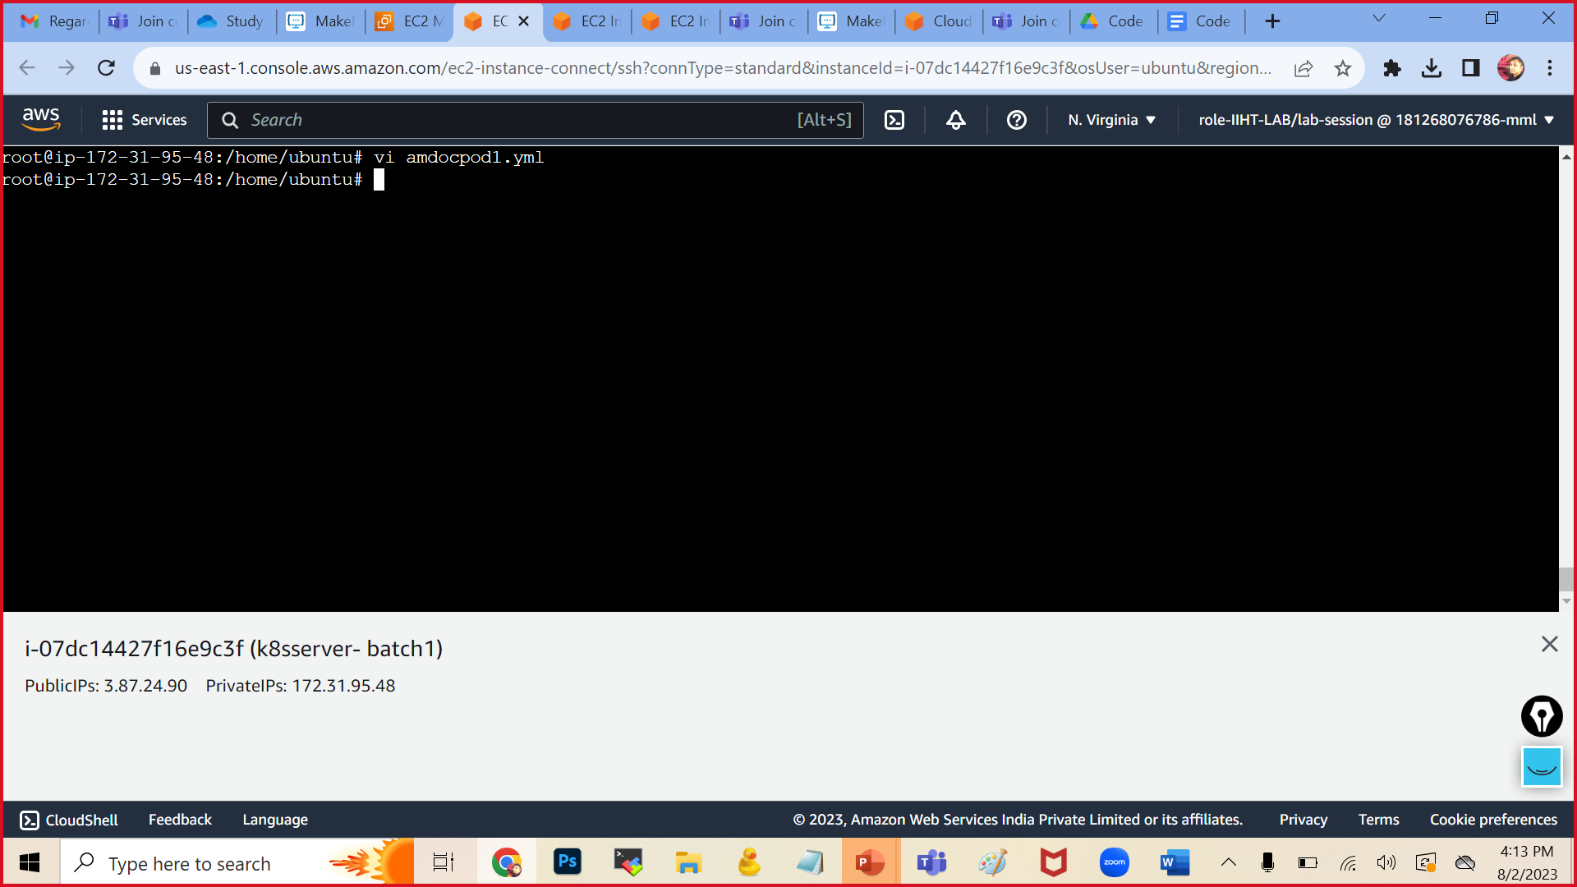

Press i to insert

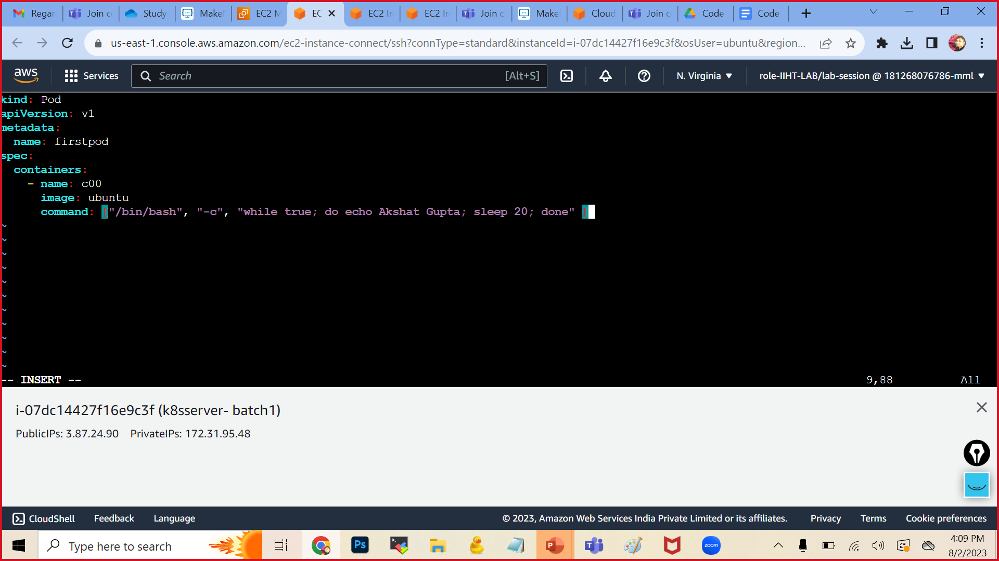

Press esc :wq

To execute the yaml file:

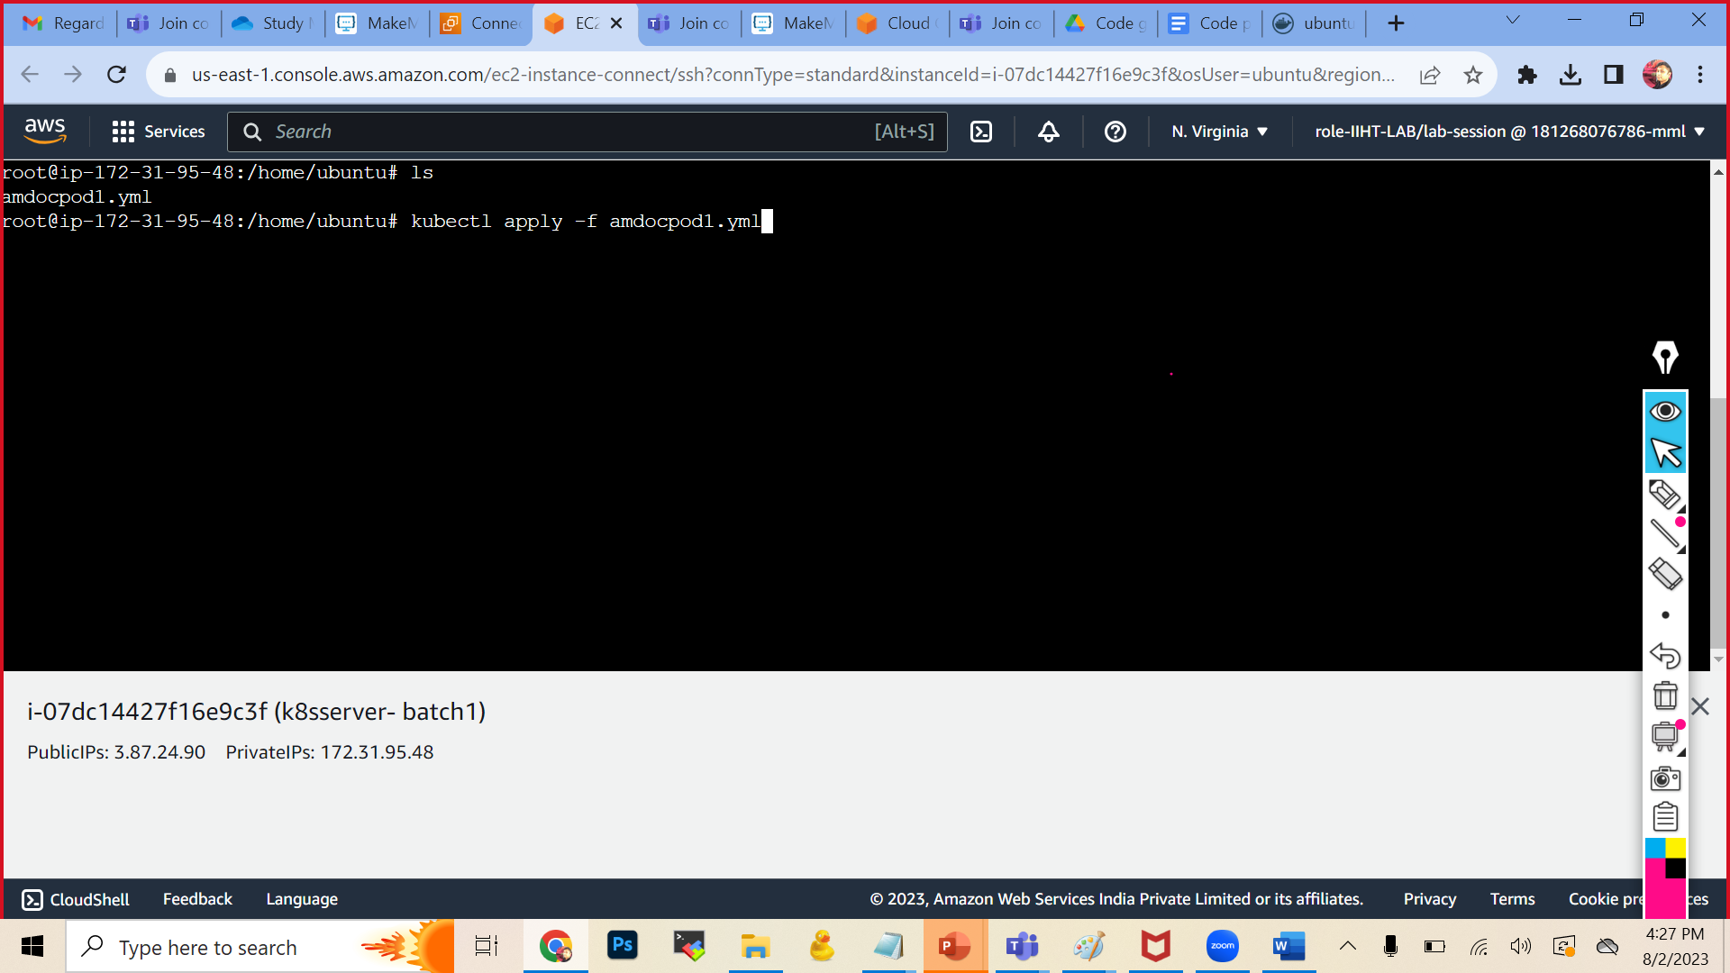

kubectl get pods

kubectl get pods -o wide

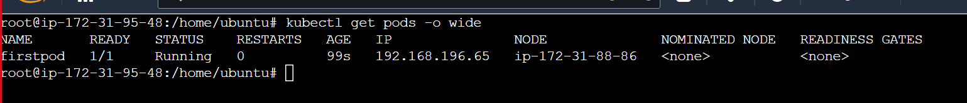

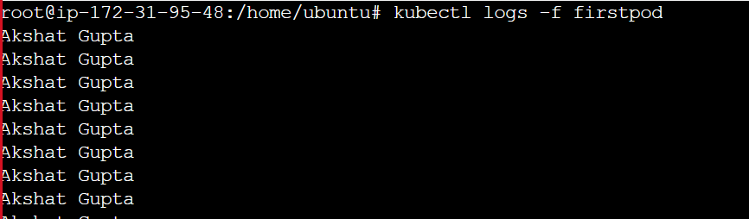

Press ctrl c

To get inside the the container of the pod firstpod

