Namespace

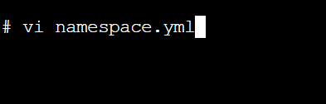

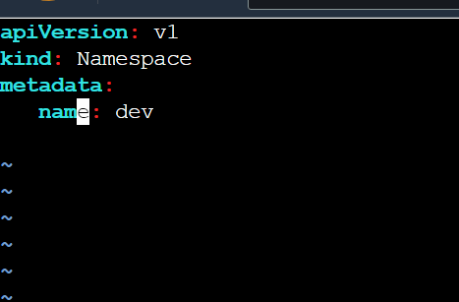

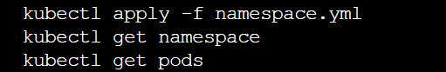

Vi pod1.yml

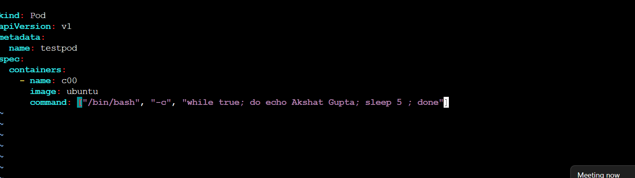

kubectl apply -f pod1.yml -n dev

kubectl get pods

kubectl get pods -n dev

kubectl delete -f pod1.yml

(o/p : error)

kubectl delete -f pod1.yml -n dev

kubectl apply -f pod1.yml -n dev

kubectl get pods

(o/p : no resource found)

kubectl config set-context $(kubectl config current-context) --namespace=dev

kubectl get pods